Modelling of Optimal Investment Policies for the Multiperiod Retrofitting of Chemical Plants
Zorka Novak Pintarič, Zdravko Kravanja
University of Maribor, Faculty of Chemistry and Chemical Engineering, Smetanova 17, SI-2000 Maribor, Slovenia

Abstract
This paper presents a multiperiod strategy for reconstruction design and capital allocation at gradual improvements of processes over a specified time horizon. A multiperiod NLP model was developed which allows the transfer of incomes, generated with more profitable modifications in the earlier periods, for investing less-profitable modifications in the later periods. In this way, the amount of required fresh investment capital can be reduced, while still achieving promising economic performance of a retrofitted plant. As a result, this model provides a financial plan and an optimal schedule of the reconstruction, according to the company’s available funds.

Keywords: multiperiod, retrofitting, investment planning.
  - Introduction
Nowadays, innovation, improvement and reconstruction of processes are the most important sources of companies’ earnings and productivity growth, sometimes even more important than the development of new products. Large amounts of capital investment are spent on improving existing plants. Some of these changes bring increase in economic benefit, e.g. heat integration, while others may be inevitable for sustainable development of the company, e.g. various environmental and safety projects. Retrofitting of processes is a common approach for implementing these changes. A systematic approach to redesign and retrofit of processes applying model-based reasoning is presented in [1]. Mathematical programming is also a useful tool for designing the reconstruction because it enables the selection of an optimal plan for process improvements, as well as optimal operating conditions, according to selected economic objectives. Mathematical optimization has been used for e.g. retrofit design of heat exchanger networks [2, 3] and capacity expansion planning [4].
When applying mathematical optimization for retrofit design, it is assumed that sufficient investment funds are available in order to accomplish the reconstruction in one-step. As in reality the investment funds are often insufficient, any improvements in processes need to be accomplished gradually over a specified time horizon rather than immediately because, in this way, the amount of required investment capital can be reduced.
This paper presents a nonlinear programming (NLP) multiperiod model in which earnings generated over preceding periods are reinvested in further improvements over the following periods. In this way, the optimal solution would be more or less in line with the solution of immediate investment, depending on the amount of disposable capital.
  - Mathematical programming for process reconstruction
Applying mathematical programming for the reconstruction of chemical processes is an even more challenging task than designing grassroot plants. Optimization of the latter comprises numerous degrees of freedom, including operating, control and design variables, which can be freely adjusted within the limits of given constraints in order to optimize the objective function. In the retrofit case, however, degrees of freedom are usually much lower because existing processes place many restrictions and limitations on designers. Moreover, numerous process changes are undesirable and should be avoided in order to preserve the integrity of the process.
    - Steps in the procedure for reconstruction planning and design
Reconstruction in this paper represents structural changes to the process topology needed when accomplishing specific improvements, and is most often connected with the enlargement of existing units and/or installation of new equipment. This complex task involves several steps:
- Analysis of the existing situation, data acquisition, and developing a mathematical model of the original process flow sheet.
- Defining those planned reconstruction alternatives and goals which should be achieved.
- Defining structural changes to the process topology associated with reconstruction, modeling and including these changes in the original mathematical model.
- Defining the incremental objective function by using differences in revenues, operating, and investment costs between the original and retrofitted solutions.
- Optimizing each individual modification in order to define the minimum set of changes to the process, i.e. process equipment that has to be either enlarged or newly-installed.
- Optimizing all reconstruction in order to obtain optimum solution without any restriction on investment funds.
- Reformulating the original mathematical model into a multiperiod model where operating and control variables are allowed to vary over the periods, while only a minimum set of process equipment (existing or new) is allowed to change in a nondecreasing way.
    - Multiperiod optimization problem
      - Basic model and the objective function
A basic mathematical model is presented with the set of equality (h) and inequality constraints (g), which describe mass and energy balances, design specifications and other specific constraints of the retrofitted flow sheet, Eqs. (2-3).
The symbol x represents the control and operating variables over a period i, e.g. flow-rates, temperatures, pressures. Design variables, d, represent the sizes of the process units, e.g. area, volume, power. In Eq. (1), represents the net present worth (NPW) of the retrofitted solution. The first term on the left side represents the difference between the available fund (Iª) and residual fund () at the end of a specified time-horizon of length N years. The second term is a sum of the annual incremental cash-flows (ΔF_{C}) discounted by discount factor (f_{d}).
      - Cash-flow terms
Incremental cash-flow is calculated using Eq. (5), based on the differential surplus of the revenues (R) over the expenditures (E). The second term () represents savings in income tax because of depreciation (D) at a given tax rate (r_{t}). The last term is that part of the cash-flow which is reallocated as investment money in the previous period, (), and can be spent during the period i.
      - Investment terms
The amount of investment (I) needed for the enlargement or installation of process equipment (Δd) over the period i is calculated by means of the exponential relationship, Eq. (7), composed of the constant, a, and the scale-up exponent (b). The financial balance over the first period, Eq. (8), requires the invested capital (I₁) and the residual amount () to be equalized with the available funds (Iª). Over the following periods, invested and residual monies should match the sum of the residual money transferred from the previous period and the amount of cash-flow generated in the preceding period available for investment, Eq. (9). The constraints in Eq. (10) require nondecreasing design variables and prevent the results with very small units.
The objective function, Eq. (1), together with Eqs. (2-10), represents a general NLP model for gradual reconstruction of a process flow sheet. The main trade-off from the problem is identified between two opposite factors: a) fast investment in order to gain benefits as soon as possible, and b) slow investment in order to obtain high cash-flows over the early periods and, thus, a higher value of net present worth. Multiperiod optimization model presented in this section can be easily extended with the option of borrowing money for initial investment over the first period, as shown more precisely in [5]. In this work, a retrofit topology was determined in advance, while in the future work a strategy for optimal synthesis of structural retrofit changes would be developed.
  - Examples
Two examples of the multiperiod retrofit model’s application will be described briefly: the design of a small heat exchanger network, and reconstruction of a methanol process.
    - Reconstruction of a heat exchanger network
This example considers two hot and two cold streams which, in the original case, are heated and cooled by utilities (Fig. 1a). The main motivation of reconstruction is to install new process exchangers (1 and 2 in Fig. 1b), in order to reduce operating costs. It was assumed that the redundant utility exchangers can not be reinstalled for heat transfer between process streams.

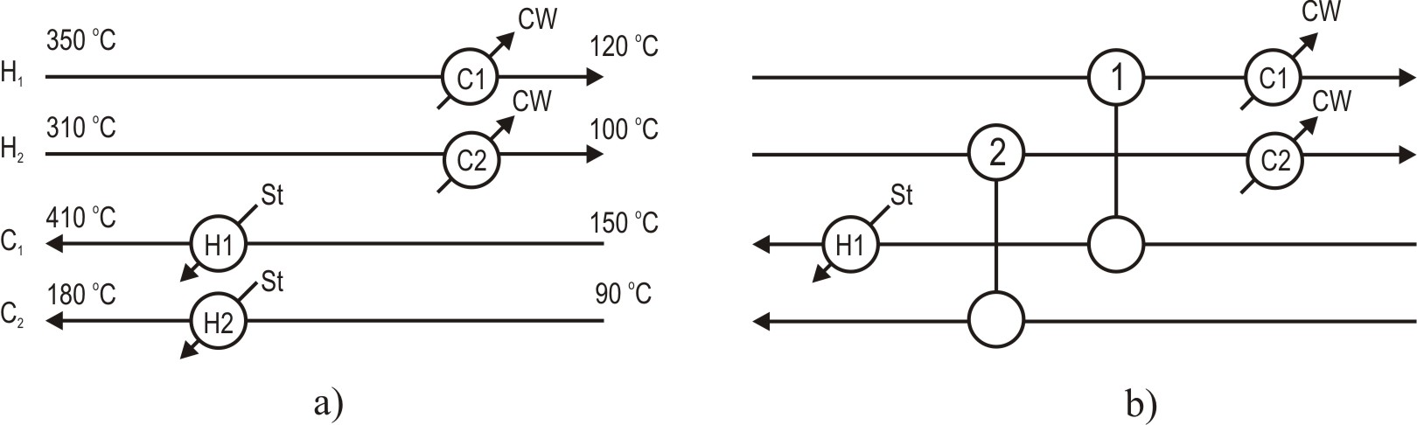
Fig. 1. Heat exchanger network, a) Basic case, b) Retrofitted case
A detailed mathematical model of this example and the results of several techno-economic analyses are given elsewhere [5]. Over a 5-year period and with no limits on invested capital, the optimal size of exchanger 1 was deduced to be 72 m², and the size of exchanger 2, 35 m². Heater H2 becomes redundant in the integrated solution. Immediate reconstruction would require investing 107 k$ and NPW amounting to 1.28 M$. Fig. 2 presents the NPW of the network retrofitted gradually over five years with various amounts of initially available funds (Iª). Lower NPW would be obtained in this way, however, by taking a loan for reconstruction, the retrofitted line approaches the maximum NPW much faster than in the case of no loan.
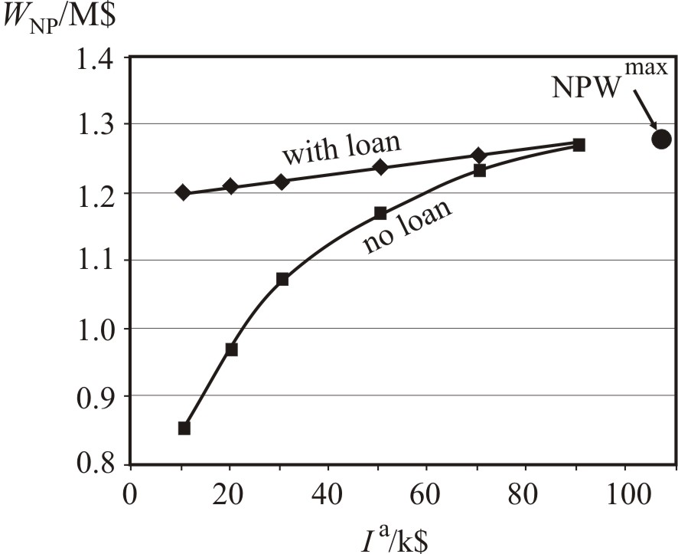
Fig. 2. NPW of the retrofitted HEN for limited funds
Table 1 presents a reconstruction plan for a 5-year period and Iª =30 k$. The NPW of this gradually retrofitted solution is 1.08 M$. In the first period the exchanger 2 should be installed within an area of 19.2 m², because the available funds do not allow more. By using generated savings from utilities, exchanger 1 is installed over the second period with a size of 67.1 m², and the exchanger 2 is enlarged to its final size 35.4 m².
Table 1: Gradual installation of heat exchangers
Period | 0 | 1 | 2 | 3 | 4 | 5
A₁ (m²) | 0 | 0 | 67.1 | 67.1 | 67.1 | 67.1
A₂ (m²) | 0 | 19.2 | 35.4 | 35.4 | 35.4 | 35.4
CPU = 0.2 s (1.6 GHz Intel Pentium 4, 0.512 MB RAM)
Sensitivity analysis has shown that longer time periods increase the NPW significantly, while at higher discount and tax rates NPW decreases somewhat. The dynamics of exchangers enlargement remains unchanged.

    - Heat integration and hydrogen recovery in a methanol process
In this example, two modifications to a methanol flow-sheet (Fig. 3) were performed: 1) heat integration and 2) gas membrane installation for hydrogen and CO recovery and consequently, greenhouse gas reduction. The modifications are shown with bold lines in Fig. 3. It was assumed that membrane permeat (gas rich with H₂) can be sold on the market. It was determined, that among the existing units only the heat exchanger HE1 needs to be enlarged, while the gas membrane and compressor 4 should be newly-installed.
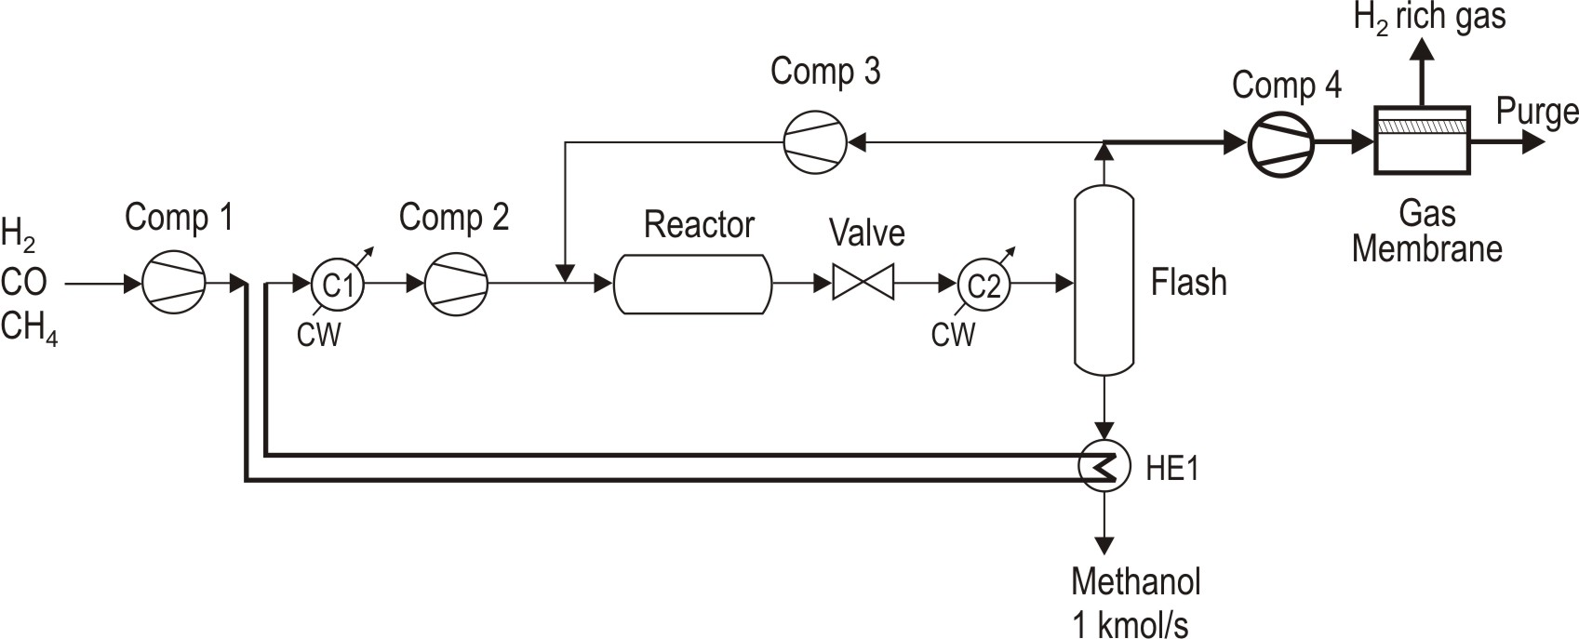
Fig. 3. Retrofitted methanol process

Preanalysis showed that immediate heat integration would require 0.8 M$ of investment and would result in a positive differential NPW of 3.2 M$. Installation of a gas membrane and compressor 4 would require an investment of 2.5 M$, and a differential NPW obtained of -2.14 M$. If both changes are performed simultaneously, the invested fund is 3.01 M$ and the differential NPW would amount to 0.76 M$.
The reconstruction plan for a 3-year period and 2 M$ of available funds is presented in Table 2. This plan predicts the enlargement of heat exchanger HE1 and installation of compressor 4 over the first period. The gas membrane would be partially installed during the first year and then enlarged to its final size during the second year. The NPW of this gradually retrofitted solution is 0.17 M$.

Table 2: Gradual retrofit of methanol process
Period | 0 | 1 | 2 | 3
Heat exchanger HE1 (m²) | 114 | 705 | 705 | 705
Gas membrane (m²) | - | 2670 | 5850 | 5850
Compressor 4 (MW) | - | 1.44 | 1.44 | 1.44
CPU = 14 s (1.6 GHz Intel Pentium 4, 0.512 MB RAM)

NPW decreases as the amount of the available fresh capital, Iª, decreases (Fig. 4). It is the choice of the decision maker as to how much capital will be invested with regard to money available for spending, and how much NPW will thus be achieved. Besides the economic aspects, the environmental issue of this reconstruction is also important: the emissions of CO and CH₄ in the purge stream would be reduced by 33 % over first two years, i.e. from 113 000 t/yr to 76 000 t/year. Global warming potential over a 100-year time horizon, as defined in [6], would decline by 15 %.
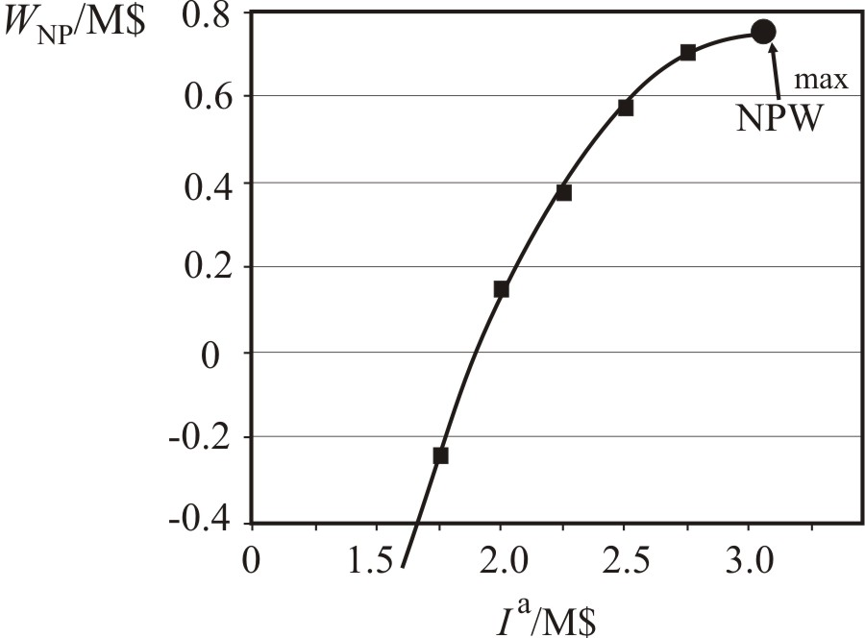
Fig. 4. NPW of the retrofitted methanol plant for limited funds
  - Conclusion
A multiperiod model for gradual retrofit of process schemes is proposed where the most profitable improvements are carried out first, while less or no profitable changes are realized over the subsequent periods. This is carried out by using additional incomes generated in the earlier periods. For example, a reconstruction designed for reducing environmental burdens, which is economically less-attractive, may be carried out by self-sustained generation of financial funds in connection with more profitable modifications. An optimal compromise is established using the proposed model between the dynamics of investing and cash flow generation. The approach presented in this paper can be used in process industries to plan capital allocation for immediate or gradual production plant retrofits and to design retrofit changes over a specified time horizon.

Acknowledgement
The authors are grateful to the Slovenian Ministry of Higher Education, Science and Technology for its financial support (Program P2-0032).
References
[1] I. López-Arévalo, R. Bañares-Alcántara, A. Aldea, A. Rodríguez-Martínez, L. Jiménez, 2007, Generation of process alternatives using abstract models and case-based reasoning, Comput. Chem. Eng., 31, 8, 902-918.
[2] K. M. Björk, R. Nordman, 2005, Solving large-scale retrofit heat exchanger network synthesis problems with mathematical optimization methods, Chem. Eng. Process., 44, 8, 869-876.
[3] A. R. Ciric, C. A. Floudas, 1990, A mixed integer nonlinear programming model for retrofitting heat-exchanger networks, Ind. Eng. Chem. Res., 29, 2, 239-251.
[4] H. C. Oh, I. A. Karimi, 2004, Regulatory factors and capacity-expansion planning in global chemical supply chains. Ind. Eng. Chem. Res., 43, 13, 3364-3380.
[5] Z. Novak Pintarič, Z. Kravanja, 2007, Multiperiod Investment Models for the Gradual Reconstruction of Chemical Processes, Chem. Eng. Technol., 30, 12, 1-12.
[6] A. Azapagić, S. Perdan, R. Clift (eds.), 2004, Sustainable Development in Practice, Willey, 426-437.

