Modeling of anaerobic bioreactors oriented to optimization. Solutions for IPDAE systems
Mauren Fuentes^{a,b}, Miguel C. Mussati^{a,c}, Nicolás Scenna^{a,c} and Pío Aguirre^{a,d}
ªINGAR (CONICET-UTN), Avellaneda 3657 (3000) Santa Fe, Argentina
^{b}Depto de Ciencias Básicas - UTN FRSF, Lavaise 610 (3000) Santa Fe, Argentina.
^{c}CAIMI-UTN FRR, Zeballos 1341 (2000) Rosario, Argentina.
^{d}Facultad de Ing. Qca, UNL, Santiago del Estero 2829 (3000) Santa Fe, Argentina.
(mfuentes; mmussati; nscenna; paguir)@ceride.gov.ar
Abstract
A global model of an anaerobic fluidized bed reactor (Fuentes et al., 2007d) is used to optimize different loading strategies and investigate some aspects on process control to drive the system towards optimal performance under disturbance scenarios. The gOPT tool of gPROMS (Process System Enterprise Ltd.) was used to perform the dynamic optimization calculations. Some aspects on DAE and IPDAE systems formulations for optimization purposes are exposed. Most of the computational work deals with piecewise constant functions. A case study related to a multispecies biofilm reactor for wastewater treatment is analyzed. Results are based on different dynamic optimization formulations such as maximization of biomass concentration inside the bioreactor and biogas production. Operating disturbances such as increased organic loading rate (feed flow rate) during the start-up period, and changes in the cations concentration, result in strong numerical discontinuities that were included in the simulation schedules. Optimization of bioreactor performance in multispecies biofilm requires formulating path constraints for system pH in order to achieve high contaminant removal efficiencies.

Keywords: anaerobic reactors, modeling, DAE/IPDAE systems, dynamic optimization.
  - Introduction
The anaerobic process-based technology for wastewater treatment has opened a new way for investigating and optimizing efficient hybrid processes. Anaerobic reactors based on biofilm development such as upflow sludge blanket (UASB), expanded granular sludge bed (EGSB) and fluidized bed (AFB) reactors are the most conventional high-rate reaction units. Although there are clear differences between these reactor types, some general hypotheses can be assumed to describe the multiple solid-liquid-gas interactions occurring in bioreactors. If environmental conditions inside the bioreactors are adequate, anaerobic processes are essentially self-controlled. However, complexity of biochemical and physico-chemical processes occurring in bioreactors, mechanic design and operating conditions, can difficult the reactor performance. A better understanding of the microbial and hydraulic mechanisms that regulate the system has contributed to the development of more compact and efficient units. However, the long period required for shifting the anaerobic system from one stable operation point to another one is a critical point that still needs to be studied. Sudden increases of the organic load due to a perturbation of either the inlet flow rate or contaminating concentration can affect the system. When the disturbance is on the former, hydrodynamics is significantly affected; whereas when a disturbance is on the latter, the biological process rates govern the transient behavior of the system (Fuentes et al., 2007a,b).
In this context, dynamic simulation and optimization are useful tools for evaluating different loading strategies. A global model of a gas-solid-liquid AFB reactor is implemented to optimize and evaluate start-up procedures in multispecies biofilm systems. Most of the computational work deals with piecewise constant functions. Optimization results are based on maximization of biomass concentration and biogas production, subjected to system pH constraints. The gOPT tool of gPROMS was used to perform the dynamic optimization calculations.
  - The Model
The AFB reactor modeling concept was established from an overall perspective based on a multi-task modeling approach of the main four subsystems: 1) the anaerobic digestion model, 2) the biofilm model, 3) the bioparticle model, and 4) the hydrodynamic model. Figure 1 represents interactions among these subsystems in the global model structure.
Anaerobic Digestion Model (ADM1)
Biofilm Model
Bioparticle Model
Biochemical processes
Physico-chemical processes
Hydrodynamics
Fluidization characteristics
Biofilm thickness
AFBR Model

Fig. 1. Global AFB reactor model structure.

The Anaerobic Digestion Model No 1 -ADM1- (Batstone et al., 2002) describes biochemical processes (growth, death, uptake, disintegration and hydrolysis) and physico-chemical processes (equilibria for calculating pH and gas-liquid mass transfer). Its application to a biofilm system requires the modeling of the interactions between suspended and attached biomass. As microorganisms attach on the bare support and grow forming biofilm, a bioparticle model is required to model an AFB reactor. The solid phase consists of the inert support particles and the (active and non-active) attached biomass. The liquid phase is composed by the chemical species in solution (substrates, products, enzymes, ions, and water) and (active and non-active) suspended biomass. The gas phase is formed by the gaseous products from degradation stages.
Depending on the assumptions made for reactor hydrodynamics, alternative models have been derived from the global scheme presented in Fig. 1. Here, two model versions are selected to discuss some aspects related to their implementation for optimization purposes using gPROMS: (1) a dynamic model with complete mixture conditions, and (2) a one-dimensional (axial, dispersive-convective) dynamic model. They are hereafter named Model 1 and Model 2, respectively. Both models are based on rigorous dynamic momentum and mass balances for phases and components in the three-phase gas-solid-liquid system. Main hypotheses and mathematical models equations have been described in previous papers (Fuentes et al., 2007a-d), which are not here included due to space restrictions.
    - Computational aspects
Model 1 resulted in differential and algebraic equations (DAEs) system. Model 2 resulted in integral partial differential algebraic equations (IPDAEs) system. In both cases, an additional programming effort was needed since “high-index” DAE systems (index>1) was verified. In high-index systems, the number of initial conditions that can be arbitrarily specified is lower than the number of differential variables; differential variables are not independent and numerical methods for solving ordinary differential equations can fail. This problem can be solved by rewriting the derivative of some variables as functions of other differential variables, or directly assigning an initial condition for function to be integrated.
Since the reactor height is a time function, an axial dimensionless model was derived for Model 2 because of gPROMS does not allow the straight calculation of moving boundary problems. It is important to remark that models based on PDEs require additional programming effort to implement estimation and optimization schedules. Initial conditions have to be reformulated from dimensionless differential variables, and set to zero or one depending on the case. This causes an increase in the number of variables and equations but does not necessarily in the CPU time demanded for simulation runs.
Models are able to manage strong numerical disturbances to represent stepped start-up policies. From optimization point of view, a trade-off exists among the number of time intervals, their duration, the (constant, linear, linear continuous, polynomial) function type used for control actions, and the objective function (Mussati et al., 2003). In this work, piecewise constant control functions are experienced.
  - Load policy optimization
Most common problems posed in biotechnology are: (i) maximizing the yield of a desirable product in a fixed operation time; (ii) minimizing the operation time to reach a specified final concentration of a desirable product; (iii) maximizing the conversion of a substrate into a metabolic product. In a previous paper, Mussati et al. (2003) used an alternative formulation: (iv) maximizing the time integral of the concentration of attached biomass contained in a methanogenic reactor fed with an acetate-based synthetic substrate. In this case, the time horizon and substrate or product concentrations are unknown. This approach turned out to be robust from a numerical point of view; i.e., usually converges, provides the best results, and requires a low computational time.
The system load is defined as the pollutant mass (generally as chemical oxygen demand, COD) per time unit and reactor volume unit. Operationally, the most effective manipulated variable for reactor start-up is the feed flow rate. Other start-up policies such as substrate concentration manipulation would require storage systems, and less concentrated streams to dilute the effluent to be treated.
When dealing with multispecies biofilm models using formulation (iv), path constraints are imposed to pH to obtain optimal biomass and methane profiles in a single unit. Indeed, without setting these constraints, if a sugar-rich effluent is processed, the resulting optimal flow rate profile will increase the biomass concentration but as result of acidogens growth only. This is because of acidogens grow and consume at faster rates than methanogens, and are less inhibited by pH. Then, reactor pH decreases as consequence of an increase in the volatile fatty acids concentration from glucose degradation, inhibiting all methanogenic and acetogenic activity (results not shown).
The following results are useful as a starting point for planning experimental works using different start-up strategies. The model allows time variation of the load, substrate concentration, pH by adding acid or alkalis, and the concentration of the different microorganisms groups in the inoculum. Depending on the selected strategy, they can be manipulated variables in an optimal control experiment. The model is also sensitive to the type of support material used for biofilm development and to the bed fluidization characteristics. So, the influence of these factors on the start-up strategies can be eventually evaluated. Sensitivity analysis of optimization results to kinetic, physico-chemical and hydrodynamic parameters can also be investigated.
    - Case study
The computational experiments were performed considering a synthetic substrate based on a mixture of milk powder, acetate and glucose (10, 20 and 70% of the total COD, respectively). Although an influent COD concentration was fixed at 0.85 g L⁻¹, the organic loading rate (OLR) was increased by increasing the volumetric flow rate. The initial expanded bed volume is 3.5 L with a porosity of 60%. This case study was chosen in order to compare with experimental data obtained from a lab-scale anaerobic fluidized bed reactor fed with a similar synthetic substrate. Bioreactor specifications are described in previous papers (named R_{AS} in Fuentes et al., 2007b,c).
    - Manipulating the feed flow rate using a piecewise constant function
There are several criteria to distinguish among load policies, not only by the value of the load in a time interval, but also by the time at which it is decided to apply changes on the load. For instance, Fig. 2 shows the results from Model 1 for optimizing the load policy of the reactor manipulating the feed flow rate (Q_{f}), which is restricted to a maximum of 6 L d⁻¹. For numerical reasons, a Q_{f} value of 3.2 L d⁻¹ was fixed for the first control action. The time horizon was fixed at 40 days. Based on practical considerations, 4 control actions i.e. 4 time intervals are enough for such time horizon. The integral of the attached biomass concentration ($X_{T}^{S}$) was maximized, subjected to pH path constraints. A pH variation between 6.2 and 7.2 was allowed.
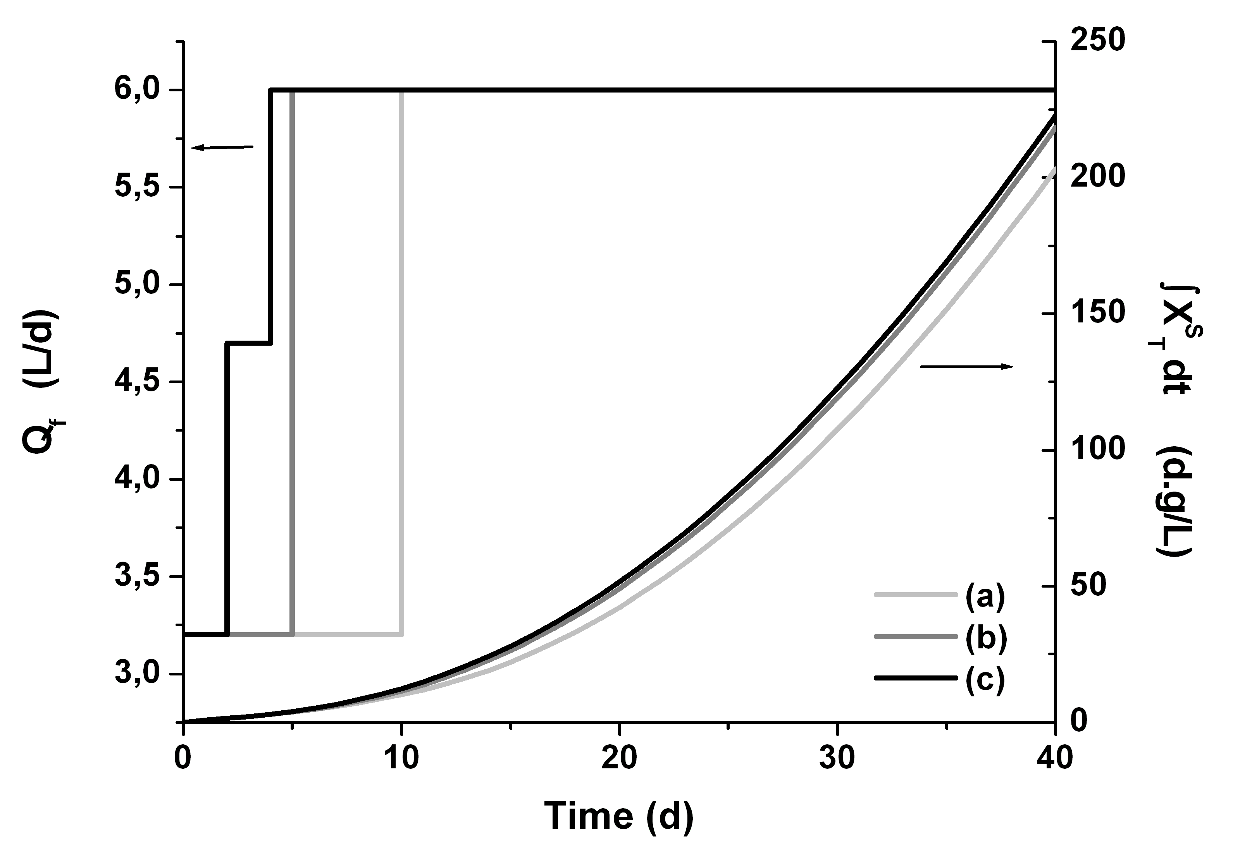
Fig. 2. Manipulating the feed flow rate (Q_{f}) using four time intervals ($t_{i}^{\text{LO}}≤t_{i}≤t_{i}^{\text{UP}}$):
a) $t_{i}^{\text{LO}}=\text{10}$ days, b) $t_{i}^{\text{LO}}=5$ days, and c) $t_{i}^{\text{LO}}=2$ days; $t_{i}^{\text{UP}}=\text{40}$ days.
As shown in Fig. 2, as the minimal time ($t_{i}^{\text{LO}}$) in which control actions must be applied is reduced, the attached biomass integral is increased; the reactor can process a higher feed flow from the beginning of the start-up. However, contrarily to solutions for $t_{i}^{\text{LO}}$ equal to 10 and 5 days, where Q_{f} reaches the value of the upper bound or the set maximal value (6 L d⁻¹) in the second control action; the solution for $t_{i}^{\text{LO}}$ equal 2 days requires an intermediate flow rate of 4.7 L d⁻¹ before setting the maximal flow value in a third control action. It seems to indicate that the system requires a longer residence time for biomass development during the first days.
    - Manipulating the feed flow rate and cations concentration using piecewise constant functions
One strategy to increase the load and improve reactors performance is manipulating both the flow rate and ions concentration simultaneously to neutralize the pH. In practice, this can be interpreted as the salts or acids dosification for pH control. If in the previous example the influent cations concentration (S_{C+}) is also manipulated, in addition to Q_{f}, for a minimal time of 2 days to perform control actions, the same optimal profile of Q_{f} is obtained (darker line, Fig. 2) but cations concentration profile is such that guarantees an increase of the attached biomass concentration integral as shown in Fig. 3.
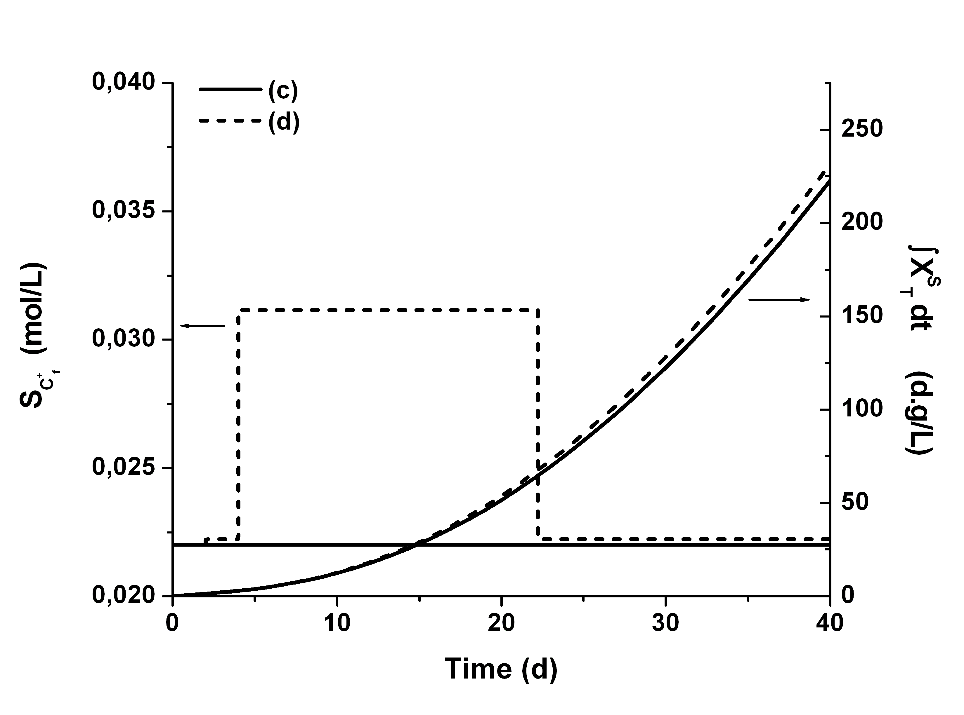
Fig. 3. Manipulating: c) the feed flow rate, and d) the feed flow rate and cations concentration; $t_{i}^{\text{LO}}=2$ days.
Figure 4 shows the total COD values for each optimal policy depicted in Fig. 2 and 3. Suspended biomass that leaves the system contributes with 7% to COD. As observed, around day 15 (when reactor reaches the maximum OLR), strategy d is a 10% more efficient than the others. Similar results are obtained for reactor start-up optimization using Model 2, when the discussion is focused on the presence of several groups of microorganisms in the biofilm system (results not shown).
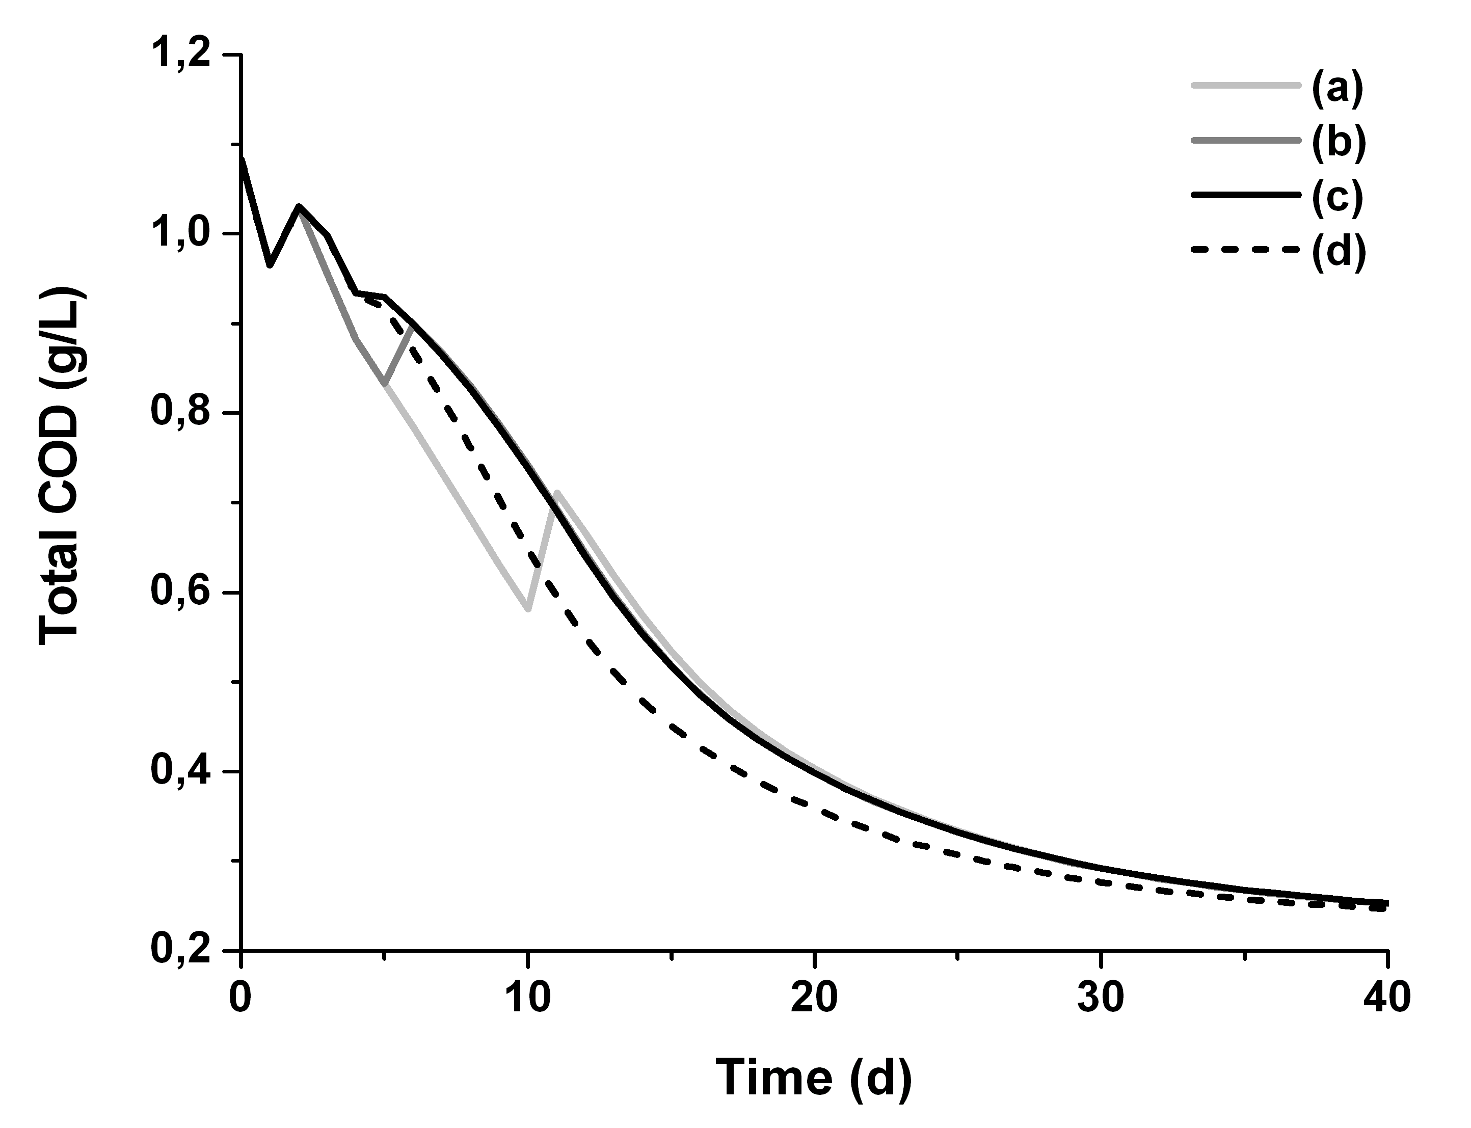
Fig. 4. Predicted total COD values for calculated optimal load policies (a-d).
    - DAE system solution versus IPDAE one
As mentioned, different efforts are demanded to implement computationally Models 1 and 2. Previously, it was concluded that from a computational point of view, the former is an “inexpensive” approach to facilitate analysis when reactor operating conditions present a complete mixture behavior (Fuentes et al., 2007d). Therefore, depending on the phase dispersion coefficient (D_{z}) value, the DAE system solution can be used as good initial values for IPDAE one. Table 1 summarizes computational statistics for solutions from Model 1 and Model 2 for a high D_{z}, manipulating the flow rate and cations concentration (Case d, Section 3.3). Figure 5 shows the resulting optimal pH profiles obtained from Models 1 and 2.

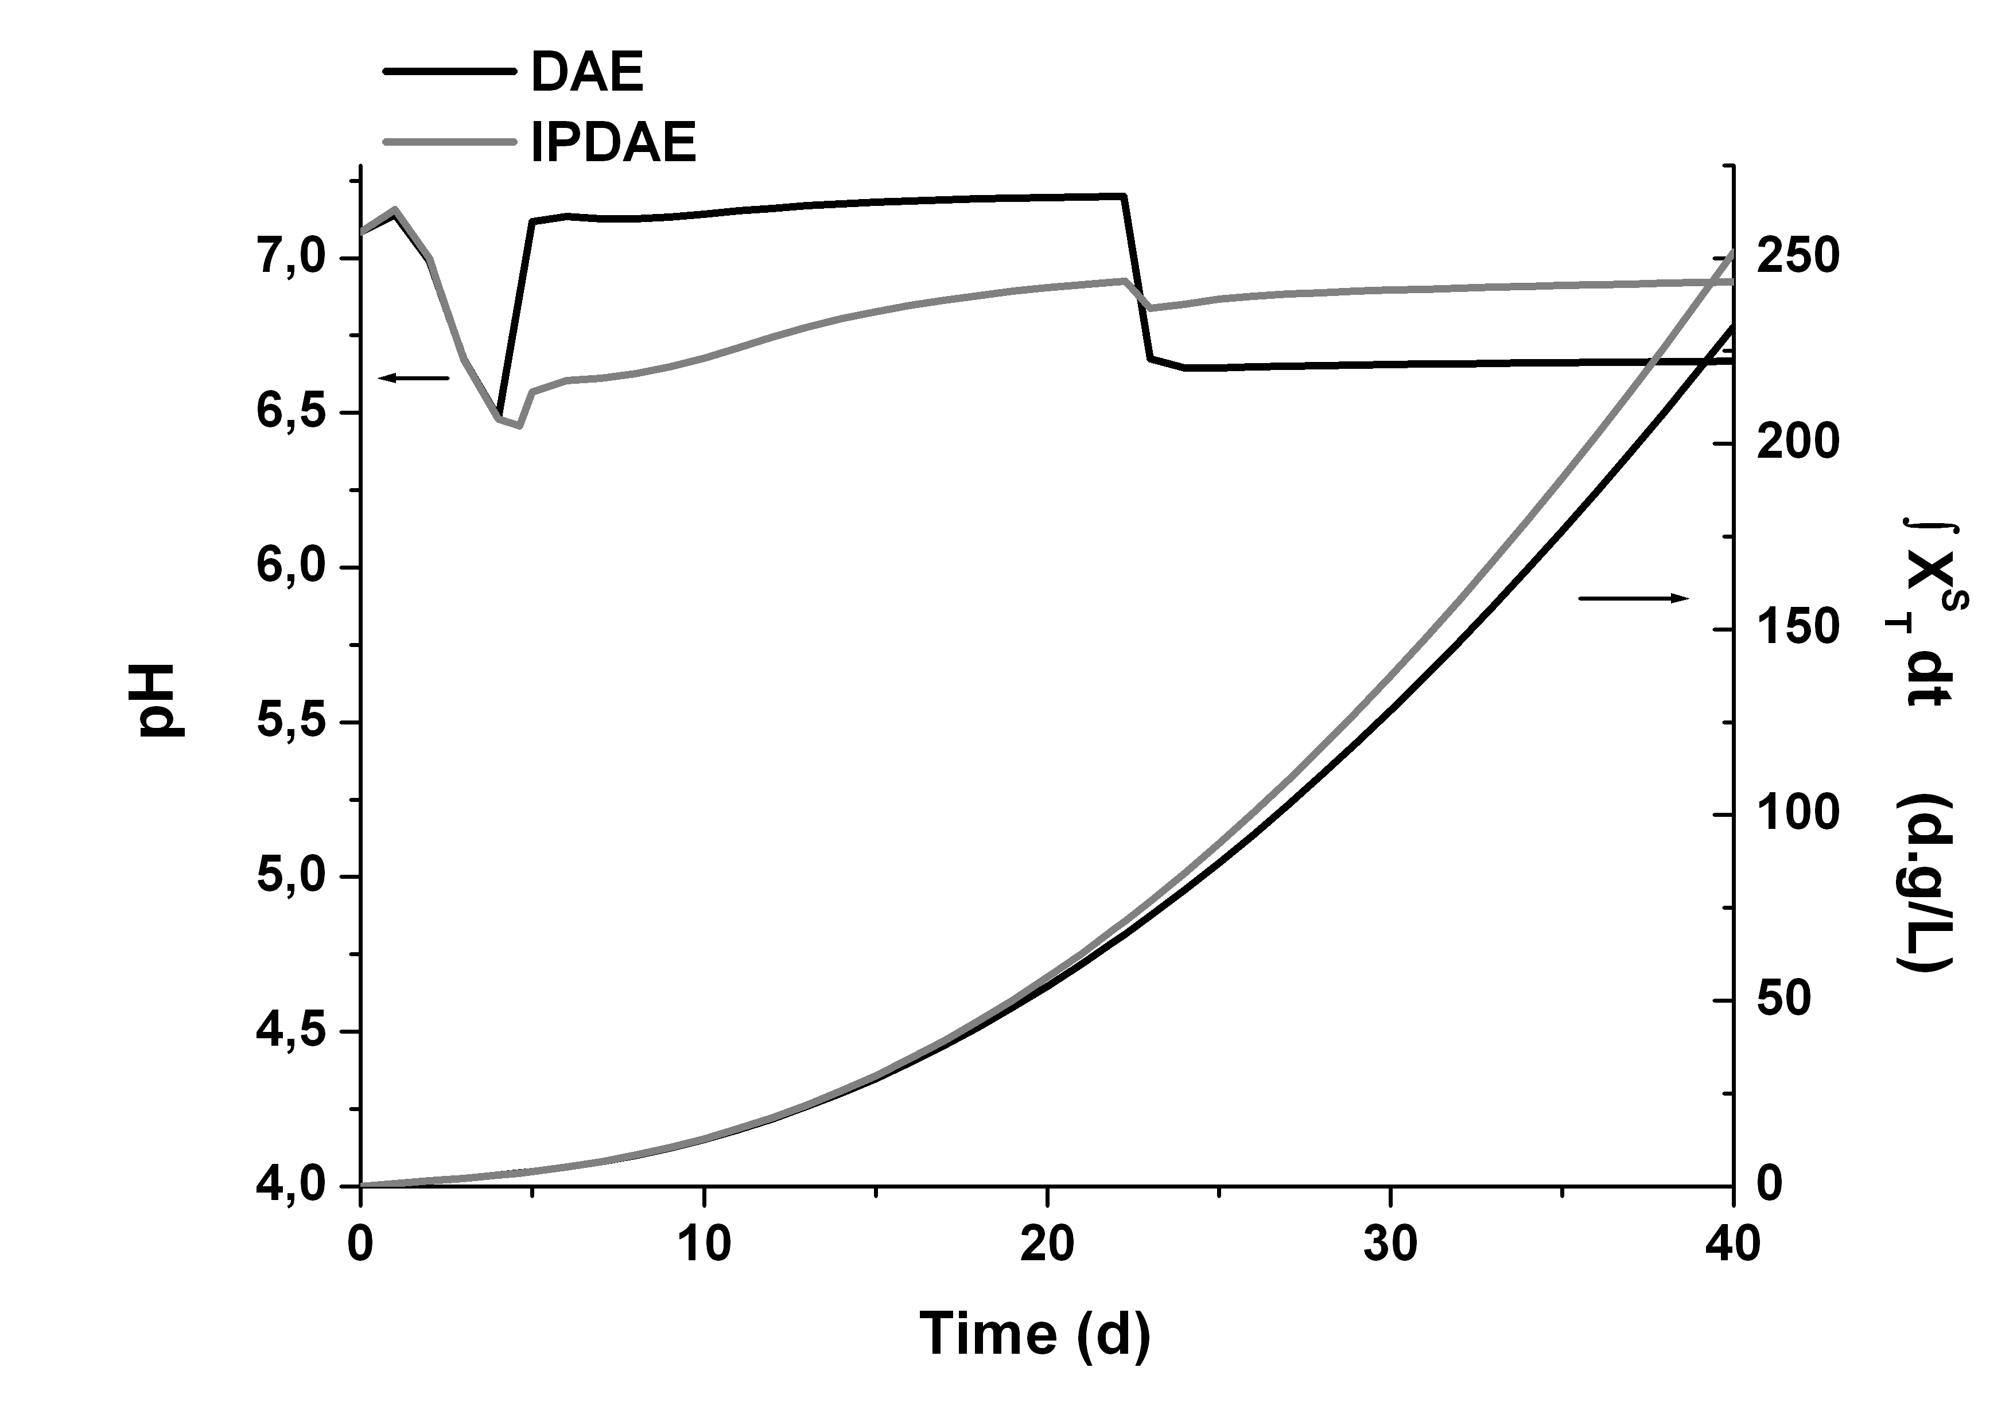

 | Table 1. Computational Statistics
 | Statistics | Models
 |  | M 1 |  | M 2
 | Total CPU Time (s) | 39.67 |  | 50675.4
 | CVP_SS Optimizer Statistics
 | CPU Time | 0.03 |  | 3.279
 | No. MINLP Iterations |  | 0 | 0
 | No. NLP Iterations |  | 7 | 32
 | No. NLP Line Search Steps |  | 7 | 62
 | DASOLV Integrator Statistics
 | CPU Time | 11.07 |  | 35803.6
 | CPU Time (Integration) | 2.43 |  | 10532.6
 | CPU Time (Sensitivity Integration) | 8.62 |  | 25271.0
Fig. 5. Optimal pH profiles from Models 1 and 2 (Case d). | Mean CPU Ratio | 4.54 |  | 3.39
  - Conclusions
In multispecies biofilm systems, reactor start-up optimization requires formulating path constraints for system pH in order to achieve high COD removal efficiencies. Before obtaining concluding remarks, some aspects still need to be addressed. They are related to the modeling of the kinetics of disintegration and hydrolysis of complex substrates and to biofilm dynamics (Fuentes et al., 2007a,b,c).
Some aspects on DAE and IPDAE systems formulations for optimization purposes were exposed. For the case study investigated, results from the former constitute good initial values for the latter. IPDAE-based model is interesting for practical applications when realistic operating schedules coupled with non-ideal flow patterns during biological and hydrodynamic transients need to be investigated.
References
Batstone D.J., et al. (2002) Anaerobic Digestion Model No. 1 (ADM1), IWA Task Group. London, UK: IWA Publishing.
Fuentes, M.; Aguirre, P.; Scenna, N. and Mussati, M. (2007a) Anaerobic biofilm reactor modeling focused on hydrodynamics. Chem. Eng. Commun., In press.
Fuentes, M.; Aguirre, P.; Scenna, N. and Mussati, M. (2007b) Anaerobic digestion of carbohydrate and protein-based wastewaters in fluidized bed bioreactors. Lat. Am. App. Res., 37(4), 235-242.
Fuentes, M.; Aguirre, P.; Scenna, N. and Mussati, M. (2007c) Application of two anaerobic digestion models to biofilm systems. Biochem. Eng. J., In press (DOI: 10.1016/j.bej.2007. 07.013).
Fuentes, M.; Aguirre, P.; Scenna, N. and Mussati, M. (2007d) Hydrodynamic aspects in fluidized bed bioreactor modeling. Chem. Eng. Proces., In press (DOI: 10.1016/j.cep.2007.07.001).
Mussati, M.; Fuentes, M.; Aguirre, P. and Scenna, N. (2003) Optimizing load policy in anaerobic biofilm reactors for wastewater treatment. Lat. Am. App. Res., 33, 301-305.

