Modified outer approximation algorithm for optimizing complex distillation processes
Barbara Czuczaiª, Tivadar Farkas^{b}, Endre Revª, Zoltán Lelkesª
ªBudapest University of Technology and Economics, Department of Chemical and Environmental Process Engineering, Budafoki ut 8. Budapest, 1111, Hungary
^{b}HAS_BUTE Materials Structure and Modeling Research Group
Abstract
Process synthesis problems formulated as MINLP containing huge number of nonlinear equations may be difficult to solve due to the large initial infeasibility which the NLP-solver cannot cope with. Similarly, strong non-convexities may cause cutting out some or all of the feasible solutions during the solution process.
A new modified Outer Approximation algorithm has been developed for handling these issues. A new step calculating initial values for all variables has been inserted between the MILP master and NLP subproblems. Besides, in order to avoid cutting off feasible solutions, the set of nonlinear equations used for the linear approximation has been reduced. The performance of the new modified Outer Approximation algorithm has been studied using an example of complex distillation optimization problem.

Keywords: Outer Approximation, Extractive distillation, AIMMS
  - Introduction
Designing economically optimal distillation configurations and sequences is still a challenge in the area of process synthesis. Although there are some interesting and successful approaches [1-4], the problem still requires suitable solution methodology. This is partially due to the numerical problems arising from the large number of nonlinear equations and strong non-convexities.
The problem formulated as an MINLP can be solved with DICOPT solver using Outer Approximation algorithm or SBB solver applying Branch & Bound technique [5]. When nonlinear programming (NLP) solvers are used for solving distillation process synthesis problems containing a huge number of nonlinear constraints and strong non-convexities, one often faces serious numerical problems. Even if the problem itself is feasible, the solver may not find solution. Although it is possible to provide good initial values for the first (relaxed) NLP, these initial values will be missed when a new NLP subproblem is to be solved at a new fixed (or partially fixed) binary variable vector in subsequent iterations (or nodes).
Additional problems may be encountered when the problem to be solved contains non-convex constraints. When generating the MILP master problem, linear approximations of the nonlinear constraints are added to the constraint system. However, the linear approximation ceases to be an outer approximation if the solution region is not convex. In these cases, considerable number (or even all) of the existing feasible solutions may be cut off [6]. Recently, this issue has been addressed by using piecewise underestimators and by eliminating the calculation of lower bound for global optimum [7].
These numerical issues at subproblems may cause that the optimal solution, or even a feasible integer solution, cannot be found with the original algorithms. Such an example is detailed in Section 4.
In the present work, a method for optimizing complex (extractive) distillation processes is provided. The original Outer Approximation algorithm is modified by inserting a new step in each iteration between the master-MILP and the NLP-subproblem in order to eliminate the disturbing effect of changing the binary variable vector. The new step calculates initial values for all the variables in the model and therefore the initial feasibility is decreased by an order of magnitudes. Besides, when generating the MILP master problems, we eliminate some equations which are the main sources of the non-convexity.
  - Model
The MINLP model developed by Farkas et al. [8] is used for optimizing single distillation columns. This model works with minimum number of binary variables. This minimum number is achieved by applying different types of units containing different equilibrium stage numbers in the superstructure of a single column (see Figure 1). If the binary variable of a unit equals one then the unit is included in the structure, all the equilibrium stages contained in that unit work, and their input- and output streams may take positive value. If the binary variable of a unit equals zero then the unit is not included in the structure, none of the equilibrium stages contained in that unit works, and their input- and output streams must equal zero. In the latter case, the liquid and vapor streams flow through transmitter units instead of the units containing equilibrium stages.
The model of Farkas et al. [8] has essential advantages compared to the earlier contributions: It eliminates the structural redundancy at the level of the superstructure; therefore, there is no need to insert new equations for handling binary multiplicity.
Figure 1 Superstructure of a single distillation column
Relaxed NLP
Generating and solving MIP
Linear approximation
Solving NLP for the fixed structure
All equations for linear approximation
Stop criterion
Vector of the binary variables
Figure 2a Original OA algorithm
However, if during the execution of the Outer Approximation one of the MIP master-problem concludes that the number of the stages in either column-section should be changed from 8 to 7 then the whole structure is changed, and the actual values of the continuous variables suddenly become very far from their feasible value. This is not so for the models of Yeomans [1] and Viswanathan [2] in case of smaller design problems. However, when large scale problems are to be solved, with as many as 160 stages (see Example in Section 4), even the NLP sub-problems become too difficult to solve.
For example, when applying the model to the problem presented in Section 4, such difficulties can be experienced (see the model statistics presented in Table 1). The problem scale is so large that the problem cannot be solved with the traditional tools (GAMS 20.0., SBB solver applying Branch&Bound technique or DICOPT using Outer Approximation algorithm, see in Figure 2a).
The NLP solver needs good initial values for the variables in each NLP-subproblem. Similarly, the problem of cutting solutions off needs to be handled.
  - The modified algorithm
    - The algorithm in theory
The scheme of the new algorithm is depicted in Figure 2b.
In order to get good initial values, we inserted a new step between the MIP master- and the NLP sub-problem in each iteration. Appropriate initial values are calculated for the variables stage to stage using the binary vector obtained from the MIP master-problem.
By this way, the initial infeasibility of the NLP-sub-problem can be smaller with orders of magnitude, making it possible for the solver to find feasible solution which satisfies all the equations in the NLP-subproblem. Besides, the solution time is decreased strongly. For handling the problem of cutting off possible feasible solutions when generating the MIP master-problems, we omit those nonlinear equations which are the main source of the strong non-convexity. The Antoine-equations, and the Wilson-equations calculating the activity coefficients, are thus eliminated.
Relaxed NLP
Generating and solving MIP
Linear approximation
Calculating initial values unit to unit
Vector of the binary variables
Equations for linear approximation
(not all)
Solving NLP for the fixed structure
Initial values
Stop criterion
Figure 2b Modified OA algorithm
Apparently, the DICOPT or SBB solvers are unsuitable to handle the problem because of their black-box nature. Another advanced tool can be used to realize these ideas. That can be the Paragon Decision’s developer system called AIMMS. AIMMS has a GMP library [9] through which the user have direct access to mathematical program instances generated by AIMMS, allowing the user to implement advanced algorithms in an efficient manner. The GMP routines can be used for nonlinear models, as well. The basic OA algorithm can be completely implemented using functionality provided by the GMP library. According to the requirements of the problem, the user is able to implement modified or customized algorithms.
    - The modified algorithm in practice – calculating the initial values
Initial values are computed to units top down in the columns. Each unit constitutes a distinct NLP problem. The NLP gets the data of leaving vapor streams and the entering liquid streams as parameters from the previous NLP problem (from the preceding unit above). The NLP problem is solved with these fixed values. Due to some numerical inaccuracy that may cause difficulties under certain circumstances, the process of calculating initial values may require some ingenuity.
In case of extractive distillation with heavy entrainer, the volatility of the entrainer is considerably smaller than that of the other components (see the Example in Section 4). It is then a straightforward idea to fix the amount of the heaviest component at zero in the leaving vapor stream of the unit at the top. However, the tolerance of the solver allows it to be equal to E-15. This small difference can cause the amount of the heaviest component in the leaving liquid stream of the actual unit to be significantly different from zero in the solution. Thus, there can practically be multiple solutions. This problem is avoided by including the entering vapor stream in the objective function. The entering vapor stream of the entrainer component will be zero in all the units, thus when turning over the fixed values of the streams from one NLP to the next, the amount of the entrainer in the entering vapor stream must not be fixed. Being this far the heaviest component in the mixture, this difference between the units will only cause a very small initial infeasibility when starting to solve the NLP-sub-problem.
  - Example
    - Process description
Our goal is to separate a three-component methanol-ethanol-water mixture into its components through extractive distillation. We have three possibilities: either we can use ethylene glycol as heavy solvent fed into the column above the feed, or we can use methanol as light solvent fed into the column below the feed, or we can use both of them simultaneously.
By combining the possible process variants with different solvents and structures, the superstructure presented in Figure 3 is constructed.
Remark: Our aim is to pick up the optimal structure for ethanol dehydration. Although it is widely supposed that extractive distillation with heavy solvent is more economical than with light solvent, we suppose that if having a feed mixture with large methanol content then the optimal structure may use light solvent.
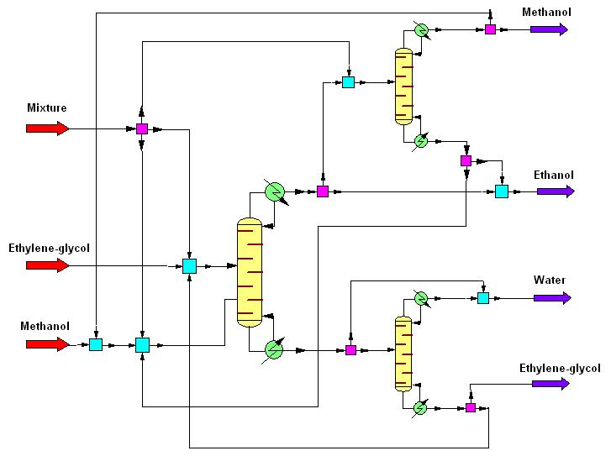
Figure 3 Superstructure of the extractive distillation system
The extractive column contains three sections; each consists of five conditional units, i.e. 95 stages altogether. The conventional columns used for separating methanol from ethanol and water from glycol are uniform with two sections, each including four units, i.e. 31 stages altogether. The feed composition in mole fractions is 0.33; 0.33; 0.34. The feed is 100 kmol/h. The specified purity is 0.98 in each product. Atmospheric column is used, P=760 torr. The mixture is assumed to be of real behavior, the activities are calculated with Wilson equations. Heat balances are considered.
The modified Outer Approximation algorithm, detailed in Section 3, is applied to the problem; initial values are calculated before each NLP-subproblem. The algorithm has been implemented in AIMMS 3.7 modeling system. CPLEX 10.0. is used as MILP solver, and CONOPT 3.14A as NLP solver.
    - Results
The model statistics are collected in Table 1. The limit number of iterations is set to 10; the solution time is 3364 sec, i.e. shorter than one hour. Due to the good initial values, the solution of the individual NLP-s no longer forms the bottleneck of the problem: each NLP requires 10 to 30 sec. Computing the initial values (as described in Section 3.2) lasts 1 to 3 sec in each iteration.
Table 1 Model statistics of the problem
Number of equations | Number of nonlinear equations | Number of variables | Number of binary variables | Solution time (number of iterations = 10)
12307 | 6439 | 10920 | 35 | 3364
The obtained solution structure, presented in Figure 4, applies glycol as entrainer; the extractive column contains ten stages, the conventional columns used for separating the methanol / ethanol mixture and for separating the water / glycol mixture consist of twenty-five and eight stages, respectively.
The required solution time for ten iterations was less than one hour. Thus, the modified algorithm provides with good solution in reasonable time even for large size processes.
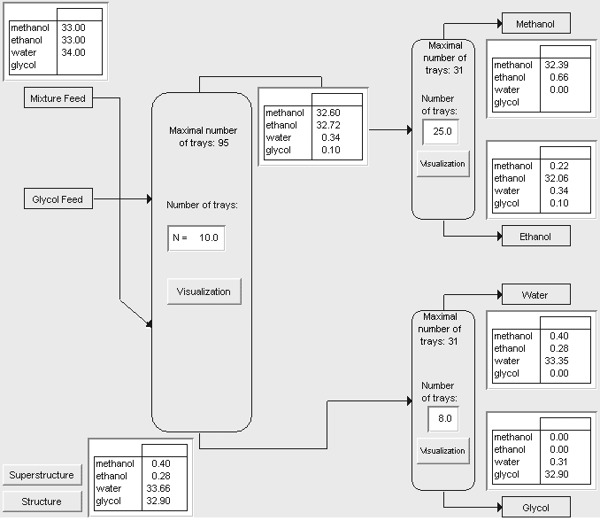
Figure 4 Structure obtained for Example
References
[1] H. Yeomans and I. E. Grossmann, 1999, Comput. Chem. Eng., 23, 709.
[2] J. Viswanathan and I. E. Grossmann, 1993, Comput. Chem. Eng., 17, 949.
[3] I. E. Grossmann, P. A. Aguirre and M. Barttfeld, 2005, Comput. Chem. Eng., 29, 1203.
[4] M. Barttfeld, P. A. Aguirre and I. E. Grossmann, 2004, Comput. Chem. Eng., 28, 2165.
[5] B. Borchers and J. E. Mitchell, 1996, Computers Opers. Res., 24, 699.
[6] J. Bisschop and M. Roelofs, 2006, AIMMS, The language reference, Paragon Decision Technology
[7] M. L. Bergamini, I. Grossmann, N. Scenna, P. Aguirre, 2008, Comput. Chem. Eng., 32, 477.
[8] T. Farkas, E. Rev, B. Czuczai, Z. Fonyo and Z. Lelkes, 2005, Computer Aided Chemical Engineering, 20, 889.
[9] AIMMS, 2007, The function reference, Paragon Decision Technology

