Parallel Simulation of a Molten Carbonate Fuel Cell System
Maksym Dosta,ª Michael Mangold,ª Achim Kienle,^{b} Volodymyr A. Svjatnyj,^{c}
ªMax Planck Institute for Dynamics of Complex Technical Systems, Sandtorstr. 1, Magdeburg 39106, Germany
^{b}Otto-von-Guericke-University Magdeburg, P.O. Box 4120, 39106 Magdeburg, Germany
^{c}Computer Science Faculty, National Technical University of Donetsk, Artem Str. 58, 83000 Donetsk, Ukraine
Abstract
The simulation of a large scale dynamical system on a single processor computer is a complicated task and in many cases even impossible. A typical example is the detailed model of a molten carbonate fuel cell stack considered in this work. Due to memory limitations there is no possibility to simulate this model on a single PC.
In this paper we introduce a parallel simulation program which was developed for solving problems of this kind. It uses a waveform relaxation method as a numerical method for the distributed simulation of differential algebraic equations. The program is part of the ProMoT/Diana simulation environment

Keywords: molten carbonate fuel cell, parallel simulation, waveform relaxation, dynamic simulation.
  - Introduction
One possible way to generate electric energy is the use of fuel cells. The main advantage of this new technology is the low pollution of the environment and the high efficiency, which is caused by the direct transformation of chemical energy into electricity. Fuel cells can be classified by the kind of electrolyte they employ. One fuel cell type is the molten carbonate fuel cell (MCFC), which uses an electrolyte composed of a molten mixture of carbonate salts. When heated to a temperature of about $\text{600}−\text{650} ° C$, these salts melt and becomes conductive.
The company CFC Solutions GmbH has developed the “HotModule” system, which contains 342 MCFCs and can deliver up to 250 kW of electric power (Bischoff and Huppmann, 2002). Heidebrecht (Heidebrecht, 2005) developed a spatially two-dimensional model of a single cell in the stack. The model has been validated successfully by experimental data (Gundermann et al., 2006). But due to the model’s high complexity it is very difficult to simulate several cells on a single PC.
A possible way to solve this and similar problems is the usage of multiprocessor computers or of networks of several single processor computers. In this contribution the object-oriented modeling tool ProMoT and the simulation environment Diana (Krasnyk et al., 2006) are extended for parallel simulation.
The following sections will describe the numerical method which is used for the distributed simulation, the basic operating principles of the new software and its application to the MCFC stack model simulation.
  - Parallel simulation program
    - Waveform relaxation method
Parallelism for initial value problems (IVP) can be classified by two main categories (Burrage, 1993):
- Parallelism across the method, where each processor executes a different part of a method.
- Parallelism across the system, such as waveform relaxation (WR) method (Crow et al., 1994), where a given system is divided into subsystems which are assigned to different processors.
The main idea of the WR method is that the system of differential algebraic equations (DAE) is divided into a set of subsystems. Over some time interval - called “window” – the subsystems are simulated independently. Unknown coupling variables are approximated using the solutions (“waveforms”) from a previous iteration. Several variants of the relaxation scheme exist, such as the Gauss-Jacobi WR or Gauss-Seidel WR. The advantage of the first approach is that all subsystems can be solved simultaneously. As an illustrative example suppose that our system is described by the following system Eq. (1):
$\begin{aligned}\left\{\frac{{\text{dx}}_{1}}{\text{dt}}=f_{1}(x_{1},x_{2}); x_{1}(0)=x_{\text{10}}; | \right.\end{aligned}$ (1)
If this system is divided into two separate parts, then the equations of the Gauss-Jacobi WR algorithm on iteration i+1 will have the following form:
$\frac{{\text{dx}}_{1}^{i+1}}{\text{dt}}=f_{1}(x_{1}^{i+1},x_{2}^{i}); x_{1}(0)=x_{\text{10}};$ (2)
$\frac{{\text{dx}}_{2}^{i+1}}{\text{dt}}=f_{2}(x_{1}^{i},x_{2}^{i+1}); x_{2}(0)=x_{\text{20}};$ (3)
Here, in every iteration Eq. (2) and Eq. (3) are solved independently using values from the previous iteration for the unknown variables. This process is repeated until convergence has been reached.
One of the main advantages of the WR method is that different solvers with different internal steps can be used for the solution of every subsystem. In situations, where fast subsystems can be separated from slower ones, this method can bring a benefit by decreasing the computational amount. On the other hand, strong coupling between the subsystems may result in poor convergence speed.

    - ProMoT/Diana simulation environment
The source model of the HotModule system is created in the object-oriented and equation-based modeling tool ProMoT. Due to the use of object-oriented modeling concepts, this is an attractive tool for the modeling of complex dynamical systems (Waschler et al., 2006). Models in ProMoT are aggregated from connected submodels. Connections between them are created with help of interfaces (“terminals”). Each submodel is described with a set of differential-algebraic equations. By terminal connections the subsystems are assembled into a global equation system of the total system.
ProMoT doesn’t contain any numerical solution methods. Instead, for every model a dynamically loaded C++ shared library is created, which can be simulated in Diana (Krasnyk et al., 2006) using the DAE solvers IDA or DASPK (Li et al., 1999). Communications between solvers and models are realized by using interfaces which were developed based on CAPE-OPEN community specifications.
    - Parallel simulation with ProMoT/Diana
The current work extends the ProMoT/Diana simulation environment to the distributed simulation on computer clusters. The parallelization process is largely hidden from the user, only minor modifications of the model sources are required. In contrast to the sequential version, in the parallel approach, an independent shared library is generated for every subsystem. The subsystems are allocated automatically to the different computers available in the network and the simulation is started.
General stages of an algorithm are shown for the example of a DAE system (Eq. 4), which is divided into k separated parts (Eq. 5), with an independent equation set generated for each of them.
$\begin{aligned}\left\{\frac{\text{dx}}{\text{dt}}=F(x,y,t); x(0)=x_{0}; | \right.\end{aligned}$ (4)
$\begin{aligned}\left\{\frac{{\text{dx}}_{j}}{\text{dt}}=f_{j}(x_{1},x_{2},\text{.}\text{.}\text{.},x_{j},\text{.}\text{.}\text{.},x_{k},y_{1},y_{2},\text{.}\text{.}\text{.},y_{j}\text{.}\text{.}\text{.},y_{k},t); x_{j}(0)=x_{j0}; | \right.\end{aligned}$ (5)
where $x∈ℜ^{n}, y∈ℜ^{m}, x_{j}∈ℜ^{n_{j}}, y∈ℜ^{m_{j}}, \sum_{j=1}^{k}{n_{j}=n, \sum_{j=1}^{k}{m_{j}=m}}$
To represent the global structure of the source model an additional “connections graph” is created. This is a directed graph with weighted edges and vertices that describes data dependencies between subsystems. Vertices weights correspond to the number of equations in submodels (and in a first approximation can be taken as a measure of the computational complexity). Edges weights indicate the number of connected variables.
In the first stage of the algorithm (Figure 1) static load balancing is made. It defines the initial distribution of the submodels on the processor network. This distribution should satisfy to 2 main conditions:
- Minimization of data transfer.
- Minimization of load imbalance.
The load balancing task can be represented as a task of mapping the connections graph to the graph which represents the network topology. In the case when the network topology is a bus, the task of mapping is equivalent to the task of dividing the connections graph into m equal parts, where m is quantity of available processors. In our software we solve this problem with the help of the multilevel k-way partition algorithm (Karypis et al., 1998).

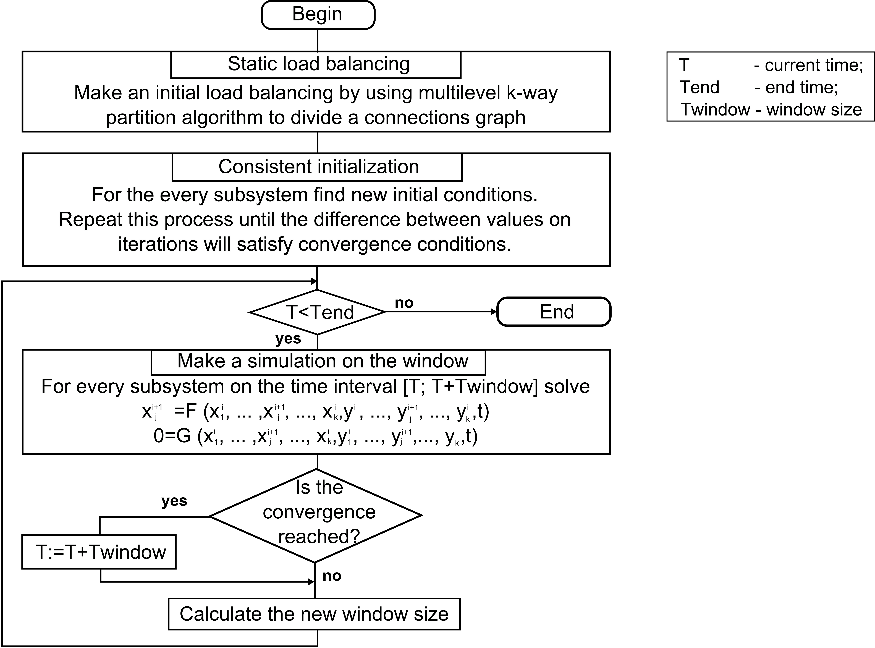
Figure 1. Flow chart of the parallel simulation algorithm.
As has been discussed above, the total system is solved by iteratively doing independent simulations of the subsystems on a certain time interval. The iterations on one time interval are repeated until the differences between two subsequent iterations meet the convergence criteria Eq. (6) and Eq. (7)
$∀j∈[1\text{.}\text{.}k] ||x_{j}^{i+1}−x_{j}^{i}||≤\text{RTol}∗|x_{j}^{i+1}|+\text{ATol}$ (6)
$∀j∈[1\text{.}\text{.}k] ||y_{j}^{i+1}−y_{j}^{i}||≤\text{RTol}∗|y_{j}^{i+1}|+\text{ATol}$ (7)
where RTol and ATol correspond to relative and absolute tolerances.
The size of the time interval for the next iteration is calculated based on the number of iterations in the current window. If convergence cannot be reached within a limited number of iterations, then the window size is decreased.
After the end of every time interval the unknown coupling variables are extrapolated to the next window where these values are used as initial guesses.
In the Diana simulation environment solvers and models are separated from each other. Therefore it is possible to implement effective dynamic load balancing strategies. Because to move a model from one computer to another, in many situations it is possible just to transmit a set of vectors which describe the model state.
  - Simulation of the MCFC model
The stack of the “HotModule” is structured internally into groups of 8 cells, separated from each other by indirect internal reforming layers on the top and at the bottom. In a first step it is assumed that all those groups of 8 cells behave in the same way and that there is a symmetry in vertical direction within the groups. Then it is sufficient to simulate 4 cells with a reforming layer on top. The cells are coupled by heat transfer in vertical direction as well as by mass fluxes from the anode outlets to the cathode inlets. Between anode outlet and cathode outlet there is a burner that completely oxidizes the anode gases and provides fresh air to the cathode. The general structure of the simulated model is shown in Figure 2. For the parallel simulation, the model of the 4 cells stack is represented as a set of 6 independent submodels, connected by gas flows and heat exchanges as is shown in Figure 3.
The single cell model is a spatially 2 dimensional model taken from the literature (Heidebrecht, 2005). The model comprises energy, mass and charge balances for the different parts of the fuel cell. It consists of 19 partial differential, 3 ordinary differential (ODE) and 55 algebraic equations. After a spatial discretization with a 10x10 grid, a system of around 1900 ODEs and 5700 algebraic equations results for the model of a single cell. The simulation of more than one cell on a single PC is hardly possible due to the huge memory requirement. This necessitates the parallel approach for the solution the stack model.

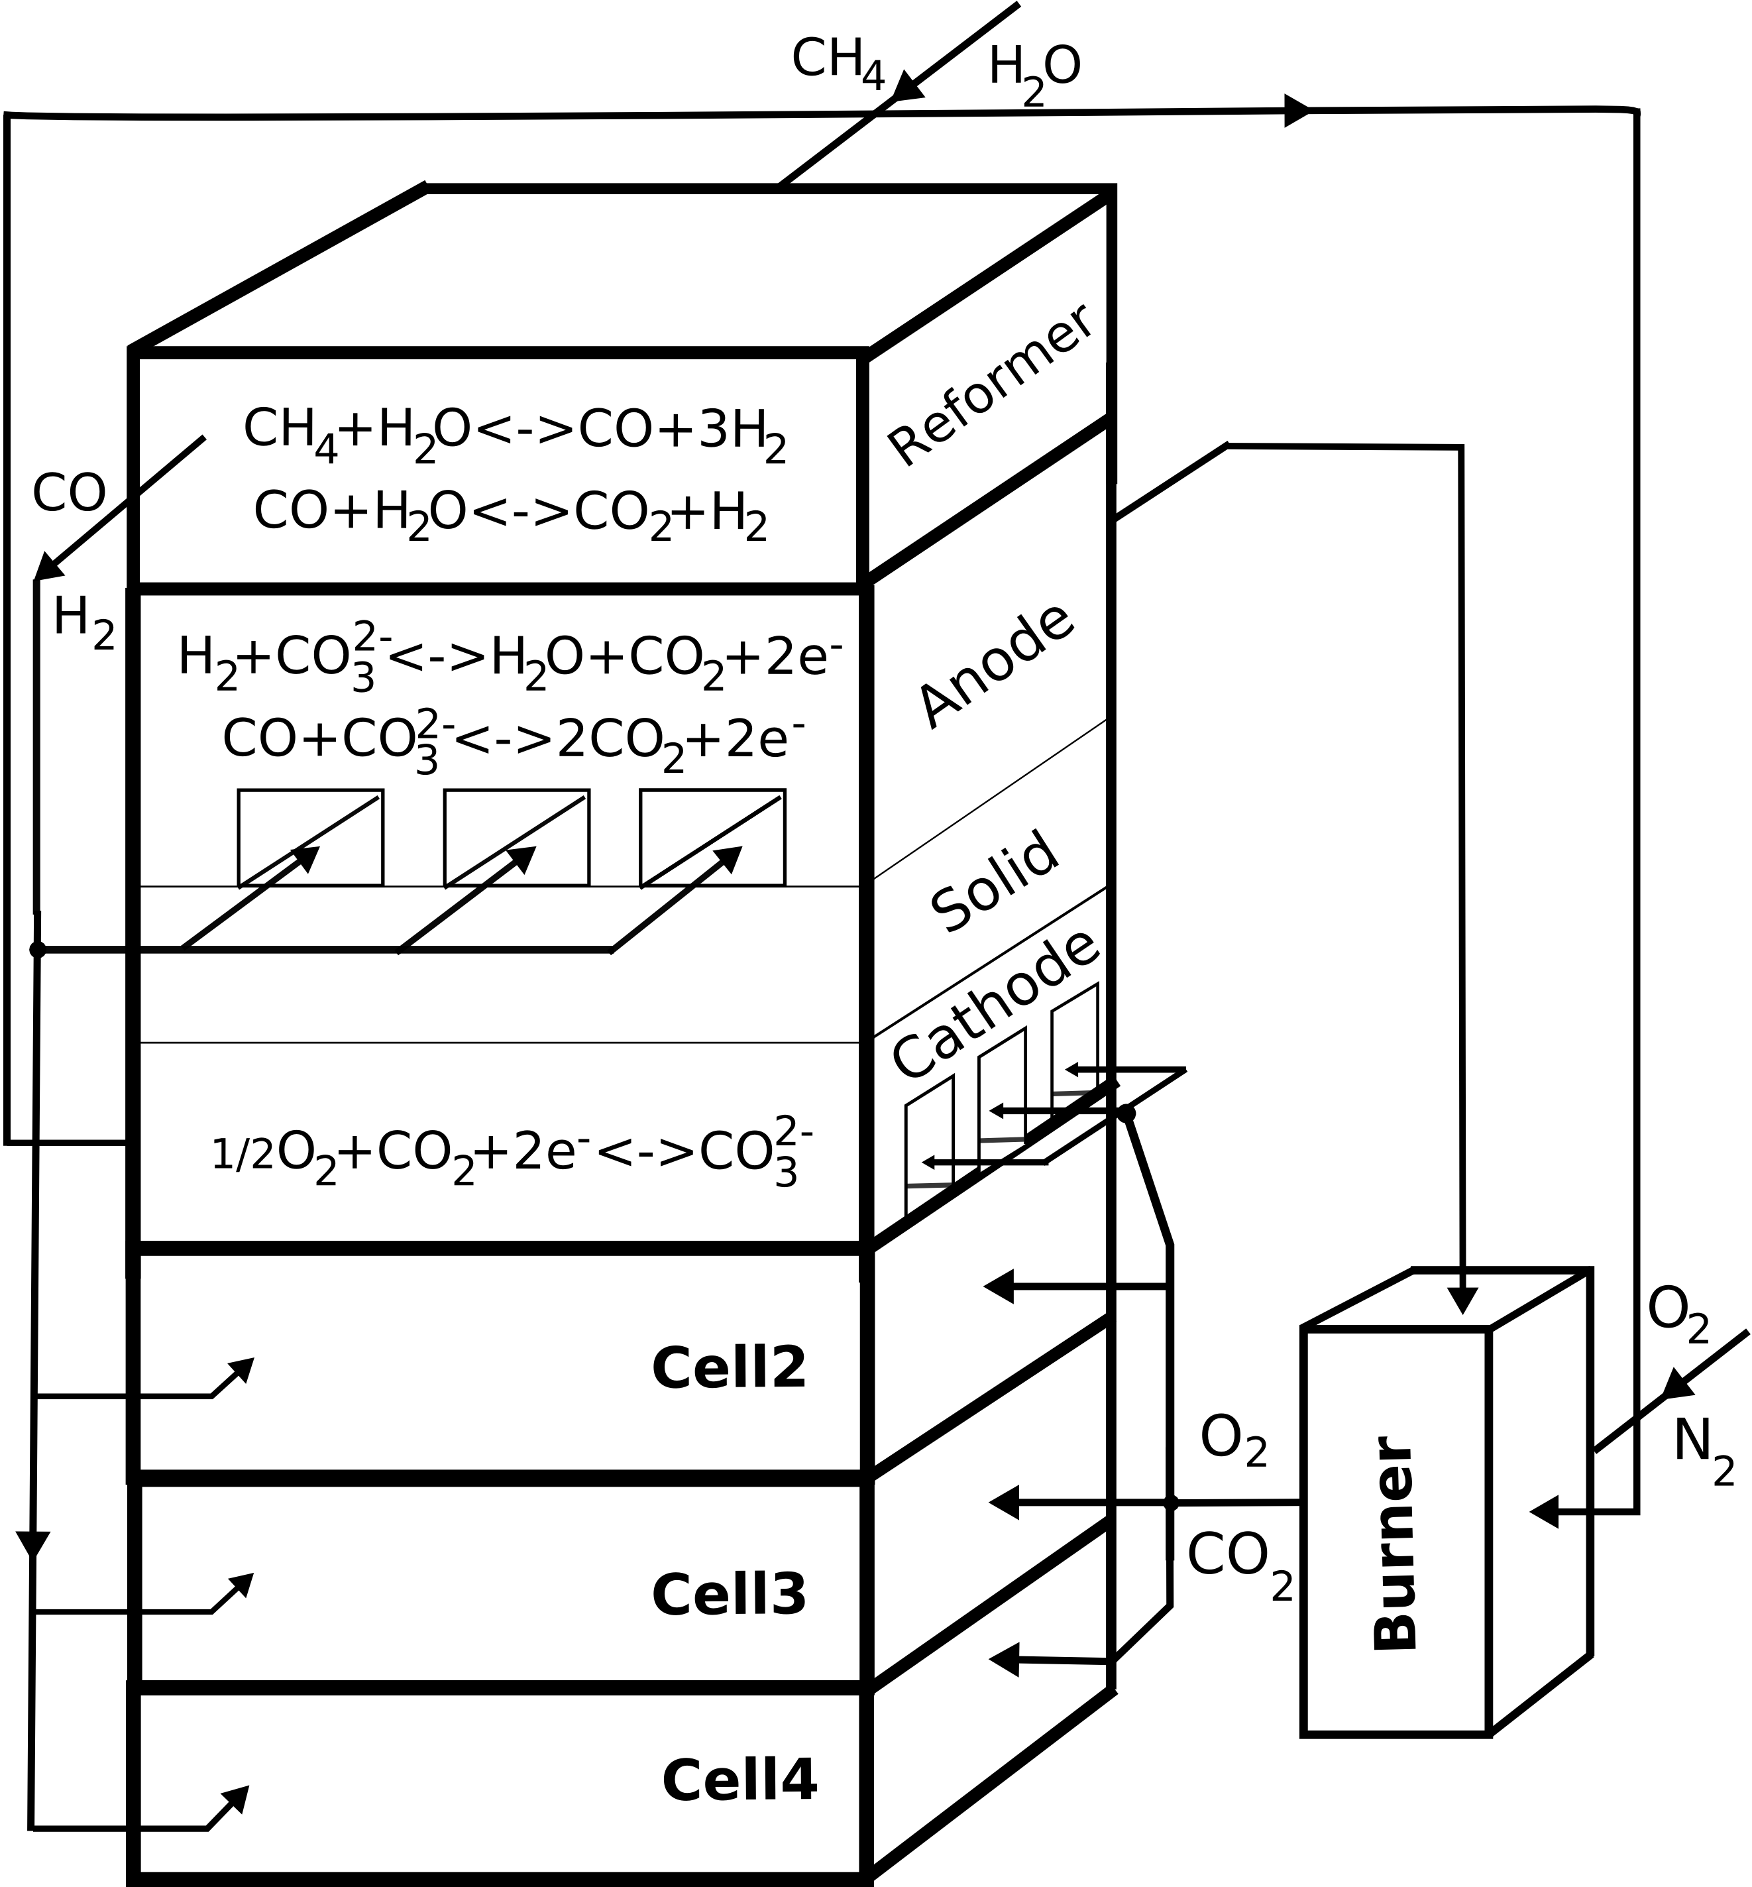
Figure 2. General structure of 4 cells stack.
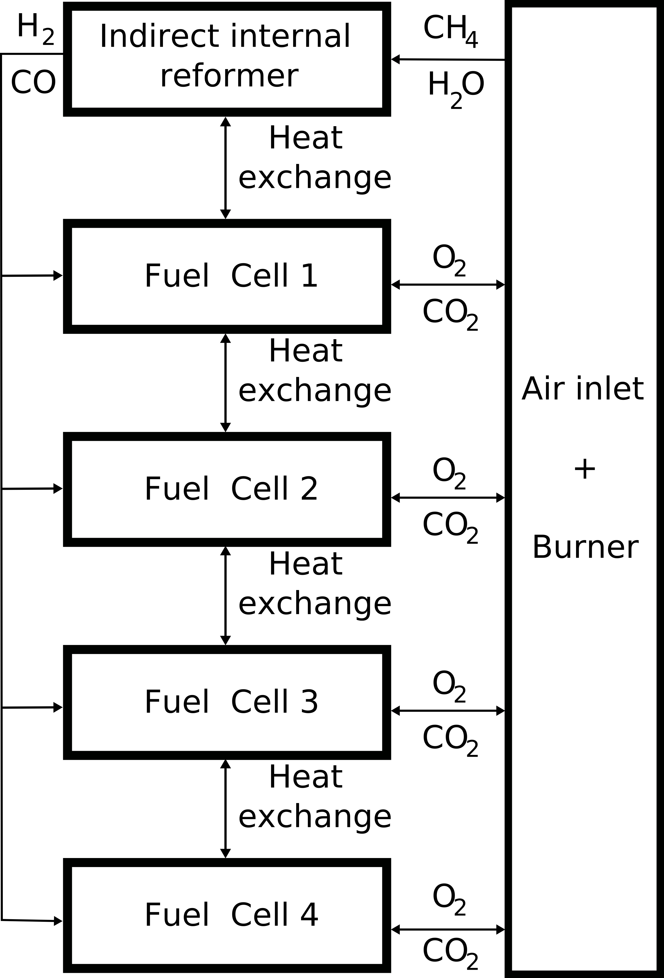
Figure 3. Representation of 4 cells stack as 6 separate submodels.

Figure 4 shows the steady state temperature profiles of the 4 cells in the stack, which was received after a distributed simulation on 6 processors.
From the picture it is seen that the first (top) cell has the smallest temperature. This occurs because the overall reaction in the indirect internal reformer is endothermic, so the reformer brings a cooling effect to the stack. The temperature gradient along one cell appears due to the different local reactant concentrations and therefore different local reaction rates.
  - Conclusion
The developed software provides a convenient and user friendly way for the parallel simulation of dynamical systems on networks of standard computers. It can be applied to various chemical engineering problems like the dynamic simulation of complex chemical plants.
Simulation results of the MCFC stack model have shown that the new software is a good possibility to make a simulation, when the size of the model doesn’t allow the use of a sequential program on a single PC due to memory limitations, caused e.g. by a fine spatial discretization. Because the quantity of transmitted data is relatively small, the parallel approach can be effectively used on networks of standard computers.
The simulation time of the divided model depends on the model state and the input parameters. If the number of iterations for the waveform relaxation is high, the parallel approach may be comparatively slow. However the main benefit of the parallel implementation is not a speed-up of the simulations, but the possibility to solve models that are too large for a single PC.
In the future it is intended to improve the distributed simulation program by implementing dynamic load balancing strategies and by extending the ProMoT tool to automatical model partition and connections graph generation.
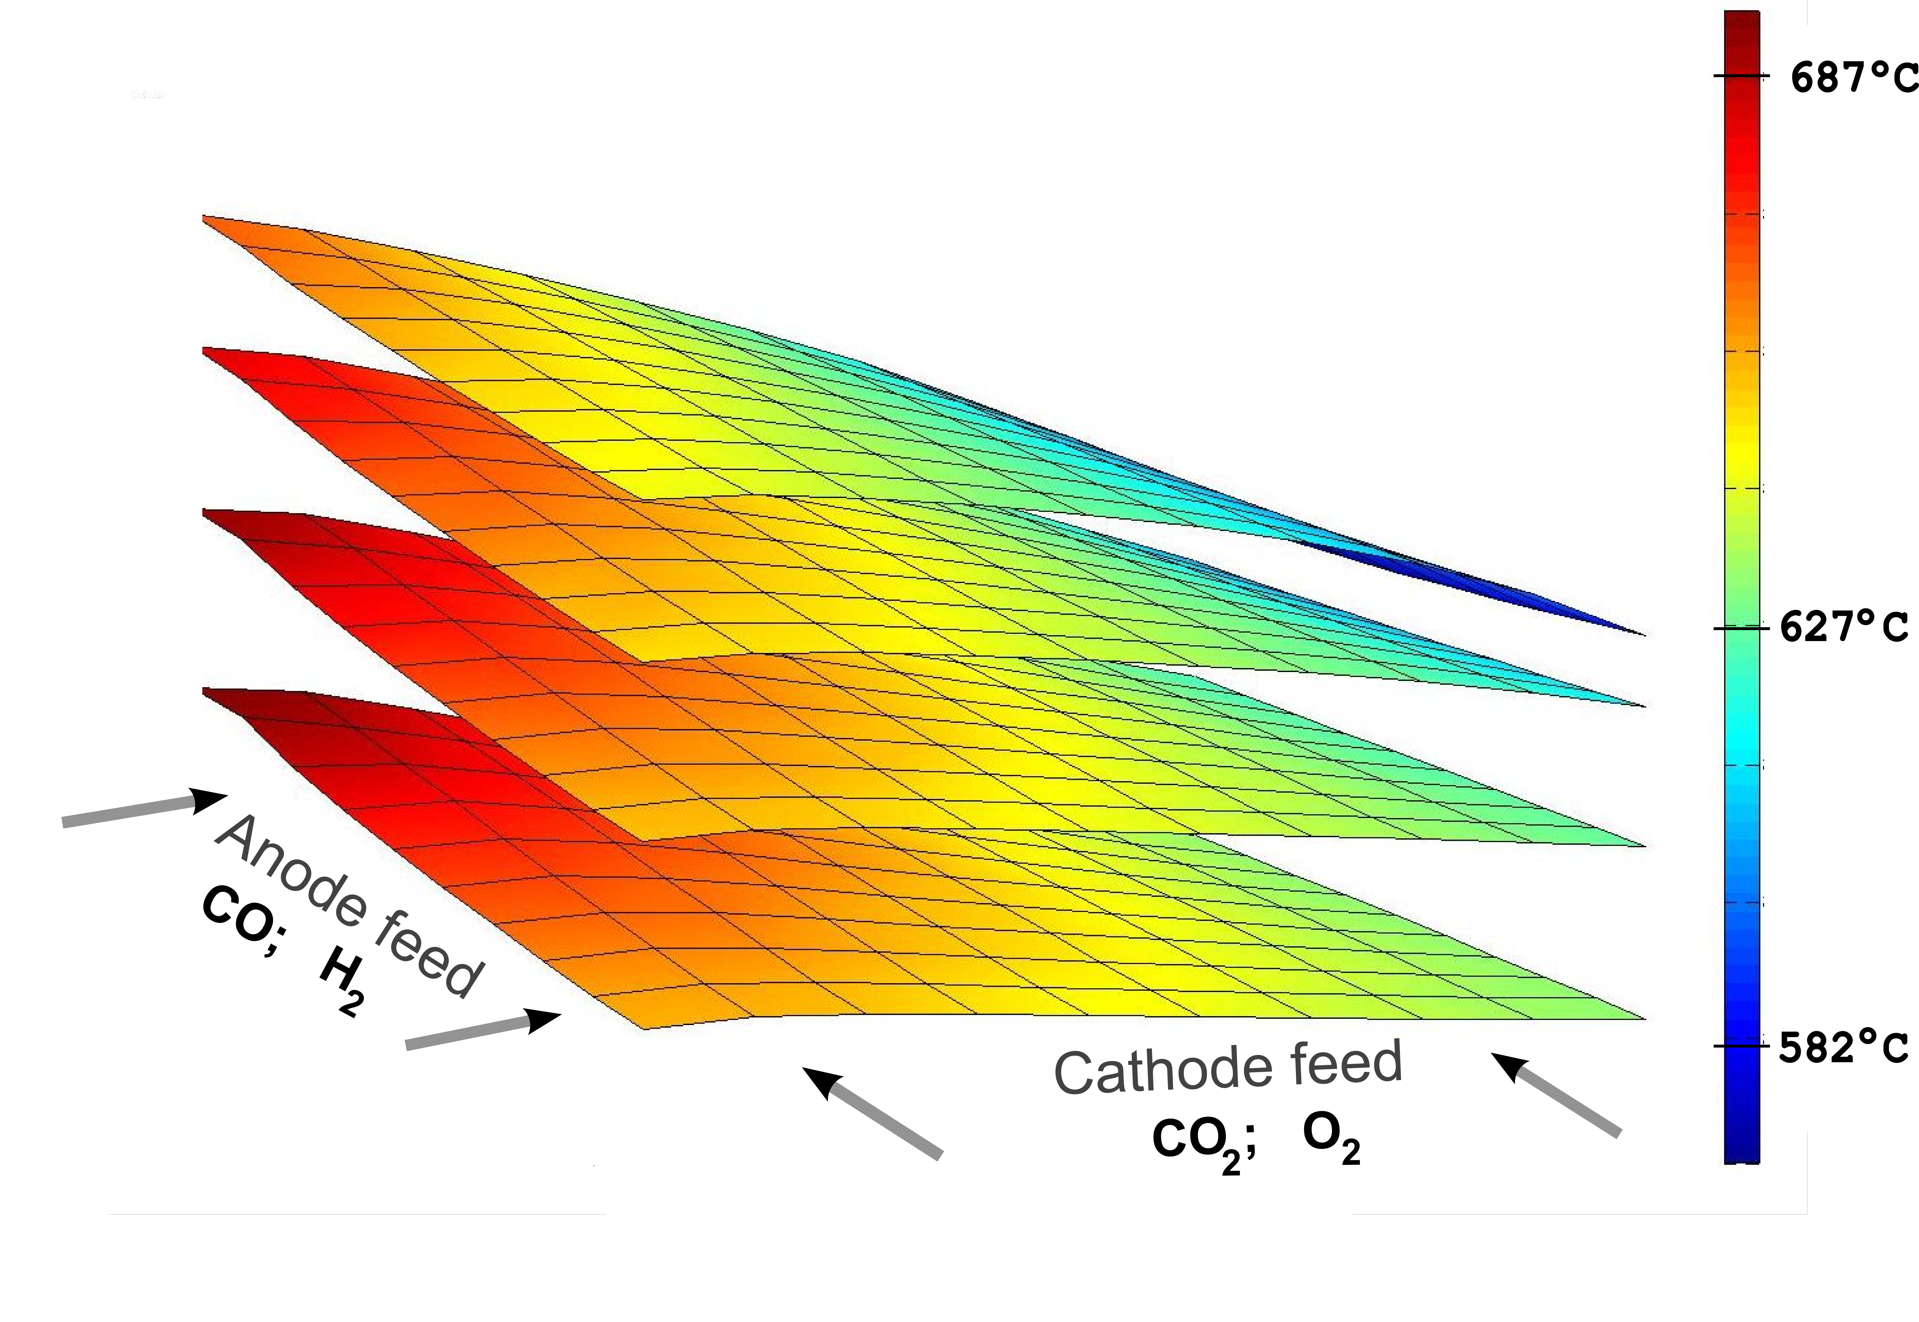
Figure 4. Simulated steady state temperature profile of the 4 cells MCFC stack.
References
M. Bischoff, G. Huppmann, 2002, Operating experience with a 250 kW molten carbonate fuel cell (MCFC) power plant, Journal of Power Sources 105, pp 216-221.
M. Gundermann, P. Heidebrecht, K. Sundmacher, 2006, Validation of a Mathematical Model Using an Industrial MCFC Plant, Journal of Fuel Cell Science and Technology, Vol. 3, Issue 3, pp. 303-307.
P. Heidebrecht, 2005, Analysis and Optimization of a Molten Carbonate Fuel Cell with Direct Internal Reforming (DIR-MCFC), Fortschritt-Berichte, VDI-Verlag, 144 p.
M. Krasnyk, K. Bondareva, O. Milokhov, K. Teplinskiy, M. Ginkel, A. Kienle, 2006, The ProMoT/Diana Simulation Environment. 16-th European Symposium on Computer Aided Process Engineering, pp. 445-450.
K. Burrage, 1993, Parallel methods for initial value problems, Applied Numerical Mathematics, Vol. 11, pp 5-25.
M. Crow, M. Ilic, 1994, The Waveform Relaxation Method for Systems of Differential/Algebraic Equations, Mathl. Comput. Modelling Vol 19., No 12, pp 67-84.
R. Waschler, O. Angeles-Palacios, M. Ginkel, and A. Kienle, 2006, Object-oriented modeling of large-scale chemical engineering processes with ProMoT, Mathematical and Computer Modeling of Dynamical Systems, Vol. 12, No. 1, pp 5-18.
S. Li, L. Petzold, 1999, Design of New DASPK for Sensitivity Analysis, Technical Report, University of California at Santa Barbara, 41 p.
G. Karypis, V. Kumar, 1998, Multilevel k-way Partition Scheme for Irregular Graphs, J. Parallel Distrib. Comput. 48(1), pp. 96-129.

