Bidirectional Branch and Bound Approach for Controlled Variable Selection
Yi Cao,ª Vinay Kariwala^{b}
ª School of Engineering, Cranfield University, Bedford, MK43 0AL, UK
^{b}Division of Chemical & Biomoleular Engineering, Nanyang Technological University, Singapore 637459
Abstract
We address the combinatorial issues arising in selection of controlled variables using the minimum singular value rule in the self-optimizing control framework. Based on previously developed downwards and upwards unidirectional branch and bound (BB) approaches, a novel bidirectional BB approach is proposed. In this approach, the selection criterion is evaluated in both directions simultaneously such that non-optimal branches are quickly pruned. Numerical case studies show that the proposed approach is able to reduce the solution time by several orders of magnitudes.

Keywords: Branch and bound, Control structure design, Controlled variables, Minimum singular value, Self-optimizing control.
  - Introduction
While designing the control system, determination of controlled variables (CVs) is a critical decision, which affects not only the control system performance but also influences the overall plant operation. Recently, Skogestad (2000) introduced the concept of self-optimizing control and locally optimal minimum singular value (MSV) rule to systematically select CVs. Though useful, this method suffers from computational intractability, as all possible alternatives need to be evaluated to find the optimal set of CVs. In this work, we present an efficient branch and bound (BB) approach to handle the combinatorial issues associated with the use of the MSV rule.

A BB approach gains its efficiency by pruning non-optimal branches without evaluating the nodes associated with them. Previously, BB approaches for CV selection have been proposed, where pruning is performed either downwards on subsets (Cao et al., 1998) or upwards on supersets (Kariwala and Skogestad, 2006). In this work, we combine both pruning approaches to form a novel bidirectional branch and bound (B3) technique. The B3 algorithm prunes non-optimal branches in both directions simultaenously. Furthermore, novel criteria are developed to avoid time consuming MSV evaluation. In comparison to available methods, the proposed B3 algorithm is extremely fast, e.g. it reduces solution time by four orders of magnitude for the HDA case study.
  - Unidirectional Branch and Bound
Let X_{m} ={x_{i} | i = 1,2,….,m} be an m-element set. A subset selection problem with criterion J is to find the globally optimal n-element subset, $X_{n}^{}$ such that
$J(X_{n}^{})=\underset{X_{n}⊂X_{m}}{\text{max}}J(X_{n})$ (1)
In (1), the total number of candidates grows very quickly as m and n increase and thus exhaustive search becomes unviable for large m and n. BB approach can find the globally optimal subset without exhaustive search. The BB approach gains efficiency by pruning branches, which cannot lead to optimal solution.
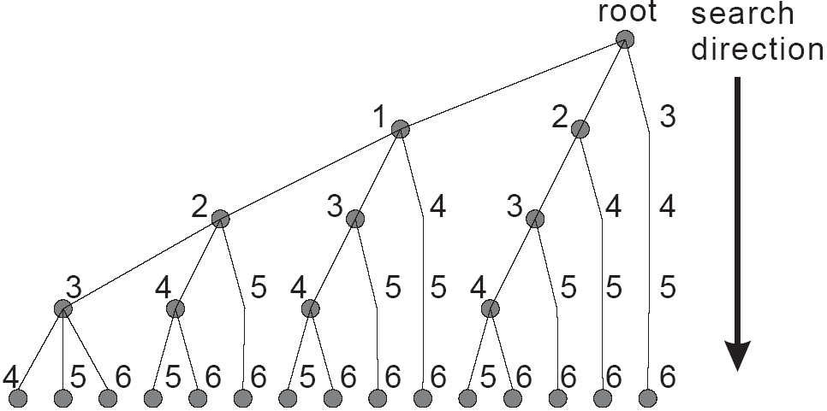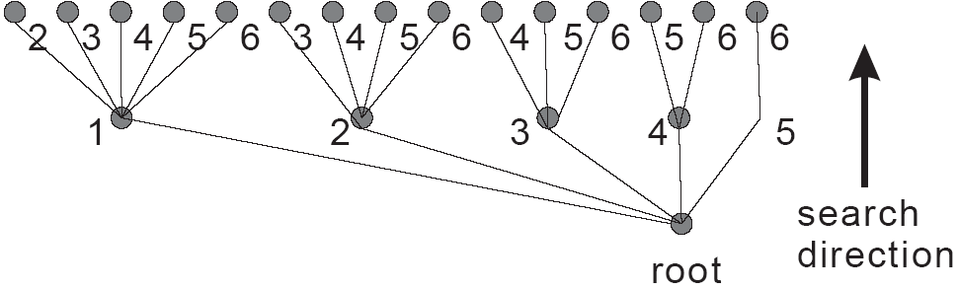
(a) Downwards branch and bound (b) Upwards branch and bound
Figure 1. Search trees for unidirectional branch and bound
Downwards branch and bound. BB search is traditionally conducted downwards (gradually decreasing subset size). A downwards solution tree for selecting 2 out of 6 elements is shown in Figure 1(a). In this tree, the root node is same as X_{m}. Other nodes represent subsets obtained by eliminating one element from their parent sets. Labels at nodes denote the elements discarded there. To describe the pruning principle, let B be a lower bound of the globally optimal criterion, i.e. $B≤J(X_{n}^{})$. Then,
$J(X_{n})<J(X_{n}^{})$, if $\bar{J}(X_{s})<B$, $∀X_{n}⊆X_{s}$ (2)
where $\bar{J}(X_{s})≥\underset{X_{n}⊂X_{s}}{\text{max}}J(X_{n})\begin{matrix}, & s≥n\end{matrix}$ is a downwards upper bound. Equation (2) states if a downwards upper bound of the criterion on a subset X_{s} is less than B, then all subsets in X_{s} will not be optimal and hence need not be evaluated. If the selection criterion satisfies the downward monotonicity, i.e. $J(X_{s})≤J(X_{t})$, if $X_{s}⊆X_{t}$, then a simple upper bound estimation can be adopted as $\bar{J}(X_{s})=J(X_{s})$.

Upwards branch and bound. Subset selection can also be performed upwards (gradually increasing subset size). An upwards solution tree for selecting 2 out of 6 elements is shown in Figure 1(b). In this tree, the root node is an empty set. Other nodes represent supersets obtained by adding one element to their parent sets. Labels at nodes denote the elements added there. To introduce the pruning principle, let the upwards upper bound of the criterion be defined as $\bar{J}(X_{s})≥\underset{X_{n}⊃X_{s}}{\text{max}}J(X_{n})\begin{matrix}, & s≤n\end{matrix}$. Then,
$J(X_{n})<J(X_{n}^{})$, if $\bar{J}(X_{s})<B$, $∀X_{n}⊇X_{s}$ (3)
Based on (3), if an upwards upper bound of the criterion on X_{s} is less than B, then all supersets of X_{s} cannot be optimal and hence can be discarded. Similar to downwards BB, the upper bound can be estimated as $\bar{J}(X_{s})=J(X_{s})$, if the selection criteria satisfies upward monotonicity, i.e. $J(X_{s})≤J(X_{t})$, if $X_{s}⊇X_{t}$.
  - Bidirectional Branch and Bound (B3)
The upwards and downwards BB approaches can be combined to form a more efficient bidirectional BB approach. This approach is applicable to any subset selection problem, for which both upwards and downwards upper bounds on the criterion are available.

Bidirectional pruning. In a BB approach, the whole subset selection problem is divided into several subproblems. Each subproblem S has a fixed set X_{f}, i.e. the f elements of X_{f} have been selected. The subproblem involves selecting (n – f) elements from the candidate set X_{c}, with c elements. In the downwards BB approach, if an upper bound of the criterion on $X_{s}=X_{f}X_{c}$ is less than the current best lower bound B, then using (2), none of the solutions of S can be optimal and hence S can be discarded (Cao et al., 1998). Alternatively, in upwards BB approach, if an upper bound of the criterion on X_{s} = X_{f} is less than B, then based on (3), S does not include the optimal solution and hence need not be evaluated further (Kariwala and Skogestad, 2006).

Since downwards and upwards pruning conditions are considered for the same subproblem, both conditions can be jointly considered in a single algorithm so that subproblems (branches) can be pruned more quickly, where
$J(X_{n})<J(X_{n}^{})\begin{matrix}, & ∀X_{n}∈S\end{matrix}$, if $\bar{J}(X_{f})<B$ or $\bar{J}(X_{f}∪X_{c})<B$ (4)
In the B3 algorithm, these two pruning criteria are applied repetitively, until no more reduction in the subset size is possible.

Bidirectional branching. In downwards BB method, branching is performed by removing elements from X_{c}, whilst in upwards BB method, branching is performed by moving elements from X_{c} to X_{f}. These two branching approaches can be combined into an efficient bidirectional approach by selecting a decision element and deciding upon whether the decision element be eliminated from X_{c} or moved to X_{f}. In the B3 algorithm, the decision element is selected as the one with the largest upwards or downwards upper bound for upward or downward search (best-first search), respectively.

The branching direction (upwards or downwards) is selected by comparing the number of terminal nodes (n-element subsets) of the resulting subproblems with alternate approaches. For downwards branching, removing an element from X_{c} results in a subproblem with $C_{c−1}^{n−f}$ terminal nodes, whilst for upwards branching, moving an element from X_{c} to X_{f} gives a subproblem with $C_{c−1}^{n−f−1}$ terminal nodes. Therefore, if 2(n-f) > c, downwards branching is performed, otherwise upwards branching is selected.
  - Bidirectional Controlled Variable Selection
The use of MSV rule is equivalent to selecting n out of m rows of an $m×n$ matrix such that the selected sub-matrix has the largest MSV among all possible $n×n$sub-matrices (Kariwala and Skogestad, 2006). With this observation, the elements of different sets, e.g. X_{f}, X_{c} and X_{s}, represent row indices in the following discussion.
Monotonicity. Defining $G_{X_{f}∪i}={\left[\begin{matrix}G_{X_{f}}^{T} & G_{i}^{T}\end{matrix}\right]}^{T}$, $G_{X_{s}}={\left[\begin{matrix}G_{{X_{s}}/i}^{T} & G_{i}^{T}\end{matrix}\right]}^{T}$and using the interlacing property of eigenvalues (Horn and Johnson, 1985), it can be shown that
$\begin{aligned}\begin{matrix}σ_{f+1}\left(G_{X_{f}∪i}\right) & & σ_{f}\left(G_{X_{f}}\right)\end{matrix}\begin{matrix}; & f<n & \end{matrix} \\ \begin{matrix}σ_{n}\left(G_{X_{s}}\right) & & σ_{n}\left(G_{X_{s}}\right) & ; & s>n & \end{matrix}\end{aligned}$ (5)
Equation (5) implies that if $σ_{f}(G_{X_{f}})<B$ or $σ_{n}(G_{X_{s}})<B$, all square sub-matrices of G that can be generated by adding rows to $G_{X_{f}}$ or by eliminating rows from $G_{X_{s}}$, respectively, cannot contain the optimal solution and hence need not be evaluated.

Criteria for Fast Pruning. The evaluation of MSV requires O(n³) floating point operations (flops) for an $n×n$ matrix. For combinatorial subset selection problems, the number of evaluations can be very large. Hence, it is desired to develop more efficient pruning algorithms to replace time-consuming MSV evaluations. We note that for pruning, it suffices to know whether the criterion value of the subset under consideration is less than the global bound B and knowledge of the exact value of selection criterion is not necessary. Based on this observation, for downwards pruning, if $σ_{n}(G_{X_{s}})=\underline{σ}(G_{X_{s}})>B$, where s > n,
$α_{i}=1−G_{i}(G_{X_{s}}^{T}G_{X_{s}}−B^{2}I)^{−1}G_{i}^{T}0⇔σ_{n}(G_{X_{s}})=\underline{σ}(G_{X_{s}})<B$ (6)
Similarly, for upwards pruning, if $σ_{f}(G_{X_{f}})=\underline{σ}(G_{X_{f}})>B$, where f < n,
$β_{i}=G_{i}G_{i}^{T}−G_{i}G_{X_{f}}^{T}(G_{X_{f}}G_{X_{f}}^{T}−B^{2}I)^{−1}G_{X_{f}}G_{i}^{T}B^{2}⇔σ_{f+1}(G_{X_{f}∪i})=\underline{σ}(G_{X_{f}∪i})<B$ (7)
The proof of (6) and (7) follows using the interlacing property of eigenvalues (Horn and Johnson 1985). Using (6) and (7), multiple sub-nodes and super-nodes can be pruned simultaneously, while avoiding costly MSV evaluations. The inverse in both (6) and (7) can be calculated through Cholesky factorization (Horn and Johnson, 1985). If the Cholesky factorization fails, then the MSV of the parent node is less then B, hence the whole sub-problem should be pruned.

Criteria for Fast Branching. While (6) and (7) can be used for pruning efficiently, the calculation of MSV values is still required to select the decision element for branching purposes; see Section 3. We observe that the selection of the decision element only requires the relative rankings of the sub- and super-nodes, which can be approximately obtained using bounds on their MSV values. Note that use of approximate rankings only affects efficiency but not optimality. The following relationships between MSV of supersets and subsets of a node and, α_{i} and β_{i}, respectively, are established:
$\begin{aligned}α_{i}≥\frac{{\underline{σ}}^{2}(G_{X_{s}})−B^{2}}{{\underline{σ}}^{2}(G_{X_{s}})−B^{2}}=\frac{σ_{n}^{2}(G_{X_{s}})−B^{2}}{σ_{n}^{2}(G_{X_{s}})−B^{2}} \\ β_{i}≤{\underline{σ}}^{2}(G_{X_{f}∪i})=σ_{f+1}^{2}(G_{X_{f}∪i})\end{aligned}$ (8)
Based on (8), the decision element among sub- and super-nodes can be approximately selected based on the downward index α_{i} and the upward index β_{i}, respectively. Hence, the evaluation of the MSV can be completely eliminated for non-terminal nodes.
Combining all of the aforesaid approaches, the final B3 algorithm is shown in Figure 2 (Cao and Kariwala, 2007).
Figure 2. Flow chart of bidirectional branch and bound algorithm for MSV maximization

  - Numerical Examples
In this section, we demonstrate the efficiency of the proposed B3 algorithm using numerical examples.

Figure 3. Solution tree of simple example

Simple example. To explain the B3 algorithm procedure, we consider a simple example, where 2 out of 6 elements are to be selected for MSV maximization of
$G={\left[\begin{matrix}\text{35} & 3 & \text{30} & 8 & \text{31} & 4 \\ \text{24} & \text{25} & \text{16} & \text{15} & \text{20} & \text{11}\end{matrix}\right]}^{T}$ (9)
Figure 3 also shows the bidirectional solution tree, where the decision elements are given under the nodes and the size of a subproblem is indicated in the circle. The algorithm is initialized with an empty X_{f} = ø, X_{c} = X₆ = {1, 2, 3, 4, 5, 6}, and (B₀)² = 0. As current bound is zero, no pruning is possible. As 2(n-f) > c, decision element for upwards branching is selected as the smallest element of α⁽¹⁾ = [0.61 0.25 0.69 0.85 0.69 0.90], i.e. element 2. Two subproblems S₁ and S₂ are generated by moving element 2 to X_{f} and removing it from X_{c}, respectively, where S₁ is solved first. Since the bound is still zero, no pruning is possible. Furthermore, as a terminal node can be obtained by moving one element to X_{f}, decision element is selected as the largest element of β⁽²⁾ = [1799.8 * 1155.4 288.6 1360.1 136.8], i.e. element 1. By moving this element to X_{f}, a terminal node results for which (B₁)² = 302.4. The other subproblem S₃ is obtained by removing element 1 from X_{c} and is evaluated next. For S₃, based on β⁽²⁾ elements 4 and 6 can be pruned; see (7). The recalculated α⁽³⁾ = [* * -0.004 * 0.38 *] indicates that upwards pruning should be performed on element 3 (negative value) by moving it to X_{f}. As X_{f} consisting of elements 2 and 3 is a terminal node, the bound is computed and updated to (B₂)² = 339.8. Now, the pending subproblem S₂ is solved. Since the associated Cholesky factorization with (B₂)² fails, when calculating α⁽⁴⁾, the whole node is pruned. Thus, the B3 algorithm finds the optimal solution as elements 2 and 3 in 6 node evaluations. In comparison, an exhaustive search method requires 15 node evaluations.

HDA case study. The B3 algorithm is also applied to select CVs for the HDA process; see e.g. (Araujo and Skogestad, 2007). The CV selection problem involves selecting 8 CVs among 129 available measurements, where the total number of alternatives is about $1\text{.}\text{52}×{\text{10}}^{\text{12}}$. A modern personal computer (2 GHz Intel Core Duo T2500) takes about 0.05 ms to carry out a single MSV evaluation. Therefore, an exhaustive search method would take more than 2 years to find the globally optimal solution. Kariwala and Skogestad (2006) applied an upward BB algorithm, which takes about 1 hour to find the optimal solution with evaluation of 809673 nodes. In comparision, the B3 algorithm solves this problem in only 0.046 seconds with evaluation of 263 nodes. This example demonstrates the incredible efficiency that the B3 algorithm can achieve.
  - Conclusions
Selection of controlled variables (CVs) using minimum singular value rule is a combinatorial optimization problem. To solve this problem efficiently, a novel bidirectional branch and bound algorithm based on fast pruning and branching approaches has been developed. In future, this algorithm will be extended for CV selection using exact local methods for self-optimizing control (Halvorsen et al., 2003).
Acknowledgements
The second author gratefully acknowledges the financial support from Office of Finance, Nanyang Technological University, Singapore through grant no. M52120046.
References
A. Araujo and S. Skogestad, Control Engineering Practice, 15(10), pp. 1222—1237, 2007.
Y. Cao and V. Kariwala, B3MSV, MATLAB File Exchange, Available at http://www.mathworks.com/matlabcentral/fileexchange/loadFile.do?objectId=17480&objectType=file, 2007
Y. Cao, D. Rossiter and D. H. Owens, In Proc. DYCOPS 5, Corfu, Greece, 1998.
I. J. Halvorsen, S. Skogestad, J. C. Morud and V. Alstad, Ind. Eng. Chem. Res., 42(14), pp. 3273—3284, 2003.
R. A. Horn and C. R. Johnson, Matrix Analysis, Cambridge University Press, Cambridge, UK, 1985
V. Kariwala and S. Skogestad, In Proc. 16th ESCAPE and 9th International Symposium on PSE, Garmisch-Partenkirchen, Germany, 2006.
S. Skogestad., J. Proc. Control, 10(5), pp. 487—507, 2000..

