Simulis® Thermodynamics: an open framework for users and developers
Olivier BAUDOUINª, Stéphane DECHELOTTEª, Philippe GUITTARDª, Alain VACHERª
ªProSim, Stratège Bâtiment A, BP 27210, 31672 LABEGE Cedex, FRANCE
Abstract
Simulis® is the name of ProSim’s new software suite. The component-oriented approach of its architecture is based on the Microsoft®’s COM/DCOM middleware. Simulis® Thermodynamics, one of the first components, is a thermophysical calculation server that generates highly accurate pure component and mixture properties (thermodynamic, transport, compressibility…) and fluid phase equilibria (liquid-vapor, liquid-liquid and vapor-liquid-liquid). One main benefit of Simulis® Thermodynamics is its CAPE-OPEN compliance through its CAPE-OPEN thermodynamic plug and socket facilities. Another powerfull feature is the capability to use legacy codes either as a DLL (Dynamic Link Library) following a standard syntax, either as VBScript (Visual Basic Script) directly written from the Simulis® Thermodynamics’ environment. The standard version of Simulis® Thermodynamics is provided as an add-in in Microsoft® Excel and as a toolbox in MATLAB® and enables the user to run complete thermodynamic calculations in these applications, but it can also be plugged in any legacy code using the SDK (Software Development Kit). This paper will introduce all these different features.

Keywords: Thermodynamic, CAPE-OPEN, Simulis, Microsoft Excel, Modeling.
  - Introduction
Throughout their history, process simulation tools had to adapt to the evolutionary nature of hardware and software technologies and to an ever more and more demanding market. Usage is again disturbed today by computer networks and co-operative work. In addition to the performance and user-friendliness criteria, the various tools must enable substitution one to another and exchange of services: they must be interoperable and integrable. New technologies based on software components developed with object-oriented languages are available to meet this new market requirement.
Considering this situation, ProSim decided to change the architecture of its tools to answer not only its own customers' expectations, but also the whole simulation process software user community. Simulis® project fulfills that goal. The software component Simulis® Thermodynamics is presented in this paper to demonstrate the advantages of this approach for both thermodynamic experts and end-users.
  - Simulis® Thermodynamics
Simulis® Thermodynamics is a thermodynamic properties and phase equilibria calculation server for pure substances and mixtures (up to 200 compounds). It is based on ProSim traditional thermodynamic calculation library which has been validated through many years of intensive industrial use. A pure substance property database, containing more than 1900 compounds (based on AIChE’s DIPPR® database), is provided with the standard version. Using Simulis® Thermodynamics, the user can calculate the following properties:

- Transport properties (Cp, μ, λ…);
- Thermodynamic properties (H, S, U…);
- Compressibility properties (Z, Cp/Cv…);
- Non-ideality properties (γ, φ…);
- Critical properties (Tc, Pc, Vc, Zc).

Derivatives of these properties can also be accessed.
The following phase equilibrium calculations can be performed:

- Vapor-Liquid flashes (TP, HP, SP, ωT, ωP, UV…) ;
- Vapor-Liquid phase envelope ;
- Liquid-Liquid flashes (TP);
- Vapor-Liquid-Liquid flashes (TP, HP, ωP).

Its model library includes the most important ones such as:

- Soave-Redlich-Kwong (SRK),
- Peng-Robinson (PR),
- Lee-Kesler-Plöcker (LKP),
- Benedict-Webb-Rubin modified Starling (BWRS),
- PPR78,
- Wilson,
- NRTL,
- Margules,
- UNIQUAC,
- UNIFAC original,
- UNIFAC modified Dortmund,
- UNIFAC modified Larsen,
- PSRK,
- Engels,
- Chao-Seader,
- Sour water,
- MHV2,
- ULPDHS…
  - Simulis® Thermodynamics and CAPE-OPEN
    - CAPE-OPEN

CAPE-OPEN is an industry standard on interfaces between software commonly used in process engineering modeling and simulation activities. CAPE-OPEN standard is supported, enhanced and maintained by the CAPE-OPEN Laboratories Network (CO-LaN), a non-for-profit organization created in 2001. CAPE-OPEN technology widens the application range of any CAPE software and a number of CAPE software providers, such as ProSim, have already brought their software to CAPE-OPEN compliance.
CAPE-OPEN facilitates plug and play in CAPE tools, meaning that the same software component (unit operation module, thermodynamic property package…) can be used in a number of process modeling environments without having to write any single line of code.
Development costs for specialized CAPE tools are consequently reduced while the market for each software component is immediately expanded. This facility motivates software developers to migrate their product to CAPE-OPEN compliance in order to retain and achieve market competitiveness.
On the usage side, CAPE-OPEN compliant software tools are providing end-users with an increased capability to choose and use the best tools available for the process engineering objective they have to meet.

    - CAPE-OPEN Thermodynamic Plug and Socket

Even if Simulis® Thermodynamics architecture is not based, in native, on CAPE-OPEN standard (mainly in order to re-use existing codes), Simulis® Thermodynamics offers a complete interoperability with other software implementing the CAPE-OPEN standardized interfaces.
On one hand, throughout its “socket” facility, Simulis® Thermodynamics allows a client application to calculate properties and phase equilibria using an external “CAPE-OPEN Thermodynamic Property Package” coming, for example, from Aspen Properties (AspenTech), PPDS (TUV-NEL), Multiflash (Infochem)...
On the other hand, with Simulis® Thermodynamics, a end-user is able to create a “CAPE-OPEN Thermodynamic Property Package” which can be used inside software from other providers: this is the CAPE-OPEN thermodynamic “plug” facility.
Thanks to existing Simulis® Thermodynamics features, a thermodynamic expert can easily build, record and deploy a Property Package to his colleagues. Then, the Property Package can be safety used in all CAPE-OPEN compliant modeling tools of a company. This functionality has been successfully tested in Aspen Plus® and Aspen Hysys® (AspenTech), PRO/II (SimSci-Esscor), gPROMS® (PSE), INDISS (RSI) or Xchanger Suite 4.0 (HTRI). Any application integrating Simulis® Thermodynamics automatically inherits this CAPE-OPEN thermodynamic compliance, both as a plug and as a socket.
  - “Integrability” capability of Simulis® Thermodynamics
Another important capability of Simulis® Thermodynamics is what we call "integrability". Benefiting of the architecture based on a component approach, any application supporting the COM/DCOM technology can be linked with Simulis® Thermodynamics. So, the standard commercial packaging of Simulis® Thermodynamics contains a Microsoft® Excel add-in and a MATLAB® toolbox and allows to use it in these different environments. A complete SDK (Software Development Kit) is also provided and it can be easily programmed by using languages such as Visual Basic, C++, Delphi, FORTRAN…
  - Expert Mode
Recently, at the opposite of the “integrability” capability seen previously, Simulis® Thermodynamics “Expert Mode” has been implemented. It is dedicated to users (or developers) willing to integrate existing codes or to develop their own new thermodynamic models in view to using these developments in other applications (commercial software, Microsoft® Excel, MATLAB®, legacy codes…). Two possibilities are offered:

- VBScript (Visual Basic Script);
- External DLL (Dynamic Link Library).

    - VBScript

When the Expert Mode is enabled, a specific tabsheet (Figure 1) is available to enter new models using VBScript. Then, the code can be directly entered after double-clicking on the required function, creating automatically a skeleton of the method. The function syntax (parameters, units…) is displayed at the bottom of the screen. A feature allowing to test, in place, the implemented function brings also more efficiency to the developer to include his own code with more safety.

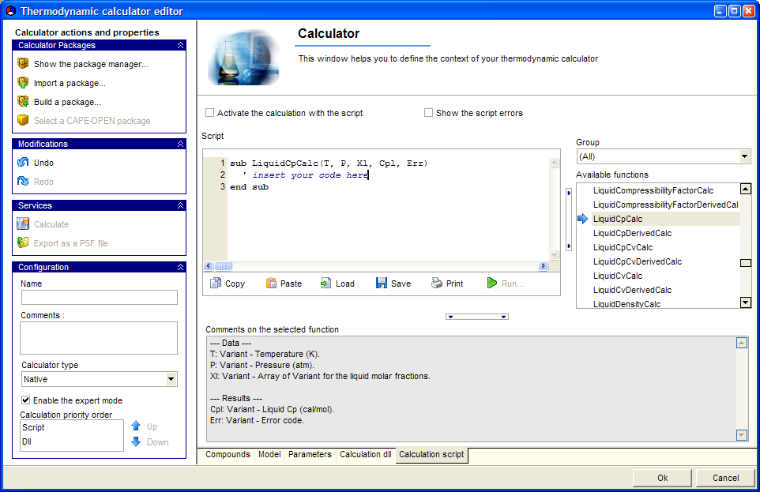
Figure 1: VBScript in Simulis® Thermodynamics
VBScript is an interpreted language and is not very efficient. This way to include external models must be considered as a first step, a step of prototypes showing the feasibility of a model. External DLL use might be the next step.

    - External DLL

Like for VBScript, the Expert Mode being activated, a specific tabsheet (Figure 2) is available to connect an external DLL to Simulis® Thermodynamics. The user must select the required library implementing his own functions. These functions are marked using a bold font within the global list of all possible ones. Like for VBScript approach, the syntax (parameters, units…) of the different functions (entry points from the DLL) is displayed at the bottom of the screen and an integrated tool also allows testing the function from the window. User parameters, used in some models, are supported and can be entered thanks to a specific dialog.

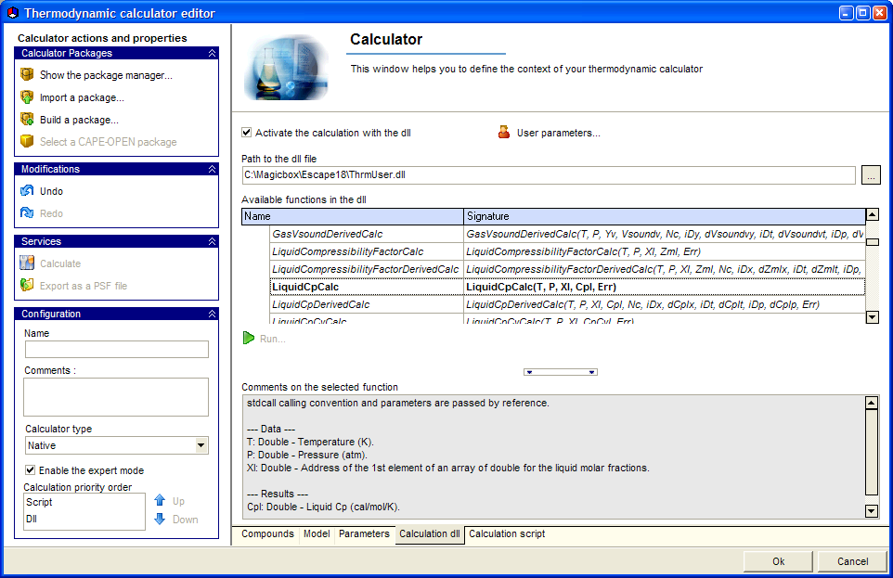
Figure 2: External DLL in Simulis® Thermodynamics
It is important to note that the external DLL can be built using any languages (FORTRAN, C++, Delphi…), the unique constraint is to respect the syntax of the different functions and the calling convention (stdcall by reference) that have been specified. Following this methodology, existing codes can be easily re-used and wrapped in such libraries. To conclude on external DLL, this way can be very efficient, definitively more than VBScript, and could be applied in applications requiring performances in computing time.

    - General considerations

With the Expert Mode, it is not necessary to implement all properties and equilibrium calculations. In fact, VBScript, external DLL and native models can be mixed, each one computing a different property or equilibrium. However, the user must define priorities between the 3 sources of models when different implementations are available to calculate a property or an equilibrium (native models will be used when neither VBScript models nor DLL model are found). This point appears as a great advantage compared with a CAPE-OPEN Thermodynamic Wizard approach where all the capacities of the final CAPE-OPEN Thermodynamic Property Package require to be written. To complete the comparison, the Expert Mode allows an easy configuration in term of pure compounds and in term of thermodynamic profile which has been selected. Even switched to Expert Mode, the user can continue to take advantage of Simulis® Thermodynamics environment, graphical editors and all other graphical services. Globally, the Expert Mode offers a more general and flexible approach than previously proposed systems.

    - REFPROP: an application case

The Expert Mode in Simulis® Thermodynamics introduces an interesting way to embed external codes. To demonstrate the power of this approach, it has been recently selected for instance to develop a link with REFPROP calculation library developed by the NIST (US Department of Commerce) for fluid properties. The wrapping has been done in a reduced time and now the user can access REFPROP, throughout Simulis® Thermodynamics’ framework, in different client applications: Microsoft Excel, MATLAB, CAPE-OPEN Process Modeling Environments… Furthermore, the Expert Mode manages directly the interface with REFPROP calculation kernel and will fix all conflicts between the current release and next ones.

  - Conclusion
More generally, the Expert Mode allows the user (developer) to focus his work on his know-how related to some specific models and to inherit automatically all features from Simulis® Thermodynamics without any more efforts, Simulis® Thermodynamics offering a real development environment for thermodynamic users and developers.

