Detection of multiple structural changes in linear processes through Change Point Analysis and bootstraping
Belmiro P.M. Duarte^{a,b}, P.M. Saraiva^{b}
ªDepartment of Chemical Engineering, Instituto Superior de Engenharia de Coimbra, Rua Pedro Nunes, 3030-199 Coimbra, Portugal, bduarte@isec.pt.
^{b}GEPSI – PSE Group, CIEPQPF, Department of Chemical Engineering, University of Coimbra, Pólo II, Pinhal de Marrocos, 3030-290 Coimbra, Portugal, pas@eq.uc.pt.
Abstract
This paper presents an approach for detecting structural change of processes described by linear relations from restrospective data. The algorithm proposed comprises two steps: i. location of the change point at which the structural change did occur; ii. assessment of the confidence level of the change point detected. The location step is carried out by fitting linear models using Ordinary Least Squares (OLS) in the partitions generated from considering each data point as a pottential boundary. Subsequently, the supremum of Wald statistic is employed to estimate the change point. The confidence level is computed using a bootstraping with replacement algorithm. The approach is applied to a benchmark problem to assess its performance, and to a set of data sampled from an industrial process devoted to the production of precipitated calcium carbonate, comprising four input variables and a quality variable as output.

Keywords: Change point, structural change, bootstraping, process monitoring.
  - Introduction and Motivation
The need of industrial plants to operate within optimal regions and implement adequate global control strategies is nowadays well recognized and accepted. Within such a context, the development of control approaches focused on quality control and process monitoring techniques based upon data mining, analysis and the associated knowledge extraction, has become more and more relevant. One of the most commonly found problems in this regard corresponds to the proper identification of structural process changes, designated as change points, since they are associated with signals of malfunctions and/or process shifts [1]. Change point detection procedures fall under two main categories: retrospective (or a posteriori) tests, and on-line (or a priori) tests [2].
Here we consider a process described by a linear model, comprising multiple input variables and one output variable, which also includes a white noise term, subject to multiple structural changes quantified by variations on the parameters involved in the underlying plant model. The aim is to detect structural changes of the model based on retrospective data to improve the process knowledge and indentify the causes that lead to those changes. This kind of problem is quite common in econometry to identify process shifts [2]. In this paper we propose a combination of techniques already applied in the analysis of econometric time series to identify process changes in the operation of chemical processes. It is assumed that the output variable is related with inputs through linear relations, but the process analysis in larger time horizons may reveal near non-linear behaviors in result of different piecewise sequential linear models. The purpose of the approach is particularly focused on the detection of the points where one piecewise linear relation is replaced by another, thus indicating the occurrence of important shifts on the process.
  - Structural change detection algorithm
Here we consider that the retrospective data, termed , was discretely sampled from a process, with , representing the input vector, and the output. The sequences , and are observations sampled at instants , where is the initial absolute reference time, is the sampling time, and is the number of observations. The process follows a linear regression model :

(1)

with standing for the random error, and for the vector of parameters. One assumes that no structural change occurs during the first records of the data sample, a common assumption in structural change identification designated by non-contamination condition, represented by the relation [3].
The purpose is to test the model structural stability, designated as null hypothesis vs. the occurrence of model structural changes at point , with , denoted as hypothesis . Several test procedures can be employed for such a purpose. Among them are all tests belonging to the generalized fluctuation test framework [4], the tests based on Maximum Likelihood scores [5], and the tests derived from the F statistic [6]. Recently Zeileis demonstrated that all three families of tests can be unified into a framework designated as generalization of M-fluctuation tests [7]. The family of tests based on F statistics, such as the Wald statistic and likelihood ratio were developed for testing the occurrence of a single structural change at an unknown time instant [8]. We address a similar problem, thus choosing the sup W test [6], belonging to the F statistic-based tests, for the purpose of testing the null hypothesis. It must be stressed that one assumes that the underlying process has an unknown number of structural changes, which are determined one at a time by iteratively partitioning and testing the original data set.
The model estimation algorithm employed is OLS, and the methodology is described as follows. For each partition comprising the observations the associated least-squares estimates of , termed as , are obtained through the minimization of . The complementar set of the partition , denoted as , includes observations , and the associated least squares estimates of are computed by the minimization of . The sum of square residuals for each of the pottential partitions considered under the hypothesis depends on the break point , and is given as:

(2)

The Wald statistic can now be constructed, assuming that the covariance matrix of the residuals is heteroskedastic [9] :

(3)

where is the sum of square residuals of the model fitted under the null hypothesis. The change point, , is therefore estimated as :

(4)

with=0.15, the fraction of points considered to define a non-contamination condition [6]. Next to the assessment of the change point one has to validate it deriving confidence intervals for its occurrence. In the literature two basic strategies are employed for such a purpose: i. the deveolpment of proper analytical assymptotic estimators for the statistic ; ii. the use of bootstraping algorithms. The bootstraping technique was firstly proposed by Effron and Tibshirani to build an approximation of the distribution of a test statistic [10]. The idea behind its application is to create a new sample by drawing the error terms from the empirical distribution produced by the null hypothesis model, where no break exists. Each bootstrap sample serves to compute a test statistic in the same fashion as . Here we employ a parametric bootstrap technique standing on a data-generating process described by a parametric distribution of arising from fitting the model with the complete set of data. An uniform distribution that assigns probability is used to sample with replacement the values of and build a new distribution of the error, , subsequently employed to build a new distribution of the output, denoted as [11]:

(5)

and a new data sample is then used to determine the bootstrap change point . The degree of confidence of is therefore given by:

(6)

where is an indicator function whose value is 1 if its argument is true and 0 if not, and is the number of bootstrap samples. In case a structural change occurred at the point and both partitions and are subsequently tested (one at a time) regarding the occurrence of structural changes, with standing for the Type I error assumed. This procedure is carried out iteratively until no more change points found achieve probabilities higher than .

  - Application
The algorithm described in Section 2 was tested with two data samples. The process has a structural change at the point , which is captured with 100% of confidence, and no more change points are identified. The values of and employed were 399 and 0.01, respectively, in both cases handled. The number of bootstraps was chosen taking into account the empirical rule of Davidson and MacKinnon, who proposed that should be an integer in order to achieve an exact test [12]. The power of the test increases as increases, however the computational effort also augments proportionally, thus requiring an appropriate trade-off between those two factors.
The first data set represents a benchmark problem with a single input and a single output, with the data generated according to the relation :

(7)

and standing for normal noise, and is an integer counter. Figure 1 reveals the accuracy of the algorithm, and Table 1 presents the stuctural form of the local models identified. The change point is located at observation 50 due to noise of the output variable, as can be seen from Figure 1. Moreover, the local models identified are in close agreement with the data, thus proving the accuracy of the algorithm.

Table 1 – Structural models for each of the regions.
Region | Interval
1 | [1;49] | [4.8852 -0.0970]^{T}
2 | [50;100] | [-5.6084 0.1010]^{T}

The second case used for testing the methodology is about an industrial unit devoted to the production of precipitated calcium carbonate (PCC). The process dynamics are monitored measuring an output variable which is simultaneously a quality variable, and four input variables which affect the former. The data set used for analyzing the occurrence of structural changes is formed by 93 records respecting to almost 3 months of operation. One may see from Figure 2.a that 2 structural changes were identified, with the order representing the sequence of change points detected. The visual analysis of the output variable does not reveal different trends, but the structural changes correspond to different linear models (Table 2). The quality variable exhibits an almost random behavior due to the changes of the input variables. Additionally, the magnitude of inputs becomes larger for days, thus leading to an increase of the model residuals (Figure 2.b). However, our approach is able to capture changes in regression coefficients. Although with a different variation, due to model structural and input changes, one can see from Figure 2 that no underlying structure seems to be present in the zero centered residuals, apparently confirming that linear input-output relationships do convey a good approximation about this plant´s behaviour. The statistical analysis of the residuals produced by three local model stucture revealed its independency on the inputs and normality
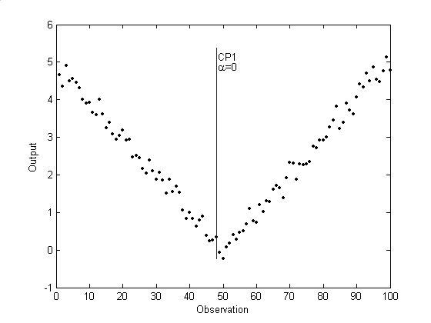
Figure 1 – Results for Case 1 (CPi identifies ith change point and for the Type I error probability).
Table 2 – Structural models for each of the regions.
Region | Interval | $$β$$
1 | [1;33] | [10.9877 -0.0101 -0.4398 -2.6186 -1.7795]^{T}
2 | [34;62] | [39.1254 0.1533 26.3165 36.3046 -91.9578]^{T}
3 | [62;93] | [63.1440 -0.2038 -88.8527 -34.4503 178.7011]^{T}
  - Conclusion
In this paper a methodology often used in the analysis of econometric time series (Change Point Analysis) is employed to detect structural changes of the process model of production units based on retrospective data series. The process model is linear and OLS is used to fit the data. The detection of a single change point estimator at an unknown instant is performed employing the sup W test, a tool included in the group of F statistics tests. The construction of confidence level intervals for such an estimator is carried out through a bootstrap technique based on sampling with replacement of the error terms of the model associated to the null hypothesis. The detection of change points and validation through the computation of its confidence level is performed sequentially by partitioning the original data into smaller regions, where no change point is found. The approach was successfully applied to a benchmark process model an to an industrial set of data representing the dynamics of a process unit during a certain time horizon.
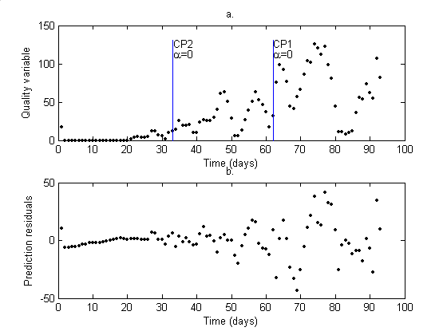
Figure 2 – Results for Case 2 - Plot a. Behaviour of the quality variable and change points where CPi identifies ith change point and stands for the Type I error probability; Plot b. L ocal model residuals .
References
- F. Li, G.C. Runger, E. Tuv, Inter. J. Prod. Res., 44 (2006) 2853-2868.
- M. Basseville, I.V. Nikorov, Detection of abrupt changes – theory and applications, Prentice Hall (1993).
- C.-S. J. Chu, M. Stinchcombe, H. White, Econometrica, 64 (1996) 1045-1065.
- L. Horváth, M. Husková, P. Kokoszka, J. Steinbach, J. Stat. Planning and Inference, 126 (2004) 225-251.
- B.E. Hansen, J. Policy Modeling, 14 (1992) 514-533.
- D.W.K. Andrews, Econometrica, 61 (1993) 821-856.
- A. Zeileis, Econometric Reviews, 24 (2005) 445-466.
- J. Bai, P. Perron, Econometrica, 66 (1998) 47-78.
- J. Bai, Econometric Theory, 13 (1997) 315-352.
- B. Efron, R.J. Tibshirani, An introduction to the bootstrap, Chapman & Hall (1994).
- J. Jouini, M. Boutahar, Working paper, http://www.edge-page.net/jamb2003/Jamboree-Greqam-Jouini.pdf (2003).
- R. Davidson, J. MacKinnon, Econometric Reviews, 19 (2000) 55-68.

