Optimum Experimental Design for Key Performance Indicators
Stefan Körkelª, Harvey Arellano-Garcia^{b}, Jan Schöneberger^{b}, Günter Wozny^{b}
ªInstitut für Mathematik, Humboldt-Universität zu Berlin, Unter den Linden 6, D-10099 Berlin, Germany (corresponding author)
^{b}Institut für Prozess- und Verfahrenstechnik, Technische Universität Berlin, Straße des 17. Juni 135, D-10623 Berlin, Germany
Abstract
In this paper the methods of experimental design are used to minimize the uncertainty of the prediction of specific process output quantities, the so called key performance indicators. This is achieved by experimental design for constrained parameter estimation problems. We formulate these problems and apply our methods to an example from chemical reaction kinetics.

Keywords: dynamic process models, constrained parameter estimation, optimum experimental design.
  - Introduction
Optimal experimental design for parameter estimation is a powerful method used for model validation. It drastically reduces the experimental cost to obtain significant estimates of the unknown model parameters. Numerical methods and application examples are discussed in [1,2]. The paper [3] addresses a sequential approach for parameter estimation and experimental design. A robust modification considering the parameter dependency in nonlinear models is introduced in [4].
In this paper, we want to use the method of experimental design to minimize not only the statistical uncertainty of the model parameters but also of some quantities of interest – the key performance indicators – which are given implicitly as functions of the model state variables. To this end we consider experimental design for constrained parameter estimation problems. We give an analysis for this class of problems and apply our approach to an example from chemical reaction kinetics.
  - Modeling and Simulation of Nonlinear Processes
Modeling of chemical engineering processes by physical and chemical principles, as e.g. mass action kinetics, conservation laws, thermodynamics or phase transitions, typically yields systems of differential equations, e.g. differential algebraic equations (DAE):
$$\begin{aligned}\overset{˙}{y}\text{=f}(\text{t,y,z,p,q}) \\ 0\text{=g}(\text{t,y,z,p,q})\end{aligned}$$
with state variables $(y,z)$, unknown model parameters $p$and process controls $q$.
Typically in chemical engineering, these equations are nonlinear and stiff.

We assume that for given parameters $p$, controls $q$ and initial values, the solution of the model equations exists and is unique. For DAE this e.g. is the case if the functions $f$and $g$are continuously differentiable with bounded derivatives and if the DAE is of index 1, i.e. $∂g/∂z$ is regular.
The solution of the model equations can be computed by use of suited numerical methods. This procedure is called simulation of the process. We will write $x(t;p,q)$ for the simulation results of the states as functions of parameters and controls.
  - Key Performance Indicators
Often the engineer is interested in specific outputs of the process, for example the yield of a certain substance or the ratio of main product and byproducts. We want to call these target quantities key performance indicators $s$. Usually they can be defined as functions of states, controls and parameters and may be given explicitly
$s_{i}=r_{i}({\tilde{t}}_{i},x({\tilde{t}}_{i};p,q),p,q)$, $i=1,…,K$
or implicitly
$r({\tilde{t}}_{1},x({\tilde{t}}_{1};p,q),…,{\tilde{t}}_{K},x({\tilde{t}}_{K};p,q),p,q,s)=0$.
In the following sections the approach of optimum experimental design will be used to give precise predictions for the values of the key performance indicators.
  - Constrained Parameter Estimation Problems
To estimate the unknown parameters, the model has to be fitted to experimental data. For given measurement values $η_{i}$ measured with variances ${σ_{i}^{2}}/{w_{i}}$ at measurement times $t_{i}$, $i=1,…,M$this yields – under assumption of normal distribution of the measurement errors – the least squares parameter fit problem
$$\begin{aligned}\underset{p,s}{\text{min}}\sum_{\text{i=}1}^{M}{w_{i}\frac{(η_{i}−h_{i}(t_{i}\text{,x}(t_{i};p,q)\text{,p,q}))^{2}}{σ_{i}^{2}}} \\ s\text{.}t\text{.} \\ r({\tilde{t}}_{1},x({\tilde{t}}_{1};p,q),…,{\tilde{t}}_{K},x({\tilde{t}}_{K};p,q),p,q,s)=0\end{aligned}$$
In this formulation, the equations defining the key performance indicators $s$ become constraints of the parameter estimation problem and the $s$ become additional variables besides the parameters $p$. Thus the values of the key performance indicators are also estimated from the experimental data.

The quantities $w_{i}$ are 1 for every given measurement point. Later in experimental design they can be used to select the actual measurements out of all possible measurements by choosing $w_{i}∈\left\{0,1\right\}$.
For the solution, tailored methods for constrained optimization of least squares problems have to be applied. In general, data not only from one experiment but from a series of experiments is available. In this case it is useful to apply special multi-experiment formulations. For details on the numerical methods see e.g. [5] and [6].

In the next section we will calculate the variance-covariance matrix as a measure of the uncertainty of the parameter estimation.
  - Statistical Analysis and Nonlinear Experimental Design
Because the input of the parameter estimation problem – the experimental data – is random, so is the solution – the estimate of the parameters and key performance indicators. We apply a first order analysis by linearizing the parameter estimation problem in the solution point $(\hat{p},\hat{s})$:
$$\underset{Δp,Δs}{\text{min}}‖F_{1}+J_{1}\left(\begin{matrix}Δp \\ Δs\end{matrix}\right)‖_{2}^{2} s\text{.}t\text{.} F_{2}+J_{2}\left(\begin{matrix}Δp \\ Δs\end{matrix}\right)=0$$
where
$F_{1_{i}}=\sqrt{w_{i}}\frac{η_{i}−h_{i}(t_{i}\text{,x}(t_{i};\hat{p},q),\hat{p}\text{,q})}{σ_{i}}$$F_{2_{i}}=r_{i}({\tilde{t}}_{1},x({\tilde{t}}_{1};\hat{p},q),…,{\tilde{t}}_{K},x({\tilde{t}}_{K};\hat{p},q),\hat{p},q,\hat{s})$,
and $J_{1}=\left(\begin{matrix}J_{1}^{p} & J_{1}^{s}\end{matrix}\right)$, $J_{2}=\left(\begin{matrix}J_{2}^{p} & J_{2}^{s}\end{matrix}\right)$ consist of the Jacobian w.r.t. $p$
$J_{1}^{p_{i,j}}=−\frac{\sqrt{w_{i}}}{σ_{i}}\left(\frac{∂h_{i}}{∂x}(t_{i},x(t_{i};\hat{p},q),\hat{p},q)\frac{∂x}{∂p_{j}}(t_{i};\hat{p},q)+\frac{∂h_{i}}{∂p_{j}}(t_{i},x(t_{i};\hat{p},q),\hat{p},q)\right)$$J_{2}^{p_{i,j}}=\frac{∂r_{i}}{∂X}\frac{∂X}{∂p_{j}}+\frac{∂r_{i}}{∂p_{j}}$with$X=(x({\tilde{t}}_{1};\hat{p},q),…,x({\tilde{t}}_{K};\hat{p},q))$
and the Jacobian w.r.t. $s$: $J_{1}^{s_{i,j}}=0$, $J_{2}^{s_{i,j}}=\frac{∂r_{i}}{∂s_{j}}$.
The solution of this linearized parameter estimation problem is $\left(\begin{matrix}Δp \\ Δs\end{matrix}\right)=−J^{+}\left(\begin{matrix}F_{1} \\ F_{2}\end{matrix}\right)$ where $J^{+}$ is the generalized inverse $J^{+}=\left(\begin{matrix}I & 0\end{matrix}\right){\left(\begin{matrix}J_{1}^{T}J_{1} & J_{2}^{T} \\ J_{2} & 0\end{matrix}\right)}^{−1}\left(\begin{matrix}J_{1}^{T} & 0 \\ 0 & I\end{matrix}\right)$.
The variance-covariance matrix
$${\text{C=J}}^{+}\left(\begin{matrix}I & 0 \\ 0 & 0\end{matrix}\right)J^{+^{T}}$$
describes the statistical uncertainty of the distribution of the model parameters and the key performance indicators.

The variance-covariance matrix depends on the process controls $q$ and the measurement selection weights $w$. Optimum experimental design aims at computing controls $q$and weights $w$in order to maximize the statistical reliability of the parameter estimation by minimizing a functional (e.g. trace, determinant or maximal eigenvalue) on the variance-covariance matrix:
$$\underset{q,w}{\text{min}}φ(C)$$
subject to constraints on feasibility, operability and costs of the experiments. The design may consist of a single or several parallel new experiments and may sequentially take into account the information from several previous old experiments. Numerical methods for the solution of this nonstandard optimization problem are discussed e.g. in [2].
  - Example
As an example process we consider the Diels-Alder reaction [7], see Fig. 1. It is a chemical reaction with a catalytic and a non-catalytic reaction channel. Modeling of the reaction as a batch-process in a homogenous stirrer tank yields a system of ordinary differential equations. The activation energies and steric factors of the reaction velocities of the two reaction channels and the deactivation rate of the catalyst are the five unknown model parameters. Details of the model can be found in [2].

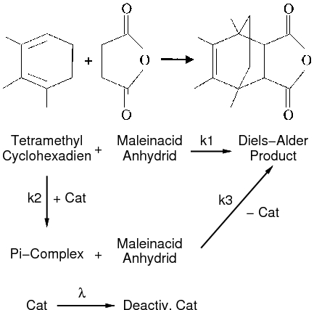
Figure 1: Reaction mechanism of the Diels-Alder reaction. There is a catalyzed and a non-catalyzed reaction channel.
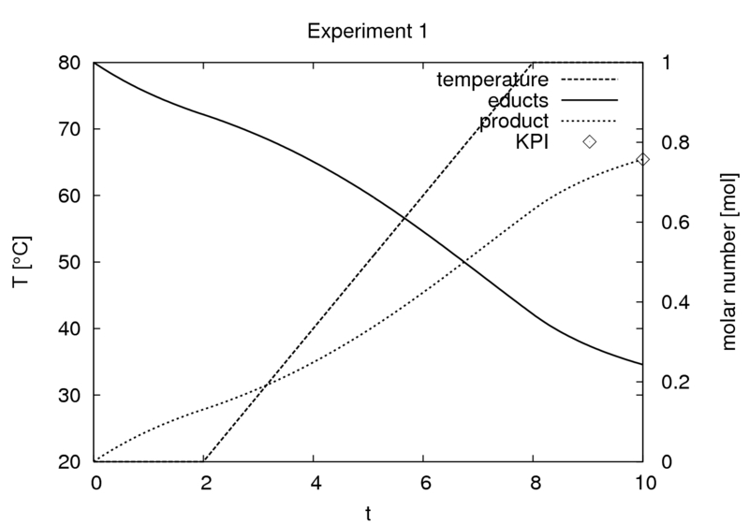
Figure 2: The production scenario experiment. The plot shows the temperature profile and the molar numbers of the educts and the reaction product.

A first experiment is run in the “production conditions” scenario. In this experiment, no measurements are taken and the experimental settings are fixed. The quantity of interest is the yield of the reaction product at the end of the experiment, see Fig. 2. Hence the molar number of the reaction product is defined as the key performance indicator (KPI).

Four additional parallel “laboratory conditions” experiments are now planned by experimental design taking into account the first experiment, i.e. we consider the variance-covariance matrix for a constrained parameter estimation problem consisting of five experiments. Experimental design variables are the initial molar numbers of the educts, the molar number of the solvent, the concentration of the catalyst and the temperature profile as well as the placement of six HPLC measurements of the mass concentration of the reaction product for each experiment.

Optimization yields the experimental settings shown in Table 1 and Fig. 3.

Experimental design variables | Exp. 1 (fixed) | Exp. 2 (optimized) | Exp. 3 (optimized) | Exp 4 (optimized) | Exp. 5 (optimized)
Initial molar number of first educt | 1.0 | 1.84 | 2.09 | 2.24 | 2.30
Initial molar number of second educt | 1.0 | 2.22 | 2.14 | 2.26 | 2.36
Molar number of solvent | 4.0 | 0.85 | 0.90 | 0.96 | 1.00
Catalyst concentration | 1.0 | 0 | 0.05 | 1.11 | 1.72
Initial temperature | 20.0 | 29.6 | 84.4 | 46.8 | 20.0
Final temperature | 80.0 | 27.0 | 60.8 | 44.9 | 45.7
Measurements at | - | 5, 6, 7, 8, 9, 10 | 0.3, 0.6, 1, 1.3, 1.6, 2 | 0.33, 0.66, 1, 8, 9, 10 | 1, 1.3, 1.6, 8, 9, 10
Table 1: Results of the optimization: design of five parallel experiments with the first experiment fixed.

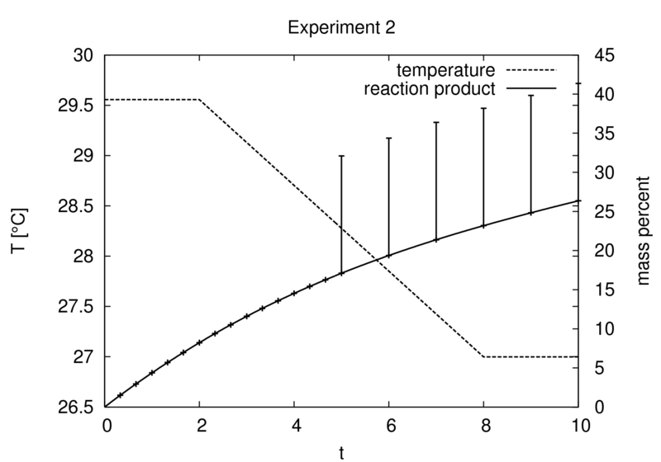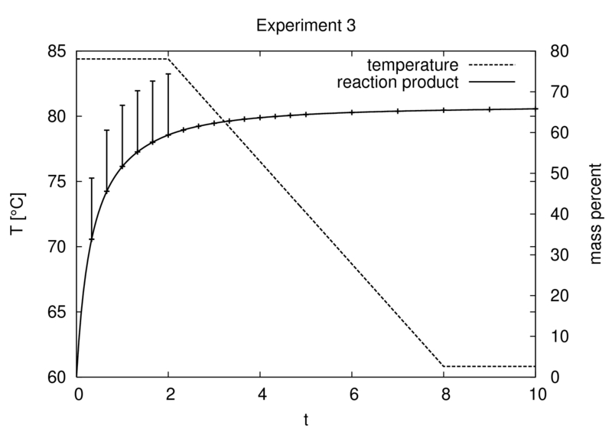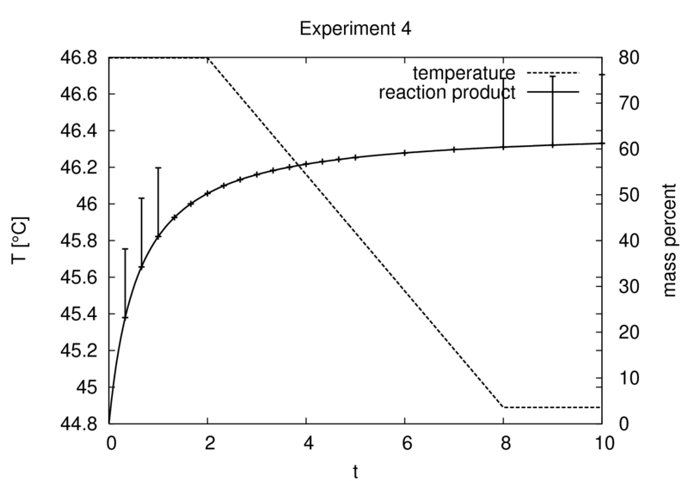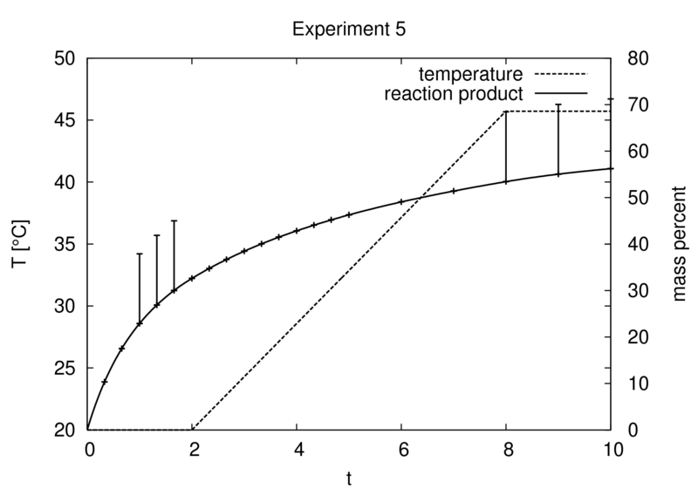
Figure 3: The four optimized experiments. The plots show the temperature profiles and the placement of measurements, indicated by the bars on the curve of the measurable quantity.

Table 2 shows the improvement of the standard deviations of the parameters and the key performance indicator by experimental design optimization. The standard deviation of the key performance indicator is reduced by a factor 10. The overall statistical quality is improved by an average factor 7. In comparison, to achieve this gain without optimization by just repetition of experiments would require a 49 times higher experimental effort.

Parameter | Standard deviations in %  before optimization | Standard deviations in %  after optimization
Steric factor uncatalyzed | 22 | 3.3
activation energy uncatalyzed | 20 | 1.2
Steric factor catalyzed | 11 | 4.3
activation energy catalyzed | 11 | 4.0
catalyst deactivation rate | 21 | 7.5
key performance indicator | 10 | 1.0
Table 2: Standard deviations of the parameters and the key performance indicator before and after experimental design optimization.

The numerical computations have been run with our software package VPLAN [2].
  - Conclusion
We have extended the approach of minimizing the statistical reliability of parameter estimates to user defined quantities of interest, the key performance indicators. To cope with this task, the treatment of experimental design for constrained parameter estimation is necessary. In an ongoing project together with partners from industry, we will apply this method to industrial processes.
Acknowledgement
The idea of applying experimental design to key performance indicators has arisen from discussions with Johannes Schlöder, University of Heidelberg, and Hergen Schultze, BASF AG Ludwigshafen.
References
[1] I. Bauer; H. G. Bock, S. Körkel, J. P. Schlöder, Numerical methods for optimum experimental design in DAE systems, Journal of Computational and Applied Mathematics, 2000, 120, 1-25
[2] S. Körkel, Numerische Methoden für Optimale Versuchsplanungsprobleme bei nichtlinearen DAE-Modellen, Dissertation, Universität Heidelberg, 2002
[3] S. Körkel, I. Bauer; H. G. Bock, J. P. Schlöder, A sequential approach for nonlinear optimum experimental design in DAE systems, In Keil, F.; Mackens, W.; Voss, H. & Werther, J. (eds.), Scientific Computing in Chemical Engineering II, Springer-Verlag, 1999, 2, 338-345
[4] S. Körkel; E. Kostina, H.G. Bock, J. P. Schlöder, Numerical Methods for Optimal Control Problems in Design of Robust Optimal Experiments for Nonlinear Dynamic Processes, Optimization Methods and Software (OMS) Journal, 2004, 19, 327-338
[5] H. G. Bock, Randwertproblemmethoden zur Parameteridentifizierung in Systemen nichtlinearer Differentialgleichungen, Bonner Mathematische Schriften 183, 1987
[6] J. P. Schlöder, Numerische Methoden zur Behandlung hochdimensionaler Aufgaben der Parameteridentifizierung, Dissertation, Hohe Mathematisch-Naturwissenschaftliche Fakultät der Rheinischen Friedrich-Wilhelms-Universität zu Bonn, 1987
[7] R. T. Morrison, R. N. Boyd, Organic Chemistry, Allyn and Bacon, Inc., 1983

