Biclustering of data matrices in systems biology via optimal re-ordering
Peter A. DiMaggio Jr.,ª Scott R. McAllister,ª Christodoulos A. Floudas,ª Xiao-Jiang Feng,^{b} Joshua D. Rabinowitz,^{b} Herschel A. Rabitz,^{b}
ª Department of Chemical Engineering, Princeton University, Princeton, NJ, 08544 USA
^{b} Department of Chemistry, Princeton University, Princeton, NJ, 08544 USA
Abstract
In this work we present an optimal method for the biclustering data matrices in systems biology. Our approach is based on the iterative optimal re-ordering of submatrices to generate biclusters. A network flow model is presented for performing the row and column permutations for a specified objective function, which is general enough to accommodate many different metrics. The proposed biclustering approach is applied to a set of metabolite concentration data and we demonstrate that our methods arranges the metabolites in an order which more closely reflects their known metabolic functions and has the ability to classify related objects into groups.

Keywords: rearrangement clustering; biclustering; network flow; Mixed-integer linear programming (MILP).
  - Introduction
Problems of data organization and clustering are important and utilized in a variety of applications. The overall purpose of data clustering, regardless of the content of the data set being analyzed, is to organize the data in such a way that objects which exhibit “similar” attributes are grouped together. The definition of similarity is dependent on the types of trends that one hopes to extract from a given data set.
The most common methods available for the clustering of large-scale data sets are hierarchical [1] and partitioning [2] clustering. These formulations are often solved using heuristics and result in suboptimal clusters because comparisons are only evaluated locally. The problem of rearrangement clustering has emerged as an effective technique for re-ordering data based on minimizing the sum of the pair-wise distances between rearranged rows and columns. The bond energy algorithm (BEA) was originally proposed for finding “good” solutions to this problem [3] and it was later discovered that it could be cast as a traveling salesman problem (TSP) [4,5].
The concept of biclustering has emerged in the context of microarray experiments since a gene can be involved in more than one biological process or could be co-expressed with other genes for only a subset of the conditions. Several existing approaches use heuristic methods, discretize the expression level, and/or solve a simplified model to address this NP-hard problem [6]. An excellent review of several biclustering methods can be found in [7].
In this work, we present a method for biclustering data matrices which is based on iteratively computing the optimal ordering for the rows and columns of a data matrix. We present a general form of the objective function for quantifying the similarity between rows or columns that are adjacent in the final ordering. A network flow model is used to perform the actual permutations of the rows and columns. Our method is applied to a set of metabolite concentration data [8] and compared with other clustering techniques. We show that the proposed approach provides a denser grouping of related metabolites (i.e., rows of the data matrix) than does hierarchical clustering, which suggests that optimal ordering has distinct advantages over local ordering. It is also demonstrated that this global method also reconstructs underlying fundamental patterns in the data as it perfectly separates the nitrogen and carbon starvation conditions (i.e., the columns) into different halfs of the data matrix.
  - Biclustering algorithm
In this section we present the mathematical framework used for biclustering dense data matrices. We begin by defining the problem representation, which is based on nearest neighbor assignments in the final ordering. Given the proposed variable representation, we present a generalized objective function for assessing the quality of a reordering. A network flow model is then used to perform the actual permuations of the rows and columns of the data matrix according to the selected objective function. For the sake of brevity, we present the terminology and mathematical model only for the rows of the data matrix, but an analogous representation follows for the columns.
    - Variable Definitions
We define the index pair (i,j) to correspond to a specific row i and column j of a matrix and the value asscoiated with this pair is denoted as a_{i,j}. The cardinality (or in this case, the dimension) of the rows and columns of the matrix will be represented as |I| and |J|, respectively. The problem respresentation adopted in this article is based on defining whether or not two rows i and i' are adjacent in the final rearrangement of the matrix, where row i' is directly below row i. We accomplish this by defining the following binary {0-1} variables.
y_{i,i’} = 1 if row i is adjacent and above row i’ in the final arragnement, 0 otherwise

For instance, if the binary variable y_{8,3} is equal to one then row 8 is immediately above row 3 in the final arrangement of the matrix. The assignment of y_{8,3} = 0 implies that row 8 is not immediately above row 3 in the final arrangement, but does not provide any additional information regarding the final positions of rows 8 and 3 in the matrix.
    - Objective Function
The proposed method optimally rearranges the rows and columns of a data matrix according to a metric of similarity, which is left to the user to specify. Given the problem representation of assigning neighboring elements in the final ordering using the binary variables y_{i,i'}, we present a generic similarity measure for determining the associated cost of placing rows i and i’ adjacent in the final ordering in Eq. (1).
∑ _{i} ∑ _{i'} ∑ _{j} y_{i,i'} ∙φ(a_{i,j}, a_{i’,j}) (1)

In Eq. (1), φ(a_{i,j}, a_{i’,j}) represents any pairwise similarity measure between the elements of two rows. For instance, one might want to penalize large pairwise differences between adjacent elements in the final rearrangement. For this purpose, one could evaluate the squared difference between two rows as shown in Eq. (2).
∑ _{i} ∑ _{i'} ∑ _{j} y_{i,i'} ∙(a_{i,j}-a_{i’,j})² (2)

It should be noted that the form of the objective function presented in Eq. (2) is not limited to this Euclidean metric and can accommodate almost any pairwise similarity measure.
    - Network Flow Model
Network flow models [9] have been extensively studied in the field of optimization and mathematical programming. The final ordering of the row permutations can be represented as a directed acyclic graph, where the rows correspond to nodes and an edge connects two nodes (rows) if they are adjacent in the final ordering. As defined in the previous section, the binary variables y_{i,i'} represent the assignment of a neighboring row i' directly below row i in the final arrangement. Thus, this binary variable y_{i,i'} represents the physical existence of an edge between the rows i and i'.
We introduce another set of binary variables, y_{source,i} and y_{sink,i}, to indicate which rows are assigned at the top and bottom of the final rearranged matrix, respectively.
y_{source,i} = 1 if row i is the top-most row in the final ordering, 0 otherwise
y_{sink,i} = 1 if row i is the bottom-most row in the final ordering, 0 otherwise

A set of continous variables, f_{i,i'}, are denoted as the flows of the network. For this problem representation, we define the flow entering a node (row), f_{i,i’}, to denotes its final position in the re-ordered matrix. Note that there is a one-to-one correspondence between the existence of an edge, y_{i,i'}, and the flow assigned to that edge, f_{i,i'}. These flows start from a fictitious source row and end at a fictitious sink row.
f_{i,i'} = the flow from row i to row i'
f_{source,i} = the flow entering the source row i
f_{sink,i} = the flow leaving the sink row i

To ensure that each row has unique neighbors, we define constraints that assign exactly one row above and one row below each row i in the final ordering, as shown in Eqs. (3) and (4), respectively.
∑ _{i'≠i} y_{i’,i} + y_{source,i} =1 (i) (3)
∑ _{i'≠i} y_{i,i'} + y_{sink,i} = 1 (i) (4)

These constraints enforce that each row, i, has only one neighboring row above it (or is the top-most row) and only one neighboring row below it (or is the bottom-most row) in the final arrangement, respectively. We also need to enforce is that only one row is the top-most row (i.e., source) row and only one bottom-most (i.e., sink) row in the final arrangement.
∑ _{i} y_{source,i} = 1 (5)
∑ _{i} y_{sink,i} = 1 (6)

The set of constraints defined by Eqs. (3) through (6) are sufficient for assigning a unique ordering of the rows. However, cyclic arrangements of the rows can also satisfy these constraints (i.e., it is possible to have y_{i,i'} = y_{i,i'’} = y_{i’’,i} = 1, which corrsponds to the cyclic ordering of i, i', i'', i, ... etc.). To remove cyclic arrangements in the final ordering, unique flow values, f_{i,i'}, are assigned to each edge, y_{i,i'} which denote their final positions in the ordering. We intialize the positions to begin at the source row (or top-most row) by setting it equal to the total number of rows (|I|).
f_{source,i} = |I|∙y_{source,i} (i) (7)

Starting from this source row, each subsequent row in the final arrangement will have an entering flow value of |I|-1, |I|-2, and so on. This cascading property of the flow values will ensure that the flows corresponding to the final orderings are unique. A flow conservation equation is used to model this cascading of the flows by requiring that the flow entering a row is exactly one unit greater than the flow leaving that row.
∑ _{i'} (f_{i’,i} - f_{i,i'}) + f_{source,i} – f_{sink,i} = 1 (i) (8)

Since we have defined the convention that f_{source,i} starts at |I|, then f_{sink,i} has a flow value of zero and thus can be eliminated from the model. Lastly, we can assign general upper and lower bounds for all flow values since a flow connecting two rows i and i' (i.e., y_{i,i'} =1) can never be greater than |I|-1 nor less than 1.
y_{i,i'} ≤ f_{i,i'} ≤ (|I| - 1) ∙y_{i,i'} (i,i’) (9)

These constraint equations also ensure that if rows i and i' are not connected by an edge (i.e., y_{i,i'} = 0), then no flow is assigned (i.e., f_{i,i'} = 0). The set of constraint in Eqs. (3)-(9) comprise the entire mathematical model necessary for performing the row and column permutations, which are guided by any of the aforementioned objective functions. This is a mixed-integer linear programming (MILP) model and can be solved to global optimality using existing methods such as CPLEX [10].
    - Iterative Approach
We utilize the mathematical model for optimal re-ordering in an iterative framework to bicluster data matrices. First, a single dimension of the data matrix is optimally re-ordered and we refer to this dimension as the columns of the data matrix. For example, in gene expression data the columns would correspond to the conditions over which the expression levels are measured. Given the optimal re-ordering of the columns, the median value of the objective function for every pair of adjacent columns in the final arrangement is computed. Cluster boundaries are defined to lie between those columns which have the largest median objective function value and these boundaries are used to partition the original matrix into several submatrices. The rows of each submatrix are then optimally re-ordered over their corresponding subset of columns and the clusters in this dimension are defined based on the largest median objective funciton values between adjacent rows in the final ordering.
  - Computational Studies
    - Metabolite Concentration Data
The proposed biclustering approach, denoted as OREO, was applied to a data set comprised of concentration profiles for 68 metabolites recorded dynamically over the conditions of nitrogen and carbon starvation for the organisms E. coli and S. cerevisiae [8]. The columns of the data matrix (i.e, the starvation conditions) were re-ordered using the objective function in Eq. (2). The network flow formulation for the column re-ordering problem was solved by CPLEX [10] in 168 seconds on an Intel 3.0 GHz Pentium 4 processor and the results are presented in Fig. 1. It is interesting to note in the column re-orderings that the nitrogen and carbon starvation conditions are perfectly separated into different halfs of the matrix. This suggests that the algorithm has the ability to reconstruct underlying fundamental patterns. The top four cluster boundaries partition the original matrix into the five submatrices A, B, C, D and E, as shown in Fig. 1.

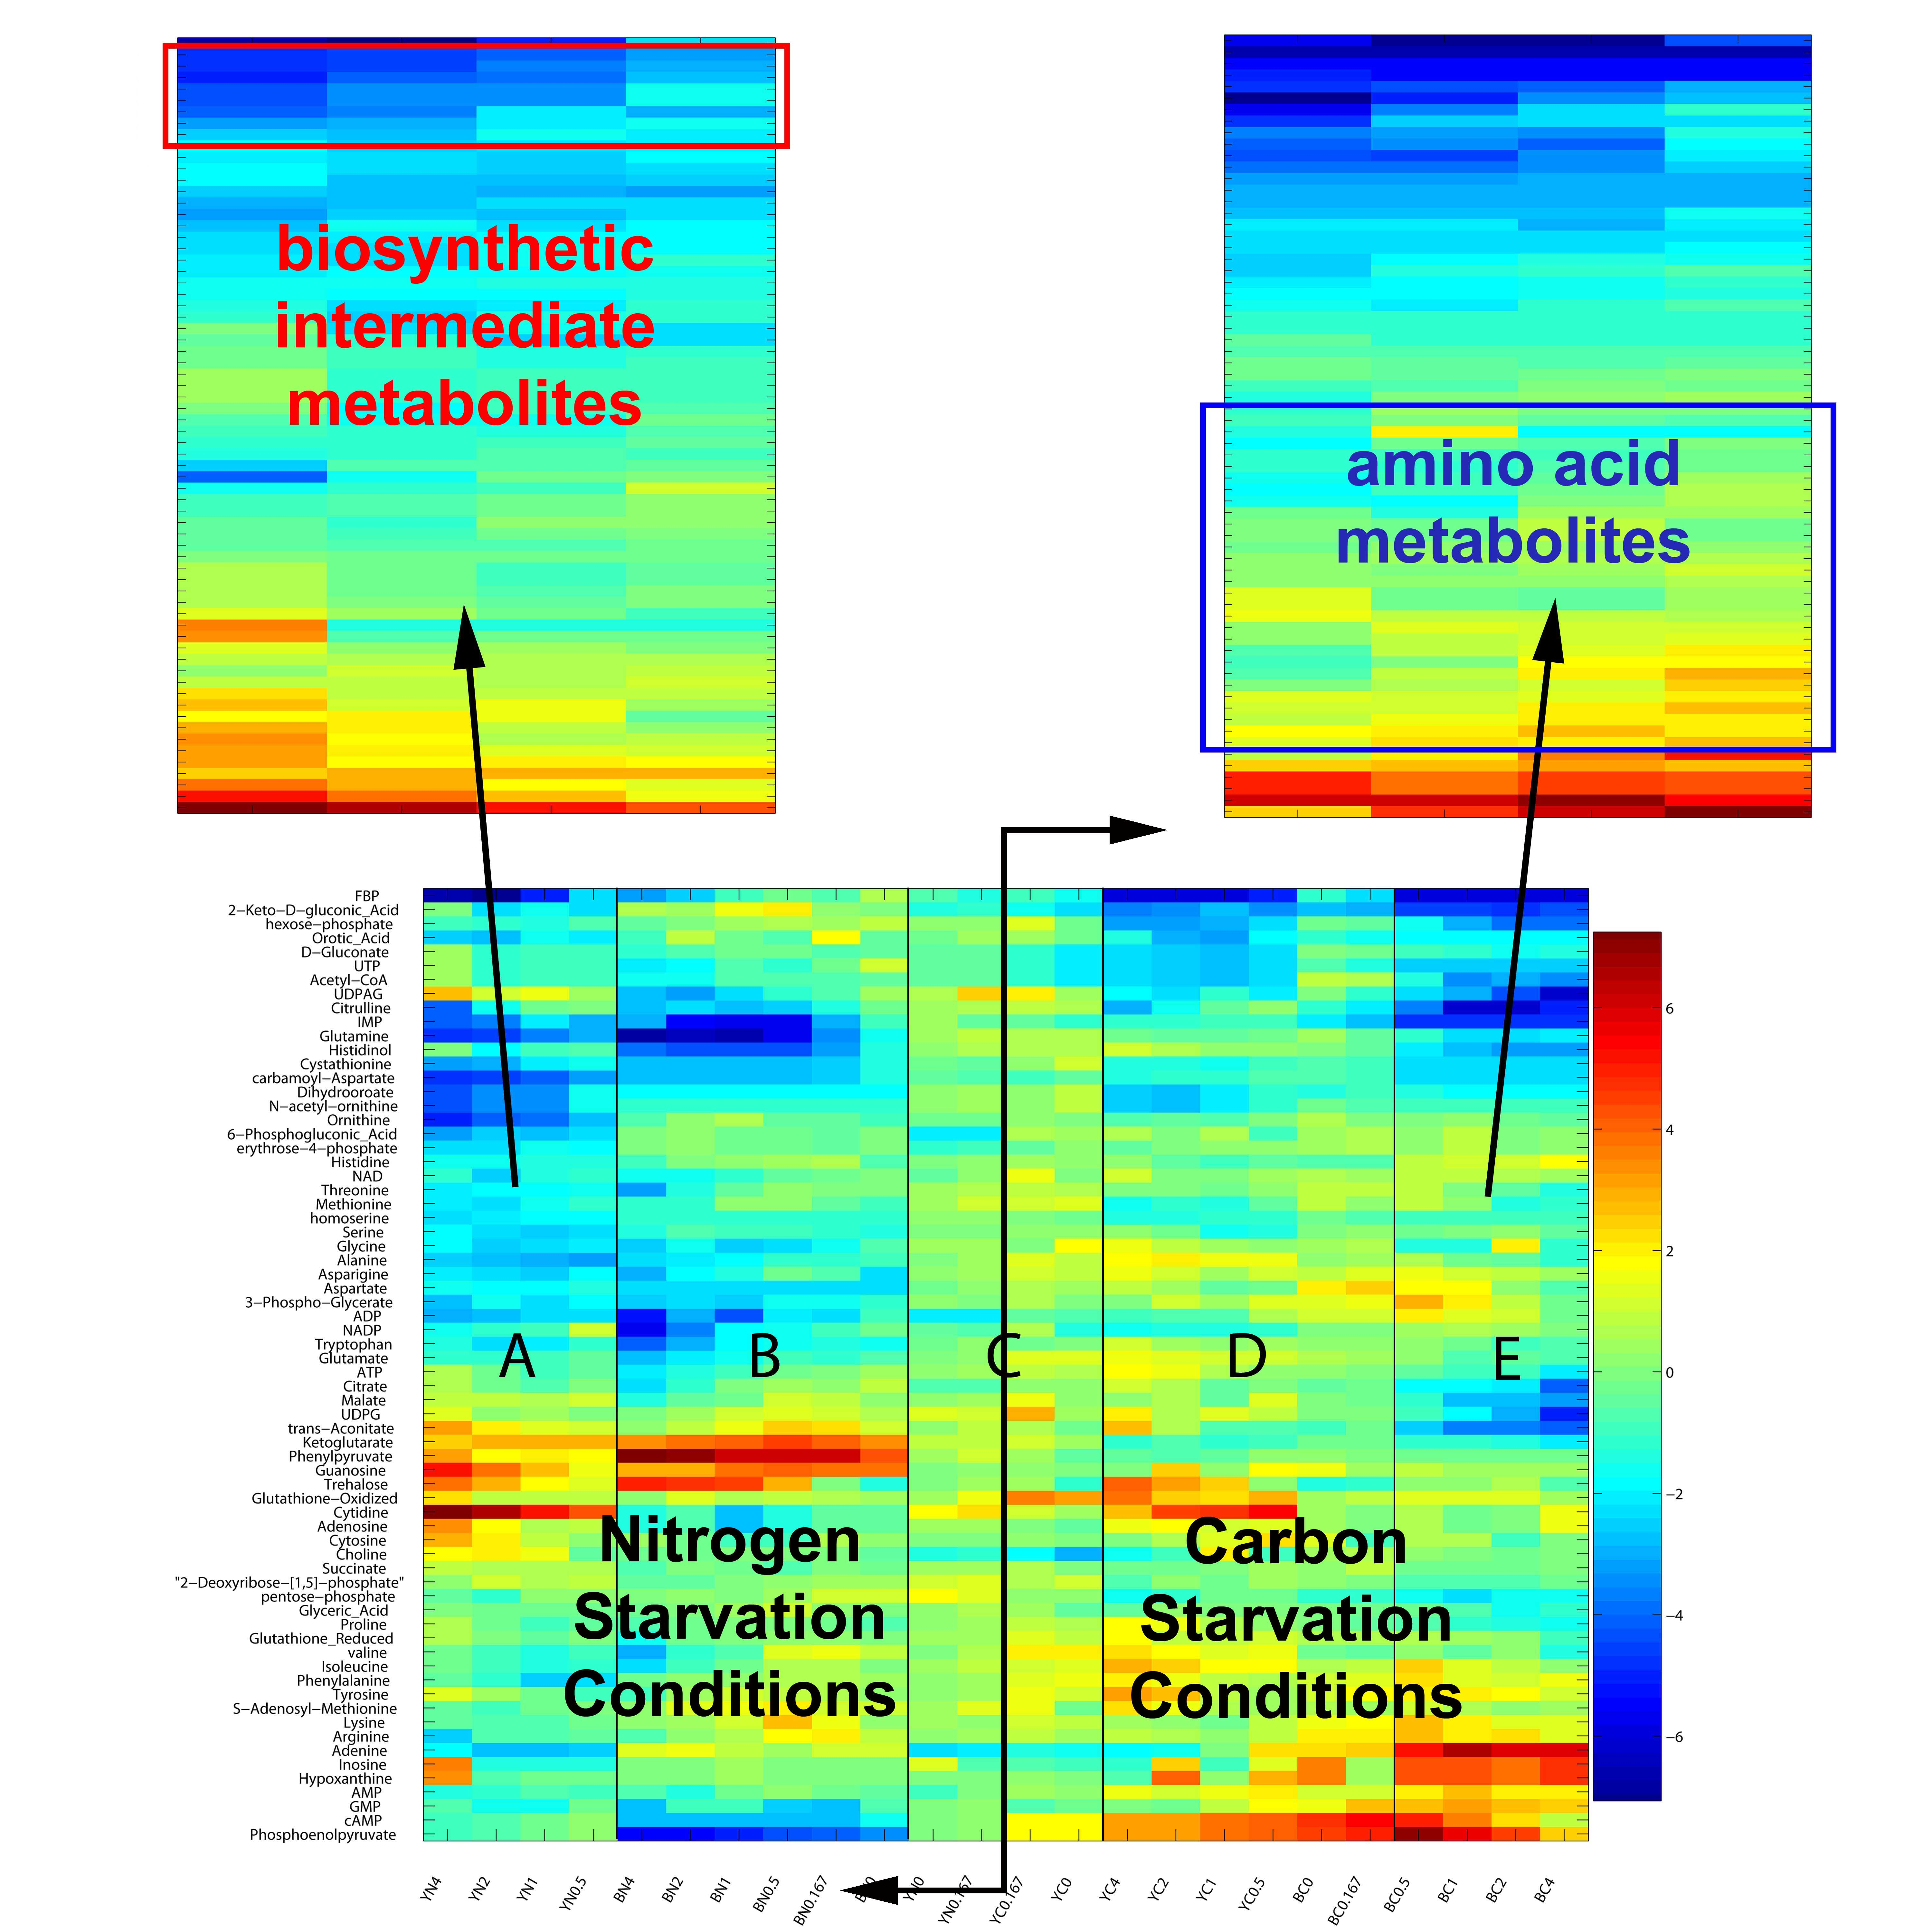
Figure 1: Optimally re-ordered columns of metabolite concentration data result in submatrices A, B, C, D and E. The enlarged regions show the concentration profiles for the optimally re-ordered metabolites in submatrices A and E.

For the sake of brevity, we only present the optimal ordering over the metabolites for the submatrices A and E using the objective function in Eq. (2), which were optimally re-ordered in 4085 and 4587 CPU seconds using CPLEX, respectively, and the results are shown in the enlarged regions in Fig.1. It is important to note that the re-orderings over different submatrices result in better groupings of different metabolites. For instance, the optimally re-ordered metabolites in region A produce a strong grouping of the biosynthetic intermediate metabolites carbamoyl-aspartate, ornithine, dihydrooroate, N-acetyl-ornithine, IMP, cystathionine, and orotic acid. This clustering supports the observation that most biosynthetic intermediates decrease in concentration over all starvation conditions based on the hypothesis that the cells turn off de novo biosynthesis as an early, strong, and consistent response to nutrient deprivation [8]. In contrast, the re-orderings of the metabolites in region E results in an excellent grouping of 16 amino acid metabolites into a single cluster and 8 of these metabolites are ordered consectively: serine, glycine, valine, glutamate, tryptophan, alanine, threonine, and methionine. This richness of amino acid metabolites is consistent with the observation that amino acids tend to accumulate during carbon starvation [8]. One should note the almost monotonic behavior of the re-ordered concentration profiles in regions A and E, which groups the decreasing concentrations at the top and the increasing concentrations at the bottom of the matrix
As a basis for comparison with traditional clustering techniques, we examined the results for hierarchical clustering applied to the metabolite concentration data [8]. Overall, when compared to hierarchical clustering, OREO arranges the metabolites in an order which more closely reflects their known metabolic functions. We also applied the biclustering methods ISA, Cheng and Church, BiMax, and Samba to the metabolite concentration data but all these methods were unable to produce any biologically meaningful biclusters.
References
- M.S. Eisen, P.T. Spellman, P.O. Brown, and D. Botstein, 1998, Cluster analysis and display of genome-wide expression patterns, Proc. Natl. Acad. Sci., 95(25), 14863-14868.
- J.A. Hartigan and M.A. Wong, 1979, Algorithm AS 136: a K-means clustering algorithm. Applied Statistics, 28, 100-108.
- W.T. McCormick Jr, P.J. Schweitzer, and T.W. White, 1972, Problem decomposition and data reorganization by a clustering technique. Operations Research, 20(5), 993-1009.
- J.K. Lenstra, 1974, Clustering a data array and the traveling-salesman problem. Operations Research, 22(2), 413-414.
- J.K. Lenstra and A.H.G. Rinnooy Kan, 1975, Some simple applications of the traveling salesman problem. Operations Research Quarterly, 26(4), 717-733.
- Y. Cheng and G.M. Church, 2000, Biclustering of expression data, Proc. ISMB 2000, 93-103.
- S.C. Madeira and A.L. Oliveira, 2004, Biclustering algorithms for biological data analysis: A survey. IEE-ACM Trans. Comp. Bio., 1(1), 24-45.
- M. J. Brauer, J. Yuan, B. Bennett, W. Lu, E. Kimball, D. Bostein, and J.D. Rabinowitz, 2007, Conservation of the metabolomic response to starvation across two divergent microbes. Proc. Natl. Acad. Sci., 103,19302-19307.
- Ford L, Fulkerson D, 1962, Flows in Networks, Princeton University Press.
- CPLEX, 2005, ILOG CPLEX 9.0 User's Manual.

