Optimization of WWTP control by means of multi-objective genetic algorithms and sensitivity analysis
Benoit Beraud,ª Jean-Philippe Steyer,^{b} Cyrille Lemoine,ª Eric Latrille^{b}
ª Anjou Recherche – Veolia Environnement, Chemin de la Digue – BP 76, Maisons Laffitte, F-78603, France
^{b} INRA, UR050, Laboratoire de Biotechnologie de l’Environnement, Avenue des Etangs, Narbonne, F-11100, France

Abstract
This study presents the application of the multi-objective genetic algorithms NSGA-II to the optimization of a control law for a wastewater treatment plant. A sensitivity analysis is then performed to check the long term performances of the optimized controller settings. The combination of these two techniques allows us to obtain the best tradeoffs for minimizing the effluent quality together with the energy consumption while providing information on the robustness of the controller settings.

Keywords: BSM1, multi-objective, optimization, wastewater.
  - Introduction
The environmental impact of wastewater treatment plants (WWTPs) is influenced by many factors such as the pollution emitted to the receiving body, the energy consumed for the treatment (aeration, pumping) as well as the sludge produced for disposal. The control of the WWTPs has to be designed to reduce these competing factors all together. However, no general rules for the optimal operation of WWTPs are available due to the highly varying influent composition, the different design and sizing of WWTPs as well as the numerous possible control laws. On the other hand, recent advances in modelling allow on-desk dynamic simulations of a WWTP with its control law for the evaluation of its performances. Optimization algorithms are also nowadays widely available. The next step consists in bringing these two fields together, in order to assess the best performances of the different control laws for a given WWTP. Such a methodology is of great help for the decision maker who has to choose an optimal control law and its settings for a specific plant.
The approach presented in this paper consists in using the multi-objective genetic algorithm NSGA-II [1] for the optimization of an advanced control law used for simultaneous Nitrification/Denitrification (NDNs) [2] on the case study proposed in the Benchmark Simulation Model 1 (BSM1) [3]. The two objectives considered for the optimization are the effluent quality and the energy consumption. To have additional insights onto the long-term robustness of the optimized parameters, the final models are simulated for 609 days with a highly variable influent as proposed in the long-term extension of BSM1 [4]. The analysis of these long-term simulations is then performed by a Principal Components Analysis (PCA) of the daily performances.
  - Methods
    - WWTP model and control law
The model used for the simulation is the Matlab implementation of BSM1 [3]. BSM1 was developed for unbiased comparison of different control laws. The WWTP is modelled with five activated sludge tanks in series using the Activated Sludge Model 1 (ASM1) [5] and a secondary clarifier modelled according to the method of Takács et al. [6] (see Fig. 1). All parameters are set as defined in the BSM1 protocol.
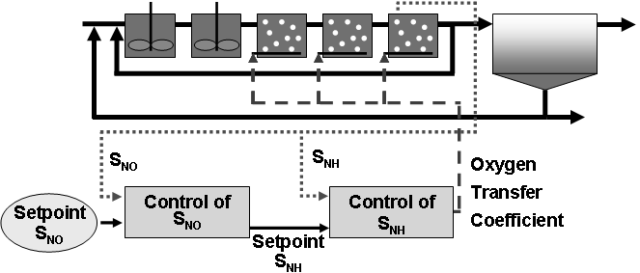
Fig. 1, WWTP and controller layout
In this study, the NDNs control law is used [2], which allows the exact control of the quantity of oxygen necessary for optimal performances of the activated sludge for both reactions of nitrification and denitrification. This control law is based on two PI controllers in cascade. The first one controls the concentration of nitrate (S_{NO} in g.m⁻³) by manipulating the set-point of ammonia (S_{NH} in g.m⁻³) while the second controller acts on the level of ammonia by manipulating the oxygen transfer coefficient (K_{L}a in s⁻¹). In real WWTPs, the oxygen transfer coefficient is controlled with air flow rate but this is not included in our model. The measurements are made in the last activated sludge tank and the same K_{L}a is applied to the three last tanks.
Many performance indexes are available in the BSM1 protocol for the evaluation of the control performance such as the effluent quality, the energy consumption and the sludge production. In this study, only the first two indexes will be used since they are the most influencing ones. The effluent quality is defined as a weighted sum of the different pollutants mass fluxes (COD, BOD, TSS, NTK, and nitrate). The energy consumption is the sum of the aeration energy (linked to the oxygen transfer coefficient used in each tank) and the pumping energy (sum of energies used for internal recirculation, recirculation from the clarifier and sludge extraction).
The procedure used for the evaluation of the performances is composed of two steps. First, the seven initial days of dry weather proposed in BSM1 are repeated until stabilization of the system is achieved. The system is considered as stabilized when the relative differences of all states between the beginning and the end of the week are inside a given tolerance. Then, the seven days of rain weather proposed in BSM1 are used for the evaluation of the performance index. In fact, the first step of this procedure performs the stabilization of the plant with a dynamic influent, while the second one performs the evaluation of the performances when facing an important disturbance.
    - Genetic algorithm and definition of the problem
As already mentioned, two optimization objectives were chosen in this study: the effluent quality and the energy consumption. In the case of multi-objective optimization, two solutions are possible. The first one consists in choosing a weighting scheme that will aggregate the different objectives in a single criteria. This technique is acceptable when it is possible to find a common measure or unit for all objectives. In our case, the effluent quality is already an aggregation, in unit of kilograms of pollution units per day, and the energy consumption is in kWh per day. Vanrolleghem and Gillot [7] proposed to measure them as costs by transforming the effluent quality in penalty according to local regulation and the energy consumption into electricity cost according to local price.
This solution is convenient but do not allow a full insight into the control law performances. Moreove, it requires a priori knowledge about the problem and no information about the trade-off between both objectives is available. Another technique consists in searching for the Pareto front. The Pareto front is the set of the best solutions for which it is impossible to find any other solution enhancing all objectives at the same time. The decision maker can then choose his operating point among this set of solutions. With this front, he/she will have a clear insight into the trade-offs between the objectives of its problem at hand.
Genetic algorithms are particularly well fitted for multi-objective optimization. NSGA-II is one of the most popular genetic algorithms capable of searching for the Pareto front. Compared to other multi-objective genetic algorithms, its strength is the distribution of the points along the Pareto front in the objective space while its weakness is its convergence rate [8]. Its settings for this study were the following ones: population size of 40 individuals, computation of 100 generations, probability of crossover of 0.9, crossover distribution index of 10, probability of mutation of 0.1 and mutation distribution index of 20.
There are four decision variables for the optimization. Bounds for all decision variables are summarized in the Table 1. The first three variables play a key role in the control of the nitrification/denitrification reactions. The fourth parameter is the sludge wastage flow rate, which is constant during the whole simulation. It is used to choose an appropriate Sludge Retention Time (SRT) for the plant. For each variable, the lower bound is zero. This may seems unreasonable as the corresponding behavior of the plant is unstable (especially for the sludge extraction flow rate), but the genetic algorithm is able to handle this without any problem. In fact, our goal is not to constrain too much the search space so that the algorithm will not miss any promising solution.
Table 1. Decision variables to optimize
Decision variable | Lower bound | Upper bound | Unit
Setpoint S_{NO} | 0 | 8 | g.m⁻³
Lower bound S_{NH} | 0 | 8 | g.m⁻³
Difference (upper – lower) bounds S_{NH} | 0 | 8 | g.m⁻³
Sludge extraction flow rate | 0 | 400 | m³.day⁻¹
    - Post processing
After the optimization, the robustness of the Pareto front has to be assessed. For each final solution of the optimization, a simulation of 609 days is performed with the influent proposed for BSM1_LT. This influent is typical of the events which perturb the WWTPs like rains, storms and holidays. After this long-term simulation, daily means are computed for both objectives. Then, for the evaluation of the robustness, a Principal Components Analysis (PCA) of these 609 daily mean values is performed. This provides the two directions of variations. 10th and 90th percentiles of the projections of daily means on these two axes are also computed.
  - Results and Discussion
The performances of the optimized settings of the NDNs control law are presented in Figure 2. The results of the default settings of BSM1 are also plotted for comparison purpose. The point labeled 'BSM1 Openloop' is the result of applying constant values for all oxygen transfer coefficients (respectively 0, 0, 240, 240 and 84 d⁻¹ for the 5 ASUs) and all fluxes (55338 m³.d⁻¹ for the internal recycle flow, 18446 m³.d⁻¹ for the recycle flow from the clarifier and 385 m³.d⁻¹ for the sludge extraction) as depicted in the BSM1 protocol [3]. The point labeled 'BSM1 Closedloop' is the result of the same settings except that two PI controllers are now used as suggested in the BSM1 protocol: one to control the aeration in the 5th tank so that the concentration of oxygen is equal to 2 g.m⁻³ in this same tank and another one to control the internal recycle flow so that the concentration of nitrate in the 2nd tank is equal to 1 g.m⁻³. Compared to these two points, a reduction of the energy consumption of 15% or 18% is achieved thanks to the NDNs control law for the same effluent quality. The graph even indicates possibilities to reduce at the same time the energy consumption and the effluent quality from 10 to 15%.
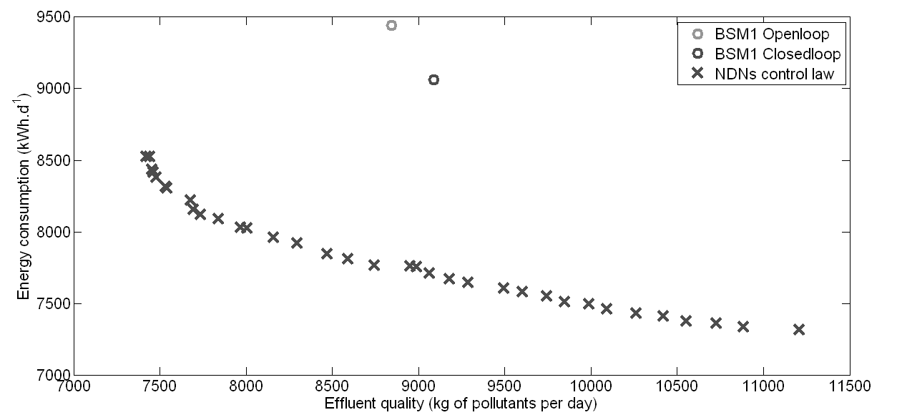
Fig. 2, Results of the optimization of the Nitrification/Denitrification control law
The second step in this study consisted in simulating the settings issued from the optimization with the BSM1_LT influent of 609 days. A sample point was selected in the middle of the Pareto front and is illustrated in Figure 3.
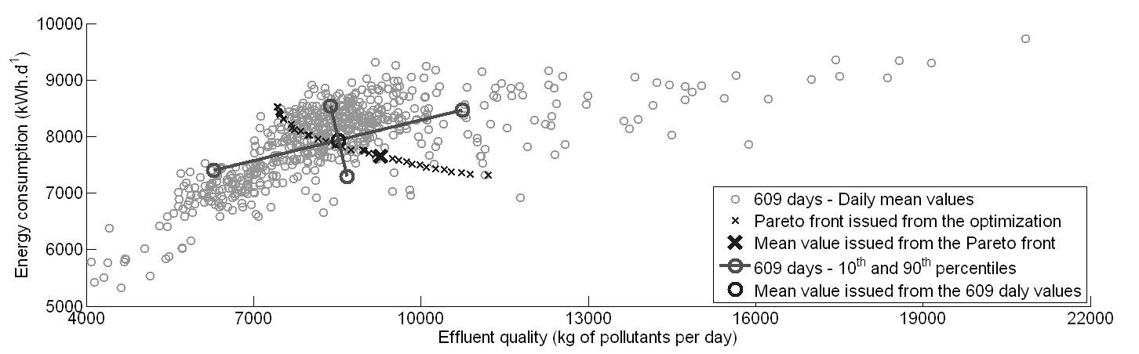
Fig. 3, Performances during 609 days of an optimized functioning point
As can be seen, the deviation between the mean value issued from the optimization and the global mean value of the 609 daily mean values is acceptable (- 8.3% for the effluent quality, + 3.7% for the energy consumption). The PCA gives the two axes illustrated by two lines. The length of these two lines represents the 10th and 90th percentiles of the projection of all 609 daily mean values on these two new axes. These percentiles correspond to deviation of the mean value of ± 27% for the first axis and - 8.2% / + 7.8% for the second axis. These values are usual in WWTPs, especially taking into account the fact that no strategies have been applied for the long term operation of the plant or the monitoring of rain events or storms. The main axis of the PCA indicates that the energy consumption tend to be reduced when the effluent quality is better, which is quite not intuive. This may be explained by the occurrence of low load periods during which it is easier to degrade most of the pollutants with a lower consumption. Moreover, the Nitrification/Denitrification control law is based on the concentrations of pollutants in the last aerated tank while the effluent quality is based on loads of pollutants in the effluent, which may explain the variations. If the control is perfect, the concentrations should be almost constant and as the flow rate vary, the pollutants loads in the effluent (and the effluent quality) will vary.
The same PCA analysis can be done for all points of the Pareto front. The results for three points considered as representatives are illustrated in Figure 4. The axes of the PCA are almost parallel for all three points, which indicates a similar behavior for all settings. This indicates that the control law is very close to behave the same for all settings, which is the goal of the optimizer.
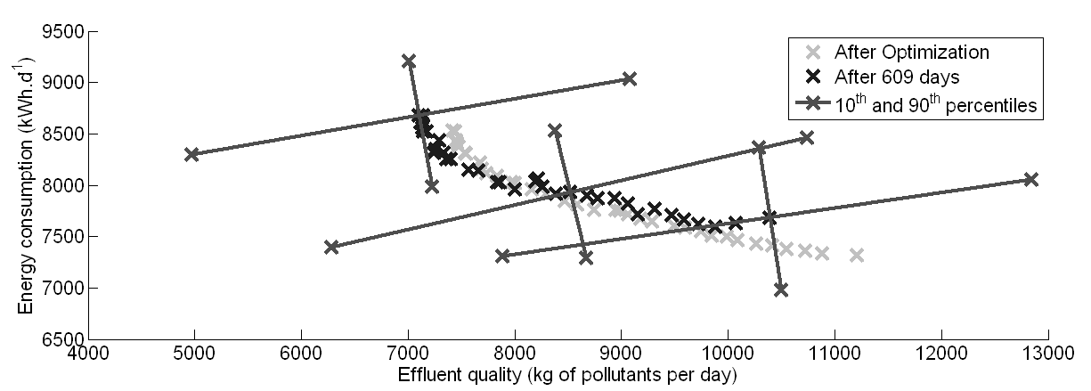
Fig. 4, Performances of Pareto-optimal settings during 609 days of simulation
For comparison purpose, another case is exposed in Figure 5. The procedure was exactly the same except that five PI controllers are now used to have precise setpoints of oxygen in each tank instead of the NDNs control law. The values of these setpoints were optimized and the grey points were obtained, which seemed to be relevant and even more promising than the NDNs control law. However, the dark points are illustrating the mean performances for the simulation of the plant during 609 days with the optimized settings. It shows that only one half of the settings were reliable, the performances of the other half been too much influenced by the perturbations. This type of information is very important to have in order to choose only relevant points of the Pareto front or to add constraints to the optimization problem.
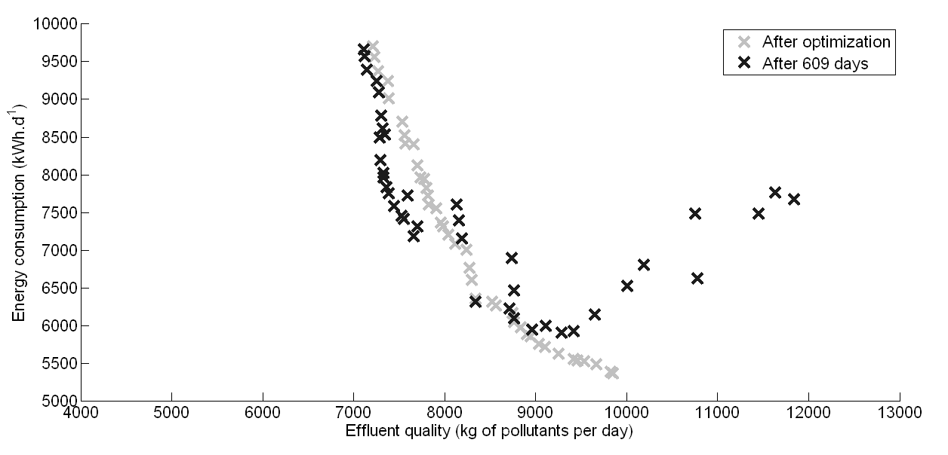
Fig. 5, Example of huge deviation of the performances for an O₂ control law
To conclude, the technique developed in this study proved to be reliable for the optimization of a complex control law, as well as the determination of its robustness. Further work will focus on the comparison of different usual control schemes. Their multi-objective optimization will help us to have a clear insight into their optimal performances. Other objectives formulations will also be studied that may lead to better understanding of these results by the decision maker. Typically, at the industrial scale, a WWTP manager does not want to discharge pollutant loads as low as possible but his objective is to have the insurance to meet the quality standards (usually in term of maximum admissible concentrations of pollutants, not loads) at all time with the lower possible energy consumption. Searching for a compromise between the risk of non-conformity and the energy consumption may be more adequate. Other types of performance indexes may therefore be necessary for the development of this computer aided technique of control law optimization and parameters setting.
  - Conclusion
Optimization is still a new approach for wastewater treatment. A bridge has to be built between users of WWTP models and users of optimization algorithms. Gains in terms of operating costs and environmental impact are expected. The use of optimization in wastewater treatment will help the practitioners of WWTPs to have more insight into the possibilities of treatment of their plants and the best ways to manage them. Traditionally, the practitioners try to reduce as much as possible the concentrations of pollutants in the effluent, which may have a huge negative environmental impact due to increased energy consumption.
In this study, the optimization of a WWTP control law by means of a multi-objectives genetic algorithm proved to be a reliable technique. To be feasible, this optimization however needs to be performed on a limited time horizon (typically two or three sludge retention times). This study showed that the addition of a long term simulation of final optimized settings allows the decision maker to check the quality of the results produced, as well as to have more insight into the performances of the control law.

Acknowledgments
The authors wish to sincerely thank Dr. Ulf Jeppsson and Dr. Christian Rosen from the University of Lund in Sweden for providing us with their MATLAB implementation of the benchmark simulation model. Their help is greatly appreciated.

References
1. Deb, K., Pratap, A., Agarwal, S., Meyarivan, T., 2002. A fast and elitist multi-objective genetic algorithm: NSGA-II. IEEE Transaction on Evolutionary Computation, 6(2), 181-197.
2. Lemoine, C., Payraudeau, M., Meinhold, J., 2006. Aeration control for simultaneous nitrification-denitrification in a biological aerated filter using internal model approach. Water Science and Technology, 54 (8), 129-136.
3. Copp, J.B. (Ed.), 2002. The COST Simulation Benchmark - Description and Simulator Manual. Office for Official Publications of the European Communities, Luxembourg.
4. Jeppsson, U., Rosen, C., Alex, J., Copp, J.B., Gernaey, K.V., Pons, M.-N., Vanrolleghem, P.A., 2006. Towards a benchmark simulation model for plant wide control strategy performance evaluation of WWTPs. Water Science and Technology, 53(1), 287-295.
5. Henze, M., Grady, C.P.L. Jr, Gujer, W., Marais, G.v.R., Matsuo, T., 1986, Activated Sludge Model No. 1. IAWPRC Scientific and Technical Report No. 1, IAWQ, London.
6. Takács, I., Patry, G.G., Nolasco, D., 1991. A dynamic model of the clarification-thickening process. Water Research, 25(10), 1263-1271.
7. Vanrolleghem, P.A., Gillot, S., 2002. Robustness and economic measures as control benchmark performance criteria. Water Science and Technology, 45(4/5), 117-126.
8. Kollat, J.B., Reed, P.M., 2006. Comparing state-of-the-art evolutionary multi-objective algorithms for long-term groundwater monitoring design. Advances in Water Resources, 29(2006), 792-807.

