Fault Diagnosis and Identification System Applied To a Non invasive Biosensor of Blood Glucose
Basualdo M^{a,b}, Zumoffen D^{a,,b}, Rigalli A^{c}
ªCIFASIS, CONICET, Universidad Nacional de Rosario UNICAM III
Bv. 27 de Febrero 210 Bis, S2000EZP Rosario, Argentina.
^{b} Universidad Tecnológica Nacional (FRR)Zeballos 1341, S2000EZP Rosario, Argentina.
^{c} Facultad de Cs. Médicas-UNR CONICET S2000EZP Rosario, Argentina.
Abstract
Several works have proposed in the past alternative control strategies for regulating the blood glucose levels inside a healthy range for patients who suffer Type I Diabetes Mellitus (T1DM). All of them considered the availability of accurate measurements of glycaemia, generally recorded from invasive methods. However, a common problem of this methodology, since the control point of view, is the variable delay depending of the type of sample extraction, that is subcutaneous (SC) or intravenous (IV). In the last decade, intensive research has been focused on developing and testing non invasive sensors of blood glucose levels. However, it has been reported some faulty or inaccurate measurements with them. Up to now, nobody has considered the use of tolerant control for this kind of systems. Hence, in this paper a fault diagnosis and identification (FDI) system based on the Discrete Wavelet Transform (DWT) is used to detect faulty behaviour from those non invasive sensors. The FDI is integrated to the Predictive functional controller (PFC), turning it as fault tolerant control which supports the decision about the correct insulin dosage. Several simulation results are presented by employing a rigorous endocrine model which can emulate the interaction among glucose-insulin-glucagon.

Keywords: diabetes faulty biosensor wavelet decomposition endocrine model tolerant PFC
  - Introduction
Diabetes Mellitus is a disease that often causes difficulties to maintain the patient without blood glucose concentrations at high and low levels. The problem is that it induces secondary complications or hypoglycaemic events respectively. Therefore, a real need exists for a glucose monitoring system that can give detailed and accurate information on glucose patterns through the overall day. A number of alternative strategies are being under development to allow pain free glucose monitoring. Non-invasive glucose monitoring is clearly the most attractive approach for patients with T1DM, allowing more frequent measurements without any pain or sensation. Such a system would also lead to a reduction in the number of undiscovered hypoglycaemic events as well as in the number of episodes and length of hyperglycaemic periods. However, the main difficulties with these techniques are the limited resolution and the insufficient precision. In this work, the results reported in [1] about the use of a biosensor based on impedance spectroscopy and their published experimental data are reproduced. The sensor used in their proofs is the size of a wristwatch and holds an open resonant circuit coupled to the skin and a circuit performing an impedance measurement. Changes in the glucose concentrations were monitored by varying the frequency in the radio band over a range, optimised to measure the impact of glucose on the impedance pattern. In most cases, the experiments presented a good correlation between changes in blood glucose and the sensor recordings. However, they detected that sudden relocation of the sensor, variations in temperature, etc. were the most common causes of erroneous measurements. Therefore, based on the good results presented in [2], in this work is proposed to develop a fault diagnosis and identification (FDI) system based on the Discrete Wavelet Transform (DWT). It represents a valuable tool applied to a faulty glycaemia measurement as a signal to decompose. The DWT can be implemented as a low-pass and high-pass multi-resolution filter of the signal. These filters are specifically designed and are function of the selected wavelet family as well as of its corresponding scaling function. Here it is used the Daubechies wavelet family. Another largely studied problem on this discipline is the use of several control strategies acting as artificial pancreas for deciding the correct insulin dosage according to the glycaemia level. Then, if the FDI is properly integrated with the Predictive functional controller (PFC), it would be turned as a fault tolerant control (FTC). In a previous work [3], the PFC was successfully tested but assuming invasive subcutaneous (SC) tissue and intravenous (IV) glycaemia measurement and SC and IV infusion of insulin. In order to demonstrate the potentiality of the methodology used here several simulation results are presented by employing the same model structure as used in [4].
  - The Interaction Model: Glucose-Insulin-Glucagon
The mathematical model used in this work is based on a compartmental one analogous to that explained at [3]. It includes a single glucose compartment representing the extra cellular fluids, three insulin compartments (liver and portal plasma insulin, plasma insulin, and insulin in the interstitial fluids), and a glucagon compartment. The considered unit processes are net hepatic glucose balance, renal excretion of glucose, and insulin-independent glucose utilization. However, some model parameters which characterize different diabetic levels were adjusted based on biological data obtained through experiments with rats [5]. This model allows simulating the dynamic effect of exogenous glucose and insulin dosage under different specific tests for healthy or diabetic patients. A second order transfer function is included in order to emulate the path between oral glucose and blood glucose. The model equations used in the simulations are:
${\overset{}{x}}_{1}(t)=\left(\text{NHGB}(x_{1},u_{\text{12}},u_{2})−F_{3}(x_{1})−F_{4}(x_{1},u_{\text{13}})−F_{5}(x_{1})+I_{x}(t)\right)\text{.}$ (1)
${\overset{}{u}}_{1p}(t)=−k_{\text{12}}\text{.}u_{1p}+k_{\text{12}}\text{.}u_{2p}+w(x_{1})$ (2)
${\overset{}{u}}_{2p}=k_{\text{12}}\text{.}u_{1p}−[k_{\text{12}}+k_{\text{02}}(x_{1})]\text{.}u_{2p}$ (3)
${\overset{}{u}}_{\text{11}}(t)=−(m_{\text{01}}+m_{\text{21}}+m_{\text{31}})\text{.}u_{\text{11}}+m_{\text{12}}\text{.}u_{\text{12}}+m_{\text{13}}\text{.}u_{\text{13}}+I_{u}(t)$ (4)
${\overset{}{u}}_{\text{12}}(t)=−(m_{\text{02}}+m_{\text{21}})\text{.}u_{\text{12}}+m_{\text{12}}\text{.}u_{\text{11}}+k_{\text{02}}(x_{1})\text{.}u_{2p}$ (5)
$\text{NHGB}=F_{1}(x_{1},u_{\text{12}},u_{2})−F_{2}(x_{1},u_{\text{12}})$ (6)
Where NHGB Net hepatic glucose balance; x₁: glucose in plasma and extracelular fluids(mmol); u_{1p}: pancreatic stored insulin (μU /kg); u_{2p}: Glucagon, (μU /kg); u₁₁: Plasma insulin, (μU/kg); u₁₂: Liver insulin, (μU /kg); u₁₃: Interstitial insulin, (μU /kg); w and F₁ to F₇ : are nonlinear monotonic functions; Ix e Iu: external glucose, (mg/kg min) and insulin (μU/kg) respectively; m_{ij}, Concentration of insulin U ml; h_{ij} y k_{ij}: constants; k₀₂ depends of x_{1.} In Fig. 1 are shown the model prediction and the real data of an adult rat belonging of a control group (left) and from the rat injected with 40 micromole of sodium fluoride (NaFl)/100 g of body weight, 15 minutes before the administration of glucose (Fig. 1 right). The NaFl produces a temporal T1DM and enables recording information about the dynamic response when 0.5g of glucose in a solution of 0,55 moles/l is given intraperitoneally to rats of 200-220g of body weight. The blood samples were obtained before and after 15, 30, 45, 60, 90, 120 y 240 minutes of the glucose administration. As can be seen the model can follow properly the real behavior of blood glucose. Obviously the experimental data obtained with rats were taken into account because of the similarity with the human behavior. Another model validation results were presented in [3].
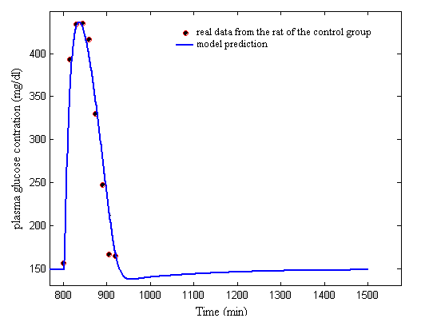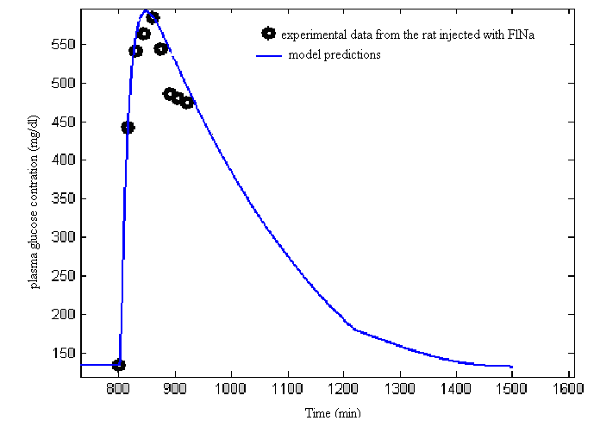
Figure 1: validation model with experimental data (left) of a healthy rat from the control group and (right) a rat injected with NaFl (temporary diabetic)
  - The Biosensor for Blood Glucose Concentration
In this section a brief description of the sensor used in [1] is included as well as the reconstruction of the experimental measurements reported in that work. The sensor uses electromagnetic waves in the selected frequency band that interacts with the skin and underlying tissue, to be able to monitor its electrical properties. The impedance of the sensor at a given resonance frequency depends on the impedance changes within the human skin and underlying tissue. It is shown that the resonance frequency and the minimum of the impedance modulus |Z| change with different blood glucose concentrations. Based on the several human experimental results presented in [1] it was concluded that the sensor presented great potentiality even though some aspects needed to be improved. For example, in some experiments a shift between the sensor signal and the real value of the blood glucose concentration was reported. Accounting this information, the reconstructed sensor signals will be displayed in section 6, including noise and the abrupt shift on the measurement of blood glucose concentration. It can be done thanks to the use of the model described before which allows performs simulations for evaluating the FDI integrated with tolerant PFC behaviour.
  - Fault Detection and Identification System based on Wavelet Decomposition
In this section the FDI based on wavelets decomposition is adopted accounting the successful application presented in [2]. According to the faulty behaviour explained in section 3 it is clear that if a FDI is available and able to detect the quick changes in the measured signal, it will be useful for accounting with accurate measurements provided by the non invasive sensor. Another important reason is the fact that only if the correct glycaemia value is available the insulin dosage will be properly administrated. It is found that the DWT is a valuable tool applied to different signals for detecting changes of high frequency. The signal can be decomposed in low and high-pass multiresolution filters. These filters are defined as functions of a selected wavelet family as well as of its corresponding scaling function (more details can be found in [6]). In the wavelet transform, the basis functions are little waves called wavelets. They are able to adjust their scale according to the nature of the signal features. The low and high-pass filtering versions are called approximation signal A and detail signal D, respectively. For the application considered here, the Daubechies wavelet family of second order was used and the decomposition scale was selected to be equal to one. In section 6 [Fig. 3 (right)] it will be presented the wavelet detail decomposition of the non invasive sensor signal.
  - Fault Tolerant Predictive Functional Control (FTPFC)
The PFC technique is the third generation of a family of Model Algorithmic Control (MAC). PFC basically consists of four main elements such as a process dynamic model; a reference trajectory y_{r} (n), a self-compensation of the predicted error and a specif structure for the manipulated variable. The trajectory y_{r} can be interpreted as the desired behaviour of the closed loop system. The future error between y_{r} and the predicted output over the coincidence horizon [H₁, H₂] is estimated. A self compensation is done accounting the actual mismatch between real data and model output. The estimation of the future error at the coincidence horizon by specific kind of extrapolation, allows to improve the model prediction. In this case the relationship between insulin infusion (manipulated variable) and blood glucose (controlled variable) is named Gmi. Meanwhile Gdi refers to the relationship between exogenous glucose and blood glucose.
In this work, the development of the control strategy includes the following steps: 1) implement the mathematical model of a patient with T1DM for doing the simulation of the faults in the blood glucose measurement, using the non invasive biosensor; 2) obtention of the internal (predictive) model by using basic identification techniques; 3) design the PFC accordingly and 4) perform the numerical experiments on closed-loop control for comparison purposes with and without the FDI integration. Calling the inputs of the manipulated variable u(n) and the perturbation d(n), the first order model response at the coincidence point (n+H) becomes
(7)
(8)
(9)
$λ=e^{−\frac{3\text{Ts}}{\text{TRBF}}}$ (10)
The parameters to be tuned for PFC are: coincidence point (H). Closed loop time response (TRBF) of the reference trajectory. The control zone is considered so TRBF is moving linearly between two extremes values recognized as TRBF _L (low) and TRBF _H (high). Transition zone [%] set the allowed zone for the controlled variable expressed as ± Delta% with respect to set point value, constraints to manipulated variable are also included by fixing maximum (Umax), minimum (Umin) and variations for it [(dU/dt)max]. In Table 1 are included the adopted parameters for the simulations shown in this work.
Table 1: Controller Parameters Setting
TRBF _L: 10 | Umax: 1x10⁻⁴ | Tmi: 4 | H: 20
TRBF _H: 250 | (dU/dt)max: 2x10⁻⁴ | Kdi: 6 | H1: 20
Delta: 10 | Kmi: -975x10³ | Tdi: 45 | H2: 1000
Umin: -1.4x10⁻⁵ | Ti: 25 | Tmd: 12 | Ts: 1

  - Results and Discussion
Several tests have been done supported by the endocrine model. However, here only few of them are shown because of the space limitation. In the Fig. 2 can be observed the blood glucose time evolution when a sensor fault occurs at t=1000 min. without FTPFC strategy. In this case the controller masks the fault and behaves quite similar as when a perturbation enters in the system producing a good rejection of it. The problem is that during 300 min. the real blood glucose moves towards to more dangerous glycaemia level. Another situation can be seen in Fig.3 (left) when the FTPFC is working. The real blood glucose is returned to its original and safety value because the measurement is compensated thanks to the FDI integration. In the Fig. 3 (right) it can be seen how the wavelet detail at level 1 can detect the moment when the sensor gives the wrong measurement. Negative deviations (peaks) correspond to positive shift in the sensor signal and vice versa.

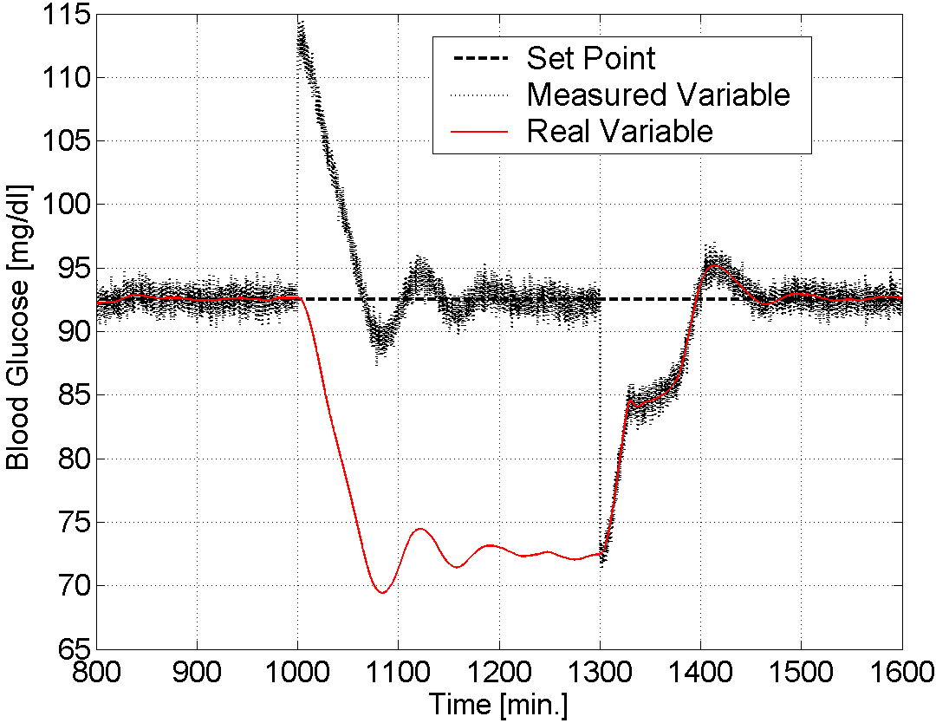
Figure 2: Sensor Fault without FTPFC
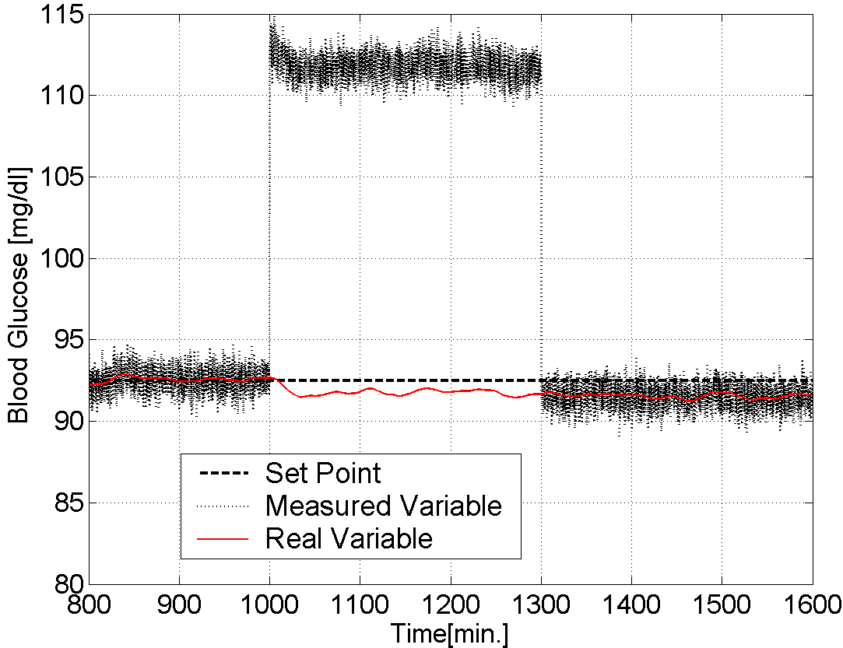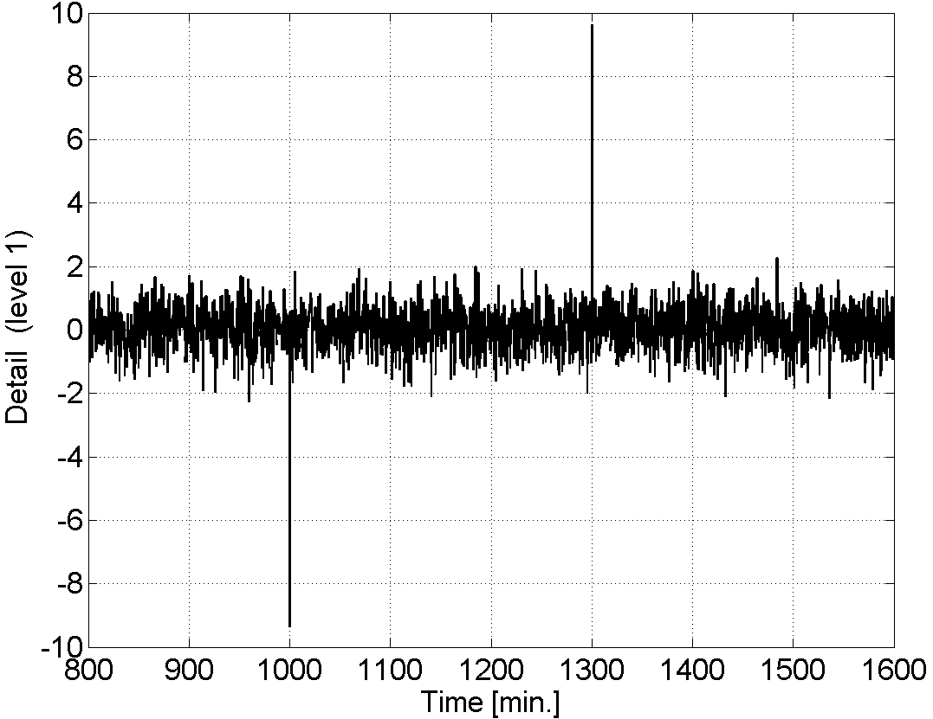
Figure 3: Sensor Fault with FTPFC (left) and Wavelet detail (right)
As can be seen, the high-frequency content of the wavelets results enough lower than that produced by the fault to be easily recognized as an abnormal event by the FDI. In addition the height of the peak is closely related with the magnitude of the shift measurement. This characteristic allows to do accurate correction of the signal to be accounted by the PFC. Therefore in the Fig. 4 (left) can be seen how the FTPFC delivers the correct insulin dosage. Meanwhile, in Fig. 4 (right) the correct fault magnitude estimation, based on the DWT support, is shown This magnitude is used for doing the additive measurement compensation.
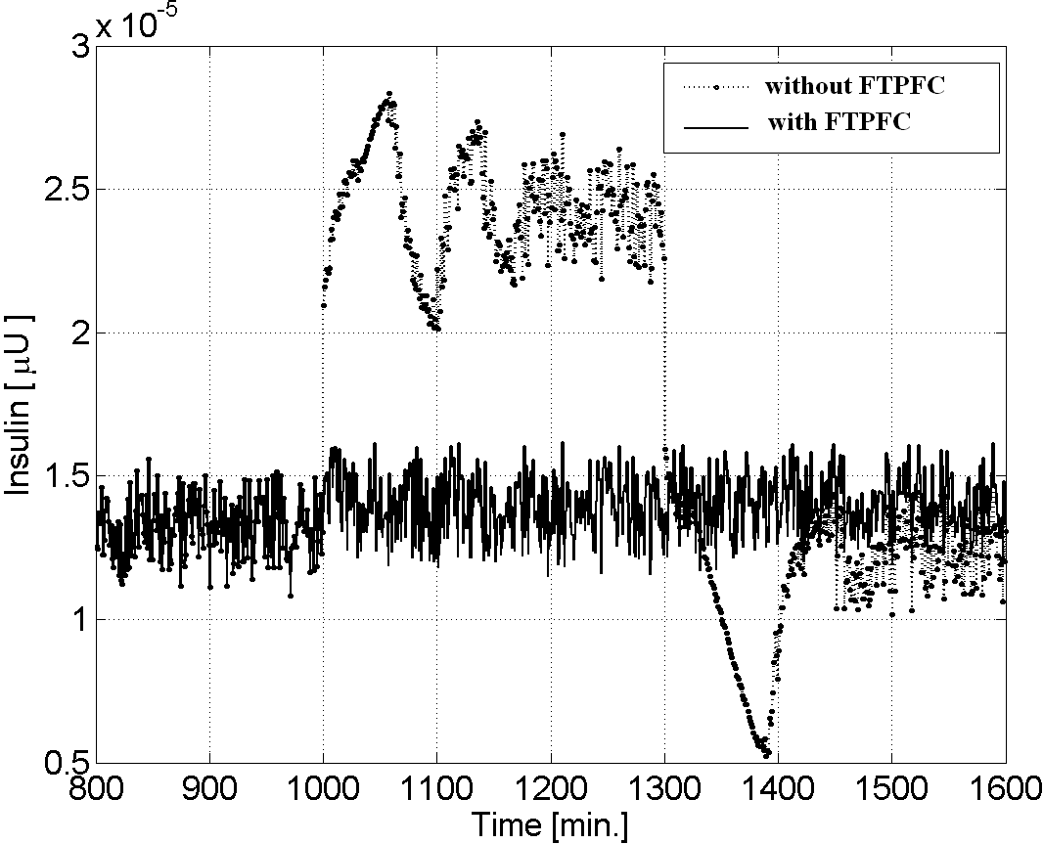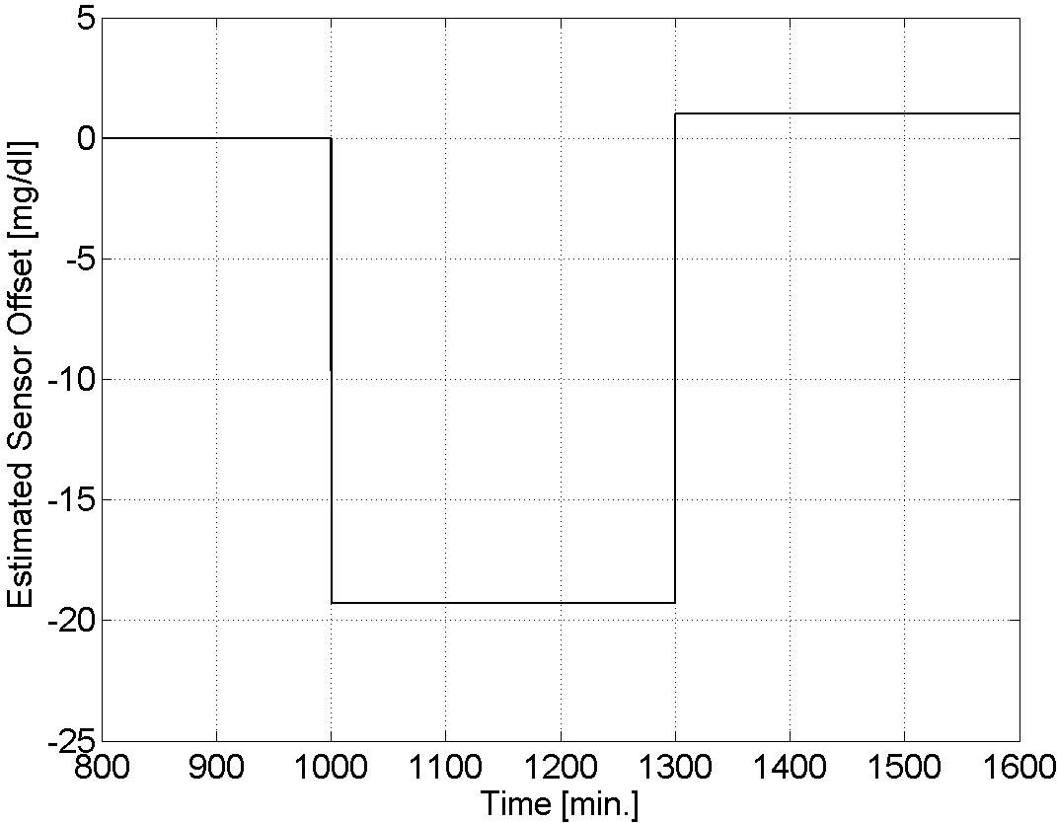
Figure 4: Insulin dosage with and without FTPFC (left), magnitude fault estimation from Wavelet detail support (right)
  - Conclusions
According to the obtained results it can be concluded that for the reported faults that could present this kind of non invasive biosensors the FDI methodology offers a good alternative of measurement correction. It is important specially for preventing those problems where the glycaemia level is out of the healthy range. In particular is crucial when the controller works as a decision support maker for proper insulin dosage determination. It is considered that this work is the first one which applies FDI system for supporting fault tolerant predictive functional control applied to the endocrine system. The tests were done thanks to the valuable help of a well validated rigorous model.

References
[1]Caduff A., E. Hirt, Yu. Feldman, Z. Ali , L. Heinemann Biosensors and Bioelectronics 19 (2003) 209.
[2] Zumoffen D., M. Basualdo, M. Jordan, A. Ceccatto. Ind. Eng. Chem. Res. 46 (2007) 7152.
[3]Díaz R. G. Aguerre S. Roldan G. and Basualdo M.. 16 ^{th} IFAC World Congress.; Praha. Check Rep. (2005). Work 4749
[4] Basualdo M., Rigalli A.,Rial A.,Barbosa RIAI- IFAC. Vol 4 (2007) 109.
[5] Menoyo I., A. Rigalli, R.C. Puche. Arzneimittelforschung. 55(8) (2005) 455.
[6] Mallat, S. G. IEEE Trans. Pattern Anal. Machine Intelligence (1989), II, 674.

  - Acknowledgements
The authors want to acknowledge the financial support from CONICET , ANPCYT, UNR and UTN.

