Application of adaptive neurofuzzy control using soft sensors to continuous distillation
Javier Fernandez de Canete, Pablo del Saz-Orozco, Salvador Gonzalez-Perez
System Engineering Dpt. , Plaza El Ejido s/n, Malaga, 29013, SPAIN

Abstract
Recent years have seen a rapidly growing number of hybrid neurofuzzy based applications in the process engineering field, covering estimation, modeling and control among others. In fact, proper operation of a distillation column requires knowledge of products compositions during the entire duration of the operation. The use of inferential composition estimators (soft sensors) has long been suggested to assist the monitoring and control of continuous distillation columns. In this paper we describe the application of an adaptive network based fuzzy inference system (ANFIS) predictor to the estimation of the product compositions in a binary methanol-water continuous distillation column from available on-line temperature measurements. This soft sensor is then applied to the composition dual control of the distillation column. Genetic algorithms are used to automatically selection of the optimum control signal based on an ANFIS model of the plant. The performance of the developed ANFIS estimator is further tested by observing the performance of the dual control system for both set point tracking and disturbance rejection cases.

Keywords: distillation control, neurofuzzy networks, soft sensors, genetic algorithms
  - Introduction

Neural and fuzzy applications have been successfully applied to the chemical engineering processes [1], and several control strategies have been reported in literature for the distillation plant modeling and control tasks [2]. Recent years have seen a rapidly growing number of neurofuzzy control applications [3]. Beside this, several software products are currently available to help with neurofuzzy problems.

Basically, a fuzzy controller is composed of a rule base containing fuzzy if-then rules. A database with membership functions of the fuzzy sets, an inference engine and two fuzzification and defuzzification interfaces to convert crisp inputs into degrees of match with linguistic values and vice versa. An ANFIS system (Adaptive Neuro Fuzzy Inference System) [4] is a kind of adaptive network in which each node performs a particular function of the incoming signals, with parameters updated according to given training data and a gradient-descent learning procedure. This hybrid architecture has been applied mostly to the control of nonlinear single input single output (SISO) nonlinear systems [5], while application to general multiple inputs multiple outputs (MIMO) control problems rely both on decoupling control to produce a set of SISO controllers or else designing a direct multivariable controller .

Proper operation of a distillation column requires knowledge of products compositions during the entire duration of the operation. Although product composition can be measured on-line, it is well known that on-line analyzers are complex pieces of equipment that are expensive and difficult to maintain. They also entail significant measurement delays, which can be detrimental from the control point of view [6]. Therefore, to circumvent these disadvantages, it is possible to estimate the product composition on-line, rather than measuring it. The use of such inferential composition estimators (or soft sensors) has long been suggested to assist the monitoring and control of continuous distillation columns [7].

Genetic algorithms (GA) are model machine learning methodologies, which derive their behaviour from a metaphor of the processes of evolution in nature and are able to overcome complex non-linear optimization tasks like non-convex problems, non-continuous objective functions, etc. [8]. They are based on an initial random population of solutions and an iterative procedure, which improves the characteristics of the population and produces solutions that are closer to the global optimum. This is achieved by applying a number of genetic operators to the population, in order to produce the next generation of solutions. GAs have been used successfully in combinations with neural and fuzzy systems. Particularly in neurofuzzy control, GAs have been utilized extensively to tune the neurofuzzy controller parameters and acquire the fuzzy rules [9].

In this paper we describe the application of an adaptive network based fuzzy inference system (ANFIS) predictor to the estimation of the product compositions in a binary methanol-water continuous distillation column from available on-line temperature measurements. This soft sensor is then applied to train an ANFIS model so that a GA performs the searching for the optimal dual control law applied to the distillation column. The performance of the developed ANFIS estimator is further tested by observing the performance of the ANFIS based control system for both set point tracking and disturbance rejection cases.
  - Process Description

The distillation column used in this study is designed to separate a binary mixture of methanol and water, which enters as a feed stream with flow rate F_{vol} and composition X_{F} between the rectifying and the stripping section, obtaining both a distillate product stream D_{vol} with composition X_{D} and a bottom product stream B_{vol} with composition X_{B}. The column consists of 40 bubble cap trays. The overhead vapor is totally condensed in a water cooled condenser (tray 41) which is open at atmospheric pressure. The process inputs that are available for control purposes are the heat input to the boiler Q and the reflux flow rate L_{vol}. Liquid heights in the column bottom and the receiver drum (tray 1) dynamics are not considered for control since flow dynamics are significantly faster than composition dynamics and pressure control is not necessary since the condenser is opened to atmospheric pressure.

The model of the distillation column used throughout the paper is developed by [10], composed by the mass, component mass and enthalpy balance equations used as basis to implement a SIMULINK model (figure 1) which describes the nonlinear column dynamics as a 2 inputs (Q , L_{vol} ) and 2 output (X_{D} , X_{B} ). Implementations details for the overall column dynamics are given in [11].

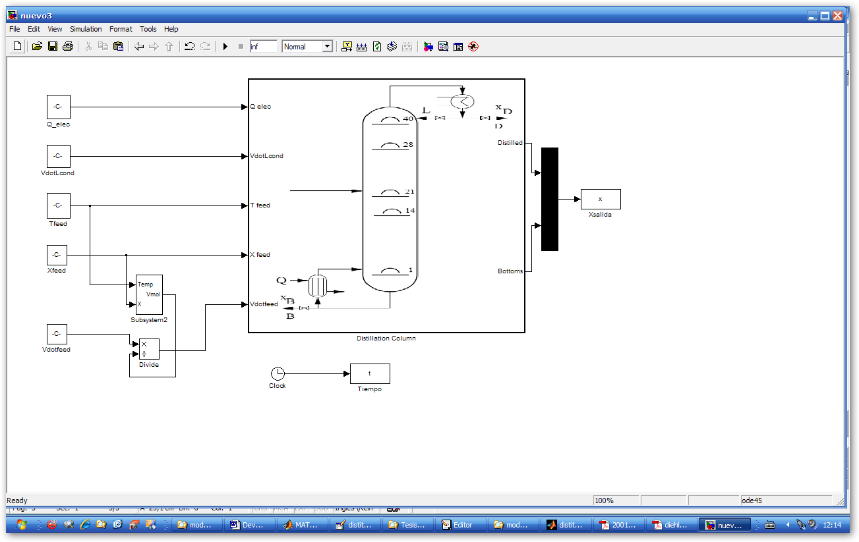
Figure 1. Schematic of the SIMULINK model of the distillation
  - ANFIS Estimator

An ANFIS system is a kind of adaptive network in which each node performs a particular function of the incoming signals, with parameters updated according to given training data and a gradient-descent learning procedure. This hybrid architecture has been applied to the modeling and control of multiple-input single-output (MISO) systems [4].
Figure 2. Architecture of the ANFIS structure

The architecture of the ANFIS is constituted by several layers (fig. 2). If we consider for simplicity two inputs x and y and two outputs f₁ and f₂ for a first-order Sugeno fuzzy model, with A_{i} and B_{j} being the linguistic label associated with x and y respectively, every node in layer 1 represents a bell-shaped membership function $μ_{A_{i}}(x)$ or $μ_{B_{i}}(y)$ with variable membership parameters. Usually we choose the bell-shaped functions. Nodes of layer 2 output the firing strength defined as the product$ω_{\text{ji}}=μ_{A_{i}}(x)×μ_{B_{i}}(y)$, where the set of nodes in this layer are grouped for each output j. A normalization process is computed in layer 3 giving the normalized $\bar{ω_{\text{ji}}}$, and the Sugeno-type consequent of each rule with variable parameters p_{i}, q_{i} and r_{i} is implemented in layer 4 yielding f_{j} as the output of the single summation node $f_{i}=\sum_{i}{{\bar{ω}}_{\text{ji}(}}p_{i}x+q_{i}y+r_{i})$ and finally the single node of layer 5 computes de overall output as a summation of all incoming signals.

The learning procedure consists of two stages. In the forward pass training input data go forward the ANFIS architecture, and in the backward pass the error rates propagate backward, being the both the consequent and the membership parameters updated by gradient descent.
  - ANFIS-GA Controller

The complete ANFIS based estimation and control system is described below (figure 3).
ANFIS
MODEL
GA
CONTROLLER
DISTILLATION COLUMN
+
-
ANFIS ESTIMATOR
TDL
TDL : Tapped Delay Line
Figure 3.Estimation and Control ANFIS based structure
    - ANFIS estimator of the composition (ANFIS ESTIMATOR block)

In order to infer the composition from temperature an ANFIS net is used. Previously, a sensitivity study is performed in order to choose the correct set of temperatures to infer top and bottom compositions (figure 4). The sensitivity index proposed is defined as the partial derivative of each available primary variable (product composition) with respect to changes in each secondary variable (tray temperature).

Figure 4.Composition-temperature dependencies.
A three temperature vector T[k] = [T₄₁[k],T₂₁[k],T₁[k]] is selected as input to the ANFIS predictor which output the predicted values of composition vector $\hat{y}[k]=[{\hat{X}}_{D}[k],{\hat{X}}_{B}[k]]$. After a trial-error process we have selected 5 membership functions per input as a compromise solution between computation time and precision. Normally, in a plant operation, both real values are measured off-line in the laboratory. In this study, the ANFIS parameter update is made accepting the simulation results as same with the actual plant data. Training set is generated by selecting 1200 temperature data points obtained by during column open loop operation with range for L_{Vol} (0-5E-06 m3/h) and heat flow Q (0-2000 J/s) for fixed feed rate conditions F_{Vol} = 1 E-06 m3/h, X_{F} = 0.3. An additional temperature data set consisting of 150 data points was used to test the ANFIS predictor afterwards. The error in the training phase is under 0.00025% and 0.0015% in the validation phase. For training pattern generation we assume an initial steady state for the column after a start-up process.

    - ANFIS modeling of the distillation column (ANFIS MODEL block)

Prior to the design of the controller, an ANFIS network has been used as an identification model of the distillation column dynamics. To obtain representative training data, varying feed flows, initial liquid composition values both in the column, boiler and condenser along with input values for the control actions were imposed on the model. The identification model has been carried out using an ANFIS network given by $\tilde{y}[k]=f(\hat{y}[k],\hat{y}[k−1],\hat{y}[k−2],u[k])$ after selecting the best structure among possible ones, with u[k] = [L_{Vol}[k],Q[k]] and $\hat{y}[k]$ regularly spaced covering the same range as defined in section 4.2. As the model’s dynamic will be modified with unknown perturbations, this ANFIS model will be updated with the real plant response.

    - Genetic Algorithm Controller (GA CONTROLLER block )

As the estimation of the composition vector $\tilde{y}[k]$ in the next simulation step according the present and previous states of $\hat{y}[k]$ and the input to the system u[k] can be achieved using the ANFIS model net, the control problem can be implemented as an optimization problem in which the function to minimize is the difference between the desired output $y_{d}[k]$ and the estimated one $\tilde{y}[k]$ in the next step. As a result, the optimum control law u[k] is elicited for the distillation control problem. This control approach enables the searching of an optimum control signal for each point in the operating range of the nonlinear distillation plant.

In order to search for the optimum for the highly non-linear function a genetic algorithm is used with 75 members fixed population, 75 generations and random mutation. If an error under 0.01% is achieved, the algorithm is stopped in order to accelerate the simulations.
  - Results

The aim in the design of the composition ANFIS estimator is to use together with ANFIS-GA for dual composition control of the distillation column. Therefore, the composition estimator is tested by using the SIMULINK model before it is used for control. The performance of the control structure is checked for set-point and disturbance rejections, as is shown in figure 5.
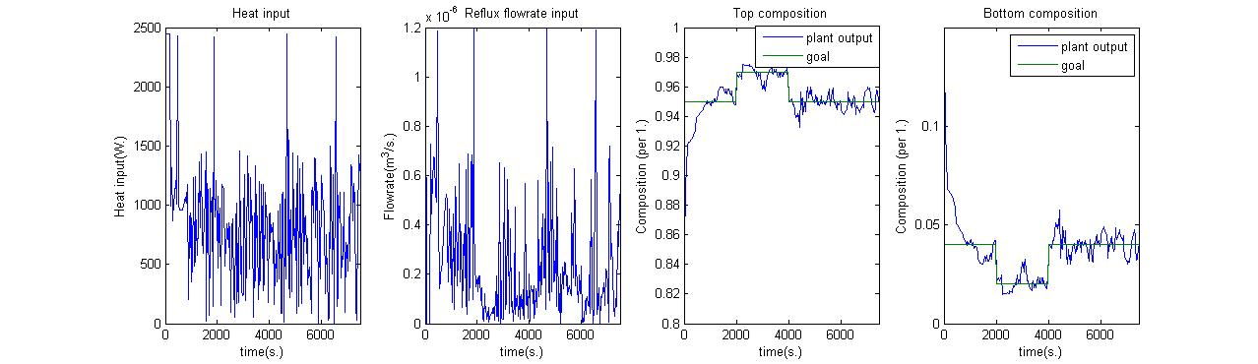
Figure 5. Performance of the ANFIS-GA for a pulse change in top (bottom) product purity from 96% to 98% (4% to 2%) in t = 2000 s and change in X_{F} from 40% to 30% in t = 4450 s.
  - Conclusions and Future Works

We have proposed a hybrid neurofuzzy design methodology to dual composition control in a MIMO binary distillation column. An ANFIS structure has been employed both for prediction of composition profiles from temperatures and design of optimum control law using a GA search technique, by using an ANFIS model based fitness function. The results obtained point to the potential use of this control strategy in areas of design related to operability and control in process engineering. Future works are directed towards the application of the proposed methodology to a real small scale pilot plant.
References

[1] A. Bulsari. Neural networks for chemical engineers. Elsevier, Amsterdam, 1995.

[2] M.A. Hussain, M. A. “Review of the applications of neural networks in chemical process control. Simulation and on-line implementations”, Artificial Int. in Eng, Vol. 13 (1999) pp. 55-68.

[3] J. Engin, J. Kuvulmaz and E. Omurlu. “Fuzzy control of an ANFIS model representing a nonlinear liquid level system”. Neural Computing and Appl., Vol. 13, n. 3 (2004) pp. 202-210.
[4] R. Jang and C. Sun. Neuro-fuzzy modeling and control. Proceedings of the IEEE 1995, Vol. 83 n. 3 (1995) pp. 378-405.
[5] M. Denai, F. Palis and A. Zeghbib. “ANFIS based modeling and control of nonlinear systems: A tutorial”, Proceedings of the IEEE Conference on SMC (2004), pp. 3433-3438.
[6] H. Leegwater. Industrial experience with double quality control. In W. L. Luyben (Ed.), Practical distillation control. New York, USA: Van Nostrand Reinhold, 1992.
[7] S. Park and C. Han. “ A non-linear soft sensor based on multivariate smoothing procedure for quality estimation in distillation columns”, Comp. and Chem. Eng. Vol. 24 (2000), pp. 871-877.
[8] Z. Michalewitz, Genetic Algorithms + Data Structures = Evolution Programs, Springer, Berlin, Germany, 1992.
[9] P. Fleming and R. Purshouse – Evolutionary algorithms in control systems engineering: a survey. Control Engineering Practice, Vol. 10 (2002) pp. 1223–1241.
[10] M. Diehl, I. Uslun and R. Findeisen.”Real-time optimization for large scale processes: Nonlinear predictive control of a high purity distillation column”, On Line Optimization of Large Scale System: State of the Art, Springer-Verlag, 2001.
[11] J. Fernandez de Canete, S. Gonzalez-Perez and P. del Saz Orozco. “A development of tools for monitoring and control of multivariable neurocontrolled systems with application to distillation columns”, Proc. EANN 2007 Int. Conf., Thesaloniki, Greece, (2007), pp. 296-305.

