Advanced Control Monitoring in Petrobras’ Refineries: Quantifying Economic Gains on a Real-Time Basis
Rafael Pinotti,ª Antonio Carlos Zanin,ª Lincoln Fernando Lautenschlager Moroª

ªPetrobras, Refining Technology, Optimization,Av. República do Chile, 65, Sala 2102, Centro, Rio de Janeiro - 20031-912 - Brazil
Abstract
In this paper we describe how Petrobras’ engineers have been using information from real-time databases in order to continuously monitor the performance of advanced control applications, including the calculation of economic gains.
The monitoring uses formulas that take into account feed flow rates, targets calculated by the optimization layer of multivariable control, controlled variables upper and lower limits and other parameters. The economic benefits are based on the degrees of freedom and the active constraints at the steady state predicted by the linear model embedded in the controller. In order to improve the current monitoring, parameters dealing with process variability will be incorporated in the formulas. By doing this, it will be also possible to quantify external disturbances that affect the performance of the advanced control systems and identify regulatory control problems.

Keywords: advanced control monitoring, industrial automation, refining industry, online optimization
  - Introduction
The Advanced Control Monitoring in Petrobras’ refineries serves a twofold objective: to evaluate the efficiency of the installed applications, and to manage the engineering staff aiming at the improvement of this efficiency, which can be translated through adequate formulas into economic gains. The fact that Solomon’s 2006 Worldwide Refining APC/ Automation Performance Analysis placed Petrobras in the second quartile, and one particular refinery in the first quartile, shows us not only that we have managed well the applications and the several systems that support them, such as DCS and data banks, but also that there is still room for improvement.
Advanced Control applications are part of the broader context of Industrial Automation, a multidisciplinary activity which has evolved for more than twenty years in our refineries, so it seems fit to start with a brief history of Industrial Automation in the Downstream area of the company. This is dealt with in section 2. Section 3 explores the details of the monitoring process and the plans to develop a more comprehensive approach by adding measures of process variability. Section 4 shows the results obtained by the management of advanced control applications, and section 5 summarizes the main conclusions.
  - Industrial Automation in Downstream

Nowadays every Brazilian oil refinery has at least one operating advanced control application. This is the result of many years of investment in hardware, software and the development of human resources. Additionally, real time optimization systems are being successfully implemented in many units.
Industrial Automation history in the Petrobras’ Downstream area can be traced back to 1986, when the company decided to replace old analog instrumentation by digital control systems (DCS), which, given the sheer size of the refining park, with 10 oil refineries, demanded a considerable investment.
A second stage was initiated in 1989, with the issue of a general plan, focusing on the rate of return of investments in industrial automation. It was acknowledged then that this return would only be fully realized through the implementation of systems aiming the real time optimization of process units.
This situation prompted a significant investment in:
- An array of technical training to the technical staff, ranging from specialization to doctoral work, in order to provide the company with high level human resources;
- Development of Multivariable Predictive Control (MPC) algorithms [1] and inferences, through a gradual absorption of technology;
- Widespread installation of automation systems, including advanced control, real time optimization, blending, etc.

A third stage has been initiated around the year 2000, focusing on the effectiveness of the installed applications. In order to guarantee such effectiveness a series of actions has been planned and executed:
- Development of a benefits evaluation methodology for each kind of optimization application [2];
- Rigorous monitoring of the actual results;
- Technical assistance to solve problems that negatively impact the applications performance;
- Continuous improvement of the technology and software;
- High level training to improve the technical skills of users and developers;
- An extensive optimization program, involving the mathematical modeling of all process units and the use of these models to define the operating targets.
  - Advanced Control Monitoring
The main benefits that can be obtained from advanced control are:
- Improvement in product quality;
- Increased yields of the most valuable products;
- Increase in unit feed flow rate;
- Energy savings;
- Improved operational stability;
- Increased unit operational factor by protecting the process from violating operational constraints.

It is usually assumed that an advanced control application will reduce the standard deviation of controlled variables by at least 50%. This allows the controller to move the controlled variables closer to the constraints, without increasing the probability of off-spec production, as illustrated in figure 1. Cutler and Perry [3] state that available benefits for on-line optimization plus advanced control can amount to 6-10% of the added value of a given process.
The basis for the monitoring methodology is the fact that the economic benefits from the advanced control are directly associated with the activation of process constraints within the operating region, that is, a good control system pushes as many as possible controlled variables to their limits, although it is not always true due to the nonlinearities involved.
Thus, each control application calculates an index, defined as:

$$\text{PCAT}=\frac{\text{Nactcontr}}{\text{Nman}}×\text{100}$$
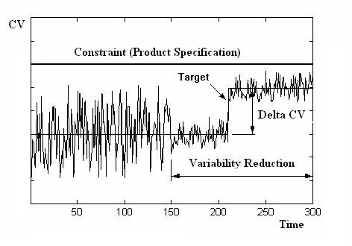
Figure 1 – Illustration of Advanced Control Benefits

Where PCAT stands for Percent of Active Controlled Variables, while Nactcontr is the number of active controlled variables and Nman is the total number of manipulated variables.
However, this formula has to be corrected with a factor PCATopt (Optimum PCAT) due to the fact that not every manipulated variable corresponds to a degree of freedom and that disturbances in the unit prevent the controller from operating continuously at constraints. So, the economic benefits from the application are calculated as follows:

$$\$\text{CAV}=\$\text{Benefit}×\frac{\text{PCAT}}{\text{PCATopt}}$$

Where $CAV is the economic benefit obtained and $Benefit is the standard benefit for the unit, drawn from literature or from process data before and after advanced control implementation. Both have units of dollars per unit feed flow rate.

The Optimum PCAT is defined as:

$$\text{PCATopt}=\frac{\text{fd}×\text{PNactcontr}}{\text{Nman}}×\text{100}$$

Where fd is a factor (smaller than 1) used to compensate for unit disturbances, and PNactcontr is the potential number of active controlled variables, which is defined according to the optimization objectives and the controller potential for effective action upon these variables.

4. Results

The Advanced Control Performance Index for each application is defined by the fraction PCAT/PCATopt [2], where PCATopt is defined case-by-case. The Performance Index for a whole refinery is calculated as a weighted average of the application indexes, with each weight corresponding to the application economic benefit. Although the Performance Index has oscillated substantially for some refineries, the general average has been fairly stable above 80%, with a slight tendency for increase.
This methodology can pinpoint applications that demand technical assistance, but a thorough performance assessment requires a more detailed analysis. More specifically, the current methodology has the following disadvantages: it offers only a macroscopic analysis of the applications; it does not give a statistical distribution of the active variables, which is of great value for the improvement of the operating systems; it does not assess the operational stability of the process.
So, a computational solution has been developed to provide valuable information on the statistical distribution of active variables, both controlled and manipulated. It consists, as shown in figure 2, of a Visual Basic tool, which gets data from the process historian and from the MPC configuration database.
The tool can generate reports in Excel format. Figure 3 shows a a general view of the controlled (CV) and manipulated (MV) variables. Figure 4 shows a VB display for the end point of gasoline, a very important product quality parameter and an advanced control controlled variable as well.
As for the operational stability of the process, Petrobras has recently developed another VB tool, which also generates excel reports. The mathematical basis for the measurement of operational stability is focused on the standard deviation of process variables related to product quality (mainly product draw temperatures from fractionators).
Petrobras joined the group of oil companies that participated in Solomon’s 2006 Worldwide Refining APC/ Automation Performance Analysis, and the final report ranked Petrobras, in the second quartile, with one particular refinery in the first quartile.
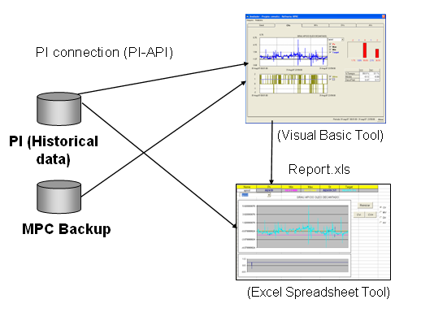
Figure 2 – Computational Tools for Advanced Control Monitoring

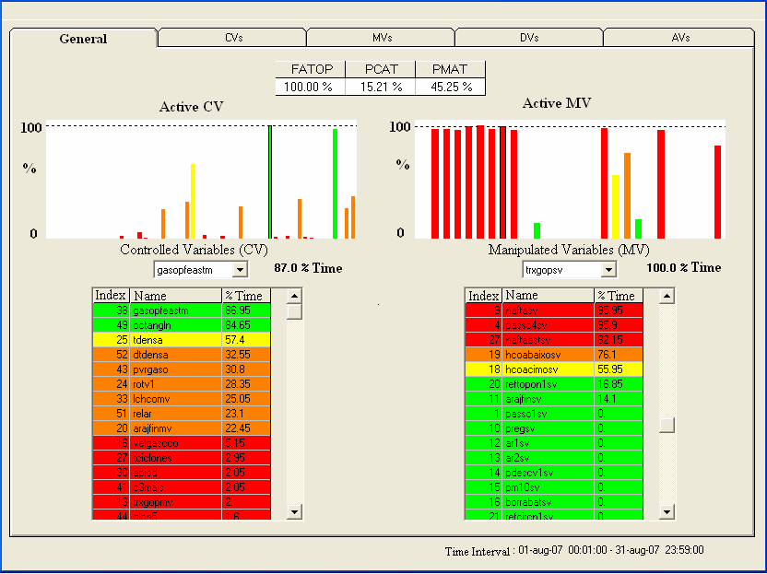

Figure 3 – VB display of a general view of the variables
  - Conclusions

The advanced control applications installed in Petrobras’ refineries are part of an Industrial Automation effort that goes back more than twenty years. The recent focus on the monitoring of these applications in order to guarantee the realization of their full economic benefit has prompted the development of a useful methodology, which shows that we are now reaping more than 80% of the potential benefits, on average. However, this methodology has a macroscopic nature.

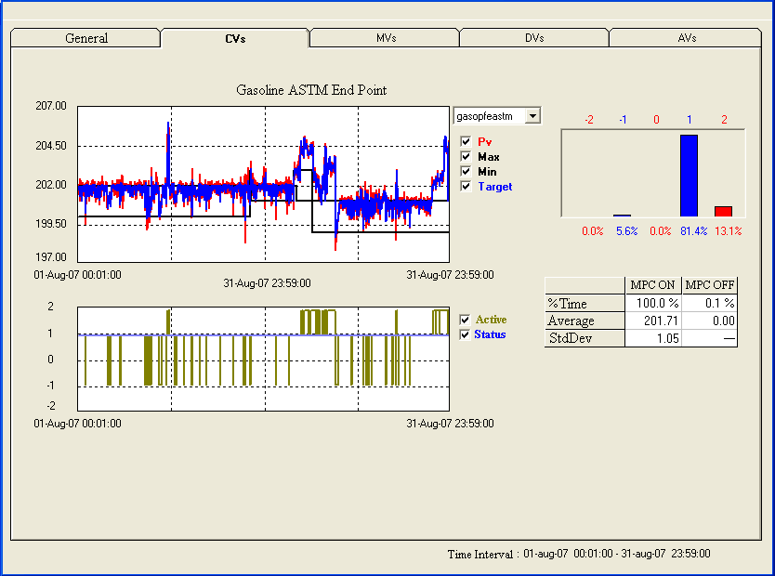

Figure 4 – VB display of the gasoline ASTM end point

New tools have been recently developed allowing a thorough analysis of each application in terms of statistical distribution of active variables and of process variability. The last Solomon APC Study has evidenced the fact that the company has a good position among the leading oil companies with respect of advanced process control and automation performance in general.
References
1. L. F. L. Moro, D. Odloak, 1995, “Constrained multivariable control of fluid catalytic cracking converters”. Journal of Process Control, v.5, n.1, p.29-39.
2. A. C. Zanin, L. F. L. Moro, 2004, “Gestão da Automação Industrial no Refino”. Rio Oil & Gas Expo and Conference.
3. C. R. Cutler, R. T. Perry, 1983, “Real time optimization with multivariable control is required to maximize profits”. Computers and Chemical Engineering, v.7, n.5, p.663-667.

