Load balancing control system of a furnace from atmospheric distillation unit
Cristian Pătrăşcioiuª, Sanda Mihalacheª
ªPetroleum Gas University of Ploiesti, 100680, Bd. Bucuresti, Romania
Abstract
The furnace from the atmospheric distillation unit represents an example of heat transfer equipment with big capacity, with two parallel passes. Because of constructive imperfections and non-uniformly heat transfer, the difference between the two passes becomes significant. This paper presents the results of research in studying, modeling and simulating the control systems for load balancing. The paper is structured in four parts. The first part presents the main issues regarding load balancing control for multiple parallel passes. The second part is dedicated to the proposed structure design of the load balancing control system for the furnace from atmospheric distillation unit. The third part contains the developing of a specific control algorithm. The fourth part contains the tests made by the authors for tuning the designed controller using the control system model and simulations and presents the implementation of the structure design of the load balancing control system for the furnace from atmospheric distillation unit.
Keywords: tubular furnaces, load balancing control, dynamic simulations.
  - Operating issues of tubular furnaces with multiple parallel passes
The process specifications on raw material speed through furnaces coils imposed the use of two or four parallel passes, e.g. the furnaces from the atmospheric distillation unit, vacuum distillation unit, catalytic reforming unit, coker unit, catalytic cracking unit. The conventional control structure of radiant section for a typical tubular furnace from the atmospheric distillation unit (output capacity 3.5 Mt/year) is presented in figure 1 [1]. Because the conventional temperature control system only controls one outlet temperature or in the best case the temperature of the mixing point, in current operations there are several situations [1, 2, 3]:
- One of the outlet temperatures is bigger than the setpoint for the associated pass. This situation leads to a growing coking and cracking phenomena on this coil. Under conditions, the vaporized fraction diminishes, affecting the light oils efficiency.
- One of the outlet temperatures is smaller than the setpoint for the associated pass, this leads to a reduction of the vaporized percent from the raw material, reducing the plant efficiency.
World-wide there were developed and implemented control structures that solve particular problems of load balancing control [4, 5, 6].
This paper presents the results of research in studying, modeling, simulating and implementing the control systems for load balancing.
  - Proposed control system structure
The structure of a load balancing control system mainly depends on the particularities of the constructive furnace [7, 8]. The literature study and also the research in the Romanian refineries over the last 15 years have led to the following stages in designing the control system:
- designing the control structure;
- generating control algorithm;
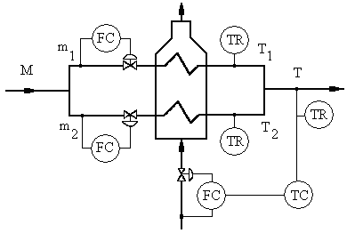
Fig. 1. The conventional control structure of a furnace from the atmospheric distillation unit.
- mathematical modeling of the control system;
- digital simulating and tuning of the controllers;
- industrial testing of the proposed control system.
In figure 2 there is presented the proposed control system structure for load balancing control for two parallel passes furnaces. The control system for load balancing in the atmospheric distillation unit furnace must accomplish the following functions:
- control the throughput of the furnace;
- load balancing of the two parallel passes.
The throughput control function is accomplished by B₁, B₂, S₁, S₂, S₃ and S₄ blocks. The throughput controller has as setpoint the total flowrate $M^{i}$. The total flowrate processed within furnace is computed with sum S₂, the error ∆M^{d} is computed in S₁ sum, and B₂ block equally divides the throughput variation for the two parallel passes. The load balancing function is achieved by S₃, S₄, S₅, S₆ and B₃ modules. The S₆ comparator computes the temperature difference from the two passes, and the B₃ block computes the setpoint for the first pass, $m_{1}^{i}$. The flowrate setpoint for the second pass is calculated by S₅ sum. The S₃ and S₄ sums are intended to form the flowrate setpoints for the two parallel passes. For each pass, the flowrate setpoint is formed by two components: one generated by the load balancing control system and the other generated by the throughput control system.
The measured process variables are: T_{1,} T₂ – passes temperatures; m₁, m₂ – volume flowrates of the two passes.
  - The control algorithm
The control algorithm consist in two parts: the first part is dedicated to temperature balancing for parallel multiple passes and the second part is for total flowrate control.
    - The load balancing control algorithm
This algorithm is based on eliminating the effect of error, defined as
$e=T_{1}−T_{2}≡ΔT$, (1)
where T₁,T₂ represent parallel passes temperatures at the output of the radiant section.
The elimination of the effect of the error is achieved with a PI control algorithm. The command u of the PI controller is the flowrate setpoint of the first pass of furnace, $u=m_{1}^{i}$, and the second flowrate setpoint is computed with relationship $m_{2}^{i}=M−m_{1}^{i}$.
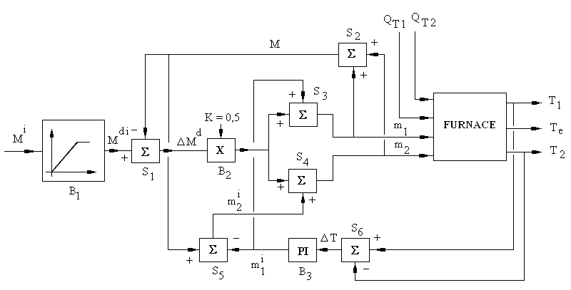
Fig. 2. The proposed control system structure.
    - The total flowrate control algorithm
The total flowrate M, processed in furnace is computed as the sum of the measured flowrates m₁ and m₂, $M=m_{1}+m_{2}$, and controlled with the two flowrate control systems on each pass. The setpoint of the total flowrate controller, $i=M^{i}$, is applied in a temporized manner such as
$M^{\text{di}}=\left\{\begin{matrix}\frac{1}{τ}\int_{0}^{t}{M^{i} \text{dt}, t<τ} \\ M^{i}, t≥τ\end{matrix}\right.$ (2)
The setpoint variation ${ΔM}^{d}=M^{\text{di}}−M$, makes the corrections of the total flowrate. This action is equally divided between the two parallel passes.
  - The control system model and simulation
The control system is composed of the process subsystem (tubular furnace) and the control equipment. The control system model is obtained from each subsystem model.
    - The process model
The process model is represented by the heat transfer and the mixing process of the two heated parallel passes (figure 3). The input variables of the process are: the thermal duties on the two parallel passes, $Q_{\text{Ti}}, i=1, 2$, and the associated volume flowrates, $m_{i}, i=1, 2$. The mathematical model of the furnace is composed of the model associated to each coil and the model of the mixing node with temperature T_{e}:
$a_{p}\frac{{\text{dT}}_{i}}{\text{dt}}+T_{i}=\frac{Q_{T_{i}}}{{\text{cm}}_{i}}, i=1,2$; [°C] (3)
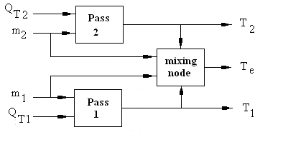
Fig. 3. The block scheme of the mathematical model of the tubular furnace.
$T_{e}=\frac{m_{1}T_{1}+m_{2}T_{2}}{m_{1}+m_{2}}$, [°C] (4)
where a_{p} is the time constant of the transfer process, c – the thermal coefficient.
    - The control equipment model
The control equipment model is composed of three temperature transducers models and two control valves models, each model defined by
$a\frac{\text{dy}}{\text{dt}}+y=\text{bx}$, (5)
where a is the specific time constant, y – the output variables, b – the gain factor, x – the input variables.
The control equipment model is completed by the pass balancing controller model and the temperature controller model.
    - The control system simulation
In order to simulate the mathematical model of the control system there is required that the model constants and the initial conditions of the control system are specified. The disturbances applied to the control system consist in de-balancing the temperatures of the two parallel passes. In this way, the thermal duty of the first parallel pass is bigger than the second pass duty so that the total thermal duty remains unchanged and the mixing node temperature as well. The settling time of control system is presented in figure 4. The control system response is damped oscillating, being characterized by the following qualitative parameters: the maximum dynamic error, ${ΔT}_{\text{max}}=\text{max}\left|T_{1}\left(t\right)−T_{2}\left(t\right)\right|$, and the oscillations damping period, $τ_{\text{amort}}$, corresponding to an error $\left|ΔT\left(t\right)\right|≤2 °C$.
    - The controller tuning
The PI controller, dedicated to the load balancing and throughput control, has two tuning parameters: the proportional gain K_{p} and integral time T_{i}. A proper functioning of the control system requires a good tuning of the software controller. According to the simulated results, the quasi-optimum tuning parameters of the controller are: $K_{p}=2\text{.}5$ and $T_{i}=1$ min. These values ensure a maximum dynamic error of 5°C and an oscillation damping period of 2.7 min.
  - Implementing the control system
The proposed control system is applied to the atmospheric distillation unit furnace. In figure 5 there is presented the proposed solution for implementing the control system.
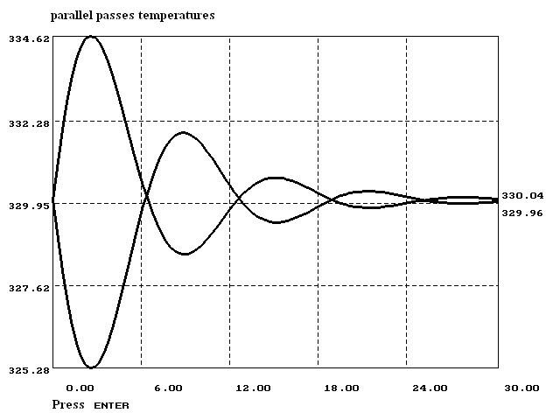
Fig. 4. The damped oscillations response to the changes of disturbances.
The authors have implemented and tested the proposed control system in a Romanian petroleum refinery. In figure 6 there is presented the capture of an industrial test. The difference between the temperatures of the two passes is over 20°C in the case of no load balancing control. At the moment when the control system is activated, this difference drops bellow 4°C, which is the resolution of the diagram from figure 6. As shown in figure 6, the test was done with the main temperature control system (of the heated product) on manual mode. Compared to some existing multivariable control packages the proposed method uses a controller design procedure that does not need high level of expertise. Completing the control structure with total outlet temperature loop, the results proved the efficiency of proposed method that can be extended to larger number of passes.
  - Conclusions
An industrial furnace with multiple parallel passes and multiple burners is commonly used in petroleum refineries to heat the preprocessed oil to a specific temperature.
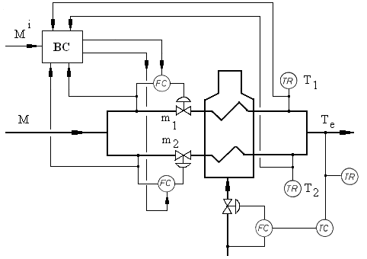
Fig. 5. The implementing the load balancing control system for the furnace from the atmospheric distillation unit: BC – the balancing controller.
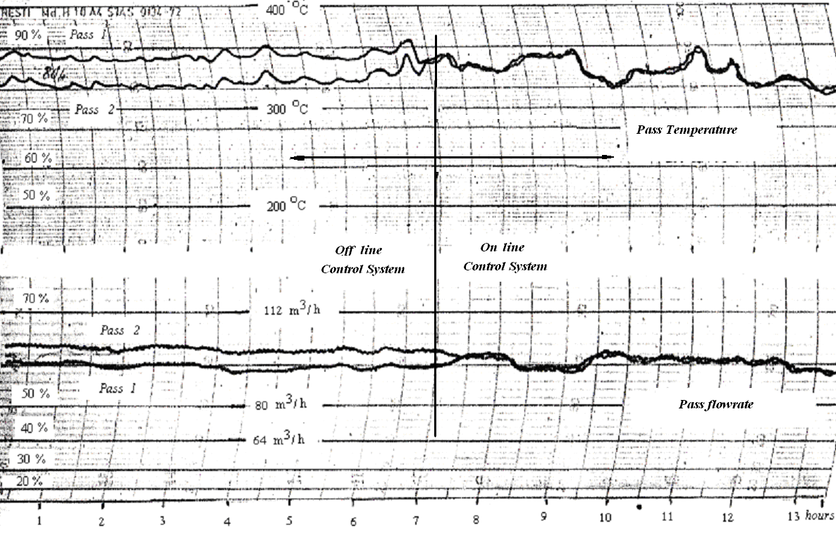
Fig. 6. The results of the industrial test.
In order to maintain the furnace running in a safe, stable, and high-efficiency state it is necessary to control the outlet temperatures of the multiple passes to be the same. Traditional control methods usually have difficulties in controlling these temperatures, and some advanced control methods are too complex for a convenient use. In this paper, a control technique is proposed to distribute the inlet flowrates so that the outlet temperatures are as identical as possible. The principle of the proposed method is firstly explained and demonstrated, then the system analysis, the controller design, and the simulation experiments are presented, and finally the results of application to an industrial refinery furnace are reported. This technique has the following advantages: it does not need complicated design procedures, the controller structure is simple, it is easy to apply and it can be extended to furnaces with different number of passes.
References
[1] C. Pătrăşcioiu, Automatic optimization of fuel combustion in tubular furnaces (in Romanian), PhD Thesis, Petroleum-Gas University of Ploiesti, Romania (1994).
[2] X. Wang, D.Z.Zheng, Load balancing control of furnace with multiple parallel passes, Control Engineering Practice, Volume 15, Issue 5 (2007).
[3] M.E. Masoumi, S.M. Sadrameli, J. Towfighi, A. Niaei. Simulation, optimization and control of a thermal cracking furnace, Energy Volume 31, Issue 4 (2006).
[4] * * * Advanced Process Control Handbook 2, Hydrocarbon Processing, March (1987).
[5] * * * Advanced Process Control Handbook 3, Hydrocarbon Processing, March (1988).
[6] * * * Advanced Process Control Handbook 4, Hydrocarbon Processing, March (1989).
[7] S. Frâncu (Mihalache), Modern control of a balancing furnace system. Proceedings of 2-nd Technical & Scientifical Session, Universities from România & Moldova, Ploieşti, Romania (1999).
[8] Del Vale El Cid J. L. Bessere Automatisierung mit neuen Systemen, Regelungstechniche Praxis, Jahrgang, (1981).

