Correlation-Based Just-In-Time Modeling for Soft-Sensor Design
Koichi Fujiwara, Manabu Kano, Shinji Hasebe
Kyoto University, Nishikyo-ku, Kyoto, 615-8510, Japan
Abstract
Soft-sensors are widely used for estimating product quality or other key variables when on-line analyzers are not available. However their estimation performance deteriorates when the process characteristics change. To cope with such changes and update the model, recursive methods such as recursive PLS and Just-In-Time (JIT) modeling have been developed. When process characteristics change abruptly, however, they do not always function well. In the present work, a new method for constructing soft-sensors based on a JIT modeling technique is proposed. In the proposed method, referred to as correlation-based JIT modeling, the samples used for local modeling are selected on the basis of the correlation among variables instead of or together with distance. The proposed method can adapt a model to changes in process characteristics and also cope with process nonlinearity. The superiority of the proposed method over the conventional methods is demonstrated through a case study of a CSTR process in which catalyst deactivation and recovery are considered as changes in process characteristics.

Keywords: soft-sensor, Just-In-Time modeling, recursive partial least squares regression, principal component analysis, estimation
  - Introduction
A soft-sensor, or a virtual sensor, is a key technology for estimating product quality or other important variables when online analyzers are not available (Kano and Nakagawa, 2008). In chemical industry, partial least squares (PLS) regression has been widely used for developing soft-sensors (Mejdell and Skogestad, 1991; Kano et al., 2000; Kamohara et al., 2004). However, their estimation performance deteriorates when process characteristics change. For example, equipment characteristics are changed by catalyst deactivation or scale adhesion. Such a situation may bring to decline product quality. Therefore, soft-sensors should be updated as the process characteristics change. To cope with such changes and update statistical models, recursive methods such as recursive PLS were developed (Qin, 1998). However, when a process is operated within a narrow range for a certain period of time, the model will adapt excessively and will not function within a sufficiently wide range of operation. On the other hand, Just-In-Time (JIT) modeling, which was proposed to cope with the changes in process characteristics and the process nonlinearity (Bontempi et al., 1999), generates a local model from past data around a query point only when an estimated value is requested. JIT modeling is useful when global modeling does not function well. However, its estimation performance is not always high because the samples used for local modeling are selected on the basis of the distance from the query point and the correlation among variables is not taken into account.
In the present work, a new method for soft-sensor design is proposed. In the proposed method, referred to as correlation-based JIT (C-JIT) modeling, the samples used for local modeling are selected on the basis of the correlation instead of or together with the distance. The C-JIT modeling can cope with abrupt changes of process characteristics that conventional method cannot. The usefulness of the proposed method is demonstrated through a case study of a CSTR process in which catalyst deactivation and recovery are investigated as the changes in process characteristics.
  - Conventional methods
In this section, conventional soft-sensor design methods are briefly explained.
    - Dynamic PLS
PLS has been widely used for building a soft-sensor because it can cope with a colinearity problem. Here $X∈ℜ^{N×M}$ and $Y∈ℜ^{N×L}$ are matrices whose ith rows are the ith measurements of inputs x_{i} and outputs y_{i}, respectively. The columns of these matrices are mean-centered and scaled appropriately. In PLS, X and Y are decomposed as follows:
$X={\text{TP}}^{T}+E$, $Y={\text{TQ}}^{T}+F$ (1)
where $T∈ℜ^{N×R}$ is the latent variable matrix, $P∈ℜ^{M×R}$ and $Q∈ℜ^{L×R}$ are the loading matrices of $X$ and $Y$, respectively. $R$denotes the number of latent variables. E and F are the error matrices. The estimation performance of soft-sensors can be improved by taking into account process dynamics. For this purpose, the past information is used as inputs in addition to the present information. This method is referred to as Dynamic PLS (Ricker, 1993; Kano et al., 2000).
    - Recursive PLS
The estimation performance of a statistical model will deteriorate when process characteristics change. Therefore, soft-sensors should be updated as process characteristics change. However, redesign of them is very laborious and it is difficult to determine when they should be updated. To cope with these problems, recursive PLS was proposed (Qin, 1998). Whenever both new input and output variables, $x_{\text{new}}$ and $y_{\text{new}}$, are measured, the recursive PLS updates the model by using
$X_{\text{new}}=\left[\begin{matrix}{βP}^{T} \\ x_{\text{new}}^{T}\end{matrix}\right] Y_{\text{new}}=\left[\begin{matrix}{βQ}^{T} \\ y_{\text{new}}^{T}\end{matrix}\right]$, $0<β≤1$ (2)
where $β$ is the forgetting factor.
    - Just-In-Time modeling
In general, a global linear model cannot function well when a process has strong nonlinearity in its operation range, and it is difficult to construct a nonlinear model that is applicable to a wide operation range since a huge amount of samples are required. Therefore, methods that divide a process operation region into small multiple regions and build a local model in each small region have been proposed. An example is a piecewise affine (PWA) model (Ferrari-Trecate et al., 2003). However, in the PWA model, the optimal division of the operation region is not always clear and the interpolation between the local models is complicated. Another method for developing local models is JIT modeling, which has the following features:
- When new input and output data are available, they are stored into a database.
- Only when estimation is required, a local model is constructed from samples located in a neighbor region around the query point and output variables are estimated.
- The constructed local model is discarded after its use for estimation.
In JIT modeling, samples for local modeling should be selected appropriately and on-line computational load becomes large.
  - Correlation based Just-In-Time modeling
Conventional JIT modeling uses a distance to define a neighbor region around the query point regardless of the correlation among variables. In the present work, a new JIT modeling method that takes account of the correlation is proposed. In the proposed C-JIT modeling method, the data set that has the correlation best fit to the query sample is selected for local modeling.
    - Evaluation of correlation similarity
Although several indices of similarity between data sets have been proposed (Kano et al., 2001; Kano et al, 2002), the Q statistic is used in C-JIT modeling. The Q statistic is derived from principal component analysis (PCA), which is a tool for data compression and information extraction (Jackson and Mudholkar, 1979).
$Q=\sum_{p=1}^{P}{(x_{p}−{\hat{x}}_{p})^{2}}$ (3)
where ${\hat{x}}_{p}$ is the prediction of the pth input variable by PCA. The Q statistic is a distance between the sample and the subspace spanned by principal components. That is, the Q statistic is a measure of dissimilarity between the sample and the modeling data from the viewpoint of the correlation among variables. In addition, to avoid extrapolation, Hotelling's $T^{2}$ statistic can be used.
$T^{2}=\sum_{r=1}^{R}{\frac{t_{r}^{2}}{σ_{t_{r}}^{2}}}$ (4)
where $σ_{t_{r}}^{2}$ denotes the variance of the rth score $t_{r}$. The $T^{2}$ statistic expresses normalized distance from the origin in the subspace spanned by principal components. To improve the model reliability, Q and $T^{2}$ can be integrated into a single index for the data set selection as proposed by Raich and Cinar (1994) for a different purpose:
$J={λT}^{2}+(1−λ)Q, 0≤λ≤1$ (5)
    - Correlation-based Just-In-Time modeling
In the proposed C-JIT modeling, samples stored in the database are divided into several data sets. Although the method of generating data sets is arbitrary, each data set is generated so that it consists of successive samples included in a certain period of time in this work, because the correlation among variables in such a data set is expected to be very similar. To build a local model, the index J in Eq. (5) is calculated for each data set, and the data set that minimizes J is selected as the modeling data set.
Figure 1 shows the difference of sample selection for local modeling between JIT modeling and C-JIT modeling. The samples consist of two groups that have different correlation. In conventional JIT modeling, samples are selected regardless of the correlation, since a neighbor region around the query point is defined by distance. On the other hand, C-JIT modeling can select samples whose correlation is similar to that of the query point by using the Q statistic.
Assume that S samples are stored in the database and $z_{i}=[x_{i}^{T},y_{i}^{T}]^{T}$. To cope with process dynamics, measurements at different sampling points can be included in$z_{i}$. The procedure of C-JIT modeling is as follows:
- Newly measured input and output measurements $z_{S+1}$ are stored in the database.
- The index J is calculated from $z_{S+1}$ and a data set $z^{\left\{S\right\}}$ that was used for building the previous local model $f^{\left\{S\right\}}$. $J_{I}=J$.
- If $J_{I}≤{\bar{J}}_{I}$, then $f^{\left\{S+1\right\}}=f^{\left\{S\right\}}$ and $Z^{\left\{S+1\right\}}=Z^{\left\{S\right\}}$. $f^{\left\{S+1\right\}}$ is used for estimation until the next input and output measurements $z_{S+2}$ are available. When $z_{S+2}$ is available, return to step 1. If $J_{I}>{\bar{J}}_{I}$, go to the next step. Here ${\bar{J}}_{I}$ is the threshold.
- $k=1$.
- The kth data set $Z_{k}=[z_{k},⋯,z_{k+W−1}]^{T}∈ℜ^{(M+L)×W}$ is extracted from the database, where $W$ is the window size.
- The index J of the kth data set, $J_{k}$, is calculated from $Z_{k}$ and$z_{S+1}$.
- $k=k+d$. If $k≤S−W+1$, then return to step 5. If $k>S−W+1$, then go to the next step. Here d is the window moving width.
- The data set $Z_{k}$ that minimizes $J_{k}$ is selected, and it is defined as $Z^{\left\{S+1\right\}}$.
- A new local model $f^{\left\{S+1\right\}}$ whose input is $X^{\left\{S+1\right\}}=[x_{K},…x_{K+W−1}]^{T}$ and output is $Y^{\left\{S+1\right\}}=[y_{K},…,y_{K+W−1}]^{T}$ is built.
- The updated model $f^{\left\{S+1\right\}}$ is used for estimation until the next input and output measurements $z_{S+2}$ are available. When $z_{S+2}$ is available, return to step 1.
Principal component regression (PCR) is used in the proposed C-JIT modeling because scores are calculated in step 6. In addition, steps 2 and 3 control the model update frequency.
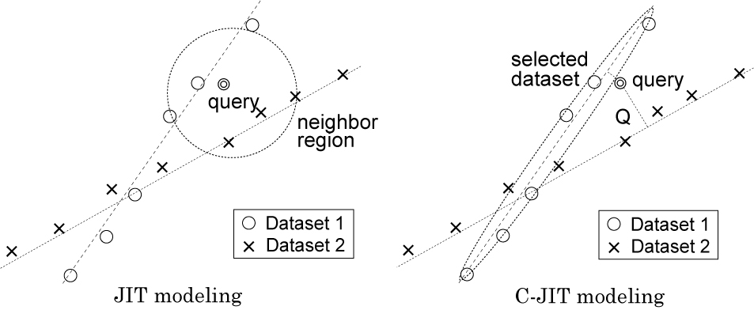
Fig. 1: Sample selection for local modeling in JIT modeling (left) and C-JIT modeling (right).
  - Case Study
In this section, the estimation performance of the proposed C-JIT modeling is compared with that of recursive PLS and conventional JIT modeling through their applications to product composition estimation for a CSTR process.
    - Problem Settings
A schematic diagram of the CSTR process is shown in Fig. 2 (Johannesmeyer and Seborg, 1999). In this process, an irreversible reaction $A→B$ takes place. The set point of reactor temperature is changed between 2K every ten days. Measurements of five variables, reactor temperature T, reactor level h, reactor exit flow rate Q, coolant flow rate Q_{C}, and reactor feed flow rate Q_{F}, are used for the analysis and their sampling interval is one minute. In addition, reactant concentration C_{A} is measured in a laboratory once a day. A soft-sensor that can estimate C_{A} accurately in real time needs to be developed. In this case study, to consider catalyst deactivation as the changes in process characteristics, the frequency factor k₀ is assumed to decrease with time. In addition, the catalyst is recovered every half year (180 days). Figure 3 shows the deterioration and recovery of the frequency factor. The operation data for the past 540 days were stored in the database. While newly measured data are stored, the soft-sensor is updated in the next 180 days.
    - Estimation by Recursive PLS and Just-In-Time modeling
Soft-sensors are constructed by using recursive PLS with the forgetting factor $β=0\text{.}\text{97}$ and JIT modeling. In recursive PLS, the model is updated every 24 hours when C_{A} is measured. To take into account process dynamics, the inputs consist of the samples at present and one minute before. The number of latent variables is four, which is determined by trial and error. On the other hand, in JIT modeling, linear local models are built by using Euclid distance as the measure of selecting samples used for local modeling. Matlab Lazy Learning Toolbox was used (http://iridia.ulb.ac.be/~lazy).
The estimation results are shown in Table 1. In this table, r denotes the correlation coefficient between measurements and estimates, and RMSE is the root mean square error. The results show that neither recursive PLS nor JIT modeling functions well. In general, recursive PLS is suitable only for slow changes in process characteristics. On the other hand, the reason for the poor performance of JIT modeling seems that JIT modeling does not take account of correlation among variables when a local model is built.
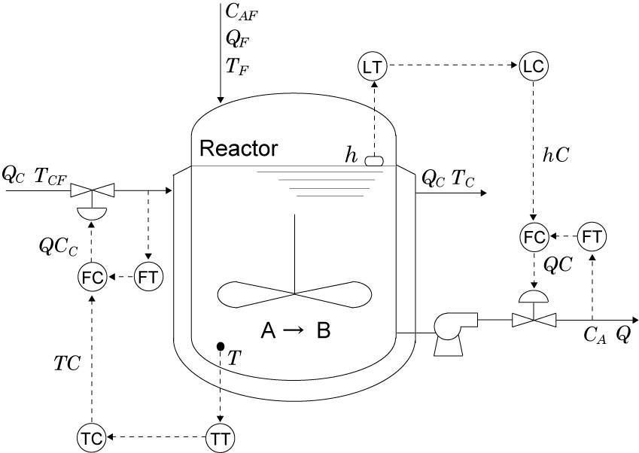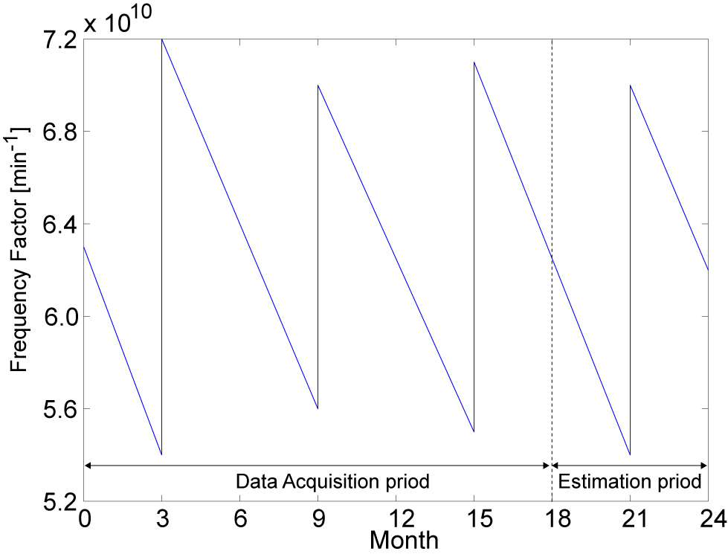
Fig2: Schematic diagram of CSTR. Fig. 3: Change of a frequency factor.
Table 1: Estimation performance of recursive PLS, JIT modeling, and C-JIT modeling
 | recursive PLS | JIT modeling | C-JIT modeling
r | 0.88 | 0.82 | 0.99
RMSE | 2.07 | 2.43 | 0.54
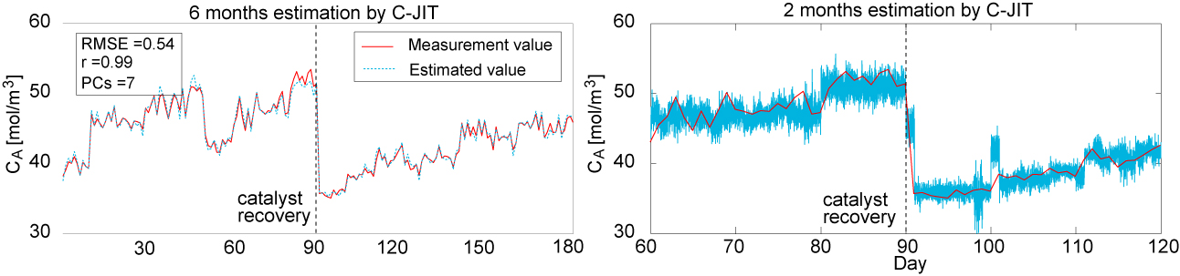
Fig. 4: Estimation result of C_{A} by C-JIT modeling with $λ=0\text{.}\text{01}$ (Window Size: 10 day).
    - Estimation by Correlation-based Just-In-Time modeling
The criterion for selecting a data set is to minimize the index J in Eq. (5) with $λ=0\text{.}\text{01}$. The local model is updated every 24 hours when C_{A} is measured, W=10, and d=1, which are determined by trial and error. The estimation results are shown in Fig. 4 and Table 1. The left figure shows the estimation result for 180 days. The right figure shows the enlarged result for two months before and after the catalyst recovery. In this figure, PCs is the number of principal components. The results show that the estimation performance of C-JIT modeling is significantly higher than that of the conventional methods. With the proposed C-JIT modeling, RMSE is improved by about 78% and 74% in comparison with recursive PLS and JIT modeling, respectively.
  - Conclusion
In the present work, to develop a soft-sensor that can cope with the changes in process characteristics, a new correlation-based JIT modeling method is proposed. The superiority of the proposed C-JIT modeling over the conventional methods is demonstrated through a case study of a CSTR process in which catalyst deactivation and recovery are investigated. In recursive PLS and conventional JIT modeling, it is difficult to adapt models when the process characteristics change abruptly. On the other hand, the C-JIT modeling can cope with the abrupt changes in process characteristics.
References
G. Bontempi, M. Birattari and H. Bersini, 1999, Lazy Learing for Local Modelling and Control Design, Int. J. Cont., Vol. 72, No. 7/8, 643
G. Ferrari-Trecate, M. Muselli, D. Liberati, and M. Morari, 2003, A Clustring Technique for the Identification of Piecewise Affine System, Automatica, Vol. 39, Issue 2, 205
J. E. Jackson, and G. S. Mudholkar, 1979, Control Procedures for Residuals Associated with Principal Component Analysis, Technometrics, Vol. 21, Issue 3, 341
M. Johannesmeyer and D. E. Sebog, 1995, Abnormal Situation Anaylsis Using Pattern Recognition Techniques and Histrical Data, AIChE Annual meeting, Dallas, Oct.31-Nov. 5
H. Kamohara, A. Takinami, M. Takeda, M. Kano, S. Hasebe and I. Hashimoto, 2004, Product Quality Estimation and Operating Condition Monitoring for Industrial Ethylene Fractionator, J. Chem. Eng. Japan, Vol.. 37, No.3, 422
M. Kano, S. Hasebe, I. Hashimoto and H. Ohno, 2002, Statistical Process Monitoring Based on Dissimilarity of Process Data, AIChE J., Vol. 48, No.6, 1231
M. Kano and Y. Nakagawa ,2008, Data-Based Process Monitoring, Process Control, and Quality Improvement: Recent Developments and Applications in Steel Industry, Comput. Chem. Engng., Vol. 32, 12
M. Kano, H. Ohno, S. Hasebe, and I. Hashimoto, 2001, A New Multivariate Statistical Process Monitoring Method Using Principal Component Analysis, Comput. Chem. Engng., Vol. 25, No.7-8, 1103
M. Kasper and W. H. Ray, 1993, Partial Least Squares Modeling as Successive Singular Value Decomposition, Comput. Chem. Engng., Vol. 17, Issue 10, 985
T. Mejdell and S. Skogestad, 1991, Estimation of Distillation Compositions from Multiple Temperature Measurements Using Partial-Least-Squares Regression, Ind. Eng. Chem. Res., Vol. 30, Issue 12, 2543
S. J. Qin, 1998, Recursive PLS Algorithms for Adaptive Data Modeling, Comput. Chem. Engng., Vol. 22, No. 4/5, 503
A. Raich and A. Cinar, 1994, Statistical Process Monitoring and Disturbance Diagnosis in Multivariable Continuous Processes, AIChE J., Vol. 42, Issue 1,995
N. L. Ricker, 1988, Use of Biased Least-Squares Estimators for Parameters in Discrete-Time Pulse Response Models, Ind. Eng. Chem. Res., Vol. 27, Issue 2, 343

