Hybrid Fault Diagnosis System For Large Chemical Plants Under Control
David Zumoffen^{a,b} and Marta Basualdo^{a,b}
ªCIFASIS-(CONICET-UNICAM III-UNR), Bv. 27 de Febrero 210 Bis, S2000EZ, Rosario, Argentina
^{b}UTN-FRRo, Zeballos 1341, S2000EZP, Rosario, Argentina.
Abstract
In this paper, a novel monitoring system, able to support fault tolerant control, is presented. It is developed by connecting different research areas such as statistical monitoring, knowledge-based and history-based systems. Several tools such as Adaptive Principal Component Analysis (APCA), Fuzzy-Logic (FL) and Artificial Neural Network (ANN) are integrated to develop a fault detection, isolation and estimation (FDIE) system for specific faulty process elements. In this work faults such as extra dead time in actuators and bias in sensors which cause saturation are analyzed. The FDIE implementation is done on a benchmark of Waste Water Treatment Plant (WWTP). This is specially chosen in order to give a complete set of simulation results for a wide range of different abnormal events. Specific performance indexes for analyzing the effectiveness of the methodology proposed here are accounted.
Keywords: Fault Diagnosis, Adaptive PCA, FL, ANN, WWTP.
  - Introduction
Malfunction in sensor and actuators are common problems in chemical plants. These abnormal events can generate degradation in the closed loop performance and could have an important impact on the safety and the productivity of the plant. Therefore is very helpful to account with a proper expert system able of handling these abnormal events for monitoring and tolerance.
A deep review about this subject is given in [1] and [2]. Different strategies exist [3,4], but only few are thought to integrate monitoring and fault tolerant control (FTC) applied in large chemical plants.
In this work a FDIE system design is proposed using a hybrid strategy, specially thought for integration to FTC . Faults such as extra dead time in actuators and bias in sensors which cause saturation are analyzed. Tools as APCA, FL and ANN are combined to give an adaptive, fast and robust on line monitoring system. The efficacy of the proposed approach is demonstrated through several simulation results. In addition, typical indexes used for the WWTP and others useful for evaluating the FDIE performance and quantitative comparison purposes are presented here .
  - Fault Detection, Isolation and Estimation Approach
In this section only the main aspects of the FDIE algorithm are discussed. For more details about the theoretical topics of each subsystem and a complete set of simulation the reader is referred to Zumoffen and Basualdo [2].
    - Monitoring and Fault Detection
This subsystem makes the monitoring and fault detection tasks based on statistical tools. In classical PCA the different plant operation conditions and modes can produce excessive number of false alarms or alternatively missed detection of the process faults. To overcome this problem a modified version of Moving PCA (MPCA) working together with combined statistics is proposed here in order to improve the accuracy and robustness of the monitoring system. Hence, the algorithm is given by:
- Initialization, $k=0$: Acquire training data which represent normal process operation X. Auto-scale the training data to zero mean and unit variance $\bar{X}$with the scaling factors b(0) and s(0). Obtain the correlation data matrix R and perform the Singular Value Decomposition (SVD) to develop the PCA model P, selecting the A principal component using the Cumulative Percent Variance (CPV) approach of about 90%. Determine the control limits $δ_{T^{2}}(0)$ and $δ_{\text{SPE}}(0)$. Set the moving window N_{w} and the normal data matrix ${\bar{X}}_{n}(0)$.
- Monitoring, k>0: Obtain next process data sample x(k).
(1) Scale x(k) using scaling factors to obtain $\bar{x}(k)$.
(2) Evaluate the T²(k) and SPE(k) statistics with the actual PCA model.
(3) Construct the combined statistic z(k) with the last control limits $δ_{T^{2}}(k−1)$ and $δ_{\text{SPE}}(k−1)$.
(4) Check if $z(k)≤δ_{z}$. If it is true update de normal data matrix ${\bar{X}}_{n}(k)$ by deleting the oldest data and concatenating the new data sample$\bar{x}(k)$.
(5) If $z(k)>δ_{z}$ a Warning alert appears. If four consecutive Warning alerts occur a Fault alert appears.
(6) If a Fault alert is given, store the process data vector x(k) in an auxiliary matrix X_{aux} during the next N_{aux} samples.
(7) If a Fault alert is given and $k≥N_{\text{aux}}$, update de scaling factors b(k) and s(k) with the auxiliary matrix X_{aux} scaling factors.
(8) Update the control limits $δ_{T^{2}}(k)$ and $δ_{\text{SPE}}(k)$, using the actual normal data matrix and the 99\% confidence level criteria.
(9) Calculate the SVD of the correlation data matrix for the normal data matrix ${\bar{X}}_{n}(k)$.
(10) Select the principal components retained A(k) using CPV approach for 90%. Update the PCA model, and
(11) Return to the monitoring step again (obtain next process data sample) with k+1.

Two additional steps in the previous algorithm can be included for taking into account modifications in the data correlation structure, given a modified version of the previous applications [2]. The combined statistic $z(k)=T^{2}(k)/{δ_{T^{2}}}(k)+\text{SPE}(k)/{δ_{\text{SPE}}}(k)$ uses both the Hotelling's and squared prediction error (SPE) statistics. The confidence limits are updated by $δ_{i}=μ_{i}+{\text{υσ}}_{i}$[4], where $μ_{i}$ and $σ_{i}$ are the mean and variance values for the statistic i computed from the normal data matrix, with i=T², SPE and $υ=2,3$ according to the 95% or 99% confidence level respectively. The principal component selection is based on $\text{CPV}(A)=\text{100}\text{\%}\sum_{j=1}^{A}{λ_{j}}\text{/trace}(R)$, where $λ_{j}$ is an eigenvalue of the correlation matrix R. In this case a search of A, such that $1≤A≤n$, is made in order to be satisfied the condition $\text{CPV}(A)≥\text{90}\text{\%}$ with the minimum A.
    - Isolation: FL System and Automatic Rule Extraction
This part of the FDIE receives the signals information given by the APCA monitoring system, such as $t(k)=P^{T}\bar{x}(k)^{T}$ and/or $Δx(k)=(I−{\text{PP}}^{T})\bar{x}(k)^{T}$, in order to classify the operational state of the process. The input to the FL system is defined as u_{FL}(k)=[u₁(k),u₂(k),… ,u_{r}(k)], where u_{i}(k) (Fig. 1, right) are the variables to analyze which are auto-scaling with respect to the normal operation behavior and r is the number of the components. Using the fault detection instant T_{d}, given by the APCA system, a zone analysis is defined as [T_{iz},T_{fz}] for each component. In the Fig. 1 is remarked as T_{f} the exact time at which a sensor fault occurs. In order to evaluate the process state using both the u_{FL}(k) and the zone analysis, the mean contribution in this zone can be computed through Eq. (1)
$u_{\text{FL}}^{m}=[u_{1}^{m},u_{2}^{m},…,u_{r}^{m}], \text{with} u_{i}^{m}=\text{mean}(u_{i}(k)), T_{\text{iz}}≤k≤T_{\text{fz}}, 1≤i≤r$ (1)
Each component $u_{i}^{m}$ can be classified by a linguistic value l_{i} (H: high, N: normal or L: low) according to its individual membership function (mf) degree (see Fig. 1, left part). Analyzing the overall r components a pattern (signature) for each abnormal event, called rules associated with each fault, is defined. For a particular fault type p the corresponding rules are defined by $R_{p}=[l_{1}^{p},l_{2}^{p},…,l_{r}^{p}]$. Thus, analyzing off-line the abnormal process behavior data base the rules of the FL system can be developed. This procedure is named the automatic rule extraction. These rules are stored in the rules matrix $R_{\text{matrix}}=[R_{1},R_{2},…,R_{p}]^{T}$, being p the amount of considered faults types and will be used for the on-line fault classification.
The FL system outputs y_{FL}=[y₁,y₂,…,y_{p}] are the possibility of the occurrence of each fault type. This possibility is a scalar value between 0 and 1 and represents the so called rule support in FL theory. Values close to zero indicates a low possibility of the corresponding rule be true. Values close to one indicate the opposite situation. Each FL output is computed by means of the defuzzification procedure, evaluating the corresponding rule support from the rules matrix, $y_{i}=\text{mean}(R_{i}(u_{i}^{m}))=\text{mean}[{\text{mf}}_{j}^{1,i}(u_{1}^{m}),{\text{mf}}_{j}^{2,i}(u_{2}^{m}),…,{\text{mf}}_{j}^{r,i}(u_{r}^{m})]$ with i=1,…,p faults types, r the components of $u_{\text{FL}}^{m}$ and ${\text{mf}}_{j}^{r,i}$ the corresponding membership function according to the linguistic values present in the rules matrix j=L,N,H. Thus the fault is isolated analyzing the y_{FL} with greater support.
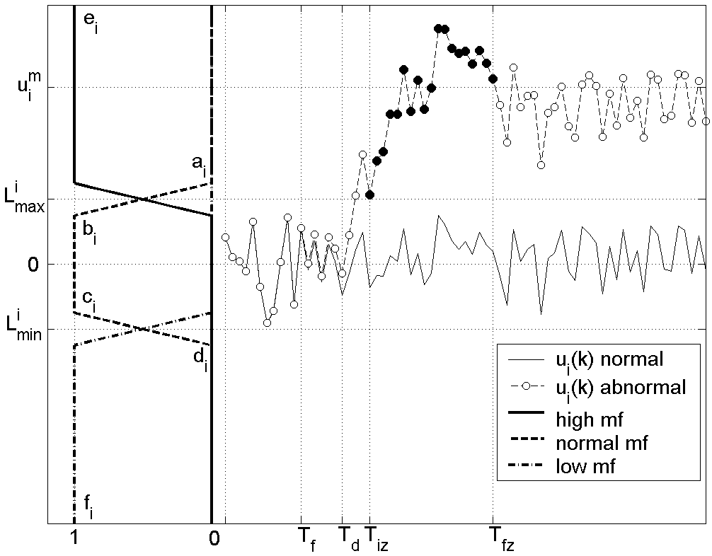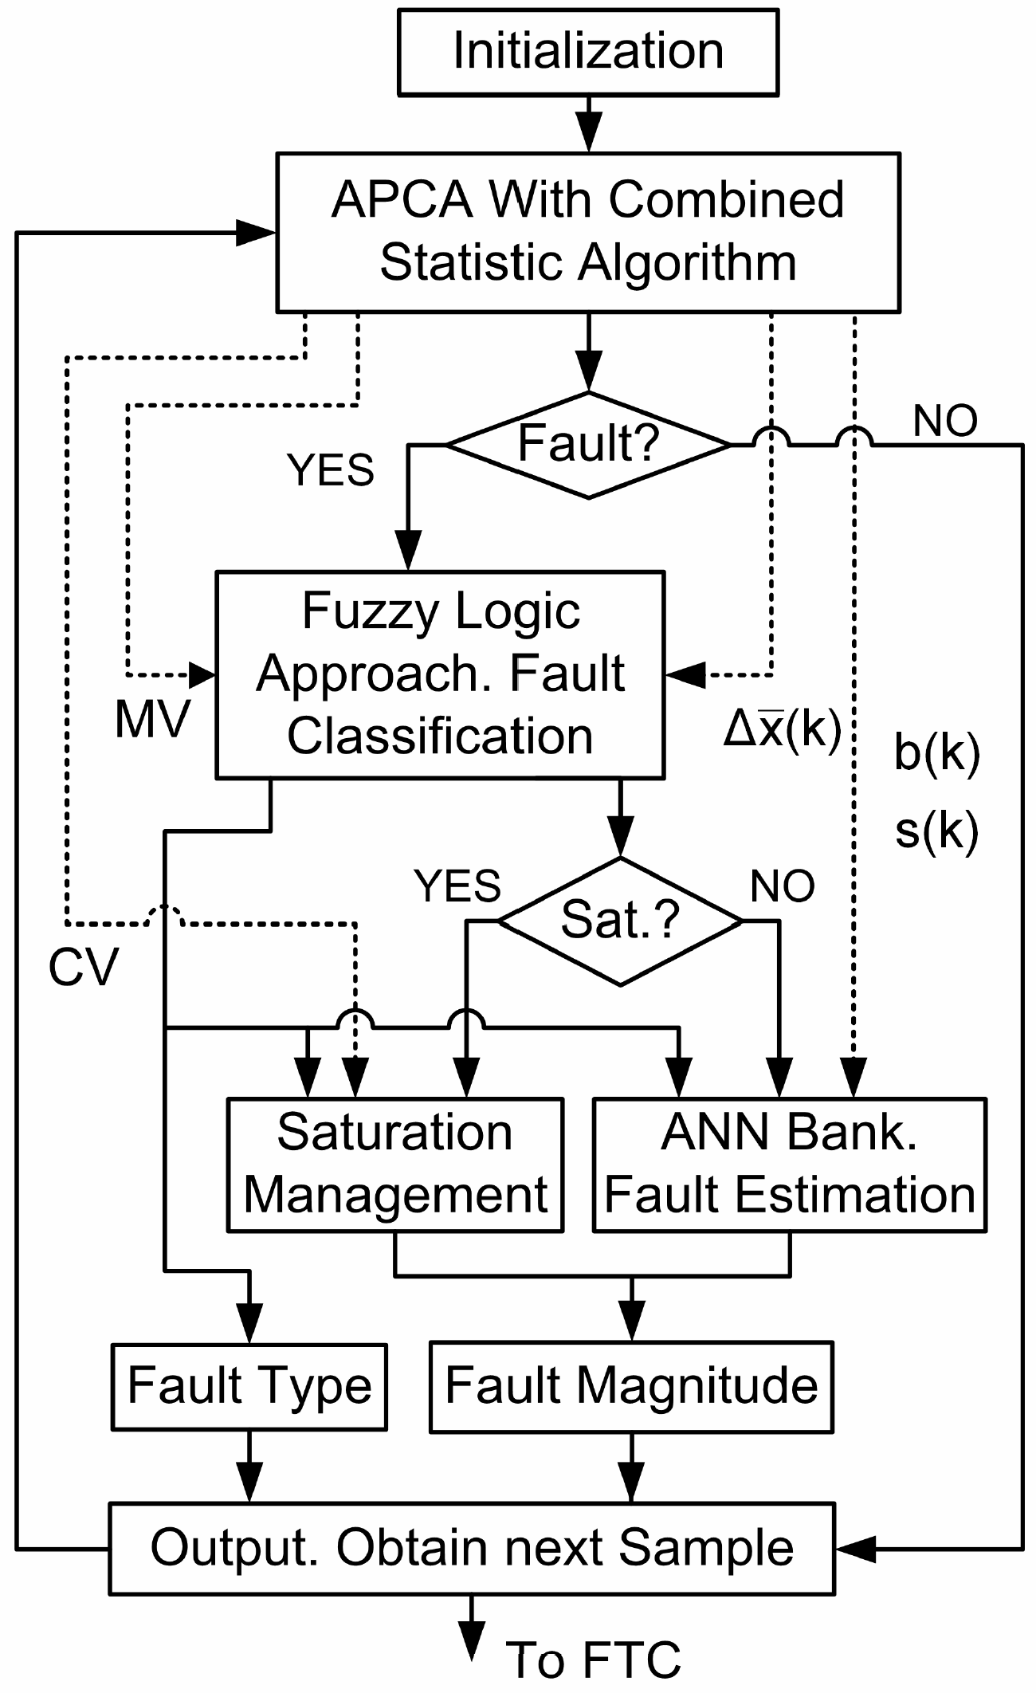
Figure 1: Fuzzy logic methodology. Figure 2: FDIE System.

    - Fault Estimation: ANN Approach
Finally, an ANN based approach is developed in order to estimate the faults magnitude using the APCA information. It provides mean and standard deviation of the process variables as soon as a fault appears. Analyzing the process from the abnormal behavior data base (when different fault types are present), the following relationships are accounted:
- Sensor Faults (Offset): can be directly related with the mean value variations of the Manipulated Variables (MV's).
- Actuator Faults (Dead time): can be directly related with an effective change in the standard deviation of the Controlled Variables (CV's).
In order to obtain information about the fault magnitude in sensors and actuators two mapping are proposed, firstly, MV's mean variations--CV's offset magnitude and CV's std variations--dead time magnitude by means of the ANN approach. For the WWTP case study, a feedforward network [5] with two layers has been used. A representative relationship input-output was obtained adjusting the network weights and biases by minimizing the squared prediction error. Several methods exist for solving the learning procedure. Some of them can be mentioned such as the gradient, Newton, Gauss-Newton, pseudo-Newton and the Levenberg-Marquardt methods [5]. Here the last one has been chosen. Thus, in this case the offset and the delay estimation, are given directly by means of the corresponding network prediction as shown in Eq. (2),
${\hat{o}}_{\text{CVj}}(k)={\text{ANN}}_{i}(b_{\text{MVp}}(k)), {\hat{d}}_{\text{MVj}}(k)={\text{ANN}}_{i}(s_{\text{CVp}}(k))$ (2)
where ${\hat{o}}_{\text{CVj}}(k)$ is the offset estimation present in the j CV, ${\hat{d}}_{\text{MVj}}(k)$ is the delay estimation present in the j MV, ANN_{i} is the neural network which does the estimation, b_{MVp}(k) is the mean variation for the p MV and s_{CVp}(k) is the standard deviation variation for the p CV. Both b_{MVp}(k) and s_{CVp}(k) are given by the APCA approach. In the case that FL system detects saturation in the MV due to sensor faults occurrence the magnitude estimation process becomes simpler in the range given by Eq. (3).
${\hat{o}}_{\text{CVj}}(k)=\left\{\begin{matrix}−\text{max}({\text{sp}}_{i}(k)−{\text{meas}}_{i}(k)), \text{if} {\text{MV}}_{j}(k)≥{\text{MV}}_{j}^{\text{max}} \\ −\text{min}({\text{sp}}_{i}(k)−{\text{meas}}_{i}(k)), \text{if} {\text{MV}}_{j}(k)≤{\text{MV}}_{j}^{\text{min}}\end{matrix}\right.$ (3)
where sp_{i}(k) is the set point policy, meas_{i} (k) is the CV measurement, MV_{i}(k) is the MV, ${\text{MV}}_{j}^{\text{max}}$ and ${\text{MV}}_{j}^{\text{min}}$are the maximum and minimum limits of the MV, with i = DO, N and j=K_{La5}, Q_{intr} respectively. In the Fig. 2 the overall FDIE scheme is presented.
  - Application Case: Waste Water Treatment Plant (WWTP)
The application case considered here is the COST benchmark presented at [6]. The activated sludge process aims to achieve, at minimum costs, a sufficiently low concentration of biodegradable matter in the effluent together with minimal sludge production. The complete process layout, the control strategy and the faulty process elements locations are represented in the Fig. 3.

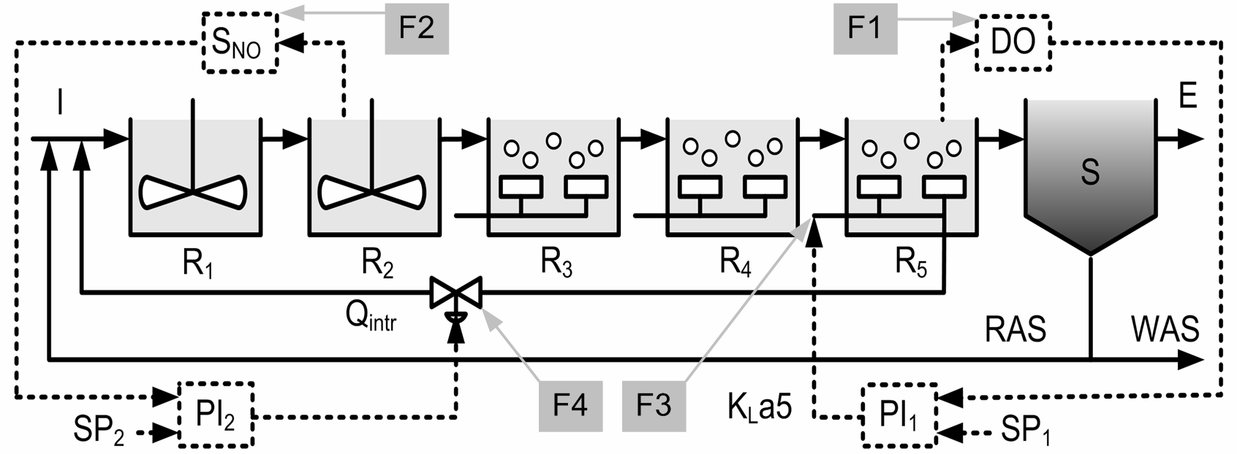
Figure 3: WWT Process
  - Simulation Results
In this section the main results obtained from the application case are shown. Considering the space limitation most of the simulations are summarized in tables using the performance indexes.
The APCA subsystem is evaluated according to its speed of detection respect to the slowest dynamic T_{sd} reported by the process. Thus the Detection Percent Time (DPT) is defined as, DPT = ((T_{d}-T_{f})/T_{sd})100%, with T_{f} as the instant when the fault occurs and T_{d} is the precise time of fault detection.
The FL subsystem is evaluated according to its classification accuracy. Thus it is defined the Rule Support Percent (RSP) index that measures the relationship between the mean support of the rules that were discarded in the classification and the correct rule support classification in percentage, ${\text{RSP}}_{j}=\text{100}\text{\%}(y_{j}−(p−1)^{−1}\sum{y_{i}})/{y_{i}}$, where y_{j} is the FL classification, $(p−1)^{−1}\sum{y_{i}}$the mean contribution in the incorrect event classification and $1≤i≤p$with $i≠j$. If RSP_{j}>0 indicates good fault classification properties, so the true fault can not be confused by another one. On the other hand RSP_{j}≈0 indicates a high probability of wrong classification procedure. Finally, RSP_{j}<0 clearly indicates totally wrong classification.
The automatic rule extraction for the WWTP can be observed in the Table 1. The process variables of the individual state depending of the fault (F) are represented by means of the linguistic code. In addition, sat_{min} means saturation to lowest limit and sat_{max} means saturation to upper limit. The faults patterns are configured by the contribution to SPE statistic and the manipulated variables K_{La5} and Q_{intr}.
Table 1: Automatic Rules Extraction For Each Fault Pattern
Fault Type | K_{L}a5 | Q_{intr} | ∆x₁ | ∆x₂ | ∆x₃ | ∆x₄ | ∆x₅ | ∆x₆
Under Control
F₁ | N | N | L | H | L | L | N | N
F₁ | N | H | L | H | L | L | N | H
F₂ | N | H | L | H | L | H | L | H
F₃ | sat_{max} | N | H | L | H | H | L | N
F₄ | N | sat_{min} | N | N | N | N | N | N
Lose of Control
F₁ | sat_{min} | sat_{max} | L | H | L | L | H | L
F₁ | sat_{max} | N | H | L | H | H | L | H
F₂ | N | sat_{max} | L | H | H | H | L | H
F₂ | N | sat_{min} | L | L | L | L | H | L

The ANN subsystem is evaluated according to its prediction capacities. Thus the mean squared prediction error index, between the real magnitude and the ANN estimation, is computed. Both offset and delay estimation are evaluated by this way.
In the Fig. 4 the combined statistic time evolution when a Dissolved Oxygen (DO) level sensor fault occurs (F₁) at T_{f} is presented. At T_{r} the correct PCA adaptation allows the detection in case of any new sequential fault appears. In the Fig. 5 can be observed the correct offset estimation (1.02) and the corresponding rule support (1) given by the FDIE system.

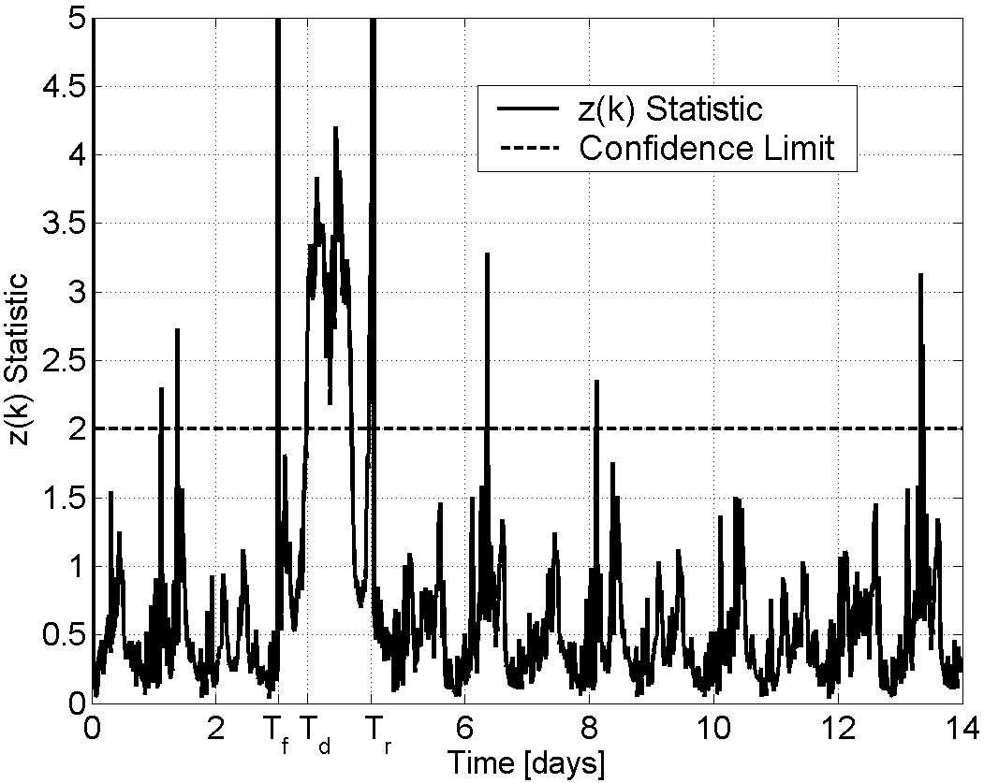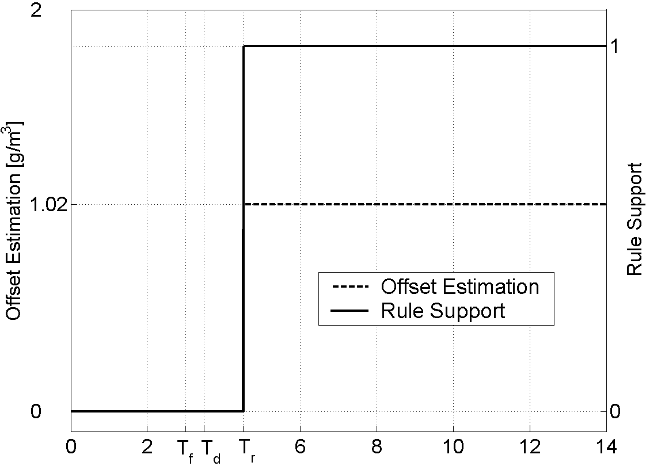
Figure 4: z(k) statistic for fault F₁ Figure 5: FDIE Outputs for fault F₁

In the Fig. 6 and Fig. 7 the combined statistic time evolution and the FDIE outputs when a K_{La5} actuator fault ( F₃, extra delay of 0.6 min.) occurs at T_{f}. Other faults considered are summarized in the Table 2 together with their corresponding performance indexes.

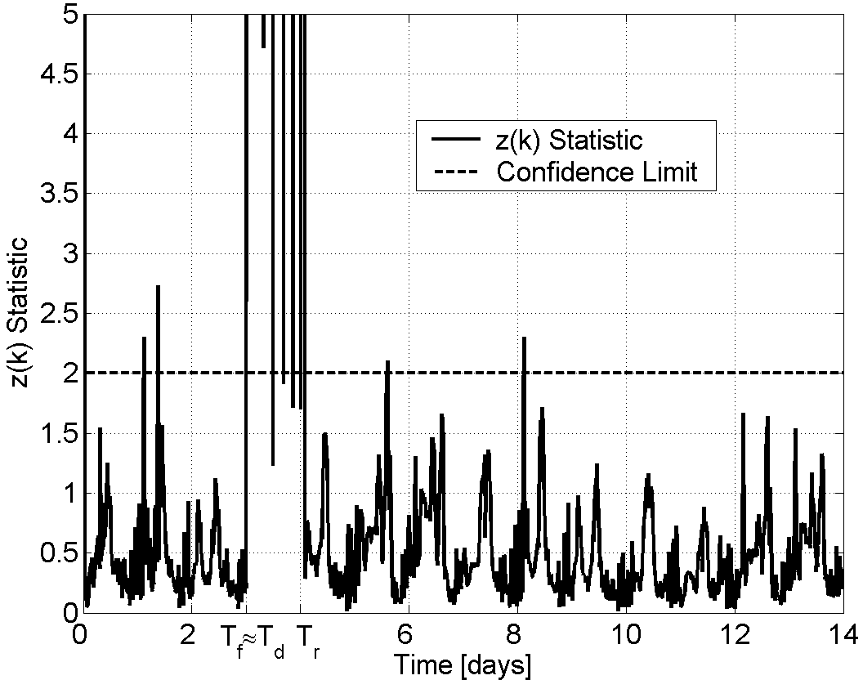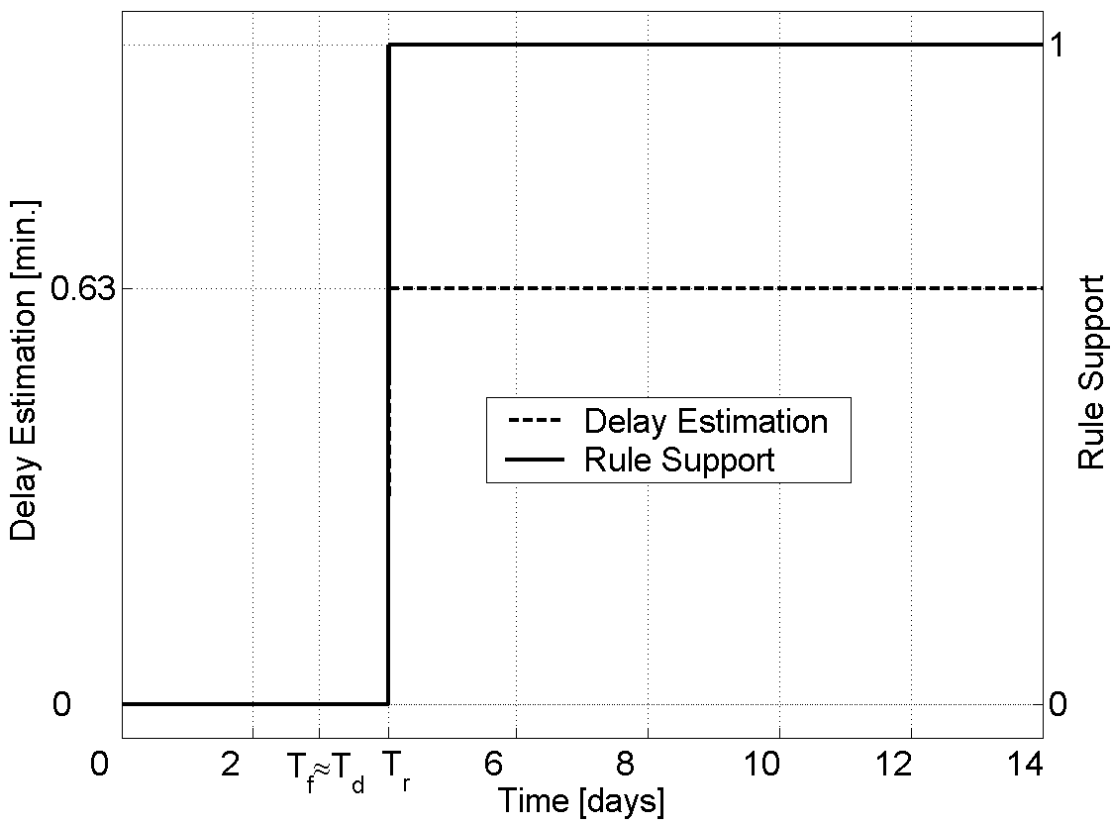

Figure 6: z(k) statistic for fault F₃ Figure 7: FDIE Outputs for fault F₃

According to the indexes given in Table 2 the DPT is close to zero in the most cases indicating a quick fault detection. The higher value for F₁ (1[g/m³]) is explained because of the bias magnitude which is more difficult to detect since it does not produce valve saturation. None of the RSP_{j} index is less than 56,25 which indicates a good robustness characteristics for classification aspects. This fact is based on the good values for y_{j} (close to 1). The MSPE_{j} values demonstrated to be enough for doing very accurate fault magnitude estimations which are crucial for applying an efficient fault tolerant strategy.

Table 2: Performance Indexes For WWTP
Events  code | Process  Element | Tf [d.] | Td [d.] | DPT [%] | Y_{j} | RSP_{j} [%] | MSPE_{j}
F1(1[g/m³]) F1(4[g/m³])  F2(-1[gN/m³]) F2(4[gN/m³]) F3(0.6[min.]) F4(20[min.]) | DO level sensor  DO level sensor  N level sensor  N level sensor K_{La5} actuator  Q_{intr} actuator | 3,00  3,00  3,00  3,00  3,00  3,00 | 3,48  3,02  3,02  3,02  3,03  3,09 | 31,94  1,38  1,38  1,38  2,08  6,25 | 1,00  1,00  1,00  1,00  1,00  0,87 | 62,50  70,32  56,25  65,62  79,68  78,57 | 8, 64 × 10⁻⁴  4, 00 × 10⁻⁸  5, 63 × 10⁻⁵  2, 46 × 10⁻² 9, 36 × 10⁻⁴  3, 10 × 10⁻³
  - Conclusion
In this work a new FDIE system for addressing the possible faults occurrence in the process elements is presented. It belongs to a series where the FDIE has been successfully tested for large chemical plants and under different kind of faults in sensors and actuators. In particular the WWTP presents the MV saturations for important bias magnitude in sensors, and the delays in actuators that could produce serious instability problems. This last fault was considered based on the assumption that a real chemical process involves significant time delays which often occur due to transportation lag such as in flow through pipes, dead times associated with measurement sensors (measurement delays) and control actuators (manipulated input delays) as the most common reasons.
The FDIE system developed based on history data such as APCA, FL and ANN for doing the fault detection, classification and estimation respectively, demonstrated to be able for dealing with a wide range of abnormal events. Additionally, because of its design objectives, is very helpful for fault tolerant control (FTC) integration [2]. The overall system shows a good temporal resolution, robustness in classification and accuracy on fault magnitude estimations. These aspects are very helpful for giving important improvements in fault tolerance characteristics through a well designed control structure of the plant. The performance indexes shown in this paper clearly quantify the advantage produced by the methodology explained here.
  - Acknowledgements
The authors want to acknowledge the financial support from CONICET (Consejo Nacional de Investigaciones Científicas y Técnicas), ANPCYT (Agencia Nacional de Promoción Científica y Técnica) from Argentina. To Dr. Ulf Jeppsson, Associate Prof. from Technology Institute of Lund- Sweden who developed and gave us the rigorous model of (WWTP) using Matlab/Simulink. Finally, to UTN-FRRo.
References
[1] D. Zumoffen, M. Basualdo, M. Jordán, A. Ceccatto. Ind. Eng. Chem. Res. 46 (2007), 7152–7163.
[2] Zumoffen, D.; Basualdo, M.. Ind. Eng. Chem. Res.. Web Release Date: 03-Jan-(2008); DOI:10.1021/ie071064m.
[3] G. Lee, T. Tosukhowong, J.H. Lee, C. Han. Ind. Eng. Chem. Res. 45 (2006), 9061–9074.
[4] Musulin, E; Yélamos, I; Puigjaner, L.. Ind. Eng. Chem. Res, 45, (2006)1739-1750.
[5] M Nørgaard, O. Ravn, N.K. Poulsen, L.K. Hansen. Neural Networks For Modelling And Control Of Dynamic Systems: a practitioners handbook. Springer-Verlag London, 2nd edition. (2001).
[6] J. Copp. The COST Simulation Benchmark - Description and Simulator Manual. COST (European Coop. in the field of Scientific and Technical Research), Brussels, Belgium. (2001).

