New Method for Sensor Network Design and Upgrade for Optimal Process Monitoring
Miguel J. Bagajewicz, DuyQuang Nguyen and Sanjay Kumar Sugumar
School of Chemical, Biological and Materials Engineering, University of Oklahoma, Norman, OK 73069

Abstract
Previous methods on nonlinear sensor network design minimize cost subject to a variety of constraints linked to the network performance: precision, residual precision, error detectability and resilience. In recent work, the use of accuracy as an attribute of a network that can replace precision, error detectability and resilience more effectively has been considered. In this paper, we propose a sensor network design methodology based on accuracy thresholds.

Keywords: Software Accuracy, Sensor Networks, Instrumentation Network Design.
  - Introduction
In contrast with the use of objective functions such as observability or reliability that had been used, Bagajewicz (1997, 2000) formulated a mixed integer nonlinear programming to obtain sensor networks satisfying the constraints of residual precision, resilience, error detectability at minimal cost. A tree enumeration was proposed where at each node the optimization problem of the different characteristics are solved.

To reduce the computational time Gala and Bagajewicz (2006a), proposed the tree enumeration approach based on branch and bounding, using cutsets. To make the computation more effective, especially for large scale problems, Bagajewicz and Gala (2000b), proposed a decomposition procedure where the process flow diagrams are decomposed to reduce the number of cutsets used for the enumeration.

Non linear networks have been discussed by Nguyen and Bagajewicz (2007), where they resort to an equation based approach using bipartite graph as opposed to regular directed graphs and show that the concept of cutsets needs further modification. They explore the use of variable enumeration in an inverted order that is removing sensors from a fully instrumented network, as opposed to adding sensors to a sensor-empty network. This strategy proved efficient for networks with stringent requirements of precision, error detectability and resilience.

All the above work focused on minimizing network cost using precision, residual precision, error detectability and resilience constraints. In this work we also minimize network cost, but we use software accuracy (as defined by Bagajewicz, 2005), which replaces all the above network attributes, as a constraint. We first review accuracy and we then discuss issues of the methodology involved to calculate accuracy at each node. We finish with an example.
  - Software Accuracy

Accuracy has been conventionally defined as the sum of absolute value of the systematic error and the standard deviation of the meter (Miller, 1996). Since in the absence of hardware or software redundancy the systematic errors cannot be detected, this conventional definition is not practical. Bagajewicz, (2005) defined accuracy with respect to the gross error detection scheme used to identify gross errors, thus differentiating software accuracy from hardware accuracy.

Specifically, Bagajewicz (2005) considered that the presence of gross systematic errors induces biases in all streams through the use of data reconciliation. These induced biases are given by
(1)

where,, matrix A is the incidence matrix and matrix S is the variance-covariance matrix of measurements. The case considered is the linear case. He then defines accuracy as the sum of precision and the maximum undetected aforementioned induced bias.
(2)

where and are the accuracy, the maximum undetected induced bias and the precision (square root of variance ,) of the estimator, respectively. Next, he proposed to calculate the maximum undetected induced bias under the assumption that the maximum power test would be used in a serial elimination procedure. Thus, the maximum induced bias that will be undetected is given by (Bagajewicz, 2005):

(3)

In the presence of n_{T} gross errors in positions given by a set T, the corresponding induced bias in variable i is

(4)

where is the vector containing a critical value of the gross error size in the selected positions corresponding to the set T at the confidence level p. In order to find the maximum possible undetected induced bias, one has to explore all possible values of gross errors in the set. Thus for each set ‘T,’ he proposed to define a binary vector ‘q_{T}’ to indicate the location of gross errors and obtain the maximum induced and undetected bias by solving the following problem:
(5)
The absolute value constraint can be replaced by two inequalities, one for the negative sign and one for the positive one. The problem becomes a linear one. Thus for n_{T}=2, the feasible region has a form of a rhombus, as in Figure 1. The rhombus is composed of positive and negative constraints of the problem that arise from the absolute value. We recognize that the solution lies in one of the four corners, which depends on how the two gross errors in question contribute to the induced bias

Both θ₁ & θ₂
are detected
θ₁

δ₂
δ₁
Only θ₁ is detected
Only θ₁
is detected
Only θ₂
is detected
- δ₂
- δ₁
No gross error
is detected
θ₂
Both θ₁ & θ₂
are detected
Both θ₁ & θ₂
are detected
Both θ₁ & θ₂
are detected
Only θ₂
is detected
Figure 1. Different regions when two gross errors are present in the system (From Nguyen et al, 2006)

Worth noticing, in some cases the above set of equations can be linearly dependant. This happens when the set of gross errors proposed in an equivalent set (Jiang and Bagajewicz, 1998). We illustrate this for the system of Figure 2.
S₁
S₂
S₃
Figure 2. Equivalency of gross errors

Assume that one wants to compute the induced bias in stream S₁ by considering two biases in S₂ and S₃. This leads to two parallel lines, as it is illustrated in Figure 3.
θ₂
θ₁
Undetected region
Figure 3. Graphical consequence of biases equivalency
It can be inferred from figure 2 and clearly shown in figure 3 that if the bias in stream S₂ and bias in stream S₃ are equal but in opposite side (such that the balance S₁ = S₂ + S₃ is still valid), then those biases cannot be detected no matter how big they are.

  - Calculation of Software Accuracy at each node of the search tree

In this work, we use the tree enumeration method using list of fundamental units, which can be variables (Bagajewicz, 1997) or cutsets (Gala and Bagajewicz, 2006a, b) or equations (Nguyen and Bagajewicz, 2007). At each node, software accuracy needs to be evaluated based on two inputs:

- The positions of the sensors (given by a binary vector q). We assume there are n sensors.
- The maximum number of gross errors (n_{T}) the user is willing to consider in the definition of accuracy.

Thus, if n_{T} >n, the maximum number of gross errors is assumed to be n, that is n_{T}=n. When n=n_{T} , only one system of equations needs to be solved, and if n_{T}<n, all combination of n_{T} biases in the n sensors need to be evaluated. Thus, all the corresponding equations of the LP need to be included.

  - Example
We consider the process illustrated in Bagajewicz, (2005) (Figure 4) that has 7 streams and 4 nodes.
F₁
F₃
F₇
F₅
F₆
F₄
F₂

Figure 4. Flowsheet for example

We assume we need accuracy of 3% in stream 1 and 2% in stream 2 allowing only one gross error (n_{T}=1). The sensor precisions, flowrates and sensor costs are given table 1.

Table1. Precision, Flow rates, Sensor Cost of Example 1
Stream | Sensor Precision (σ_{i}) | Flow  Rates (F_{i}) | Sensor Cost
S1 | 1 | 100 | 20
S2 | 0.447 | 140 | 25
S3 | 1 | 140 | 20
S4 | 1 | 20 | 15
S5 | 1 | 120 | 20
S6 | 1 | 20 | 10
S7 | 1 | 100 | 30

The above problem was solved by using the tree enumeration algorithm to find the accuracy values at each node and compare with the desired accuracy. It is found that the optimal solution is obtained only when all the streams but S7 and S2 are measured. The network cost is 85.

It is also of interest to study the way accuracy changes as sensors are added. This is shown in Table 2 and Figure 5. This would correspond to the first branch of the enumeration tree (no branching criteria used).

Table 2. Accuracy and Cost as a function of the number of sensors
Streams measured | Accuracy (a_{i}) % | Cost of the network
1 | S1= 1223.69  S2= 979.46 | 20
1,2 | S1= 531.09  S2= 385.93 | 45
1, 2, 3 | S1= 531.09  S2= 1.56 | 65
1, 2, 3, 4 | S1= 385.38  S2= 1.57 | 80
1, 2, 3, 4, 5 | S1= 385.39  S2= 1.28 | 100
1, 2, 3, 4, 5, 6 | S1= 2.67  S2= 1.24 | 110
1, 2, 3, 4, 5, 6, 7 | S1= 1.55  S2= 1.23 | 140
Optimal Solution  1, 3, 4, 5, 6 | S1= 2.79  S2= 1.99 | 85

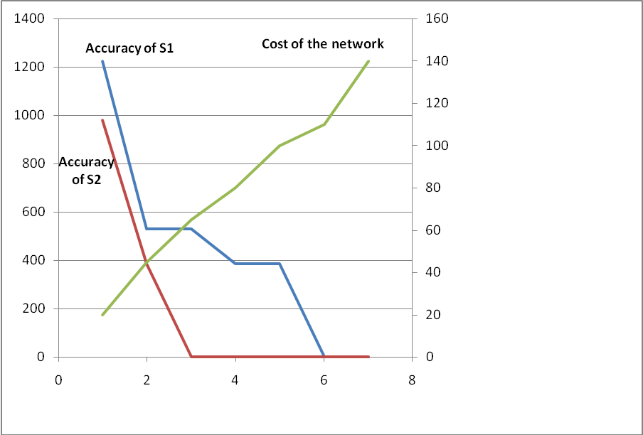
Figure 5. Accuracy vs. Number of Streams Measured

We consider now the case of two gross errors in the system (n_{T}=2). In this case, several equivalencies of gross errors can appear and therefore many combinations of errors lead to unbounded accuracy. Table 3 shows only the nodes of the tree that do not show unbounded results. Clearly, in this problem, one needs to measure all streams if accuracy is to be below 2.8 and 2.0 for streams S1 and S2. Only one node with 6 streams qualifies for a requirement of accuracy below 3.3 and 2.5 for streams S1 and S2 respectively. All other bounded nodes exhibit accuracies that are unacceptable. This is something that error detectability used together with precision constraints cannot capture. Situations with 3 or more gross errors will be discussed in future work.

Table 3. Accuracy and Cost as a function of the number of sensors (n_{T}=2)
Streams measured | Cost | Accuracy (a_{i}) %
Any 2 measurements |  | S1= unbounded  S2= unbounded
Any 3 measurements  (1,2,5) | 65 | S1= 797.07  S2= 557.53
4 Measurements  (1,2,3,5) | 85 | S1= 770.07  S2= 283.01
4 Measurements  (1,2,5,7) or (1,3,5,7) | 95 | S1= 396.71  S2= 557.92
5 Measurements  (1,2,3,6,7) | 105 | S1= 391.32  S2= 284.15
6 Measurements  (1,2,3,4,5,7) | 130 | S1= 396.71  S2= 2.198
6 Measurements  (1,2,3,4,6,7) | 120 | S1= 3.264  S2= 2.446
6 Measurements  (1,2,3,5,6,7) | 125 | S1= 3.136  S2= 283.149
All measurements | 140 | S1= 2.748  S2= 1.98
  - Conclusions
A method incorporating software accuracy to design sensor networks was presented. We highlighted the importance of gross error equivalency (Bagajewicz and Jiang, 1998) in determining accuracy. Thus, we conclude that networks prone to have more than one bias need to be heavily instrumented if all reasonable biases are to be detected so that software accuracy is reasonable.

Acknowledgement: Support from a Grant from the Petroleum Research Fund PRF # 45603-AC9 is acknowledged.

References
M. Bagajewicz, 1997, “Design and Retrofit of Sensor Networks in Process Plants”, AIChE Journal, Vol. 43, No. 9
M. Bagajewicz, 2000, “Process Plant Instrumentation: Design and Upgrade”, Technomic Publishing Company, Inc, Lancaster, PA.
M. Bagajewicz, 2005, “On the definion of Software Accuracy in Redundant Measurement Systems”, AIChE Journal, Vol. 51, No. 4.
M. Bagajewicz, M. Gala, 2006a, “Efficient Procedure for the design and Upgrade of Sensor Networks using Cutsets and Rigorous Decomposition”, Ind. Eng. Chem. Res., Vol. 45, No. 20.
M. Bagajewicz, M. Gala, 2006b, “Rigorous Methodology for the Design and Upgrade of Sensor Networks using Cutsets”, Ind. Eng. Chem. Res., Vol. 45, No. 20.
M. Bagajewicz and Q. Jiang, 1998, “Gross Error Modeling and Detection in Plant Linear Dynamic Reconciliation” Comput. Chem. Eng., 22, 12, 1789-1810.
M. Bagajewicz, D. Nguyen, 2007, submitted for publishing, “Design of Nonlinear Sensor Networks for Process Plants”.
R. W. Miller, 1996. Flow Measurement Engineering Handbook, McGraw-Hill, New York.
S. Narasimhan and C. Jordache, 2000, Data Reconcialiation & Gross Error Detection: An Intelligent Use of Process Data”, Gulf Publishing Company, Houston, TX.
D. Nguyen Thanh, K. Siemanond, and M. Bagajewicz, 2006. On the determination of downside financial loss of instrumentation networks in the presence of gross errors. AIChE Journal. Vol 52, No 11, pp. 3825-3841.

