Validation of an Ice-cream factory operations model
Peter M.M. Bongers, Bas H. Bakker
Unilever Food and Health Research Institute, O. van Noortlaan 120, 3133 AT Vlaardingen, The Netherlands

Abstract
The process plant of one of Unilevers ice-cream factories, needed to increase the output by 30%. Outsourcing the volume or working overtime are not possible to generate the additional output. The immediate engineering response was to propose a capital investment project for building additional capacity. The key question is then in which area of the plant to invest, because the bottleneck might not be obvious and might depend on the actual portfolio. As an alternative we have pursued a modelling and simulation route to identify which bottleneck(s) need enlarging, taking into account the costs and the time needed. The model has been designed to quantify the effect of working procedures, minimum and maximum storage time of the mixes, equipment extensions and modifications.
Using the model, various scenario’s have been simulated and the outcome evaluated. Apart of a number of bottlenecks which have been identified and improved, the main one has been the fact that only the packing lines are scheduled.
By scheduling the factory as a whole, the available overall capacity of the factory can be increased significantly. The above factory schedule generates 10-30% additional capacity without significant capital expenditure.
In this paper, the main emphasis will be the validation of the model to confirm that the predicted capacity is achievable.
  - Problem description
    - Process description
Figure 1 shows the ice-cream manufacturing process: All ingredients are stored in the local warehouse, depending on quantities used, different ways of storage are used (bags, silo’s, buckets, etc.). From here, the ingredients are transported to the mix department where according to the recipe, all ingredients are mixed, pasteurised and stored in so-called ageing vessels. After a minimum required ageing time, the mixes are frozen in continuous freezers. A number of freezers are needed to assemble the final products on the packing lines. After the product assembly, the products are frozen in a hardening tunnel.


Figure 1. Process flow diagram of ice cream manufacturing
Processing
Line 1
4000 kg
F1
F3
Process Line
8000lph
8000 kg
4000 kg
F2
Line 13
Line 3
Line 23
Line 2
F4
8000 kg
F5
8000 kg
4000 kg
F7
Line 5
F6
8000 kg
Line 4
F8
Line 8
8000 kg
20000 kg
4000kg
4000 kg
F9
Mixing
Buffering
Freezing
Packing
Ingredient
storage
Processing
Line 1
4000 kg
4000 kg
F1
F3
Process Line
8000lph
8000 kg
4000 kg
4000 kg
F2
Line 13
Line 3
Line 23
Line 2
F4
8000 kg
F5
8000 kg
4000 kg
F7
Line 5
F6
8000 kg
Line 4
F8
Line 8
8000 kg
20000 kg
20000 kg
4000kg
4000 kg
F9
Mixing
Buffering
Freezing
Packing
Ingredient
storage
    - Manufacturing complexity
The complexity of this manufacturing site (at the time of this study) includes:
- 8 packing lines
- Buffer tanks per line vary in number and size
- One process line to feed all packing lines
- 130 SKUs and 160 recipes
- Fresh dairy ingredients (limited shelf life)
- Stringent cleaning regime on process (Allergens & Kosher)
- Minimum and maximum standing time in buffers
- Mandatory CIP (24 hour cycle on process, 72 hour cycle on all other equipment)
    - Problem description
The key question is how to increase the output of the factory by 30% within three months. Outsourcing the volume or working overtime are not possible to generate the additional output. The immediate engineering response is to propose a capital investment project for building additional capacity. The key question is then in which area of the plant to invest, because the bottleneck might not be obvious. In this paper we will pursue a modelling and simulation route to identify which bottleneck(s) need enlarging, taking into account the costs.
  - Factory modelling
In this section, the design of the multi-stage scheduling model of the ice cream plant will be described, following Bongers and Bakker (2006,2007). The model should be the lowest complexity description of the plant behaviour of the:
- Manufacturing lines and their key equipment
- Material flow through the plant;.
- Operating procedures inside the plant.
The model will be built according to the schematics of Fig.2. It should be noted that the ‘soft’information bit provides valuable information about the plant operations, as there is almost always a discrepancy between the written procedures and the actual ones.
Figure 2 Model building schematics.
The model has been implemented in the INFOR advanced scheduling software (INFOR 2003). Within the INFOR software, stages are being defined as processes coupled with tanks. The behaviour of the stage is determined by the characteristics of both the process as well as the tank. Products can be seen as the material flow from one stage to another stage. A process step describes how a product is made (which stage, process, tank and characteristics).
As an example, the 2 stages of the plant are depicted in Fig.3.
Figure 3 two-stages as part of the scheduling model
  - Baseline operations
Before the benefits can be quantified, the baseline should be established. To this end, the designed multi-stage scheduling model has been used to establish this baseline, i.e. given the current portfolio, equipment and operating procedures is a 30% volume increase possible? (see Fig. 4).
Figure 4 base-line
Fig.4 shows clearly that the requested 30% volume increase is not possible. The model has been key to identify that the limitations are upstream in the process and not at the packing lines. This is for the operational staff counter-intuitive as they observe a bottleneck if the packing lines cannot run. The figure shows two main limitations: (i) no space for CIP on the processing line, where there needs to be a mandatory cleaning every 24 hrs. (ii) a tank overlap, showing insufficient capacity of the buffer vessels.

In utilising the model and analysing the results on a minute based scale, three bottlenecks where idenfified:
- The homogeniser was blocked for a long time by the pre-mix vessels in preparing a water batch for cleaning between the different products;
- CIP of the mixplant was longer than in other comparable plants;
- Due to lack of transparancy in the operations, the mix plant operators are not aware that any delay in changing between batches was causing reduction in volume. As there is a large time delay between mix preparation and consumption, it is extremely difficult to relate packing shortages can be caused the day before.

For both bottlenecks solutions have been identified:
- Water batches for cleaning are now taken from mains water. This needed some additional pipe work, valves and update of the control system;
- CIP time reduction by learning from other plants;
- Scheduling the upstream bottlenecks by multi-stage scheduling of the whole factory and instructing the mix plant operators about the importance of their work.

The baseline mixplant output was retrieved from the factory data system prior to implementing changes, it slightly depending on the product portfolio.

By implementing solutions (1) and (2) in the factory, and, adapting the multi-stage scheduling model to the new situation, the improvements can be visualised figure 5. In order to simulate the factory operations, the stragtegy that the operators are normally using in the factory are used (i.e. filling the first tank that becomes available). An improvement of appr. 8% in the capacity of the factory can be derived from figure 5.
Figure 5 effect of implementation of the technical changes
In the next step, the multi-stage scheduling (3) has been implemented in the factory, i.e. the production schedule for the whole factory is made by the multi-stage scheduling model. This weekly schedule is made by (i) importing the amount of SKU’s to be produced from the local ERP system; (ii) then the whole schedule from mixing to packing is generated by the software; (iii) this schedule is exported to log-sheets for each of the departments (including the start-time and end-time for each of the batches.

The actual production schedule for the whole plant, as generated by the model, for one week is shown in figure 6. The amount of volume requested from the mixplant is an increase by 30% with respect to the base-line.
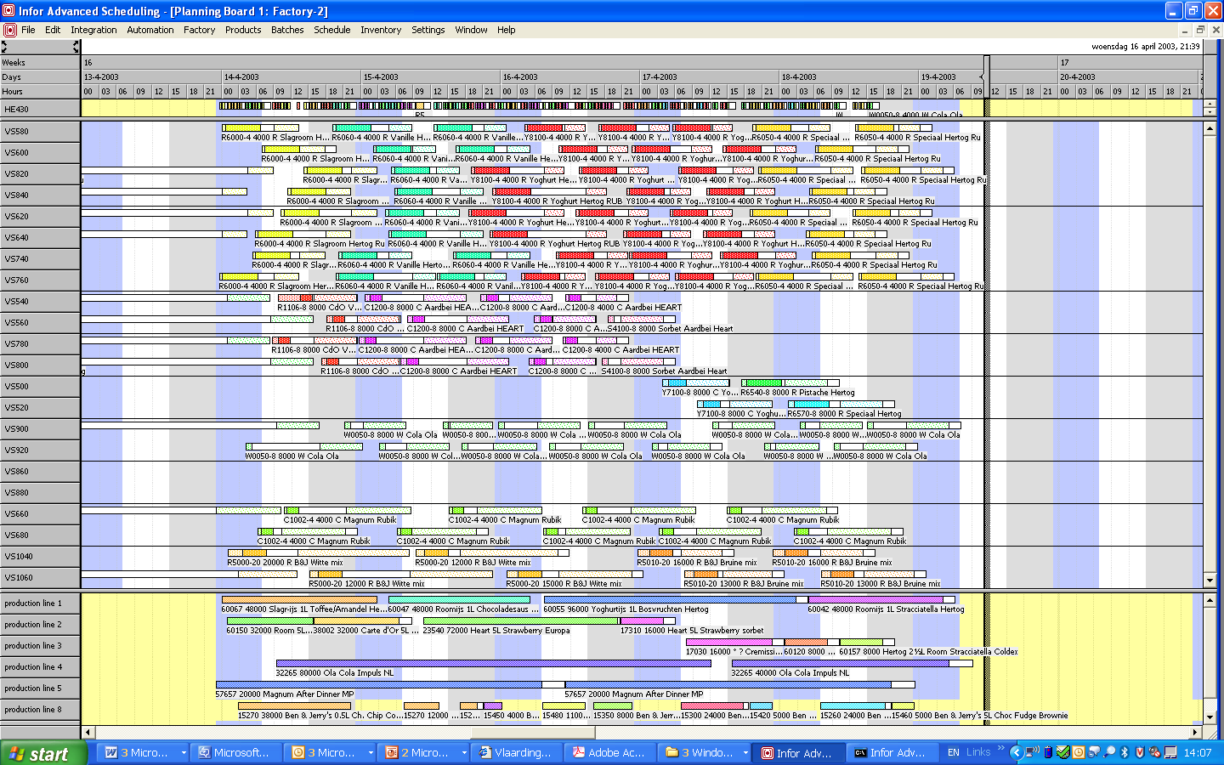
Figure 6 Implementation of both the technical changes and the multi-stage scheduling
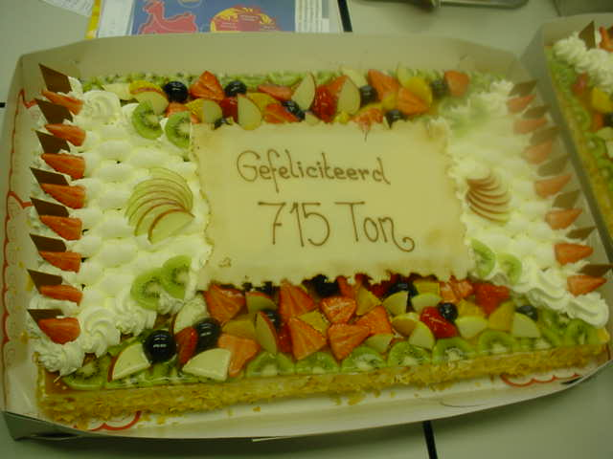
Based on the produced log-sheets (generated the week before), the operators in each of the departments worked towards achieving the timings in the provided log-sheets.

During this week, the actual produced amount was 29% more than the baseline (1% less than scheduled by utilising the model), thereby validating the model. This resulted in a celebration in the plant, see the figure on the left

Furthermore, the idle time due to lack of ingredients was reduced by 4% to virtually not occurring anymore.

  - Conclusions and future work
The local ice-cream factory has achieved the required 30% volume increase.

A lot of attention was given to the operational implementation in its widest sense, as the use of the model meant a complete new way of working for the people in the factory. Furthermore, the model had to be embedded in the factory infrastructure. The key changes that have been implemented where:
- Implement the technical changes
- Apply multi-stage scheduling for the whole factory, from material call-off to packing lines, instead of scheduling the packing lines only.

Future work will include:
- The modelling and optimisation of a much more complex factory
- Optimisation of feasible schedules
References
Bongers, P.M.M., B.H. Bakker (2006). Application of multi-stage scheduling, ESCAPE 16 proceedings
Bongers, P.M.M., B.H. Bakker (2007). Modelling an Ice cream factory for de-bottlenecking, ESCAPE 17 proceedings
INFOR (2003), Advanced Scheduling: Users Course and Modelling course, Rijswijk, The Netherlands

