Model Predictive Control of the Waste Water Treatment Plant Based on the Benchmark Simulation Model No.1-BSM1
Vasile-Mircea Cristea, Cristian Pop, Paul Serban Agachi
Babes-Bolyai University, 11 Arany Janos Street, 400028 Cluj-Napoca, Romania
Abstract
Control of the WWTP is not a trivial task since the unit is nonlinear, features large time constants and delays, and interaction between variables is important. Model Predictive Control algorithm is a good candidate for such demanding task. The paper presents the results for controlling the WWTP using MPC. The Benchmark Simulation Model No.1-BSM1 has been used as a standard for performance assessment and evaluation of the control strategy. Control of the Dissolved Oxygen in the aerated reactors and nitrate level in the anoxic compartments has been performed using the MPC control strategy. Air flow rate in the aerated reactors and internal recycle flow have been chosen as manipulated variables. The obtained results show the incentives of MPC over classical PI control with respect to overshoot and time response. A combined feedback-feedforward MPC scheme is also proposed for disturbance rejection and its incentives are shown.

Keywords: MPC, WWTP, BSM1.
  - Introduction
As the public awareness of environmental problems increases and the environmental legislation gets stricter, the Waste Water Treatment Plant (WWTP) operating requirements are becoming more and more demanding. WWTPs protect local ecosystems against increased load of waste products and waste disposal, preventing waste accumulation in lakes, rivers or underground waters. Degradation of organic material present in wastewaters consumes the oxygen inventory and the lack of oxygen may affect the living organisms. Even if most of the organic components are removed prior to accumulation in receivers, there are other chemical species, such as phosphorous and nitrogen, that are still present and may produce eutrophication, which is also a source of the oxygen consumption. Consequently, the WWTP has to remove the organic components and the suspended solids but also to reduce the nitrogen and phosphorous to an acceptable content.
Usually, a WWTP consists in a mechanical treatment step where filters remove larger objects and particles, followed by the chemical-biological treatment steps where chemicals and microorganisms remove organic matter and reduce the nitrogen and phosphorous content from wastewaters. The most widespread biological treatment process is the activated sludge process, where microorganisms (bacteria, fungi, protozoa, and rotifers) are used for oxidizing organic material and nitrogen removal. A wide range of municipalities and industries that treat wastewater containing organic chemicals, petroleum refining wastes, textile wastes, and municipal sewage uses the activated sludge process. The active sludge process converts dissolved and colloidal organic contaminants into biological sludge, further removed by settling. For nitrogen removal the activated sludge process consists in both aerated and non-aerated (anoxic) reactors. In the aerated reactors the bacteria oxidize ammonium to nitrate by the so-called nitrification process. In the anoxic reactors bacteria change nitrate into nitrogen, using oxygen present in the nitrate ions. This transformation is denoted as the denitrification process.
The demanding operating requirements may be only obtained, especially for large wastewater treatment units, by appropriate control techniques intended to keep the operation of the unit at the most efficient working regime. Model Predictive Control (MPC) is a good candidate for these challenging control tasks.
  - Model description and model predictive control approach
The Benchmark Simulation Model No.1-BSM1 has been used as a standard model [1], based on the most popular Activated Sludge Model No.1 (ASM1) developed by the International Association on Water Pollution Research and Control, for modelling and for performance assessment and evaluation of the control strategy [2]. The schematic representation of the WWTP is presented in Fig.1.
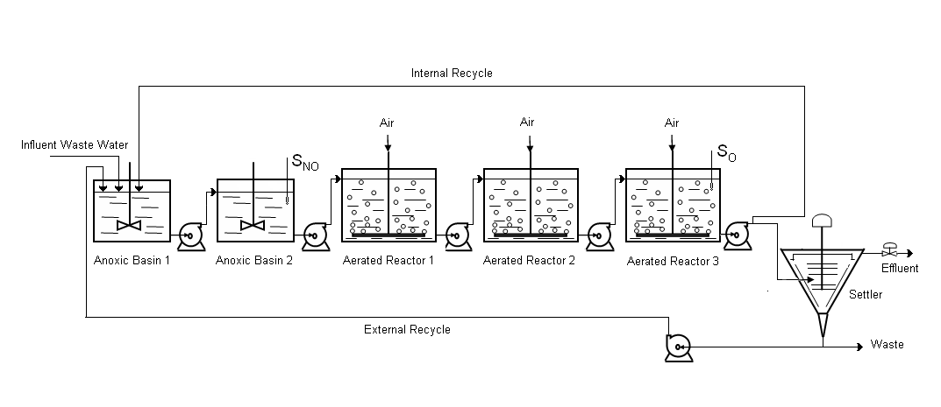Figure 1: WWTP activated sludge process with predenitrification.
As presented in Fig.1 the nitrogen removal is achieved using a first denitrification step performed in the anoxic tanks, placed before the aerated basins where the nitrification step is carried out. The unit consists in five biological reactor tanks connected in series. The first two anoxic tanks are assumed perfectly mixed and have a volume of 1000 m³ each. The rest of the three aerated tanks have a volume of 1333 m³ each. They are all modelled according to the ASM1 model. Eight different processes are modelled, involving thirteen state variables. An internal recycle from the last tank to the first one is used to supply the denitrification step with nitrate. The last tank has to reduce the Dissolved Oxygen (DO) concentration before the recycled water is fed back to the first anoxic tank. For the secondary settler the one-dimensional ten-layer system implementing the double exponential settling velocity model has been used [3]. In order to investigate the control performance for disturbance rejection a set of three different weather conditions, i.e. dry weather, stormy weather and rainy weather, have been considered in special designed disturbance influent input files.
The dynamic model succeeds to capture the main dynamic features of the biological wastewater treatment unit, needed for the control investigations.
Model Predictive Control, also referred as moving or receding horizon control, has become an attractive control strategy especially for linear but also for nonlinear systems subject to input, state or output constraints [4]. MPC determines the control action based on the prediction of future dynamics of the system, allowing early control action to be taken in order to accomplish the control performance based on the expected future behaviour. The incentives of MPC algorithm, compared to traditional control algorithms, are associated to the need the system usually has for satisfying input, state or output constraints. These constraints put limitations on the achievable control performance, but this task is systematically managed by the MPC optimisation objective (with associated constraints), compared to the ad-hoc solutions frequently used in conventional control.
The MPC algorithm used for the control of the wastewater treatment unit uses the combination of feedback and feedforward control design in order to reduce the effects of the large time constants shown by the process.
  - Results of the MPC and PID control approach
Control of the WWTP is difficult because the unit is nonlinear, features large time constants and pure delays, and interaction between variables is important [5]. The lack of feasible measuring instrumentation and the strong disturbances acting on the unit during changing weather conditions result in influent composition and flow rate upsets that make the control of the WWTP even more challenging. Advanced control strategies, such as Model Predictive Control, are needed to obtain good control performance.
Available manipulated variables for the nitrogen removal are: air inlet flow rate in the aerated compartments, internal recycle flow rate, sludge recycle flow rate and eventually, the external carbon dosage. The first two of them will be used in the present study. In the traditional decentralized control approach the air flow rate is employed for the control of the DO concentration in the aerated reactors, since the autotrophic nitrification bacteria development may be directly affected. The internal recycle flow rate influences the supply of nitrate for the denitrification process but also the DO concentration in the anoxic reactors, since DO may be also transported from the aerated reactors. It becomes obvious that, due to interactions, a multivariable control strategy would bring better performance, compared to the classical decentralized PID approach.
For the beginning, the decentralized approach has been implemented with two PI control loops in order to have a reference to which the MPC performance may be compared. The two control loops are: control of the DO level in the last aerated reactor to a setpoint value of 2 g/m³ by manipulating the air inlet flow rate of the same reactor (in fact, the oxygen transfer coefficient K_{La}, constrained to a maximum value of 10 h⁻¹) and control of the nitrate level in the second anoxic reactor to a setpoint value of 1 g/m³ by manipulating the internal recycle flow rate (constrained to a maximum value of 92230 m³/day). The tuning parameters of the two PI controllers are those recommended in the Cost Simulation Benchmark [1].
Control results of the PI decentralised approach will be further presented together with the MPC results, for the case of the dry weather input disturbance scenario. The dynamic simulator and the control simulations have been implemented on the Matlab/SimulinkTM platform.
The second investigated control approach is based on the MPC algorithm, aimed to control the same output variables (nitrate and DO concentrations) by manipulating the same (air and internal recycle) flow rates. The control set-up is presented in Fig.2.

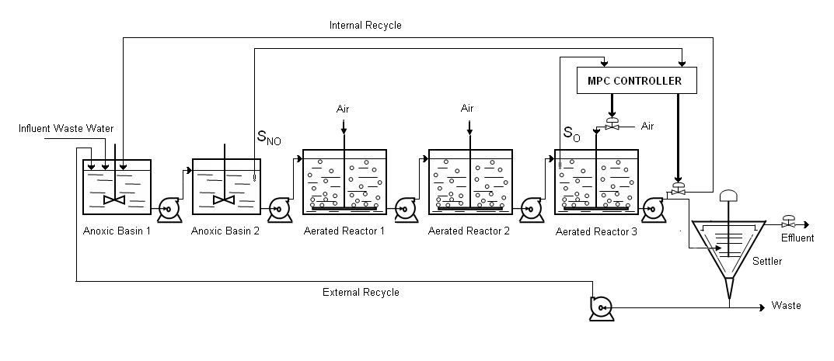
Figure 2: MPC feedback control scheme.
Comparison between the PI decentralized control and MPC control of the nitrate and DO concentration is presented in Fig. 3 and Fig. 4.
Figure 3: Comparison between MPC and PI control of the nitrate concentration.
Figure 4: Comparison between MPC and PI control of the DO concentration.
The WWTP control results presented in Fig.3 and Fig.4 show the superiority of the MPC nitrate concentration control compared to the PI control. Although the MPC DO concentration control is less effective, compared to PI control, it may be assessed that the overall MPC control performance for disturbance rejection is superior to the case of the PI control approach. This conclusion may be drawn on the basis of the relative small offset introduced by the MPC of DO concentration compared to the important reduction of the offset brought by MPC of the nitrate concentration.
For the MPC multivariable controller a sampling time of T=5 min has been used. The prediction horizon has been of p=200 and the control horizon of m=10. The appropriate MPC controller tuning has been achieved by simulation.
For further improvement of the control performance the MPC feedforward-feedback control structure is proposed. The nitrate and DO concentrations in the inlet flow of the first anoxic reactor are measured and used for feedforward control, while the nitrate concentration in the second anoxic reactor together with the DO concentration in the last aerated rector are used for feedback control. The combined feedforward-feedback MPC is presented in Fig.5.
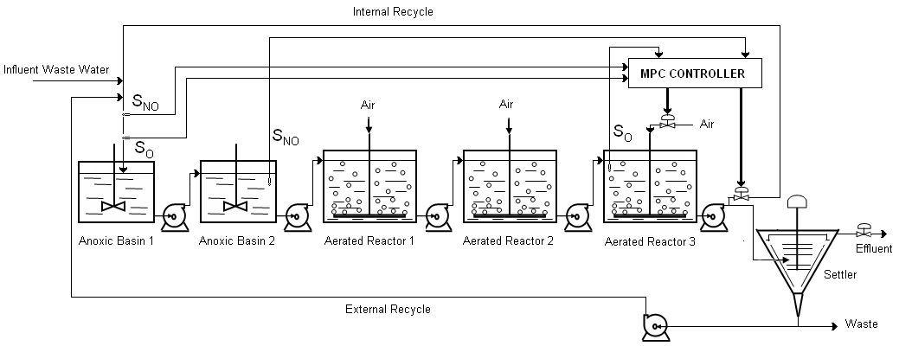
Figure 5: MPC feedforward-feedback control scheme.

Results of the MPC feedforward-feedback MPC are presented in Fig.6 and Fig.7. A detailed representation, extracted from the 14 days simulation of the WWTP control, is shown for revealing incentives of the proposed control approach.
Figure 6: Nitrate feedforward-feedback MPC. Figure 7: DO feedforward-feedback MPC.
Results presented in Fig.6 and Fig.7 show an improvement of the nitrate concentration control for the case of the feedforward-feedback MPC, compared to feedback MPC resulting in diminished overshoot, smaller offset and shorter settling time. For the DO concentration the improvement is not important. The feedforward-feedback MPC controller has been used with the same tuning parameter values as for the feedback MPC case.
MPC control approach shows its incentives over the classical decentralized PI control due to the intrinsic capability of counteracting interactions between controlled variables, the use of future process behaviour predictions for computing the control actions, the straightforward implementation of the combined feedforward-fedback control setup, the capability of systematic constraints handling and its optimal feature, all as a result of directly involving the process model in the MPC control law.
  - Conclusions
The presented MPC control performance of the nitrate concentration in the second anoxic reactor and the DO concentration control in the last aerated reactor of the predenitrification WWTP have shown improved results compared to the traditional decentralised PI control. The multivariable feedback MPC controller provides an effective improvement of the WWTP operation aimed to organic and ammonium pollutants removal, proved in the presence of the dry weather disturbance programme of the Cost Benchmark WWTP BSM1.
Although the feedback MPC control approach presents favourable performance, the combined feedback-feedforward MPC control approach succeeds to accomplish superior control performance, shown by its short setting time and reduced overshoot and small offset. Further development of the feedforward-feedback MPC approach for controlling a larger number of the WWTP variables is straightforward. As MPC control may successfully work in the presence of constraints, for both manipulated and controlled variables, the proposed control design outperforms the traditional control approach and reveals incentives for its practical implementation.
Acknowledgements
Funding from grants CEEX 112 and PN 71-006 is gratefully acknowledged.
References
[1] J.B Copp (Ed.), 2002, The COST Simulation Benchmark-Description and Simulation Manual, Luxembourg: Office for Official Publications of the European Communities.
[2] H. Henze, C.P.L. Jr. Grady, W. Gujer, G.V.R. Marais, 1987, T. Matsuo, A general model for single-sludge Wastewater Treatmant systems, 1987, Wat. Res., 21(5), 505-515.
[3] I. Takaks, G.G. Patry, D. Nolasco, 1991, A dynamic model of the clarification thickening process, Wat. Res., 25(10), 1263-1271.
[4] M.V. Cristea, S.P. Agachi, V. Marinoiu, 2003, Simulation and Model Predictive Control of a UOP Fluid Catalytic Cracking Unit, Chem. Eng. and Proc., 42, 67-91.
[5] M. Yong, P. Yongzhen, U. Jeppsson, 2006, Dynamic evaluation of integrated control strategies for enhanced nitrogen removal in activated sludge process, Contrl. Eng. Prac., 14, 1269-1278.

