MONITORING BATCH POLYMERIZATION USING CUMULATIVE AMOUNT CHANGES

Carlos R. Alvarez^{a,b}, Adriana Brandolínª, MabelC. Sánchezª, Luis Puigjaner^{b}
ªPlanta Piloto de Ingeniería Química,BahiaBlanca 8000, Argentina
^{b}Universitat Politècnica de Catalunya, Barcelona 08029, Spain

Abstract

Batch processes are naturally time-varying; therefore their dynamics should be taken into account, for example, in terms of variable correlations, auto-correlations, and variable cumulative changes. In this sense, classical monitoring strategies have incorporated information related to variable correlations and auto-correlations. But little attention has been devoted to the fact that both, the mass of each species and the energy suffer global changes during the batch operation. In this work a monitoring strategy which incorporates this issue is presented. Measurements are combined to define a new set of variables, which enable us to follow the cumulative changes in reactive species, and in the energy exchanged and contained in the system. The proposed methodology is applied to monitoring the operation of an emulsion polymerization semi-batch reactor. Results are compared with those obtained using a classical Multiway Principal Component Analysis (MPCA) monitoring technique, and conclusions about the impact of considering the cumulative nature of this kind of processes are presented.

Keywords: Batch Process, Statistical Process Control, Multiway Principal Component Analysis.
  - Introduction
Batch processes are mainly devoted to the production of high quality - low volume products like polymers, pharmaceuticals, foods, bio-chemicals and semiconductors. In this type of processes, batch to batch variations, which are difficult to be taken into account by the control system, may arise from errors in charging raw materials, the impurity concentrations, variations in refrigerant temperature, etc. Small variations in operating conditions may degrade the product quality if the problem is not detected and corrected fast enough. Multivariate Statistical Control techniques are developed for on-line monitoring and fault diagnosis of discontinuous processes. These techniques are commonly based on MPCA and Multiway Partial Least Square (MPLS) strategies (Nomikos and MacGregor, (1994, 1995)).
Since batch processes are naturally time variant, it is desirable to incorporate information related to variable autocorrelations in addition to the classically used variable correlations. Several works have been proposed with this goal. Most of them take into account variable’s profiles as time series and introduce this information into the correlation matrices (Wei et. al, 2004). Other methods use time-windows to relate the current variable values to previous observations (Lennox et. al, 2001).
On the other hand, different approaches have been presented for monitoring the whole batch course from the beginning up to the current time, as the time evolving strategy proposed by Ramaker et al. (2005).
In this work we propose to incorporate the previous history of the batches by considering changes in cumulative variables obtained by combining measured variable values. The rest of this paper is organized as follows. In the next section, the general process monitoring procedure is briefly reviewed. The proposed strategy in terms of cumulative variables is presented in Section 3. Then, application results are provided for a non-isothermal semi-batch reactor that produces methyl-methacrylate by an emulsion polymerization process. Conclusions are presented in the last section.
  - General Process Monitoring Strategy
The general procedure in batch process monitoring is described in this section.
After charging the equipment with raw materials, batch operation is initiated and, the observation of the first point is obtained. This corresponds to a vector of dimension (J×1). Process time evolution is then registered measuring the same J variables at different times, resulting 1, 2, 3, K, observations when the operation is finished. The information of I normal batch runs is arranged as a three-way data matrix X (I×J×K), which represents the normal operation condition (NOC) data set.
Then, the off-line stage of the MPCA monitoring procedure is performed which involves the following steps:
a) Centering and scaling of each column of matrix X (I×J×K) to obtain Z (I×J×K)
b) Vertical unfolding of Z to form matrix Z(IK×J) (Wold et al., 1998)
c) Empirical modeling based on PCA for matrix Z. This matrix is decomposed into a summation of R products of score vectors t_{r} and loading vectors p_{r} plus a residual matrix E
(1)
where dimensions of these matrices are T(IK×R), P(J×R) and E(IK×J).
d) Definition of the D_{k} control charts. The D statistic is defined using the Mahalanobis distance between a given observation and the mean value of its corresponding distribution
(2)
where t_{k} and S_{k} are the score vector and its corresponding correlation matrix for the k-th sample of a given batch.
e) Definition of the SPE_{k} control charts. The SPE statistic measures the Euclidean distance from a given observation to the subspace formed by the R retained P.C.s
(3)
(4)
where e_{j,k} is the j-th component of the residue vector e_{k} of a given batch at the k-th observation and, t_{k} is its score vector.
Critical values for both statistics have been obtained using kernel density estimation, because data shown compelling evidence of non-normality especially during the middle course of the reaction.
Once the PCA model has been formulated, the on-line stage of the MPCA monitoring procedure follows. It consists of the following steps:
a) Detection. A new vector of properly standardized observations is projected into the latent variable space and, the statistics D_{k} and SPE_{k} are calculated. The score and model prediction error vectors for the k-th observation are:
(5)
(6)
The D_{k} and SPE_{k} statistics for the new observation are
(7)
(8)
b) Fault Identification. If the process is out of control, the identification of the fault source can be accomplished using contribution plots. A faulty state is declared after three consecutive observation fall outside the limits for a given confidence level. Variable contributions have been calculated using the approach presented by Alvarez et al. (2007).
  - Process monitoring using cumulative variables
In general, previous monitoring strategies make use of flowrate, temperature, pressure, etc. measurements as process state descriptors. These observations are inappropriate to reveal the changes in extensive variables that occur between two states corresponding to a non-stationary process. For example, variations in the values of concentration of a given product can not be utilized alone to measure changes in the molar amount of this component if the reaction volume is also time dependent. Nevertheless changes in the product of the aforementioned variables give an adequate estimation for this variation.
Since usually it is attempted to take advantage of as much information as possible to detect and identify abnormal situations, variables with different conceptual nature are simultaneously considered. For example, concentrations and flowrates are used together with monitoring purposes, but a concentration represents a process status meanwhile a flowrate is related to a rate change which can affect the first one. In this work, variables belonging to the first type (i.e. species’ concentrations, temperatures, vessel volumes, etc.) will be called hereinafter “status variables” and, the variables belonging to the second type will be denominated “flow variables”.
Taken into account the time variant nature of batch processes, a statistical process monitoring strategy that considers cumulative changes in mass and energy amounts is proposed. Measurements are combined to obtain a set of new variables, called pseudo-observations, which allows determining the global change with respect to a reference state. This is selected as the initial condition.
Mass or energy fluxes are transformed into cumulative variables using numerical integration methods. In this work the simple trapezium rule has been used. The total cumulated amount of a variable related only to a flow-variable, such as a flowrate, can be estimated as it is stated in Eq.10
(10)

where t₀ and t₁ are the reference and current time respectively, n is the number of intervals in which the whole operation time has been divided into, and f(t) is the measured value of the considered flow at the time interval t.
Regarding a total cumulative variable related only to a status-variable, it is calculated as the difference between the current value and the one taken as reference. This is shown in Eq. 11 for a chemical specie j whose concentration C_{j} is measured,
(11)
where ∆J is the molar cumulative change of the specie j between t₀ and t_{k}, and V is the volume.
Finally cumulative values for variables which are related to both kinds of variables are evaluated using the appropriate relationships.
After obtaining the new set of variables, the general procedure explained in section 2 is applied. During the on-line procedure, the corresponding transformations are performed for each new observation.
  - Case Study
A non-isothermal semi-batch reactor for the emulsion polymerization of methyl-methacrylate is considered. The set of normal batches is generated by simulation using a mathematical model of the process, which was validated against experimental information (Alvarez et al., 2006). The model is based in a detailed description of the physical phenomena and chemical reactions that take place both in the aqueous and in the polymer phases. Both micellar and homogeneous nucleation are considered. Radical entry into particles and micelles as well as desorption of radicals from particles are also included.
A reference normal data-base composed by 61 batches is employed. For each one, it is assumed that eight measurements (molecular weight MW, monomer inlet flow rate Q0, surfactant concentration in aqueous phase SW, reactor temperature T, reactor-jacket temperature TR, refrigerant inlet temperature TR0, volume VR and conversion X) are sampled every 2 minutes for a period of 80 minutes.
In order to implement the proposed strategy the following variable transformations have been done. Measurement Q0 has been integrated during the batch course as it is indicated in Eq. 10. Observations SW, T and TR have been replaced by SW×VR, T×VR and TR×VR, respectively. In this case some assumptions, for example average values for density and heat capacity, have been considered to match some new variables to physical magnitudes, as cumulative amounts of energy. Due to size restrictions, just two tests are presented in this work.
The first one, identified as MB₈, represents a batch with a small change in the tuning of the temperature controller from k=2 up to the end of the reaction. Although both the classical MPCA and the proposed technique detect a faulty state at the middle term of the run (k=23), the new strategy maintains this indication up to the end of batch. In contrast, the classical approach indicates a normal state after the 28th observation, as it is shown in Fig. 1. The upper part of the graph presents the D² and SPE profiles obtained for the classical MPCA procedure and the lower graphs correspond to the results in terms of pseudo-observations. These pictures show the fault is detected without delay respect to the classical strategy for α=0.05 and, one measure after for α=0.01.
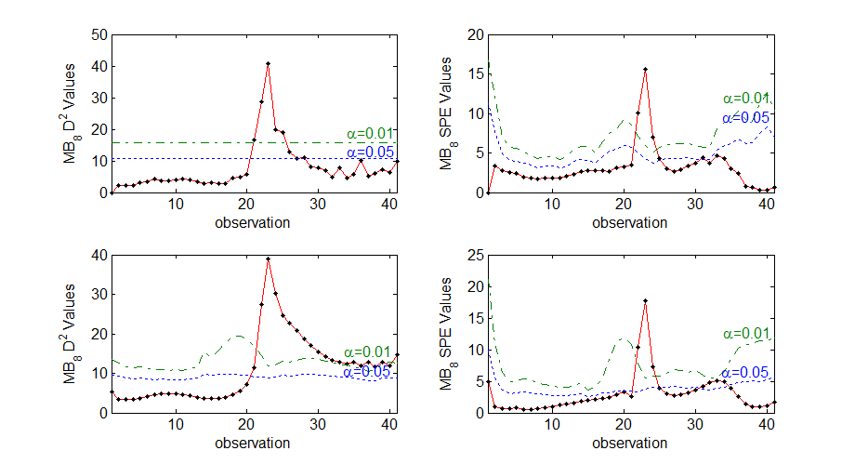Figure 1. D² and SPE statistics for a batch with a small change in the tuning of the temperature controller from k=2 up to the end of the batch.

The second case study, identified as MB₆, presents a fault in the monomer flow rate Q0 which takes place during the middle term of the batch operation. It strongly affects unmeasured quality parameters as molecular weigh distribution, solid contents, etc. The fault corresponds to a step decrease in the monomer flowrate between observations 10 and 21. Results obtained by applying MPCA and the proposed procedure are displayed in the upper and lower graphs of Fig. 2, respectively.
As Fig. 2 shows, classical MPCA strategy detects the fault immediately and it is declared at k=13, but, as soon as the monomer flowrate returns to normal values both statistics get normal values as well, making us unable to detect possible problems caused in unmeasured variables which can propagate during time.
In contrast, the new strategy detects the faulty state with a little delay in comparison with the classical strategy, but it remains present up to the end of the operation. This provides an indication of the cumulative effects on unmeasured quality variables (as molecular weight distribution) that the batch deviation from its normal operation originates. The fault source was properly identified using variable contribution plots for the D² statistic (Alvarez et al., 2007).

  - Conclusions
A new monitoring strategy based in the cumulative changes in process mass and energy content is presented. The approach is applicable to processes which undergo changes in these amounts during their normal operation (batch processes, grade changes etc).
The proposed technique makes use of adequate combinations of measurements to obtain a new set of pseudo-observations, with physical meaning, that measure the cumulative changes during the batch run. A conventional monitoring procedure is carried out using these new pseudo-observations.
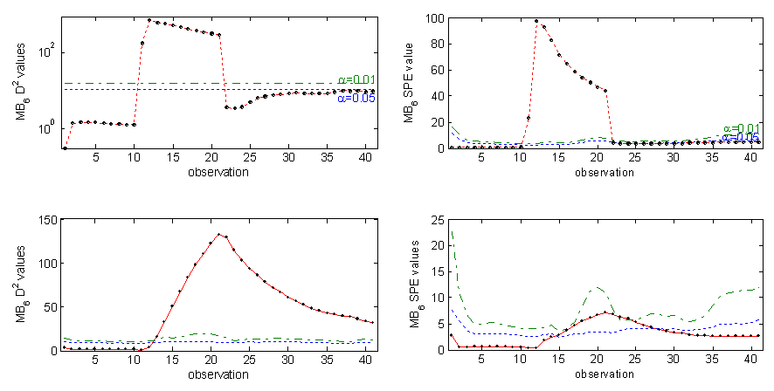
Figure 2. D² and SPE statistics for a batch with a step decrease in the monomer flowrate between observations 10 and 21.
The proposed strategy shows better results than the classical MPCA to detect small changes sustained in time, which can strongly affect unmeasured variables, especially the ones related to product final quality.

Acknowledgments

Financial support received from the European Community project MRTN-CT-2004-512233 and CONICET (National Research Council of Argentina) is fully appreciated.

References

C.R. Alvarez, A. Brandolin and M. C. Sánchez, 2006, Production Monitoring in Polymerization Processes, Proc. 41st International Polymer Congress (MACRO 2006), Rio de Janeiro, Brazil.
C.R. Alvarez, A. Brandolin and M. Sánchez, 2007, On the variable contributions to the D Statistic, Chemom. Intell. Lab.88, 2,189-196
B. Lennox, G. Montague, H. Hiden, G. Kornfeld, P. Goulding, 2001, Process monitoring of an industrial fed-batch fermentation, Biotechnology and Bioengineering 74 125-138
P. Nomikos and J. F. MacGregor, Monitoring Batch Processes Using Multiway Principal Component Analysis, AIChE J., 40, 1361-1375 (1994).
P. Nomikos and J. F. MacGregor, Multiway Partial Least Squares in Monitoring Batch Processes, Chemom. Intell. Lab., 30, 97-108 (1995).
H. Ramaker, E. Van Sprang, J. A. Westerhuis and A.K. Smilde, 2005, Fault detection properties of global, local and time evolving models for batch process monitoring, Journal of Process Control, 15, 7, 799-805.
J. Wei, 2004, Multivariate Control Charts for Monitoring Autocorrelated Processes, Journal of Quality Technology, Vol. 36, 4, 367-379
S. Wold, N. Kettaneh, H. Fridén and A. Holmberg, 1998, Modelling and diagnostics of batch processes and analogous kinetic experiments, Chemom. Intell. Lab., 44, 331-340.

