Improving Steady-State Identification
Galo A. C. Le Roux,ª Bruno Faccini Santoro,ª Francisco F. Sotelo,ª Mathieu Teissier,^{b} Xavier Joulia,^{b}
ªLSCP, Departamento de Engenharia Química, Escola Politécnica da USP, Av. Prof. Luciano Gualberto 580, Tr3, São Paulo, SP zip code 05508-900, Brazil
bEcole Nationale Supérieure des Ingénieurs en Arts Chimiques et Technologiques
118 Route de Narbonne 31077 TOULOUSE Cedex 04, France
Abstract
The use of online data together with steady-state models, as in Real Time Optimization applications, requires the identification of steady-state regimes in a process and the detection of the presence of gross errors. In this paper a method is proposed which makes use of polynomial interpolation on time windows. The method is simple because the parameters in which it is based are easy to tune as they are rather intuitive. In order to assess the performance of the method, a comparison based on Monte-Carlo simulations was performed, comparing the proposed method to three methods extracted from literature, for different noise to signal ratios and autocorrelations.
The comparison was extended to real data corresponding to 197 variables of the atmospheric distillation unit of an important Brazilian refinery. A hierarchical approach was applied in order to manage the dimension of the problem.
The studies showed that the method proposed is robust and that its performance is better than others.

Keywords: Steady-State, Savitzky-Golay, Simulation, Non-Parametric Tests, Refining
  - Introduction
Petroleum shortage is an important issue. Improving the efficiency of refineries by optimising their operation is one of the measures that must be implemented. In order to do so using computational tools available, like Real Time Optimization (RTO), it is mandatory to use data obtained in steady-state operation. This justifies the need for steady-state detection procedures, because the adaptation of process models to data obtained exclusively in steady state operation leads to better solutions (Bhat & Saraf, 2004).
The analysis of real data is non-trivial because they include a stochastic component and statistical methods must be employed in order to perform the task.
In this work an original usage of Savitzky-Golay filter is proposed. An estimate for the local derivative is obtained from the interpolation process, which is used in a test that allows the discrimination of steady-states.
In this contribution, first, a short review of the steady-state identification methods most used is presented. Then, a comparison of the behavior of these methods based on benchmark data is performed in order to develop and calibrate the methodologies that are further applied to a case study based on real data from a crude distillation unit.

  - Steady-State Identification
Steady-State identification is the first step for data processing in RTO (Bhat and Saraf, 2004) that also includes gross error detection and data reconciliation. In this work we present a review of the techniques used for steady-state identification. But, as literature reports experiences exclusively with parametric methods, we propose the study of some non-parametric techniques.

    - Modified F Test
Cao & Rhinehart (1995) proposed an F-like test applied to the ratio (R) of two different estimates of the variance of the system noise. Each of these estimates is calculated using an exponential moving-average filter. The data are also filtered using a moving-average filter. One parameter, varying from 0 to 1, must be chosen for each of the filters (λ₁, λ₂ and λ₃). The values of these parameters are set based on the relevance of the actual values in comparison to the past ones, and could be interpreted as forgetting factors and express something analog to a window size.
If the statistic R, which is evaluated at each time step, is close to one, then the data can be considered in steady state. The maximum acceptable variability is defined by means of a critical value R_{crit}. Cao & Rhinehart (1995) proposed that the parameters of the method be tuned empirically and present some guidelines for the procedure.

    - Reverse Arrangements Test (RAT)
A non-parametric test is the Reverse Arrangements Test, in which a statistic, called A, is calculated in order to assess the trend of a time series. The exact procedure of calculation as well as tables containing confidence intervals is described in Bendat & Piersol (2000). If A is too big or too small compared to these standard values could mean there is a significant trend in the data, therefore the process should not be considered in steady state. The test is applied sequentially to data windows of a given size.

    - Rank von Neumann Test
The rank modification of von Neumann testing for data independence as described in Madansky (1988) and Bartels (1982) is applied. Although steady-state identification is not the original goal of this technique, it indicates if a time series has no time correlation and can thus be used to infer that there is only random noise added to a stationary behavior. In this test a ratio v is calculated from the time series, whose distribution is expected to be normal with known mean and standard deviation, in order to confirm the stationarity of a specific set of points.

    - Polynomial Interpolation Test (PIT)
Savitzky & Golay (1964) developed the algorithm for a filter to treat data measured in noisy processes, as spectroscopy. An experimental measurement series is filtered first by choosing a window size, n (which must be an odd number). Each window is interpolated using a polynomial of degree p, with p < n. Information obtained from the interpolated polynomial is less noisy. Thus, the first derivative of each polynomial at the central points is calculated and the value is used as a statistic for assessing the stationarity of the point. The parameters of the filter are the window size, n, and the polynomial degree, p.
  - Benchmark Data
To analyze the advantages and drawbacks of each test comparatively, two sets of calibration functions were created. The first one is derived from four functions, representing different levels of stationarity. In each of these cases, three levels of random white noise are added with different amplitudes corresponding to 1, 5 and 10% standard deviations, of the original data. This set of functions is presented in Fig. 1.

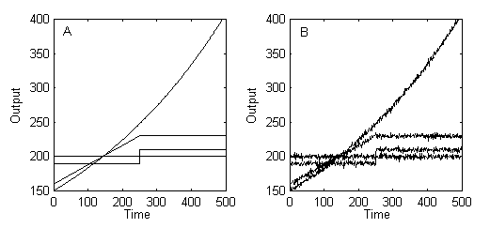

Figure 1. Set of calibration functions: (A) original and (B) with first level of noise

The second one is based on two intervals: a ramp and a constant segment. For the ramp segment, three different slopes are tested: 1, 0.5, and 0.1. As previously, random noise with different amplitudes was added. A Monte-Carlo study was carried out in order to estimate the performance of each test. The methodology for assessing the performance is as follows: random noise is generated and each test for stationarity is applied to the central point of the positive slope segment and also at the central point of the constant piece. The number of times where the test succeeds or fails are recorded and a new random noise is generated.

After some iterations (typically 1000) it is possible to find an approximate distribution for the probability of success and also for the type I (the process is considered non-stationary while it is in fact) and II errors. This procedure is applied for each test and for different parameters, thus portraying the sensitivity of the probability distribution as a function of the parameter values. Even for non-parametric tests, such sensitivity can be studied with respect to the size of the window, for instance.
  - Results and Discussion
    - Benchmark Set
      - Polynomial Interpolation Test
The degree of the polynomials is kept constant and equal to 2. This choice is justified by the fact that results depend more on the window size than on the degree of the polynomial.

When applied to the first set of functions, the estimations of the first derivative are quite close to the intuitive expected values. In order to quantify its efficiency, the second set of functions is used in the Monte-Carlo study described above. For a given noise level, the average accuracy is calculated as the mean of accuracies for the 3 different slopes.

The major difficulty in tuning this test is not that of choosing n but that of finding which should be the threshold for the derivative for a process is considered as stationary. This is the most important parameter and must be chosen according to the expected tolerance to variations. In Fig. 2, the dependence of the quality of the results on this treshold value is apparent.

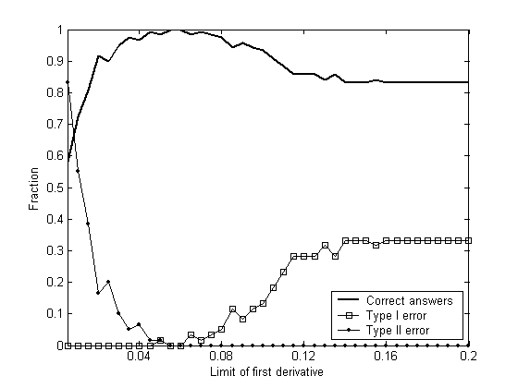
Figure 2. Performance of Polynomial Interpolation Test for window size=51 and first level of noise

The existence of a region where fractions of errors type I and II are simultaneously small indicates that for some data series this test is able to clearly identify a stationary from a non-stationary point. However, for the case with several simultaneous variables that is analyzed later this is not necessarily true.

      - Modified F Test
For the first set, it was possible to observe that this test works adequately (there is a significant trend in the analyzed data) and the values of R obtained were much larger than R_{crit}. However, as noise level increases, the test does not perform properly and all the functions are considered stationary.

It is possible to verify this fact from the Monte Carlo analysis results (Table 1) and to notice that its efficiency is similar to PIT for the first level of noise, which is the closer to real data. It is found that λ_{i} parameters have little influence over the final result.

      - Reverse Arrangements Test
Standard values of A are only tabulated for a few data sizes. As a consequence it is more difficult to choose a length for the window that would be neither too small nor too large. One reasonable choice was to consider 30 data points. But, for this, only the means of 3 successive points could be analyzed because the resulting time series has to be only 10 values long, which is the smallest value presented in tables. Unfortunately, averaging reduces the influence of noise.

As for the other tests, this test behaves adequately for the first data set. From Monte Carlo analysis it was observed that the results are worst than for the Polynomial Interpolation Test but better than the techniques described in literature.

      - Rank von Neumann Test
30-points data windows were analyzed in order to make the comparison with the previous tests similar. The performance is adequate for the first data set, but type I errors get too large if the noise is too intense. The same behavior arises when testing the second set (Table 1).

Table 1. Results of Steady-State identification on benchmark set (MF = Modified F test, RAT = Reverse Arrangements test, RVN = Rank von Neumann test)

Noise Level | 1 |  |  | 2 |  |  | 3
Test | MFª | RAT | RVN | MFª | RAT | RVN | MFª | RAT | RVN
Correct Answers | 78,52 | 87,58 | 84,75 | 50,77 | 72,42 | 63,92 | 50,52 | 59,67 | 53,45
Type I Error | 41,88 | 13,17 | 26,40 | 97,46 | 44,50 | 68,13 | 97,92 | 69,75 | 89,13
Type II Error | 1,08 | 11,67 | 4,10 | 1,0 | 10,67 | 4,03 | 1,04 | 10,92 | 3,97
ª λ₁ = 0.2, λ₂ = 0.1, λ₃ = 0.1

    - Case study: crude oil atmospheric distillation unit
Data from a Brazilian Refinery corresponding to the units comprehended from the desalinization to the separation into LPG, naphtha, kerosene, diesel and gasoil were analyzed. 197 relevant variables were retained and data measurements concerning 5 months of operation (one measurement every ten minutes) were available.

Among the variables, 27 were considered to be key to the process, based on engineering considerations. The stationarity test is applied only to this smaller set. The whole system is considered to be at steady state if and only if all these 27 variables are stationary.

As RAT appeared to be the most reliable test among the non-parametric ones, it was used to designate some steady-state windows from the huge database. According to RAT there are not many of these windows. Even so, one can choose some of them and verify the agreement between any other given test and RAT.

If the accuracy of both parametric tests was not so different in the benchmark set, the situation changes dramatically towards PIT performance. This might be explained by, what can be termed “lack of noise” in the real data. In fact, for a time series to be considered stationary by the F-like test, it must have some level of noise. Cao & Rhinehart (1995) recommend the introduction of a white noise before analyzing data, but this procedure could lead to inconsistent results, for enough noise makes any time series “stationary “.

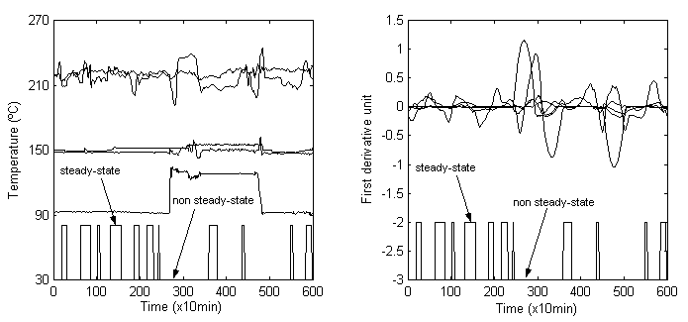
Figure 3. Steady-state identification for real data and for its first derivative (window size=51 and limit of derivative =0.1)

In Fig. 3 an example of the steady-state identification using PIT for real temperature data (left side) is presented. For illustrative purposes only five variables were used. The analysis of the first derivative (right side) is an auxiliary tool in order to analyze the behavior of the system.
  - Conclusions
It was shown that for simulated data PIT performs better than the other tests studied. In addition, this test is the one that agrees better with RAT in the real case study. Its most important parameter, the window size, can be adjusted in order to deal with situations where the process could be more sensitive to small changes. PIT is very simple and intuitive: for its implementation, a plot of the derivatives can be used in order to help in the selection of the steady states.
References
Savitzky, M. Golay, 1964, Smoothing and Differentiation of Data by Simplified Least Squares Procedures, Anal. Chem., Vol 36, pp. 1627-163
S. Cao, R. Russell, 1995, An efficient method for on-line identification of steady state, J. Proc. Cont. Vol 5, No. 6, pp. 363-374
S.A. Bhat, D.N. Saraf, 2004, Steady-state identification, gross error detection, and data reconciliation for industrial process units, Ind. Eng. Chem. Res. Vol 43, pp. 4323-4336
J. Bendat, A. Piersol, 2000, Random data : analysis and measurements procedures, John Wiley & Sons
Madansky, J. 1988, Prescriptions for working statisticians, Springer - Verlag New York
R. Bartels, 1982, The Rank Version of von Neumann’s Ratio Test for Randomness, Journal of the American Statistical Association, Vol. 77, No. 377, pp. 40-46

