Comparison of features in classifying steel surface quality
Daeyoun Kim,ª J. Jay Liu,^{b} Chonghun Hanª
ªSchool of Chemical and Biological Engineering, Seoul National University, San 56-1, Shillim-dong, Kwanak-gu, Seoul 151-742, South Korea
^{b}Samsung Electronics, Myeongam-ri 200, Tangjeong-myeon, Asan, Chungchengnam-do 336-840, South Korea
Abstract
The development of a variety of image sensors, multivariate statistical techniques and image processing technologies has brought about the emergence of automated systems for evaluating visual quality. Feature extraction from images using wavelet transforms is an essential step in the methodology for an automated image grading system. In previous works, wavelet texture analysis (WTA) based on the discrete wavelet transform (DWT) has been recognized as one of the most successful feature extraction methods for classifying steel quality. In this work, we propose two methodologies for steel texture classification: one is based on the wavelet packet transform, and the other is the best-basis approach. Our experiments provide two findings: First, the method based on the wavelet packet transform is more useful in characterizing steel quality than the previous DWT-based method. The wavelet packet transform are more powerful than other methods due to its equal frequency bandwidth. Second, the best-basis approach, which requires only a small number of features, is superior to the full packet methodology.
Keywords: Best-basis approach, Feature selection, Steel quality classification, Wavelet packet transform, Discrete wavelet transform.
  - Introduction
The surface quality of steel sheets is important to automakers since it can significantly affect the coating quality. In such cases, the visual quality and the physical or mechanical qualities of a product surface must be controlled or maintained [1]. When analyzing an image, the texture plays an important role in characterizing the regional features. Though lacking a formal definition, texture can be considered as a spatial area consisting of an arrangement of primitives that resemble each other [2, 3]. A new texture-based methodology for process industries has been proposed to handle the stochastic nature of the visual quality in industrial processes and products [4]. The proposed methodology has been successfully applied to a number of industrial processes such as for the determination of the colour and appearance of mineral flotation froth [5], identification of visible patterns such as stripes and swirls on the surfaces of injection-moulded plastic panels [6] and determination of the surface quality of engineered stone [1, 7].
Figure1. Framework for texture classification of steel quality
In Bharati’ s work, the wavelet texture approach based on the wavelet transform is recognized as being very efficient in the classification of steel surface quality. In addition, the wavelet texture approach is more efficient in the characterization of surface textures [8]. Accordingly, in this study, we compared the three feature extraction methods: the wavelet packet transform, discrete wavelet transform and best-basis approach for the wavelet packet transform.
The difference between the two wavelet transforms, the wavelet packet transform (WPT) and discrete wavelet transform (DWT), are examined in the classification of the surface quality of rolled steel sheets—the same industrial dataset used in Bharati et al. [8], where the DWT exhibited the best performance among other texture analysis techniques. Also, we discuss a simple yet powerful method for selecting the best basis for WPT by searching for the optimal discriminative wavelet packets.
  - Texture Classification based on Wavelet Transform
    - Framework for Texture Classification
The fundamental structure is based on the ‘machine vision framework’ [4]. Fig. 1 shows the framework for texture classification used in this study. To compare the two wavelet transform methods (DWT and WPT), we used both methods in the wavelet transform step.
    - Wavelet Transform
      - Discrete Wavelet Transform
The separable solution for achieving a two dimensional (2-D) DWT is given in Fig. 2. It provides rectangular divisions of the frequency spectrum and strongly oriented coefficients (often called sub-images because the wavelet coefficients for 2-D signals are also 2-D) in the horizontal, vertical and diagonal directions. It consists of horizontal and vertical filtering of 2-D signals using low-pass and high-pass 1-D wavelet filters, H₀ and H₁. Separable horizontal (2↓1) and vertical (1↓2) downsampling by a factor of two affords a separable sampling lattice [1].
Figure 2. A separable structure for 2-D DWT [1]
      - Wavelet Packet Transform
The DWT produces dyadic decomposition and thus yields narrower bandwidths in the lower-frequency regions and wider bandwidths in the higher-frequency regions. In other words, the DWT yields an octave frequency bandwidth. This octave frequency bandwidth of the DWT is suitable for analyzing signals whose information is only located in the low-frequency regions. However, the DWT may not be suitable for signals with the information mainly located in the middle- or high-frequency regions due to the wide bandwidth in the higher-frequency region. To analyze this type of signal, the DWT is generalized to include a library of modulated waveform orthonormal bases, called wavelet packets. Implementation of the WPT can be achieved through tree-structured filterbanks. While the DWT is implemented through iterative decomposition of approximation coefficients using a two-channel filterbank, the WPT can be implemented through iterative decomposition of all coefficients, yielding an equal frequency bandwidth [1, 9].
    - Wavelet Texture Analysis
When regarding each sub-image from wavelet decompostion as D(J,I), where J is the depths of level of decompostion, I is the number of packets in the depths. The energy of sub-image can be defined as follows:
$E_{D(J,I)}=‖D(J,I)‖_{F}^{2}$ (1)
The energy divided by the number of pixels is the averaged power or normalized energy. The most popular wavelet textural feature, the wavelet energy signature, is a vector organized by the energies of all the sub-images.
    - Classification Using Wavelet Energy Signatures
For classification, we applied a K-nearest neighbour (KNN) classifier to the wavelet energy signatures obtained from the previous step. In case of the best-basis approach, only the selected signatures were included for classification. The leave-one-out method was used to estimate the classification performance.
    - Best-basis Feature Selection
It is not always guaranteed that the use of all features directly translates to smaller classification errors [3]. The approach of selecting features of optimal subbands is part of the so-called best-basis paradigm or optimal feature selection [10].
      - Fisher’s Criterion
Let the between-class scatter matrix be $S_{B}$, and the within-class scatter matrix be $S_{W}$. Then, the optimal projection $W_{\text{opt}}$ is chosen as the matrix with orthonormal columns which maximizes the ratio of the between-class scatter to the within class scatter [11].

$J(W_{\text{opt}})=\frac{\left|W^{T}S_{B}W\right|}{\left|W^{T}S_{W}W\right|}$ (2)
The objective value, denoted as $J(W_{\text{opt}})$, is called Fisher’s criterion. Fisher’s criterion obtained from Eq. (2) can be used as an approximated classification performance measure for different datasets. Among the different feature vectors, a well-classifiable one will have a high Fisher’s criterion value. In this work, we also employ a Fisher’s criterion value and use this as the selection criterion for the best-basis feature selection step.
      - Decomposition Rule for Optimal Features
Simple decomposition rule was applied to the feature selection problems[2, 9, 10]. We set the following:
- $D_{\text{best}}$: data sets consisting of only selected features
- $D_{\text{ik}}$: current state feature
- $D^{{}_{\text{ik}}}$: decomposed feature of $D_{\text{ik}}$
where the depth of the decomposition level is i, and the number of packets is k.
As one moves from the upper levels to the lower levels and from the lower packet numbers to the higher packet numbers in each level, the selection of features is performed by using the following simple selection rules:
If J($D_{\text{best}}∪D_{\text{ik}}$) > J($D_{\text{best}}∪D^{{}_{\text{ik}}}$), then $D_{\text{best}}$ includes the current state set $D_{\text{ik}}$.
If J($D_{\text{best}}∪D_{\text{ik}}$) J($D_{\text{best}}∪D^{{}_{\text{ik}}}$), then $D_{\text{best}}$ includes the decomposed feature set $D^{{}_{\text{ik}}}$, where J is Fisher’s criterion. In case of the best-basis approach, the optimal feature bands were selected by using Fisher’s criterion, and step-by-step decomposition was performed from the lower to the upper levels. Merging of signatures was performed only when the Fisher’s criterion value for the next level was larger than that of the previous level. This method does not require a recursive sorting process as, once selected, the same set of features is employed till the end.
  - Implementation for Classification of Steel Surface Quality
    - Descriptions of Steel Images
To compare the two wavelet transform methods (DWT and WPT), we applied them to the classification of the quality of steel surface images. Bharati et al. used these same images to illustrate the use of wavelet texture analysis. A detailed description of the data acquisition and image pre-treatment methods can be found in Bharati et al. [8].
Fig. 3 shows examples of steel surface images. The steel images were labelled as excellent, good, medium or bad by skilled graders based on various criteria representing the degree of surface quality. The quality of a steel sheet is reflected in the number and severity of the pits on its surface. Steel surfaces with good quality have a few pits that are quite shallow and randomly distributed. In contrast, bad-quality surfaces have deep craters throughout. For this study, a total of 35 images of steel surfaces were used. Each image was an eight-bit grayscale image with pixel dimensions of 479 × 508 [8].
    - Quality Classification of Steel Sets
      - Preparation of Input Images
To obtain greater consistency, each original image was divided to four sub-images. (See Fig. 4a.) The number of samples in each class was 8 (excellent), 9 (good), 6 (medium) and 12 (bad). Therefore, the new image set had a total of 140 images: 32 (excellent), 36 (good), 24 (medium) and 48 (bad).
      - Determination of Optimal Decomposition Level for Wavelet Transform
The maximum decomposition level used for all the three methods (WPT, DWT and best-basis approach) was four. The maximum decomposition level used for the wavelet transforms was selected in accordance with certain guidelines [9].
Figure 3. Sample images of steel sheets [1]
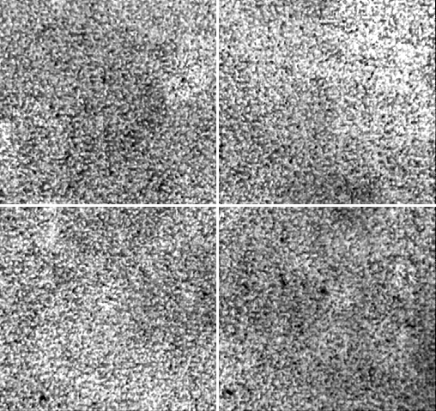 | 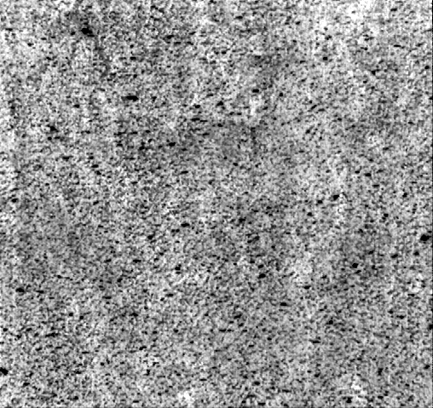 | 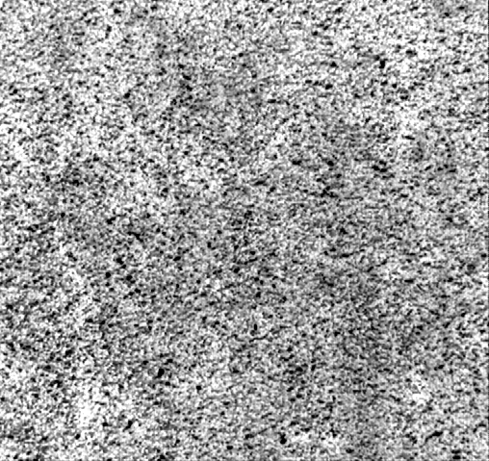 | 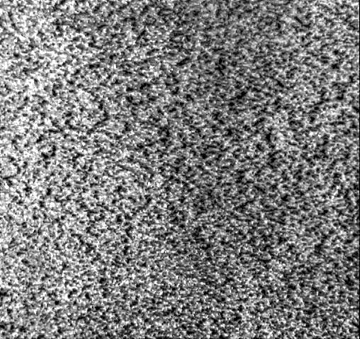
(a) Excellent | (b) Good | (c) Medium | (d) Bad
  - Results and Discussions
Table 1 shows a comparison of the classification performance of the leave-one-out validation results. The best-basis approach achieves the best classification performance among the three methodologies (WPT, DWT and best-basis approach). Moreover, the two proposed approaches (WPT and best-basis approach) are superior to DWT. Overall, the performances during testing were poorer than those during training.
Table 1. KNN estimates of steel surfaces
3-NN Estimates | DWT | WPT | Best-basis Approach
Classification Errors (Training) | 0.10092 | 0.043525 | 0.043371
Classification Errors (Test) | 0.27143 | 0.16429 | 0.14286
Number of Features Used | 13 | 340 | 156.01

Table 1 also shows a comparison of the number of features used in classification. In DWT and WPT, no selection of features is performed; hence, all the features generated by the wavelet transforms are used. The number of features for the proposed method is considerably greater than that for the previous DWT-based method.
The best-basis approach has least number of features but an efficient classification performance. This implies that the best-basis approach properly selects the most discriminative features; this proves that our simple rule using Fisher’s criterion is very efficient for selection.
The reason why the WPT and best-basis methods are more suitable for the classification of the steel images lies in the nature of the images themselves. Bharati et al. examined the (spatial) frequency distribution of steel images with different class labels [8]. Images from the Bad class had larger energy signatures in lower-frequency regions, while images from the Excellent class had larger energy signatures in higher-frequency regions. Therefore, the WPT is more suitable for classifying all classes equally well when the class information for an image is distributed across all frequency regions; this is because the WPT has an equal frequency bandwidth.
  - Conclusions
We examined the performance of the WPT instead of the DWT in texture classification problems. Our work proved that the WPT is more appropriate for characterizing steel surface quality than the DWT. But the WPT has higher dimensionality than the DWT, and in many pattern recognition problems, a high dimension of features is no guarantee for good performance. Hence, to solve the high-dimensionality problem, we added a simple feature selection stage to the framework. As a result, our best-basis approach showed better classification performances with fewer features than WPT. The two main contributions of our work are as follows: First, we proved that the WPT is more suitable for characterizing steel quality than the previous DWT. The reason for this is that the WPT has an equal frequency bandwidth. Second, we applied a simple best-basis approach for selecting the best discriminative features. Our work may be applicable to the classification of other images which have characteristics similar to those of steel images, where important textural information lies not only in the lower-frequency regions, but also in the middle- and higher-frequency regions.

References
[1] J.J. Liu, D. Kim and C. Han, Ind. Eng. Chem. Res., 46 (2007) 5152.
[2] N.M. Rajpoot, Texture classification using discriminant wavelet packet subbands. In: Proceedings of 45th Midwest Symposium on Circuits and Systems, MWSCAS-2002, vol. 3, pp. III-300-III-303.
[3] N.M. Rajpoot, Proc. SPIE, 5207 (2003) 774.
[4] J.J. Liu, Machine Vision for Process Industries Monitoring, Control, and Optimization of Visual Quality of Processes and Products, McMaster University, Hamilton, 2004.
[5] J.J. Liu, J.F. MacGregor, C. Duchesne and G. Bartolacci, Minerals Engineering, 18 (2005) 65.
[6] J.J. Liu and J.F. MacGregor, Ind. Eng. Chem. Res., 44 (2005) 4687.
[7] J.J. Liu and J.F. MacGregor, Machine Vision and Applications, 16 (2006) 374.
[8] M.H. Bharati, J.J. Liu and J.F. MacGregor, Chemometrics and Intelligent Laboratory Systems, 72 (2004) 57.
[9] T. Chang and C.C.J. Kuo, IEEE Transactions on Image Processing, 2 (1993) 429.
[10] N. Saito and R.R. Coifman, Journal of Mathematical Imaging and Vision, 5 (1995) 337.
[11] R.O. Duda and P.E. Hart, Pattern Classification and Scene Analysis, Wiley, New York, 1973.

