Process Real-Time Optimization using Evolutionary Improvement Algorithm
Seunghyok Kim, Seungjune Choi, En Sup Yoon*
* Department of Chemical and Biological Engineering, Seoul National University
Shillim-dong 56-1, Kwanak-gu, Seoul, Korea Republic

Abstract
A conventional Real-Time Optimization (RTO) system can not deal with the higher frequency disturbance because the steady-state should be achieved to execute RTO system. And the performance of optimization is highly dependent on the process complexity. And RTO is a model-based process control approach that use current process information (i.e. process model and economic data) to predict the optimal operating policy for a process unit during the next RTO interval. Although most RTO systems attempt to improve model accuracy through model updating, there are always problems such as plant/model mismatch. Most process models are incomplete because they use principle model with many assumptions.
This study proposes an effective framework for process real-time optimization. The proposed RTO framework with evolutionary improvement algorithm does not wait for the steady-state and it corrects the set-point continuously through the similar way that genetic algorithm exploit to find optimal points. It can deal with higher frequency disturbances and be less influenced by control system performance. Moreover, it is able to address the convergence to suboptimal. The performance of proposed method was successfully illustrated by Tennessee Eastman process.

Keywords: real-time optimization, evolutionary method, genetic algorithm
  - Introduction
Process optimization methodology has developed in many aspects. One of those aspects, real-time optimization (RTO) which affect process profitability has taken a great role in process operation and optimization. Real time optimization or on-line optimization has been shown to yield a significant increase in plant profit for many different applications. The objective of real time optimization system is to operate the plant as optimum operating conditiions nearly at transient moments.
Applying real-time optimization can increase production rates and yield improvement in chemical plant so that it becames decisive technique. RTO has become more and more common in the chemical process industry because of improved technology, its ability to estimate the optimum operating conditions of a process accurately, and the increase in profit that can be attained. However, currently, RTO presents following drawbacks : 1) steady-state must be achieved for optimization, 2) to implement the set-points resulting from the optimization, the plant must still be in the original steady state, 3) the magnitude of set-point changes must be bounded for safety reasons.

  - Real-time evolution
    - Real-time evolution for continuous process
In practical real-time optimization application, the goal is to solve the problem in an efficient way. To accomplish this, it should be needed to deal with the changing conditions originated from the disturbances that affect the profit significantly.
The proposed method is to obtain a continuous adjustment of set-point values, according to current disturbance measurements, present operating conditions and a steady state model called real-time evolution (RTE) (Sequeira, 2002). Conventional RTO must not be performed until steady state is attained. RTE, however, does not wait for the process to reach steady state to begin moving the process towards a new optimum. When a disturbance is measured, RTE will calculate a new optimum even if the process is not at steady state. To adapt the changing conditions, RTE improves the operating condition continuously by similar way which the genetic algorithm finds the optimum. Moreover, RTE uses disturbance measurements, current setpoints, and rigorous models to find the new optimum during the transient periods. But the RTO, when several decision variables are involved, the optimization procedure might require too much time. Even worse, if the solver is not sufficiently robust, it might not converge. To implement the set points resulting from the optimization, the plant must still be in the original steady state. Finally the magnitudes of setpoint changes must be bounded for safety reasons. Thus it is not clear which setpoints should be implemented when setpoint changes resulting from optimization exeed the bounds. On the other hand, RTE will slightly move the setpoint towards a better objective function value at the corresponding steady state immediately after the disturbance begins.
On this wise, regarding the information exchange with the control system, there is a subtle difference between RTO and RTE.
    - Real-time evolution with genetic algorithm
The RTE system can be more effective than typical RTO because it can produce a successive improvement of process performance. However the RTE with direct search requires more operating conditions and its computation time than RTO.
In order to improve the shorcomings of conventional RTO and RTE with direct search methods, an effective method can be proposed. The proposed improvement algorithm is analogous to the genetic algorithm which finds the optimum with given constraints. This algorithm is independent to the problem complexity because it does not use the objective function derivative or Hessian matrix and only use the objective function value itself and can provide a global search method. And these computation time increase just linearly with problem size.
    - Outline of the proposed algorithm
As genetic algorithm obtains the optimum through evolutionary procedure, so the proposed framework implements evolutionary improvement algorithm for real time optimization. The algorithm begins by creating a random initial population within specific region around current process operating condition. The algorithm then creates a sequence of new populations or generations. At each step, the algorithm uses the individuals in the current generation to create the next generation. To create the new generation, the algorithm performs the following steps: a) it scores each member of the current population by computing its fitness, b) scales the raw fitness scores to convert them into a more usable range of values, c) selects parents based on their fitness, d) produces children from the parents. Children are produced either by making random changes to a single parent (e.g. mutation) or by combining the vector entries of a pair of parents (e.g. crossover) and e) replaces the current population with the children to form the next generation. When the algorithm generates specific generation step size, the average value of current improved population is implemented as new adjusted setpoint of process. The control system receives above values. Using this evolutionary improvement algorithm, the proposed RTO system is able to adapt external disturbance continuously. First, the random generation is conducted and then initial population generates around initial operating condition. And it adapts external disturbance, finally improves with genetic operator and converges to global optimum.
    - Constraints
There are several techniques to handle constraints with genetic algorithm such as rejecting method, repairing method and penalty method. A rejecting method discards all infeasible chromosomes created throughout evolutionary process. It is simplest but least effective way. A repairing method involves taking an infeasible chromosome and generating a feasible one through a repair procedure. It is used as solving combinational optimization problems. A penalty method is the most common technique used in genetic algorithms for constrained optimization problems. This technique transforms a constrained problem into an unconstrained problem by penalizing infeasible solutions, which a penalty term is added to the objective function for any violation of constraints.

(1)
where
f : the value of scaled fitness function
f_{avg} : average value of f at current generation
f’ : fitness value with penalty term
gen : the number of current generation
max_gen : the number of termination generation
ref_gen : reference generation

The function, Φ_{hi} and Φ_{gi}, represent intensity of constraints violation and it is defined as following equations.

(2)

  - Case study
    - Tennessee Eastman Process
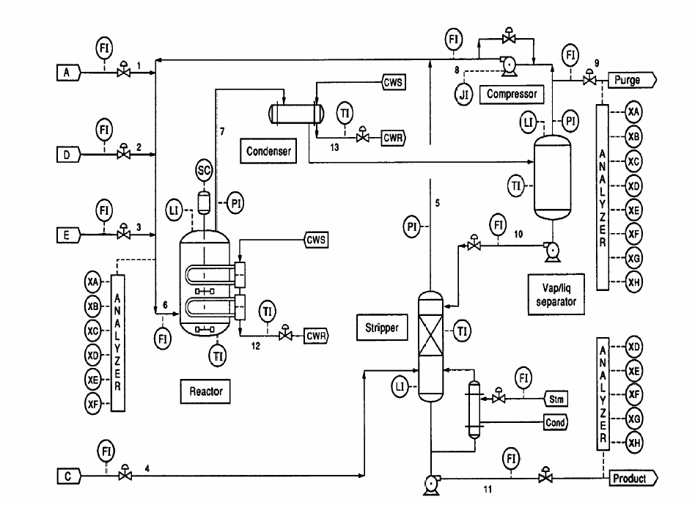
The Tennessee Eastman plantwide industrial process developed by Downs and Vogel (1993) is an ‘industrial challenge problem’ for researchers in process control and related fields. The process involves five unit operations: a two-phase reactor, a condenser, a vapour/liquid separator, a stripper and a recycle compressor. The process produces two products (G and H) from four reactants (A, C, D and E). A further inert trace component (B) and one byproduct (F) are present. The reaction stoichiometries are,
Fig. 1. Tennesee Eastman process
(3)
(4)
(5)
(6)
These reactions are irreversible and exothermic with rates that depend on temperature and on the reactor gas phase concentration of the reactants. The process consists of a continuous stirred tank reactor, a condenser, a flash drum and a stripper. The reactants A, C, D and E are partly converted into products G, H and the byproduct F. The heat of reaction is removed by an internal heat exchanger using water as coolant. The products and unreacted reactants leave the reactor as vapour. The original process has 12 manipulated variables and 41 measurements. The 22 measured process variables (F1 to T22) which are sampled every 3 minutes and the 19 composition measurements (XA to ZH) are obtained from stream 6, 9 and 11. All the process measurements include Gaussian noise.
    - Scenario
The objective function is to minimize operating cost. The operating cost is determined by following equation,
(7)
The operating cost is highly dependent on the cost of purged reactants. The decision variables or the setpoints of controllers are selected as follows: product component E, purge component B, reactor level, reactor pressure, reactor temperature, recycle flow, product separator level, stripper level. The comparative case is the conventional RTO system which uses the principle models of each unit’s material and energy balance. And above equation (7) will be executed every 30 minutes with the pre-decided genetic parameters (the number of population : 500, the number of elite individual : 30 and the percentage of crossover : 65%).
    - Results
In conventional RTO system, the steady state is detected in 12.3 hours approximately. The simultaneous implemenation of changed setpoints takes time to be settled on new operating condition and the decision variables which need not to change (separator level and stripper level) are purturbed by the other variables setpoint change (Fig. 2.). This fact implies system tend to be tightening the bounds associated to the setpoint changes or improving the controller’s performance.
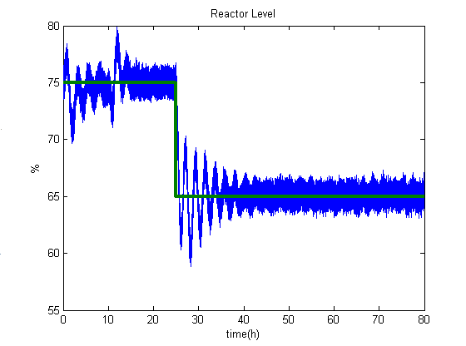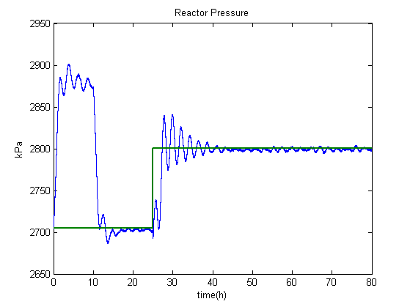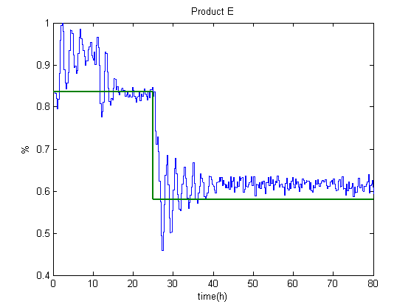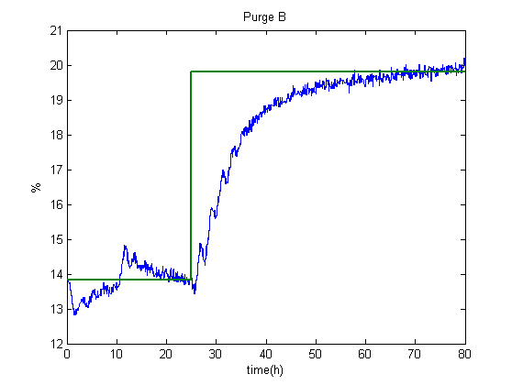
Fig. 2. Conventional RTO response

On the other hand, in the proposed RTE system, disturbed setpoints are corrected step by step then the system is progressively improving the operating points(Fig. 3.). And the settling time is much faster than the conventional RTO case. In spite of disturbances of other variables, separator level and stripper level are hardly affected.
Also, comparative results of conventional RTO and the proposed RTE with operating cost as the instantaneous objective function (IOF) can be shown in Fig. 4. More significantly, using the mean objective function (MOF) which contains the history of process and is defined as following equation, the comparative plot can be obtained.
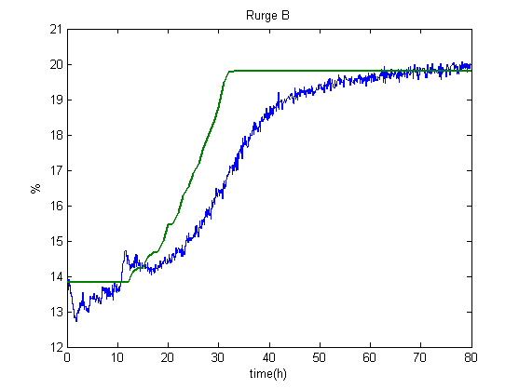
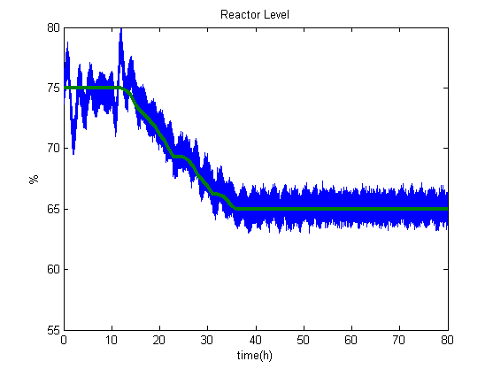
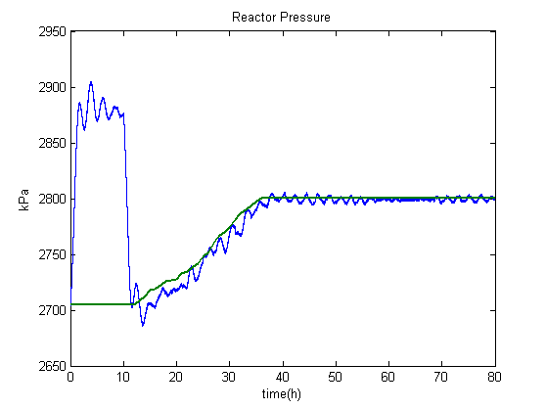
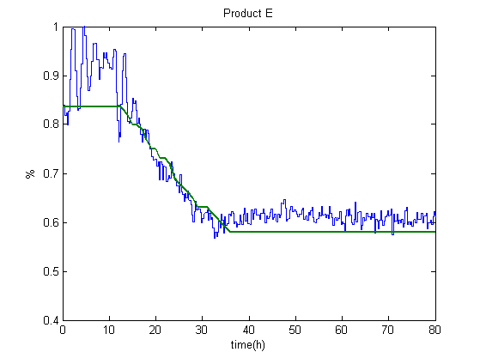
(8)
where
t : the current time
t₀ : reference instant

Surely, for this case, the proposed has produced faster improvement of MOF than the conventional RTO.
Fig. 3. The proposed RTE response
Fig. 1. IOF(left) and MOF(right) plot of conventional RTO and the proposed RTE
  - Conclusion
When disturbance information is available, above proposed framework keeps adjusting of setpoint values according to current disturbance measurements, present operating conditions and a steady state model. The adjusted setpoints are obtained by using genetic algorithm which need not to be steady state. The proposed method is very practical, simple and fast. And then, it is able to deal with higher frequency disturbance.
References
Sequeira, S.E. et al., “Real time evolution for on-line optimization of continuous processes”, Ind. Eng. Chem. Res., 41(7), 1815-1825 (2002)
Forbe, J.F. and Marlin, T.E., “Model accuracy for economic optimizing controllers: the bias update case”, Ind. Eng. Chem. Res. 33, 1919-1929 (1994)
Bhat, N. and McAvoy, T., “Information retrieval from a stripped back-propagation network”, AIChE Meeting (1990)
Karnin, E. D., “A Simple Procedure for Pruning Back-Propagation Trained Neural Networks”, IEEE Trans. on Neural Networks, 1, 239 (1990)
Forbe, J.F. et al., “Model accuracy requirements for optimizing plant operations”, Com. Chem. Eng. 18, 497-510 (1994)
Miletic, I. And Marlin, T. E., “On-line statistical results analysis in real-time operations optimization”, Ind. Eng. Chem. Res., 37, 3670-3684 (1998)

