Real time optimization of large scale processes: control of an autorefrigerated CSTR polymerization reactor
Eduardo C. Vasco de Toledoª, Delba N. C. Melo^{b}, Adriano P. Mariano^{b} and Rubens Maciel Filho^{b}
ªPetrobras SA, Paulínia Refinery (REPLAN), Rodovia SP 332 - KM 132, P.O. Box 1, CP13140-000. Paulínia, SP-Brazil.
^{b}Faculty of Chemical Engineering, State University of Campinas (UNICAMP), CP6066, CEP13083-970, FAX +551937883910. Campinas, SP-Brazil.
Abstract
The optimization and temperature control of an industrial CSTR polymerization reactor connected to a semi-flooded horizontal condenser (autorefrigeration technology), where bulk reactions take place via styrene free-radicals, is presented in this work. This work introduces an investigation study of the optimization of polymerization reactor to determine the optimal operating conditions and, in a second stage, advanced control algorithms are evaluated. The optimal operating condition or the set-points are defined in the optimization layer and then used in the advanced control layer. The real time process integration is carried out with the two-layer approach, where the control is set in a hierarchical structure and an optimization layer calculates the set-points to the advanced controller, based on the Generic Predictive Control procedure, predictive QGPC (model predictive controls with restrictions using optimization routine, SQP) and the adaptive STQGPC (predictive algorithms coupled to the identification algorithm RLS). The proposed two-layer approach for real time process integration, based on the SQP method as the optimization algorithm showed to be very efficient to control the reactor even with significant changes on the operating conditions, allowing to operate the reactor with efficiency and safety.

Keywords: polymerization, dynamic modelling, optimization, control, real time.
  - Introduction
Nowadays there is a significant incentive to develop optimization strategies, especially those related to real time process integration, where the process optimization is coupled with a model-based advanced predictive control. This is especially true for large scale processes as the polymerization one, where significant improvements and economics can be obtained with these strategies. However, the proper operation of a polymerization reactor that meets different product requirements is not an easy task, because of the complex reaction mechanism, the dramatic increase in the viscosity of reaction mixture and the highly nonlinear nature of polymerization processes. Besides, there is a lack of on-line process sensors to measure polymer properties. Therefore, sophisticated model based controllers are needed to ensure the safe and proper operation of these processes [1-3].
Polymerization reactors are also usually characterized by problems in their refrigeration. Difficulties for the heat transfer are due to properties variations, as viscosity, during the reaction phase, what generate hot spots with different conditions of temperature and concentration and consequent heterogeneity in the product. The traditional methods of jacket and cooling coils or external heat exchanger present low efficiency especially in the case of bulk polymerization reactions. An interesting alternative for the cooling of this type of process is to have a condenser connected to the reactor, which makes use of the solvent and/or reagents latent heat of vaporization as an effective mechanism to remove heat from the reactor. To achieve this, the reflux rate of the condenser is used to control its liquid level and, indirectly, control the reactor temperature. This control strategy is termed auto-refrigerated reactor, largely utilized for a great variety of exothermal reactions, including polymerization [4-10]. Thus, this work introduces an investigation study about the real time process integration of an autorefrigerated continuous polymerization reactor, where optimal operating conditions are determined and, in a second stage, advanced control algorithms are evaluated.
  - Autorefrigerated polymerization reactor
    - System
The case study considered in this work is the bulk polymerization via styrene free radicals, because this is a well-known process with many studies published in the literature, besides its great industrial importance. The description and kinetics of the reactions involved in the bulk polymerization of styrene via free radicals can be found elsewhere [7-9].
The configuration of the continuous polymerization reactor connected to a semi-flooded horizontal condenser is shown in Figure 1a. This technique of cooling by means of the latent heat of vaporization involves two mechanisms that quickly respond to temperature changes inside the polymerization reactor. In the first mechanism, the cooling area of the condenser increases directly as a result of temperature increase in the reactor, lowering the level of condensed monomer. In the second mechanism, the volume of condensed monomer displaced from the condenser is fed back into the reactor, generating an instantaneous cooling effect [7-9].

    - Process Model
A detailed deterministic mathematical model was formulated to represent in a more realistic way the dynamic behaviour of the CSTR plus semi-flooded horizontal condenser. It consists of an ordinary differential equation system that represents the effects of volume contraction, auto acceleration (gel) and the effect of non-condensable gases. The model also takes into account the variation of the physical properties, of the reaction heat, of the global coefficient of heat transfer, and uses the Flory-Huggins equation to describe the reactor pressure. Integration was obtained with the routine LSODAR, used for the integration of stiff ODE systems.
Equations and more details about the modelling, dynamic behaviour and description of the system operation are given in some published works [4-9].
    - Advanced Control and Real Time Optimization
The controlling of polymerization reactors is a difficult task due to the dynamic characteristics of the system, which is complex and non-linear. This reactor presents great heat exchange difficulties in practice due to the polymeric incrustation in the reactor wall and the increase of reaction medium viscosity that makes the heat exchange difficult when a traditional method is used. Moreover, there are difficulties in measuring the polymers structural characteristics in real time. The difficulty in defining the several objectives for the control of the reactor temperature, with the purpose of achieving the desired products specifications and overcoming the inherent difficulties of these processes, also makes this a complex task. However the semi-flooded horizontal condenser showed to be an efficient refrigeration system for the CSTR reactor where the bulk styrene free radical polymerization happens [7-9]. A temperature controller connected to the reactor, operating in cascade with a level controller, associated to the condenser, makes the temperature control. The system periodically purges the non-condensable gases from the condenser, which prevent the level of condensed fluid from reaching critical values. This control scheme has proved to be efficient for this system and more details can be obtained in elsewhere [7-9]. In Figure 1a, TC is the temperature controller, NC the condenser level controller and V the valve that sends the condensate back to the reactor (reflux rate of the condenser, Fc).
Although several studies on modelling and control have been made for such system it is important to study the problem of control and optimization in a real fashion. The real time process integration involving optimization and process control can be carried out simultaneously or sequentially. The traditional structure is built in two layers, as seen in Figure 1b. In this case, the optimization layer calculates the reference values used sequentially by the advanced control layer.

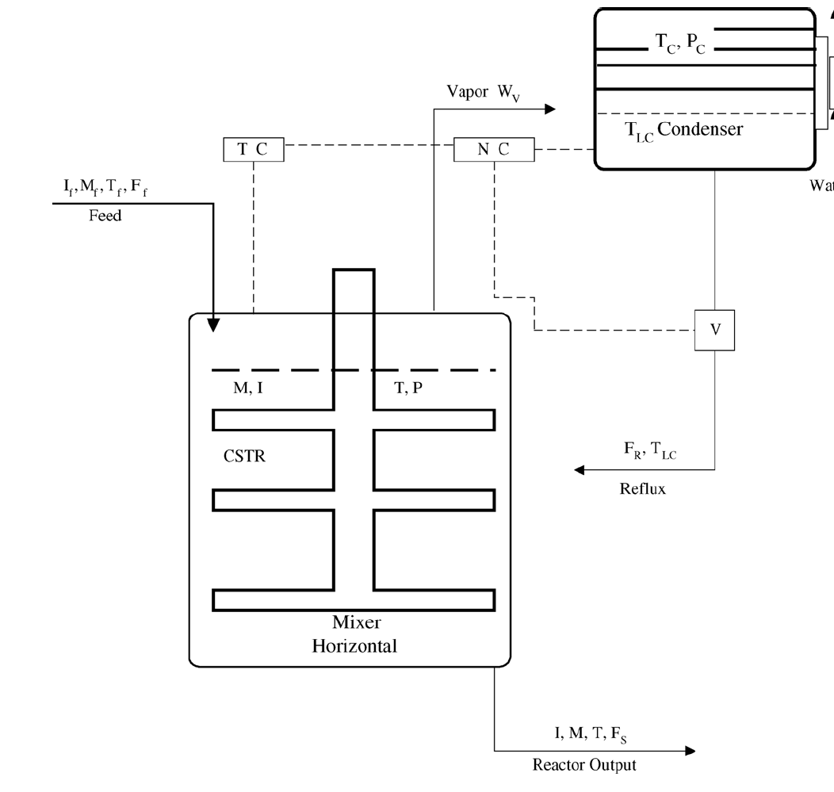  (a) | (b)
Figure 1. (a) Scheme of a CSTR connected to a semi-flooded condenser. (b) Real time process integration - two-layer structure

The polymerization reactor is a nonlinear multivariable system with a relatively large number of operating variables that can be chosen as decision variables. The optimization performance is dependent on the right choice, what is not a trivial task. Besides, due to the nonlinearity of the system, local minimums can be found and the solution trajectory can be a function of the initial estimates. Another point to be considered is the interaction between variables and their impacts in the behaviour of the process.
Therefore, in this work the real time process integration is carried out with the two-layer approach, where the control is set in a hierarchical structure and an optimization layer calculates the set-points to the advanced controller, based on the Generic Predictive Control procedure, predictive QGPC (model predictive controls with restrictions using optimization routine, SQP) and the adaptive STQGPC (predictive algorithms coupled to the identification algorithm RLS).
The mathematical description of the optimization problem considered in this work can be seen as follow:

Objective function: $\underset{T_{f}}{\text{min}}(T−T_{\text{reference}})^{2}$ | (1)
subject to: 1) Fc^{min} ≤ Fc ≤ Fc^{max} ; Fc^{min} = 0.7*Fc; Fc^{max} = 2.0*Fc;
2) model equations: steady-state.

Where Fc is the reflux rate of the condenser; T is the reactor temperature and the value of T_{reference} is specified to keep the conversion of the process in a suitable operating range.
Therefore, the optimization is designed to minimize the temperature difference (T-T_{reference}) in face to new feed conditions (previously known) before they affect the process. The result of the optimization is a new set-point sent to the advanced controller, aiming a better performance of the controller under the new conditions.
With the control of the reactor temperature, indirectly the conversion is kept in a desired range. However, it is important to stress that for a more accurate control of the polymer properties, it is necessary to control other variables besides the temperature (multivariable control).
The two-layer procedure allows to conciliate the larger computational time demanded by the optimization layer with the control layer, aiming the real time process integration.
  - Results
Regarding the control of the reactor, Figures 2 and 3, respectively, present the supervisory and regulatory control of the system without the optimization layer (RTO). The best performance of the long-range quadratic predictive algorithm (QGPC), over the quadratic predictive adaptive algorithm (QSTGPC), is visibly noticeable.

Figure 2. Supervisory control (without RTO). | Figure 3. Regulatory control (without RTO).

However, the performances of both algorithms are superior to those of classical algorithms reported in previous works [7-9]. As advanced controllers have more complex algorithms with a greater number of tuneable parameters, they can interfere more efficiently in the dynamic characteristics of the system.
Examples of the control of the reactor with the optimization layer can be seen in Figures 4 to 9. In all cases, the control was carried out with the QGPC algorithm, since the previous analysis showed that this algorithm has a superior and more robust performance in relation to the QSTGPC algorithm.

Figure 4. Temperature dynamic behaviour with RTO. Directly controlled. | Figure 5. Conversion dynamic behaviour with RTO. Indirectly controlled.

Figures 4 and 5 show the temperature and conversion dynamic profiles in close loop when the feed temperature of the polymerization reactor (Tf) is altered by 5 %. Based on the knowledge of the alteration in the feed condition of the reactor, the optimization layer is activated and generates a new set point to the advanced controller, QGPPC, aiming to keep the reactor temperature (indirectly the reactor conversion) close to the value before the perturbation in Tf. In these Figures it is possible to observe that the optimization layer (RTO) is able to provide the suitable set point to keep the temperature and conversion values close to the desired values.
The next cases (Figures 6 and 7) present, respectively, the temperature and conversion profiles when there is an alteration of 5 % in both feed concentration of monomers (Mf) and feed temperature (Tf). The optimization layer is activated to generate a new set point to the controller and despite the changes in the feed conditions, the two layer strategy is again able to keep the reactor operating at the desired conditions.

Figure 6. Temperature dynamic behaviour with RTO. Directly controlled. | Figure 7. Conversion dynamic behaviour with RTO. Indirectly controlled.

In the sequence, Figures 8 and 9 show the case where there is a change in the reactor temperature set point of 10º K (supervisory control) followed by an alteration of 5 % of the feed temperature (Tf), with the optimization layer generating a new set point to keep the reactor in the desired operating conditions. As in the previous cases, the control based on the two layer approach successfully delivers its objectives.

Figure 8. Temperature dynamic behaviour with RTO. Directly controlled. | Figure 9. Conversion dynamic behaviour with RTO. Indirectly controlled.

The profiles of the manipulated variables are qualitatively similar to the controlled one and, if necessary due to operating restrictions, their variation ranges can be reduced by tuning the controller parameters.
Therefore, the results show that the two-layer approach (optimization layer and advanced control) provides a robust, fast and efficient control of the autorefrigerated polymerization reactor in face to alterations of the feed concentration and temperature, as in the cases of supervisory and regulatory controls demanded during the operating routines in an industrial plant.
  - Conclusions
The integration optimization and control in a real time fashion of the autorefrigerated polymerization reactor was presented in this work, where the controllers QGPC / QSTGPC and the SQP optimization method were employed. The optimization layer was designed to keep the temperature and indirectly the conversion, close to the reference values, independently of the perturbations in the process. Generally, the two-layer approach presented a good performance, being a good strategy to keep the polymerization reactor operating at desired conditions suitable to produce polymers under specifications.
References
[1] G. Özkan, S. Özen, S. Erdogan, H. Hapoglu and M. Alpbaz, Comp. Chem. Eng., 25 (2001) 757.
[2] V. Prasad, M. Schley, L. P. Russo and B. W. Bequette, J. Proc. Control, 12 (2002) 353.
[3] S. Hur, M. Park and H. Rhee, Korean J. Chem. Eng., 20(1) (2003), 14.
[4] W. L. Luyben, J. Proc. Control, 9(4) (1999) 301.
[5] L. S. Henderson, Chem. Eng. Prog., 83(3) (1987) 42.
[6] L. S. Henderson and R. A. Cornejo, Ind. Eng. Chem. Res., 28(11) (1989) 1644.
[7] E. C. Vasco de Toledo, R. F. Martini and R. Maciel Filho, Comp. Chem. Eng., 24 (2000) 481.
[8] E. C. Vasco de Toledo, R. F. Martini, M. R. Wolf Maciel and R. Maciel Filho, Comp. Chem. Eng., 29 (2005) 1447.
[9] E. C. Vasco de Toledo, R. F. Martini, M. R. Wolf Maciel and R. Maciel Filho, Can. J. Chem. Eng., 84(4) (2006) 469.
[10] S. Arora, R. Gesthuisen and S. Engell, Comp. Chem. Eng., 31 (2007) 552.

