Hybrid strategy for real time optimization with feasibility driven for a large scale three-phase catalytic slurry reactor
Delba N.C. Meloª, Adriano P. Marianoª, Eduardo C. Vasco de Toledo^{b}, Caliane B. B. Costaª and Rubens Maciel Filhoª
ªLaboratory of Optimization, Design and Advanced Control (LOPCA).Faculty of Chemical Engineering; State University of Campinas (Unicamp). P.O. Box 6066 - 13081-970, Campinas, SP, Brazil. delba@lopca.feq.unicamp.br
^{b}Petrobras SA, Paulínia Refinery (REPLAN),Rodovia SP 332 - KM 132, P.O. Box 1, CP: 13140-000. Paulínia, SP- Brazil.
Abstract
In this work it is proposed a suitable hybrid optimization algorithm built up with the association of global and local optimization methods. The adopted computer assisted approach is driven by the need for a global optimization method characterized by efficiency in terms of reduced computational time and efforts whereas being robust. The basic idea is to join the fast convergence properties of gradient-based optimization methods with the wide exploration ability of population-based ones, which makes the developed algorithm a useful tool in real-time applications. Since unavoidable disturbances are present during process operation, efficient optimization algorithms must be available to deal in an on-line fashion with high dimensional and non-linear processes. In the developed code, a Genetic Algorithm (GA) is designed to provide an estimate of the global optimum. Then, a local method of search (the Sequential Quadratic Programming, SQP) is used to improve this candidate solution. As case study, the optimization of a three-phase catalytic slurry hydrogenation reactor is considered. The optimization algorithm determines, in real time, the optimal operating condition, defined in terms of maximization of profit. This condition should then be used in an advanced control layer. The results of the hybrid approach are compared with those obtained only considering the micro-GA. The latter approach was able to, alone, solve the optimization problem, but using a large number of generations and, consequently, with higher computational time. The advantage of the hybrid algorithm are that fewer number of generations is employed prior to the SQP utilization. Thus, the new GA-SQP code was able to determine the final solution considerably faster than the isolated GA, reducing the number of functions evaluations for solutions when compared to the number required for the GA to stop the evolution. The hybrid algorithm drives to feasible solution translated into higher profits at reasonable computational costs, being identified as a robust optimization code, useful in real time optimization applications.

Keywords: Real-time Optimization, Genetic Algorithm, Sequential Quadratic Programming, Hybrid Algorithms, Hydrogenation Reactors.
  - Introduction
On-line optimization must cope with the variability of the process conditions, originated by disturbances that significantly affect the process economy.
The present work introduces a hybrid optimization algorithm, GA-SQP, which joins an initial genetic search to a deterministic optimization algorithm (Sequential Quadratic Programming, SQP). This sort of hybrid algorithm is demanded for efficient online optimization of high dimensional and non-linear processes, in which purely deterministic optimization algorithms normally fail to drive the process to the global optimum.
In order to illustrate the application of the developed hybrid algorithm, the optimization of a three-phase hydrogenation catalytic slurry reactor is considered. The study aims to determine the optimal operating conditions that lead to maximization of profit.
Some researchers have combined various optimization algorithms to improve the search efficiency and computational effort, including evolutionary algorithms (EA), simulated annealing (SA), particle swarm optimization (PSO), ant colony optimization (ACO), hybrid PSO-SQP, hybrid GA-ACO. Nevertheless, the combination of the GA and SQP algorithms is reported only in a few works [1,2].
  - Case Study- Three-phase hydrogenation catalytic slurry reactor
In order to show the efficiency and applicability of the hybrid optimization algorithm, the three-phase catalytic reactor, in which the hydrogenation of o-cresol to 2-methyl-cyclohexanol takes place, is considered. This process was modeled by Mariano et al. [3]. The resistances to mass and heat transfers at the gas–liquid and liquid–solid interfaces, the heat exchange with the coolant fluid and the consideration of the physicochemical properties variation, which impacts on the mass and heat-transfer coefficients, were considered. The rigorous model also included a multi-component flash to consider the effect of the phase change of the reacting medium on the reactor dynamic behavior, as well as an appropriate procedure of correction of the global heat-transfer coefficient to represent the phase change of the refrigerant fluid. The model developed by Mariano et al. [3] is therefore here used as internal process model for the optimization routine, which seeks the optimal process conditions that drive the reactor to maximization of profit.
  - Proposed Hybrid Optimization
The proposed hybrid optimization algorithm is built up with the association of global and local optimization methods. The basic idea is to join the fast convergence properties of gradient-based optimization methods with the well-known ability of population-based ones, which makes the developed algorithm a useful tool in real-time applications. In the developed code, a Genetic Algorithm (GA) is designed to provide an estimate of the global optimum. Then, a local method of search (Sequential Quadratic Programming, SQP) is used to improve this candidate solution. Figure 1 illustrates the basic idea of the hybrid algorithm. The hybrid optimization starts with the GA, which executes all subroutines until the specified number generations; the algorithm then shifts to the SQP, which is a faster method.
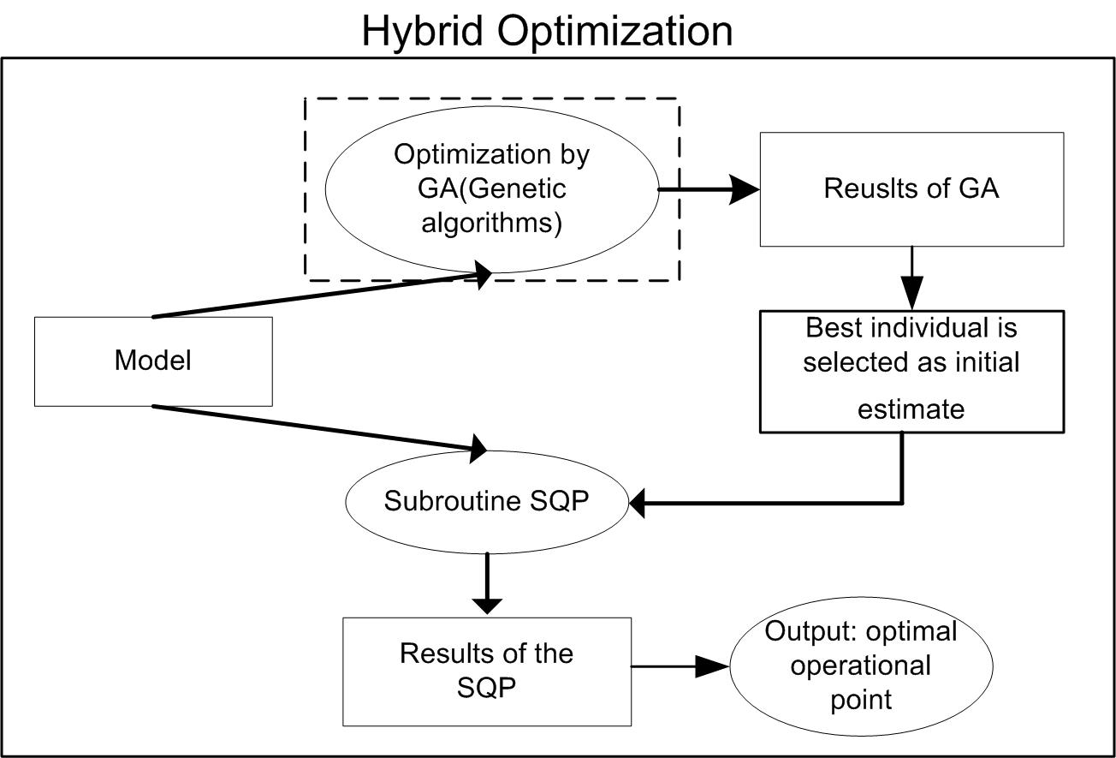
Figure 1. Flowchart of the GA-SQP Hybrid Optimization Algorithm.
  - Optimization Problem Applied to the Case Study
    - Selection of the decision variables
The decision variables used for the optimization of the reactor must be selected among the operating ones. After considering industry requirements, the effect of each of the operating variables on the objective function and the easiness of how these variables can be changed in the plant, the feed flow rate of hydrogen (FAo) and the reactor feed temperature (Tfo) were chosen as the decision ones. Thus the optimization routine searches for the values of FAo and Tfo that, with the current value of o-cresol flow rate, lead to maximal reactor profit.
    - Selection of objective function
The optimization of any industrial process aims the profit maximization. Thus, the profit function is a natural choice as an objective function. The profit function, as outlined by Xiong and Jutan [4] and Sequeira et al. [5], can be calculated based on the selling price of the products and on the costs of raw materials, operation and energy. Then, in this work, the objective function, adapted to the multiphase reactor, is as follows:
Profit = a*(FC) – b*(FAo-FA) – c*(FBo-FB) (1)
where a is the selling price of the reaction product and b and c are the costs of raw materials; FA, FB and FC are the molar stationary flow rates of hydrogen, o-cresol and 2-methyl-cyclohexanol at the reactor exit, respectively and FAo and FBo are the flow rate of hydrogen and o-cresol in the feed. In Eq. (1), it is considered that there is a recycle of unreacted hydrogen and o-cresol. Since the remaining operating costs are fixed (salaries and others) and the energy cost related to the utilities can be considered negligible (the excess heat generated by the chemical reaction can be removed without significant cost [6]), the terms related to operating and energy costs do not appear in Eq. (1). It is important to stress that this work considers just the reactor itself in the hydrogenation plant and, therefore, the higher the o-cresol conversion, the greater the profit is expected to be. In this way, separation costs are not considered and, consequently, the profit here maximized is referred only to the reactor operation. Obviously, upstream and downstream operations have their own costs, which would decrease the calculated profits of Section 5.
    - Optimization Problem
The optimization problem considered is expressed by Eq. (2).
$\begin{aligned}\underset{(\text{FAo, Tfo})}{\text{Maximize }} \text{Eq}\text{.}(1) \\ \text{subject to model equations}\end{aligned}$ (2)
In order to search for the optimum, the relations between variables must be given to an optimization algorithm. This is here provided by the model equations developed by Mariano et al. [3]. The model calculates all mass and heat transfers, besides the hydrogenation reaction rate. Since there are three phases (the catalysts is solid, the hydrogen is a gas and the o-cresol is liquid), both reactants must come to the solid pores, where the reaction takes place, and the unreacted reactants and the reaction product must then leave the catalyst particle. All these phenomena are accounted for by partial differential equations for mass and energy balances for each component in each phase.
Since the feed flow rate of hydrogen and the reactants temperature are searched for, the upper and lower bounds stipulated for these variables in the optimization algorithms were selected according to the hydrogenation reaction stoichiometry and practical possible temperatures. For the optimizations here accomplished, the o-cresol feed rate was considered to be 1.29 kmol/h. In this way, Table 1 shows the lower and upper bounds of the considered decision variables.
Table 1. Lower and upper bounds of the decision variables
Variable | Lower bound | Upper bound
FAo (kmol/h) | 1.07 | 6.44
Tfo (K) | 450.0 | 650.0
  - Results and Discussion
    - Optimization by Genetic Algorithm (GA)
A binary micro genetic algorithm (GA) code was run for 50 generations with 5 individuals, totalizing 250 evaluations of the objective function. A maximum number of generations were used as stopping criterion in the genetic programming. The values for the crossover, the jump mutation and creep mutation probabilities (the genetic algorithm parameters) were previously optimized and the best ones were 0.5, 0.02 and 0.02, respectively. These values were the ones used in all optimization trials using the GA in this work.
Table 2 brings the characteristics of the optimal operating point found solely by a micro-GA for the 50 generations, as well as the computational time demanded for the search (on a 2.8 GHz 768 Mb RAM AMD Athlon processor).

Table 2. Optimal response found by micro-GA
Optimal point and run characteristic | Value
Profit (US$/h) | 467.02
o-cresol conversion (%) | 94.37
FAo (kmol/h) | 1.16
Tfo (K) | 649.2
Computational time (min) | 184

Figure 2 shows the profit evolution for the best individual in each generation. This Figure shows how the solutions evolve in the 50 generations. Clearly the profit increases rapidly in the beginning of the search, but, after some generations, the rate of improvement gradually ceases, until almost no gain in the objective function is achieved in the last generations.
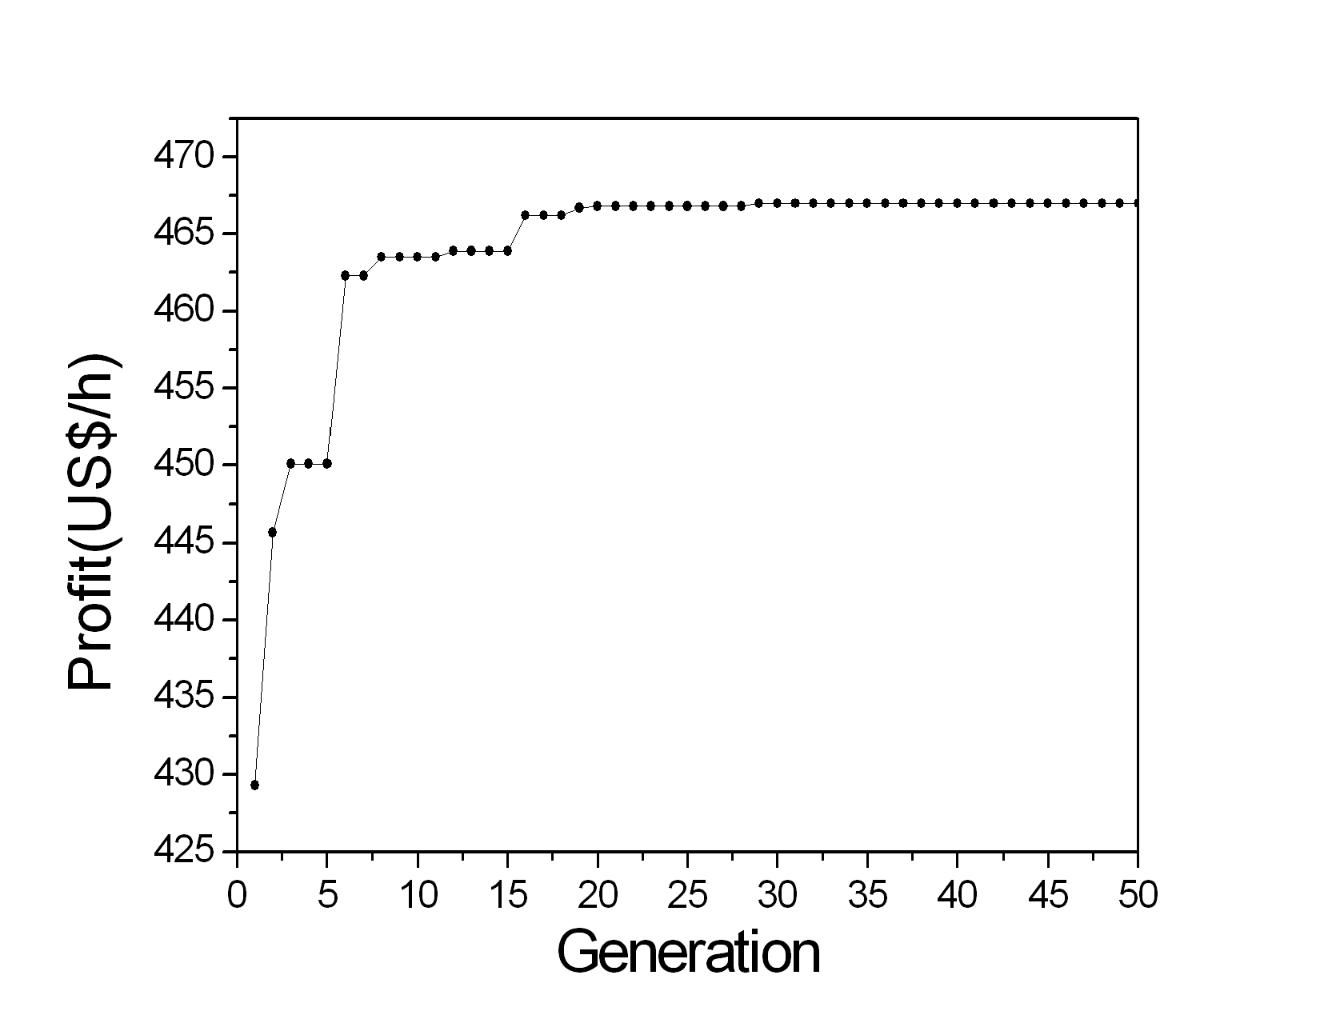
Figure 2. Evolution of the profit for each generation in a solely micro-GA optimization run
    - Hybrid optimization
As it was observed in item 5.1, the GA was able to solve the problem after a large number of generations, consuming around 3h of CPU time, although it was also observed that the best fitness value does not change after a number of generations. In this way, a hybrid approach has been used, which couples GA with SQP. The GA procedure is used in the first stage to find a solution (i.e. an individual) within the attraction domain of the supposed global optimum. This solution is then used as initial guess for the SQP algorithm.
The GA-SQP hybrid algorithm was built in order to run a micro-GA with the same code parameters as in section 5.1, except by the maximal number of generations, which was stipulated to 5. Afterwards, a SQP algorithm is used to improve the best individual found by the GA. Table 3 brings the optimal characteristics found by the hybrid algorithm, as well as the computational time the code demanded for the search.

Table 3. Optimal response found by GA-SQP
Optimal point and run characteristic | Value
Profit (US$/h) | 467.90
o-cresol conversion (%) | 94.54
FAo (kmol/h) | 1.07
Tfo (K) | 650.0
Computational time (min) | 13

The hybrid structure was proved to be of high efficiency. First of all, it is easy to see, from Tables 2 and 3 that the profit and conversion are slightly greater for the optimal point found by the GA-SQP algorithm. Secondly, and very importantly, the computational time was significant lower for the hybrid algorithm, with scales compatible with real time applications for a supervisory control.
The time demanded for an optimization algorithm to solve the problem is a consequence of the number of function evaluations it uses to come to the response. The micro-GA (section 5.1) evaluated the profit 250 times, each one for each individual of each generation. The GA-SQP, however, demanded just 31 function evaluations and, even so, achieved a better objective function value than the isolated micro-GA. The evolution of both algorithms (isolated GA and GA-SQP) during the search, as a function of objective function evaluations, is shown in Figure 3.
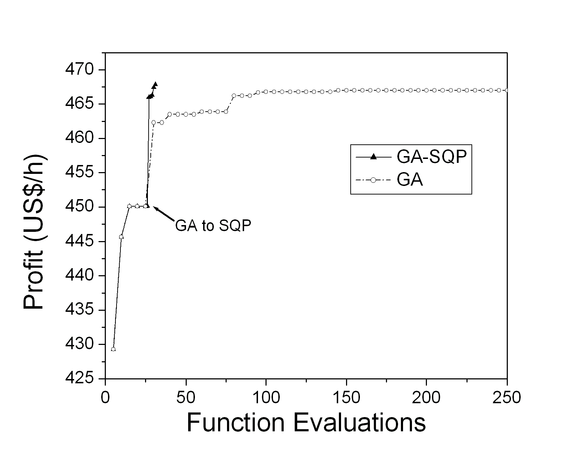
Figure 3. Trajectory of GA and GA-SQP methods towards the optimum point
  - Conclusions
A hybrid optimization algorithm was developed joining a genetic search (GA) to the Sequential Quadratic Programming (SQP) algorithm. The developed code had its efficacy tested in the maximization of a hydrogenation reactor profit. Although no proof of convergence is available for GA-based codes in literature, the hybrid algorithm was able to solve the optimization problem, achieving a better optimal point within only 7% of the time demanded by a rigorous GA search. The computational time the GA-SQP algorithm solves the problem makes it a useful tool for real-time applications in a supervisory control structure.
Acknowledgements
The authors acknowledge FAPESP (Fundação de Amparo à Pesquisa do Estado de São Paulo) for the financial support given to this work.
References
[1] B. Mansoornejad, N. Mostoufi and F. Jalali-Farahani, Chem. Eng., in Press (2007).
[2] R. Faber, H. Arellano-Garcia and G. Wozny, 2007. A Hybrid Optimization Approach to parameter Estimation. In: V. Plesu and P. S. Agachi (Eds.), Proceedings of the 17th European Symposium on Computer Aided Process Engineering (ESCAPE 17), Bucharest, Romania.
[3] A. P. Mariano, E. C.Vasco de Toledo, J. M. F. Silva, M. R. Wolf-Maciel and R. Maciel Filho, Comp. Chem. Eng., 29 (2005), 1369.
[4] Q. Xiong, A. Jutan, Chem. Eng. Sci., 58 (2003), 3817.
[5] S. E. Sequeira, M. Herrera, M. Graells and L. Puigjaner, Comp. Chem. Eng., 28 (2004), 661.
[6] J. F. Forbes, T. E. Marlin and J. F. MacGregor, Comp. Chem. Eng., 18(6) (1994), 497.

