Optimization and control for real time integration of the biotechnological process of acrylic acid synthesis: a two-layer approach using model predictive control application
Betânia H. Lunelli,ª Delba N. C. Melo,ª Eduardo C. Vasco de Toledo,^{b} Maria Regina Wolf Maciel,ª Rubens Maciel Filhoª
ªLaboratory of Optimization, Design and Advanced Control, Department of Chemical Processes, School of Chemical Engineering, State University of Campinas
P.O. Box:6066, Campinas, São Paulo, 13083-970, Brazil
^{b}Petrobras SA, Paulínia Refinery (REPLAN), Rodovia SP 332, KM 132, P.O. Box: 1, Paulínia, São Paulo, 13140-000, Brazil
Abstract
In this paper is presented the modeling, optimization and control of an alternative process for the acrylic acid biotechnological synthesis. The model is based on the concepts of structured representation, and adapted from a structured growth model. The bioreactor is continuously operated and for the control of its high productivity, strategies of control and optimization involving two-layer approach are proposed and evaluated. In this approach the control is set in a hierarchical structure, where an optimization layer calculates the set point for the advanced control. The Successive Quadratic Programming (SQP) and Levemberg-Marquardt Method are used as optimization algorithms and the advanced control is based on the Dynamic Matrix Control (DMC). The proposed two-layer approach for real time optimization showed to be able to achieve high operational performance for the alternative biotechnological process to acrylic acid synthesis.

Keywords: biotechnological process, acrylic acid, model-based control, two-layer approach.
  - Introduction
Biological processes have become widely used in the industry for the last decades, with different purposes: either to produce some chemical compounds synthesized by a microorganism (for instance, alcoholic fermentation), to cultivate a biomass for its utilization (baker’s yeast) or extraction of its metabolites or to degrade a pollutant [1]. From of the industrial point of view, the acrylic acid production by fermentative process is seen as an innovative process of large importance, due to the possibility of low cost production, use of renewable feedstock and environmental preservation [2]. In fact, this biotechnological route may be quite attractive compared to the conventional chemical processes, depending upon the level of conversion, so that it is necessary to work out towards biotechnological route based process improvement.
In this work an alternative structured model for acrylic acid biotechnological synthesis is presented and used to propose and to evaluate strategies of optimization and control in a real time operation fashion. The concept of two-layer approach is used in order to determine optimum values for the set point as well as for the manipulated variable.
  - Structured Mathematical Model
A structured mathematical model for simulating the biotechnological synthesis of acrylic acid was developed. In this approach is possible to obtain acrylic acid continuously from the sugar cane fermentation [3]. The model was adapted from a structured growth model developed by Lei et al. [4] and modified to simulate the intrinsic reactions taking place in the fermentation process to obtain acrylic acid.
A continuous stirred tank bioreactor (CSTBR) was used in the modeling. The bioreactor behavior is based on the mass balances for the main components of the fermentative process and a kinetic predictive, based on Michaelis-Menten kinetic was established for the process. The mass balance equations of the model can be described of the following form:
$\frac{∂S}{∂t}=−\left(R_{1}+R_{2}\right)X+D\left(S_{\text{in}}−S\right)$ (1)
$\frac{∂P}{∂t}=\left(0\text{.}\text{978}R_{1}−R_{3}\right)X−D\left(P\right)$ (2)
$\frac{∂L}{∂t}=\left(1\text{.}\text{023}R_{3}−R_{4}−R_{5}\right)X−D\left(L\right)$ (3)
$\frac{∂\text{AA}}{∂t}=\left(0\text{.}8R_{4}\right)X−D\left(\text{AA}\right)$ (4)
$\frac{∂X}{∂t}=\left(0\text{.}\text{732}R_{2}+0\text{.}\text{821}R_{5}\right)X+D\left(X_{\text{in}}−X\right)$ (5)
$\frac{∂X_{a}}{∂t}=0\text{.}\text{732}R_{2}+0\text{.}\text{821}R_{5}−R_{6}−R_{7}−\left(0\text{.}\text{732}R_{2}+0\text{.}\text{821}R_{5}\right)X_{a}$ (6)
$\frac{∂X_{\text{Ladh}}}{∂t}=R_{6}−\left(0\text{.}\text{732}R_{2}+0\text{.}\text{821}R_{5}\right)X_{\text{Ladh}}$ (7)
where, S is the substrate concentration; R_{i} is the reaction rate; D is the dilution rate; P is the pyruvate concentration; X is the biomass concentration; L is the lactate concentration; AA is the acrylic acid concentration; X_{a} is the active cell material; X_{Ladh} is the lactate dehydrogenase enzyme.
The model was developed in FORTRAN language and the system of ordinary differential equations was integrated, in respect to time, by LSODAR integrator.
  - Process control
    - Two-layer approach
The control of bioreactors is a delicate problem since most of the time the available biological models are only rough approximations [1]. When high operational performance is required is necessary to be able to define optimal or near optimal operating conditions in a continuous basis. To control and to optimize the continuous bioreactor of acrylic acid synthesis is proposed the implementation of the two-layer strategy. In this strategy, the control is set in a hierarchical structure, where an optimization layer calculates the set point to the advanced control. Fig. 1 represents schematically the two-layer real time optimization (RTO) strategy. This strategy is usually more reliable and less sensitive to model mismatch when compared to other RTO approaches. The lower layer is responsible for the process control, and the upper layer, determines, through the optimization algorithms, the best set point of the variable for steady state, as function of the controlled variable, process constraints and of the objective function. This information is sent to the lower layer as a set point of the controlled variable [5]. The optimization algorithm is based on the either Successive Quadratic Programming (SQP) or Levenberg-Marquardt Method, which solve a non-linear least square problem subject constrains in the manipulated variable. The advanced control is based on the Dynamic Matrix Control (DMC). Details regarding the Successive Quadratic Programming (SQP), Levenberg-Marquardt Method and Dynamic Matrix Control can be found in Biegler and Grossman [6], Marquardt [7] and Luyben [8], respectively.

Figure 1. Schematic of the two-layer approach for real time integration [5]
This control structure supported by an optimization layer in the two-layer approach is very important to guarantee a safe and effective operation of the reactor when meaningful changes occur in the reactor operational conditions. Also, it is worthwhile mentioning that the optimized value of the set point and manipulated variable may be either directly implemented or used in a piecewise form, depending on the process sensitivity or safety procedure [5].
In this work, the optimization was carried out with the process deterministic model; in fact, the mass balances for the continuous bioreactor (Eqs. 1-7). The main goal of the optimization is to maximize the acrylic acid yield. The problem is subject to the equality constraint described by the mass balances and to the inequality constrains. The yield can be described by:
$Y_{\text{AA}S}=\frac{\text{AA}}{S_{\text{in}}−S}$ (8)
where, AA is the acrylic acid concentration, S_{in} and S are the feed substrate concentration and substrate concentration at the exit of the reactor, respectively.
Therefore, the objective function was formulated as follows:
$\begin{aligned}\text{Max}f\left(x\right) \\ s\text{.}t\text{.} \text{Eqs}\text{.}\left(1−7\right)\left(\text{steady}−s\text{tate}\right) \\ 0\text{.}\text{01}<D<0\text{.}5\end{aligned}$ (9)
where, $f\left(x\right)=\text{yield}$and D (dilution rate) is the optimized variable. Through the dilution rate optimization it is possible to maximize also the yield of intermediates products (pyruvate and lactate) and to analyze their influence on the acrylic acid final concentration. In the two-layer approach, it was proposed two strategies of optimization and control. In the first, the feedback strategy, the optimum value of the controlled variable (acrylic acid final concentration) is calculated in the optimization layer and then sent to the advanced control (DMC), as set point. In this strategy, at each time interval, a new value of the manipulated variable (D) is calculated with the purpose of leading the process to reach the optimum set point. In the second strategy the feedback plus feedforward strategy is implemented. In this strategy the optimized controlled (set point) and optimized manipulated variables are sent to the controller and the process is operated in the optimum conditions from the start of the process. An alternative procedure the manipulated variable may or not be used directly in the process (feedforward strategy).
  - Results and discussion
A two-layer approach was proposed and applied to evaluate its benefits on the alternative process proposed for the acrylic acid production. The bioreactor is fed continuously with a substrate concentration (S_{in}), a biomass concentration (X_{in}) and a dilution rate (D) of 0.05h⁻¹, and a structured model represents its kinetics. The Fig. 2 depicts the concentration profiles of the main process components of acrylic acid production, obtained by the simulation of the developed model.

Figure 2. Concentration profiles of the main process components
Through the open-loop simulations, it was possible to identify the influence of the operational parameters on the acrylic acid concentration at the bioreactor. From obtained open-loop results, it was identified that the dilution rate is the most influent process variable; therefore, this variable was used as manipulated variable. Acrylic acid final concentration in the reactor exit was used as controlled variable (set point). As the kinetic of the biotechnological process of acrylic acid synthesis is a predictive kinetics, all parameters used in the model were simulated and can be changed by the user together with the operating and design conditions. This makes this tool a very interesting one to study and to search operating conditions, which leads to yield as closer as possible, of the stoichiometric yield. Initially, it was optimized the manipulated variable (dilution rate), with the purpose of founding an optimum value to maximize the acrylic acid yield. Posteriorly, it was seen that is interesting to maximize the yield of the intermediates products. In such study, it was possible to realize that the optimized value of the manipulated variable to maximize the intermediates products is different of the optimum value to maximize the acrylic acid concentration. These results are show in Table 1. This is an important feature to be understood in the definition of the operation and control strategies, since the intermediates products can be on-line monitored a long the process running time.
Table 1. Optimum value of manipulated variable
Product | Optimum value of the dilution rate (D) (in 50 hours of process)
Acrylic acid | 0.0864
Pyruvate | 0.5000
Lactate | 0.0794
The Successive Quadratic Programming and Levenberg-Marquardt optimization algorithms were used in the real time process integration through two-layer approach. The SQP requires a higher number of iterations to found out the manipulated variable, providing a pathway of the optimal conditions, while the Levenberg-Marquardt method generates only the optimum value. The optimum value obtained for manipulated variable by two methods of optimization was identical, leading thus to the same results for acrylic acid concentration. However in some cases is important to know the root locus of possible optimal values to take decisions, especially the economic ones. The Fig. 3 shows the yields of acrylic acid obtained with different values of the manipulated variable by the application of the SQP algorithms.
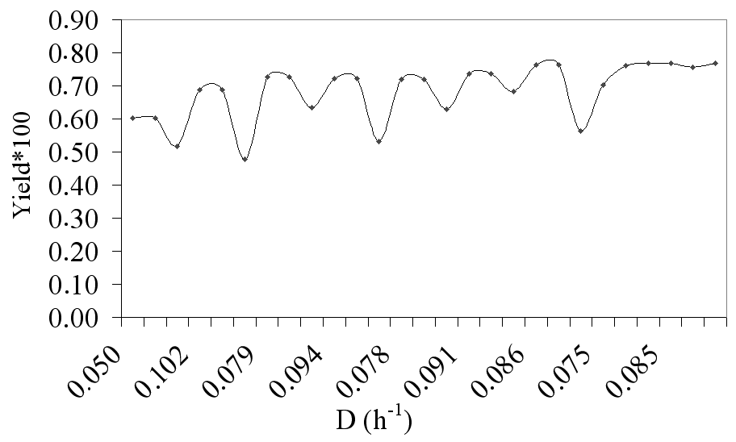

Figure 3. Two-layer approach: acrylic acid yield
The Fig. 4 shows the performance two-layer approach; where the main objective it was maximizes the acrylic acid yield in the bioreactor exit. In the feedback strategy, when the optimized manipulated variable is not used in the process, and only the set point is sent the response is slower. When feedback plus feedforward strategy was applied the optimized manipulated variable is used and set point calculated is sent to controller and a quicker response is obtained, considering fast and robust performance for this strategy when compared with feedback strategy. It was possible also to obtain a yield near of stoichiometric yield (0.8). In Fig. 5, it is possible to visualize the acrylic acid concentration in the bioreactor exit, when the manipulated variable was optimized to maximize the acrylic acid yield and also the yield of the intermediate products (pyruvate and lactate). In these simulations the feedback plus feedforward strategy was used.

Figure 4. Two-layer approach: acrylic acid concentration profiles | Figure 5. Two-layer approach: acrylic acid concentration profiles

These results showed the potential of the two-layer approach based on SQP and Levenberg-Marquardt methods of optimization and advanced control to achieve high operational performance for the alternative biotechnological process to acrylic acid synthesis.
  - Conclusion
In this work was proposed and evaluated a two-layer optimization strategy for an alternative process for acrylic acid synthesis. Through of the application of this strategy it was possible to determine the best value of manipulated variable (D) to maximize the acrylic acid concentration and also to determine the maximum concentration that can be obtained for this proposed process. Evaluation of optimization studies to is necessary to identify the high sensitive of some parameters in the process operational performance. This information is important in the definition of working control strategies in the two-layer approach context aiming lower operating and production costs.
Acknowledgments
The authors are thankful to FAPESP for the financial support.
References
[1] L. Mailleret, O. Bernard and J. P. Steyer, Automatica, 40 (2004) 1379-1385.
[2] B. H. Lunelli, E. R. Duarte, E. C. Vasco de Toledo, M. R. Wolf-Maciel and R. Maciel Filho, Appl. Biochem. Biotechnol., 138 (2007) 487-499.
[3] B. H. Lunelli, Modeling and control of the acrylic acid synthesis by fermentative process. FAPESP Report, August 16, São Paulo, Brazil, 2007. (in Portuguese)
[4] F. Lei, M. Rotboll and S. B. Jorgensen, J. Biotechnol., 88 (2001) 205-211.
[5] D. N. C. Melo, E. C. Vasco de Toledo, M. M. Santos, S. D. M. Hasan, M. R. Wolf-Maciel and R. Maciel Filho, Comput. Chem. Eng., 29 (2005) 2485-2493.
[6] L. Biegler and I. E. Grossmann, Comput. Chem. Eng., 28 (2004) 1169-1192.
[7] D. W. Marquardt, J. Soc. Ind. Appl. Math., 11 (1963) 431-441.
[8]W. L. Luyben, Process modeling simulation and control for chemical engineers. 2n ed. McGraw-Hill Publishing Company, New York, 1996.

