Nonlinear Identification and Model Based Control of an Oil Well Drilling Process
Marcia P. Vega,ª ClaudiaMíriam Scheid,ª Luis Americo Calçada, ª Mauricio C. Mancini, ª André L. Martins,^{b}
ªUniversidade Federal Rural do Rio de Janeiro, BR465, km 7, Rio de Janeiro, 23890-000, Brazil.
^{b} PETROBRAS S.A./CENPES/PDP/TEP, Av. Hum Quadra 07, Ilha do Fundão, Rio de Janeiro, 21494-900, Brazil.
Abstract
Dynamic simulation analysis and the investigation of bifurcation diagrams (open/closed loop analysis) of an oil well drilling process, using choke opening index and annulus pressure set point as the bifurcation parameters, were employed as synthesis criteria for nonlinear identification and model based control purposes.

Keywords: Nonlinear model predictive control, Bifurcation theory, Pressure control.
  - Introduction
As pointed out by Hahn et al., 2004, bifurcation analysis and control theory are two areas of research that have been developed independently from one another. Bifurcation analysis by continuation involves linearizations of generally nonlinear process models. This often causes confusion as readers assume that linearizations inevitably imply that the analysis is local only. Bifurcation analysis by continuation can in fact be used for more than local analysis of nonlinear systems, despite using linearizations, for they are carried out along curves of steady states. The main objective of this paper is using open/closed loop bifurcation analysis for proper nonlinear empirical model (internal model) and model based control (nonlinear model predictive control, NMPC) synthesis.
Nonlinear system identification involves model parameters selection, determination of the forcing function, which is introduced into the plant to generate the output response, estimation of model parameters and comparison of plant information and model predictions for data not used in model development. All steps represent very challenging theoretical and practical problems, for a general theory is not available. The neural network (NN) approach has proved to be a useful tool and is a popular framework for empirical model development. In order to control annulus bottom hole pressure, a NMPC strategy was developed, using a NN as the internal model, by manipulating the choke opening index. NMPC technology is indicated for process with strong nonlinear characteristic or with weak nonlinear characteristics used in a large range of operating regimes. An important aspect of experimental process control problems is the presence of constraints on input and output variables. Predictive controllers have explicit constraint handling capability. The use of a NMPC algorithm to oil well drilling systems may be justified if one realizes that this system is nonlinear and introduces dead time to the output signals.
Concerning oil well drilling control, the pressure balance between the well section and the reservoir is a fundamental variable. If the pressure in the well is higher than the reservoir pore pressure, the circulation fluids penetrate into the reservoir formation, reducing well productivity. On the other hand, if the pressure in the well is lower than the reservoir pore pressure, the reservoir fluids migrate into the well annulus, producing the risk of an uncontrolled ‘‘blow-out’’ situation, with large amounts of the reservoir fluids penetrating into the well and following the well to the surface (Nygaard et al., 2006).
  - Bifurcation analysis and dynamic simulations
Bifurcation theory provides tools for a system stability analysis under its parametric changes. As the parameters undergo changes, the existence of multiple steady states, sustained oscillations and traveling waves might occur for highly nonlinear processes (Ray and Villa, 2000).
The quality of the different nonlinear empirical models was evaluated by comparing their dynamic structure (attractors and respective stability characteristics) to the dynamic behavior of the “real” process (the phenomenological model of the drilling system). In order to do that, bifurcation and stability analyses were carried out to unveil attractors, employing well-known continuation methods. The computations presented in this paper were carried out with routines provided by AUTO (Doedel, 2001). Branches of steady state solutions and periodic solutions were calculated with the arc-length method developed by Keller (1977). Nonlinear system theory states that if all eigenvalues of the Jacobian matrix lie in the open left half of the complex plane, the system is stable. Conversely, the steady state is unstable if the Jacobian matrix has at least one eigenvalue in the open right half of the complex plane. The empirical model (internal model based on NN) is described as a discrete model, so that the stability characteristics are determined by the eigenvalues of the Jacobian matrix of the nonlinear map, which relates present data with the future process output. The stability characteristics of the closed loop (discrete system) are also determined by the eigenvalues of the Jacobian matrix of the nonlinear map: Steady states are stable if all eigenvalues of the Jacobian matrix are inside the unity circle. If any of the eigenvalues is outside the unity circle, the solution is unstable. At a Limit Point, an eigenvalue becomes identically equal to +1. At this point, multiple steady state solutions usually appear and a change in stability occurs. At a Hopf (Thorus) Bifurcation Point, a pair of complex eigenvalues crosses the unit circle with non-zero imaginary component and a branch of oscillatory solutions may appear. At a Period Doubling Bifurcation Point an eigenvalue becomes equal to -1 and branches of periodic solutions usually develop. AUTO automatically detects bifurcation points and provides routines for computation of the multiple steady state solutions, oscillatory and periodic solutions that arise at these special points. Unstable behavior usually occurs in the vicinities of these bifurcation points.
It is assumed here that a good empirical model based on NN should exhibit a dynamic behavior that resembles the one of the original process. This means that the empirical models should present the same modes of operation of the original process. Therefore, in our particular case, a good empirical model should not display multiple or oscillatory solutions nor unstable operation conditions.
As a result, the identification of the bifurcation diagram and dynamic structure of open/closed loops may allow the understanding of how and why the empirical models fail at certain process operation conditions, even when allowing a satisfactory one step ahead prediction of process dynamics, required by traditional validation methods (Sriniwas et al., 1995), producing spurious controller performances.
  - The process analyzed
A drilling system consists of a rotating drill string, which is placed into the well. The drill fluid is pumped through the drill string and exits through the choke valve (Figure 1). An important scope of the drill fluid is to maintain a certain pressure gradient along the length of the well.

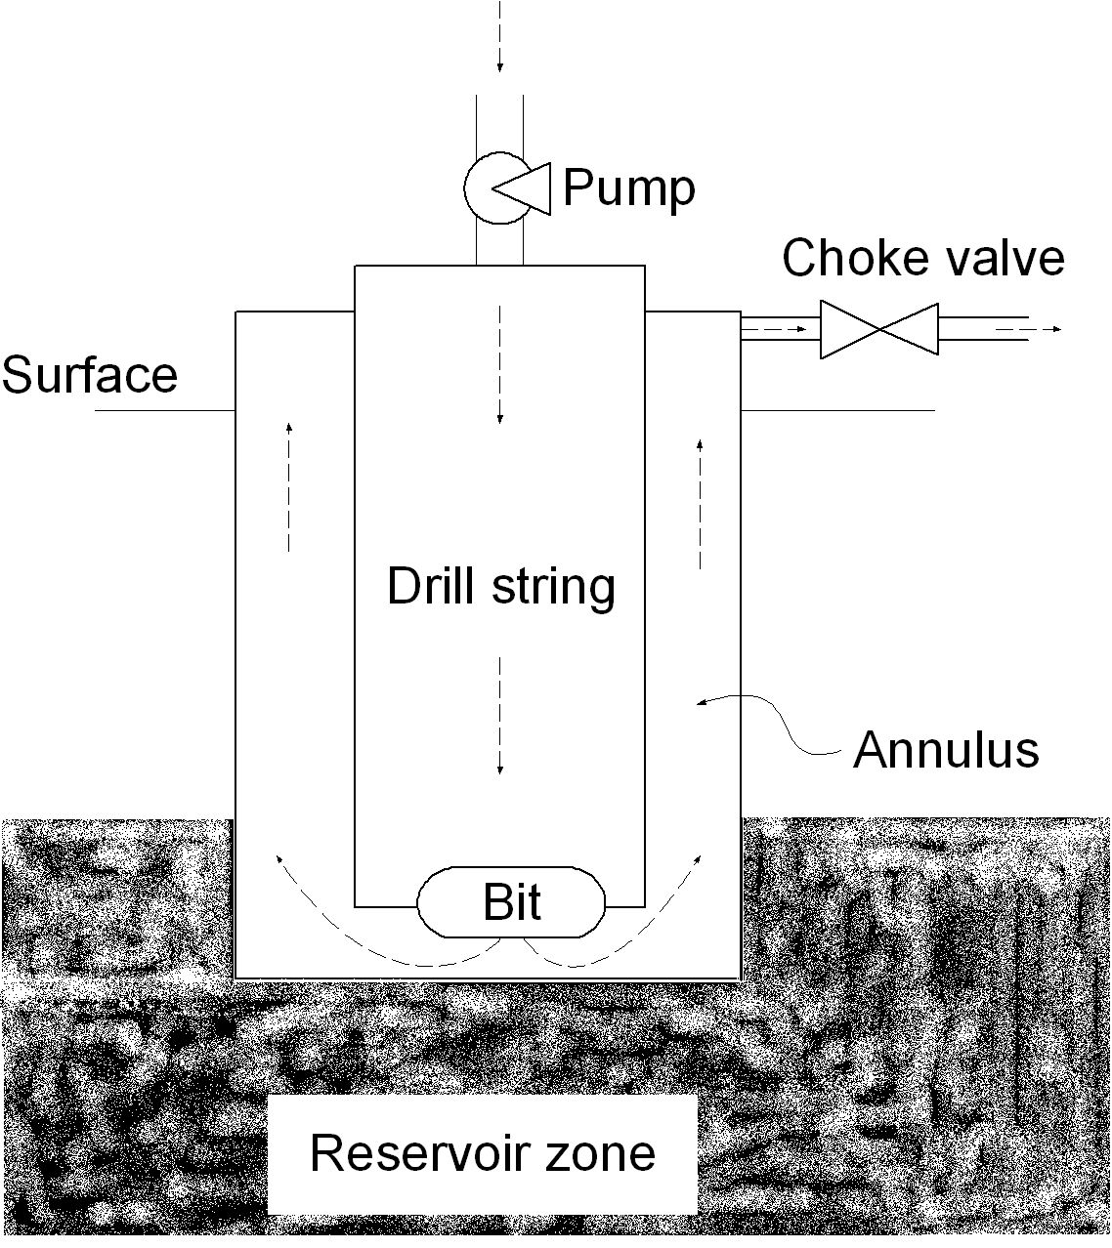
Figure 1. Oil well drilling scheme.

In two-phase fluid flow systems, the interaction between the gas and the liquid causes nonlinear behavior. As pointed out by Nygaard et al., 2006, the actuators and disturbances caused by pumps might bring the fluid flow outside the validity range of a linearized model. Besides, during drilling, disturbances that produce fluctuations in the well pressure might occur. As the well is drilled, the hydrostatic pressure increases because of the well length grow. In addition, the reservoir fluid influx changes the well flow rate and density of the well fluid mixture. Finally, the pipe connection procedure, which requires stopping and starting of the drill fluid, produce severe fluctuations in the well flow rates.
A nonlinear mathematical model (gas-liquid), representing the drilling system, was developed based on mass and momentum balances. The mass balance comprised two systems: the drill string and the annulus between the wall of the well and the drill string. The momentum balance was evaluated at the drill bit and at the choke valve, taking into account frictional losses and compression and hydrostatic pressures. The flow from the reservoir into the well was modeled using a simple relation named productivity index, which is a constant scalar defining the mass flow rate based on the pressure difference between the reservoir and the well. The annulus bottom hole pressure (controlled variable) was defined as the summation of annulus compression and hydrostatic pressures, frictional losses, pressure loss over the choke and atmospheric pressure. The dynamic simulation of the drilling system phenomenological model for varying choke opening index and flow rates is shown in Figure 2.

Figure 2. The drilling system model dynamic simulation.

  - Results and discussion
In order to control annulus bottom hole pressure, a NMPC strategy was developed (Henson, 1998), using a NN as the internal model, named empirical model, by manipulating the choke valve opening index. All NNs present 6x3x1 architecture (actual and past annulus bottom hole pressure, choke opening index and pump mixture mass flow rate as inputs and future annulus bottom hole pressure as the output).
Empirical models were compared with the corresponding dynamic simulations of the phenomenological model, regarded as the real process (plant). Vega et al. (2004) pointed out that the use of traditional validation tests was not enough to guarantee successful use of NNs as the internal models of NMPCs. Care must be taken regarding the strategy for data generation, as the simple manipulation of the neuron activation functions, NN architecture and initial guesses used for NN training are not enough to guarantee the building of proper models.
As shown in Figure 3, the complex dynamic behavior displayed by the model (built with incomplete data set) may be completely different from the one displayed by the plant. Concerning stability analysis of the spurious neural model, a Hopf bifurcation singularity is observed in Figure 4, as a pair of complex eigenvalues crosses the unit circle with non-zero imaginary component, producing a branch of oscillatory solutions. The empirical model bifurcation diagram (Figure 5), built with complete data set, displays a drilling system phenomenological model similar behavior.
For closed loop bifurcation diagram synthesis (Figure 6), the output of the controller (choke opening index) serves as input to the system and has to be removed from the set of variables to be used for bifurcation analysis. Then, the set point of the system (annulus bottom hole pressure) is the continuation parameter. As a result, the analysis can be performed over an entire operation region of the process rather than for a particular fixed value of the set point. Good controller performance was obtained when model and plant showed similar dynamic simulations. Anomalous empirical models (built with incomplete data set) always produced poor control efficiency.
Figure 3. Spurious NN model.

Figure 4. Floquet multipliers.
Figure 5. NN model built with complete data set.

Figure 6. Closed loop analysis of the model based controller.

  - Conclusions
It was observed that nonlinear models may present incompatible complex dynamic open loop behaviour, producing incompatible controller performance, unveiled by dynamic simulations and bifurcation theory. Bifurcation diagrams and dynamic behaviour indicate whether spurious model responses are present and, therefore, indicate whether additional effort is needed for proper model development. Bifurcation analysis was used as an efficient tool for validating nonlinear models, using available first principles mathematical modelling data. Finally, it was shown that bifurcation analysis was successfully implemented for closed loop system analysis under phenomenological model and plant (internal model) mismatch of a NMPC scheme. Requiring stability of the closed loop system over the entire operating region is important because bifurcation analysis only results in steady state information, and it has to be ensured that the system trajectories cannot leave the regions of attraction of the steady state operating point.

References
E.J. Doedel, , R.C. Paffenroth, A.R. Champneys, T.F. Fairgrieve, Y.A. Kuznetsov, B. Sandstede, X. Wang, Technical Report, California Institute of Technology, 2001.
J. Hahn, M. Mönnigmann, W. Marquardt, 2004, A method for robustness analysis of controlled nonlinear systems, Chemical Engineering Science, 59, 4325.
M.A. Henson, 1998, Nonlinear model predictive control: current status and future directions , Computers and Chemical Engineering, 23, 187-202.
H.B. Keller, 1977, Applications of Bifurcation Theory, Academic Press, New York.
M. Mönnigmann, W. Marquardt, 2002, Proceedings of the 15 th IFAC World Congress, Barcelona, Spain.
G. Nygaard, G. Naevdal, 2006, Nonlinear model predictive control scheme for stabilizing annulus pressure during oil well drilling, Journal of Process Control, 16, 719.
W.H. Ray, and C.M. Villa, 2000, Nonlinear dynamics found in polymerization - a review, Chemical Engineering Science, 55, 275-290.
G.R. Sriniwas, Y. Arkun, I-L Chien and B.A. Ogunnaike, 1995, Nonlinear identification and control of a high-purity distillation column: a case study, Journal of Process Control, 5, 149-162.
M.P. Vega, K.B. Coimbra, J.A. Mattos, CM. Scheid, 2004, Proceedings of the DYCOPS-2004, Cambridge, Massachusetts.

