Data Reconciliation for Industrial Processes
Lucia KRISHNAN-DUMITRESCUª, Wassim EL OSTA^{b} and Claude LAIGNEAU^{b}
ªSenior Consultant Engineer,^{b}Consultant Engineer,
Advanced Systems Engineering, Technip France,
92973 Paris La Défense

Abstract
In spite of advances in instrumentation technology, visibility into a process and its monitoring are often hindered by errors due to on-line measurements, such as drifts, bias, spikes, precision degradation and instrument failures. Errors in on-line measurements, either ‘gross‘or random ones, are an inherent problem that the process industries still face nowadays. Furthermore, for economical or technical reasons, it is not always possible to install extensive, best available instrumentation in a plant to improve the process visibility.
In many cases, the use of data reconciliation technique can be a viable solution to the problem, as by definition this technique aims to reduce the effect of the random errors in the on-line measurements.
This paper presents the data reconciliation algorithm from an industrial point of view, through its use in computer applications such as computation of plant wide reconciled mass balance which forms the basis for the material accounting of a plant production.
It is based on TECHNIP’s extensive experience with data reconciliation (including plant mass balance reconciliation) software engineering projects.
Keywords: data reconciliation, reconciled mass balance, plant model.
Some Definitions and Abbreviations

MBR: Mass Balance Reconciliation is data reconciliation that treats only measurements expressed as mass units through only mass balance type of redundancy relations
Raw Measurement/ Input Data: input values to the MBR reconciliation algorithm run
Reconciled Measurement/Output Data: values resulting from the MBR algorithm run
Equation Residue/Imbalance: the value by which the sum of inputs is different from the sum of outputs in the mass balance equation
Reconciled Mass Balance: balance that always closes (residue is zero).
MBR Network: A simplified process flow sheet that describes the plant facilities.
MBR Node: A material group (e.g. a plant unit, storage tank, shipment /reception facility, etc.,) around which is possible to compute a mass balance equation.
MBR Flows: Material movements characterized by a source and a destination: process streams, tank inventory variations, and material losses.
MBR User Data Value: Value of a data modified by the MBR user

  - Introduction
Without getting into a discussion of the quite recent history of the data reconciliation theory, one must note that several software packages that perform data reconciliation dedicated to industrial use have been developed during the last 20-25 years and they are now field proven and largely implemented in major process industry groups. Companies like TOTAL have been pioneers in developing and implementing in house data reconciliation software applied to measuring instruments or to plant-wide mass balance.
Based on statistical techniques and mathematical algorithms, these software packages treat the “raw” data from the instruments and transform” them into “reconciled” data, thereby increasing their accuracy, and rendering them reliable and consistent.
It is not difficult to install industrial data reconciliation software, provided some redundant measuring instrumentation is available and the plant is decently equipped with systems: Distributed Control Systems (DCS), Control and Data Acquisition (SCADA) and tank gauging, oil movement, Real-Time Data Base (RTDB) and Relational Data Base Management System (RDBMS). However, implementing and using such software application require a good understanding of process operations, dynamics and a good knowledge of available plant resources. This is explained by the fact that, as developed further, the software works on a plant model to which it applies the reconciliation algorithm.
Among the main steps and issues related to mass balance reconciliation (MBR) software engineering projects, the paper focuses on the two topics: the plant model to be used by the reconciliation algorithm and typical steps of running MBR software.
  - Mass Balance Reconciliation Background
MBR can be seen as a particular case of the data reconciliation and therefore its objectives, mathematical foundation, and benefits are similar to data reconciliation.
    - Some theory recall
The MBR reconciliation processing is from mathematical view point an algorithm of minimization of a criterion under linear constraints.
Consider the following assumptions:
- constraints are linear (mass balances),
- random errors are unbiased,
- measurements are not correlated,
- variables are not bounded.
Let $A_{m\text{.}n}$ (m rows, n columns) be the matrix of constraints,
$X_{M}$ the vector of the true values of measured variables,
$X_{U}$ the vector of unmeasured variables,
Y the vector of measurements,
and $ε$ the vector of random errors ($E(ε)=0$,$\text{Cov}(ε_{i},ε_{j})=0$ if$i≠j$)
Note by$X={\left[\begin{matrix}X_{M} & X_{U}\end{matrix}\right]}^{T}$, we can write: $A\text{.}X=0$ and $Y=X_{M}+ε$ .
The A matrix can be decomposed with respect to the measured and unmeasured variables:
$A_{M}\text{.}X_{M}+A_{U}\text{.}X_{U}=0$ (1)
The quadratic criterion to minimize is:

$\text{min}\left[(Y−X_{M})^{T}\text{.}W\text{.}(Y−X_{M})\right]$ (2)
with $W={\left[\text{Cov}(Y−X_{M})\right]}^{−1}$ the inverse of the covariance matrix calculated using the CHOLESKY decomposition.
The MBR algorithm reconciles redundant measures and estimates unmeasured observable variables:$\hat{X}={\left[\begin{matrix}{\hat{X}}_{M} & {\hat{X}}_{U}\end{matrix}\right]}^{T}$.
If P is the projection matrix ($P\text{.}A_{M}\text{.}X_{M}=0$), an analytical solution is obtained based on (2) and using the Lagrange multipliers:
$\hat{X}=\left[\begin{matrix}{\hat{X}}_{M} \\ {\hat{X}}_{U}\end{matrix}\right]=\left[\begin{matrix}\left[1−W^{−1}\text{.}P\text{.}A_{M}^{T}\text{.}(P\text{.}A_{M}\text{.}W^{−1}\text{.}A_{M}^{T})\text{.}P\text{.}A_{M}\right]\text{.}Y \\ −(A_{U}^{T}\text{.}A_{U})^{−1}\text{.}(A_{M}\text{.}{\hat{X}}_{M})\end{matrix}\right]$ (3)
One can write the ARR (Analytical Redundancy Relations) leading to the mass balance equations around nodes (e.g. below a process plant storage tank):
$P\text{.}A_{M}\text{.}{\hat{X}}_{M}=0⇔|\begin{matrix}\text{node}\left[1\right]:\text{Input}\left[1\right]−\text{Output}\left[1\right]−\text{Dltgauge}\left[1\right]−\text{Loss}\left[1\right]−\text{Imbalance}\left[1\right]=0 \\ \text{node}\left[2\right]:\text{Input}\left[2\right]−\text{Output}\left[2\right]−\text{Dltgauge}\left[2\right]−\text{Loss}\left[2\right]−\text{Imbalance}\left[2\right]=0 \\ ⋮ \\ \text{node}\left[n\right]:\text{Input}\left[n\right]−\text{Output}\left[n\right]−\text{Dltgauge}\left[n\right]−\text{Loss}\left[n\right]−\text{Imbalance}\left[n\right]=0\end{matrix}$where Dlt gauge is the storage inventory variation within a given period (see Figure1)

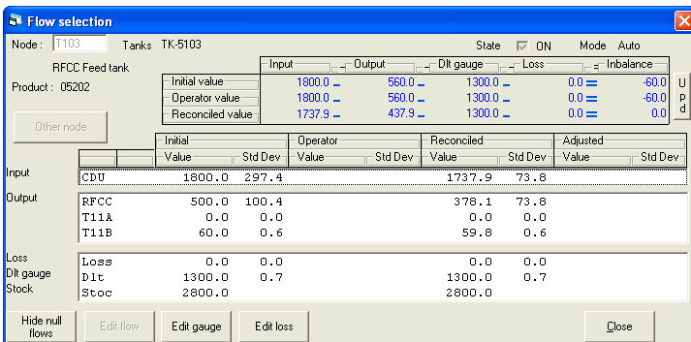
Figure 1: Input (‘initial’), user (‘Operator’) and output (‘Reconciled’) MBR values

In the above figure, one can see the mass balance around the node T103 with the detail data on the node input and output flows.
    - Actually
MBR provides, through a single application, reconciled values of process flow measurements, tank inventory variations, receipts and shipments and unit and tank losses on a daily basis. The MBR shall work either on mass or on weight data to benefit from the mass conservation law but also to eliminate the volume shrinkage problem.
As any data reconciliation software, MBR reduces the effect of random errors on measurements and ‘optimally’ corrects them through a process that implies:
- making use of the measuring instrument redundancy,
- taking into account of their accuracy and precision,
- building and making use of the process model linking the instruments, model expressed through mass balance equations (see further),
- applying a computation algorithm such as the one shown above.
The reconciled values have three interesting characteristics, as they are:
- closest to the raw values (the correction made by the MBR software through the reconciliation treatment shall be minimum),
- satisfying the mass balances around nodes while taking into account the accuracy of the measuring sensors (the correction shall be normalized by the standard deviation of the measurements),
- more accurate than the raw measurements (reconciled standard deviation is smaller than the initial one). See the ‘StDev’ values in Figure 1.
  - Reconciliation Model Building
The MBR model is typically a simplified graphical representation of the plant process flow diagram also referred to as the MBR network. See an example below:

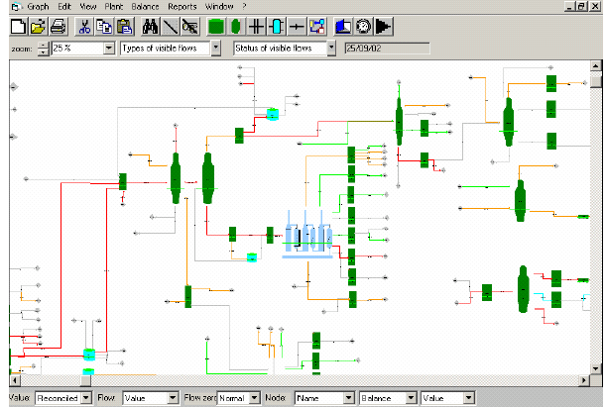
Figure 2: Example of a graphical model by a TOTAL/TECHNIP MBR software

Building the process model on which the MBR software applies consists mainly in defining the MBR network elements (nodes and flows) and ‘writing’ the mass balance equations that link measurements to each other around nodes. The number of equations depends on the number and diversity of the available plant measurements.
The MBR flows configuration shall allow for defining and distinguishing:
- ‘Permanent’ flows, i.e. those flows permanently present in the network and that are initially defined at the time of application configuration.
- ‘User’ flows, i.e. the flows that can be manually created by the user to deal with unrecorded material movements that have occurred during the treated day.
In addition, one expects MBR software to automatically create flows upon detection of a material movement. This type of flow shall exist in the network as long as the movement occurs; it is a ‘temporary’ flow dynamically generated by the MBR. This feature is of major importance as it is not practically possible to model all plant movement operations bearing in mind that circuit pipe line-up offers very numerous combinations of movement routings.
The model shall also include all "structural" data necessary to MBR, as for instance: parameters required for loss estimate on units, tank geometrical data for tank loss computation, data necessary to compute the standard deviation of all modeled measurement instruments.
The MBR structural mode data are called so to be distinguished from the measurements and the other live information that represents the MBR "dynamic" data.
The MBR model built at the time of the mass balance application configuration must, once the application is operational, be maintained by its user, through minor adjustments daily made within the MBR runs, or through more important modifications to reflect possible process changes such as unit modification, new process lines, new tanks.
  - Mass Balance Reconciliation Run Steps
The schematic below gives the typical MBR run steps:
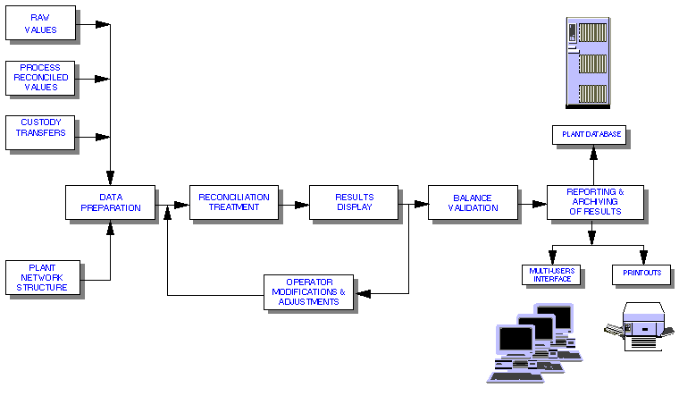
Figure 3: Example of typical MBR software run steps
    - The time horizon
The calendar day horizon is deemed to be the time window the most reasonable and suitable (from operation dynamics view point) to the process industry plants. Higher frequency, although feasible from software view point may lead to results non-representative for the global picture of operations within a calendar day. On the other hand, aggregation of balances over several days dilutes information and leads to loss of the operations traceability (product movements, feed receipts, product shipments, unit run case changes) that explain the origin of possible mass imbalances and help to properly correct them. Cumulating of the daily-reconciled data over longer time periods, typically the month shall produce, for instance, the monthly-reconciled balance.
    - Data preparation step : consistent measurement units and initial value of data
Prepare the model input data is a critical step for an MBR application as the validity of the MBR results depends on the accuracy of its inputs. User must ensure to meet requirements such as consistency of measurement units (e.g. metric tons) or data granularity to cope with the data reconciliation time span (e.g. day). Depending on the process data acquisition systems available in the plant, preparation may consist in converting molar and volume flow to mass flow or perform discrete integration of recorded flow rates. Prior to the execution of the reconciliation algorithm, the MBR software shall associate various measurements to the MBR flows and calculate an initial value and an initial standard deviation for each flow. Starting from the initial values, the reconciliation processing calculates the best estimate of the true values for the flows that satisfy the material balance equations; these values are the "reconciled values".
The model portion displayed in Figure 4a shows the mass balance computed by MBR software around the Naphtha Hydrotreater unit node (NHT) with initial values provided by the RTDB and the offsite management systems. One can see the imbalance values on the NHT and on some of the neighbor nodes.
    - Reconciliation run step
The adjustment through the reconciliation is performed optimally so that the measurements that are more prone to error receive the larger percentage correction while the total adjustment is kept to minimum. The first reconciliation run can start:
- automatically triggered at a pre-defined time, when all data required for the daily balance computation are deemed to have been acquired, or
- manually triggered by the user, at the appropriate time.
At the end of each reconciliation run, the MBR provides the user with the necessary information to assess the validity of the mass balance reconciliation results; i.e. the MBR software shall include reconciliation diagnostic features.
The MBR software shall also provide "adjustment" facility for the values, standard deviations and the operating parameters that enables the user to modify the initial values or to complement, with manual inputs, the data so as to put the mass balance application in conformity with the plant operating reality of the treated day. After having made the necessary "adjustments", the user restarts the reconciliation; the starting point of the upcoming run is the set of values modified by him (see ‘Operator’ values in Figure 1).
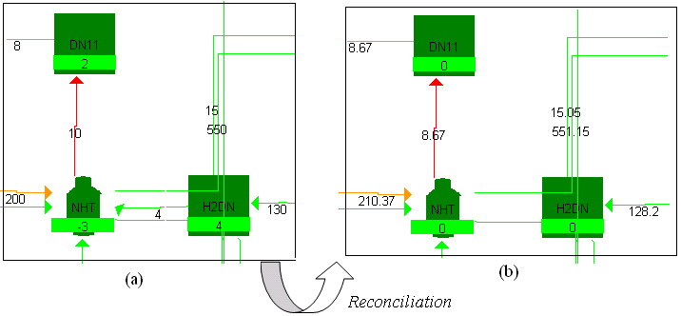
Figure 4: Mass balance values before reconciliation (a) and after reconciliation (b)
    - MBR results
In Figure 4b above, are displayed the reconciled balances computed by MBR around the NHT node and its neighbor nodes. One notices that the flows have been “adjusted” and now the balances around nodes close (zero imbalance). Color codes “tell” the user how much MBR has corrected the initial flow values.
When the material balance is satisfactory (i.e. the balance data reflects the plant operations of the day) the user validates the results and the data are stored in the MBR data base and then transferred to the plant RDBMS; associated reports can be issued.
  - Conclusion
The main advantages of using industrial data reconciliation software include: improved process visibility, increased accuracy of process performance monitoring, accurate computation of yields, better estimate of losses, and sound input data to computer applications such as unit advanced control and real-time optimization, and plant-wide reconciled mass balance. The keys to successfully achieve the benefits from such system are: quality, timeliness, consistency and integrity of input data, adequate modeling, proper integration within the existing system environment and large publishing of the output data to concerned users.
References

M. Alhaj-Dibo, D. Maquin and J. Ragot, 2007, Data reconciliation, a robust approach using a contaminated distribution, Control Engineering Practice.
S. Nrasimhan and C. Jordache, 2000, Data Reconciliation and Gross Error Detection, Gulf Publishing Co
L. Krishnan-Dumitrescu, 2001, The Hunt for Errors in the Process Measurements, Honeywell User’s Group: Conference for the EMEA, Excellence in the Process, October 2001, Nice, France.
W. El Osta, B. Ould Bouamama and C. Sueur, 2006, Monitorability Indexes for Fault Tolerance Analysis using a BG Approach, 6th IFAC Symposium on Fault Detection, Supervision and Safety of Technical Processes, 2006, Beijing, China.
W. El Osta, B. Ould Bouamama and C. Sueur, 2004, Monitoring of Components in Industrial Processes Based on A Bond Graph Model. 2nd IFAC Symposium on System, Structure and Control, pp. 430-435, Oaxaca, Mexico.

