RCS for process control: Is there anything new under the sun?
Manuel Rodríguez, Ricardo Sanz
ASLab-UPM, José Gutiérrez Abascal, Madrid 28006, Spain
Abstract
The purpose of this paper is to explore the potential use in process control of cognitive architectures used in other domains. A well-known cognitive architecture, used to control complex systems of different areas has been selected. It has been compared with the current control strategy used in process plants. Conclusions on its applicability, its strengths and weaknesses are also presented in the paper.

Keywords: complex control, cognitive architecture, process control.
  - Introduction
The process industry is quite mature in many aspects. One of these is process control. Although decentralized control based on PID controllers still is extensively used, significant advances (and research) have been made: multivariable predictive control, use of simulation models, real-time optimization, change in communication protocols (hybrid or digital). Even the implementation of the control architecture may change (and flatten) in the future if standard protocols like Industrial Ethernet apply to all the levels of the plant [1]. But still the classic hierarchical organization in four levels remains. Nowadays many fields look into other domains to see if the ideas developed for the original domains can be successfully applied to their domains. In this paper a cognitive architecture successfully applied to implement complex controllers in different areas is considered and its possible application to the process industry studied.

The paper is organised as follows: next section presents the RCS cognitive architecture, its components and organization, section three describes how process control is currently implemented in most industrial plants, section four compares both approaches and finally section five draws some conclusions out of the presented ideas.
  - RCS: the cognitive architecture
RCS (Real-time Control System) [2-4] is a cognitive architecture designed to enable any level of intelligent behavior. Initially based on a theoretical model of the cerebellum, it has been evolving over the last three decades. Today it is a real-time cognitive control architecture with different applications. It has been used for intelligent machine tools[5], factory automation systems[6] and intelligent autonomous systems[7] among others.

RCS is a multilayered multiresolutional hierarchy of computational agents or nodes. RCS nodes have vertical (hierarchical) as well as horizontal relationships. Each node follows a common design pattern, being composed of the following elements: sensory processing (SP), World Modeling (WM), value judgment (VJ), behavioral generation (BG) and knowledge database (KD).

Figure 1 shows the basic control node with its elements and relationships.

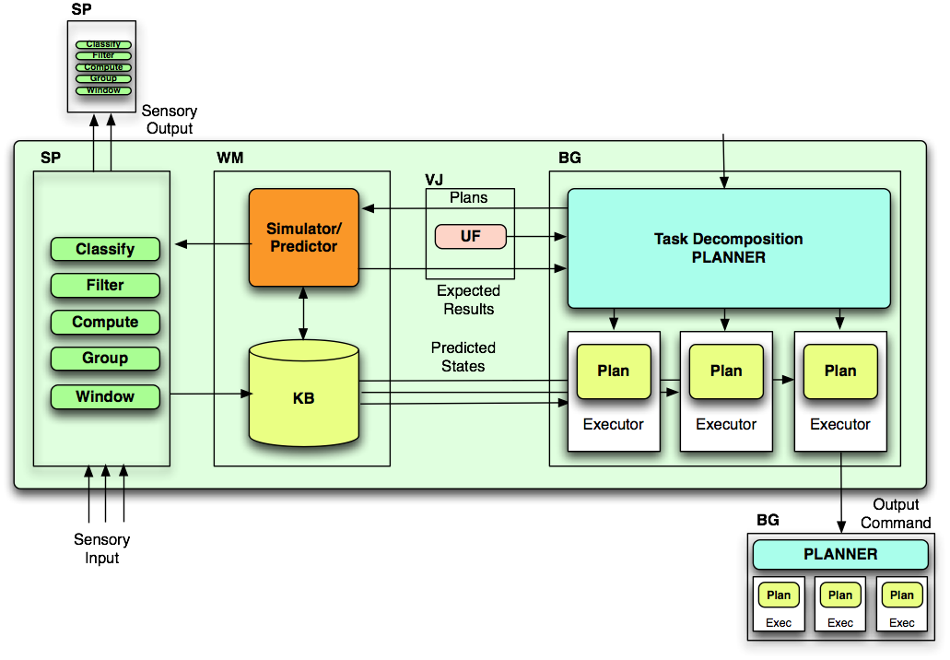
Fig 1. RCS Computational (control) node.

A brief description of the different elements of each of the control agents follows.

Sensory Processing: This element gets sensory input and compares these observations with expectations generated by an internal world model.

World Model: It is the system’s best estimate of the state of the world. The world model includes a database of knowledge (KD) about the world. It also contains a simulation capability which generates expectations and predictions. It can provide answers to requests for information about the past, present and probable future states of the world (What if and What is queries). This information goes to the task decomposition element (in the BG) and to the sensory processing element.

Value Judgment: It determines what is good and bad. It evaluates the observed and predicted state of the world. It computes costs, risks and benefits of observed situations and of planned activities.

Behavior Generation: Behavior is generated in a task decomposition element that plans and executes tasks by decomposing them into subtasks, and y sequencing these subtasks so as to achieve goals. Goals are selected and plans generated by a looping interaction between task decomposition (hypothesize plans), world modeling (predict results) and value judgment (evaluate the results). Behavior generation is typically done via Finite State Machines or rules governing costs for nodes and edges in a graph-search method. This node contains three subelements: the Job Asigner, the Planner and the Executor. RCS systems are built following the RCS methodology that has several steps. The first one is to gather domain knowledge with experts, and to generate (with the help of the experts) the hierarchical task decomposition.

Knowledge Database: It stores information about space, time, entities, events, states of the system environment and about the system itself, parameters of the algorithms, models for simulation, etc.
  - The process control hierarchy
The process industry comprises mainly continuous but batch processes also. The industries involved are chemical, petrochemical, pharmaceuticals, refineries, etc. These are usually very large and complex facilities. The main goal of any process plant is to get the maximum benefit (which means the demanded amount with the specified quality using the less resources) assuring safety and stability of the plant. In order to achieve this goal, control strategies have been applied and evolved over the years as new capabilities were available. From the initial manual control to the current digital distributed control system (DCS).

To handle the complexity of the plant and to still achieve the overall goal, a control hierarchy has been developed and used for many years. This architecture gets the company policy (several weeks time resolution) and refines it to the current action to be applied on any actuator of the plant (ms-sec resolution time). The procedure is to observe the state of the plant through thousands of sensors and evaluate the next action for any resolution time. Implicit, explicit, heuristic and first principles models are used in order to generate the adequate action. The common process control architecture has four control levels. The lower level of the architecture is the basic regulatory control, this control is achieved by single decentralized loops. Most of these loops are controlled by standard PID controllers. The actuating horizon at this level is just one.

The second level is the advanced and predictive control. These are two different control schemes that work at the same level. Information is transmitted horizontally and vertically in this (and upper) level. More elaborated control strategies as selective control, ratio control, feedforward control are implemented. In this second level implicit as well as explicit (heuristic and first principles based) models are used to generate the action. The action is the set point (goal) to achieve at the lowest level. Prediction horizon is (in the case of model predictive control) of tens of movements.

Upper levels of control deals with optimization, scheduling and planning. Unit optimization can be made on-line with continuous information flow from and to the lower levels. Site optimization, scheduling and planning are done off-line. Very different types of models are used in these levels. As commented, information flows vertically and horizontally through the architecture and each upper level is of lower time resolution.
  - RCS vs DCS
Many similarities exist between the two architectures, as can be observed in figure 2. Of course in the process control system there is no a common identified computational agent with so well defined elements as in the RCS architecture, but at any level a good matching can be established, as it is shown in the following comparison between the process control and the RCS elements
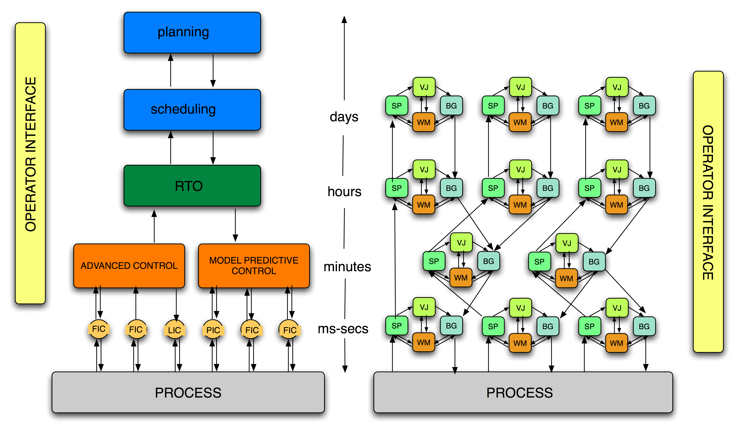Fig 2. DCS vs. RCS architecture
Regulatory control node. This is the simplest node. It implements the simplest RCS node, one in which the behavior is purely reactive. It has a World model (the PID algorithm is a model, an empirical or heuristic model, but a model of the system under control), but this model does not predict the behavior. It only reacts to the current values of the plant and decides an action to be performed (there is no plan, it is just an action for the next time). It can be considered to have a KD where the model parameters are stored. Very simple preprocessing is performed (but some it is done as signal failure,...)

Model predictive control node. MPC has several components. It has a model (usually an identified linear) of the world. It has a KD where past values of the manipulated variables (MVs) and controlled variables (CVs) are stored. In this KD other information is stored as MVs and CVs limitations, weighting factors, etc. The model uses the inputs to predict the future. This state is used in Behavior Generation module. In this module an optimization is performed to select the best action plan. This plan (a set of movements for the MVs along with CVs values) is set and sent to the regulatory level. Some preprocessing is implemented as well. The MPC module implements also a feedback loop to correct model errors (due to model mismatch with the actual plant).

Real Time Optimization. This module receives the values of the variables of the plant, performs reconciliation on these values. This node has a steady state (mathematical, physically based) model of the plant. An optimization is made using that model every hour or so. The optimization results are sent to the lower level, the supervisory control. These results are the new set points of the controlled variables. The best operating point of the plant (which means a set of set points values) is calculated in each optimization. The optimization takes into account constraints on the variables (limited change in manipulated variables, safety, quality, etc. constraints in controlled variables). The node uses as well a historian module with past data of the plant.

Planning and scheduling. This module corresponds with the business part of the control hierarchy. It has a business model and based on plant data (current and past values), on external data (market data, external plant info, etc.) and using the company business goals derives a production plan for the plant. It gives capacity production values as well as quality values to the lower, optimization, level. The resolution time at this level is days or weeks.

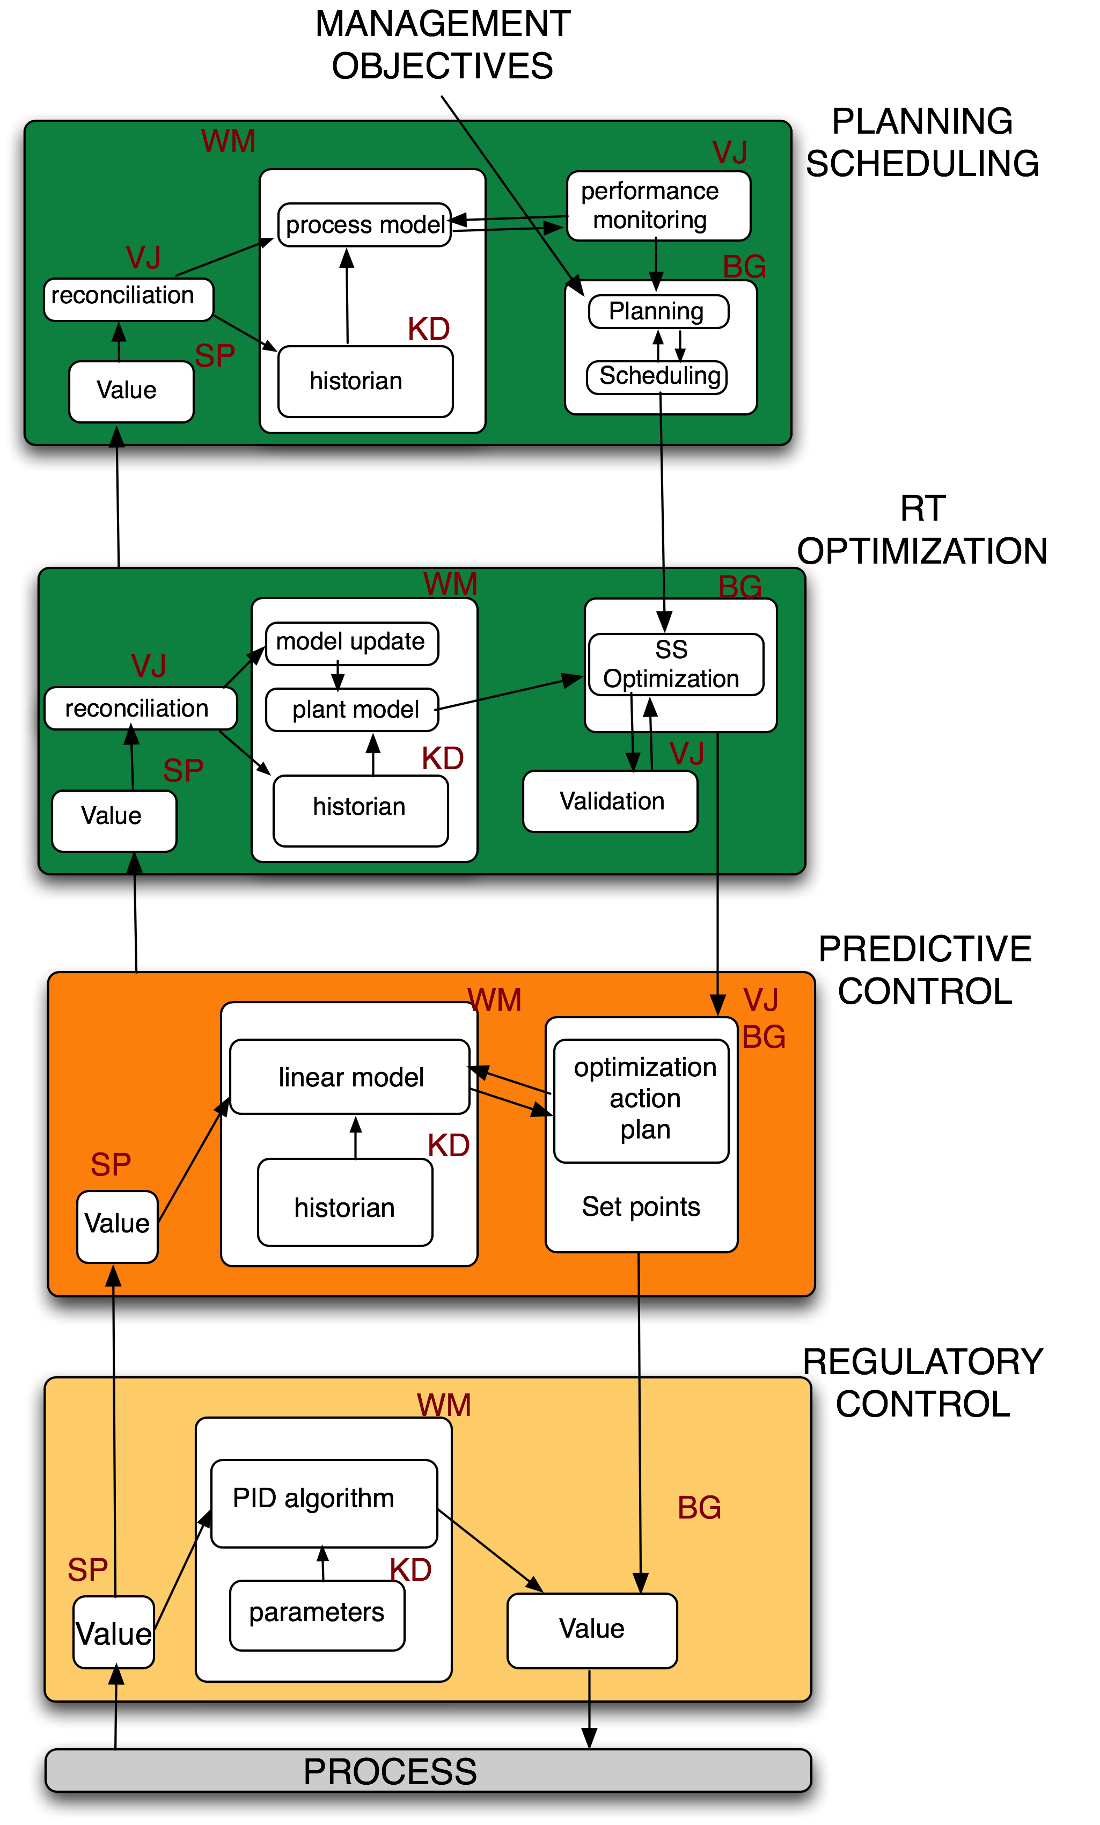
Fig 3. Process control levels as RCS agents
The control levels introduced above are presented in the figure 3. following the structure of a RCS node. It can be observed that the node in any level complies with the RCS node. As a preliminary conclusion it can be said that the conventional control structure is RCS compliant, or can be considered as an implementation of it. So is there anything new under the sun?, what's the benefit of using RCS (or other type of cognitive architecture) for process control?

The answer is that it depends on the application and on the point of view. In spite of this and knowing that DCS is RCS compliant some differences or capabilities must be stressed:

- Model update. In the RCS architecture the World Model update is made continuously and in an automatic way. In the process control architecture (PCA) it usually is made by hand.
- Task decomposition. In the PCA the task decomposition is unique, i.e., there are no different explicit tasks to evaluate in order to select the best one. In the case of normal operation of the plant this is perfectly right but the RCS allows in the presence of faults (detected by the SPs and WM) to select new different tasks.
- Adaptivity. Although not explicitly said in the literature, RCS seems well suited to be dynamically (or almost) changed in size or in configuration. PCA is less flexible and more conditioned by the initial design.
- Behavior generation. RCS way of generating behavior seems best for discrete or semi-continuous systems (usually implements finite state automata). There is no documented application of RCS for large continuous processes. Some adaptation on how to exploit the knowledge should be done (for process systems, knowledge is strongly based in laws and equations so numerical techniques to deal with them should be available).
- Querying. In the process industry it is very important to be able to answer structural (What is) questions as well as functional (What if). RCS integrate this capability in its structure while in the PCA it is generally done using external tools.
- Heterogeneity. The ability of having different views and different models for the same part of a system seems to be easier to implement using RCS than using PCA.
  - Conclusions
In this paper the use of cognitive architectures for process control has been explored. Specifically, the real-time control system architecture which has been applied to implement different complex control systems. A comparison between the current process control architecture and the proposed one has been established showing that the existing architecture is very similar to the RCS and can be considered compliant to it. Even so, there are some features of the cognitive architectures that seem appealing for the process control. These have been identified in the present paper. Their implementation is subject of future research along with the study of the benefits of providing a new capability to the process control (as it is in the cognitive architecture): world and self awareness.
- References
[1] P. Neumann, “Communication in industrial automation—What is going on?”, Control Engineering Practice, Volume 15, (2007), pp. 1332.
[2] J.S. Albus, “Outline for a Theory of Intelligence,”, IEEE Transactions on Systems, Man and Cybernetics, Vol. 21, (1991) pp. 473.
[3] J.S. Albus, “The NIST Real-time Control System (RCS): An approach to Intelligent Systems Research,” Journal of Experimental and Theoretical Artificial Intelligence, 9, (1997) pp. 157
[4] Albus, J. and Meystel, A. Engineering of Mind: An Introduction to the Science of Intelligent Systems, John Wiley & Sons, N.Y., 2001
[5] F.M. Proctor, B. Damazo, C. Yang and S. Frechette , “Open Architectures for Machine
Control,” NISTIR 5307, National Institute of Standards and Technology,1993, Gaithersburg, MD,
[6] H.A. Scott, K. Strouse, “Workstation Control in a Computer Integrated Manufacturing System,” Autofact VI, 1984, Anehiem, CA.
[7]M. Herman and J.S. Albus, “Overview of the Multiple Autonomous Underwater Vehicles
Project,” IEEE International Conference on Robotics and Automation, Philadelphia, PA, 1988

