DIAGNOSIS OF HYBRID SYSTEMS COUPLING CLASSIFICATION METHOD AND DYNAMIC HYBRID SIMULATION
Aimed Mokhtariª, Marie-Veronique Le Lann^{a,c}, Gilles Hétreux^{b,c}, Jean-Marc Le Lann^{b,c}
ª CNRS ; LAAS, 7, avenue du Colonel Roche, F-31077 Toulouse, France
^{b}CNRS ; LGC, 118, Route de Narbonne,31077 Toulouse, France
^{c} Université de Toulouse ; INSA ,INPT, LAAS,LGC ; 135, avenue de Rangueil ; F-31 077 Toulouse, France
Abstract
This paper presents the development of a methodology associating the fault detection performed by a data–driven technique with the dynamic hybrid simulation for the diagnosis step. The problem of diagnosis is then to link them to a precise dysfunction. A possibility is therefore to explore all possible scenarios of faults and compare with actual measurements. Nevertheless the number of possibilities increases in an exponential way. The aim of the developed methodology is to restrict the detected fault to a category of failures. Only these failures are then explored. The data-driven technique used in the proposed methodology is a fuzzy-classification method LAMDA (Learning Algorithm for Multivariate Data Analysis) enabling the partition of the data space in clusters related to identify symptoms. The second step of the procedure involves the dynamic hybrid simulation performed only for the restricted faults. In the framework of this study, the simulation aspects are ensured by the general object-oriented environment PrODHyS (Process Object Dynamic Hybrid Simulator).

Keywords: Fault diagnosis, Petri nets, Hybrid Dynamic Simulation. Classification.
  - Introduction

Modern technology is increasingly leading to complex artefacts with high demands on performance and availability. As a consequence, fault-tolerant control and an underlying monitoring and diagnosis capability play an important role in achieving these requirements. The objective of our work has been to investigate how to diagnose hybrid systems. For any industrial system, the early detection and diagnosis of faults is important, since a lot of damage and loss can result before a fault present in the system is detected. In addition, it becomes harder to distinguish the root cause of the fault as it propagates through the system. This is therefore more crucial in hybrid processes mixing both continuous and discrete aspects. In this context, the traditional tools such as continuous dynamic simulation or discrete event simulation are not well adapted to these problems and the use of hybrid dynamic simulators seems to be a better solution. In this framework, the first part of this article focuses on the main fundamental concepts of the simulation library PrODHyS using Object Differential Petri Nets (ODPN) formalism. In the second part, the design of the supervision and diagnosis module currently developed – using both simulation and classification method based on analysis of measurement data to restrict the explored possibilities to a category of failures – is described.
  - Process modelling with PrODHyS
    - General structure of the simulation model
The design of PrODHyS follows a software development process based on the object technology (UML, C++). Currently, this software consists of more than one thousand classes distributed into two functional layers and seven packages.[1][2]
The internal level corresponds to the simulation kernel of the platform. It provides the basic elements useful for the formal modeling and the simulation of any dynamic hybrid system. This layer includes:
• The Disco module which is the numerical kernel of the system. It allows an object representation of the continuous mathematical models and provides a set of solvers and integrators (EDA, EANL).
• The Hybrid module which contains the set of classes used for the description of the ODPN formalism as well as the hybrid simulation kernel.
The higher level gathers the classes used specifically for the modeling of chemical processes. This layer encapsulates the simulation layer and provides a set of general and autonomous entities (objects) that can be exploited by any user who wishes to build its own simulation system or prototype. This level includes:
• The ATOM module which constitutes the thermodynamic data base of the system; it is based on an object representation of the material and allows the computing of thermodynamic properties,
• The Process module which gathers a set of generic and abstract classes, corresponding to a very general description of the process,
• The Reaction module which allows the modeling of chemical reactions,
• The Device module which gathers the “concrete” elementary devices,
• The Composite Device module which contains devices resulting from the composition and the specialization of elementary devices defined in the Device module.
    - Connections between “devices” PN and “recipe” PN
The exchanged signals, between the command part and the operative part, are modelled by a discrete place. The state of a signal state is associated to the marking of the corresponding place. In this framework, an entity is either an active device if it has one or more signal places (such as valves, pumps, feeds, column, captors) or a passive device if there is no direct relation with the recipe (such as simple tanks or reactors). These notions are illustrated on figure 1. It represents an operative sequence which permits the feeding of a tank until a fixed volume is reached. The marking of the signal place of an active entity induces the evolution of its Petri net. This Petri net can itself induce the evolution of active or passive entities in cascade through the net composed with the connection of different material or energy ports [3].
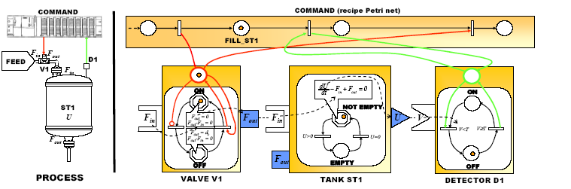
Fig.1.Interactions between the command level and the process level
  - System diagnosis architecture
The proposed diagnosis methodology[4][5] illustrated in Fig.2 consists of two mains steps : (i) detection with LAMDA classification method enabling the extraction of a set of possible faults ,and (ii) isolation of the fault within this set of possible faults by simulation via PrODHyS. The real process (the operative part) has been replaced in this study by hybrid simulation using PrOHDyS.
Operative part
Process (Real process or PrOHDyS Model with simulated breakdown)
Learning off line using LAMDA
Command module
Process recipe :Petri net
Recipe in breakdown mode
Informations
Detection fault and extraction scenario of the explored tree to a category of failures using on line recognition with LAMDA
Detection module
Simulation fault 1
Simulation fault 2

Simulation fault n

Residue of fault 1
Residue of
fault 2
Residue of
fault n
MIN

Diagnosis of fault
Diagnosis module
Supervision part

Fig.2. Diagnosis methodology
The proposed approach begins with the simulation of the system in normal conditions until the existence of dysfunction has been detected by recognition using learning model obtained with the method of classification LAMDA. We obtained several scenarios of faults leading to identical symptoms. The second step involves the dynamic hybrid simulation performed only for these restricted scenarios. Each fault of this set is simulated. Then, the simulated scenarios are compared to the observed behaviour through a criterion composed of residues (the squared difference between the variables measured and the variable simulated with the fault). Finally, the diagnosis of the fault is performed by choosing the fault with the smallest residue.
  - Classification with LAMDA
Process monitoring using classification method consists in determining at each sample time, the current class which was associated beforehand to a functional state of the process. There are two principal phases: the training and the recognition. In the first step (off-line training), the objective is to find the process behaviour characteristics which will allow differentiating the process states (each one being associated to a class). The second step (on-line recognition) identifies, on the basis of available measurements and the prior established functional model, the class (i.e. the process state). LAMDA (Learning Algorithm for Multivariate Data Analysis) is a methodology of fuzzy conceptual clustering and classification based on the concept of adequacy of an element to each class. An element is a set of attributes or descriptors (measurements). A marginal adequacy degree (MAD) of each descriptor to a class is then computed [6]. Aggregation of the (MAD)s is made via linear compensated fuzzy connectives to obtain the global adequacy degree (GAD) of this element to a class. LAMDA properties are: both supervised and unsupervised learning may be carried out, simultaneous processing of numerical and qualitative information, learning is made in a sequential and incremental way. A detailed description of this method can be found in [6] [7].
  - Case study
The considered hydraulic system (cf. Fig.3) is inspired by a benchmark defined by the AS193"Diagnosis of the hybrid systems" (cf. http://www.univ-lille1.fr/lail/AS193/).

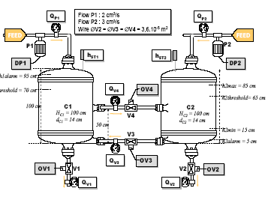
Fig.3. Flowsheet of the benchmark
This system consists of two cylindrical tanks C1 and C2, connected by two pipes with “on/off” valves V3 and V4. The feed of the tanks is maintained by the “on/off” pumps P1 and P2. The tank C2 can be drained through the “on/off” valve V2. The goal of the control device consists in maintaining the liquid level h2 in C2 between the heights h2min and h2max by controlling the valve V4. The valve V3 is opened only when the level in C2 is such as h2≤h2alarm. The Petri net associated with the command level is presented on figure 4:
Fig .4.Command Petri net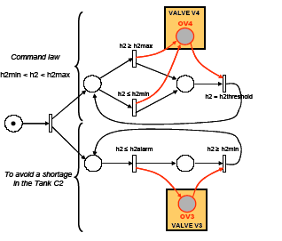
In this context, various scenarios can be simulated by action on the pumps P1 and P2 and the valve V2. Five faults have been considered: P1 blocked open (P1BO); P2 blocked open (P2BO); P2 blocked close ( P2BC); V2 blocked open (V2BO); V2 blocked close (V2BC). A first step is to simulate off line each fault using PrODHyS to obtain a learning model using LAMDA. The simulated fault results and the learning model obtained by unsupervised-learning are presented on figure 5.
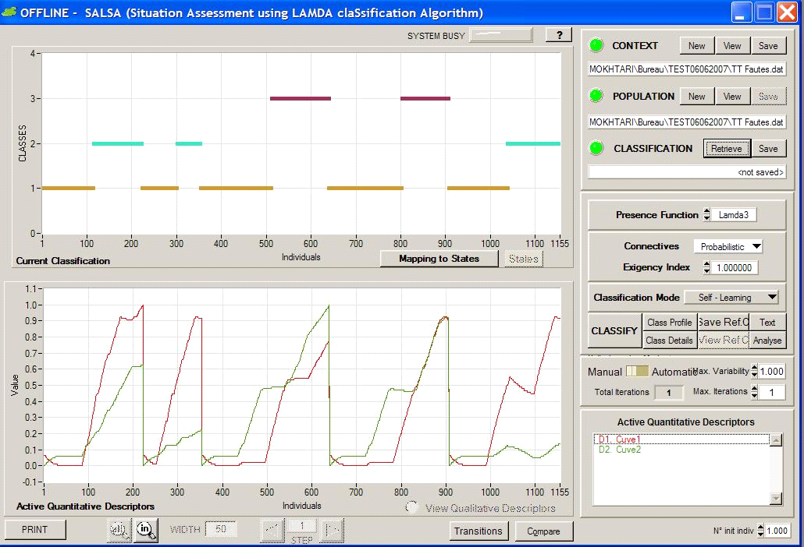

Scenario A
Scenario B
Normal state
P1BO
P2BC
P2BO
V2BC
V2BO

L i q u i d l e v e l
i n t h e t a n k C 1

L i q u i d l e v e l
i n t h e t a n k C 2

Fig .5. Learning model of faults
According to the results of classification (cf figure 5) the classification was able to identify only two scenarios:
- Scenario A (class 2) which regroups the faults P1BO, P2BC and V2BO.
- Scenario B (class 3) which regroups the faults P2BO and V2BC.
The second step of the procedure is to validtae the model by testing on-line recognition.
The PrODHyS simulation results of on-line recognition are presented on figure 6
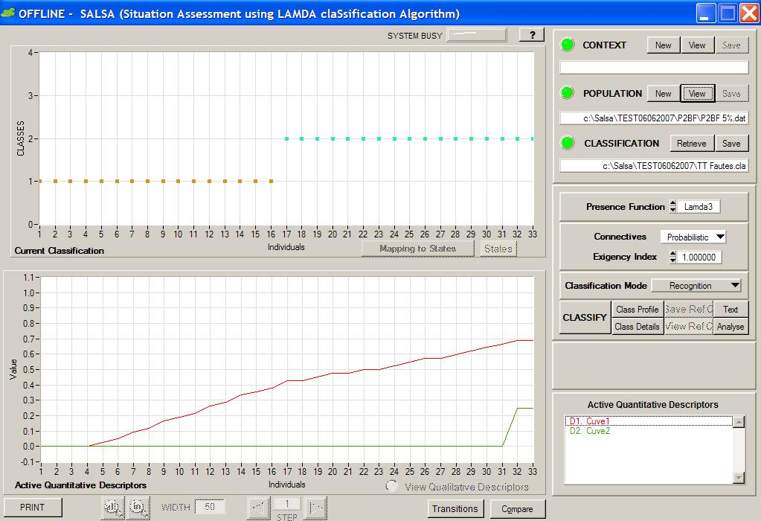

Scenario A

Beginning of fault P2BC

Fig .6. Recognition step
Scenario A is identified. At this step we can conclude that, the fault occurred can only be P1BO or P2BC or V2BO. This will restrict the next step to simulate only 3 faults over the 5 with the dynamic hybrid simulation. Then the residues are calculated. Finally, the fault diagnosis is made by choosing the one exhibiting the smallest residue computed in this example as: (h1measured-h1simulated)²+(h2measured-h2simulated)². The fault with the smallest residue corresponds to P2BC.
Fig .7. Diagnosis of fault
  - Conclusion

We have developed a hybrid system diagnosis methodology that combines a model-based approach (via a hybrid Petri net modelling) and a classification technique, this latter one enabling to restrict the tree of possible faults to be examined. This study showed that ODPN, besides being useful as tools for system design and simulation can also be a valid support to the problem of the diagnosis of system malfunctions.
  - Bibliography
[1]Hétreux G., Perret J., Le Lann J.M., Object hybrid formalism for modelling and simulationofchemical processes, ADHS’03, Saint-Malo, France, 2003
[2]Perret J., Hétreux G., Le Lann J.M., Integration of an object formalism within a hybrid dynamic simulation environment, Control Engineering Practice, Vol. 12/10, pp. 1211-1223, 2004
[3]Olivier N., Hétreux G., Le Lann J.M., Formal modelling and simulation for control of batch processes, Conference on Conceptual Modelling and Simulation CMS’05;
Marseille, France, 2005
[4]A.Mokhtari, M.V.Le Lann, G.Hetreux, J.M.Le Lann, A fault diagnosis approach for hybrid systems,32 nd Annual Conference of the IEEE Industriel Electronics Society(IECON006) Paris 7-10 NOV 2006.
[5]A.Mokhtari, M.V.Le Lann, G.Hetreux, J.M.Le Lann fault diagnosis approach using ODPN simulation for hydraulic systems EMSS European Modeling and Simulation Symposium Barcelone (Espagne) 4-6 octobre 2006
[6] Aguilar-Martin J., López de Mántaras R., "The process of classification and learning the meaning of linguistic descriptors of concepts". Approximate Reasoning in Decision Analysis. Nor1th Holland, 1982 p. 165-175
[7] Kempowsky T., Aguilar-Martin J., Subias A., Le Lann M.V., Classification tool based on interactivity between expertise and self-learning techniques, "IFAC-Safeprocess 2003", Washington D.C., USA, 2003.

