Using kriging models for real-time process optimisation
Marcos V.C. Gomes,ª I. David L.Bogle,^{b} Evaristo C. Biscaia Jr.,^{c} Darci Odloak^{d}
ªPETROBRAS S.A., Av. Horácio Macedo, 950, Rio de Janeiro RJ,Brazil 21941-915
^{b}Chemical Engineering Department, University College London, London WC1E 7JE,UK
^{c}Programa de Engenharia Química – COPPE, Universidade Federal do Rio de Janeiro, P.O. Box 68502, Rio de Janeiro, 21945-970, Brazil
^{d}Departamento de Engenharia Química, Universidade de São Paulo, São Paulo 05508-900 Brazil
Abstract
Kriging models have been used in a number of engineering applications, to approximate rigorous models when those computer codes become too time-consuming to be used directly. In this context, they are called surrogate models or metamodels. The use of kriging models as metamodels for process optimisation was addressed in a previous paper [1] where a methodology for metamodel-based process optimisation was proposed, focusing on real-time applications.
In this work, new developments were achieved through the use of new examples, one of which the optimisation of a real crude distillation unit involving 19 decision variables. The performance of the metamodel-based optimisation is compared with results obtained with the optimisation based on a first-principles model, embedded in a sequential-modular process simulator. It is shown that metamodel-based optimisation with adaptation of the metamodels during the optimisation procedure provides results with good accuracy and significant reduction of computational effort. The performance comparison between neural networks and kriging models for chemical processes is another contribution of this work.

Keywords: optimisation, crude distillation, kriging, neural network.
  - Introduction
A metamodel is a reduced model that is fitted to approximate a complex model (usually a rigorous, first-principles mathematical model). The data used to fit the metamodel is obtained from several runs of the rigorous model, frequently called computer experiments. By analogy to physical experiments, experimental design techniques are used to define the sites where the data should be generated.
Metamodels have been widely used in many fields of engineering, to replace rigorous mathematical models when they become too time-consuming or prone to numerical problems. One of the most typical uses of metamodels has been in optimal design where many design scenarios can be easily analysed by optimisation techniques.
One of the most used families of reduced models that have been used as metamodels [2] are the kriging models.
    - Kriging models
The kriging model structure presented here is the most frequently used in the literature (for more details, refer to [3]). Let the set of functions y(x,u) be a rigorous mathematical description of a process, where x are independent variables and u model parameters.
The kriging models that approximate the rigorous one are built from a set of design points (X,Y) obtained from runs of the rigorous model for a set of parameters u₀. They are composed by a linear regression model and a random function:
${\hat{y}}_{i}\left(x\right)=β_{i}^{T}⋅f(x)+z_{i}(x),i=1…\text{nY}$ (1)
The first term is usually a low-order polynomial. The random functions z_{i} have the following form:
$z_{i}=r_{i}^{T}(x)⋅R^{−1}(Y−{\text{Fβ}}_{i})$ (2)
where
$r_{i}(x)={\left[\prod_{j=1}^{\text{nX}}{ℜ_{\text{ij}}}(θ_{\text{ij}},X_{\text{kj}}−x_{j})\right]}^{T}\text{and} R_{\text{im}}(X_{m})={\left[\prod_{j=1}^{\text{nX}}{ℜ_{\text{ij}}}(θ_{\text{ij}},X_{\text{kj}}−X_{\text{mj}})\right]}^{T}, k,m=1…\text{nP}$ (3)
The matrix F is obtained by computing the f(x) values for the design inputs X. ℜ are correlation models [4], usually built as functions of the distance between two sites. Therefore, R_{im}(X_{m}) is a matrix that contains the correlations between the design sites, and r_{i}(x) is a vector that contains the correlations among a new site x and the design sites.
    - Applications on chemical processes
Palmer and Realff [2] proposed the first work based on metamodels applied to chemical process design, using kriging models and polynomials. Later, Gomes et al.[1] proposed the use of metamodels for RTO applications. The alkylation process optimisation problem was used to validate the proposed methodology. Accurate solutions were reported with the metamodel approach with less than 30% of the required runs of the original model when compared to the solution based exclusively on the original model. As an extension of this work, it was attempted [5] to apply this methodology to two other examples, one of them a large real optimisation problem of a crude distillation unit (CDU). It was concluded that the previous proposed procedures should be improved, in order to allow their successful application to a wider class of problems. This improvement was accomplished by the introduction of a SAO algorithm.
    - Sequential Approximate Optimisation (SAO)
SAO is a procedure used to solve optimisation problems when the model computation is time-consuming. The optimisation problem is decomposed into subproblems, confined to a fraction of the original search space, that are solved sequentially based on a trust-region strategy. The original problem functions are usually replaced by polynomials. The way by which the trust region is changed, the assessment of the model approximations and the termination criteria are important issues of the SAO algorithm.
In this work, some aspects of a new methodology based on the use of metamodels for real-time process optimisation are presented. This methodology comprises the metamodel generation and its use along with a new SAO algorithm that contains automatic procedures for adaptation and assessment of metamodels.
In this work, the highlights of the proposed methodology are presented, along with the results obtained with the optimisation of a real, industrial-scale crude distillation unit.
  - Example
In order to validate the proposed methodologies, a real industrial problem has been addressed: the optimisation of the Crude Distillation Unit (CDU) and the Solvents Units of RECAP, a Brazilian refinery of PETROBRAS.
    - Process description
The crude oil is fed to the pre-flash column (N507) of the CDU, from which three streams are obtained. The top product is light naphtha which is sent to the solvents units. An intermediate stream constitutes extra-light diesel (DEL). The bottom stream is sent to the atmospheric column (N506), where it is split into the atmospheric residue (RAT), Kerosene, heavy diesel oil and heavy naphtha. The light and the heavy naphtha streams constitute the Solvents Units feed, where the high-valued products rubber solvent (SBO) and Paint diluent (DTI) are obtained after many separation operations. A third stream containing the heaviest remains of the feed is mixed to DEL, Kerosene and Heavy Diesel streams to generate the diesel oil stream. A recycle stream between column N751 and the solvents units feed tank is used to minimize losses of SBO.
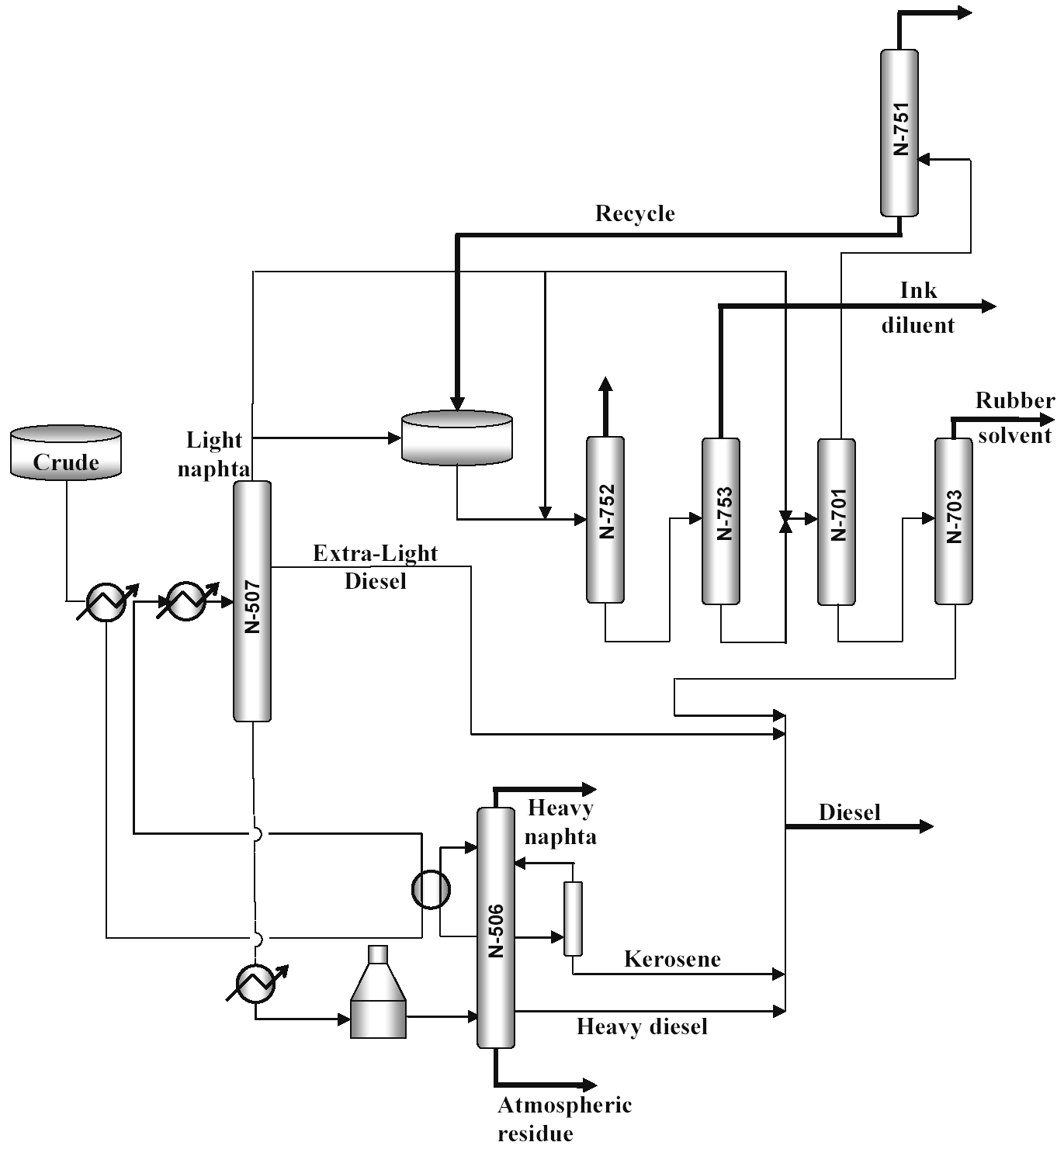
Figure 1 – Scheme of the CDU and the Solvents Units of RECAP/PETROBRAS.
    - The process model
The process model was built using PETROX, a proprietary sequential-modular process simulator from PETROBRAS. The simulation comprises 53 components and pseudo-components and 64 unit operation modules, including 7 distillation columns and a recycle stream. All modules are built with rigorous, first-principles models. For optimization applications, PETROX was linked to NPSOL, an SQP optimisation algorithm.
    - The optimisation problem
The optimisation problem takes the following form:
$\begin{aligned}\underset{x}{\text{min}} f\left[y\left(x\right)\text{,x}\right] \\ s\text{.}t\text{.}: h\left[y\left(x\right)\text{,x}\right]=0 ; g\left[y\left(x\right)\text{,x}\right]≤0\end{aligned}$ (4)
The set of functions y(x) in Equation (4) comprises all variables whose values are to be obtained from runs of the process simulator to compute the objective function and equality or inequality constraints. The objective function is the operational cost (Γ):
$Γ=\sum_{i=1}^{\text{nprods}}{\$_{i}^{\text{prods}}⋅{\text{product}}_{i}−}\sum_{j=1}^{\text{nutils}}{\$_{j}^{\text{utils}}⋅{\text{utility}}_{j}−}\$^{\text{feed}}⋅\text{feed}$ (5)
Table 1 presents the description of the decision variables and constraints of the problem.The problem inequality constraints (constraints 3-21) are related to product specifications and safety or performance limits. The equality constraints 1 and 2 were included to model the heat integration between the atmospheric column and the feed pre-heating train. Another 18 process variables take part of the objective function, as product flow rates or utilities.
Table 1 - Decision variables and constraints of the optimisation problem
 | Decision variables (x) |  | Constraints (h,g)
1 | Crude flow rate | 1 | Equality constraint #1 – heat integration
2 | Steam flow rate to N507 | 2 | Equality constraint #2 – heat integration
3 | Steam flow rate to N506 | 3 | Light naphta flow rate
4 | Pumparound flow rate | 4 | Diesel ASTMD86 85% temperature
5 | Atmospheric heater outlet temperature | 5 | Naphta recycle flow rate
6 | Kerosene flow rate | 6 | DTI– Dry point
7 | Diesel reflux flow rate | 7 | DTI– Initial boiling point ASTMD86
8 | Heavy naphta molar flow rate | 8 | N703 reboiler steam flow rate
9 | DEL flow rate | 9 | SBO– Dry point
10 | Temp. #2 N507 | 10 | SBO– Initial boiling point ASTMD86
11 | N701 feed flow rate | 11 | N753 control temperature
12 | N701 control temperature | 12 | N753 reboiler steam flow rate
13 | N703 control temperature | 13 | N753 bottom flow rate
14 | N703 reflux flow rate | 14 | Temp #2 N506
15 | N752 control temperature | 15 | N506 #10 – molar flow rate
16 | N753 reflux flow rate | 16 | N506 #22 – molar flow rate
17 | N506 pumparound outlet flow rate | 17 | N507 #10 – molar flow rate
18 | N753 top/feed ratio | 18 | N701 #17 – molar flow rate
19 | preheating train heat duty to N506 | 19 | N703 #3 – molar flow rate
 |  | 20 | N752 #8 – molar flow rate
 |  | 21 | N753 #14 – molar flow rate
  - Methodology: Metamodeling and SAO
The methodology for the use of metamodels in RTO begins with the off-line generation of a base metamodel. All the following steps shall be performed during the optimisation procedure. The use of this metamodel in a real-time environment requires its adaptation to face not only changes in the process behaviour, but eventual mismatches between the metamodel and the rigorous model. A validation procedure is required to allow the assessment of the metamodel throughout the optimisation procedure, as well as a suitable set of termination criteria. A comprehensive description of the proposed methodology is presented in [5].
    - Generation of the base metamodel
The main aspects for metamodel generation are: (i) Generation of training data, through an experimental design strategy; (ii) Independent variable selection; (iii) Parameter estimation and (iv) Metamodel validation.
The training data is generated based on the Latin Hypercube Design (LHD). A forward stepwise regression procedure is used to select the independent variables to be used by the metamodels of each dependent variable.
For kriging models, the structure is defined by the set of independent variables selected – including quadratic terms – and the selection of the correlation model. The parameter estimation is performed by a maximum likelihood procedure. For neural nets, the activation function to be used is defined a priori. The structure is completed by the selection of the number of neurons in the hidden layer. A backpropagation procedure has been used for training.
The procedure is presented in Figure 2. It starts with the training data, a set of candidate metamodel structures and a set of sets of initial estimates for the metamodel parameters. The best metamodel will be the one that provides the smaller prediction errors computed with a set of independent validation data. The best metamodel will be the one that provides the smaller prediction errors, computed with a set of independent validation data.
    - Sequential Approximate Optimisation (SAO)
The SAO algorithm proposed in [6] was used as a basis of the algorithm proposed here (Figure 3). The key features of this algorithm are related to the way by which the base metamodel is adapted and assessed, the trust region updating procedure and the termination criteria for the optimisation procedure.
Metamodel Adaptation

Optimisation

C
heck Termination Criteria

Update Trust
Region

END

YES

NO

Rigorous
Model

CONFIGURA
TION

▪

Rigorous Model

▪

Base Metamodel

▪

SAO Parameters

▪

Problem configuration: Variables, Limits, Initial estimates

,
OK?

Figure 3 – SAO strategy applied to the metamodel-based optimisation.

j > nθ?

Validation
data

no

yes

no

yes

Parameter
Estimation

Compute
prediction
errors

Keep best
metamodel

B
est metamodel

k > nS ?

Variable
selection

Figure 2 – The general procedure for metamodel generation
Training data
Set of model structures {S_{1,…,}S_{k,…,}S_{nS}}
Sets of parameter estimates {θ₁,…, θ_{j,} …, θ_{nθ}}
  - Results
Kriging models and neural nets were generated for each of the 39 dependent variables required for the computation of the objective function and the constraints. Table 2 presents the main characteristics of the metamodels (for more details, refer to [5]).
To simulate a real-time operation, a set of case studies (Table 3) were proposed, where changes in the process behaviour were introduced by changing the model parameters. The objective was to verify if the adaptation procedure would be able to change the base metamodels in order to allow acceptable solutions to the optimisation problem. The selected model parameters were the feed composition (I and II), the global heat coefficient of the atmospheric column pumparound (U_{PPA} – III and IV) and the global heat coefficient of the condenser of column N753 (U_{COND} - V).
Table 2 - Main characteristics of the metamodels
Size of training data set | 186
Size of validation data set | 399
Number of initial estimates | 10
kriging | Regression model |  | quadratic
kriging | Correlation models |  | Gauss
kriging |  |  | Spline
kriging |  |  | Spherical
Neural nets | Neurons in the hidden layer |  |  |  |  | 2 - 5
Neural nets | Activation functions |  |  | Hidden layer |  | Log-sigmoid
Neural nets |  |  |  | Output layer |  | Linear

Table 3 – Cases for assessment of the SAO/metamodel procedure
Case | CDU Feed, °API | U_{PPA} | U_{COND}
Base | 33.0 | 967 | 750
I | 32.5 | 967 | 750
II | 33.5 | 967 | 750
III | 33.0 | 800 | 750
IV | 33.0 | 1300 | 750
V | 33.0 | 967 | 900
Two indexes were used to assess the proposed methodology, whose computation is described in Equation (6). The relative benefit shows the fraction of the profit obtained with the rigorous solution that could be attained with the metamodel/SAO procedure. x⁰ is the initial state of the decision variables, x^{RIG} is the rigorous solution and x^{SAO} is the approximate solution. The relative effort shows the ratio between the number of simulation runs with the rigorous model required by the metamodel/SAO procedure and the correspondent number of simulations required by the rigorous solution.
$\text{Benefit}\left(\text{\%}\right)=\text{100}⋅\frac{\left|F_{\text{obj}}\left(x^{\text{SAO}}\right)−F_{\text{obj}}\left(x^{0}\right)\right|}{\left|F_{\text{obj}}\left(x^{\text{RIG}}\right)−F_{\text{obj}}\left(x^{0}\right)\right|} \text{Effort}\left(\text{\%}\right)=\text{100}⋅\frac{{\text{NSIM}}_{\text{SAO}}}{{\text{NSIM}}_{\text{RIG}}}$ (6)
Table 4 presents the obtained results. In most cases, a relative benefit above 85% was obtained, with a minimum value of 77%. The observed relative computational effort remained below 50% for 9 of the 12 cases studied, showing that good accuracy on the optimisation results was obtained with significant reduction of the computational effort.
Table 4 - Attained benefit and relative computational effort with the SAO/metamodel procedure.
Case | Kriging models |  | Neural nets
Case | Benefit, % | Effort, % | Benefit, % | Effort, %
Base | 94.0 | 35.8 | 97.1 | 43.1
I | 78.7 | 42.5 | 77.1 | 42.5
II | 89.0 | 22.4 | 89.7 | 53.1
III | 85.2 | 21.1 | 84.6 | 12.9
IV | 97.9 | 87.0 | 93.9 | 19.5
V | 90.2 | 29.7 | 94.6 | 54.7
  - Conclusions
A new strategy for Real-Time Optimisation combining metamodels and a Sequential Approximate Optimisation (SAO) procedure has been proposed. This methodology is based on automatic procedures, aiming its use in real-time applications. Kriging models and neural nets were used as metamodels.
The methodology was tested with an example involving the optimisation of a crude distillation unit, using the first-principles models of a sequential-modular process simulator. The solution of the corresponding optimisation problem with this rigorous model required considerable computational effort.
It is shown that the proposed methodology provides solutions with good accuracy and a significant reduction of computational effort. Another advantage of this approach is that the occurrence of numerical problems during the solution of the rigorous model does not result in the failure of the optimisation procedure. The reported results show that kriging models can be used to model chemical processes involving a large number of independent variables, and that they can perform as good as or better than neural nets.
References
- M.V.C.Gomes, I.D.L.Bogle, D. Odloak, E.C.Biscaia Jr., An application of metamodels for process optimisation, Proceedings of the 16th European Symposium on Computer Aided Process Engineering, (2006) 1449.
- K. Palmer, M. Realff, Trans IchemE, 80 (2002) Part A 760.
- T.J. Santner, B.J. Williams, & W.I. Notz, Springer-Verlag New York, Inc. (eds.) The Design and Analysis of Computer Experiments. New York, 2002.
- S.N. Lophaven, H.B. Nielsen, J. Sondergaard, DACE - A MATLAB Kriging Toolbox. Technical University of Denmark, Technical Report IMM-TR2002-12, 2002.
- M.V.C.Gomes, Otimização Seqüencial por Aproximações – Uma aplicação em tempo real para o refino do petróleo, D.Sc. Thesis, (in portuguese), PEQ/COPPE/UFRJ, Rio de Janeiro, Brazil, 2007.
- A.A.Giunta, M.S.Eldred, Proceedings of the 8th AIAA/USAF/NASA/ISSMO Symposium on Multidisciplinary Analysis and Optimisation, Long Beach, USA, AIAA-2000-4935.

