Online LQG stabilization of unstable gas-lifted oil wells
Esmaeel Jahanshahi, Karim Salahshoor, Riyaz Kharrat
Petroleum University of Technology, South Khosro St., Sattarkhan Ave., Tehran 1453953153, Iran
Abstract
The proposed strategies for stabilization of gas-lifted oil wells are offline methods which are unable to track online dynamic changes of the system. However, system parameters such as flow rate of injected gas and also noise characteristic are not constant with respect to time. An adaptive Linear Quadratic Gaussian (LQG) approach is presented in this paper in which the state estimation is performed using an Adaptive Unscented Kalman Filter (AUKF) to deal with unknown time-varying noise statistics. State-feedback gain is adaptively calculated based on Linear Quadratic Regulator (LQR). Finally, the proposed control scheme is evaluated on a simulation case study.

Keywords: gas-lift; casing heading; state estimation; AUKF; LQR.
  - Introduction
Gas-lift is a method for activation of low pressure oil wells. Figure 1 shows a typical diagram of a gas-lifted oil well [1]. In this method, gas is routed through surface gas injection choke (A) into the annulus (B) and then injected (C) deep into tubing (D) in order to be mixed with the fluid form reservoir (F). This reduces the density of oil column in tubing and lightens it to increase the production (E) rate from the low pressure reservoir. The oil production in the gas-lifted oil wells at their decline stages becomes unstable for low gas lift rates. This study focuses on the instability of gas-lifted wells due to casing heading phenomenon.
Figure 2 demonstrates a typical example of the casing heading phenomenon simulated in OLGA®v5.0 [2]. The cyclic operation consists of three main phases [3] as follows:
- The upstream pressure is smaller than P_{ti} (tubing pressure at injection point), therefore no gas enters the tubing. The annulus pressure builds up until it reaches P_{ti}. Then, injection into the tubing starts.
- As gas mixes with oil in the tubing, the column lightens and the well starts producing. The gas injection rate does not fulfill the well’s need. Therefore, the pressure in the casing drops and production reaches a maximum.
- Annulus pressure drops carrying along the injection gas rate w_{iv} and the oil production. Less gas being injected, the oil column gets heavier and P_{ti} exceeds the upstream pressure. Gas injection in the tubing stops.
In order to suppress this oscillatory behaviour, the use of the automatic feedback control has been considered [4]. State space model and nonlinear full-state feedback have been used for stabilization of the system [5]. But, some of these state variables are not measurable, therefore, concept of state estimation from well-head measurements has been considered. A nonlinear observer is used for state estimation [6] which has shown satisfactory result in experiment [7]. As noted in [7], estimation is affected by noise. The standard Kalman filter has been used for state estimation and down-hole soft-sensing [8]. Advantage of Kalman Filtering (KF) compared to the nonlinear observer [7] is its capability of working in presence of noises [9]. But, the standard Kalman filter could be used only in a single operating point for a locally linearized dynamic of the system. To deal with this problem, extended Kalman Filter (EKF) has been used in [10] for down-hole soft sensing in gas-lifted oil wells.
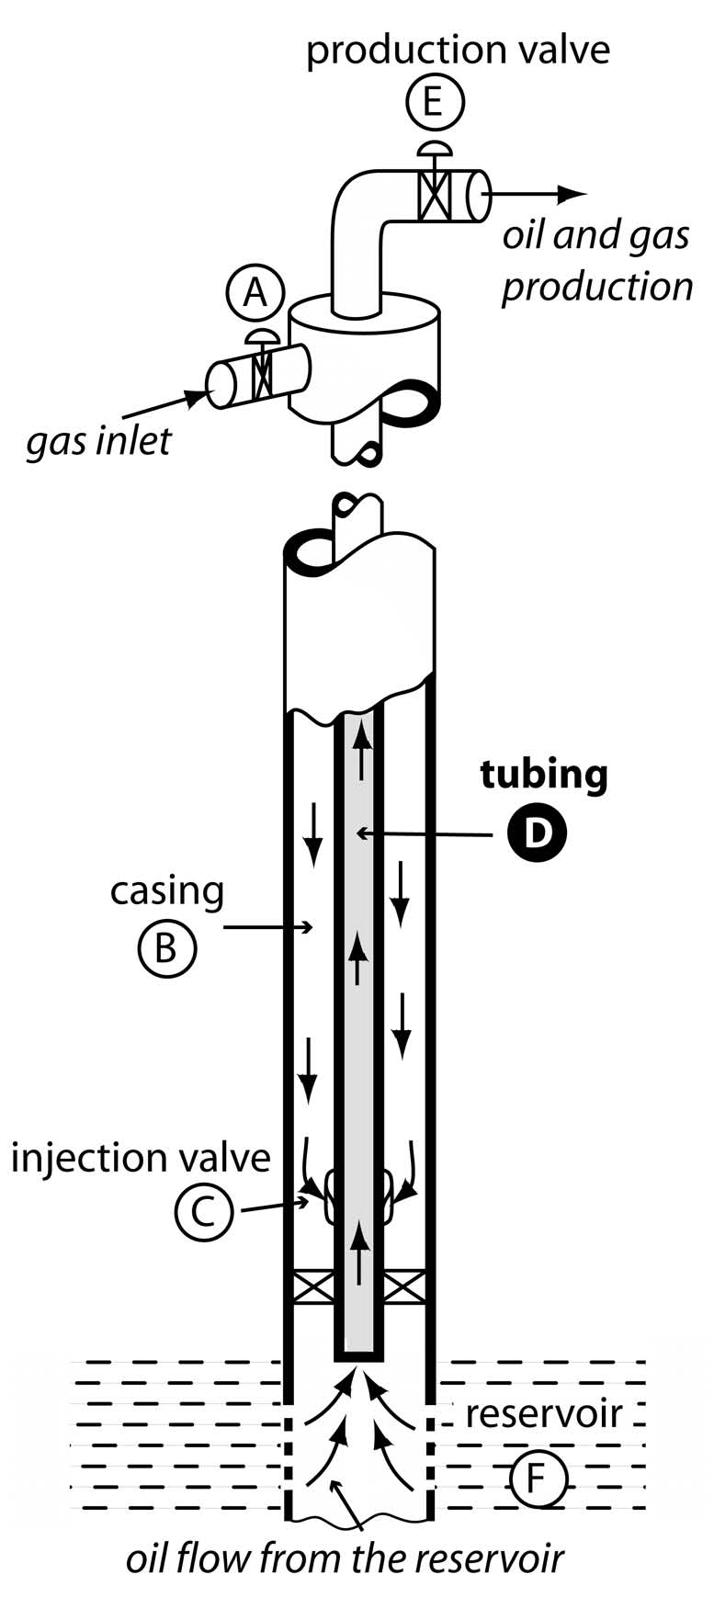  Fig. 1. A gas lifted oil well | 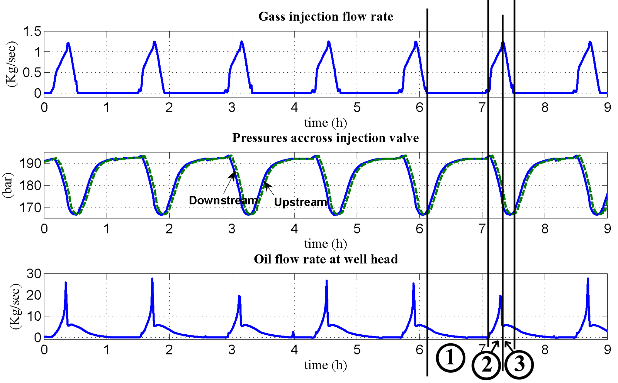  Fig. 2. Casing-heading phenomenon simulated with OLGAv5.0
EKF estimation accuracy may not be satisfactory to use estimated states for feedback control. Because, EKF uses a first-order approximation of nonlinear dynamics [9]. For state estimation of highly nonlinear systems, UKF is recommended [9]. However, for these methods, the measurement noise should be zero-mean Gaussian noise with known statistic characteristics. In this paper, an AUKF estimation approach has been proposed to increase the accuracy of state estimates despite the unknown time-varying statistic characteristics of measurement noise in online real world situations.
The organization of this paper is as follows. In Section 2, the mathematical model of system is described. In Section 3, the AUKF algorithm is developed. In Section 4, an optimal control strategy will be introduced to stabilize the system. Simulation results are presented in Section 6. Finally, the results are summarized in Section 7.
  - Mathematical Model
The gas-lift oil well operation can be described by the following state-space equations [7]:
(1)
Where the state variables consist of x₁ as the mass of gas in the annulus, x₂ as the mass of gas in tubing, and x₃ as the mass of oil in tubing. For more details, refer to [6, 7].
  - AUKF State Estimation Algorithm
In practice, down-hole measurements relating to tubing and annulus variables are not in general available. x₁ can be measured and the remaining two states (x₂ and x₃) should be estimated. The available measurements are assumed to be y₁(t)=x₁ and y₂(t)=P_{t} (tubing pressure at well head) [7].
The process dynamics and the measurement equations obey the following non-linear relationships:
(2)
(3)
Where f and h are known nonlinear functions. The random variables w_{k} and v_{k} represent the process and measurement noises, respectively. They are assumed to be independent, white noises with normal probability distributions; p(w)~N(0,Q) and p(v)~N(0,R).
Julier and Uhlmann [11, 12] developed the UKF algorithm which does not require to linearize the foregoing general nonlinear system dynamics. The UKF algorithm uses a "deterministic sampling" approach to calculate the mean and covariance estimates of Gaussian random state variables (i.e., x) with a minimal set of 2L+1 sample points (L is the state dimension), called as sigma points [12, 13], through the actual nonlinear system dynamics without any linear approximations. Hence, this approach yields more accurate results compared to the KF and EKF. The results are accurate to the third order (Taylor series expansion) for Gaussian inputs for all the nonlinearities. For non-Gaussian inputs, the results are accurate to at least the second order [12]. The UKF algorithm is well described in [9] and for sake of limited space we refer readers to this reference.
Often, we do not know all parameters of the model or we want to reduce the complexity of modeling. Therefore, in real application, the exact value of R is not known a priori. If the actual process and measurement noises are not zero-mean white noises, the residual in the unscented Kalman filter will also not be a white noise. If this happened, the Kalman filter would diverge or at best converge to a large bound. To prevent the filter from divergence, we use adaptive version of UKF as follows.
The innovation sequence is defined as . Substituting the measurement model into, gives, with the fact that the difference between and is a small divination, we could use a linear approximation for the term inside brackets, as, where. Noting that we have, and. On the basis of assuming that w_{k} and v_{k} are uncorrelated white Gaussian noise sequences and the orthogonallity condition exists between observation error and state estimation error, the innovation covariance can be computed as.
Combining the preceding equations, gives. When the innovation covariance is available, the covariance of the observation error R_{k} can be estimated directly from the preceding equation. Calculation of the residual covariancenormally uses a limited number of samples of the innovation sequence:
(4)
As a result,
(5)
In which M=100 represents the estimation window size. However, it is noted that (5) gives a valid result when the innovation sequence is stationary and ergodic over the M sample steps.
  - Adaptive LQR Control
State feedback control is commonly used in control systems, due to its simple structure and powerful functions. Data-driven methods such as neural networks are useful only for situations with fully measured state variables. For this system in which state variables are not measurable and measurement function is nonlinear, we are dependant on system model for state estimation. On the other hand, as shown in figure 2, in open-loop situations, system has limit cycle behavior and measurements do not give any information of system dynamics. Therefore, we use model-based approach.
Parameters and variables that determine the system dynamic changes, such as ambient temperature, flow rate of well-head injected gas are measurable or a priori known as opening of production choke. Therefore, using these values, model can be adapted to the plant.
To develop an adaptive controller, it is necessary to solve the related non-adaptive control problem when the parameters of the controlled plant are known. A crucial issue is the existence of an ideal (nominal) controller for a given control objective, which is equivalent to a set of matching conditions [14].
To calculate state feedback gain K[k], discrete linear-quadratic (LQ) regulator is used. The sate feedback law minimizes the quadratic cost function [15]:
(6)
Where gain K[k] is calculated using following Riccati Equation:
(7)
K[k] is derived from S by . Control scheme tracks values of variables and parameters that determine the operating point of systems and with any change in these parameters, a new linear controller gain is calculated based on the most recent operating point. It should be noted that computation time of every step for the combined state estimation and solving Riccati equation must be less that sampling time of the system.
  - Simulation Results
Simulation of the model [6] and the proposed control scheme are implemented in MATLAB® with the nominal values of the case study described in [3]. For the sake of comparison, the same characteristics for process and measurement noises are considered in all simulation runs. The initial values assumed for states and estimates have been considered similarly in all simulation runs. A Gaussian noise with constant variance of 0.03 is added to w_{gc} as process noise. Variances of measurement noises for the first hour of simulation are considered to have constant values: 5 for y₁(t) and 5000 for y₂(t). From t=1 h to the end of simulation run, variances are increased linearly as unknown drifts, so that variances of measurement noises reach up to 50 and 80000 at the end of simulation time. Note that nonlinear observer [6, 7] also needs w_{pc} (flow rate of production choke) as a third measurement that we do not consider any noise for it. First, we simulated the nonlinear observer proposed in previous works [6, 7]. As shown in figure 3, its estimation for the second state variable is very weak in presence of noises.
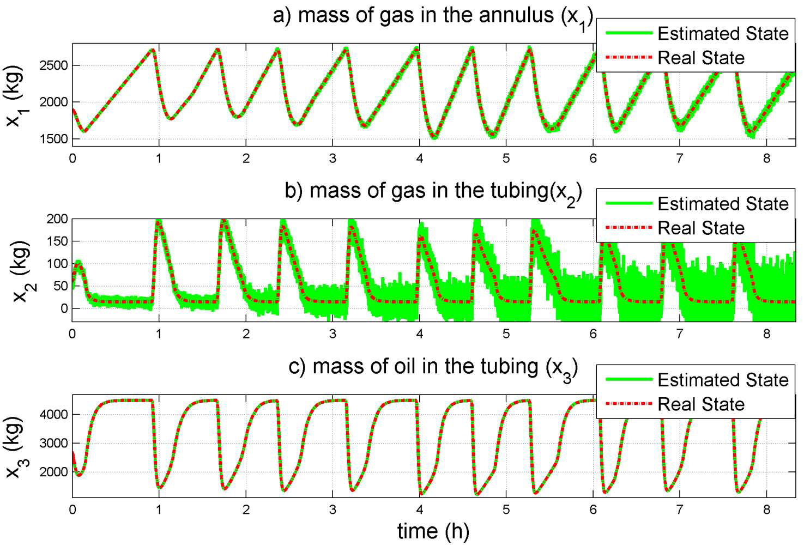  Fig. 3- The nonlinear observer estimates | 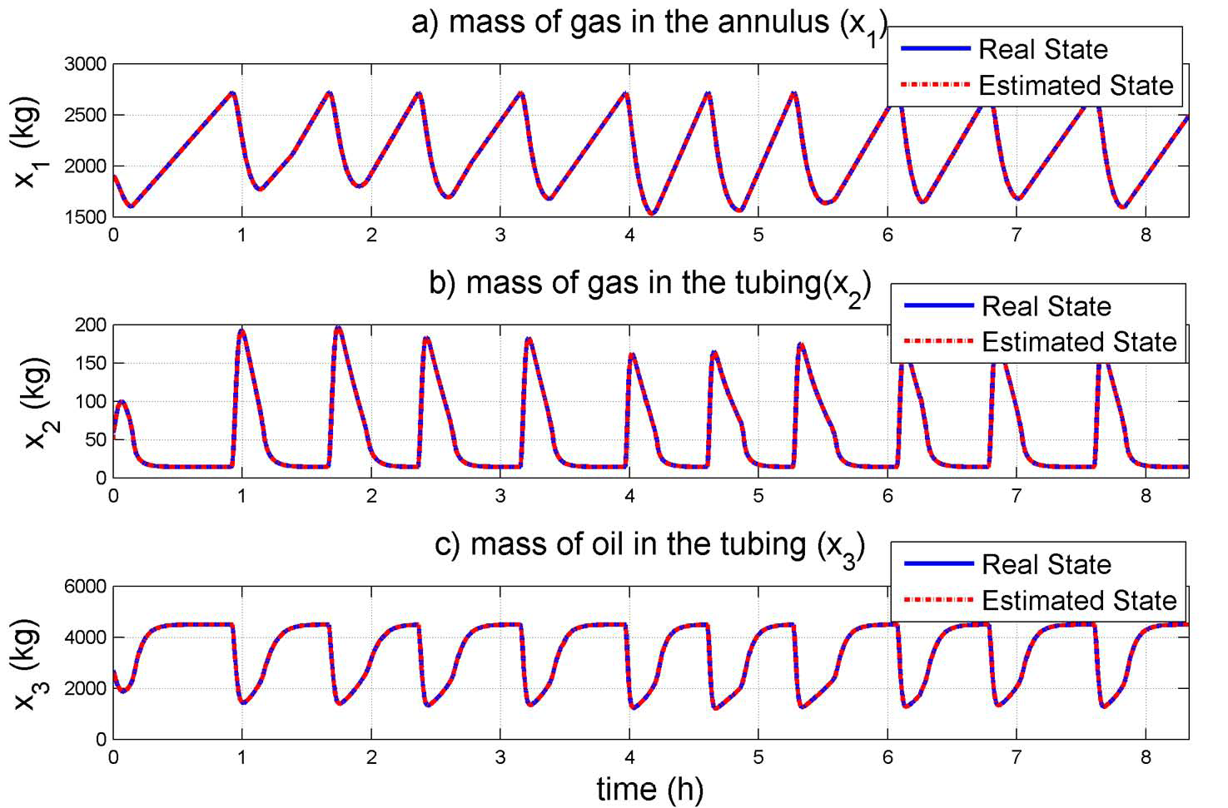  Fig. 4- AUKF estimation for open-loop system
Figure 4 shows performance of the proposed AUKF for open-loop system. As described, it’s assumed that the induced drift in sensor noises are not known a priori to the filter and variances of measurement noises are estimated recursively by the adaptive estimation algorithm.
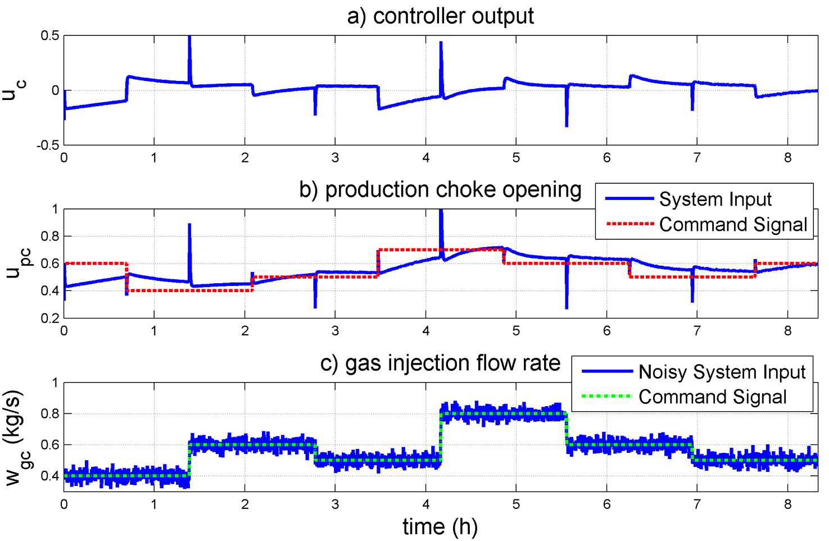  Fig. 5- Control signal and inputs to the system | 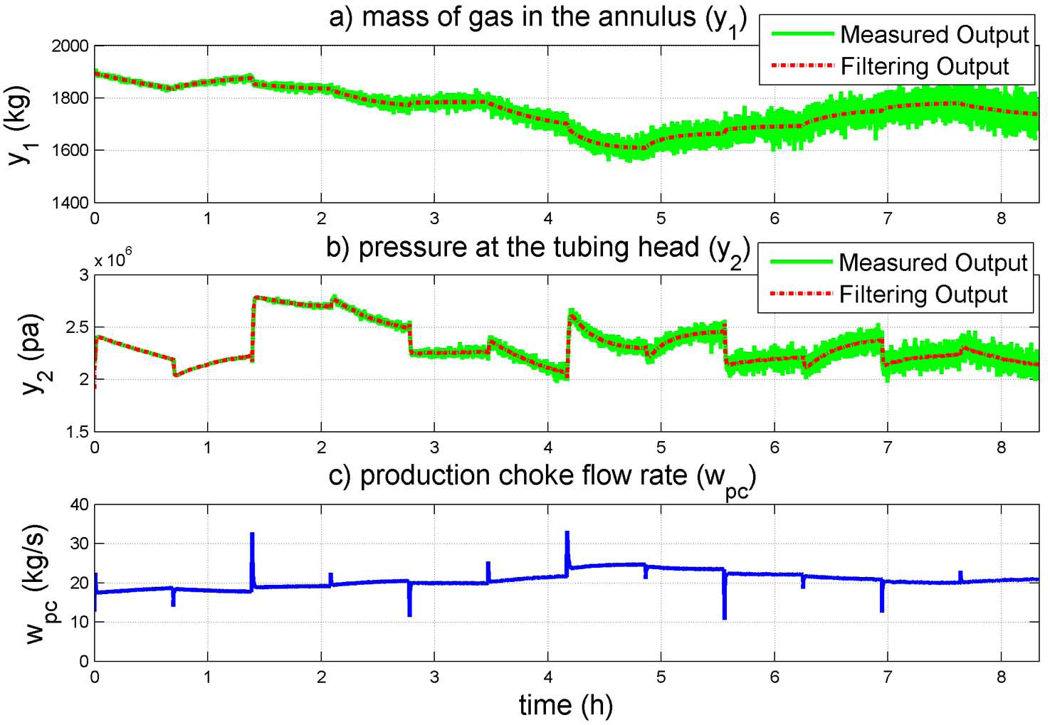  Fig. 6- Outputs of the closed-loop system
To evaluate the proposed adaptive control performance, opening of production choke and flow rate of injected gas at the well-head are random pulses as command signals, as shown in figure 5. The opening value of the production choke u_{pc} also is the manipulated variable of the control strategy. Figure 6 shows noisy measurements and filtering outputs of closed-loop system, where variable variances of measurement noises are apparent. Note that w_{pc} illustrated the stabilized behavior of closed-loop system.
The state estimation also has been performed by Particle Filter [9] for comparison purposes. In this case, the algorithm was run with 1000 particle, so that the computation time could be affordable. Also, roughening factor of 0.1 is used. Similarly, the standard UKF algorithm has been simulated. In table 1, root mean square error values and computation times for different simulations are presented. Note that EKF and nonlinear observer estimate accuracies are not satisfactory and closing feedback with them can not stabilize the system.
Algorithm | RMSE |  | Computation time of the open-loop system
Algorithm | Open-loop | Close-loop | Computation time of the open-loop system
Observer in [6, 7] | 28.50, 28.43, 7.62 | ----------- | 20 sec
EKF | 19.13, 5.21, 100.8 | ----------- | 122 sec
Standard UKF | 1.41, 0.83, 8.77 | 1.85, 0.52, 6.86 | 155 sec
AUKF | 0.84, 0.25, 5.26 | 0.49, 0.18, 3.72 | 188 sec
Particle Filter | 1.13, 0.42, 42.71 | 0.84, 0.32, 4.24 | 30400 sec
Table 1- Comparison of root mean square error and computation time of different algorithms.
  - Conclusions
An adaptive UKF algorithm is presented to estimate the state variables in the face of unknown changes in characteristics of measurement noise. Accuracy of the proposed AUKF estimator is the best even compared with that of Particle Filter with much less computation time. The proposed LQG control scheme using this adaptive estimator can successfully stabilize the system despite of any system parameter and noise characteristic changes. Implementation of the proposed method in laboratory scale in the same way that is performed in [7] is recommended.
References
[1] L. Sinegre, "Etude des instabilités dans les puits activés par gas-lift", in Spécialité “Mathématiques et Automatique”, Phd. thesis, Paris: Ecole des Mines de Paris, 2006.
[2] Scandpower, OLGA Software Verion 5 User's Manual: Scandpower, 2006.
[3] L. Sinegre, N. Petit, and P. Menegatti, "Predicting instabilities in gas-lifted wells simulation", American Control Conference, ACC, Minneapolis, Minnesota, USA, 2006.
[4] B. Jansen, M. Dalsmo, L. Nøkleberg, K. Havre, V. Kristiansen, and P. Lemetayer, "Automatic Control of Unstable Gas Lifted Wells", SPE Annual Technical Conference and Exhibition, Houston, Texas, USA, 1999.
[5] L. Imsland, B. A. Foss, and G. O. Eikrem, "State Feedback Control of A Class of Positive Systems: Application To Ggas Lift Stabilization," European Control Confrence, Cambridge, UK, 2003.
[6] O. M. Aamo, G. O. Eikrem, H. Siahaan, and B. Foss, "Observer Design for Gas Lifted Oil Wells", American Control Conference, ACC, Boston, Massachusetts, USA, 2004.
[7] O. M. Aamo, G. O. Eikrem, H. Siahaan, and B. Foss, "Observer design for multiphase flow in vertical pipes with gas-lift - theory and experiments", Journal of Process Control, vol. 15, pp. 247–257, 2005.
[8] G. O. Eikrem, L. s. Imsland, and B. Foss, "Stabilization of Gas Lifted Wells Based on State Estimation," Intl. Symp. on Advanced Control of Chem. Processes, Hong Kong, China, 2004.
[9] D. Simon, Optimal State Estimation, Kalman, H-inf and Nonlinear Approches. Hoboken, New Jersey: Wiley-Interscience, 2006.
[10]H. H. J. Bloemen, S. P. C. Belfroid, and W. L. Sturm, "Soft Sensing for Gas-Lift Wells", SPE Annual Technical Conference and Exhibition, Houston, Texas, USA, 2004.
[11]S. J. Julier and J. K. Uhlmann, "A New Extension of the Kalman Filter to Non-linear Systems," presented at AeroSense: The 11th Int. Symp. A.D.S.S.C., 1997.
[12]S. J. Julier, J. K. Uhlmann, and H. Durrant-Whyte, "A new approach for filtering non-linear systems,", American Control Conference, ACC, Seattle, Washington, USA, 1995.
[13]E. A.Wan and R. v. d. Merwe, "he Unscented Kalman Filter for Non-linear Estimatio," presented at IEEE Symposium 2000 (AS-SPCC), Lake Louise, Alberta, Canada, Oct. 2000.
[14]G. Tao, Adaptive Control Design and Analysis. New york: Wiley-Interscience, 2003.
[15]J. B. Burl, Linear Optimal Control: H-2 and H-inf Methods. Menlo Park, California: Addison Wesley Longman Inc., 1999.

