Comparison of model predictive control strategies for the simulated moving bed
Adrian Dietz, Jean-Pierre Corriou
Laboratoire des Sciences du Génie Chimique (LSGC), Nancy Université, CNRS, 1, rue Grandville, BP 20451,F- 54001 Nancy Cedex
Abstract
This work addresses the study of an efficient chromatographic separation unit operation control, the simulated moving bed (SMB). Linear model predictive control (MPC) is considered in this work. A comparison of two different sets of manipulated inputs is carried out: on one hand, the classical one often presented in the literature, which consists in manipulating directly different flow rates involved in the process and, on the other hand, an approach coming from other counter-current separation processes which consists in manipulating the ratios of flow rates of each SMB zone. The advantages and drawbacks of each control strategy are discussed. In all cases, results show clearly the interest of applying MPC to high complexity systems such as the SMB.

Keywords: simulated moving bed, model predictive control.
  - Introduction
Chromatographic techniques allow the separation of products with a high purity required in industrial fields such as fine chemistry, pharmaceutics, food. This unit operation is usually operated in batch mode and is well known for its high investment cost due to the adsorbent and large eluent consumption. In order to tackle this drawback, the continuous moving bed technology was first developed as the true moving bed (TMB) where the solid and the liquid flows move in countercurrent way. However, because of the solid flow, this process causes solid attrition, so that the SMB technology was then developed. In a SMB, the solid movement is simulated by simultaneous switching of the inlet and exit ports corresponding to feed, eluent, extract and raffinate, in direction of the fluid flow (Figure 1). Consequently, the continuous system corresponding to the TMB where a steady state can be obtained becomes a hybrid one resulting from a cyclic operation mode. Typical studies in the literature range from the design stage [1-5] to the operation [6], identification [7], parameter and state estimation [8-10], and control [11-16] of the SMB. Many different control techniques are mentioned including linear and non linear model predictive control and non linear geometric control. Several variants of this technology are also developed such as the Varicol process or the power feed operation.
In this work, two different model predictive control strategies of a SMB differing by the choice of the manipulated inputs are compared. On one hand, the classical one often presented in the literature consists in directly manipulating different flow rates involved in the process and, on the other hand, the strategy mentioned by Couenne [17] consists in manipulating ratios of flow rates and is used for xylenes separation. The idea of using ratios of flow rates was already used in distillation control [18] where Skogestad consider the two-ratio configuration (L/D,V/B) as the best choice of manipulated inputs in case of dual control. In the same manner, the choice of flow rates ratios seems to be interesting for the SMB control because it reduces the high non-linearity of the process as the separation phenomena are directly related to flow rate ratios rather than to flow rates themselves. In the flow rate ratio control scheme [17], the two main outputs are the purity and yield of the products, two other outputs are respectively defined to guarantee a stable operation of the process and to optimize it. The manipulated inputs are the ratios of liquid flow rate in zone k divided by the equivalent solid flow rate. In the flow rate control scheme, the controlled outputs are the purities at the extract and raffinate outlets and the manipulated inputs are the eluent (solvent), extract, recycle and equivalent solid flow rates.
Eluent
Extract
Raffinate
Feed
Port switching direction
Zone I
Zone III
Zone II
Zone IV
Figure 1: Scheme of the Simulated Moving Bed.
A linear model predictive control law is retained in both cases because of its attracting characteristics such as its multivariable aspects and the possibility of taking into account “hard” constraints on inputs and inputs variations as well as “soft” constraints on outputs (constraint violation is authorized during a short period of time). To practise model predictive control, first a linear model of the process must be obtained off-line before applying the optimization strategy to calculate on-line the manipulated inputs.
The model of the SMB is described in [8] with its parameters. It is based on the partial differential equation for the mass balance and a mass transfer equation between the liquid and the solid phase, plus an equilibrium law. The PDE equation is discretized as an equivalent system of mixers in series. A typical SMB is divided in four zones, each zone includes two columns and each column is composed of twenty mixers. A nonlinear Langmuir isotherm describes the binary equilibrium for each component between the adsorbent and the liquid phase.
  - Identification of the linear model
The linear model for predictive control is based on the step responses of the process with respect to the various manipulated inputs. As mentioned previously, in a SMB, the solid flow is simulated by synchronous valve switching at given intervals. The switching period of the SMB is computed from the equivalent solid flow rate. A variable switching period induces a varying sampling period as the measurements are assumed to be performed only after each commutation and correspond to average concentrations over this switching period.
    - Linear model for flow rate control
The step responses of the extract and raffinate purities, resp. y₁ and y₂, (Fig. 2) are obtained for 0.05% steps of respective eluent, recycle, extract and solid flow rates,resp. u₁, u₂, u₃ and u₄, used as manipulated inputs. The steps are performed after the process reaches a steady state purity of 95% for both products. Most of the responses are close to first order step responses and present similar time constants, which is suitable for further control. Only the step response of the extract purity with respect to the eluent flow rate (y₁/u₂) displays an inverse response, however it has a low order of magnitude like two other step responses (y₁/u₁, y₁/u₃).
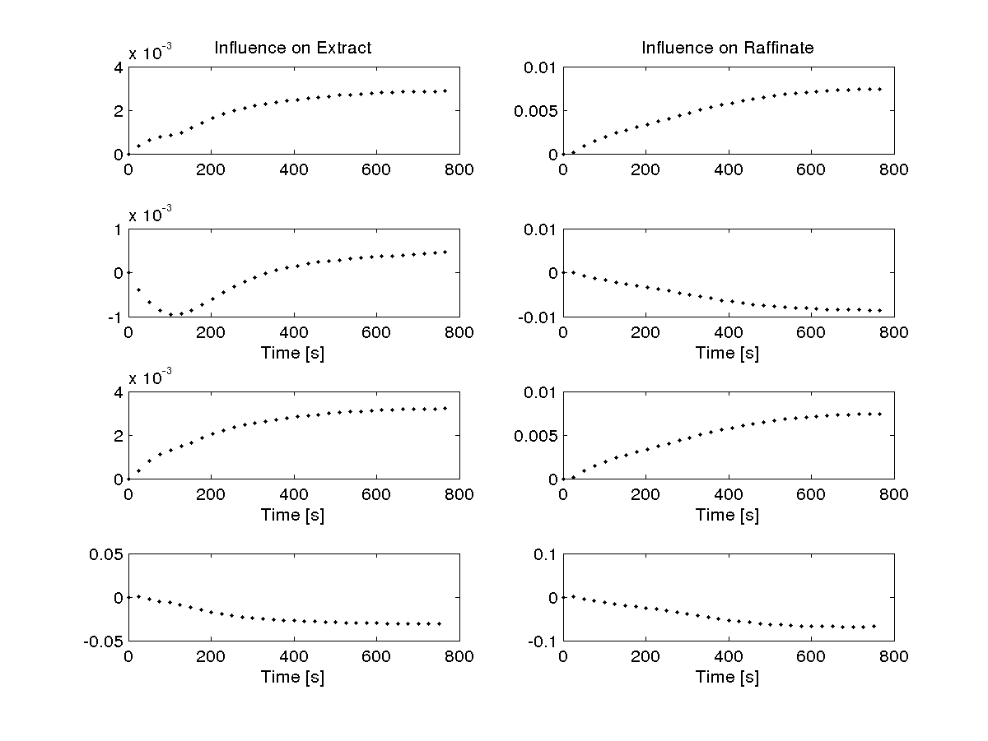
Figure 2: Step response coefficients of the extract and raffinate purities with respect to the flow rates (from top to bottom: eluent, recycle, extract and solid ).
    - Linear model for ratio control
The step responses for ratio control are obtained by varying successively the ratios u_{k} of the liquid flow rates of the successive zones k over the equivalent solid flow rate (Fig. 3). The results show that several inverse responses are present; moreover different types of response dynamics exist. The liquid flow rates are calculated from the ratios in order to obtain a constant flow rate ratio in each zone of the SMB.
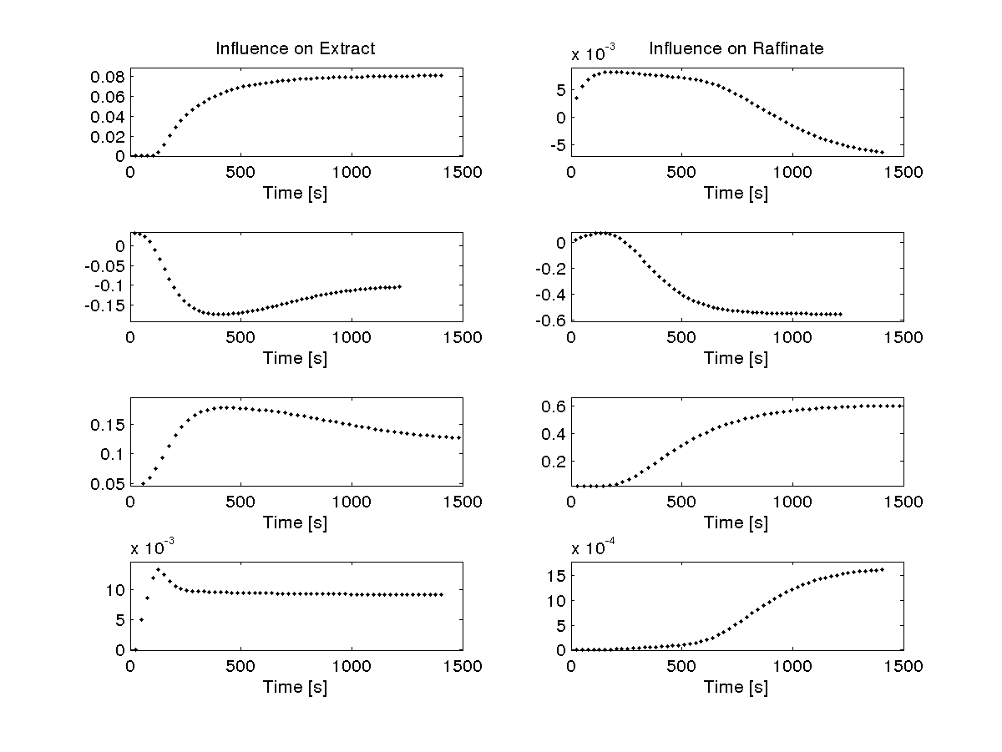
Figure 3: Step response coefficients of the extract and raffinate purities with respect to the flow rates ratios (from top to bottom: ratio in zone 1, zone 2, zone 3, zone 4 ).
The main remark is that the ratio step responses are very different from the simple flow rate step responses of Fig. 2. Second order responses are present (y₁/u₂, y₁/u₃), some step responses show low magnitudes (y₁/u₄, y₂/u₁, y₂/u₄). Also, some time constants are relatively different. When ratios are manipulated, several flow rates are simultaneously manipulated which makes the total character complex and unpredictable.
  - Model predictive control
The model predictive control used includes all features of Quadratic Dynamic Matrix Control [19], furthermore it is able to take into account soft output constraints as a non linear optimization. The programs are written in C++ with Fortran libraries. The manipulated inputs (shown in cm³/s) calculated by predictive control are imposed to the full nonlinear model of the SMB. The control simulations were made to study the tracking of both purities and the influence of disturbances of feed flow rate or feed composition. Only partial results are shown.
    - Flow rate control
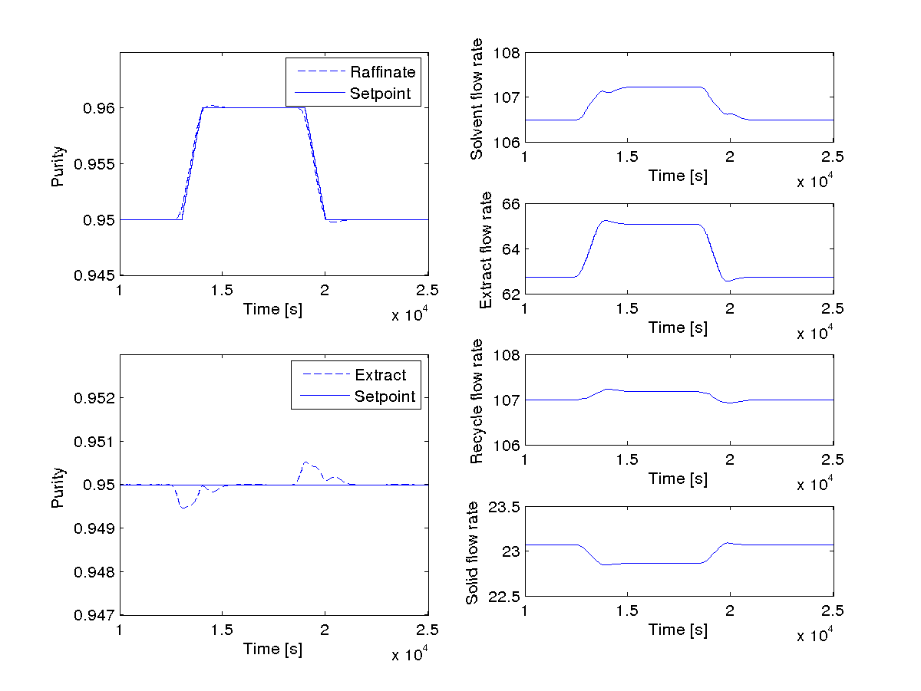
Figure 4: Flow rate control in case of raffinate purity tracking. Left: controlled outputs. Right: manipulated inputs.
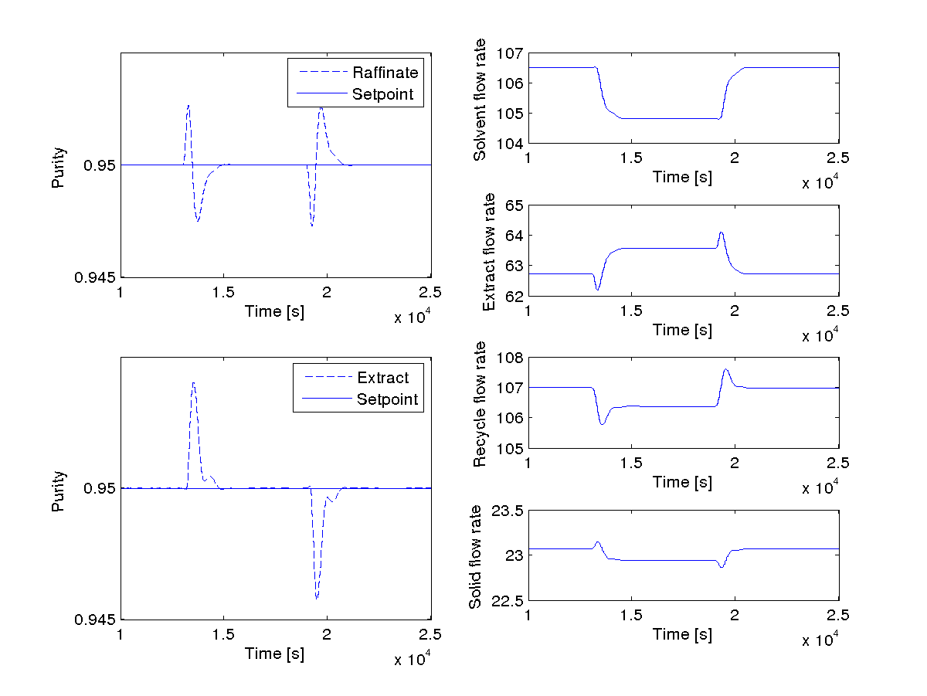
Figure 5: Flow rate control in case of feed flow rate disturbance rejection. Left: controlled outputs. Right: manipulated inputs.
Several points must be emphasized before discussing the results obtained. Being given that the sampling period depends on the solid flow rate, the dynamic matrix must be rebuilt at each computing step. In order to maintain the QL (optimization of quadratic criterion with linear constraints) nature of the optimization problem, the switching period for the future inputs is assumed to be identical to the first one calculated. The predicted outputs at different times are obtained by cubic spline interpolation. For a set point change of the raffinate purity from 0.95 to 0.96 and back to 0.95 (Fig. 4), the control of the raffinate purity is well ensured and the manipulated inputs undergo acceptable moves. The control of the extract purity would show similar characteristics. The disturbances of the feed flow rate of +10% and -10% applied at times 13000 and 19000s (Fig. 5) are well rejected and the manipulated flow rates are stabilized after a transient period corresponding to the disturbance effect.
    - Ratio control
As previously mentioned, the manipulated inputs are now the ratios of the liquid flow rates in each zone over the equivalent solid flow rate. However, in the Figures, the operating flow rates are shown. In the case of the SMB, the identification procedure presented some difficulties compared to the more classical flow rate identification and control. The control horizon was set to one for stability reasons, and higher prediction and model horizons were used. Fig. 6 is obtained for the same set point tracking as Fig. 4. The tracking is acceptable, more coupling is present for the extract purity and the manipulated inputs moves are less smooth. These results are slightly less satisfying than for flow rate control.
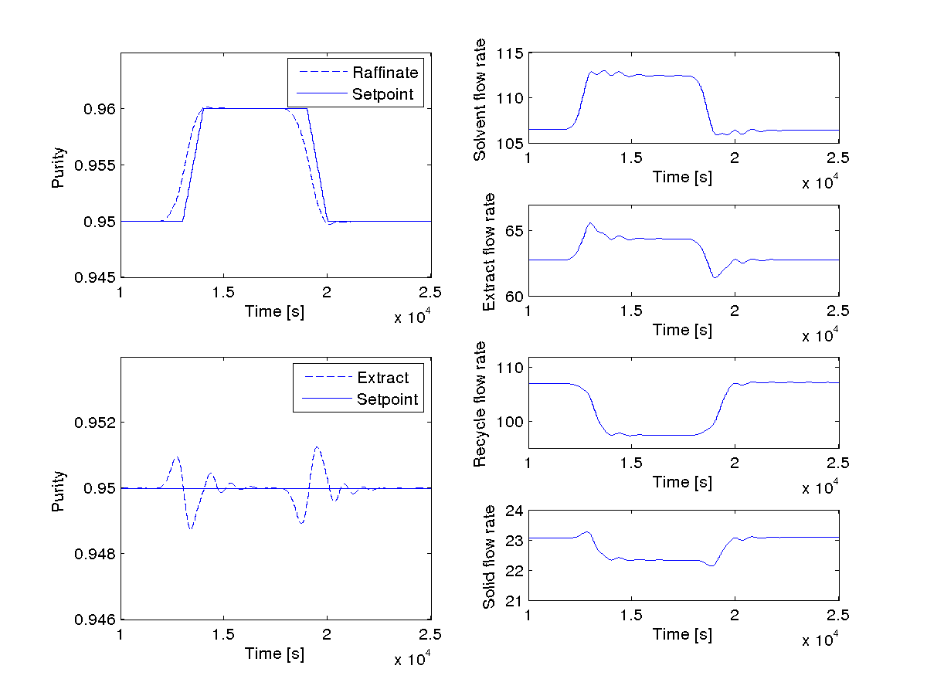
Figure 6: Ratio control in case of raffinate purity tracking. Left: controlled outputs. Right: operating flow rates.
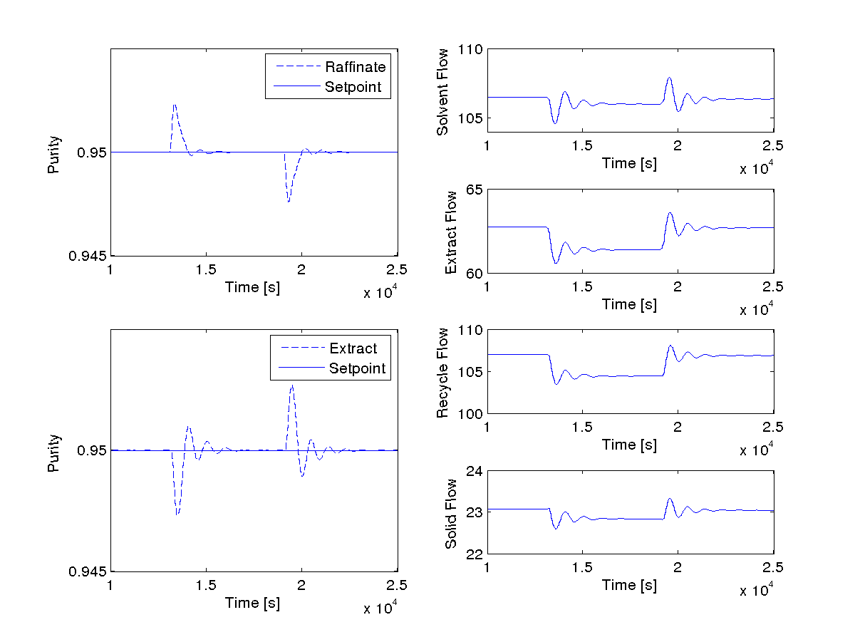 Figure 7: Ratio control in case of feed concentration disturbance rejection. Left: controlled outputs. Right: operating flow rates.
The unmeasured feed concentration disturbance rejection posed more difficulties (Fig. 7). On the opposite, the measured feed flow rate disturbance is rejected without dynamic effects (Fig. 8) as the manipulated inputs are algebraically and linearly related to the disturbance value. Even if ratio control is globally less efficient that flow rate control, the capacity of ratio control to reject feed flow rate disturbances is attractive in some particular cases such as the pharmaceutical or the fine chemistry where the production is carried out by batches. Thus the set point remains constant because it is associated to the batch recipe resulting in a given final product concentration, and the main disturbance comes from the feed flow rate that can be modified by the pump operation or the operator.
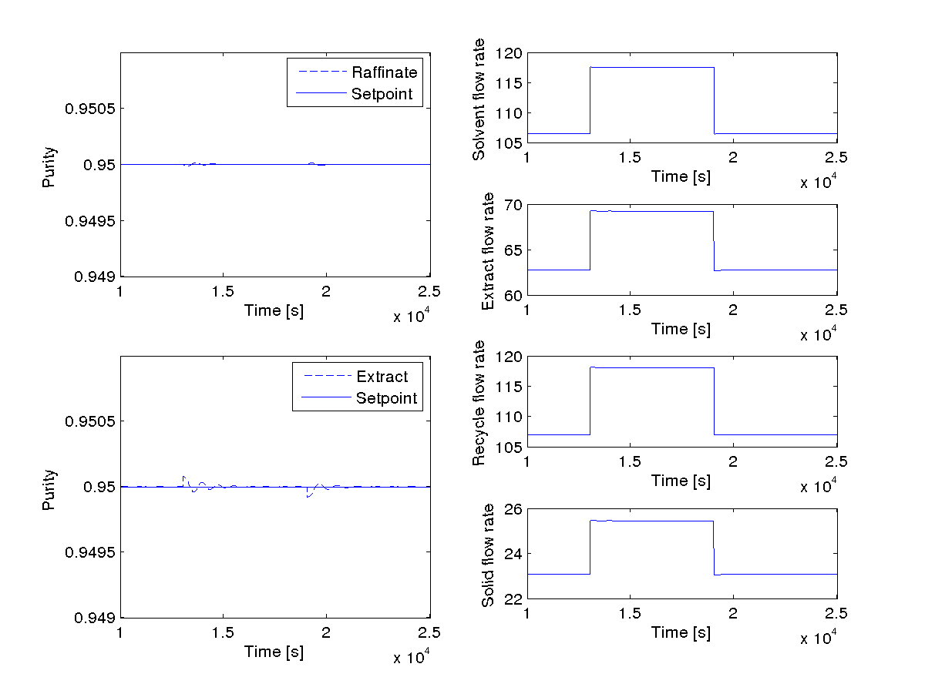 Figure 8: Ratio control in case of feed flow rate disturbance rejection. Left: controlled outputs. Right: operating flow rates.
4 Conclusions and Perspectives
In this work, the influences of two different sets of manipulated inputs have been compared in the case of linear model predictive control of a simulated moving bed. The first one consisting in direct manipulation of flow rates of the SMB showed a very satisfactory behavior for set point tracking and feed disturbance rejection. The second one consists in manipulating the flow rates ratios over each SMB section. At the identification stage, this strategy proved to be more delicate as the step responses displayed important dynamic differences of the responses. However, when the disturbance concerns the feed flow rate, a better behavior is obtained whereas a feed concentration disturbance is more badly rejected.
Other control studies, such as robustness and other control strategies, will be carried out in next works. Although the SMB control was carried out in simulation based on a realistic model of the process, the application of these control strategies to a real SMB for validation purposes should be done.
References
[1] F. Charton and R.M. Nicoud, J. Chromatogr. A, 702 (1995), 97-112
[2] RM. Nicoud, LC-GC Int., 5 (1992), 43-47
[3] M. Mazzotti, G. Storti and M. Morbidelli, J. Chromatogr. A, 769 (1997), 3-24
[4] O. Ludemann-Hombourger and R.M. Nicoud, Sep. Sci. Technol. 35(12), (2000), 1829-1862
[5] C.B. Ching, K.H. Chu, K. Hidajat and M.S. Uddin, AIChE J., 38(11) (1992), 1744-1750
[6] M. Mazzotti, G. Storti and M. Morbidelli, J. Chhromatogr. A, 827 (1998), 161-173
[7] I.H. Song, S.B. Lee, H.K. Rhee and M. Mazotti, Chem. Eng. Sci., 61 (2006), 1973-1986
[8] M. Alamir, F. Ibrahim and J.P. Corriou, J. Process Cont., 16 (2006), 345-353
[9] E. Kloppenburg and E.D. Gilles, J. Process Cont., 1, (1999), 41-50
[10] M. Alamir, J.P. Corriou, J. Process Cont., 13, (2003), 517-523
[11] M. Alamir, F. Ibrahim and J.P. Corriou, J. Process Cont., 16 (2006), 333-344
[12] G. Erdem, S. Abel, M. Morari, M. Mazotti, M. Morbidelli and J.H. Lee, Ind. Eng. Chem. Res., 43 (2004), 405-421
[13] K.U. Klatt, F. Hanisch, G. Dünnebier, J. Process Cont., 12 (2002), 203-219
[14] M. Ben Thabet, M. Alamir, M. Bailly and J.P. Corriou, AIChE 97, Los Angeles, (1997), 1316-1321
[15] S. Natarajan and J.H. Lee, Comp. Chem. Engng., 24 (2000), 1127-1133
[16] A. Toumi and S. Engeel, Chem. Eng. Sci., 43(14), (2004) 3895-3907
[17] N. Couenne, G. Bornard, J. Chebassier and D. Humeau, in congress SIMO 2002, Toulouse, France, 10 (2002)
[18] S. Skogestad, P. Lundstrom and E.W. Jacobsen, AIChE J, 36(5), (1990) 753-764
[19] C.E. Garcia and A.M. Morshedi, Chem. Eng. Comm., 46 (1986), 73-87

