Optimal Experimental Design of a Catalytic Fixed Bed Reactor
Jan C. Schönebergerª, Harvey Arellano-Garciaª, Holger Thielert^{b}, Stefan Körkel^{c}, Günter Woznyª
ªFachgebiet Dynamik und Betrieb technischer Anlagen, TU Berlin, Sekr. KWT-9, Str. d. 17. Juni, 10623 Berlin, Germany
^{b}Thyssen-Krupp Uhde GmbH, Friedrich-Uhde-Str. 15, 44141 Dortmund, Germany
^{c}DFG Forschungszentrum Matheon und Institut für Mathematik, Humbold Universität zu Berlin, Unter den Linden 6, 10099 Berlin, Germany
Abstract
In this work, a developed approach is proposed which aims at computing experimental layouts, setups and controls in order to optimize the statistical reliability of parameter estimates from the resulting experimental data. Furthermore, since the optimum experimental design depends on the values of the parameters, a sequential design is proposed. This represents an interaction between proposed experiments (inlet temperature and concentration), their evaluation, parameter estimation, and new designs information (reactor layout, sampling points and temperature measurement positions). This follows an iterative procedure until all parameters achieve a prescribed statistical quality. To show the efficiency of the performed framework, it is applied to a contact reaction. This reaction is a basic step in the sulphuric acid production and takes place in a catalytic fixed bed reactor called the contact horde.

Keywords: Nonlinear Optimal Experimental Design, Catalytic Fixed Bed Reactor, Sulfur Dioxide Oxidation, Experimental Set-Up, Parameter Accuracy, Model Validation
  - Introduction
Mathematical models are widely used to represent individual unit operations as well as entire processes and consequently their behavior. They can be applied for simulation, process design and/or improvement of existing understanding about specific phenomenon. On the other hand, the accurate and reliable representation of the basic phenomena strongly relies upon model structure and the parameter values, which are to be adjusted so as to correspond with the real process. Therefore, experimental data are required in order to estimate the model parameters and thus to validate the developed model. However, the estimation error depends on the design of the experiments. In particular for nonlinear systems, the decision on the experiments to be executed is decisive on account of cost and time. This issue represents a compromise between experimental attempt and data quality. Methods for the determination of the data quality, i.e. the model parameter accuracy, were first developed for linear systems (see e.g. [1]) and then expanded to nonlinear problems, [2]. The descriptiveness of these properties allows the so called experimental design to perform experiments that improve these characteristic, [3]. The application of these methods is especially useful, when the experiments are aligned to a high financial and temporal effort. In this work, they are applied to the process of sulfur dioxide oxidation. Since sulphuric acid is worldwide one of the most produced chemicals [4], the reaction has been subject of many experimental studies. This is also the reason why plenty of catalysts are commercially available and there are still new catalysts entering the market. On the other hand, the experimental effort for new catalyst materials represents an expensive and challenging task since high temperatures are required for this particular reaction and corrosive and toxic gases are involved, which not only form sulphuric acid but corrodes almost every steel type when condensing. This makes an optimal experimental design necessary.

In a first step the experimental set-up can be designed in an optimal way applying the method of dynamic experimental design to a steady state problem. Then, the optimal control factors, e.g. inlet temperature, pressure and concentrations, for each experiment can be calculated to reach maximal model parameter accuracy, i.e. a maximal model quality. Finally, it is possible to determine the number of experiments necessary to reach a desired or required parameter accuracy. In the next section the sulphuric acid production process is presented, pointing out the importance of an accurate model for the sulphur dioxide conversion.
  - Sulfuric Acid Production
All established processes for the production of sulfuric acid work with the intermediate product sulfur dioxide. This can be produced by the combustion of brimstone, sulfur ore or hydrogen sulfide. The whole process is shown in fig. 1. The further oxidation to sulfur dioxide takes place in fixed bed reactors catalyzed by a Vanadiumpentoxid containing catalyst. Due to the strong heat production, the reaction beds are separated allowing a quenching with air. They are allocated together in the contact tower. The sulfur dioxide is converted to sulfur trioxide, which then can be absorbed in sulfuric acid increasing its concentration. The input of make-up-water allows the steady state production of sulfuric acid with a desired concentration.

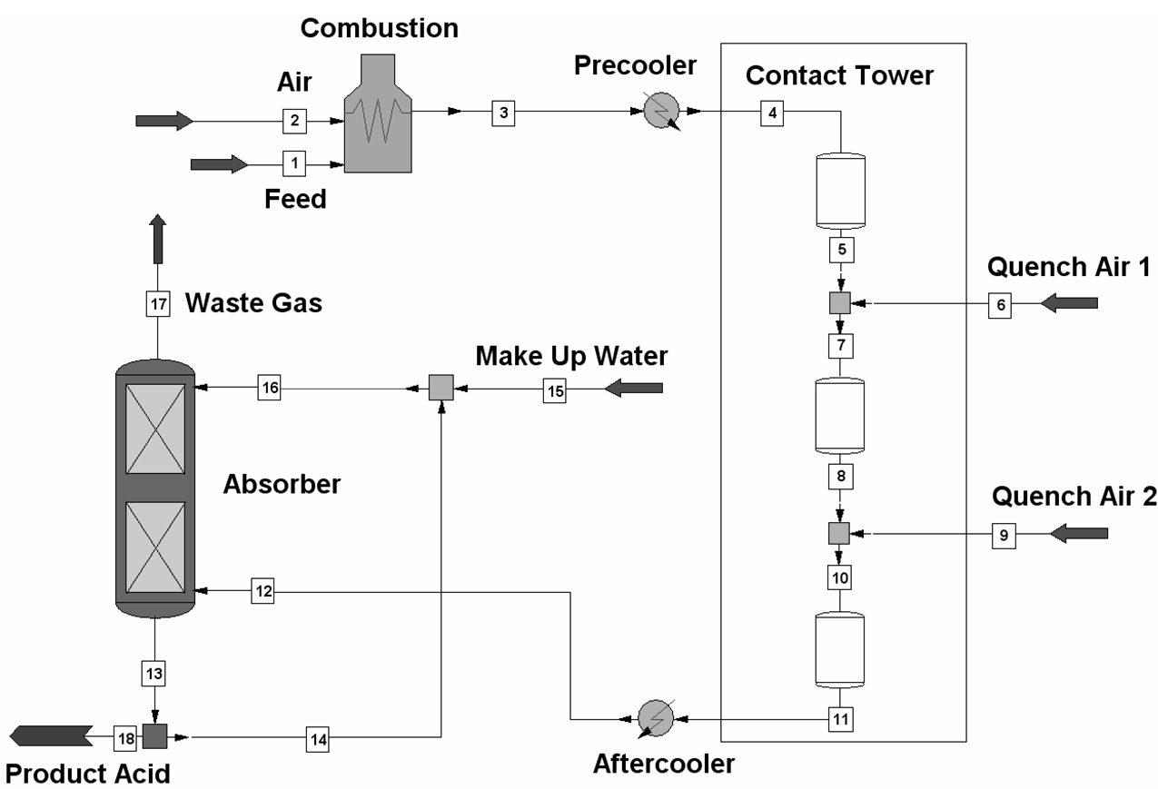
Figure 1: Sulfuric acid production process.
The main task in the process design is the determination of the bed length and number so as the amount of quench air. With these steps, on the one hand the conversion of the sulfur dioxide is determined, which is important in order to hold waste gas directives. On the other hand, the main stream amount leading to smaller or bigger apparatus size is fixed. To find an optimal design and fulfill the restrictions, a reliable reactor model is essential. This has been developed and shall be validated with the proposed methods.
  - Nonlinear Optimal Experimental Design
For the nonlinear optimal experimental design, a nonlinear constrained optimization problem has to be solved. The optimization variables in this case are the experimental design variables as well as the inlet conditions and the measurement positions for state variables. The optimization problem is given in eq. (1).
$\begin{aligned}\underset{{\text{q,w,x}}_{s}}{\text{min}}φ\left(C\right) \\ s\text{.}t\text{.} \\ F(\overset{˙}{x}{\text{,x,p,q,w,x}}_{S})=0 \\ G({\text{x,p,q,w,x}}_{S})=0 \\ a≤ψ(\text{q,w})≤b\end{aligned}$ (1)
Where q are the experimental conditions, w the measurement points and x_{S} the discrete state variables. F gives the model equations and G the nonlinear constrains, while Ψ defines the boundaries of the optimization variables. The objective is to minimize a function φ of the covariance matrix of the parameter estimation problem C. There are different criteria that can be minimized, see e.g. [2]. In this study the A-Criterion was chosen, i.e. minimizing the trace of C. The optimization problem is solved with an approach based on sequential quadratic programming (SNOPT) with a tailored derivative computation.
  - Reactor Model
In order to describe the process units behavior the conservation equations for a fixed bed plug flow reactor are utilized eq. (2)-(4).
$\frac{{\text{dF}}_{i}}{\text{dz}}=ν_{i}⋅\overset{˙}{r}⋅\left(1−ε\right)⋅ρ_{\text{Kat}}⋅\frac{π}{4}D²$ (2)
$\frac{\text{dT}}{\text{dz}}=\frac{−\overset{˙}{r}⋅{ΔH}_{\text{Rx}}⋅\left(1−ε\right)⋅ρ_{\text{Kat}}⋅\frac{π}{4}D²}{\sum{\left(F_{i}⋅c_{P,i}\right)}}$ (3)
$\frac{\text{dP}}{\text{dz}}=−\frac{\sum{\left(F_{i}⋅M_{i}\right)}}{ρ_{\text{Gas}}⋅\frac{π}{4}D²⋅D_{P}}⋅\left(\frac{1−ε}{ε³}\right)⋅\left[\frac{\text{150}⋅(1−ε)⋅η}{D_{P}}+1\text{.}\text{75}⋅\frac{\sum{\left(F_{i}⋅M_{i}\right)}}{\frac{π}{4}D²}\right]$ (4)
Making use of the laws of stoichiometry, the material balances (2) can be reduced to equation (5), balancing the conversion X of sulphur dioxide over the reactor length.
$\frac{\text{dX}}{\text{dz}}=\frac{\overset{˙}{r}⋅\left(1−ε\right)⋅ρ_{\text{Kat}}⋅\frac{π}{4}D²}{F_{{\text{SO}}_{2}}^{0}}$ (5)
The reaction that takes place over the vanadium catalyst,
SO₂ + ½ O₂ ↔ SO₃, (6)
can be described with the kinetic equation given by Eklund [5],
$\overset{˙}{r}=\underset{k}{\underbrace{\text{exp}\underline{\left[−\frac{k_{1}}{T}+k_{2}⋅\text{ln}(T)+k_{3}\right]}}}⋅\sqrt{\frac{P_{{\text{SO}}_{2}}}{P_{{\text{SO}}_{3}}}}\left[P_{O_{2}}−{\left(\frac{P_{{\text{SO}}_{3}}}{P_{{\text{SO}}_{2}}K_{P}}\right)}^{2}\right]$ (7)
or reformulated as a function of conversion:
$\overset{˙}{r}=k⋅\sqrt{\frac{\left(1−X\right)}{\left(Θ_{{\text{SO}}_{3}}+X\right)}}⋅\left[\frac{\left(Θ_{O_{2}}−ν_{O_{2}}X\right)⋅P}{\left(\sum{Θ_{i}−ν_{O_{2}}X}\right)}−{\left(\frac{Θ_{{\text{SO}}_{3}}+X}{\left(1−X\right)⋅K_{P}}\right)}^{2}\right]$. (8)
The parameters that have to be estimated during the model identification and the validation procedure are the kinetic constants k₁, k₂ and k₃. The complete set of equations was discretized with the method of orthogonal collocation using 3 points and 5 intervals, which shows a good behaviour in optimization problems [6].
  - Results
    - Experimental Set-Up
To determine the best experimental set-up a specific scenario is given. As shown in figure 2 the experimental reactor is divided into 5 sections. In all of these sections the temperature can be measured. Additionally the concentration at the reactor outlet can be measured. Due to concentration measurements are expensive and time consuming (e.g. gas chromatography) only two more concentration measurements are allowed. It shall be determined at which positions these measurements are most informative.

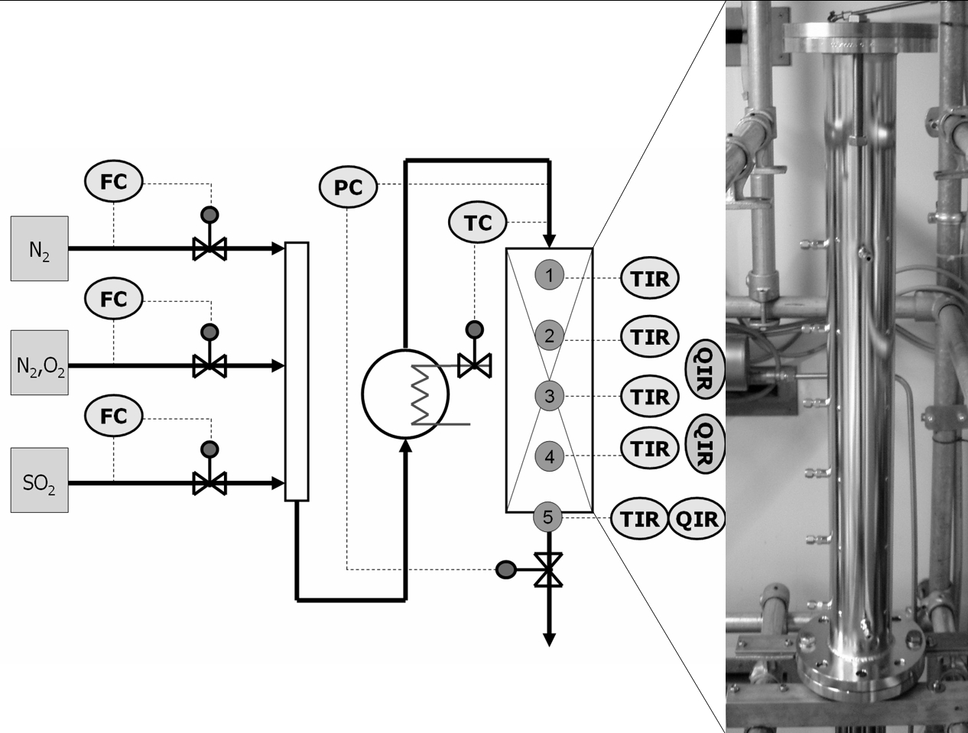
Figure 2: Experimental set-up and image of the PFR.
It was found that from 10 optimally designed experiments in 9 of these the position 3 and 4 (fig. 2) were the best. This can be interpreted as follows: The concentration profile can be ‘moved’ through the reactor with the other design variables, i.e. the inlet conditions. The latter positions are of advantage because of the final concentration measurement that is fixed at the reactor outlet.

    - Optimal Single Experiment
In the next step, one optimal experiment is designed. The design variables are the inlet conditions of the experimental reactor. They can be influenced as shown in figure 2. Table 1 summarizes the derived inlet conditions which are the Reynolds number Re, the mole fractions x_{i} of sulfur dioxide and oxygen and the inlet temperature as well as their boundaries.
Table 1: Design variables and their boundaries.
Inlet Condition | Re [-] | x_{SO2} [mol/mol] | x_{O2} [mol/mol] | T [K]
Minimum value | 300 | 0.002 | 0.002 | 673
Maximum value | 400 | 0.080 | 0.100 | 773
Optimal value | 300 | 0.08 | 0.100 | 706

In figure 3 the trajectories of the measurable state variables temperature and conversion are illustrated. These profiles of the optimal single experiment are given by the solution of the optimization problem. The design variables for this experiment are listed in table 1. This result is quite intuitive, because the profiles show a variation from each measured point to the other. The ellipsoid marking the confidence region for this experiment can be found together with the multiple experiments ellipsoids in figure 4.
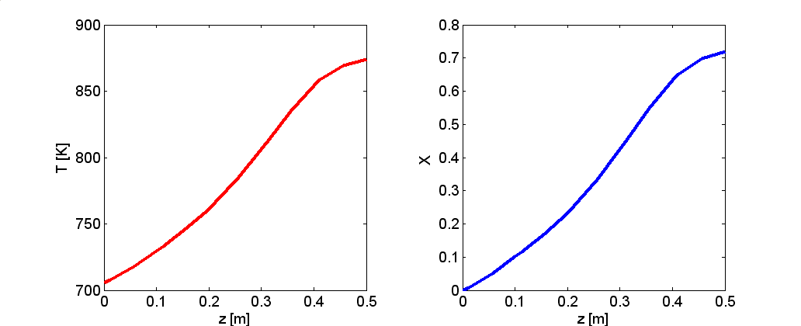
Figure 3: Trajectories of temperature T and conversion X in the optimal single experiment.
    - Multiple Experiments
With the presented techniques it is possible to design a set of multiple experiments. As an objective, a certain parameter accuracy can be defined. Moreover, based on sequential experimental design it can be determined how many experiments are required to reach the requested accuracy. This gives an idea of the amount of experimental work that has to be done in order to reach the given objective. In figure 4 the design variables for 20 experiments can be found namely scaled to percent referring to table 1. Figure 4 to the right shows the development of the confidence region with an increasing number of experiments. Therefore the parameters are scaled to a dimensionless value of one. Only the confidence region for two parameters is shown. The others (k₁-k₃ and k₂-k₃) look similar. With 5 optimal designed experiments the variation of k₁ and k₂ is between 5 %. With an increasing number of experiments the ellipsoid shrinks. It can be noticed that the shrinking slows down with the number of experiments.
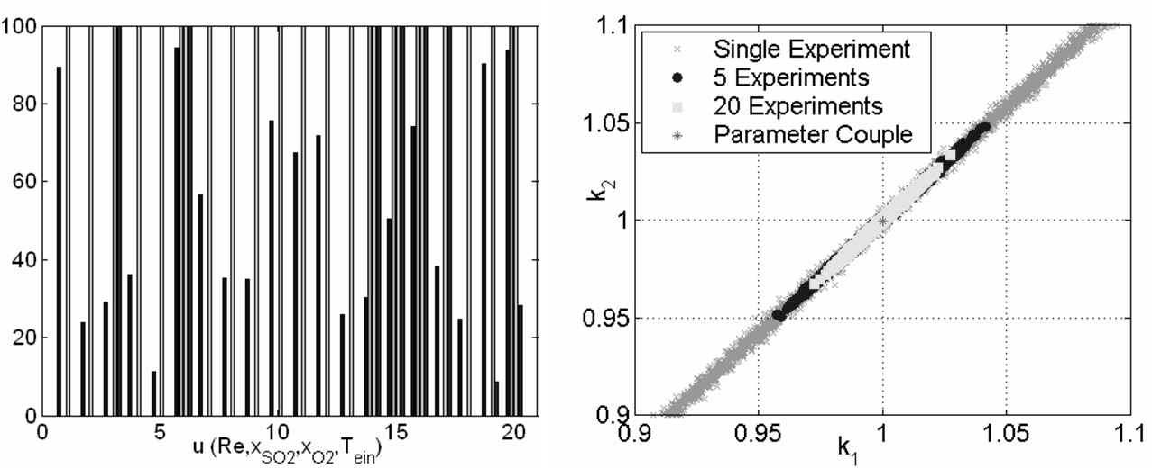
Figure 4: Design of 20 experiments and the confidence regions for 2 parameters.
  - Conclusions and Outlook
The application of the methods of nonlinear optimal experimental design to steady state space-variant reaction systems gives fairly good results and enables new options in the planning of experiments. While a single experiment can be designed intuitive, for multiple experiments this is not the case. It can be shown that the confidence region can be reduced considerably with the optimal designed experiments. Furthermore, a control of the parameter accuracy is possible and thus an estimation of the experimental effort. It can be concluded that the important procedure of model identification and validation can be solved in a much more systematic way using the methods of nonlinear optimal experimental design.
Moreover restrictions related to the state variables can be introduced. By this means can be assured that the temperature in the reactor does not cross a critical temperature. This leads to a nonlinear constrained optimization problem. The results show an interesting change in the trajectories of the optimal single experiment.
In this work a simple model is presented, in order to test the proposed methods. However, a more rigorous model, taking into account heat and mass transfer between the gas phase and the solid phase will be presented. The dynamic behavior of the reactor is modeled which leads to a formulation with partial differential equations. This represents a challenge on the field of both, identification and experimental design [7].
References
[1] Z.R. Lazic, Design of Experiments in Chemical Engineering, Wiley-Vch, 2004.
[2] S. Macchietto and S.P. Asprey, Ind. Eng. Chem. Res, Vol. 44, Iss. 18 P. 7120, 2005.
[3] C.P. Majer, Parameterschätzung, Versuchsplanung und Trajektorienoptimierung für verfahrenstechnische Prozesse, PhD Thesis, VDI Verlag, 1998.
[4] M. McCoy et al., Chem. Eng. News, Vol. 81, Iss. 27, 2003.
[5] R. Eklund, The Rate of Oxidation of Sulfur Dioxide with a Commercial Vanadium Catalyst, Almqvist&Wiksells Boktr., Uppsala, 1956.
[6] J. Schöneberger, H. Arellano-Garcia, H. Thielert and G. Wozny, Computer-Aided Chem. Eng., Vol. 24, P. 521, 2007.
[7] A. Bardow, W. Marquard, A. Göke, H.-J. Koss and K. Lucas, AIChE., Vol. 49, Iss. 2, P. 323, 2003.

