DIVIDED WALL DISTILLATION COLUMN: DYNAMIC MODELING AND CONTROL
Alexandru Woinaroschy, Raluca Isopescu
UniversityPolitehnica of Bucharest, Polizu Str. 1-5, Bucharest 011061, Romania
Abstract
The dynamic modeling of the dividing wall distillation column is used to determine optimal startup policies that minimise the time required to reach the imposed steady state operating values in terms of product compositions and flow rates. The problem is resolved by a convenient transformation of the dynamic model in a system of differential equations, avoiding algebraic calculations generally imposed by equilibrium solving, and by using iterative dynamic programming for the minimization of the startup time. An example referring to the separation of a ternary hydrocarbon mixture is presented. The variables that mostly influence the startup time were found to be the reflux ratio and side-stream flowrate. The optimal policies identified realise a considerable reduction of startup time, up to 70% compared to the startup operation at constant reflux ratio or constant side draw flowrate.

Keywords: divided wall distillation column, dynamic modeling, optimal startup control
  - Introduction
Despite its high energy consumption, distillation is the widest used separation technique in petrochemical and chemical plants. Thermally coupled distillation columns can lead to a significant energy reduction, up to 40% for the totally thermal integrated structure which is the Petlyuk column. The Petlyuk column built in a single shell is the divided wall distillation column (DWC) and is considered a very attractive solution for energy and capital cost savings in separation processes. Though its efficiency has been proved by numerous theoretical studies such as Triantafillou et al (1992), Sierra et al (2001) and also by some practical industrial applications, among which at least the 40 DWC implemented by BASF should be mentioned, the DWC is not yet a common solution. A reason for this can be a lack of understanding of the design and control of a DWC. Theoretical studies and experimental confrontations are still necessary to prove the big advantages of this solution and to find practical ways for a good design methodology and control strategies. The design and optimization of a divided wall column can be achieved by defining tray sections interconnected by liquid and vapor streams that represent the complex arrangement of a DWC. The structure used in the present paper lumps in four column-sections the trays of the DWC. These column sections represent the top of the DWC (trays above the dividing wall), the prefractionator (left side of the dividing wall) where the feed is located, the right side of divided wall where the side draw is located and the tray section below the dividing wall.
The increased number of degrees of freedom (DOF) for a DWC imposes a thorough analysis of control variables to establish a convenient approach in modeling the process and establishing the control policy. Due to the increased number of DOF, both steady state and dynamic modeling of a DWC raises more problems than a simple column with a side draw and needs adequate solving algorithms. Halvorsen and Skogestad (2004) proved that the liquid and vapor splits have a great influence on the thermal efficiency of the DWC. More recently, Wang and Wong (2007) demonstrated that outside a given region defined by certain liquid and vapor split values, the composition control can compensate only for variation in feed characteristic, such as feed or composition, but not for internal flow changes. They proposed a temperature-composition cascade scheme to control a DWC. Temperature control strategies proved to be efficient also for complex schemes including heterogeneous azeotropic distillation and a DWC (Wang et al 2008). Startup policies must be considered as well when analysing the efficiency of a DWC. In order to promote the generalisation of DWC in industrial application it is necessary to provide reliable design methodologies and convenient start up strategies of the column.
In order to promote the generalisation of DWC in industrial application it is necessary to provide reliable design methodologies, but it is also very important to define strategies for a convenient startup of the column. The present paper proposes a new dynamic model for a DWC and applies it to formulate the startup control.
  - Dynamic Distillation Model (DDM)
The DDM proposed by Woinaroschy (1986, 2007) represents a good compromise between the degree of complexity and correctness. The advantage and originality of the selected model consist in the fact that the iterative algebraic equations are avoided. The core of the model consists in the following system of ordinary differential equations (with the usual notations for distillation field):
Total mass balance around plate j:
$\frac{{\text{dN}}_{j}}{\text{dt}} = L_{j−1} + V_{j+1} − L_{j} − V_{j} ± F_{L,j} ± F_{V,j}$ (1)

Component mass balance around plate j for component i:
$$\frac{d(N_{j}x_{i,j})}{\text{dt}} = L_{j−1}x_{i,j−1} + V_{j+1}y_{i,j+1} − L_{j}x_{i,j} − V_{j}y_{i,j} ± F_{L,j}x_{F,i,j} ± F_{V,j}y_{F,i,j}$$
(2)
Original equation for dynamic calculation of temperature on plate j:
$\frac{{\text{dT}}_{j}}{\text{dt}} = − \frac{\sum_{i=1}^{m}{ \frac{γ_{i,j}P_{i,j}}{p_{j}} \left(1 + \frac{x_{i,j}}{γ_{i,j}}\frac{{dγ}_{i,j}}{{\text{dx}}_{i,j}}\right)\frac{{\text{dx}}_{i,j}}{\text{dt}}}}{\sum_{i=1}^{m}{\frac{x_{i,j}γ_{i,j}}{p_{j}}\frac{{\text{dP}}_{i,j}}{{\text{dT}}_{j}}}}$ (3)
The state variables are N_{j}, j=1,2..n; x_{i,j}, i=1,2..m-1, j=1,2..n; and T_{j}, j=1,2..n.
The variation of total pressure during each time integration step is much smaller than the variations of composition and temperature. In order to simplify the procedure, the vapor pressure on each tray is considered constant along the time integration step, but it will be recomputed at the beginning of the new time step. The tray pressure drop is calculated on the base of hydraulic correlations, specific for the plate type.
Vapor flow rate V_{j} is obtained from total energy balance and the vapor composition is calculated according to Murphree efficiency. Liquid flow rate L_{j} is computed on the base of Francis' correlation for the corresponding plate weir. The equilibrium, thermodynamic data, and other physical properties correlations are selected in function of the mixture nature. The system of differential equations was numerically integrated by fourth order Runge-Kutta-Gill method, the DDM being coded in FORTRAN.
  - Example
A mixture of three components (60% benzene, 30% toluene and 10% ethylbenzene) is separated in a DWC with sieve plates and lateral downcomers. The vapor pressures P_{i,j} of components were calculated on the basis of Antoine equation, and the trays efficiency was set at value 1 (equilibrium trays).
    - Design of the divided wall column.
The next column parameters were imposed as follows: feed specification: liquid at bubble point; feed flow rate: 0.0053 kmol s⁻¹; side stream flow rate: 0.001455 kmol s⁻¹; type of condenser: total; condenser pressure: 760 mm Hg; reflux ratio: 3; type of reboiler: total; reboiler heat duty: 417 kW; bottom liquid volume: 0.146 m³; tray surface (for top and bottom sections): 0.451 m²; tray surface (for right and left side of the dividing wall): 0.2255 m²; weir height: 0.025 m; hole diameter: 0.002 m.
Using DDM (searching the values at final, stationary state) were established by several iterations the number of trays for the column sections, the location of the feed and side streams and the fraction of liquid flowing in the right hand side of the dividing wall. This iterative search was made in order to obtain the best separation of each component. The corresponding values are: Number of trays: top section: 6; left side: 15; right side: 15; bottom section: 13; Feed stream location: the 2nd from the top of the left side; Side stream location: the 3rd from the top of the right side; Fraction of liquid flowing in the right hand side of the dividing wall: 0.45. In these conditions the components’ mole fractions in the products are: 0.9564 benzene in the top product, 0.970 toluene in the side product and 0.9340 ethylbenzene in the bottom product.
    - Optimal startup control.
Startup of distillation columns is a very challenging control and simulation problem due to both theoretical and practical aspects. A general sequence of actions which forms the basis for different startup procedures was formulated by Ruiz et al (1988). At the end of several preliminary actions all plates have enough liquid holdup, so that the liquid can start to fall down the downcomers. The downcomers are sealed and no vapor can go up through them. The liquid composition is the same on all plates, being equal with the feed composition. In the frame of present work these conditions define the initial state from which begins the effective startup transient operating regime procedure. Traditionally, the column is operated at constant values of control parameters. Usually, these are the prescribed values for the desired stationary regime. In an optimal transient regime procedure the column will be operated at prescribed time-distributed values of control parameters, in order to minimize the duration of the transient regime. In fact, optimal startup control consist in reaching a desired final state from a set of given initial condition in minimum time by an adequate control policy. That means minimization of the penalty performance index formulated as:
$I = t_{f} + ω \frac{\sum_{i=1}^{\text{ns}}{\left| 1 − \frac{s_{i}(t_{f})}{s_{s_{i}}}\right|}}{\text{ns}}$ (4)
where t_{f} is the final time, ω > 0 is a penalty coefficient, s_{si} are the desired final stationary state values, and the final values of state variables s_{i} (t_{f} ), i = 1,2,…ns are calculated by integration of equations (1)-(3). Minimization of the penalty performance index is made through control variables u_{i} subject to the bounds:
$u_{{\text{min}}_{i}} ≤ u_{i} ≤ u_{{\text{max}}_{i}} i = 1, 2\text{.}\text{.}\text{.},\text{nu}$ (5)
A set of DDM simulations indicated that the more suitable control parameters for the optimal startup of the divided wall distillation columns are the reflux ratio and the side-stream flowrate. The task of optimal startup control of the DWC was solved using the algorithm proposed by Bojkov and Luus (1994), based on the iterative dynamic procedure given by Bojkov and Luus (1992, 1993) which employs randomly chose candidates for the admissible control. The algorithm was applied for 5 time stages. The grid points number for state-grid was 5, 9 for policy-grid, and 9 for piece time-grid. The region contraction factor was set at 0.8, and the total number of iterative dynamic procedure iterations was 10.
The startup time for optimal reflux control is 120 min. and for side-stream flowrate control is 130 min. These results (for each case obtained after 44805 numerical integrations of the system (1)-(3) with 200 differential equations) are remarkable in comparison with operating at constant control parameters where the startup time is 380 min. For all these regimes the final stationary state corresponds to an average value of the normalized derivatives less than 10⁻⁶ (maximum integration step is 1 s.).
In figures 1 and 2 are presented the optimal reflux control and the optimal side-stream flowrate control (subscript s indicates final, stationary value).

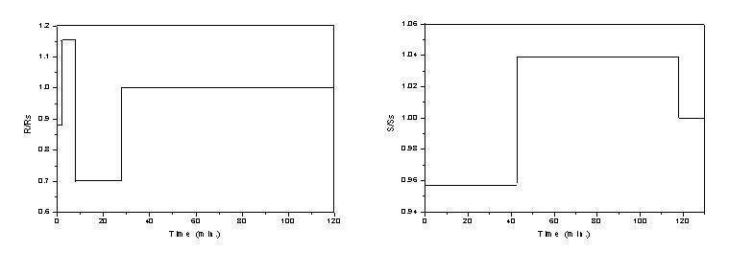
Figure 1. Optimal reflux control Figure 2. Optimal side-stream flowrate control

The selected control variables (reflux or side-stream flowrate) can be easily manipulated in practical applications. In a DWC the reflux must be high enough to build-up the reflux on both sides of the dividing wall. The value of the reflux ratio strongly modifies the separation on both sides of the diving wall and hence it will affect the concentration profiles along the trays. Not only the distillate and bottom product will be influenced by the variation of reflux ratio, but also the side-stream which is desired to contain the intermediate component at very high concentration. This consideration can lead to the conclusion that a correct reflux policy will bring the DWC in stable operating condition in a reasonable time. The liquid split which is a means of controlling the side draw purity (Mutalib and Smith, 1998) was imposed at the value obtained in steady state as the feed composition did not vary in the present study. The influence of the liquid split variation along the startup period had an insignificant influence on the startup time. As regarding the vapor split it was left to adjust naturally according to the temperature distribution along the trays and pressure drop.
In figures 3 and 4 are presented the evolutions of components’ mole fractions in the top and bottom products. In figure 3 the evolution of the benzene concentration in the top product at constant control parameters and at optimal side-flowrate control overlaps (for the entire time domain of optimal side-flowrate control, respectively 130 min.).
It can be observed that the responses in the bottom concentrations are determinant for the values of startup time, as it was expected.

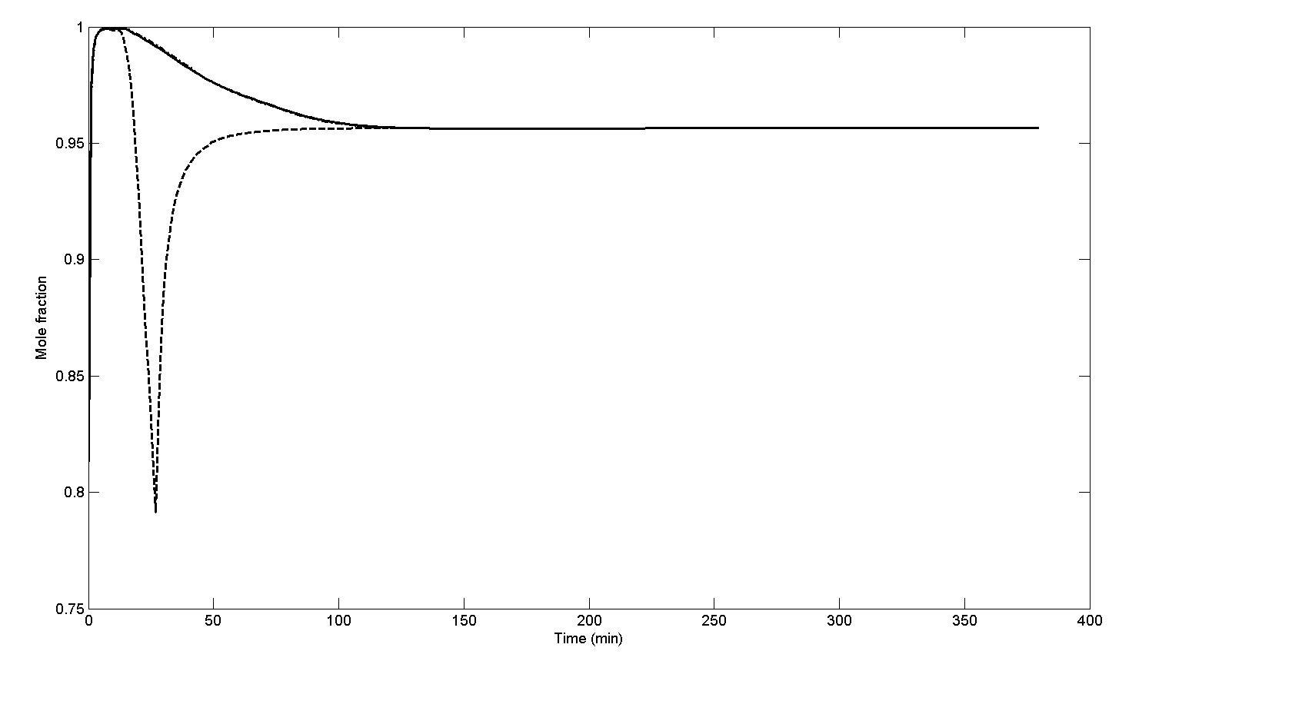
Figure 3. Evolution of benzene concentration in the top product for startup at constant control parameters and at optimal side-flowrate control ( ― ), and at optimal reflux control (---).
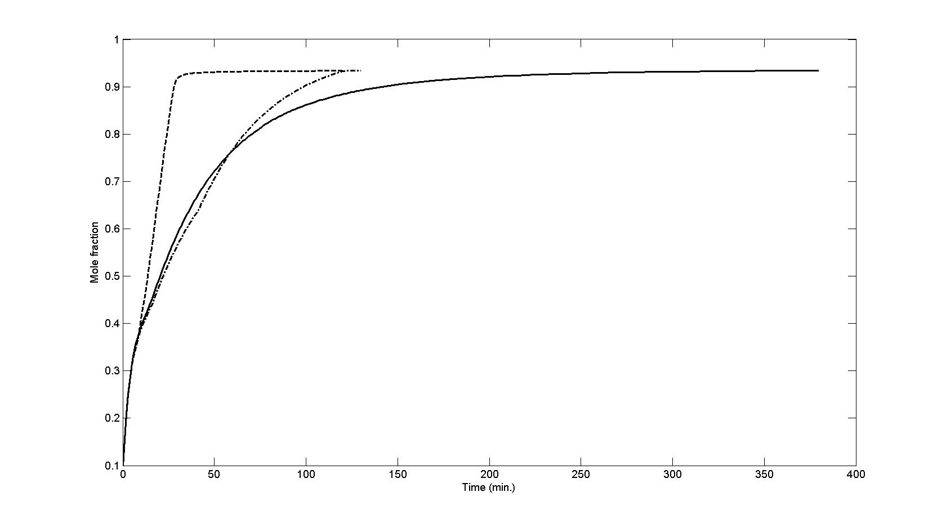
Figure 4. Evolution of ethylbenzene concentration in the bottom product for startup at constant control parameters (― ), at optimal reflux control (---) and at optimal side-flowrate control (– ∙ –).
  - Discussion
The selected value for the number of time stages to 5 seems to be too small. A higher value of this number increases drastically the CPU time, without a substantial improving of the performance index (Luus, 1989; Luus and Galli, 1991). In the case of side-stream flowrate control, the increase to 10 of the number of time stages have reduced the startup time only with one minute, but the corresponding control policy is more complicated. The attempt to find the optimal startup control of the divided wall column with other optimization techniques (Luus-Jaakola, Hooke-Jeeves) failed. As in the case of startup optimization of classical distillation columns (Woinaroschy, 2007) it is possible to avoid the undesirable secondary bang-bang effects of the piecewise constant control by replacing it with piecewise linear control.
  - Conclusions
The dynamic model proposed proved to represent well the separation in a DWC of a ternary hydrocarbon mixture. The values of internal flows and temperature distributions along the trays reached at steady state were in good agreement with the simulations obtained in the frame of commercial simulators. The use as control variables the reflux ratio or the side-stream flowrate proved to enable a reduction of the startup time with about 70 % compared with classical startup procedures. The complex technique developed can be a useful tool in studying dynamic behavior and startup optimization for complex columns and can be easily extended to various mixtures.
References
B. Bojkov, R. Luus, 1992, Use of Random Admissible Values for Control in Iterative Dynamic Programming, Ind. Eng. Chem. Res., vol. 31, p.1308
B. Bojkov, R. Luus, 1993, Evaluation of the Parameters Used in Iterative Dynamic Programming, Can. J. Chem. Eng., vol. 71. p. 451
B. Bojkov, R. Luus, 1994, Time-Optimal Control by Iterative Dynamic Programming, Ind. Eng. Chem. Res., vol. 33, p.1486
I. J. Halvorsen, S. Skogestad, 2004, Shortcut Analisys of Optimal Operation of Petliuk Distillation, Ind. Eng. Chem. Res., vol. 43, p.3994
R. Luus, 1989, Optimal Control by Dynamic Programming Using Accessible Grid Points and Region Reduction, Hung. J. Ind. Chem., vol. 17, p.523
R. Luus, M. Galli, 1991, Multiplicity of Solutions in using Dynamic Programming for Optimal Control, Hung. J. Ind. Chem., vol. 19, p. 55
M. I. A. Mutalib, R. Smith, 1998, Operation and Control of Dividing Wall Distillation Columns, Trans IchemE, vol. 76, part A, p. 318
C. A. Ruiz, I. T. Cameron, R. Gani, 1988, A Generalized Model for Distillation Columns III. Study of Startup Operations, Comput. Chem. Eng., vol. 12, p. 1
M. Serra, M. Perrier, A. Espuna, L. Puigjaner, 2000, Study of the Divided Wall Column Controlabillity: Influence of the Design and Operation, Comput. Chem. Eng., vol. 24, p. 901
C. Tryantafillou, R. Smith, 1992, The Design and Optimisation of Fully Thermally Coupled Distillation Columns, TransIChemE, part A, Chem. Eng. Res. Des., vol. 70(A5), p. 118
S. J. Wang, D. Wong, 2007, Controllability and energy efficiency of high purity divided wall column, Chem. Eng. Sci., vol. 62, p. 1010
S. J. Wang, C. J. Lee, S. S. Jang, S. S. Shien,2008, Plant-wide design and control of acetic acide
dehydration system via heterogeneous azeotropic distillation and divided wall distillation, J.
Process Control, vol. 18, p. 45
A. Woinaroschy, 1986, A New Model for the Dynamic Simulation of the Rectification Processes. I. Development of the Mathematical Model and Algorithm, Rev. Chim., vol. 37, p. 697
A. Woinaroschy, 2007, Time-Optimal Control of Distillation Columns by Iterative Dynamic Programming, Chem. Eng. Trans., vol. 11, p. 253

