A Microeconomics-based approach to product design under uncertainty
Craig Whitnack, Ashley Heller, Miguel J. Bagajewiczª
ªSchool of Chemical, Biological and Materials Engineering, University of Oklahoma, 100 E. Boyd St., Norman, OK 73019, US
Abstract
In this paper, an existing methodology (Bagajewicz, 2007) for the development of consumer products is applied to winemaking. We use a price demand model that incorporates product quality and allows the determination of the most profitable product, which is not always the best product from the consumer’s perspective- a well known fact. The parameters of the model are however, uncertain, especially in the wine case. Thus, design under uncertainty needs to be performed. We present an analysis of profitable scenarios and their associated risk. The method allows vineyards to pick a specific wine quality, a production rate and bottle selling price based on their desired profitability and tolerable level of associated risk.

Keywords: Product Design, Wine Production
  - Introduction
Wine has long been considered an art form, where quality was held in the eyes of the producer. With the new information-rich consumer market, the consumer now holds the buying power. Because of this, wine producers must now cater more to the desires of their customers to not only obtain patronage, but loyalty as well. In order to accommodate these new demands, we apply a recently developed methodology (Bagajewicz, 2007) to winemaking which incorporates consumer satisfaction to pricing models. Consumer preferences are identified, allowing the data generated by market analysis to be related to wine properties. These wine properties are easily measured throughout the winemaking process and can be manipulated by the manufacturer at little cost. Modifiable processes include fermentation, clarification and stabilization, barrel toasting and aging (Cook et al., 1998). Finally after the consumer overall preferences are identified, the wine can be compared to the competitor and the selling price of the wine can be set by optimizing the producer’s return on investment.

We first review briefly some of the consumer preference functions. We then compute a net present value as a function of price for different qualities as suggested by Bagajewicz (2007). Finally, we discuss the uncertainty associated to the model and suggest means to deal with uncertainty.
  - Pricing and Consumer Preference Models
We use the same constant elasticity of substitution model as Bagajewicz (2007). This model is a small modification of the constant elasticity of substitution models found in literature (Hirshleifer and Hirshleifer, 1998; Varian, 1992) where hedonic theory is incorporated. This was extended to multiple competitors by Street et al. (2007). The final expression relating demand of new product to price is:
$d_{1}={\left(\frac{α}{β}\right)}^{ρ}∗\frac{p_{2}}{p_{1}}∗{\left(\frac{Y−p_{1}d_{1}}{p_{2}}\right)}^{1−ρ}∗d_{1^{ρ}}$ (1)
where d₁ is the demand of the new product, p₁ its proposed price, p₂ the average price of competitor wines, ρ a predetermined constant, α a zero to one measure of the amount of knowledge the consumer has for the product of interest and, Y is the consumer budget, which satisfies
$Y≥p_{1}d_{1}+p_{2}d_{2}$ (2)
Finally, β is a positive coefficient that relates how much more appealing the consumer will find the product of interest in comparison to the competing product. It is defined as the ratio of the consumer preference functions . In turn, the consumer preference functions are related to product attribute scores (y_{i}; in our case, taste, bitterness, sweetness, etc) as follows:
(4)
Each attribute is weighted based on the rank of importance (w_{i}) to the consumer. Thus, the scores, or values of y_{i}, can be manipulated by altering the production process.
  - Preference Functions
Consumer preferences for each attribute (y_{i}) and the weights (w_{i}) can be identified through market research. The consumer preferences are determined using descriptive words for each characteristic (good as, bad as, more than, etc.) by comparing these characteristics to existing products (other wines in this case). These words can then be related to physical, measurable qualities. This level of preference is normalized on a scale ranging from 0 (minimum of 0% preference) to 1 (maximum of 100% preference). Once the utility of the consumer is identified, these characteristics are evaluated by their relation to physical attributes that can be manipulated.

The wine attributes used here are: clarity, color, bouquet, acidity, sweetness, bitterness, body/texture, and finish/aftertaste. We now illustrate how this can be done for acidity and bouquet and leave all the rest of the attributes out for space reasons.

Acidity can be broken down into different levels based on consumer descriptions. If the acidity is too high, it begins to taste tart or vinegary, whereas if it is too low, the wine can taste flabby and insipid. This presents a need for a balance in acidity, where consumer preference is at an optimum (100% preference). For example, consumers assign 0% preference to wine with tart/vinegary and flabby/insipid attributes, as these acidity levels are undesired. Thus a parabolic curve, with the apex associated with a “balanced” wine, is used to describe consumer preference relating to acidity levels (Figure 1-a). The correlation of tart/vinegary, balanced and flabby/insipid with pH is direct, so the connection is easily found. Typical table wines can range between a pH of 3.0 and 4.0. We consider that there is a linear relationship between consumer-described acidity and pH level (Figure 1-b). Therefore, increasing pH is accompanied by a constant decrease in acidity (Pandell, 1999). Once this correlation is established, the consumer utility can be plotted against the pH in order to find the optimum pH which returns 100% consumer preference for acidity (Figure 1-c). Later, the connection of pH with some wine ingredients or manipulated variables in the fermentation is easy.

(a)
(b)

(c)

Figure 1: (a) Consumer preference curve for acidity; (b) linear relationship for acidity descriptions and pH; (c) consumer preference curve as a function of pH.

Bouquet was examined in detail to identify specific compounds which contributed to the consumer-identified aromas of the bouquet of wine stored in a toasted oak barrel. Important bouquets include butterscotch/caramel, clove, vanilla, and oak/coconut. Butterscotch/caramel bouquet is due to levels of furfural and 5-methylfurfural, with typical values ranging from 100 to 270 mg/kg of wine. A clove characteristic is due to the presence of small amounts of eugenol ranging between 5 to 25 μg/L. Vanilla levels in wine can be attributed to the amount of vanillin present. Typical values of vanillin in toasted wine range from 25 to 55 mg/kg of wine. Oak lactones are responsible for the oak/coconut presence in the bouquet, with typical values between 105-200 μg/L (Gutierrez, 2003). In our case, consumer preference reaches a maximum for high levels of vanilla and butterscotch/caramel, whereas for oak/coconut, consumer preference is at a maximum for the lowest levels of oak lactones. Consumer preference for clove, on the other hand, reaches a maximum for a moderate level of eugenol (Gawel, 2007). Just as is the case for the acidity, a parabolic curve is expected to describe the consumer preference in relation to the amount of eugenol (we skip the figures that illustrate then two step procedure and show the final one only). For all the bouquet characteristics, it is assumed that there is a direct, linear relationship between the amount of each compound and the strength of each characteristic. For example, a weak vanilla bouquet would be typical for low values of vanillin.

Bouquet can now be obtained by exploring all the different options available for toasting the oak barrels. Toasting can be further categorized by different intensities from light to heavy toasts. Medium toasts offer the most potential for flavor, as heavy toasts tend to breakdown important compounds contributing toward the bouquet (Hale et al., 1999).

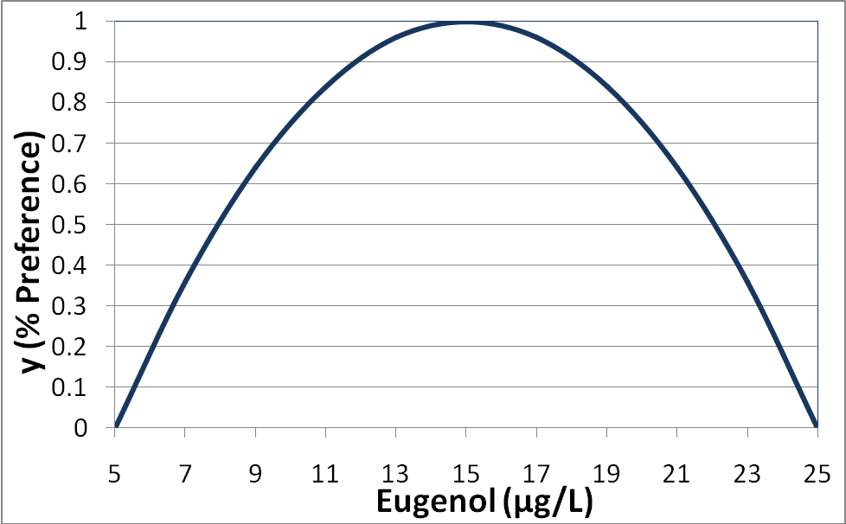
Figure 2: Consumer preference curve for clove bouquet as a function of eugenol.
  - Results
Because of its versatile nature and softness (Waldner et al., 2007), pinot noir is thought to have great marketing potential and is used to demonstrate the proposed methodology.

With α and β functions defined and integrated into the demand model, the selling price was varied at several different production rates to determine the optimum selling price based on the largest net present value calculated. Several variables were held constant, including the competition selling price p₂, interest and inflation rate, rate of return, and working capital. The superiority function β was chosen such that the “optimum” bottle of wine was being produced which maximized consumer utility for all wine attributes. Figure 3 displays the resulting range of net present values at each scenario. The graph shows a maximum net present value of approximately $180 million at a production rate of 2.5 million bottles per year and a selling price of $36.

Figure 3: Net Present Value as a function of selling price at different production rates.
Uncertainty was incorporated into the model, essentially allowing variations around a mean for the following main parameters: consumer preference (H₂, H₁), competitor price, consumer budget, and the interest rate. The resulting risk curve obtained for this optimum scenario (2.5M, $36) is shown in Figures 4 and 5 using dark large red rhombuses; The curve indicates that the probability of losing money with this product is around 16%. To explore other alternatives that could be less risky, 81 random scenarios were chosen that lie between $24 and $40 in Figure 3 and that are not necessarily on the curve of maximums. In other words, because of uncertainty, less risky propositions can come from a combination of price and production that is not on the envelope. Production rates between 1 million and 5 million bottles per year were subjected to each price range. Expected net present values and return on investments were documented and summarized along with opportunity values to display several different profitable decisions. Table 1 and Figure 4 summarize the top 10 best scenarios sorted by decreasing expected net present value and Figure 5 includes some of the most interesting ones, including one of very small risk.
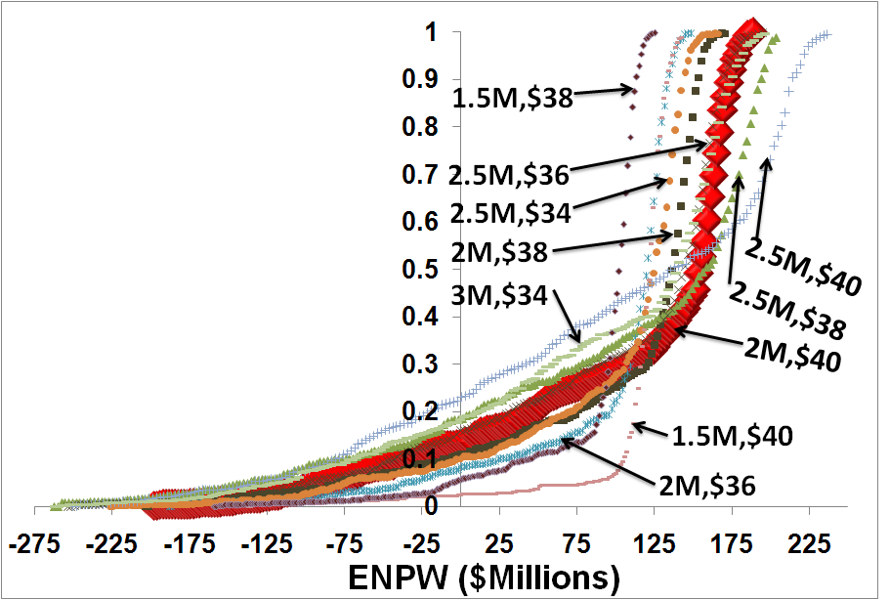
Figure 4: Risk curves for scenarios in table 1. The large font curve (2M, $40) indicates the scenario with the largest ENPW.

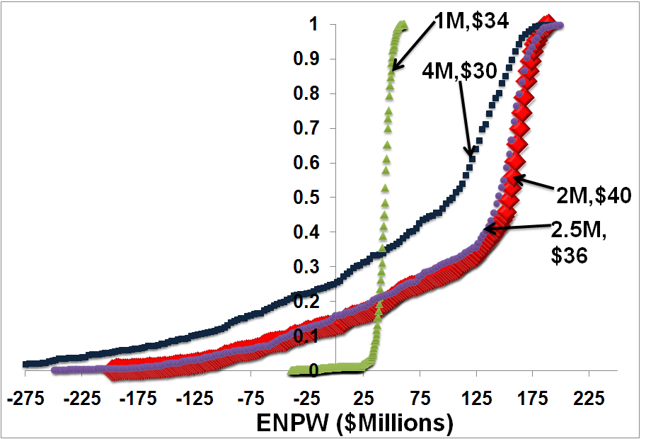
Figure 5: Notable curves. The 1M, $34 curve shows very small risk, while the 4M, $30 curve has a large amount of risk.
Table 1: Scenario summary sorted by decreasing ENPV
K (mil) | p₁ | NPW ($M) | ROI | ENPW ($M) | EROI | Ω = 0 | VAR ($M) | OV ($M)
2.0 | $40 | $164.4809 | 174.4% | $111.4790 | 117.0% | 13.2% | $199.8601 | $68.0365
2.0 | $38 | $145.4147 | 154.2% | $105.5204 | 114.8% | 10.8% | $182.1242 | $52.1656
2.5 | $38 | $180.0475 | 153.0% | $103.5408 | 89.3% | 18.5% | $238.8682 | $95.3255
2.5 | $36 | $157.9517 | 134.2% | $101.7105 | 86.8% | 16.1% | $199.2029 | $74.9491
2.0 | $36 | $125.2131 | 132.8% | $100.3082 | 104.5% | 8.2% | $137.1119 | $38.1458
2.5 | $34 | $133.6295 | 113.5% | $98.8314 | 79.6% | 10.4% | $170.6370 | $49.9637
2.5 | $40 | $196.9221 | 167.3% | $98.4923 | 85.0% | 23.1% | $230.9303 | $123.5832
1.5 | $40 | $121.0204 | 169.8% | $98.2411 | 140.7% | 7.7% | $130.4865 | $33.3729
3.0 | $34 | $160.6865 | 114.3% | $91.9723 | 66.1% | 18.8% | $207.9432 | $91.0473
1.5 | $38 | $105.9404 | 148.7% | $90.3933 | 126.7% | 5.8% | $95.7308 | $26.3069

The superiority beta (β) function was further manipulated to examine the effects it had on associated risk. It was found that manufacturing a wine of lower consumer utility (higher beta) can, in some cases, reduce the risk at similar aspiration levels. A decrease in risk is always accompanied by a lower opportunity value. This delicate balance between associated risk and opportunity value is an important factor for decision making in economics.
5. Conclusions
Each bottle of wine can be engineered to maximize the profit of the producer by use of the demand model. Incorporating uncertainty into the demand model can change the optimal product and allows manipulating financial risk. Altering the quality of the wine, or β, can in some cases, lower the associated risk with that decision.
References
M. Bagajewicz. (2007) On the role of Macroeconomics, Multi-scale Planning and Finances in Product Design. AIChE Journal, to appear.
G. Cooke, J. Lapsley. Home Winemaking. The Regent of the University of California, Division of Agriculture and Natural Resources: 1998.
R. Gawel, 2007, The Effect of Oak Type on Wine Aroma. Wine Education. http://www.aromadictionary.com/articles/oakandwinearoma_article.html. Retrieved February 21.
A. Gutierrez. Sensory Descriptive Analysis of Red Wines Undergoing Malolactic Fermentation with Oak Chips. Journal of Food Science. Vol.68, Nr.3, 2003.
M. Hale, K. McCafferty, E. Larmie, J. Newton, J. Swan. (1999). The Influence of Oak Seasoning and Toasting Parameters on the Composition and Quality of Wine. American Journal of Enology and Viticulture, Vol 50 No 4, pp 495-502.
J. Hirshleifer J. and D. Hirshleifer (1998). Price Theory and Applications. Prentice hall, New Jersey.
A. Pandell. The Acidity of Wine. (1999). Retrieved May 4, 2006. http://www.wineperspective.com/the_acidity_of_wine.htm.
J. Street, J. Woody, J. Ardila and M. Bagajewicz. (2007) Product Design: A Case Study of Slow Release Carpet Deodorizers/Disinfectants. Industrial and Engineering Chemistry Research. To appear.
H. Varian (1992) Microeconomic Analysis. W.W. Norton & Company.
M. Waldner, J. Marais. (2006). Impact Aroma Components in South African Wines: A preliminary study. http://wynboer.co.za/recentarticles/1202impact.php3. Winetech. Retrieved February 20, 2007.

