A SYSTEMATIC PROCEDURE FOR OPTIMIZING CRUDE OIL DISTILLATION SYSTEMS
Hasan Y. Alhammadi
Chemical Engineering Department, University of Bahrain
Isa Town, PO Box 32038
Kingdom of Bahrain
Abstract
Nowadays, building new refinery units is very costly. Therefore, many retrofit projects to the existing crude oil distillation system are considered to increase the production capacity of the refinery by increasing the throughput.
The objective of this research is to retrofit the atmospheric crude oil distillation column to reduce the vapor load through the column. Therefore, as the vapor load decreases, the throughput can be increased. Simultaneously, the heat exchanger network, furnace and pumps are considered both to identify any bottleneck associated with the retrofit procedure and to ensure an energy-efficient column design by reusing the available heat effectively. This retrofit design procedure will be explored by applying the suggested modifications on an existing case study by the use of a computer simulation and pinch analysis packages.

Keywords: Crude oil distillation systems – Debottlenecking – Pinch analysis.
  - Introduction
In any refinery, the atmospheric crude oil distillation column is the first processing unit. The atmospheric crude oil distillation fractionates the crude oil into products according to their boiling points. Therefore, the atmospheric column often forms the bottleneck in a refinery due to the large amount of crude oil introduced to the column to be processed. After that, each unit in the refinery processes a fraction of the feed taken as a single product from the atmospheric column [1]. In this paper, the proposed retrofit design procedure is presented and illustrated by using the case study of an atmospheric crude oil distillation column as shown in Figure 1. The bottlenecks in the existing system will be identified with respect to different points of view such as the vapour load, furnace duty, etc. Detailed information and graphs will not be presented in this paper due to the limitation in the number of pages.
    - Pinch Analysis of the Crude Oil Distillation Process
Pinch analysis is applied to the crude oil distillation system to determine the minimum utility requirements and to find any applicable modifications to the process. The petroleum refining industry ranks third, after the chemical and the primary metal industry, in its energy consumption [2]. In addition, in any refinery, there is a wide range of temperatures where heat must be supplied or removed. Therefore, applying pinch analysis to the crude oil distillation system is necessary to reduce the energy consumption as far as possible.

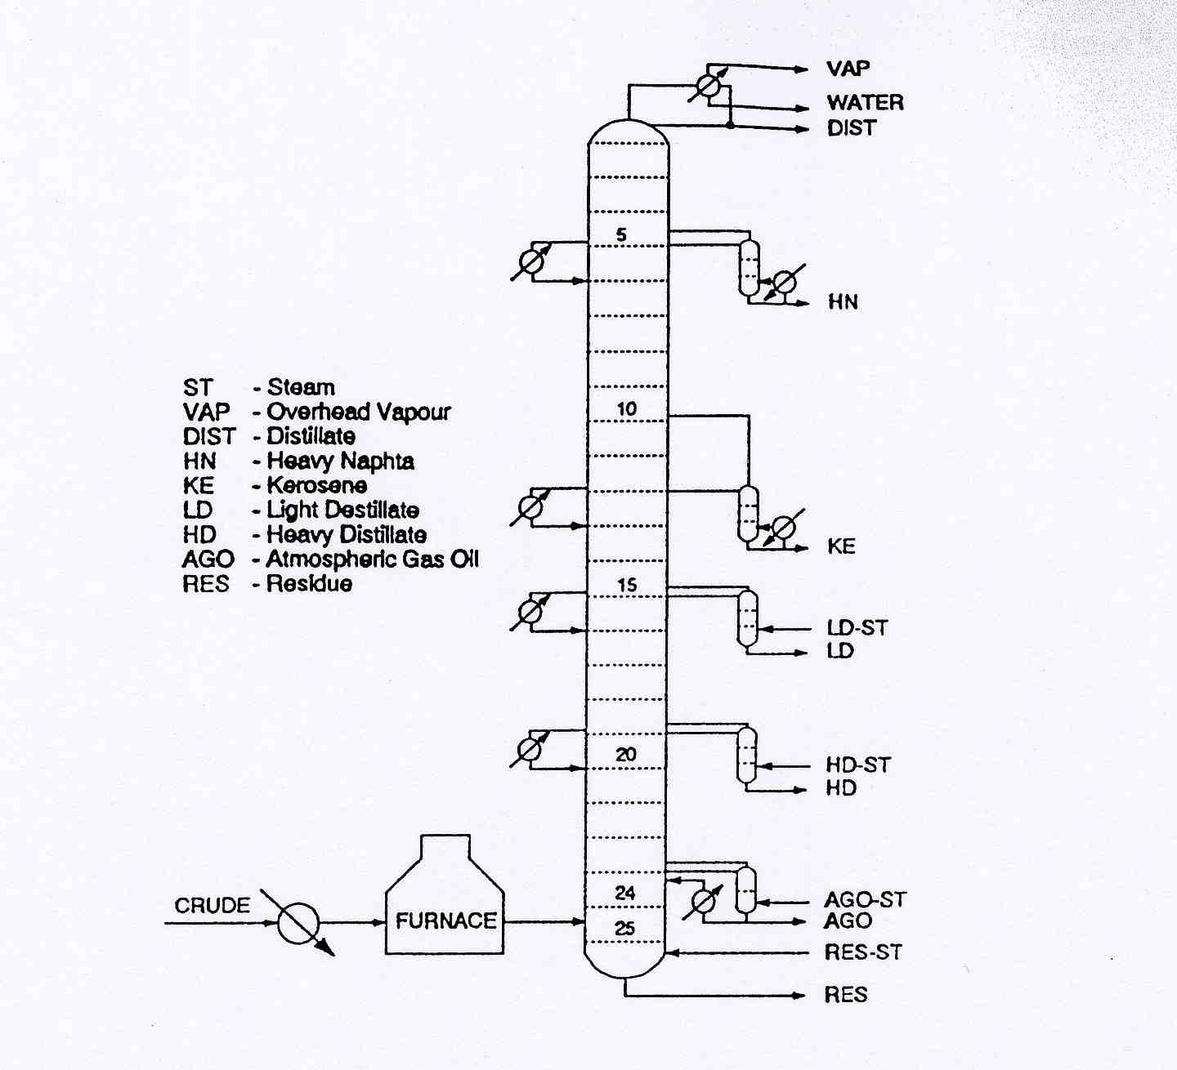
Figure 1: Base case configuration of the case study

Pinch analysis is a thermodynamically based method for the design of heat and power systems. The method of pinch analysis groups the heat sources and sinks of the process streams into temperature intervals, where it is possible to transfer heat in each interval from heat sources to heat sinks [3]. The grand composite curve can be used to provide an interface between the distillation column and the utility system. If a number of different utilities are available, the grand composite curve can be used to determine the relative amount of each utility needed.
If there are mismatches between the process streams profiles and the utility profile, then process modifications are needed to remove these mismatches as far as possible. Process modifications may change the heating or cooling requirements of the streams which will be reflected on the grand composite curve. The modifications, which increase the heat recovery, will increase energy savings. Pinch analysis, in particular the grand composite curve, provides valuable information about each modification to the crude oil distillation system with respect to the utility costs. The main objective of using pinch analysis is to maximize the use of the least expensive utilities and minimize the use of the most expensive utilities.
    - Decomposition of a Complex Column
The atmospheric distillation column in a refinery is highly complex system because of the interactions between the main column with different side strippers and draw streams where the study of this complex system will be more difficult. However, the decomposition of the complex column into a series of simple columns ease and simplify its study. There are a number of advantages of decomposing a complex tower, namely:
1. It is easier to deal with a sequence of simple columns rather than a complex column with respect to understanding the process operations and the implications of design modifications to the process.
2. It is easier to formulate and converge a computer simulation for a sequence of simple columns than a complex column.
3. To improve the stage distribution for each section in the crude tower, the tower is decomposed into a sequence of simple columns as a first step. After that, the ideal number of stages and the optimum feed stage for each simple column are found. Finally, the simple columns are merged back to the complex column with new numbers of stages for each section.
4. The available standard shortcut methods and distillation design procedures are not applicable to complex columns. However, they are for simple columns. For complex mixtures, e.g. crude oil, the standard shortcut methods are not accurate for designing the crude oil distillation column. However, these methods are used to get a starting estimation for designing the column.
In essence, every complex column configuration can be decomposed into single columns and vice versa: every sequence of simple columns can be merged in to a more complex configuration. The decomposition of a complex column into a sequence of simple columns is used only for analysing and studying the system. Therefore, after analysing and modifying the sequence of the simple columns, they must be merged back into a complex column to be compared to the original one.
  - External Modifications
The external modifications to retrofit the distillation system are considered as starting steps for the retrofit procedure. Simple modifications requiring little or no capital investment are implemented to improve the match between the heat exchanger networks (HEN) associated with the column and the available utilities. The external modifications do not change the column hardware and its internals [4].
    - Removal of Inefficiencies
In this level of retrofit, only simple modifications are implemented to remove any inefficiencies in the system and to improve the heat transfer efficiencies. In the base case study, there are some inefficiencies that are required to be removed as a starting point to increase the separation efficiencies and the energy savings. These inefficiencies are normally found in existing crude oil distillation towers because of their long working life. Through this long life, many modifications and developments are carried out for local improvements without considering the overall performance. During this long life, the crude oil distillation process is adjusted as the feed properties and the products specifications change with time.
An inefficiency in the original configuration of the case study is shown where the product of the AGO side stripper is split into two streams one of is cooled and introduced again in the main column. This sub-cooled returned liquid performs the function of a pump around. This separation and remixing is clearly inefficient because of the higher amount of stripping steam required.
One way to remove this inefficiency is done where the side draw from the main column is split first and returned as sub-cooled stream while the other stream is stripped in the side stripper. Therefore, the required stripping steam is reduced tremendously as the feed is reduced. The total savings in operating cost are $40,000/yr for this simple modification in the piping connections. Another example of inefficiency is mixing two vapour streams with a big difference in their composition causes this inefficiency. The returned vapour from the KE side stripper is mixed with the vapour inside the main column which resulting in mixing losses.
This modification suggests that the vapour must be returned to the stage of the liquid side draw where the vapour composition of this stage is similar to the returned vapour from the side stripper. Due to the reduction in the reboiler duty of the KE side stripper, the absolute saving is another $30,000/yr for changing the location of the vapour return port on the column. Finally, the sequence of these simple columns is merged into a complex column with the new values of pump around and reboiler duties while the main column will not change. The fuel consumption (i.e. the furnace) is reduced by 4.2%. A reduction of 13% in the energy costs is achieved representing savings of $526,000/yr.
Low investments are required for these external modifications to adjust the piping network to remove the inefficiencies and to install a new reboiler at the bottom of the LD side stripper. External modifications were considered first. This is because of the low investment that is required by these modifications. The throughput through the modified column could be increased by 39%. There are two options concerning the use of a reboiler or a combination of live steam and a reboiler at the KE side stripper. A trade-off exists between these two options where the use of a reboiler only is more beneficial with respect to the savings in the energy costs while the use of the combination of reboiler and steam save 16% in the furnace duty.
  - Internal Modifications
The internal modifications to retrofit the distillation system consider the distillation column and its internals. In this level of retrofit, some changes are made in the internals or nozzles of the main column and the side strippers. Moreover, the reboilers and pump around loops are examined and adjusted as required. Therefore, more complex modifications are required at this level that lead to higher investments. The objective of these modifications is to find out the ideal distribution of stages for each section in the main column [4]. This ideal design is applied to the existing column by modifying its internal to the minimum extent to reduce the costs.
    - Redistribution of stages in the Column
The main column is decomposed first into a sequence of six simple columns. After that, few iterations are done to find the ratio between the actual reflux to the minimum reflux where the total number of stages in the single columns equals the total in the original.
After that, the sequence of the resulting column is merged into a complex column; the original tower has 25 stages in the main column while the ideal tower has 20 stages in the main column. As the total number of stages is the same, the difference in the stages in the main column is distributed among the side strippers.
Obviously, it is expensive and impractical to rebuild the tower completely to match the ideal configuration. A compromise between the ideal and original design is required to reduce the modifications costs. Therefore, the original main column is kept unchanged as the ideal number of stages is less than the existed number.
The complex column is broken into a sequence of simple columns. This sequence is initially set up with no thermal coupling and with the use of stripping steam instead of reboiling to have the best heat recovery potential. Then, the heat sinks are satisfied first followed by the relaxation of the excess heat sources. Finally, the sequences merged into a complex column.
By applying the internal modifications, further reductions in the vapour load and the energy consumption compared to the external modifications are achieved. This is done by redistributing the stages of the column. After identifying the ideal distribution of stages, a compromise between the existing and the ideal columns is required to reduce the costs of these modifications. The throughput to the modified column could be increased by 48%. The maximum vapour load is shifted from the KE section (base case) to the vapour feed stage (after applying the internal modifications). When the vapour feed stage becomes the bottleneck, configurational modifications are required to be considered to reduce the vapour load through the main column.
  - Configurational Modifications
This level of retrofit design of crude distillation systems is considered last. In this step, complex and costly modifications are investigated. The third level of modifications is the consideration of changes in the column configuration. This can be done by adding a pre-fractionator, a post-fractionator or a preflash train. The main column is changed as little as possible, keeping the same number of trays and position of nozzles to minimise the costs of modifying the main column. Because of the addition of a new column, the separation load, energy consumption and vapour load are reduced in the main column. Some difficulties could arise in this level of modifications due to specific limitations, such as space limits or the length of piping required.
    - Preflash Installation
A preflash configuration is studied for this case study to reduce vapor load in the main column. The preflash is introduced to separate light products (overhead vapor, Distillate and Heavy Naphtha (HN)) outside the system. In the base case, the feed is heated from 24ºC, where the vapor fraction is zero to 335ºC to vaporize 76% of the feed. In the preflash configuration, the feed is preheated first from 24ºC to 193ºC to vaporize 30% of the feed. This preheated feed is flashed in a preflash tank to remove this light material. The vapor product of this preflash tank is processed in a separate column.
This vapor product might contain a small amount of heavy materials as will as the liquid product might contain a small amount of light materials. These light materials could be recovered in the main column as overheated vapor. However, the specifications of the light products in the new column might not satisfy as a result of the existence of a high percentage of the heavy materials in the feed stream to the new column. Therefore, the percentage of heavy materials in the vapor product of the preflash should be monitored by adjusting the preheating to reduce the amount of heavy materials in the HN product.
The specifications of the new column are estimated first by doing a shortcut simulation. The initial estimation of the pressure for the stages and the product specifications for this column are the same as for the HN section in the original tower. It is found that this column requires four trays and the feed tray is at stage 2. The liquid product of the preflash tank is repressurized and heated further in the furnace before it is flashed and introduced to the main column.
    - Rearrangement of Sections and Side Strippers
In this step, the ideal number of stages and feed tray for each of the remaining sections are calculated. After removing the top section from the main column, the total number of sections in the main column is reduced from six to five. Therefore, in the initialization step, five columns are required to separate the remaining products.
To redistribute the stages in the remaining sections, a shortcut simulation is used to find out the required number of trays, the feed tray location and the minimum reflux ratio for each column in the sequence. To make use of the existing column with the same number of trays (24 trays) iterations are required to adjust the sum of the rectifying sections in each column equal to 24 (number of trays in the main column). Finally, the sequence of the simple columns is merged into a complex column. The main column is not changed, but the side strippers and pump arounds need to be relocated or adjusted.
The new configuration suggests increasing the bottom section by two stages which means moving the lowest side draw and pump around two stages up from the existing position. Fortunately, in this case study all other nozzles for the side strippers are not changed. However, the number of stages that is required for the side strippers changes.
As the Heavy Naphtha (HN) side stripper is removed and since the AGO stripper requires two stages, rather than one, it is suggested that the AGO side stripper is replaced by the HN side stripper. The side stripper for the LD product will not change but the HD stripper requires one more stage. A new KE stripper with five stages is required. According to the pump arounds, only the top one needs to be moved. The original HN pump around can be moved from stage 5 and used as the AGO pump around at stage 21.
A large reduction in the vapor load is shown where the maximum vapor flow, after the column is modified, is 52% of the maximum vapor flow of the base case. This implies that approximately 92% more feed can be processed by the modified column that the original column. The consumption of fuel for the whole system (including the new column) is reduced by 31%. The utility cost for the new configuration including the HN tower is reduced by 18%. This reduction represents an absolute saving of $720,000/yr.
Configurational modifications are quite expensive due to the installation of a new column and pumps. However, the benefits from these modifications are much greater than for the simpler modifications discussed in the previous sections. The vapor load is reduced in the modified column by almost half which means the throughput can be almost doubled. In addition, the energy cost of the system is reduced by 18%. The options that are given for the location of the AGO side stripper give a trade-off. Which is the better option should be decided by design engineers for the specific case being investigated.
  - Conclusions
The crude oil distillation system is a unit of major importance in every refinery. Any reduction in the vapor load through the distillation column will have an impact on the capacity of the refinery. The objectives of the retrofit studies are usually throughput increases or energy savings and are required to be met with the least capital spending.
The proposed procedure divides the retrofit design procedure into three levels. At the first level, suggested external modifications to be applied where the original column does not change in order to remove inefficiencies from the system. Thereafter, reboiler and pump around duties are adjusted.
The second level suggests internal modifications to find the best distribution of the stages in the column with the least investment. Therefore, a compromise between the original column and the ideal distribution of stages must be found.
The third level of the retrofit modifications involves changing of the column configuration. This could be done by the installation of preflash units, pre-fractionators or post-fractionators units. For the presented case study, it has been shown that the throughput can be increased by 39% by applying the first level of modifications. For the second and third level, the throughput can be increased by 48% and 97% respectively.
References
[1] Gary, J. and Handwerk, G., Petroleum Refining-Technology and Economics, Marcel Dekker Inc., New York, 1994.
[2] Sittig, M., Petroleum Refining Industry-Energy Saving and Environmental Control, Noyes Data Corporation, New Jersey, 1978.
[3] Smith, R., Chemical Process Design, Wiley, 2005.
[4] Liebmann, K., Dhole, V. and Jobson, M., Integrated design of a conventional crude oil distillation tower using pinch analysis, Trans IChemE, 76, 1998.

