A sensitivity analysis on optimal solutions obtained for a reactive distillation column
Rui M. Filipeª, Steinar Hauan^{b}, Henrique A. Matos^{c}, Augusto Q. Novais^{d}
ªDEQ-ISEL, R. Cons. Emídio Navarro, 1, 1959-007 Lisboa, Portugal
^{b}DCE-CMU, Pittsburgh, PA 15213, USA
^{c}DEQB-IST, Av. Rovisco Pais, 1049-001 Lisboa, Portugal
^{d}DMS-INETI, Est.Paço do Lumiar, 1649-038 Lisboa, Portugal

Abstract
In previous work (Filipe et al. 2007) the multi-objective optimization of a distillation column was performed and the Pareto front relating the total number of stages, reactive holdup and cost, identified. In this work a study on how the Pareto optimal designs could be adapted for real implementation is presented. Different design details, such as reactive holdup and feed quality, are investigated and the sensitivity of the solutions assessed to quantify the effect on the column expected performance.

Keywords: Reactive distillation, multi-objective optimization, sensitivity analysis.
  - Introduction
The design and multi-objective optimization of complex reactive distillation columns can be addressed through a framework that combines the use of feasible regions and optimization techniques in order to assess the adequacy of this technology to reacting systems with variable degrees of relative volatilities (Filipe et al. 2006, 2007). In considering columns with distributed feeds, and given the specific nature of this intrinsically multi-objective problem, which leads to the generation of Pareto fronts, it was found that many solutions located in this front involved combining superheated and subcooled feeds. This combination provides a source or a sink of heat at specified trays of the columns which, while favorable to the reaction, tend to increase the internal flows in some sections of the column.
In Filipe et al. (2006), a new optimization objective, a cost indicator, whose minimization was envisaged, was used to build the trade-off surface in association with the other objectives, reactive holdup and number of stages. Due to the large number of designs evaluated, a cost indicator based on the capacity values (Jobson et al. 1996) was preferred to a detailed cost calculation. The authors concluded that the designs using combined feeds had lower reactive holdups but higher cost indicator values.
This work investigates some details related with the practical implementation of the Pareto optimal designs, through a number of sensitivity tests, with an emphasis being placed on catalyst usage and feed quality. The olefin metathesis system is used as the case study, wherein 2-pentene reacts to form 2-butene and 3-hexene, as a means to balance the light olefins obtained from cracking. This system is well suited for this analysis, since the vapor liquid equilibrium behavior is ideal and the reactant boiling point is intermediate to those of the two products, thus allowing for a wide range of feasible column designs.
  - Methodology
The Pareto fronts were generated using the design and optimization methodology previously described (Filipe et al. 2007). The main assumptions used at this step are: steady state operation, constant pressure, vapor-liquid equilibrium at every stage, kinetically controlled reaction occurring in the liquid phase, and negligible heat effects.
The approach used determines the optimal locations for the catalyst, feeds and feed quality. Nevertheless, many of the reported designs tend to be operationally unrealistic as some trays may have too small amounts of catalyst or a very large number of feeds. To investigate how to translate these designs obtained from that simplified optimization model to a process simulator like Aspen Plus, a set of obtained solutions were used to initialize simulations in Aspen Plus, employing the RadFrac model and the Ideal property method. The number of stages, reboil ratio, distillate to feed ratio, location and quality of the feeds, as well as the reactive holdup distribution specifications, were taken from the former optimization results.
The assumption of negligible heat effects made in the previous framework allows the decoupling of material and energy balance. The internal flows of the column will then change only due to inflows, outflows or reaction, this latter only if the number of moles change as a result of the reaction stoichiometry. However heat effects cannot be neglected in more detailed models such as those required for Aspen Plus, and simulations show that the internal flows change in trays without inlets or outlets, due to different heats of vaporization for the components inside the column. Setting reflux ratios instead of reboil ratios will then result in significantly lower values for the latter and, consequently, degradation in the purity of the outlet streams.
Aspen Plus does not support the direct specification of the feed quality. To overcome this, a design specification was implemented: the feed temperature is adjusted to provide the required energy for the change in the internal liquid flow according to L_{n} = L_{n+1} + q F where F is the feed flow, q the feed quality, and L_{n+1} and L_{n} the liquid entering and leaving the tray, respectively.
The cost indicator previously used (Filipe et al. 2006) is based on the size of internal flows, feeds and number of stages, providing an expedient method for the evaluation of a large number of solutions. In this work we analyze these solutions in more detail and employ energy demands and column diameters, with a view to compare the proposed designs, while looking at the accordance of the obtained results with capacity.
The olefin metathesis system is used, with the physical properties and reaction kinetics being taken from the literature (Okasinski and Doherty 1998). The reaction is considered only to occur in the liquid phase with a negligible heat of reaction and ideal vapor-liquid equilibrium behavior at atmospheric pressure. The specifications for column operation are taken from Hoffmaster and Hauan (2006). The goal is to convert a pure pentene feed into product streams of butene and hexene with a purity of at least 98 mole percent using a feed flow of 2 kmol/h and a distillate to feed ratio of 0.5.
  - Results & discussion
    - Sensitivity to catalyst amount
In this section a design case, designated as case A, located at the Pareto front obtained in the optimization step is used to investigate the sensitivity of the solution to changes in the total reactive holdup, i.e., the amount of catalyst required. This design has a reactive holdup (2.5 kmole) near the minimum achieved for the designated number of stages (14), which corresponds to a high capacity indicator value (65.23). It has 10 reactive stages (3 to 12), the feed is located on stage 8 and the feed quality is -0.4.
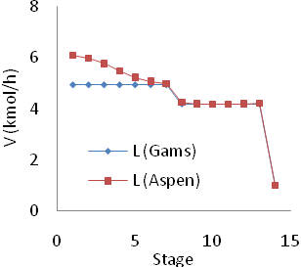
Case A was implemented in Aspen Plus and a slight reduction in the product purity was observed when compared to GAMS results. Product streams show a purity of 97.64% mole fraction instead of 98.00%. As mentioned before, while the heat effects are neglected in the GAMS approach, now the effect of different molar vaporization enthalpies (2-butene < 2-pentene < 3-hexene) is reflected in the changes of the internal flow profile, as seen in Figure 1. The effect is more noticeable in the stages above the feed (1 to 7) where the concentration of 2-butene is higher and due to its lower vaporization enthalpy, the number of vaporized moles increases. In the stages below the feed stage the effect is less noticeable, and although still present, it cannot be perceived in the figure.
Figure 1. Internal vapor flows (case A)
To investigate the flexibility of the solution, an uniform distribution of the reactive holdup was tested. Redistributing the reactive holdup evenly by three, five and seven stages around the feed stage, led to a penalization of the purity up to 0.05%, while increasing the capacity cost indicator up to 0.15%. This is no longer an optimal design located at the Pareto front, but the increased flexibility offered by the redistribution of the reactive holdup without significant penalties, may be instrumental in improving the column operability.
The effect of changing the total reactive holdup was also assessed. Figure 2 depicts the variation of the product purity, capacity and energy supplied to the column through reboiler and feed (Q), with the total reactive holdup (the reference case is indicated by the dashed line). The reactive holdup was changed proportionally in each tray and, as it can be seen, the conversion achieved is highly dependent on reaction availability. There is a noticeable decrease in purity if the reactive holdup is reduced, which is in accordance with the fact that this is a “near minimal” reactive holdup solution, as reported by GAMS. Capacity and energy follow a common trend which is expected, since the number of stages is kept constant and the column diameter was found to undergo only negligible changes. Internal flows and energy consumption are then closely related to each other.

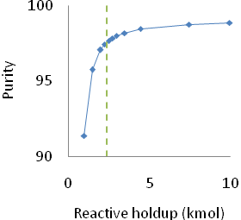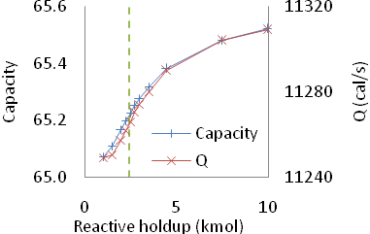
Figure 2. Variation of the stream purity, capacity and energy versus the total reactive holdup
In order to compare different solutions without explicitly calculating the cost, an objective function, OF, that considers product purity, catalyst amount and the sum of the energy supplied to the column in the reboiler and feed was defined, as follows:
$\text{OF}=\text{100}\frac{x}{x_{A}}−C_{1}\frac{\text{RH}}{{\text{RH}}_{A}}−C_{2}\frac{Q}{Q_{A}}$ (1)
where x is the purity of the stream (equal in both streams), RH the reactive holdup and Q the energy supplied as defined earlier. The subscript A designates case A which is used as the base case. The purity term is multiplied by a fixed value (100) to normalize the solutions and represents the profit obtainable by selling the product. C₁ is related to the penalty of increasing the reactive holdup and can also be seen as the cost of catalyst. C₂ is related to energy consumption in the reboiler and feed heater. The choice of values for the parameters in the function is not trivial as a large number of variables have been grouped into these coefficients, such as the market value of products and catalyst, catalyst specific activity and operating temperatures, amongst others.
The analysis of the total reactive holdup influence was extended to analyze the sensitivity of the objective function parameters C₁ and C₂. Three different scenarios for each parameter were defined and the results are depicted in Figure 3. When C₁ is increased, for a fixed C₂, the shape of the function changes demonstrating the advantage of using the smallest reactive holdup that does not compromise product purity. Decreasing too much the reactive holdup would also reduce the objective function value due to the penalty on conversion. Varying C₂, for a fixed C₁, the observed changes are only on the relative position of the curve, not on its shape, which is due to energy consumption not being a variable of the process but an Aspen Plus result.
    - Sensitivity to feed quality
In the optimization step, the feed quality q is allowed to take values between -2 and 2 (overheated vapor and subcooled liquid, respectively) and these values are usually selected, in particular, for solutions with low holdup. In fact, it was verified that the use of these feed qualities was responsible for the reduction of the total required holdup. Although interesting from the conceptual point of view and giving insight on how to overcome situations where conversion must exceed the limits imposed by the catalyst (e.g., catalyst deactivation or large volume being required), its practical implementation might be unrealistic. For example, for the particular system used in this section, the range -2 to 2 involves feed temperatures ranging between 689 and 92K.
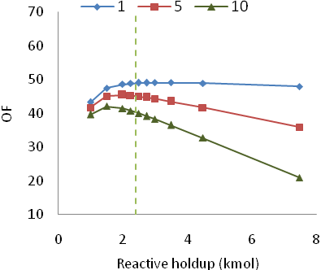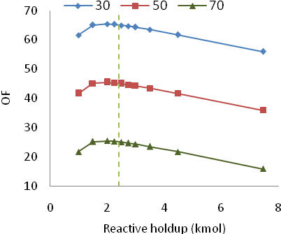

Figure 3. Influence of C₁ (left, for C₂=50) and C₂ (right, for C₁=5) on the objective function
The sensitivity to feed quality and the scope for the real implementation of designs involving extreme feed qualities is investigated in this section with case B. The details for this case are: 26 stages, 14 reactive stages (5-18), total reactive holdup equal to 1.1 kmole, two feeds (stages 9 and 20) with feed qualities of -2 and 2, respectively.
The internal flows are increased in the trays located between feeds by using overheated vapor and subcooled liquid in the lower (F₂) and upper (F₁) feeds, respectively, as seen in Figure 4. As a result, the liquid flow passing through the lower part of the reactive section increases, increasing the total conversion. It is therefore apparent that by reducing the range of the feed qualities (q₁ and q₂), the product purity will also decrease as a result of reduction of the internal flows. Figure 5 depicts the effect of the variation of q₁ and q₂ on product purity and confirms this previous finding. As expected, purity is more sensitive to q₂, since it is the actual “heat” feed, directly related to the energy supplied to the column. On the other hand, the temperature of F₁ decreases as q₁ increases, hence the available energy in the column is reduced, bringing about a degradation of the product purity.
With a view to test the practical implementation of the design, a set of scenarios was devised (Table 1). We started with case B1 where the “cold” feed, F₁, was suppressed. All the feed flow is now supplied through F₂, which explains the high value for the energy demand Q. In B2 the feed condition was changed to saturated vapor (q₂ = 0) which substantially reduces the energy supplied and, consequently, the product purity.

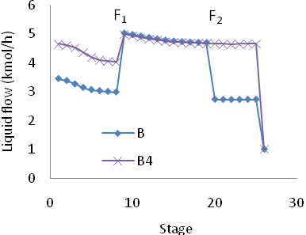
Figure 4. Internal liquid profiles
Figure 5. Variation of purity with the quality of the feeds

Table 1. Scenarios derived from case B
Case | F₁ (kmol/h) | F₂ (kmol/h) | q₁ | q₂ | Reboil ratio | Purity (%) | Q (cal/s) | Capacity
B | 1.0 | 1.0 | +2 | -2 | 1.7 | 96.96 | 8937 | 96.4
B1 | 0.0 | 2.0 | - | -2 | 1.7 | 97.56 | 14797 | 160.5
B2 | 0.0 | 2.0 | - | 0 | 1.7 | 56.05 | 7077 | 77.5
B3 | 0.0 | 2.0 | - | 0 | 3.6 | 95.18 | 10713 | 128.5
B4 | 1.0 | 1.0 | 1 | 0 | 3.6 | 98.97 | 8986 | 116.8

Case B3 was defined after case B2, by increasing the reboil ratio in such a way that the internal liquid flow at the feed stage was identical to case B. For B3, an increase in the reboil ratio has to be met also by an increase in the reboiler duty, implying a growth in the energy demand of up to 10713 cal/s.
In case B4, combined feeds were used with qualities q set to 1 (liquid at boiling point) and 0 (saturated vapor), while still maintaining the internal flow at the second feed stage as already applied in case B3 (Figure 4). Again, the advantage of the combined feeds is demonstrated and the purity is seen to rise over the value obtained in case B, only with a small increase in the energy demand. The higher value of purity is due to the reactive trays located above F₁, whose contribution now increases due to higher flows, by comparison with case B. Despite B4 being the best case, the total internal flow is found to be higher than in case B, which reflects directly in the capacity value.
These tests also point out to alternatives for improving the capacity cost indicator: cases B and B4 have the same column diameter (0.2 m), practically the same energy requirement and still the capacity is higher in case B4. This suggests that the largest liquid and vapor flows in the column could be used in the cost indicator definition, rather than the actual individual stage flow values.
  - Conclusions
This paper addresses an analysis of reactive distillation column designs obtained from optimization in GAMS with a view to their practical implementation. The sensitivity of the solutions to design variables, such as reactive holdup and feed quality are analyzed using an Aspen Plus model. It is found that some assumptions made at the optimization stage introduce deviations in the simulation results. Nevertheless, the optimized solutions are valuable starting points for further analysis and give important insights into the column design. Also, the selected range for the feed quality in the optimization stage was shown to be inappropriate for industrial practice, as it leads to unrealistic temperature ranges. However, it helped to confirm the advantage of using combined feeds, while emphasizing the need for a careful selection of the feed qualities.
Finally, some insights have been gained in respect of potential improvements of the capacity cost indicator, which will be further explored in the future.
References
Filipe, R. M., A. Q. Novais, et al. (2006). Multi-objective optimization of reactive distillation columns using feasible regions. 17th International Congress of Chemical and Process Engineering, Prague, Czech Republic.
Filipe, R. M., S. Hauan, et al. (2007). Multi-Objective Design of Reactive Distillation. 17th European Symposium on Computer Aided Process Engineering. V. Plesu and P. S. AGACHI. 24, 407-412.
Hoffmaster, W. R. and S. Hauan (2006). "Using feasible regions to design and optimize reactive distillation columns with ideal VLE." AIChE Journal 52, 5, 1744-1753.
Jobson, M., D. Hildebrandt, et al. (1996). "Variables indicating the cost of vapour-liquid equilibrium separation processes." Chemical Engineering Science 51, 21, 4749-4757.
Okasinski, M. J. and M. F. Doherty (1998). "Design Method for Kinetically Controlled, Staged Reactive Distillation Columns." Industrial & Engineering Chemistry Research 37, 7, 2821-2834.

