Supply chain optimization with homogenous product transport constraints
Tivadar Farkasª, Zoltán Valentinyi^{b}, Endre Rév^{c}, Zoltán Lelkes^{d}
ªOptaSoft Kft.; permanent job at HAS-BUTE Materials Structure and Modeling Research Group, Szent Gellért tér 4., Budapest, H1111, Hungary
^{b}Provimi Pet Food (Pet Hungaria Kft.), Puskás Tivadar u. 12., Budaörs, H2040, Hungary
^{c}Budapest University of Technology and Economics, Department of Chemical and Environmental Process Engineering, Műegyetem rkp. 3., Budapest, H1111, Hungary
^{d}OptaSoft Kft., Bölcső u. 5., Budapest, H1117, Hungary
Abstract
Provimi Pet Food is the pet food division of Provimi, one of the world’s largest animal feed manufacturing and commercial companies. The dynamic growth of the company in the last years resulted in the necessity to optimize the supply chain. The supply chain problem has special characteristics such as special logical constraints of homogeneous transport, complex cost function, and large size. The developed mathematical model and computational experiences are presented here.

Keywords: supply chain, transportation, MILP
  - Introduction
The transportation problem is to minimize the total transportation costs and utilize all the supply of a set of sourcing units with respect to satisfying all the demands of a set of destinations. This task forms the basis of much more complicated problem classes such as supply chain allocation and distribution. No standardized model of supply chain allocation problems is accepted in the literature. According to Vidal and Goetschalckx (1997), the supply chain allocation problem involves determining (1) the number, location, capacity, and type of manufacturing plants and warehouses to use, (2) the set of suppliers to select, (3) the transportation channels to use, (4) the amount of raw materials and products to produce and ship among suppliers, plants, warehouses, and customers, and (5) the amount of raw materials, intermediate products, and finished goods to hold at various locations of inventory. Special constraints of particular cases such as complex cost functions or logical constraints are not involved in the general definition of supply chain.
The case study of Provimi Pet Food, the pet food division of Provimi, one of the world’s largest animal feed manufacturing and commercial companies, is presented here in order to show the complexity and specialities of this problem, and the way it is solved. The main motives of why developing a supply chain model was necessary is first described, then the specialities of the supply chain of Provimi Pet Food are detailed with their mathematical formulation. Finally, computation results of optimizing different sizes of the problem using model versions of different complexity levels are presented.
  - Motivation
Provimi is one of the leading animal feed producers and distributors in the world, dealing with pet food, vitamins, special ready made and semi-finished products. The company developed its pet food division exponentially in the recent years, is present in 17 countries considering Europe only, has bought 20 other companies between 2002 and 2006, including 12 from Europe. Its shares have been doubled since 2001.
The company intends continuing the expansion both globally and in Europe. The management is faced to new challenges because of the sudden increase in the number of European affiliated companies, and particularly the producing plants. The producing capacities distributed in factories of different pre-history in the countries should be co-ordinated to minimize the logistic and production costs, and to provide the company and the plants in time and reliably with the related information. Considering this situation, the European management decided introducing an optimizing software system to aid the supply chain. This project including the consultation work and developing the optimizer software system has taken approximately 5 months.
  - Problem characteristics
As is expected in every particular application, the problem of Provimi Pet Food has specialities which call for special formulations and solution.
Two main decision levels, the level of plants and the level of customers, are considered in the Provimi Pet Food supply chain problem. Customers have certain demands for products which can be produced in the plants. The production process is modeled as being consisted of two consecutive steps. Semi-products are produced in production lines. These semi-products are subsequently mixed and packaged in packaging lines. This packaged product is the final product of the plants, and is transported to the customers. The semi-products can be transported between plants, i.e. a packaging line can package semi-products produced in another plant.
The level of suppliers is omitted from the model. The level of warehouses is considered merely in the transportation costs from plants to customers. If a product has to be stored in a warehouse during the transportation from a certain plant to a certain customer then the specific transportation cost of that route is increased with the cost of storage.
Therefore, three levels are considered in the supply chain model of Provimi Pet Food: (1) production lines of plants, (2) packaging lines of plants, and (3) customers (see Fig. 1).

The problem has four main special characteristics: (1) Complex cost functions, (2) Minimum constraints, (3) Homogenous transport constraints, (4) Large size.
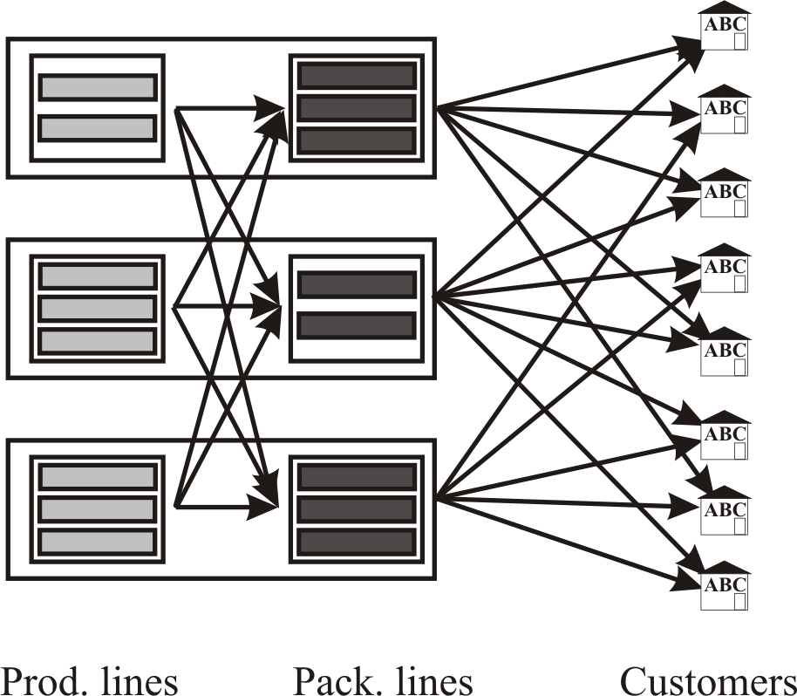
Fig. 1. Supply chain model Fig. 2. Stepwise constant cost function
    - Complex cost functions
The target is to minimize the sum of transportation costs, production costs, and packaging costs. The transportation costs are proportional to the amount of transported semi-products and products. Production and packaging costs consist of variable cost proportional to the amount of the products, and fix costs. Fix costs are given by stepwise constant functions, as is shown in Fig. 2. Intervals over which the fix costs are defined can be specified according to the working shifts, for example.
    - Minimum constraints
'Either / or' minimum constraints are considered at the production lines level, at the packaging lines level, at the semi-product transport, and at the product transport. In each case, existence of a minimum constraint means that the quantity of produced /packaged / transported semi-product / product either has to reach a defined minimum level or has to be zero. In each case this minimum constraint expresses the economical consideration that it is not worth to produce, package, or transport, below a minimum quantity (e.g. one truck, in the case of transportation).
    - Homogenous transport constraints
Homogenous transport means that any amount of a given product is transported to a customer from a single, not a priori assigned, plant even if that product can be produced in several plants. Homogenous transport is specified in order to prevent the customer from receiving a mixture of different quality products that might occur because different raw materials and processing methods are applied at the different plants.
    - Large problem size
The supply chain problem of Provimi Pet Food involves at least eight plants each containing one to three production and packaging lines, more than 80 customers, and more than 800 products.
This large size and the above mentioned special constraints result in a very difficult and complex problem, and it renders developing and applying a well-formulated mathematical model necessary, as well as special preliminary procedures before commencing the optimization process.
  - Mathematical model
The supply chain problem of Provimi Pet Food is first formulated as a Generalized Disjunctive Programming (GDP) model using continuous and logical variables, then it is transformed into a Mixed Integer Linear Programming (MILP) model using binary variables instead of the logical ones.
The mathematical models incorporate mass balance equations, capacity constraints, the cost functions, and the special constraints mentioned in the previous section. The mass balance equations, the capacity constraints, and the variable cost functions, are all linear and need not be explained here. How the special constraints are formulated is explained below.
    - Complex cost functions
The fix cost c_{l} of production or packaging line l depends on its working hours t_{l}. The range of variable t_{l} is subdivided to a number of shifts s. The time moment borders of these shifts are given by the upper bound BT_{s} of shift s. The constant fix cost of the line in shift s is given by parameter BC_{s}.
In the GDP representation, logical variables zs_{l,s} are assigned to the shifts. If the value of the independent variable is in or above shift s then zs_{l,s}=1, else zs_{l,s}=0:

$\begin{aligned}\left[{\text{zs}}_{l,0} | \right]\left[t_{l}=0 | \right] \\ \end{aligned}$ $∀l,s$ (1)

(Character ⊕ denotes the logical operation 'exclusive or' or XOR.) This logical equation is transformed into algebraic one using the method of Lelkes et al. (2005):

$t_{l}≤\sum_{s}{\left({\text{ys}}_{l,s}⋅{\text{DT}}_{l,s}\right)}$ $∀l$ (2)
$c_{l}≥\sum_{s}{\left({\text{ys}}_{l,s}⋅{\text{DC}}_{l,s}\right)}$ $∀l$ (3)
${\text{ys}}_{l,s}≤{\text{ys}}_{l,s−1}$ $∀l,s≥2$ (4)

where DT_{l,s} is the length of shift s at line l, DC_{l,s} is the fix cost increment of shift s of line l related to the fix cost of the previous shift s1, and ys_{l,s} is a binary variable.
    - Minimum constraints
How these constraints are formulated is exemplified with the minimum product transport constraint. The qt_{p,c,pr} transported quantity of product pr from plant p to customer c either has to be equal to zero or not smaller than a minimum transport quantity QTMIN_{p,c,pr}. In the GDP formulation of this constraint, logical variable zt_{p,c,pr}$∈${true, false} denotes whether there is product transport on the given route:

$\left[\begin{matrix}¬{\text{zt}}_{p,c,\text{pr}} \\ {\text{qt}}_{p,c,\text{pr}}=0\end{matrix}\right]∨\left[\begin{matrix}{\text{zt}}_{p,c,\text{pr}} \\ {\text{qt}}_{p,c,\text{pr}}≥{\text{QTMIN}}_{p,c,\text{pr}}\end{matrix}\right]$ $∀p,c,\text{pr}$ (5)

This logical constraint is transformed into algebraic form using binary variables yt_{p,c,pr}$∈${0, 1} instead of the logical zt_{p,c,pr} ones:

${\text{qt}}_{p,c,\text{pr}}≥{\text{QTMIN}}_{p,c,\text{pr}}⋅{\text{yt}}_{p,c,\text{pr}}$ $∀p,c,\text{pr}$ (6)

    - Homogenous transport constraints
The homogenous transport of product pr to customer c can be defined as a logical constraint using logical variable zh_{p,c,pr}. If zh_{p,c,pr} is true, i.e. if product pr is transported only from plant p to customer c, then the transported quantity qt_{p,c,pr} is equal to the demand D_{c,pr} of customer c for product pr, and the transported quantity from all the other p2≠p plants is zero.

$\begin{aligned}\left[{\text{zh}}_{p,c,\text{pr}} | \right] \\ \end{aligned}$ $∀p,c,\text{pr}$ (7)

This logical constraint is transformed into algebraic form using the Convex Hull technique:

${\text{qt}}_{p,c,\text{pr}}=D_{c,\text{pr}}⋅{\text{yh}}_{p,c,\text{pr}}$ $∀\left(p,c,\text{pr}\right)$ (8)
$\sum_{p}{{\text{yh}}_{p,c,\text{pr}}}=1$ $∀\left(p,c,\text{pr}\right)$ (9)

where yh_{p,c,pr} is a binary variable.
  - The optimization method
The solution of the problem is implemented in AIMMS modeling language (Bisschop and Roelofs, 1999) using CPLEX as MILP solver. AIMMS has been chosen by Provimi Pet Food because of its advanced graphical user interface, and because the most modern solvers can be attached, and the program can be easily extended and developed in case of changing requirements.
In order to facilitate the optimization, preliminary procedures are developed which run before the optimization of the main model. First, the tightest bounds of the variables are computed using a Linear Programming (LP) model. Then a feasibility check is performed by solving a simplified LP problem generated from the main MILP model. If the problem is infeasible then the program provides the user with information about the possible reasons of infeasibility. If the problem is feasible then initial values are calculated by solving the relaxed LP model of the main MILP model. As a result of this initialization, the solution procedure of the main MILP model starts from a near optimal point, and thus the solution time is decreased. Finally, the main MILP model is solved.
Solving the main MILP model takes no more than 15 seconds on a PC (2.6 MHz CPU, 512 Mb RAM), and solving the whole problem (including the generation of each mathematical model) takes no more than 5 minutes with relative optimality tolerance (gap) 10⁻¹³.
  - Computation results
The developed MILP model is tested on three example data sets of different sizes. Main characteristics of the example data are shown in Table 1.

Table 1. Characteristics of the example data sets
Size | Nr. of prod. lines | Nr. of pack. lines | Nr. of customers | Nr. of products | Nr. of eqs. | Nr. of vars. | Nr. of bin. vars.
Small | 3 | 5 | 19 | 201 | 4928 | 4659 | 1800
Medium | 6 | 11 | 45 | 299 | 17365 | 19728 | 13608
Large | 13 | 21 | 83 | 856 | 88240 | 99707 | 79826
The effect of including the special constraints (complex cost function equations minimum constraints, homogeneous transport constraints, and) are tested with different versions of the MILP model. Model 1 contains the material balances, the capacity constraints, and the cost functions only. Model 2 includes all the constraints of Model 1 and the minimum constraints as well. Model 3 includes all the constraints of Model 1 and the homogenous transport constraints as well. Model 4 contains all the above mentioned constraints. The solution time data (in CPU sec) at relative optimality tolerance (gap) 10⁻¹³ are collected in Table 2 and visualized in Fig. 3.

Table 2. Computation time of model versions
Size | Model 1 | Model 2 | Model 3 | Model 4
Small | 0.02 | 0.05 | 0.02 | 0.07
Medium | 0.08 | 0.20 | 0.11 | 0.23
Large | 1.06 | 4.58 | 1.23 | 6.47

Extending Model 1 with the minimum constraints (Model 2) increases the solution time at least with 150%. But including merely the homogenous transport constraints extension (Model 3) increases the solution time just slightly. Homogenous transport constraints are stricter constraints than minimum constraints but they probably cause smaller increase in solution time because (1) this extension means less number of constraints containing binary variables, and (2) their proper Convex Hull formulation results in smaller search space during the optimization.

Fig. 3. Computational times of model versions
  - Conclusions
An MILP model has been developed for solving the supply chain problem of Provimi Pet Food. The model includes special logical constraints such as stepwise constant cost functions of production and packaging lines, minimum constraints for production, packaging and transportation, and the constraints of homogenous product transport. The solution procedure is developed in AIMMS modeling language.
References
J. Bisschop, M. Roelofs, 1999, AIMMS The User’s Guide, Paragon Decision Technology B.V.
Z. Lelkes, E. Rev, T. Farkas, Z. Fonyo, T. Kovacs, I. Jones, 2005, Multicommodity transportation and supply problem with stepwise constant cost function, European Symposium on Computer Aided Process Engineering 15, Elsevier, 1069-1074.
C.J. Vidal, M. Goetschalckx, 1997, Strategic production-distribution models: A critical review with emphasis on global supply chain models, Eur. J. Op. Res. 98, 1-18.

