Optimal CO clean-up reactors design. Modeling and optimization aspects.
Javier A. Francesconi, Diego G. Oliva, Miguel C. Mussati, Pio A. Aguirre
INGAR Instituto de Desarrollo y Diseño (CONICET-UTN), Avellaneda 3657, Santa Fe CP:S3002GJC, Argentina
Abstract
This work applies model-based optimization techniques for designing the CO clean-up packed bed reactors involved in an ethanol processor for hydrogen production applied to PEM fuel cells. The reactors considered are the high-stage and low-stage water-gas-shift units, followed by a CO-PrOx unit. The reactors are modeled considering a 1D- heterogeneous model of a catalytic fixed bed. An optimization problem was formulated to determine the operating and design variables that minimize the total system volume. Each unit consists of a reactive bed, insulating material, reactor tube and heads. The model computes the exigencies required for the constructive materials, such as maximum and minimum operation temperature for catalyst and insulating materials. The optimization problem determines the optimal value of the reactor length and diameter, catalyst particle diameter and insulation thickness. Two alternative optimization approaches are compared: (a) single unit optimization of each reactor involved, and (b) whole-system (simultaneous) optimization. The latter allowed achieving an optimal design with a total system volume reduction about 20% compared to the single units optimization. The resulting PDAEs system is implemented and solved using gPROMS.

Keywords: CO-PrOx, WGS, PEM fuel cell, reactor design, modeling, optimization.
  - Introduction
During the last decade, there have been important advances in fuel cells technology. Fuel cells are being developed for applications to electrical energy generation and co-generation systems by coupling energy integration and power generation in both stationary and mobile systems. Since fuel cells are high-efficiency energy converter devices and due to their low polluting emission levels, they become more and more attractive as a power generation alternative, specially in transportation industry (Krumpelt et al. 2002).
Proton Exchange Membrane Fuel Cell (PEMFC) demands a free-CO hydrogen stream for operation. Since CO is adsorbed on the catalyst surface causing catalyst poisoning, it is necessary to reach CO concentrations less than 10 ppm for preventing irreversible damage. The conditioning of the gas stream generated from the steam reforming of ethanol is partially performed by the water-gas-shift reaction (WGS). The WGS stage in the reforming systems permit to achieve an output gas composition with a typical composition of 0.5-2% (v/v) of CO. Afterwards, a final CO reduction is needed. Among different selective CO removal technologies the CO preferential oxidation (CO-PrOx) is the preferred for small scale reforming systems due to relative simple implementation, lower operating costs, and minimal hydrogen loss (Choi and Stenger, 2004).
For fuel cell applications, a compact, efficient and reliable fuel processor is desirable. Process synthesis and design tasks are similar to other industrial reforming processes. However, the production capacity level required by fuel processors for vehicles or other similar devices is lower compared to industrial processes. Thus, process units of small size and specific designs are required.
To the authors' knowledge, few works have addressed the optimal fixed bed reactor design and analysis applying mathematical programming techniques. Hwang and Smith (2004) developed a generic method for the design of reactors with optimal temperature profiles focused on the use of side-streams and inert pellets to control the temperature profiles. Both 1D-pseudo-homogeneous and 1D-heterogeneous reactor models are used for modeling an ethylene oxidation reactor with SQP (Successive Quadratic Programming) and stochastic methods applied for the optimization. By applying the same methodology Hwang et al. (2004) considered catalyst characteristics -such as pellet diameter, shape and activity distributions inside a pellet- as decision variables. However, the reactor size is prefixed and constrains are not incorporated to the optimization problem. Francesconi et al. (2007b) applied model-based optimization for the design of an adiabatic WGS unit considering reactor dimensions and particle diameter as decision variables. In the case study analyzed it is necessary more than one reactor unit to achieve the required CO conversion. In addition, the optimal insulating material thickness that affects the final volume and the design variables is computed.
The aim of this work is focused on investigating the CO clean-up reactors of a fuel processor for applications in PEM-type fuel cells, and showing how the reactor design using mathematical programming techniques allows computing both reduced volumes and optimal operation conditions. The system consists of a high-stage and a low-stage water-gas-shift reactors, and a CO-PrOx unit. Two alternative optimization approaches are compared: (a) single unit optimization of each reactor involved, and (b) whole-system (simultaneous) optimization. Individual reactor sizes and relative sizes of the reactor components (catalytic bed, insulation material, reactor tube and heads) can be evaluated. Moreover, process performance bottlenecks and opportunities for optimization can be identified and analyzed. This knowledge can be used for process improvements such as lower unit weight and costs, and higher global efficiency.
  - CO clean-up system
The CO clean-up system considered is that analyzed in Francesconi et al. (2007a) for an ethanol fuel processor. The reformate gases are conditioned by two water-gas-shit reactors -the high (HTS) and low temperature (LTS) stages-, followed by a CO-PrOx unit. The water gas shift reaction takes place according to:
CO + H₂O ↔ CO₂ + H₂ = -42.2 kJ mol-1 (1)
The HTS operate between 300-450 °C over a commercial iron-based catalyst. Keiski et al. (1992) developed a power-law type of reaction rate expression for this catalyst. The LTS reactor is based on a commercial Sud-Chemie Cu/ZnO/Al₂O₃ catalyst operating between 150-250 °C (Choi and Stenger, 2003).
The main reactions involved in the CO-PrOx are the carbon monoxide oxidation (2) and the hydrogen oxidation (3).
CO + ½ O₂ → CO₂ = -283.2 kJ mol-1 (2)
H₂ + ½ O₂ → H₂O = -241 kJ mol-1 (3)
Choi and Stenger (2004) derived kinetic expressions for the simultaneous oxidation of CO and H₂ and the water-gas-shift reaction obtained over a Pt-Fe/Al₂O₃ based catalyst. Figure 1 shows a scheme of the reactors involved, and the characteristics and properties of the catalysts utilized.
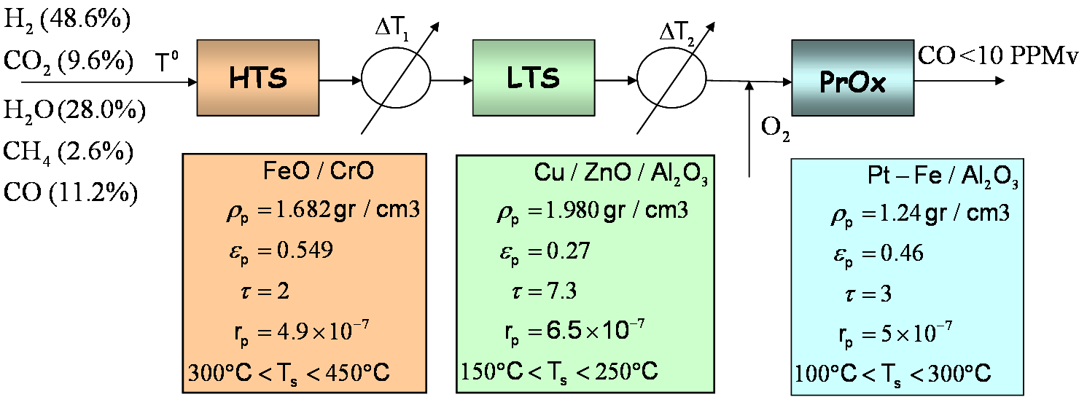
Fig. 1. CO clean-up system and catalyst properties.
In the ethanol processor, the WGS reactors constitute the piece of equipment with greatest volume due to kinetic and thermodynamic effects. On the other hand, CO selectivity and to keep the operating temperature within a determined range are the design aspects in the CO-PrOx unit. At lower temperatures the thermodynamic equilibrium of the WGS reaction on both HTS and LTS reactors is shifted to hydrogen formation diminishing the CO outlet concentration. This improves the performance of PrOx reactor, consuming less H₂. Since hydrogen is generated by the WGS reaction but is undesirably consumed during the oxidation of H₂ in the CO-PrOx reactor, there exists a trade-off between the ethanol processor efficiency and the volumes of reactors. Although the CO-PrOx reactor can operate with gaseous mixtures with CO concentration ranging between 0.2-2.0%, lowers values assure good system efficiency. Consequently, an integrated analysis considering both aspects is necessary to find out the suitable CO conversion target in each reaction unit.
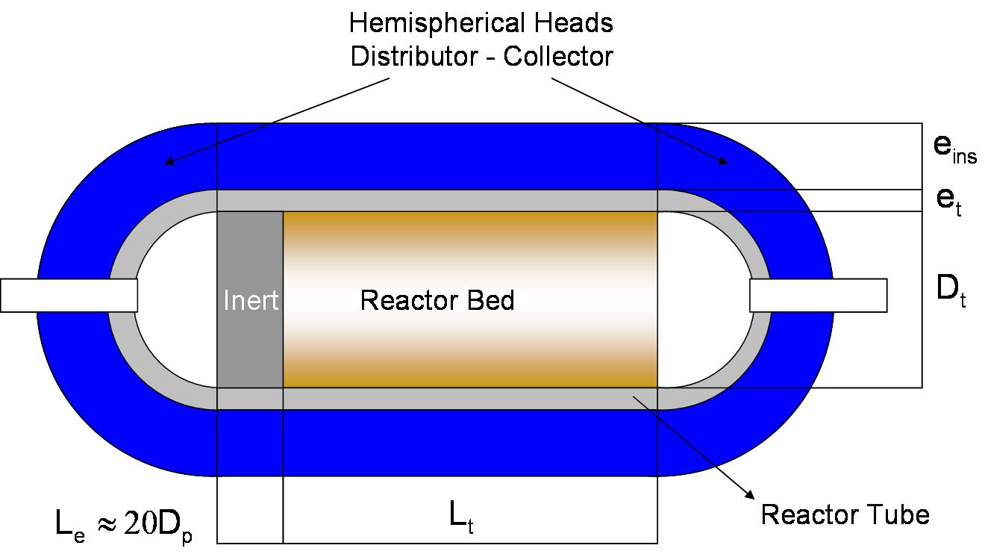
Fig. 2. Reactor unit components
In this paper conventional fixed bed catalytic reactors are considered operating in pseudo-adiabatic mode (reactor with insulation). In order to evaluate the total system volume, each reactor unit is formed by different parts: catalyst bed, reactor tube, insulating material, distributor heads and an entrance length with inert (see Figure 2). The insulating material used in the model consists of a layer of calcium silicate covered with a thin layer of aluminum. A fully developed flow is considered at the reactor bed entrance. However, it should be taken into account that the flow into the fixed-bed reactor is generally achieved by means of a feed pipe and a distribution hood. It has been found that an inert entrance length about Le=20*Dp is enough to achieve a developed flow condition (Ziolkowska, 2005). Finally hemispherical distributor and collector are considered at the beginning and ending of the reactor.
  - Mathematical model
The optimal reactor design is performed based on a 1D-heterogeneous model, which offers higher accuracy for design task (Hwang, 2004). The HTS- and LTS-WGS units are modeled considering intraparticle gradients. Only extraparticle gradients are necessary for CO-PrOx. The main differential equations are the mass and energy balances, and pressure drop along the catalytic bed for the fluid phase. In addition, extra differential variables are necessary in order to evaluate path constrains along the axial direction (z-coordinate), and for the objective function. The implemented model requires an adequate definition of dimensionless variables in order to perform the optimization. The composition and temperature profiles established inside the catalyst particle are obtained by discretizing the mass and energy differential equations using orthogonal collocation on finite element method. As the reactor is thermally-insulated, a heat loss towards the outside is considered modeling the energy transfer by conduction through the tube and insulation materials, and by convection and radiation from the insulation surface to the environment. In addition, algebraic equations needed to evaluate the fluid properties and heat and mass transfer parameters are added to the model. Explicit algebraic and differential equations are not here included due to space restrictions. Major details on the correlations used and on heat transfer modeling aspects can be found in Francesconi et al. (2007b).
The resulting Differential Algebraic Equations (DAEs) are implemented and solved using gPROMS (general Process Modeling System). gPROMS is a general propose modeling, simulation and optimization system software. DAEs are essentially sets of ordinary differential equations (ODEs), where some variables are constrained by algebraic relations. Then, the resulting initial value DAE problem is integrated along the axial direction (z-coordinate). The algorithm used in gPROMS for solving the differential equation system is based on a backward differentiation formula (BDF) type method. Finally, the optimization algorithm used is the single-shooting method, which is also available in the gPROMS environment.
  - Optimization problem formulation
The optimization problem is formulated to obtain the optimal operating conditions and equipment size aiming at minimizing the total system volume. More specifically, the optimization problem determines the optimal reactor length (Lt), reactor diameter (Dt), catalyst particle diameter (Dp), insulating material thickness (e_{ins}), and reactor inlet temperature (T⁰) that minimize the total system volume. Upper and lower bounds on temperature are set to keep the catalyst temperature within the operating range. Following, the objective function, decision variables, and specification and design constraints are listed:

Objective function: Min (Vt)
Decision variables: T⁰, Lt, Dt, Dp, e_{ins}
Path constrains:
Catalyst temperature: ≤ ≤
External insulator temperature: T_{ins} ≤ 60°C
Interior point constraints
Plug flow condition: Lt/Dp >50; Dt/Dp >10
Final point constraints
Admissible pressure drop: ΔP<30%
CO molar fraction: y_{CO} < 1x10-5 (10 PPMv)
  - Results and discussion
The reactors are optimally designed considering the most probable conditions for a small- or medium-scale ethanol processor for producing a net output power of 10kWe. The input compositions considered for design are shown in Figure 1. This case corresponds to that analyzed in Francesconi et al. (2007a). Apart from the main process stream, pure oxygen is fed to the CO-PrOx reactor to perform the oxidation reactions (O₂/CO molar ratio = 2).
    - Single reactor (individual) optimal design
Firstly, the design of each unit is performed individually. Each unit is optimized by setting the CO conversion target according to the values determined by Francesconi et al. (2007a), where the HTS and LTS output CO concentrations were 0.07 and 0.006, respectively. Table I shows the optimization results obtained.
Table I. Optimal single reactor designs
Unit | HTS | LTS | CO-PrOx
y_{CO} (input/output) | 0.112/0.070 | 0.070/0.006 | 0.006/1e-5
Dp (cm) | 0.05* | 0.05* | 0.05*
Dt (cm) | 6.9 | 8.1 | 5.4
Lt (cm) | 13.1 | 20.5 | 8.0
e_{ins} (cm) | 6.0 | 1.8 | 3.0
T⁰ (°C) | 407.3 | 148.9 | 212.1
ΔP (%) | 8.0 | 4.0 | 8.0
Reactive Bed (cm³) | 497 (6%) | 1064 (27%) | 181 (9%)
Tube (cm³) | 152 (2%) | 301 (8%) | 63 (3%)
Insulation (cm³) | 3435 (40%) | 1281 (33%) | 694 (35%)
Heads (cm³) | 4121 (48%) | 1100 (28%) | 955 (48%)
Entrance (cm³) | 311 (4%) | 129 (3%) | 117 (6%)
Unit Volume (cm³) | 8515 (59%) | 3875 (27%) | 2010 (14%)
System Total V. (cm³) | 14400

The total volume of the CO clean-up system is about 14400 cm³. The largest unit is the HTS-WGS reactor, which requires 59% of the total volume. The relative size of the reactor components shows that more than 50% of the volume corresponds to the distributor and insulation materials. This fact indicates that not only kinetics aspects are important in order to obtain compact piece of equipment. This shows that reactor engineering aspects such as heat transfer and fluid dynamics represent key features in the reactor design task. On the other hand, the insulation can be reduced integrating the reaction unit with other process tasks such as vaporizing or heating process fluids. However, from an operating point of view this concept adds complexity and a deep analysis is necessary in order to evaluate the actual effect over the system size.
    - Whole-system (simultaneous) optimization
A second approach is to consider the minimization of the total volume of the three reactors involved as the objective function to be optimized. In this case, the CO conversion value is a decision variable for all reaction units, and the global CO conversion is imposed as a problem constraint. The results are shown in Table II.
This problem formulation allowed achieving an optimal design with a total volume reduction about 20% compared to the single unit optimization. The HTS stage volume is reduced while the LTS and CO-PrOx volumes increase. As the HTS stage is the unit with lower kinetic rate and higher operating temperature, a smaller conversion reduces the catalytic bed and the insulation material contributions to the total system volume.

Table II. Whole-system optimization results
 | HTS | LTS | CO-PrOx
y_{CO} (Input/Output) | 0.112/0.095 | 0.095/0.009 | 0.009/1e-5
Dp (cm) | 0.05* | 0.05* | 0.05*
Dt (cm) | 5.0 | 9.8 | 7.1
Lt (cm) | 6.7 | 11.1 | 8.6
e_{ins} (cm) | 5.6 | 2.2 | 3.0
T⁰ (°C) | 427.0 | 148.4 | 163.5
ΔP (%) | 3.4 | 0.3 | 0.9
Reactive Bed (cm³) | 131 (3%) | 836 (20%) | 342 (11%)
Tube (cm³) | 47 (1%) | 216 (5%) | 103 (3%)
Insulation (cm³) | 1353 (31%) | 1004 (24%) | 910 (30%)
Heads (cm³) | 2609 (60%) | 1886 (46%) | 1490 (50%)
Entrance (cm³) | 229 (5%) | 185 (4%) | 158 (5%)
Unit Volume (cm³) | 4370 (38%) | 4126 (36%) | 3002 (26%)
System Total V.(cm³) | 11497
  - Conclusions
Regarding the methodology used, these results reflect clearly the advantages of applying mathematical programming techniques to optimize both design and operation conditions of the purification reactors, which are subject to several trade-offs involving operative, construction, technological and efficiency constraints. Although the results presented depend strongly on the particular catalyst and on inlet/outlet specifications considered, the methodology proposed and the preliminary results obtained can assist in designing, optimizing and controlling the global process investigated.
References
Y. Choi and H.G. Stenger (2003). J. Power Sources 124(2): 432-439.
Y. Choi and H.G. Stenger (2004). J. Power Sources 129(2): 246-254.
J. Francesconi, M. Mussati, R. Mato and P. Aguirre (2007a). J. Power Sources 167(1): 151-161.
J. Francesconi, M. Mussati and P. Aguirre. (2007b). J. Power Sources 173(1): 467-477.
gPROMS (2004). Introductory User Guide, Process Systems Enterprise Ltd.
S. Hwang and R. Smith (2004). Chem. Eng. Sci. 59(20): 4229-4243.
S. Hwang, P. Linke and R. Smith (2004). Chem. Eng. Sci. 59(20): 4245-4260.
R.L. Keiski, T. Salmi and V.J. Pohjola (1992). Chem. Eng. J. 48(1): 17-29.
M. Krumpelt, T.R. Krause, et al. (2002). Catalysis Today 77(1-2): 3-16.
I. Ziolkowska and D. Ziolkowski (2005). Chem. Eng. Process. 44(11): 1167-1180.

Acknowledgements
The financial support from CONICET, ANPCyT and UNL is acknowledged.

Corresponding author. Tel. +54 342 453 4451; Fax +54 342 455 3439. E-mail: paguir@santafe-conicet.gov.ar.

