NEW CONFIGURATION FOR HETERO-AZEOTROPIC BATCH DISTILLATION: II. RIGOROUS SIMULATION RESULTS
Ferenc Denesª, Peter Langª, Gabor Modlaª and Xavier Joulia^{b}
ªBUTE Dept. of Building Services & Process Engineering, H-1521 Budapest, Muegye-tem rkp. 3-5, ^{b}LGC-ENSIACET-INPT, 118 route de Narbonne, 31077 Toulouse, France
Abstract
On the basis of the favourable results of the feasibility studies we investigate a new double-column batch heteroazeotropic distillation configuration also by rigorous simulation using a dynamic simulator. We compare the performance of the new configuration with that of the conventional batch rectifier. For the new configuration we determine the minimal operational time. We studied the influence of the most important operational parameters. The simulations are performed for a binary (n-butanol - water) and for a ternary heteroazeotropic mixture (isopropanol – water + benzene).
Keywords: heteroazeotropes, batch distillation, dynamic simulation.
  - Introduction
In the pharmaceutical and fine chemical industries the batch heteroazeotropic distillation (BHD) is frequently applied for the recovery of organic solvents. If the components of a mixture form a heteroazeotrope or by the addition of an entrainer a heteroazeotrope can be formed, then it is possible to cross the azeotropic composition by decantation. To our best knowledge the process is exclusively applied in the industry in batch rectifiers (BR) in open operation mode. The BR was investigated with variable decanter holdup by Rodriguez-Donis et al. (2002) and with continuous entrainer feeding by Modla et al. (2001, 2003) and Rodriguez-Donis et al. (2003), respectively. The heterogeneous batch distillation for batch rectifiers (BR) and also for multivessel columns was extensively studied by Skouras et al. (2005a,b). Pommier et al. (2007) developed a specific software architecture based on the BatchColumn® simulator and on both SQP and GA algorithms for the optimisation sequential batch columns and heterogeneous batch distillation in open mode. Lang et al. (2008) suggested a new double-column system (DCS) for BHD on the basis of the results of feasibility studies based on a very simplified model (e.g. assumption of maximal separation, neglect of plate and decanter hold-ups etc.). The two column system is operated in closed circuit. The new configuration was found competitive with the BR and worthy of further, more accurate investigation.
The goals of this paper are
- to study this new double-column configuration by rigorous simulation based on much less simplifying assumptions,
- to compare its performance with that of the traditional BR.
- to verify the conclusions of the feasibility studies.
The calculations are performed for a binary (n-butanol (A) – water (B)) and for a ternary heteroazeotropic mixture (isopropanol (A) – water (B) + benzene as entrainer (E)) by using the dynamic simulator CC-DCOLUMN (Chemstations, 2007).
  - Simulation method
When making rigorous simulation calculations the following simplifying assumptions are applied:
- theoretical trays,
- constant volumetric liquid holdup on the trays and in the decanter,
- negligible vapour holdup,
- negligible duration of pumping between the two steps (BR).
The model equations to be solved are well-known:
a. Non-linear differential equations (material balances, heat balances)
b. Algebraic equations (VLE, LLE relationships, summation equations, hold-up and physical property models).
For describing phase equilibria the NRTL (for the binary mixture) and UNIQUAC model are applied. For the solution of the above equations the dynamic simulator of ChemCad 5.6 (program CC-DCOLUMN) is applied. Column sections are modelled by the module DYNAMIC COLUMN, reboilers and the (vertical cylindrical flat bottom) decanter by the DYNAMIC VESSEL, respectively (Fig. 1). Besides these units the flow-sheet still contains HEAT EXCHANGERs (condensers), MIXERs and DIVIDERs.
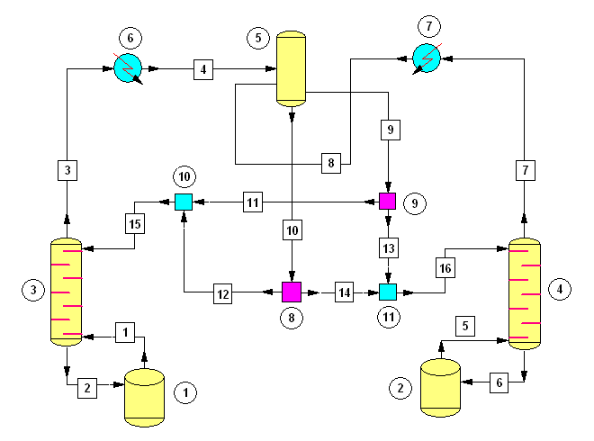
Fig.1. The ChemCad model of the new double-column configuration
  - Simulation results
In each case the total number of theoretical stages (N) without the condenser, decanter and reboiler is 10 for both configurations. The separation is performed at atmospheric pressure. Both reflux and distillate (BR) are homogeneous. In the decanter (D=0.5 m) the volume of liquid phases are prescribed constant (after the start-up). The ratio of the volumes of the two phases is equal to that of the binary/ternary heteroazeotrope. The holdup of the plates is taken ~ 1 % of the initial liquid volume in the reboiler of the given column. In each case the amount of charge (U_{ch}) is 100 kmol and the prescribed purity of both products is 99.5 mol%. The calculations are started with dry plates and decanter.
For both configurations when an entrainer is applied there is an optimal amount of E for which the (total) duration of the production cycle is minimal. For the DCS the duration of the distillation in the two columns can be also influenced by the division of the total number of plates (N^{α}/N), total heat duty (Q^{α}/Q), and the amount of charge (U_{b}^{α}/U_{ch}). In this paper for each configuration we publish the results only for the optimal case with minimal duration. For the DCS this means that the prescribed purity is reached in both columns at the same time.
First the separation of a binary heteroazeotropic mixture (n-butanol - water) by the different configurations then that of a binary homoazeotrope (isopropanol-water + benzene as entrainer) is studied.

    - Separation of a binary heteroazeotropic mixture
Three different charge compositions are studied:
1. Homogeneous charge rich in n-BuOH (A), x_{ch,A} = 0.90
2. Homogeneous charge rich in water (B), x_{ch,A} = 0.01
3. Heterogeneous charge, x_{ch,A} = 0.30
The prescribed levels of the decanter: B-rich phase: 0.1676 m, A-rich phase: 0.6 m
      - Homogeneous charge rich in A
The (total) heat duty (Q) is10 MJ/min in each case. (The charge (feed) volume is 8.360 m³.) First the BR then the DCS will be studied, finally the two configurations will be compared.
In the BR in Step 1 A is produced as bottom residue (Table 1). (When in Step 1 we tried to produce B we did not reach the prescribed purity at all.) Step 2 is very short since the amount of distillate (B-rich phase) in Step 1 is very low (7.3 mol% of the charge) and the A-content of this distillate, which must be removed in Step 2, is also very low (1.2 mol %).
In column α of the DCS the heat duty and the amount of liquid to be distilled is much higher than in the other column due to the high content of A of the charge and because the B-rich phase purified in column β hardly contains A.
Comparing the two different configurations we can state that
-The duration of the process is shorter by 8% for the BR.
-However for the BR the amount of by-products is higher by 15%.
-The recovery of A is higher for the DCS (94.5 % instead of 89.9 %).
      - Homogeneous charge rich in B
The total heat duty: Q = 16 MJ/min in each case. (The charge volume is 1.874 m³.)
a.Batch rectifier
In the BR B is produced in Step 1 as bottom residue. (If in Step 1 we try to produce A the prescribed purity can not be reached at all.) Since in the charge the amount A is very low the bottom residue reached the prescribed purity of B before filling up the decanter. (The majority of A appears in the column hold-up.) Since the amount of distillate in Step 1 is zero there is no need for Step 2.
In the DCS (similarly to the BR) A of prescribed purity can not be produced at all, A accumulates in the hold-up. In column α the heat duty and the amount of liquid to be distilled is much lower than in the other column due to the low content of A in the charge.
Comparing the two different configurations we can state that
-The duration of the process is almost the same for the two different configurations (BR: 0.15 h, DCS: 0.18 h).
-The recovery of B is similar for the BR (97.57 %) and DCS (97.01 %).

Table 1. Optimal parameters and results for the binary mixture rich in A (N^{α}=N^{β}=5)
      - Heterogeneous charge
The total heat duty is Q = 12 MJ/min in each case. (The charge volume is 3.988 m³.)
Before the distillation the charge is separated into two liquid phases:
A-rich: U_{b}^{α} = 51.8 kmol x_{A} = 0.568 B-rich: U_{b}^{β} = 48.2 kmol x_{A} = 0.012
In the BR both components could be produced in Step 1. If A is produced first we get better results (Table 2). Step 2 is very short since the amount of distillate (B-rich phase) in Step 1 is low (20.4 mol% of the charge) and the A-content of this distillate, which must be removed in Step 2, is very low (1.2 mol %).
In the DCS the heat duty of column α (95.6 %) is much higher than in the other column due to the high content of B (43.2 mol%) whilst the B-rich phase purified in column β hardly contains A (1.2 mol%). In this case the charge must be divided almost half-and-half between the two reboilers.
Comparing the two different configurations we can conclude that
-The duration of the process is slightly shorter (by 5%) for the BR.
-However for the BR the amount of by-products is higher (9.2 % vs. 7.6 %).
-The recovery of A is higher for the DCS (89.4 % instead of 82.7 %).

    - Separation of a binary homoazeotrope by using an entrainer
The total heat duty is 12 MJ/min in each case. (The volume of the charge is 5.690 m³.)
The charge composition studied is that of the binary homoazeotrope isopropanol (A)-water (B): x_{ch,A}=67.4 mol%. The prescribed levels of the decanter: B-rich phase: 0.0384 m, E-rich phase: 0.6 m.
For the BR the optimal amount of E by which the duration of Step 1 (determining primarily the duration of the production cycle) is minimal: 4.2 kmol (0.371 m³). In Step 1 A is produced (Table 3). The duration of this step is much longer than that of Step 2. Though the amount of distillate (B-rich phase) in Step 1 is not too low (36.4 mol% of the charge) but the E-content of this distillate, which must be removed (together with A) in Step 2, is very low (0.35 mol %). In Step 2 B is purified not only from E but also A in the form of binary azeotrope A-B whose A-content is relatively high.
For the DCS the optimal division of the total number of plates is rather unequal. (In all binary cases studied the influence of the division of the plates is slight on the results.)
Table 2. Optimal parameters and results for the binary heterogeneous mixture (N^{α}=N^{β})

Table 3. Optimal parameters and results for the ternary mixture (N^{α}=4N^{β})
The optimal amount of E: 3.9 kmol. The total amount of E is filled in reboiler α. The heat duty in column α (92.2 %) is much higher than in the other column. The A-content of the top vapour of column β is relatively high. In this case 77% of the charge must be filled in the reboiler α.
Comparing the two different configurations we can conclude that
-The duration of the process is slightly shorter for the DCS
-The recovery of both components is somewhat higher for the DCS.
The evolution of liquid compositions in the reboilers for both configurations is shown in Fig. 2.
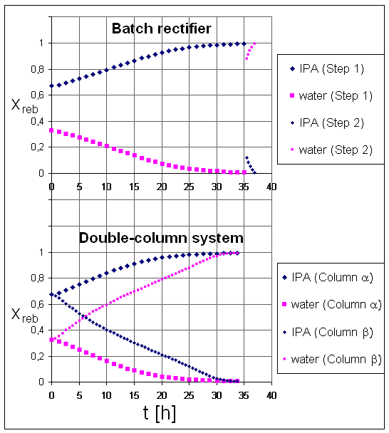
Fig. 2 The evolution of liquid compositions in the reboiler(s) (ternary mixture)
  - Conclusion
We investigated a new double-column batch heteroazeotropic distillation configuration by rigorous simulation using a dynamic simulator. We compared the performance of the new configuration with that of the conventional batch rectifier. For the new configuration we determined the minimal operational time. The simulations were performed for a binary (n-butanol - water) and for a ternary heteroazeotropic mixture (isopropanol – water + benzene). According to the results of feasibility studies the new double column system (DCS) proved competitive with the batch rectifier (BR). For the binary mixture DCS gave similar and for the ternary one better performance than the BR. Because of its performance and simple operation DCS appears to have high potential and deserves further investigations (further mixtures, closed loop control etc.).
References
Chemstations, (2007). CHEMCAD user guide.
Lang P., F. Denes and X. Joulia, (2008). New configuration for hetero-azeotropic batch distillation: I. Feasibility studies, ESCAPE-18, Lyon, France.
Modla G., P. Lang and K. Molnar, (2001). Batch Heteroazeotropic Rectification.... 6th World Congress of Chemical Engineering, Melbourne, Australia (10 pages on CD).
Modla G., P. Lang , B. Kotai and K. Molnar, (2003). Batch Heteroazeotropic Rectification of a Low Relative Volatility Mixture, AIChE Journal, 49 (10), 2533.
Prosim SA. http://www.prosim.net (2005).
Pommier S., S. Massebeuf, B. Kotai, P. Lang, O. Baudouin , P. Floquet, V. Gerbaud (2008). Heterogeneous Batch Distn Processes: Real System Optimisation, CEP, 47, 408-419.
Rodriguez-Donis I, V. Gerbaud and X. Joulia, (2002). Feasibility of Heterogeneous Batch Distillation Processes, AIChE Journal, 48 (6), 1168.
Rodriguez-Donis Y., J. A. Equijarosa, V. Gerbaud and X. Joulia, (2003). Heterogeneous Batch-extractive Distillation of Minimum Boiling Azeotropic Mixtures, AIChE J., 49 (12), 3074.
Skouras S., V. Kiva and S. Skogestad, (2005a). Feasible separations …Chem Eng Sci, 60, 2895.
Skouras S., S. Skogestad and V. Kiva, (2005 b). Analysis and Control of Heteroazeotropic Batch Distillation, AIChE Journal, 51 (4), 1144-1157.

