Role of discrete simulation in refinery offsites design
Régis
Advanced Systems Engineering (ASE)
TECHNIP FRANCE
92973 PARIS LA DEFENSE Cedex
FRANCE
Abstract
Until now, the method for designing and sizing refinery offsite facilities was based on cumulated experience of the process engineers, on mathematical reasoning and on arithmetical calculations in which only global problem parameters were considered. Typically, the throughput of process units, the average size of parcels, the frequency and maximum delay of exports or imports, the frequency and duration of process units shutdowns (turnover) were used in the calculations to determine the minimum acceptable storage capacity for each product family, the in-line blender occupancy rate or the maximum available time to execute field tasks.
Mainly because of the increasing financial pressure to minimize refining costs, offsite facilities must now be designed (or re-engineered) in the optimum way, reducing CAPEX and OPEX to the minimum for the considered business case. To achieve this objective, calculations based on averages are not accurate enough. Detailed parameters, such as the actual pattern of the imports and exports (multi-product ships, operational constraints on export pipelines…), the statistical distribution of the delay of their execution or the storage capacity saving derived from in line certification of the product quality, must be taken into account in the design.
Recent progress in discrete simulation combined with statistical calculations allows to confirm whether the design of offsite facilities is in line with the business objectives and that the refinery logistics flexibility will be preserved to capture market opportunities or to face unusual situations.
The present article gives an example of a design method, based on discrete simulation and statistics calculations, to quantify the robustness of the design of refinery offsite facilities, to confirm the profitability of an investment or the feasibility of refining business changes.

Keywords: Refinery, Offsite, Simulation, Design.

  - Preamble
Using games-like techniques to improve the design of refineries offsite and logistics is becoming more and more frequent. Among experienced project (or process) engineers, the ambition could probably be explained by psychoanalysts, as a primitive instinct to a second childhood, breaking the routine of laborious traditional methods. Young engineers, who intensively played electronic games when teenagers, may want to challenge, in their professional life, the remarkable performances of the latest software game technologies. More generally, the current image based culture is pulling designers activities towards an easy thinking and fancier world, freed from laborious reasoning.
Wouldn’t it be exciting to design refinery offsite just by playing a game with a smart and fancy software? Wouldn’t it be easy for process engineers to demonstrate the offsite operating flexibility by using real-time visual animations of interactive software games?
Obviously, most of the innovating design engineers and technology addicts will say ‘Yes’ and this is probably where our discipline goes. Even if “Ancestors’” rules of thumbs may still be used for long times, recent progress in software simulation started paving the way of a computerized design method.
  - Traditional method for designing refinery offsite
    - Gathering design bases
The starting point for designing refinery offsite consists in gathering basis information such as the refining scheme and material balance, the process units throughput in the various operating modes (ex: maximum kerosene, maximum diesel…), the typical import-export pattern, the local regulatory constraints, requirements for minimum product inventory, the refinery location and the targeted market. External operating constraints such as the requirements for sharing import-export facilities with neighbors are taken into account to evaluate the number and characteristics of dedicated facilities.
The number of blend grades, the seasonality and the requirements for quality certification are also assessed since these parameters significantly impact the design of in line blenders (number and capacity) and products storage facilities. Continuous blending in which process unit rundowns are directly mixed in inline blenders is a process that, subject to checking the feasibility of the control scheme, allows reducing the storage requirements of the components. However, process units turnover and shutdown scenarios must be carefully studied to ensure the overall operability of the refinery with reduced storage capacity of intermediate products.
    - Designing offsite facilities
The method itself is a process static study, based on the designers’ cumulated experience, on mathematical reasoning and on elementary arithmetical calculations in which global problem parameters are considered [3].
The number and the capacity of tanks are estimated based on the expected filling and emptying patterns. The capacity of import-export facilities is derived from the import-export patterns in order to minimize ships waiting times and risks of production stoppages due to storage capacity shortages. The capacity and type of blending facilities are determined according to the production objectives. The reasoning becomes increasingly complex and subject to critics if many and various constraints are taken into account (e.g. : discontinuous production, varying vessels inter-arrival time, off spec products…).
    - Power and limitations of reasoning
The static process study is the cornerstone of the offsite facilities design since no software system is available on the market to provide suitable offsite design without intellectual effort. This method gives good results and has been used for years. To be on the safe side and provide operators with acceptable flexibility, designers consider spare storage capacities or prefer to slightly over design the facilities. Obviously, designers and users have no other choice than bearing the cost of the possible over design. Because of the increasing financial pressure on CAPEX reduction, the risk of over design needs to be quantified and software simulation can help in this.
  - Offsite operations simulation
The simulation of offsite operations has recently been facilitated by the emergence of powerful simulation software. Initially suitable to manipulate discrete parcels, they have been since enhanced to allow for modeling continuous processes and can be run on fast personal computers.
    - Simulation and visual animations
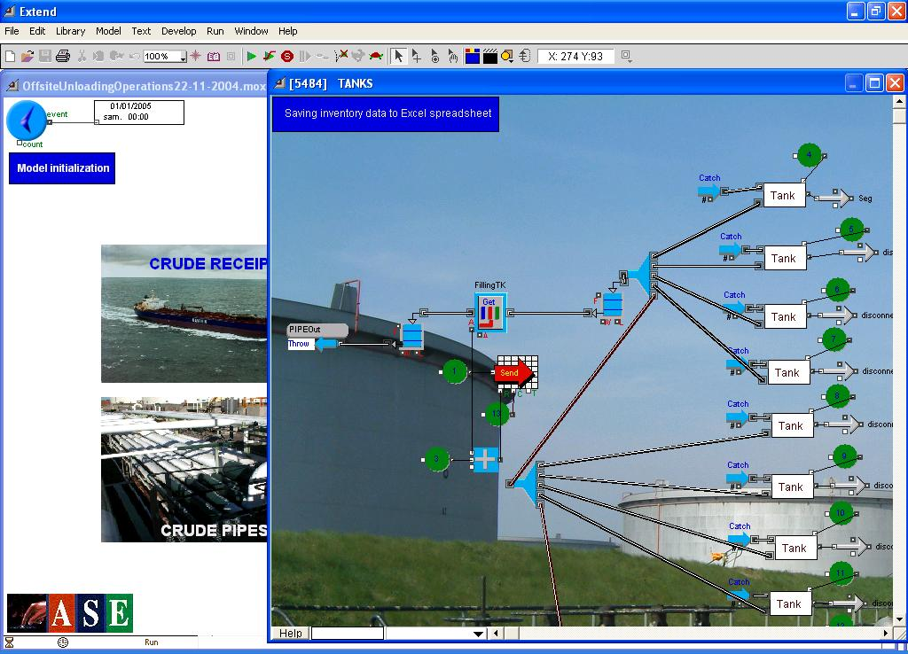
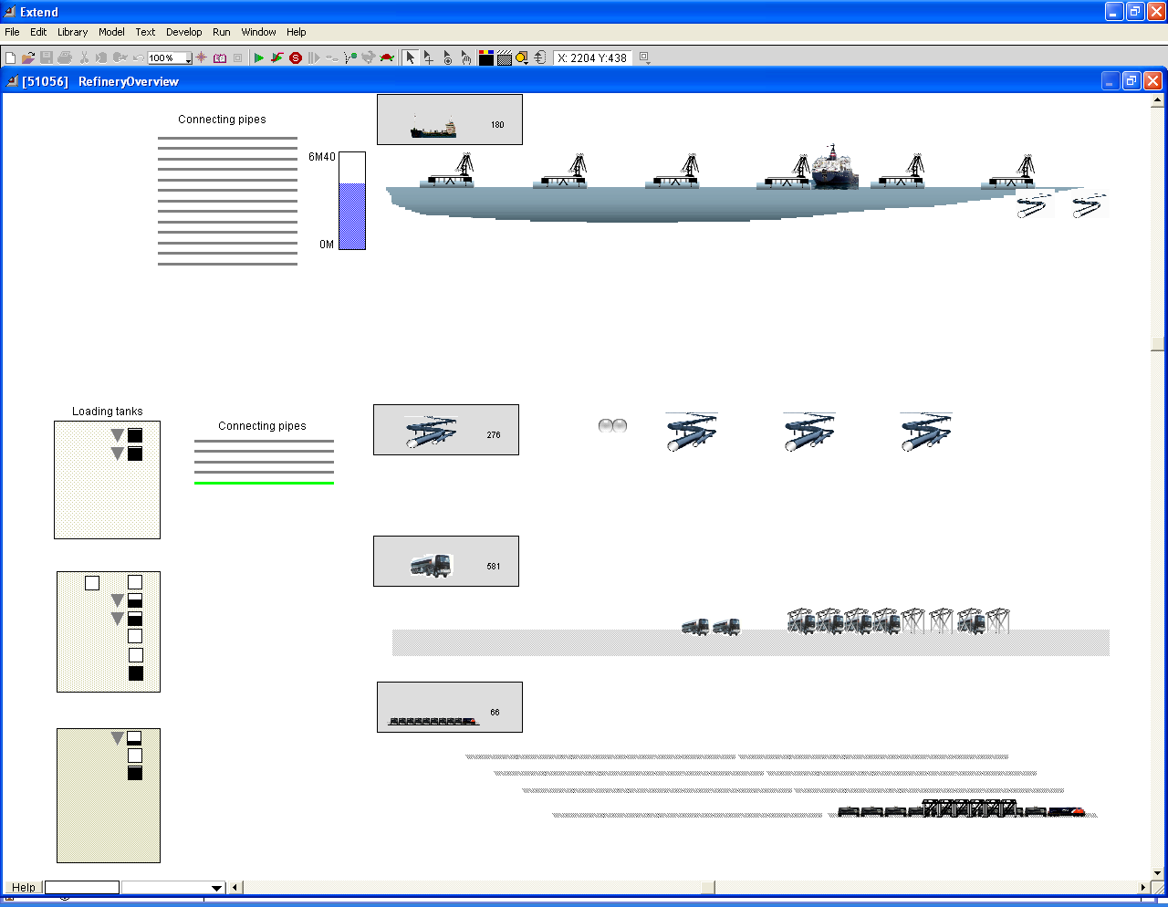
Software simulation environments provide user friendly interfaces including real-time visual animations to check whether the process behaves as expected. Visual animations are obviously good vectors of information for those Managers and Engineers not interested in each and every detail. After plant commissioning, visual animations also facilitate operators training or providing information to whomever is interested .
Figure 1: Simulation model overview and detailed view
For the offsite designers, understanding why abnormal situations occur is impossible from visual animation because of the complexity of the modeled processes and sequences of events. Detecting model errors often requires a detailed analysis of the simulation database at each simulation step. Besides nice and fancy visual animations, discrete simulation software environments like TECHNIP ASE OFFSIZER-ie provide multitude of information related to the execution of offsite operations.
    - Challenges for a relevant and meaningful simulation
The main challenge of the simulation is the definition of its scope in terms of facilities and product carriers, of processes, of disturbances, of time span and production mode. The refinery operation being extremely complex and conducted by multiple parties including planners, schedulers, operators, quality controllers, it is obviously excluded to consider simulating all facilities and processes in all production modes. Disturbances can occur at all levels of the processes. They can be random or predictable. They can alter the production in different ways. Conversely, simulating the operation of only a few of the facilities, simplifying too much the reality of the operating processes or using a too short simulation time span definitely lead to erroneous conclusions on the suitability and robustness of the considered offsite design.
    - Facilities and product carriers
Potentially, refinery facilities to be modeled include storage areas, interconnecting lines, blending systems, jetties, berths, loading arms, rail and road loading stations, pipeline terminals. Product carriers include sea vessels, trains, trucks, import-export pipelines. In some circumstances, it may be required to model facilities and processes that are not in the design scope but that could be existing already or shared with third parties. The decision to model one or another facility must be carefully made, depending on the simulation objective and on facilities interlinks.
    - Offsite processes to be modeled
Potentially any of the offsite processes can be modeled, including import-export operations, in line blending, product transfers between storage areas, finished products quality certification. A proper selection must be made to meet the simulation objectives.
    - Disturbances
Once the processes have been selected for simulation, the main disturbances that may affect them must be identified and modeled. Typical disturbances usually include bad weather, rivers flooding, vessels arrival delays [2, 4]. Decisions on configuring disturbances are made according to their anticipated impact on the processes. Each disturbance must be qualified in terms of frequency of occurrence and stochastic distribution. Once a model has been validated and provides relevant results, other disturbances can be added to demonstrate whether or not the flexibility of the considered design is acceptable.
    - Simulation time span
The simulation time span must be chosen so that the related production pattern, imports-exports patterns and disturbances patterns are consistent with the simulation objective. Should a very large export of a certain product typically occur every three weeks, selecting a four weeks simulation period will most probably be too short. Experience proves that selecting a simulation time span three to four times larger than the slowest reproducible event is sufficient.
    - Production modes
Most of the refineries are designed to handle different production modes such as maximum kerosene, maximum gas oil. In some cases, the simulation of the same period of time in each of the production modes may be required to confirm the design. Each of these production modes will have its own material balance and import-export pattern.
    - Evaluating the accuracy and relevance of the simulation
Once a simulation period and a production mode have been selected, a strategy to evaluate and estimate the accuracy and relevance of the simulation is to build up a model, to run it so that preliminary conclusions can be derived, to refine it by implementing new operating processes or disturbances expected to impact the conclusions and to run the simulation again with the same input data. The comparison between the conclusions derived from various models generally provides a good indication on the quality and accuracy of the model.
  - Deriving conclusions on the offsite design from simulation
Deriving conclusions from simulation requires running a model and performing statistical calculations on the model outputs. In the real world, the plant activity never reproduces identical mainly because of random disturbances. To account for this variability, the simulation is run several times, each run being characterized by a random combination of the modeled disturbances. The various simulation outputs are computed and histograms are built to characterize the robustness of the designed offsite. A sensitivity analysis allows for determining the impact of model parameters changes. For example, an analysis may allow for quantifying the benefit of smoothing the lifting pattern or reducing the uncertainty of the ships arrival time. More generally, the statistical calculation allows for quantifying the ‘cost’ and ‘benefit’ of various solutions (e.g.: adding new tanks [1]) and helps in identifying possible sources of operations margin increase.
    - Simulation output
A lot of information can be obtained from simulation to confirm or infirm the offsite design. Care will always have to be taken when interpreting the statistical results since they depend on the quality of the inputs.
      - Products inventory
The graphs below, obtained with TECHNIP ASE OFFSIZER-ie simulation environment, show the possible variation of Diesel (left side) and Gasoline 90 (right side) inventory for 30 simulation runs on a 4-month time span for a complex, medium size refinery.
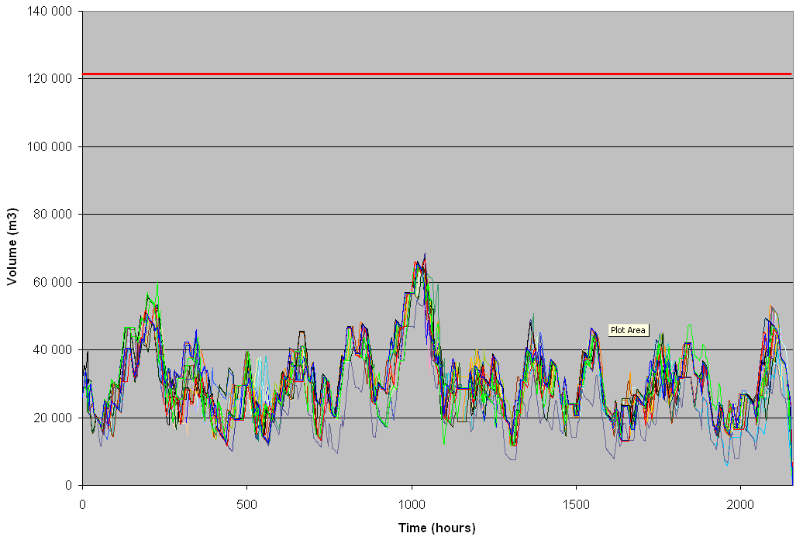
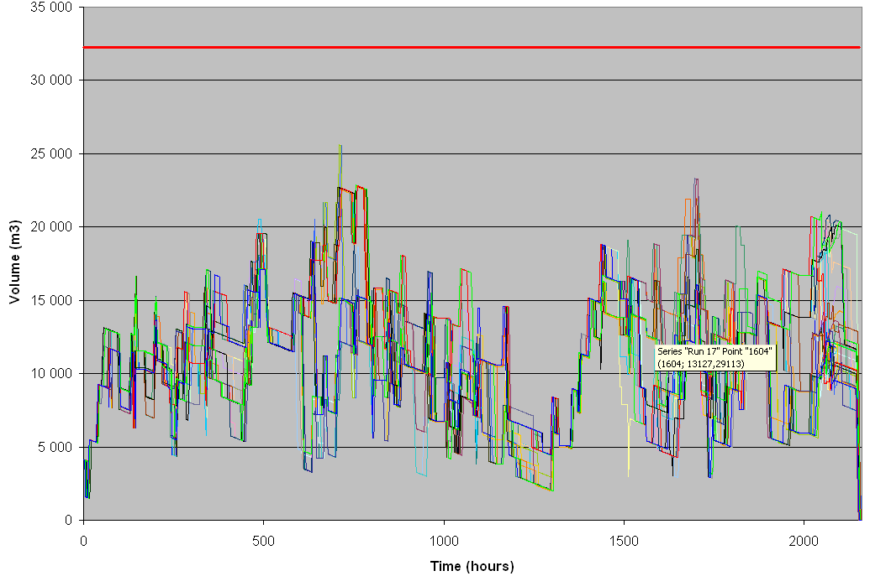

Figure 2: Example of simulation results (product inventory variation).

The storage capacity (red line) appears to be oversized for Diesel whereas it seems to be acceptable for Gasoline 90.
To confirm the over sizing of the diesel pool, multiple offsite configurations can be considered with reduced diesel storage capacity (ex: decommissioning a diesel tank or switching a big diesel tank to a smaller tank from another pool in the case of offsite re-engineering, reducing a diesel tank size in the case of a grass root project). By running the simulation in each of these configurations, new inventory data sets are obtained. The comparison of the averages and standard deviations of the data sets allows to confirm whether the offsite configurations are acceptable and also to identify the most attractive configuration.
      - Import-export facilities occupancy
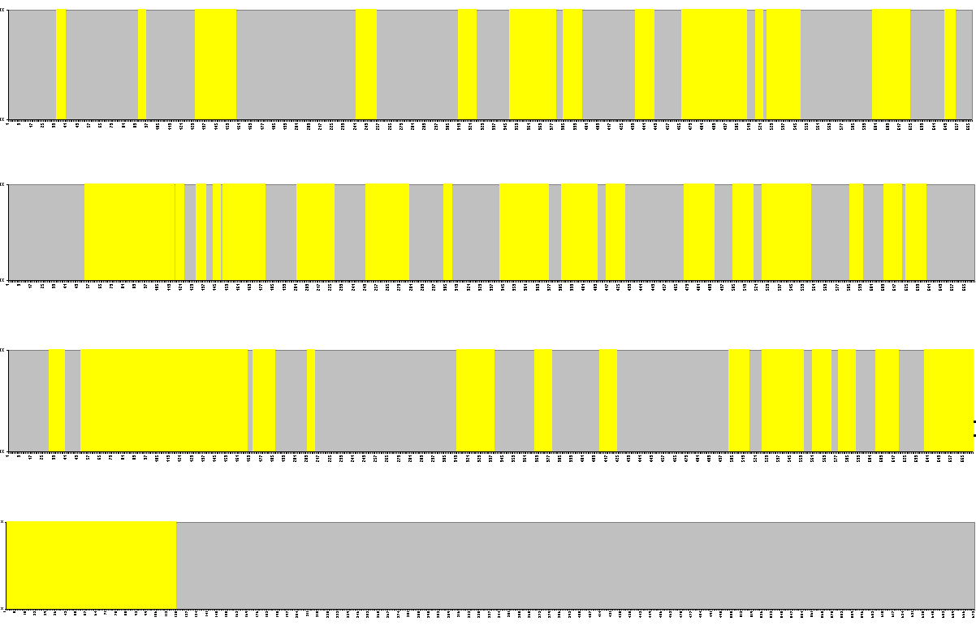
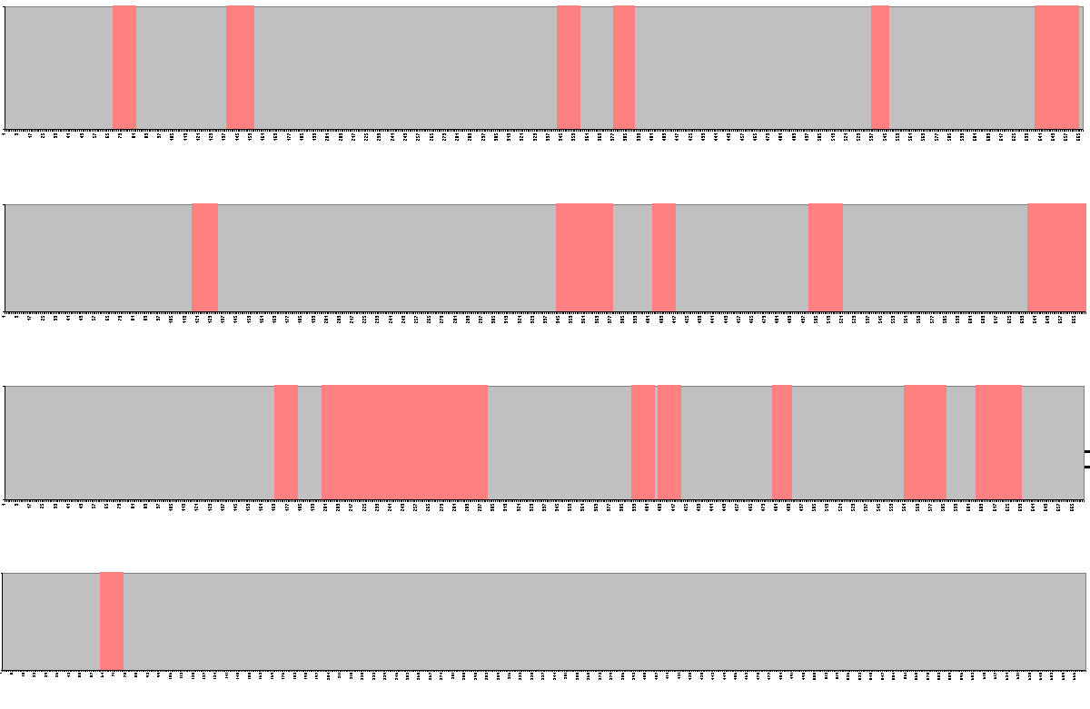
Examples of berths and pipelines occupancy graphs are given below for a 4-month time span generated with TECHNIP ASE OFFSIZER-ie.

Figure 3: Example of simulation result (berth and pipeline occupancy)

The berth is fully occupied during a few periods of time (yellow bars) while the average occupancy still remains acceptable. Similarly, the pipeline occupancy is quite low (pink bars) even if some constraints lead to utilizing the pipeline continuously during relatively long periods.
      - Ships waiting time
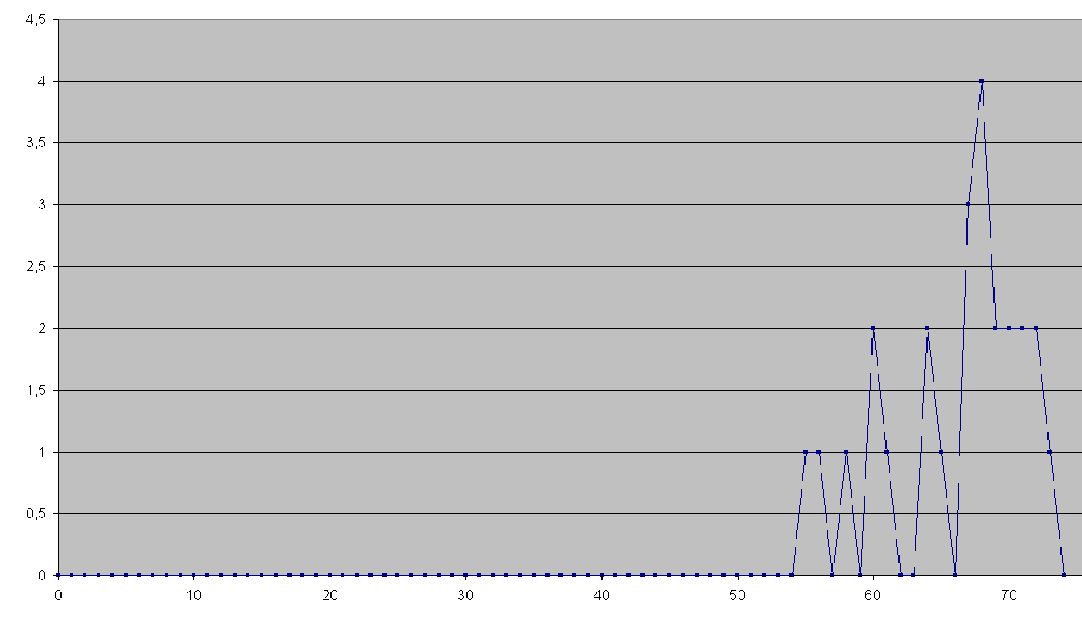
The following ships waiting time distribution shows that, out of 30 simulation runs, 4 runs showed 67 ships waiting out of 186. To improve this, the Engineer will have to change the design, simulate it and build the histogram to quantify the improvement.

Number of runs

Figure 4: Ships waiting time distribution
  - Conclusion
The oil refining margin does not only depend on the process units’ performance. It also depends on the utilities and offsite’s performance. In particular, flexible and optimized offsite facilities allow for capturing additional profit margins to compensate the limitations of the refining scheme.

Consequently, there are many incentives to properly design or re-engineer the refinery logistics and to make the offsite operations more flexible at minimum cost. This optimization can be achieved by static engineering studies. However, recently available discrete simulation techniques allow to better quantify the robustness of the design and better understand the limitations of facilities and operations.
References
[1] N. Julka, I. Kamiri, R. Srinivasan, ELSEVIER Computers & Chemical Engineering, Agent-based supply chain management, July 2002
[2] G. Chryssolouris, N. Papakostas, D. Mourtzis, ELSEVIER Computers & Chemical Engineering, Refinery short-term scheduling with tank farm, inventory and distillation management: An integrated simulation-based approach.
[3] P. Delauzun, R. Rieubon, 3rd Russia and CIS RPBC, Offsites logistics optimization, April 2005.
[4] Lee Ying Koo, Arief Adhityia, Rajagopalan Srinivasan, 2006 Winter Simulation Conference, Evaluating Refinery Supply Chain Policies and Investment Decisions through Simulation – Optimization.

