Excipient Interaction Prediction: application of the Purdue Ontology for Pharmaceutical Engineering (POPE)
Leaelaf Hailemariamª, Pradeep Sureshª, Venkata Pavan Kumar Akkisettyª, Girish Joglekar^{b}, Shuo-Huan Hsu^{b}, Ankur Jain^{e}, Kenneth Morris^{c}, Gintaras Reklaitisª, Prabir Basu^{d} and Venkat Venkatasubramanianª

ªSchool of Chemical Engineering, Purdue University, West Lafayette IN 47907 USA
^{b}Discovery Park, Purdue University, West Lafayette, IN 47907 USA
^{c}Department of Industrial and Physical Pharmacy, Purdue University, 585 Purdue Mall, West Lafayette, IN 47907 USA
^{d}National Institute for Pharmaceutical Technology and Education, Purdue University, 315 Hovde Hall, 610 Purdue Mall, West Lafayette, IN 47907 USA
^{e}Enterprise Optimization, United Airlines, Chicago, IL 60007 USA
Abstract
A drug product consists of a drug substance and one or more excipients that play specific roles in rendering desired properties to that product, from improvement of flow to control of the release of the drug substance. Inter-excipient and drug substance-excipient chemical reactions are to be avoided and formulators often use heuristics and past experience to avoid potential interactions during drug product development. Multiple tools are present to mechanistically predict chemical reactions: however their utility is limited due to the complexity of the domain and the need for explicit information. In this work, the Purdue Ontology for Pharmaceutical Engineering (POPE) was used to develop an excipient reaction prediction application that made use of structural, material and environmental information to predict reactions

Keywords: Excipient Interaction, Product Development, Ontology, Rule Language
  - Introduction

A drug product includes the drug substance along with compounds that enhance processing and effectiveness, called excipients, which perform such functions as improvement of flow or increase of tablet mass. The drug product is expected to be chemically stable to avoid formation of toxic compounds and loss of the drug substance: however reactions between the drug substance and excipients and amongst the excipients are possible. These interactions may be avoided by careful design based on experience, rigorous experimentation or using software packages to predict reactions. These packages include mechanistic tools and knowledge-based reaction prediction tools. Mechanistic tools that have been developed to predict reactions include the CAChe WorkSystem (see URL) and SPARTAN (see URL). Knowledge-based systems include reaction predictors like ROBIA (Reaction Outcomes By Informatics Analysis) (Socorro et al, 2005) and the LHASA (Logic and Heuristics Applied to Synthetic Analysis) software (see URL). However, the current solutions to chemical reaction prediction have several limitations. Secondary and tertiary interactions are rarely considered and there is little work on chemistry reasoning which is valuable for chemical stability analysis but would require an explicit information model. In addition, there is little scope for integration of the reaction information (which might describe conditions in microsolutions found between solid particles) with the solid information.

In this work a prototypical reaction prediction system which makes use of known reaction information, the molecular structure of reactants and structural and environmental information, like the backbone of the molecule and the reaction pH, is presented. First the POPE ontology, which includes descriptions of the material, chemical reaction and structure descriptors, is briefly presented. The next section is dedicated to the description of the prototype reaction prediction system, followed by application examples. The last section discusses other potential applications of the ontological approach and future work.
  - Introduction to the Purdue Ontology for Pharmaceutical Engineering

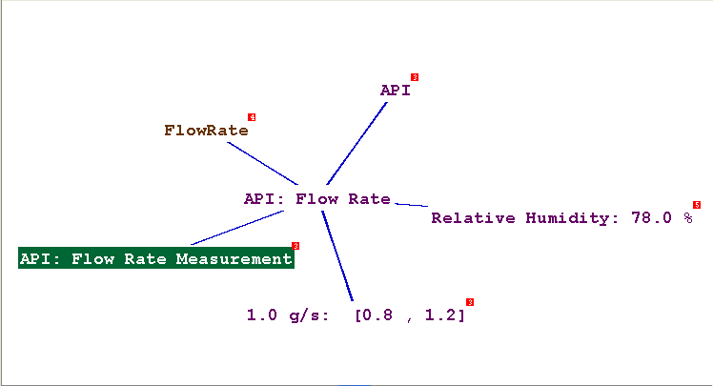
Several options exist for the explicit representation of information. XML (eXtensible Markup Language: see URL) is one. XML does not have a fixed set of tags but allows users to define tags of their own, much like the English language versus Chemistry or Biology. An example of XML Schema (glossary) examples is the Chemistry Markup Language (CML: see URL) for molecule information. XML does not provide any means of defining the semantics (meaning) of the information. The needs for explicit expression and capture of semantics are met by ontologies, which are defined as follows: “An ontology defines the basic terms and relations comprising the vocabulary of a topic area as well as the rules of combining terms and relations to define extensions to the vocabulary.” (Gomez-Perez et al., 2004). For the pharmaceutical domain, the ‘basic terms’ could be a ‘material’ and a ‘material property’ and their relations could be ‘<material> has <material property>’. An example of a simple ontology is shown in Figure 1.
Figure 1: An ontology example

The powder flow rate (a material property) of the API (a material) has an average value of 1 g/s within the range of [0.8, 1.2]. The source of the reported value was the experiment ‘API: Flow Measurement’ at a given context (78% relative humidity) The collection of the different concepts e.g. material, material property etc and their relation e.g. has Value, comprise an ontology.

The Purdue Ontology for Pharmaceutical Engineering (POPE) was developed to address the information modeling needs mentioned previously. POPE includes several smaller interrelated ontologies; the Purdue Ontology for Material Entities (POME) which describes materials; the Purdue Ontology for Degradant Structures (PODS) which describes the chemical structure of materials with respect to molecular fragments; the Purdue Ontology for Reaction Expression (PORE) which describes the interactions between materials including chemical reactions; the Purdue Ontology for Material Properties (POMP) which describes the physical, chemical and mechanical properties of materials and the Purdue Ontology for Description of Experiments (PODE).

    - Material Ontology (POME)

There had been some work done to describe materials in an explicit manner including the Standard for the Exchange of Product Data STEP (ISO 10303) and OntoCAPE, which included descriptions of phases, chemical components and reactions (Yang and Marquardt, 2004). However, in the data models above, experiments and solid properties get little treatment. POME builds on the concepts defined by OntoCAPE and includes solid and pharmaceutical properties. The material is described in terms of its substance entity (environment independent) and its phase system entity (environment dependent: solid, liquid, vapor, mixtures) and its role in a mixture (e.g. for solids: flow aid, dilunt etc). The phase system would be described by the fraction and identity of the phases comprising it (phase composition). Each phase would have a chemical composition, which describes the species and their relative abundance in the given phase as well as the environmental conditions e.g. temperature, pressure. For instance, the antibiotic Seromycin ® is manufactured as a tablet which may include several components like Cycloserine and Magnesium Stearate. The tablet is a solid mixture; the phase composition including phase, substance and amount information (e.g. Cycloserine: Solid: 83% m/m) and the role of Cycloserine being an Active Pharmaceutical Ingredient (API). The chemical composition describes a pure component. The substance aspect includes molecular structure information e.g. as a SMILES string (NC1CONC1=O).

    - Degradant Ontology (PODS)

Previous work on representation of chemical structures includes the EcoCyc Ontology (http://ecocyc.org/) for metabolites and the Chemical Markup Language (CML) among others. Ontologies developed to describe molecules include those by Feldman et al (2005) and Villanueva-Rosales and Dumontier (2007). PODS builds on the above for the pharmaceutical domain by making use of common molecular fragments (shown in Figure 2). Each fragment is part of a ‘fragment-entity’ which might participate in a reaction and is connected to (or identified as) a backbone group. For Cycloserine, the fragment entities include a five- member ring, two amine groups and a carbonyl group. PODS can be coupled with the PORE to represent chemical systems and with POME to describe a material during product development.

    - Reaction Ontology (PORE)

The concept of a reaction may include physical and chemical changes. Some work had been done previously to model chemical reactions including the EROS (Elaboration of Reactions for Organic Synthesis) system (Gasteiger et al, 2000) and work by Sankar and Aghila (2006). PORE was developed to represent reactions as interactions between functional groups/phase systems. Each reaction would have a reaction_context, which describes the pertinent descriptors of the reaction e.g. at what temperature it occurs, at what pressure, pH etc. For instance, the context for Cycloserine hydrolysis captures the temperature (60⁰C), pH range (1-7) and phase (liquid). Several restrictions such as the requirement of at least one reactant and one product for a reaction were put in place.

    - Property Ontology (POMP)

Previous work on explicit modeling of material properties includes CAPEC (Sousa et al, 1999) and OntoCAPE (Yang and Marquardt, 2004). POMP extends the properties in OntoCAPE to include interproperty relations and solid material properties. The property structure includes generic properties like heat, mass and momentum transfer properties (e.g. heat capacity, diffusivity and density respectively) as well as a separate description for solid properties. Solid properties were described at three levels; substance properties (pertaining to the molecular level e.g. molecular structure), particle properties (pertaining to single crystals or amorphous particles e.g. unit cell dimensions) and powder (bulk) properties (e.g. particle size distribution). Each property value would be correlated to a set of environmental conditions during measurement (e.g. temperature, pressure) and a source (experiment, mathematical model or literature).

    - Experiment Ontology (PODE)

Noy and Hafner (2000) developed a representation of molecular biology experiments using ontologies. Hughes et al (2004) developed a laboratory ontology which captured the relationship between materials and processes through a hierarchy of actions. PODE links experiments to material properties. Experiments have some generic characteristics which include the time and place of the experiment as well as the experimenters. Equipment and experimental procedures were modeled as a collection of actions, which could be observation /measurement actions, processing actions or operation actions. For instance the measurement of Cycloserine bulk density involves a specific experimental procedure (put powder on top of sieve: (processing action); turn on sieve (operation action); observe powder volume (observation step)).
  - Prediction of reactions between drug product components

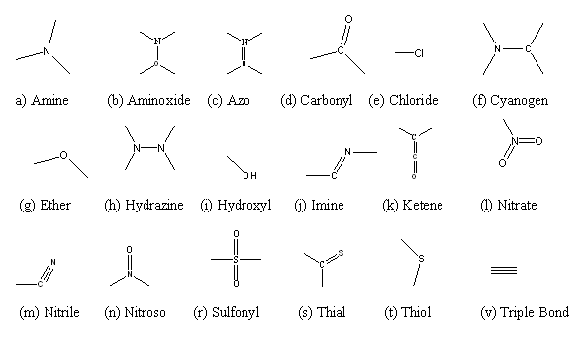
POPE had previously been used to support a decision support system for pharmaceutical product development and modeling of solid unit operations (Venkatasubramanian et al, 2006). In this application, reactions between the drug substance and the excipients are predicted through the following steps. A survey of the drug degradation domain was made and a set of common molecular fragments are collected as in Figure 2. Once the chemical structure of the new drug substance is known, the active fragments are sought through the Chemistry Development Kit (CDK) tools.
Figure 2: List of molecular fragments

Reactions involving the identified active fragments are sought from among the reaction ontology instances which describe the participant active fragments. For user input including the molecular structure (described by PODS) and reaction conditions, the relevant reactions are returned. The reaction conditions would include the environment (temperature, pressure, pH: captured by PORE), phase information (described by POME and POMP) and reported experiment procedure (captured by PODE). The ontology was coded using OWL (Web Ontology Language) using the Protégé 3.3 interface. Search was performed using the Semantic Web Rule Language (SWRL) plug-in of Protégé. The reaction database is populated from free online databases from SigmaAldrich® and Metasynthesis®. A schematic representation is shown in Figure 3.

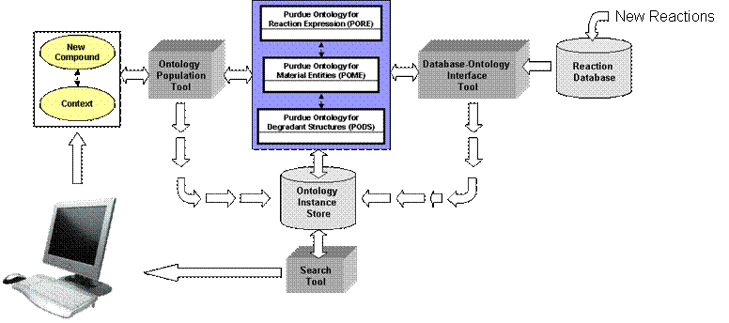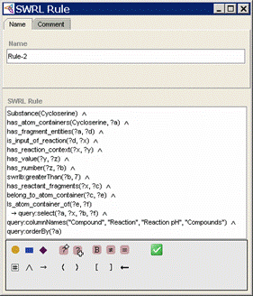
(a) (b)
Figure 3: Reaction prediction system (a) overall scheme (b) SWRL input

The system was used to predict reactions for several drug compounds. For instance, the system correctly predicted the hydrolysis, oxidation and isomerization of Cycloserine based on the compound’s similarity to γ-Butyrolactone hydrolysis, Imipramine hydrochloride oxidation and Pilocarpine epimerization. Knowledge of the possibility of Cycloserine oxidation may exclude the use of Crospovidone, which has hydrogen peroxide, a strong oxidizing agent, as a common impurity. Capturing multiple types of information, possible through the ontological approach, is useful for interaction prediction in pharmaceutical product development.
  - Summary

The Purdue Ontology for Pharmaceutical Engineering (POPE) was developed with its component ontologies for descriptions of materials, chemical structures, reactions, material properties and experiments. Based on POPE an excipient interaction prediction/diagnosis application which made use of structural and environmental information was presented. There are several challenges in the horizon, which include the consideration of rates of reaction to determine relevance and evaluation of multiple measures of molecular similarity.
Acknowledgements

The work was done through the financial support of the Engineering Research Center for Structured Organic Particulate Systems (ERC-SOPS), the Indiana 21st Century Fund and Eli Lilly and Company. The authors thank Balachandra Krishnamurthy and researchers at Lilly Research Laboratories (Henry Havel, Brian Good, Gus Hartauer, Steve Baertschi, Ahmad Almaya, Aktham Aburub, and David Long) for their support.
References

S. Baertschi (2005) Pharmaceutical Stress Testing: Predicting Drug Degradation in Drugs and the Pharmaceutical Sciences, Vol. 153, Taylor and Francis Group, Boca Raton FL.

Cache: http://www.cache.fujitsu.com/

CML: http://www.xml-cml.org

H. J. Feldman, M. Dumontier, S. Ling,., N Haider, C.W.V. Hogue (2005) CO: A Chemical Ontology for Identification of Functional Groups and Semantic Comparison of Small Molecules, FEBS Letters, 579, 4685-4691.

J. Gasteiger, M. Pförtner, M. Sitzmann, R. Höllering, O. Sacher, T. Kostka, N. Karg (2000) Computer-assisted synthesis and reaction planning in combinatorial chemistry, Perspectives in Drug Discovery and Design, 20, 245–264.

A. Gomez-Perez., M. Fernandez-Lopez, O. Corcho. (2004) Ontological Engineering: with examples from the areas of knowledge management, e-Commerce and the Semantic Web. Springer-Verlag London.

G. Hughes, H. Mills, D. de Roure, J. Frey, L. Moreau, M.C. Schraefel, G. Smith, E. Zaluska (2004) The semantic smart laboratory: a system for supporting the chemical eScientist, Organic and Biomolecular Chemistry, 2, 1-10.

LHASA: http://www.lhasalimited.org

N. Noy, C. Hafner (2000) Ontological foundations for experimental science knowledge bases, Applied Artificial Intelligence, 14, 565-618.

N. Pandit (2007) Introduction to the pharmaceutical sciences Lippincott, Williams and Wilkins, Baltimore, MD.

P. Sankar, G.J. Aghila (2006) Design and development of chemical ontologies for reaction representation, Journal of Chemical Information and Modeling, 46, 6, 2355-2368.

I.M. Socorro, K. Taylor and J.M. Goodman (2005) ROBIA: A Reaction Prediction Program, Organic Letters, 7, 16, 3541-3544.

SPARTAN : http://www.additive-net.de/software/spartan/index.shtml

V. Venkatasubramanian, C. Zhao, G. Joglekar, A. Jain, L. Hailemariam, P. Suresh, V. Akkisetty, K. Morris, G.V. Reklaitis (2006) Ontological Informatics Infrastructure for chemical product design and process development, Computers and Chemical Engineering, CPC 7 Special Issue, 30(10-12), 1482-1496.

N. Villanueva-Rosales, M. Dumontier (2007) Describing chemical functional groups in OWL-DL for the classification of chemical compounds, OWL: Experiences and Directions (OWLED 2007), co-located with European Semantic Web Conference (ESWC2007), Innsbruck, Austria.

XML: http://www.w3.org/XML/

A. Yang, W Marquardt (2004) An Ontology-based Approach to Conceptual Process Modeling In: A. Barbarosa-Póvoa, H. Matos (Eds.): European Symposium on Computer Aided Process Engineering -14, 1159-1164.

Corresponding author: venkat@ecn.purdue.edu

