Batch Scheduling With Intermediate Due Dates Using Timed Automata Models
Subanatarajan Subbiahª, Thomas Tometzkiª, Sebastian Engellª
ªProcess Control Laboratory (BCI-AST), Department of Biochemical and Chemical Engineering, University of Dortmund, 44221 Dortmund, Germany.
Abstract In the process industries, the problem of scheduling multi-product batch plants to satisfy the demand for various end-products within specified due dates occurs frequently. In contrast to the state-of-the art approach of using mathematical model formulations to solve such scheduling problems, an alternative approach is to use reachability analysis for timed automata (TA). In this paper, we discuss an extension of our earlier work on scheduling using TA models where the problem of makespan minimization was addressed. We extend the formulation to the meeting of due dates, modelled as causing additional costs (e.g. penalties for late delivery and storage costs for early production). The proposed solution by reachability analysis of priced timed automata is tested on a case study to demonstrate its successful application.

Keywords: Batch plants, scheduling, timed automata, reachability analysis.
  - Introduction
Multi-product and multi-purpose batch plants offer the advantage of increased flexibility with respect to range of recipes that can be handled and the production volumes compared to continuous plants. Batch scheduling is particularly difficult due to numerous constraints arising from the process topology, the connection between the pieces of equipments, inventory policies, material transfers, batch sizes, batch processing times, demand patterns, changeover procedures, resource constraints, timing constraints, cost functions and uncertainties. Particularly in batch plants, the problem of satisfying the demands of the various end-products within due dates occurs very often. Most of the solution approaches proposed in the last years solve such problems by modeling them by mathematical programming formulations (MILP or MINLP) and applying commercial solvers. In [8], the authors proposed a slot-based formulation with a continuous time representation which they showed to be suitable for network-based production schemes involving mass balances and product flows. The work presented in [7] proposed a MILP formulation in which the product stocks and mass balance constraints were ignored by fixing the batch sizes to discrete values. The formulation was tested on scheduling a real-life example which resulted in a model with reduced complexity and the results showed increased solution efficiency. The contribution [6] describes an extension of the previous work on continuous time formulations to deal with intermediate due dates with significant improvement in computational efficiency. However, the application of these approaches is hindered by the effort needed to formulate mathematical models and requires experience in algebraic modeling and a deep knowledge of the solver and its internal algorithms.
Recently, the approach to solve scheduling problems by reachability analysis for timed automata has gained great attention. The framework of TA has been originally proposed by [1] to model timed systems with discrete dynamics. User friendly tools (e.g. Uppaal [3], TAOpt [5]). have been developed to model and to analyze such systems. Previous work on the TA based approach to scheduling problems with makespan minimization on hard job shop benchmarks were reported in [2] and [5]. The particular appeal of this approach comes from the modular and partly graphical modeling which enables inexperienced users to build models. Another advantage is the availability of powerful search algorithms that can be modified and extended for special purposes. The primary objective of this work is to extend the TA based formulation to address the problem of scheduling batch processes with multiple release dates and intermediate due dates with the objective of minimizing tardiness. In the TA based approach the resources, recipes and additional timing constraints are modeled individually as sets of priced timed automata with costs for transitions and cost rates for staying in locations. The sets of individual automata are synchronized through synchronization labels and are composed by parallel composition to form a global automaton. The global automaton has an initial location where no operations have been started and at least one target location where all operations required to produce the demanded quantities of end-products within the specified due dates have been finished. A cost optimal symbolic reachability analysis is performed on the composed automaton to derive schedules with the objective of minimizing the overall cost incurred as the sum of costs due to transitions and the integral costs for staying in locations.
  - Test Problem
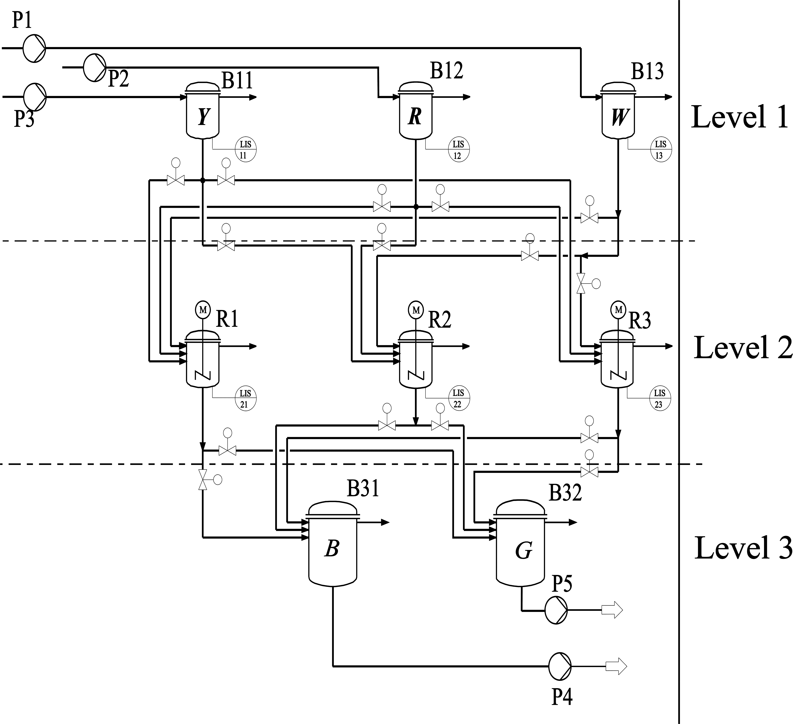
In order to illustrate the approach, a case study is considered. The case study is a multi-stage multi-product chemical batch plant demonstrator with a plant topology similar to flexible flow shops. Two recipes to produce the end-products are given. The end-products blue (B) and green (G) are produced from three raw materials, yellow (Y), red (R) and white (W). Each batch of the product results from two batches of the raw materials. The production process considered is: two batches of material Y and W reacts to produce one batch of Figure 1: P&ID of the multi-product batch plant product B ; similarly two batches of R and
W reacts to produce one batch of product G. The plant consists of 3 stages in which the first stage consists of three buffer tanks which are used to store the raw materials Y, R and W (see Fig. 1). The buffer tanks in the first stage may contain at most only two batches of the raw materials. The second stage consists of three reactors that perform the reaction process to produce the end-products. Each reactor can be filled from each raw material buffer tank in the first stage; implying that it is possible to produce either product B or product G in each reactor. After processing the materials, a reactor may contain at most one batch of the product. The third stage consists of two buffer tanks which are used to store the end-products B and G exclusively. Each of the buffer tanks has a maximum capacity to store three batches of the respective products. Operations once started should be finished without any interruption (non-preemptive scheduling). The production of one batch of a recipe (B or G) consists of 6 operations and involves timing constraints between individual operations. After the materials are processed by the reactors the end-products must be drained into the buffer tanks in the third stage immediately imposing a zero-wait constraint between the operations. We consider the task to produce 23 orders in total, 12 batches of product B and 11 batches of product G, for which 138 operations have to be scheduled. Each batch of raw material is released at different points of time and for every 3 batches of a product a due date has to be met. The release dates and the due dates are known in advance and a penalty cost is incurred for missing a due date. The objective is to produce the demanded amount of products with minimal penalty cost.
  - Background of Timed Automata
Timed Automata (TA) are finite state automata extended by the notion of clocks to model discrete event systems with timed behaviour. A timed automata is defined by a tuple, TA = ( L , C , Θ , inv , l₀ , F ) in which, L represents the finite set of discrete locations, l₀ , F $∈$ L , where l₀ represents the initial location and F represents the set of final locations. The set of clocks assigned to the TA are represented by C. The relation Θ $⊂$ L$ϕ$ActU(C)L represents the set of transitions between the locations where, $ϕ$ is a set of guards specified as conjunctions of constraints of the form c_{i}$⊗$n or c_{i} - c_{j}$⊗$n , where c_{i} , c_{j} $∈$ C, $⊗$$∈${≤ , = = , ≥ , < , >, } and n $∈$ N. The set of actions (e.g. invoking a new event or changing the value of a variable) while taking a transition is denoted by Act. U(C) represent the set of clocks that are reset to zero after taking the transition. inv represent a set of invariants that assign conditions for staying in locations. The invariant conditions must evaluate to true when the corresponding location is active and the automaton is forced to leave the location when the invariant evaluates to false. A transition between a source location l and target location l' with a guard g$∈$$ϕ$(C), performing an action a$∈$Act and resetting the clocks r$∈$U(C) is denoted by (l, g, a, r, l'). A transition can occur only when the guard conditions are satisfied. An extension of TA with the notion of costs is known as priced TA [4]. A priced TA is equipped with an additional function P : LΘ $→$R^{≥0} which assign cost rates to locations and costs to transitions. The cost of staying in a location with cost rate ċ for d time units is given by P(L) = ċ ∙ d .
The scheduling problem is modeled using the priced TA framework in a modular fashion. The resources, jobs and timing constraints are modelled as sets of priced TA. The interaction between the automata sets are established by synchronized transitions and shared variables. Two transitions are said to be synchronized when they have the same synchronization labels and the corresponding automata can only change their locations simultaneously. Such sets of automata are composed using parallel composition thereby forming one composed global automaton by considering the synchronization labels. The composed automaton represents the model of the complete system and a cost-optimal reachability analysis can be performed in order to derive schedules. The reachability analysis technique starts from the initial location of the composed automaton that represents the initial state of the system and evaluates the successor states created by a successor relation. This enumerative process is continued until the final target location specified is reached with minimal cost. In the search, branch-and-bound techniques are used in order to explore the solution space quickly.
  - Priced TA model
The idea of modeling the scheduling problem using priced TA is explained using a simple example process. Consider a process that consists of tasks T₁ and T₂ performed in resources R₁ and R₂, respectively. Let task T₁ be followed by T₂ and the time taken to perform T₁ be p₁ and T₂ be p₂. The process has a release date r_{i} and a due date d_{i}. A storage cost is incurred if the process is finished before the due date and a penalty cost is incurred for missing the due date. The basic principles of modeling the process using a priced timed automata is shown in Fig. 2. The automata on the left hand side model the process and the automata on the right hand side model the required resources. The upper automaton on the left models the release date and the operations, the due date with the penalty cost is modeled by the automaton below. Initially, the process automaton is in the location wait T₁ and wait dd representing that the process has not yet started. The release date r_{i} of the process is modeled by the guard c_{i} ≥ r_{i} . Once the guard is enabled and the resource R₁ is available, the first automaton can take the transition from wait T₁ to exec T₁ thereby allocating the resource and simultaneously making the resource automaton R₁ transit from idle to busy by the synchronization label α₁. The clock c_{i} is reset to measure the duration of the task T₁ modeled by the invariant c_{i} ≤ p₁ and the guard c_{i} ≥ p₁. After p₁ time units have elapsed the first part of the process automaton is forced to transit from location exec T₁ to wait T₂ modeling that task T₁ is finished and the process is waiting to perform task T₂. At the same time the resource automaton R₁ transits back from busy to idle representing that the resource is released by the synchronization labeled by ϕ₁. The operation of performing task T₂ in R₂ is modeled in a similar fashion. Basically the α transitions represent the allocation of a resource and the ϕ transitions represent the release of a resource.
The second automaton on the left at the start of the run takes a transition from wait dd to exec dd irrespective of the transitions in the first part of the process automata. At the same time when the transition takes place, the clock c_{d} is reset to measure the due date using the invariant c_{d} ≤ d_{i} and guard c_{d} ≥ d_{i}. In the case where the process is finished before the due date, i.e. the second part of the process automaton is still in the state exec dd and the first part is in state exec T₂ with the guard c_{i} ≥ p₂ enabled, the first process automaton transits to the location early and stays there until the due date is reached. The incurred storage cost is calculated using the cost rate at the location early and the time period for which the location is active. Once the due date is reached then the synchronized transition labeled by δ is taken thereby representing the termination of the process. On the other hand, for the case where the finishing time of the process is beyond the due date, i.e. the upper process automaton is still in one of the states before
early and the second automaton is in state exec dd with the guard c_{d} ≥ d_{i} enabled; the
Figure 2: Priced TA model of the simple example process and the corresponding resources
second automaton transits to the location tardy and stays there waiting for the last operation of the process to finish. The incurred delay cost is calculated using the cost rate at the location tardy and the time period for which the location tardy is active. Once task T₂ is finished then the synchronized transition labeled by δ is taken thereby representing the end of the process. Apart from the individual clock a global clock is present to model the completion time of the process. Using these principles, the priced TA model for the case study considered can be derived by defining interacting priced TA for the recipes and resources. Each production order (a job) consisting of a release date, due date, recipe number, storage cost and delay cost is modeled as a priced TA with an individual clock. The general structure of each job automaton depends on the corresponding topology of the recipe. Operations that can be performed in alternative resources are modeled using alternative transitions starting from the same location. The parallel operations in a recipe such as pumping the raw materials yellow (red) and white to produce blue (green) is modeled by individual automata with synchronization points established by synchronized transitions. The zero-wait constraint in the process is modeled by imposing the waiting location of the corresponding operation as an urgent location. A reactor which is allocated for preparing the end-product is occupied when the operation of draining the corresponding raw material starts. It is released only after finishing the draining of the end-product to the corresponding buffer tank. This is modeled by synchronizing the transition that represents the start of the draining operation of the raw material in the recipe automata with the transition that represents the allocation of the corresponding (reactor) resource automaton, and the transition that represents the finish of the draining operation of the end-product in the recipe automata is synchronized with the transition that represents the release of the corresponding (reactor) resource automaton.
  - Experimental Results
In order to test the proposed modeling and solution approach the prototypic tool TAOpt developed at the Process Control Laboratory is used. It consist of a reachability algorithm for priced TA to perform a symbolic reachability analysis to explore the solution space and to derive production schedules with minimal cost. Various search space reduction techniques introduced in [5] are realized in order to prune parts of the solution space that lead to sub-optimal solutions. Given the process information, priced TA models are created in a modular fashion automatically by TAOpt. The process information consist of the resource data (capacity, equipment purpose), the recipe data (duration of operations, sequence of operations, timing constraints between tasks, materials processed) and the table of production orders (due date, release date, delay cost). Once the individual automata have been created the composed automaton is realized on the fly and the reachability tree is created. The reachability tree consists of nodes and transitions; a node represents a combination of state and clock valuations of all clocks including the global clock. A cost-optimal reachability analysis is performed starting from the initial location where no jobs are started and trying to find a path to the target location where all jobs are finished within the defined due date. The objective is to minimize the penalty cost. The search algorithm used to explore the reachability graph was a combination of maximum depth and minimum cost. The search space reduction techniques weak non-laziness, sleep-set method and passed list inclusions were employed to prune parts of the reachability tree (for detailed explanations see [5]). The number of nodes for all the tests performed with TAOpt was limited to 2.6 million explored nodes. A continuous time based formulation with resource constraints
Table 1. Tardiness minimization: (T_{cpu}) computation time in CPU sec., (T_{first}) computation time required to reach the first feasible solution, (Obj.) objective value, (Opt.sol.nodes) total number of nodes explored to reach the optimal solution, (disc.) number of discrete variables, (cont.) number of continuous variables, (eqns.) total number of equations.
 | TAOpt |  |  |  | GAMS/CPLEX
Orders | T_{cpu} | 1st sol |  | Opt.Sol.  nodes | T_{cpu} | 1st sol |  | disc. | cont. | eqns.
Orders | T_{cpu} | T_{first} | Obj. | Opt.Sol.  nodes | T_{cpu} | T_{first} | Obj. | disc. | cont. | eqns.
6 | 53 | 0.02 | 320 | 330302 | 66 | 66 | 0 | 1566 | 3913 | 16803
12 | 75 | 0.04 | 74 | 335548 | 3037 | 3037 | 0 | 3132 | 6635 | 36706
18 | 1082 | 0.05 | 105 | 1670659 | 11885 | 3629 | 1 | 4640 | 9265 | 60016
23 | 1930 | 0.08 | 115 | 1998302 | 30621 | 22325 | 4 | 6148 | 11895 | 87382

presented in [6] was implemented and tested. The TA based solution approach was compared with the MILP-based solution approach for different instances of the test problem. The number of event points considered for the instances with 6, 12, 18 and 23 production orders were 27, 54, 80 and 106, respectively. The objective value of the optimal solution for all the instances was zero. The MILP model was solved with GAMS 22.5 and CPLEX 10.2. For CPLEX the standard configuration with an optimality gap of 0 was chosen. Both approaches were tested on a test environment of a 3.06 GHz Xeon machine with 2 GB memory and Linux O.S. The results obtained for various instances considered are shown in Tab.1. The investigation clearly revealed that both the approaches could reach the optimal solution with zero penalty cost. However TAOpt could compute the first feasible solution and the optimal solution faster compared to the approach proposed in [6]. Except for the first instance for all other instances considered CPLEX took more than 3000 sec to compute the first feasible solution.
  - Conclusions
This work presents a successful application of the TA based approach to solve production scheduling with multiple release dates and intermediate due dates and the test results revealed that the TA based approach is competitive compared to state-of-art approaches. Future work will investigate on using decomposition techniques to solve large scale problems and employing the TA based optimization algorithm to solve them. The authors gratefully acknowledge the financial support from the NRW Graduate School of Production Engineering and Logistics at Universität Dortmund.
References
- R. Alur and D.L. Dill, 1994, A theory of timed automata.
- Y. Abdeddaim and O. Maler, 2001, Job-shop scheduling using timed automata.
- K.G. Larsen, P.Pettersson and W. Yi, 1997, UPPAAL in a nutshell.
- G. Behrman, A. Fehnker, T.S. Hune, K.G. Larsen, P.Pettersson, J. Romijn and F.W. Vaandrager, 2001, Minimum-cost reachability for linearly priced timed automata.
- S. Panek, S. Engell, and O. Stursberg, 2006, Efficient synthesis of production schedules by optimization of timed automata.
- M.G. Ierapetritou, C. Floudas, 1999. Effective Continuous-Time Formulation for Short-Term scheduling: III. Multiple intermediate due dates.
- S. Panek, S. Engell, and C. Lessner, 2005, Scheduling of a pipeless multi-product batch plant using mixed-integer programming combined with heuristics, Proc. ESCAPE.
- J. M. Pinto and I.E. Grosmann, 1994, Optimal cyclic scheduling of multistage continuous multiproduct plants, Comp. and Chem. Eng. 18.

