INTEGRATED DESIGN OF SOLVENT-BASED EXTRACTIVE SEPARATION PROCESSES
P. Lek-utaiwan^{a,b}, B. Suphanitª, N. Mongkolsiri^{b}, R. Gani^{c}
ªChEPS, Dept of Chem Eng, King Mongkut’s Univ of Technical Thonburi, Bangkok , 10150, Thailand
^{b}SCG Chemicals, Rayong,21150, Thailand
^{c}CAPEC, Dept of Chem Eng, Technical Univ of Denmark, DK-2800 Lyngby, Denmark
Abstract
The objective of this paper is to present a systematic methodology for integrated design of solvent-based extraction processes for recovery of desired chemicals and to highlight the application of this methodology through the solution of an industrial case study involving the recovery of two highly valued with high demand chemicals, ethylbenzene (EB) and mixed-xylenes, from a C8-aromatics mixture. The computer aided molecular design (CAMD) technique integrated with process design has been used to design the solvent-based extractive separation process. The details of the systematic methodology are presented and highlighted through the results from the industrial case study. A sensitivity analysis of the design to uncertainties in thermodynamic properties has been performed to evaluate their effect on process economy and environmental impact. The sensitivity analysis also provided input to design of experiments for measurements of important uncertain properties.

Keywords: solvent-based separation, solvent selection, extractive distillation, CAMD
  - Introduction
Increasing the value of a product is an important issue in almost all chemical processes. This is particularly true in naphtha cracking processes where there are opportunities for improvements of a large range of chemical products, which are usually intermediates for a wide range of chemicals-based consumer products. In this way, they enhance the value of the naphtha cracking unit product. Among many options, two commonly employed alternatives to upgrade byproducts is to separate and purify them to high-value (pure) chemicals or to convert them to another higher value chemical through reaction pathway. In this work, the first option of purifying the chemical product is investigated.
The design objective for the solvent-based purification process is to not only satisfy the process-product specifications, but also to have a good economic return and reliability of performance. The key to success in this case is not only the process design, but also the effect of solvent selection on the process economy, process operability and the environmental impact. In this work, a systematic methodology integrating the solvent (design) selection issues with the extractive separations issues, the process economy and industrial operational as well as environmental constraints.
Various design approaches have been proposed for separation process design and optimization, such as heuristic, insights based approach, graphical or geometric approach and numerical. In this work, the driving force based design, proposed by Gani & Bek-Pedersen [2] for synthesis, design and operation of the separation processes, especially for distillation based separation system is applied. Successful solvent-based extraction system design also requires the use of a good (environmentally acceptable) solvent that can increase driving force of interesting key components.
  - Methodology for design of solvent-based extraction processes
The systematic methodology integrates the solvent design (selection) issues with the extractive separation issues, the process economy and industrial operational as well as environmental constraints. The CAMD technique [1] is combined with analysis of residue curve maps and separation driving forces to generate feasible solvent-based extractive separation process flow-diagrams. The best process is identified as the one that satisfies all the product-process constraints as well as being economic and environmentally acceptable. Figure 1 shows the main steps of the systematic methodology.
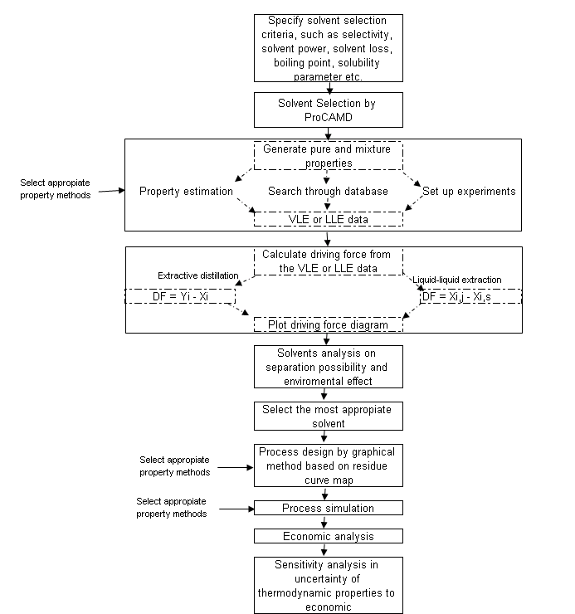
Figure 1: Block diagram of the integrated design of solvent-based separation process sequencing algorithm
The methodology highlighted in Fig 1 employs a number of computer aided methods & tools. For solvent selection, it employs the ProCAMD software [4] that designs/selects solvents for specified solvent target properties. The solvent (entrainer) plus the binary mixtures to be separated forms ternary systems whose distillation boundaries and residue curve maps are analyzed to identify the suitable solvent. ICAS-PDS is used for this purpose. As the solvent-based ternary systems are non-ideal mixtures, the accuracy of the predicted vapor-liquid phase equilibria are verified, where possible, with available experimental data and compared with more than one property model. In this case, the following software, ICAS®, Aspen Plus®, Aspen Distill®, or DistillDesigner® have been used. For solvent recovery column design, the driving force approach of Gani and Bek-Pedersen [2] has been used while for the two-feed extractive distillation column, the method proposed by Petlyuk [3] has been used. For a feasible process configuration, the operational costs as well as the equipment costs are calculated to obtain the final economic analysis. The type of solvent used and its loss with the products provides an account of the environmental impact. In a business (industrial) world, the most important issue is not just operational feasibility but also economic feasibility. Therefore, an economic evaluation is needed before any new process investment can be made. However, before any such investments, any uncertainties in the design need to be quantified. Therefore, a sensitivity analysis of the uncertain parameters to investigate the effects on process economy is performed as the last task of the systematic design methodology. The conclusions of the sensitivity analysis helps the engineers to decide if further experimental work is necessary.
  - Industrial case study
This case study involves the recovery of highly valued and high demand ethylbenzene (EB) and mixed-xylenes (comprising of p-xylene (PX), m-xylene (MX) and o-xylene (OX)) from a C8-aromatics mixture (C8A). As point out above, C8A is isomers mixture, so their separation (recovery) is not simple, that why there is only one commercial process of liquid-phase adsorptive separation available for EB recovery from C8A. [8] However, this process requires high investment cost and generates huge volume of waste adsorbent that may become an environmental problem. Therefore, another green process should be considered for the EB purification. The ratio of various properties of the key components (EB and PX) were tested to examine the possibly alternatives. The result showed, by vapor pressure ratio, the solvent-based extractive distillation can be employed for their purification. [7]

    - Solvent selection
The problem of identifying solvents for the separation of EB from PX by extractive distillation is considered first. The target solvent properties are solubility parameter, the normal boiling point, the normal melting point and selectivity (Sij = γ_{i}∞/γ_{j}∞). Specifying the above constraints to ProCAMD, a list of feasible solvents were obtained, from which, a selection is listed in Table 1.

Table 1 Selected solvent by ProCAMD
Result no | Solvent Name | Solubility parameter at 298 K (MPa^{1/2}) | Normal Melting point (K) | Normal Boiling point (K) | Selectivity
1 | Aromatic-Aldehyde-1 (AAD1) | 21.44 | 247.15 | 453.51 | 1.23
2 | Acyclic-Ester-1 (AE1) | 21.42 | 254.15 | 475.15 | 1.22
3 | Cyclic-Ketone-1 (CK1) | 17.86 | 265.05 | 488.35 | 1.22
4 | Acyclic-Ester-2 (AE2) | 19.84 | 234.15 | 453.95 | 1.20
5 | Acyclic-Ketone-1 (AK1) | 17.69 | 209.23 | 422.02 | 1.19
6 | Cyclic-Ketone-2 (CK2) | 19.88 | 244.91 | 419.32 | 1.19
7 | Acyclic-Ketone-2 (AK2) | 17.88 | 232.4 | 451.08 | 1.18
8 | Aromatic-Alcohol-1 (AAL1) | 24.09 | 248.81 | 466.67 | 1.13
9 | Cyclic-Amide-1 (CAD1) | 23.16 | 249.15 | 475.15 | 1.13
As result in table 1, the solvent that claimed by Berg’s patent [7] was also presented in the list at the fifth rank. This means successful in solvent selection could be achieved because the better solvents in term of both selectivity and solvent recovery can be acquired. (Berg’s solvent has closed boiling point to OX, so this becomes solvent recovery problem.) Due to its concentration-independent, the selectivity is the primary criterion chosen to be considered for selecting the suitable solvent in stead of the driving force. However, the selection of the best solvent based on only S_{ij} is inadequate because it does not directly relate to the distillation design. The suitable criterion should return to how significant the solvent could alter the driving force between the key components.

    - Analysis of the solvents in terms of driving force diagrams
The performance of the solvents were checked through solvent-free driving force diagrams for different choices of the property models. Figure 2 shows the solvent-free driving forces obtained for the same systems with the original UNIFAC-VLE model and the UNIFAC-Do model [5]. As solvent AE1 (acyclic-ester-1) appears to have desired predicted behavior with both models, it is selected for further studies. One important point of difference is the predicted values of Dy (see Figures 2a-2b). With the UNIFAC-VLE model, it is 0.045 while with UNIFAC-Do, it is 0.145. Therefore, experimental verification is necessary to establish the true value and a sensitivity analysis to determine the solvent property effects on process economy needs to be checked before a decision for pilot plant studies can be made.
(a) by UNIFAC (b) by UNIFAC-Do
Figure 2: Solvent-free driving force curves plots for selected solvents
Assuming that one of the models is correct, the design calculations can be continued to obtain the process economic analysis. At the same time, the environmental impact can also be investigated. As our selected solvent is an ester, it’s MSDS shows low human effect, which may only act as an irritant to skin, eye and respiratory, and do not have any other environmental effect. So, it can be concluded that solvent is suitable for separation of EB from PX by extractive distillation.

    - Process design
Solvent-based separation through extractive distillation consists of two distillations. The first is an extraction column with two feed (Aspen Distill® was used designing this column), while the second is a simple distillation column (the driving force concept was used for designing this column). The design was then verified by rigorous simulation using Aspen Plus®. The residue curve map (see Fig. 3) was used for the design of the first column to have consistent bottom and top products. The design details for this column for both models are given in Table 2.
For the solvent recovery column, fifty theoretical stages were required for total recovery the solvent with degree of purity to level of 99.99%mol. Key components for this column were AE1 and OX. By driving force concept, at Dx = 0.4, the feed location was at 30th stage. The conventional distillation for separating EB to the required purity was also designed to compare with the extractive distillation approach. Since C8 aromatics mixture is an ideal mixture, so the same results were obtained from both property packages [6], which total number of stage was 298 stages, feed location was at 179th stage (Dx = 0.4, Dy = 0.0145), reflux ratio was 20, reboil ratio was 23.3. Separation of EB by a single conventional distillation column is obviously not feasible. However, the data can be used to compare with extractive distillation system in terms of investment cost and operating cost.

(a) Feed and products specifications (b) Complete design
Figure 3 Residue curve maps of EB-PX-AE1 system
Table 2 Input data and results from Aspen Distill® for extraction column design
Input Parameter | Value | UNIFAC |  | UNIFAC-Do
Input Parameter |  | Output Parameters | Value | Output Parameters | Value
EB/PX mix. rate | 1.0 | Number of theoretical stages | 78 | Number of theoretical stages | 44
EB/PX mix. composition | EB = 0.6  PX = 0.4 | Feed location |  | Feed location
AE1 rate | 2.5 | EB/PX mix.  Stream | 58th | EB/PX mix.  stream | 33th
AE1 composition | AE1 = 1.0 | AE1 stream | 7th | AE1 stream | 8th
Distillate composition | EB = 0.995  PX = 0.005  AE1 = 1e-6 | Distillate product rate | 0.53 | Distillate product rate | 0.53
Bottom product compositon | EB = 0.031  PX = 0.121  AE1 = 0.848 | Bottom product rate | 0.47 | Bottom product rate | 0.47
Reflux ratio | 20 | Reboil ratio | 2.20 | Reboil ratio | 2.52
Operating pressure | 1 atm | (Note: Dy = 0.045) |  | (Note: Dy = 0.145)
    - Sensitivity analysis
A sensitivity analysis was performed to identify the effect of the driving force on the utility cost and the equipment cost. The results are shown in Fig. 4 and they confirm that the driving force is inversely proportional to the ease of separation and therefore the cost. This means that over-prediction of the driving force may lead to infeasible separation while under-prediction of the driving force may lead to waste of resources. The equipment costs were estimated by Aspen ICARUS® and utility pricings were based on general pricings in Thailand.

(a) Utility cost (b) Equipment cost
Figure 4 Sensitivity analysis on uncertainty effect of thermodynamic property prediction
  - Conclusions
A systematic methodology where solvent selection and process design have been integrated, has been developed and tested through the solution of an industrial case study involving a difficult separation problem. While the methodology and the corresponding tools were found to be applicable for industrial problems, uncertainties in property model predictions were noted. This pointed out that experimental verification of the model-based results is necessary and the sensitivity analysis provided enough information to plan the experimental effort, as future work for this project. Finally, it can be concluded that the available computer aided methods and tools can significantly reduce the time and effort to solve the class of problems highlighted in this work.
References
[1] AT Karunanithi, LEK Achenie, R Gani, 2006, Chemical Engineering Science 61, 1247-1260.
[2] R Gani and Bek-Pedersen, 2000, AIChE Journal, 46, 1271-1274
[3] F.B. Petlyuk, 2004, Distillation Theory and Its Application of Optimal Design of Separation units, Cambridge series in chemical engineering
[4] R. Gani, 2006, ICAS-Program Package, CAPEC Report, DTU, Lyngby, Denmark (www.capec.kt.dtu.dk)
[5] U. Domanska et. al., 2005, Fluid Phase Equilibria 235, 182-190.
[6] W.L. Rodrigues, S. Mattedi, J.C.N. Abreu, 2005, Brazilian Journal of Chemical Engineering
[7] L. Berg, Sep. of EB form PX by Ex. Dist, US Patent No. 5 425 855 (1995).
[8] UOP LLC, 2004, Process Technology and Equipment

