Population balance modeling of influenza virus replication in MDCK cells during vaccine production
Thomas Müllerª, Josef Schulze-Horsel^{b}, Yury Sidorenko^{b}, Udo Reichl^{a,b}, Achim Kienle^{a,b}
ªOtto von Guericke Universität Magdeburg, Universitätsplatz 2, D-39106 Magdeburg, Germany
^{b}Max Planck Institut für Dynamik komplexer technischer Systeme, Sandtorstraße 1, D-39106 Magdeburg, Germany
Abstract
In this contribution a population balance model of influenza A virus replication during vaccine production in Madin-Darby canine kidney (MDCK) cell cultures is developed. Differentiation on the population level is described by a degree of infection, which is proportional to the amount of intracellular viral proteins. This can be measured directly using flow cytometry. It is shown that the model shows reasonable agreement with experimental data, although not all details of the inner dynamics can be fully reproduced.

Keywords: population balance modeling, distributed populations, virus replication, vaccine production, microcarrier cell culture.
  - Introduction
In influenza vaccine production the use of permanent mammalian cell lines becomes more and more important. Besides sophisticated cell culture technologies and downstream processing methods, mathematical modeling plays a crucial role in improving production efficiency. Most notably for analysis and optimization of the process, the benefit of combining extensive experiments with mathematical modeling approaches is obvious. Thus, this strategy will contribute to the investigation of dynamic and kinetic phenomena and their link to the measured data.
One can distinguish between structured and unstructured models, the latter neglecting intracellular phenomena. On the contrary, structured models account for intracellular processes and states in different compartments of the cell or include explicit kinetics for various intracellular steps of virus replication.
Despite the high social relevance of infectious diseases and widespread use of animal cell lines in vaccine production, the application of even unstructured models for quantitative analysis and parameter estimation has not been common practice in bioprocess optimization. So far, research concerning influenza vaccine production in MDCK cell cultures has focused on the characterization of metabolism, growth of different cell lines and virus yields in various production systems [1,2].
Based on the experimental investigation of the infection status of cells by measuring immunofluorescence of intracellular viral proteins with flow cytometry [3] mathematical models are required, which are able to describe distributed populations of cells with different degrees of infection. For this purpose, in the present paper an internal coordinate is introduced to quantify the degree of infection and the previous approach by Möhler et al. [4] is extended accordingly.
  - Model formulation
The population balance model of Möhler et al. [4], which forms the basis for the presented approach, describes the replication of influenza A viruses in MDCK cells growing on microcarriers. It is unstructured and includes three concentrated state variables, which are the number concentrations of uninfected cells U_{c}, infected cells I_{c} and free virus particles V.
It is assumed that at the time of infection (t₀) all microcarriers are completely covered with cells, which corresponds to the maximum cell concentration ($U_{c,0}=C_{\text{max}}=1\text{.}2⋅{\text{10}}^{6} {\text{ml}}^{−1}$ [4]). Virus seed is added to the microcarrier cell culture and infection takes place. The amount of infectious virus particles added is described via MOI (multiplicity of infection, number of infectious virions per cell at t₀ [5]). Virus particles instantly attach to uninfected cells. Consequently, the latter become infected with the infection rate k_{vi}. After a certain time delay (τ = 4.5 h) due to intracellular processes, infected cells start releasing virus particles with the release rate k_{rel} and carry on until they die (k_{cd}). Free virions can either attach to still available uninfected cells (k_{va}) or simply degrade (k_{vd}). Attachment to infected cells is neglected.
In Möhler et al. [4] it is shown that the simple unstructured model is able to show good agreement between simulated outer dynamics and hemagglutination (HA) assays, which allow to estimate the total number of virus particles in the supernatant. However, the intracellular progress of infection is not considered, and therefore a comparison with flow cytometric fluorescence data characterizing the cell’s status during infection is impossible. To change this situation and to allow differentiation between cells the degree of infection δ is introduced as an infected cell’s property:
$$I_{c}(t,δ)=I_{c,δ}(t) \text{with}δ∈N,\left[1,∞\right]$$
The degree of infection specifies the intracellular amount of viral protein and corresponds to the equivalent number of virus particles inside the cell assuming that a complete virus particle comprises 4000 viral proteins M1 and NP (3000 M1/virion +1000 NP/virion [6]). Schulze-Horsel et al. [3] show that the intracellular amount of viral M1 and NP proteins is coupled linearly with the cell's fluorescence caused by immunostaining against influenza A virus M1 and NP. The uptake or production of 4000 viral M1 and NP proteins or 1 virus particle respectively will lead to an increase of δ by 1; the cell’s fluorescence will increase by 2.66 FU/virion (fluorescence units, data not shown).
Because not only infected cells but also uninfected cells with no intracellular viral protein show unspecific fluorescence intensity due to unspecific antibody binding, it seems suitable to change the internal coordinate from the degree of infection δ to a more general degree of fluorescence ϕ, where every step from one degree to another accounts for a change of the cell’s fluorescence intensity by 2.66 FU. Thereby, also the distributed unspecific fluorescence of uninfected cells can be taken into account:
$$\begin{aligned}U_{c}(t,ϕ)=U_{c,ϕ}(t) \\ I_{c}(t,ϕ)=I_{c,ϕ}(t) \text{with}ϕ∈N,\left[1,∞\right]\end{aligned}$$
The change of behavior along ϕ is characterized by two processes: virus replication increases fluorescence intensities with the replication rate k_{rep} while virus release decreases it respectively with the release rate k_{rel}. These two processes describe the inner dynamics of the system.
    - Model equations
It can be shown that growth and death of the uninfected cells can be neglected due to medium exchange, limited space on microcarriers and fast progression of infection. Therefore, only infection is considered for description of the uninfected cell’s behavior:
$\frac{{dU}_{c,ϕ}}{dt}=−k_{\text{vi}}U_{c,ϕ}V$ (1)
As an initial condition, uninfected cells are considered to be normally distributed over the logarithmically scaled fluorescence axis to ensure good agreement with flow cytometric data collected by Schulze-Horsel et al. [3].
Infected cells emanate from uninfected cells, intracellular virus replication starts and the number of infected cells deceases with the specific death rate k_{cd}. As described above convection along ϕ occurs due to virus protein accumulation and release. Every step from one degree of fluorescence to another is associated with the intracellular production or release of one virus particle respectively, so that the actual degree of fluorescence of every infected cell is controlled by these two effects. For brevity only the equation for ϕ > 1 is shown:
$\frac{{dI}_{c,ϕ}}{dt}=k_{\text{vi}}U_{c,ϕ−1}V−k_{\text{cd}}I_{c,ϕ}−k_{\text{rep}}\left(I_{c,ϕ}−I_{c,ϕ−1}\right)+k_{\text{rel}}\left(I_{c,ϕ+1}−I_{c,ϕ}\right)$ (2)
Free virions emerge from infected cells with ϕ > 1 by means of virus release. They are able to attach to uninfected cells (k_{va}) or degrade with time (k_{vd}).
$\frac{dV}{dt}=k_{\text{rel}}\sum_{ϕ=2}^{∞}{I_{c,ϕ}−}k_{\text{vd}}V−k_{\text{va}}\sum_{ϕ=1}^{∞}{U_{c,ϕ}V}$ (3)
Additionally, dead cells are included in the process because intact dead cells show up in the flow cytometric data. For simplicity all dead cells are considered to stay intact and keep the specific ϕ they possessed at time of death.
  - Parameters
As the focus of this work is on the further development of the model of Möhler et al. [4], parameter identification was skipped for the time being and the “best-fit” parameter set was adopted. It is worth noting that the parameters used here have the same significance as in the undistributed model, except for the replication rate k_{rep} which has been introduced for the present model; its value has been derived from the flow cytometric data by means of sum-of-least-squares method (data not shown). Initial conditions are in agreement with the same set of experimental data of Schulze-Horsel et al. [3]. Table 1 summarizes the applied parameters and initial conditions, which differ from the ones published by Möhler et al. [4, Tab. 1, p. 50].
Table 1. Applied parameter set and initial conditions (note, that not every virus particle is infectious and non infectious virions have to be considered)
Parameter | Value | Unit
k_{rep} | 502 | h ⁻¹
V₀ (MOI = 0.025) | 3 | 10⁶/ml
V₀ (MOI = 1.0) | 120 | 10⁶/ml
V₀ (MOI = 3.0) | 360 | 10⁶/ml
  - Simulation results
All simulations were performed with the dynamic simulator Diva and visualized with Matlab. For simplicity the delay behavior between infection and virus release was reproduced by simply shifting the simulation results by t_{shift} = 4.5 h [4].
    - Outer dynamics
Figure 1 shows the evolution of virus yields over time for two of the three observed initial conditions. There is no detectable difference between the present structured model and the unstructured approach of Möhler et al. [4]. That is because of the unstructured model being included in the structured model as the zeroth order moment.
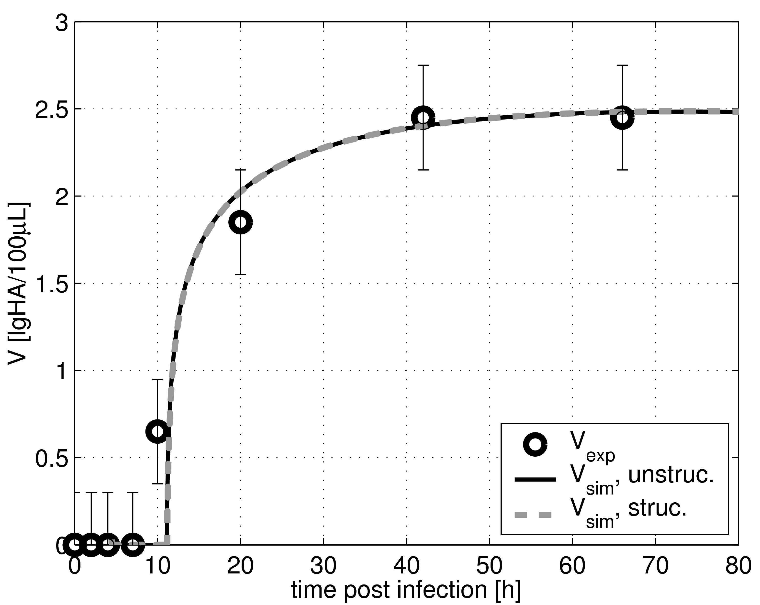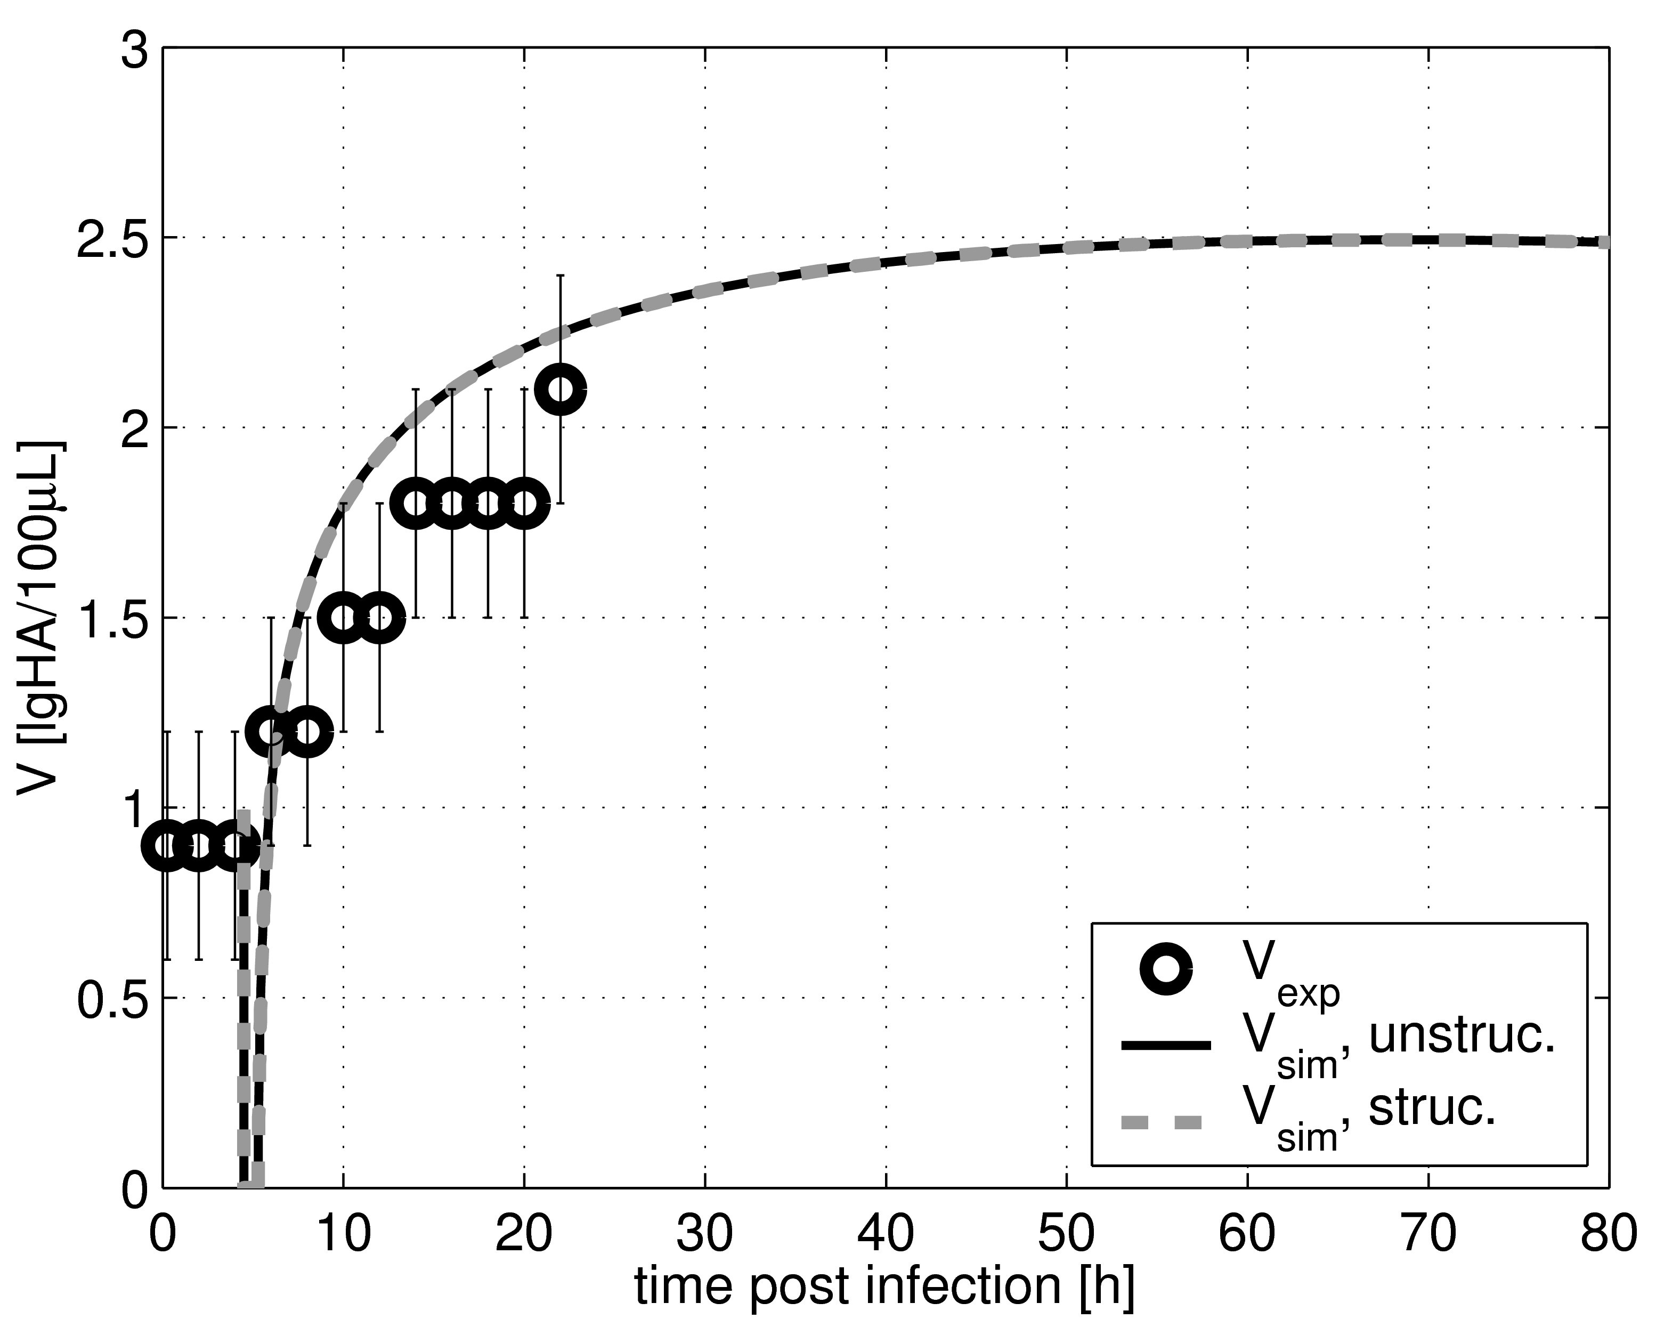
(a) MOI = 0.025 (b) MOI = 3.0
Figure 1. Outer dynamics in comparison with model of Möhler et al. [4]: virus yield vs. time post infection for different MOI (circles: experimental results, solid line: unstructured model, dashed line: structured model, t_{shift} = 4.5 h)
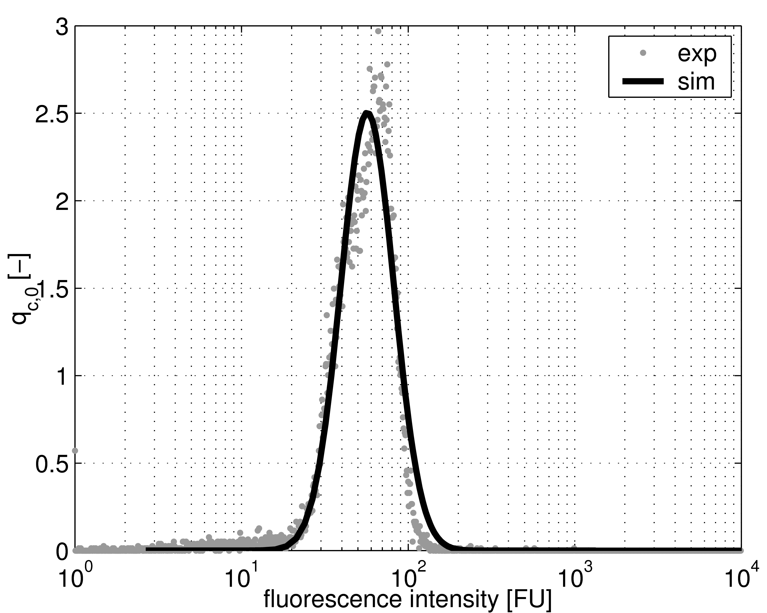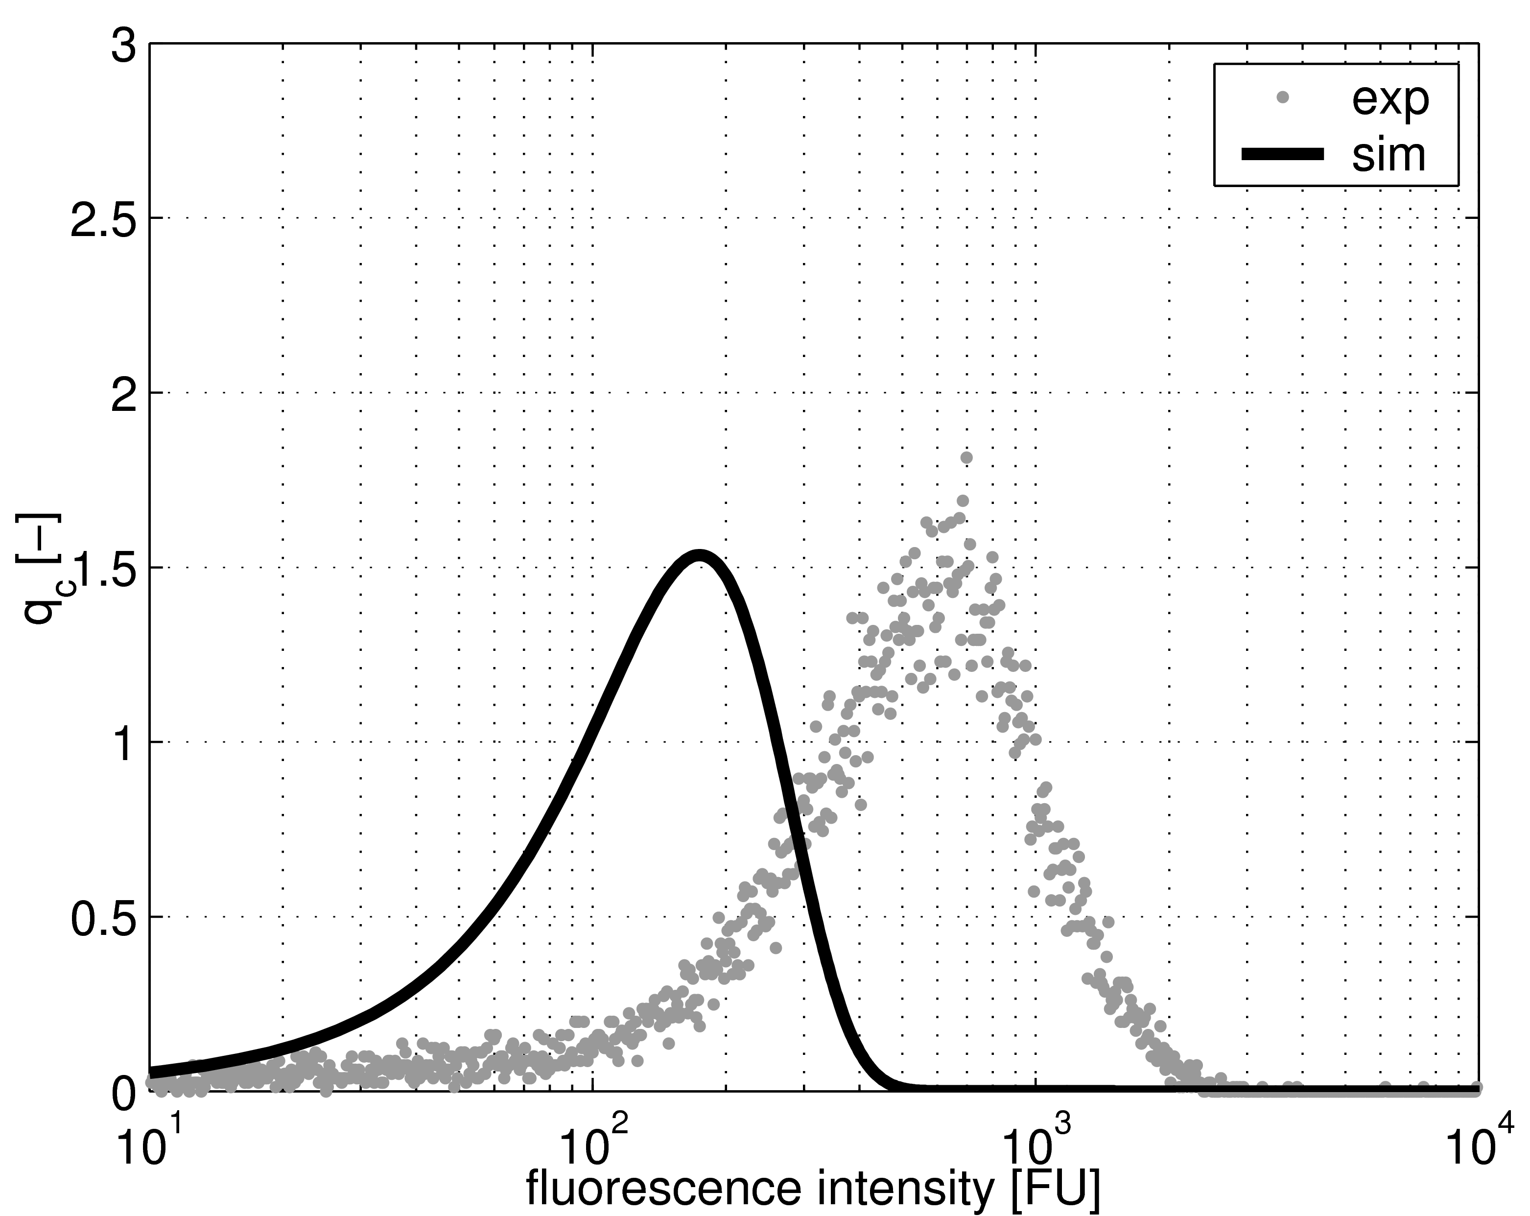
(a) t = 0 h (b) t = 6 h
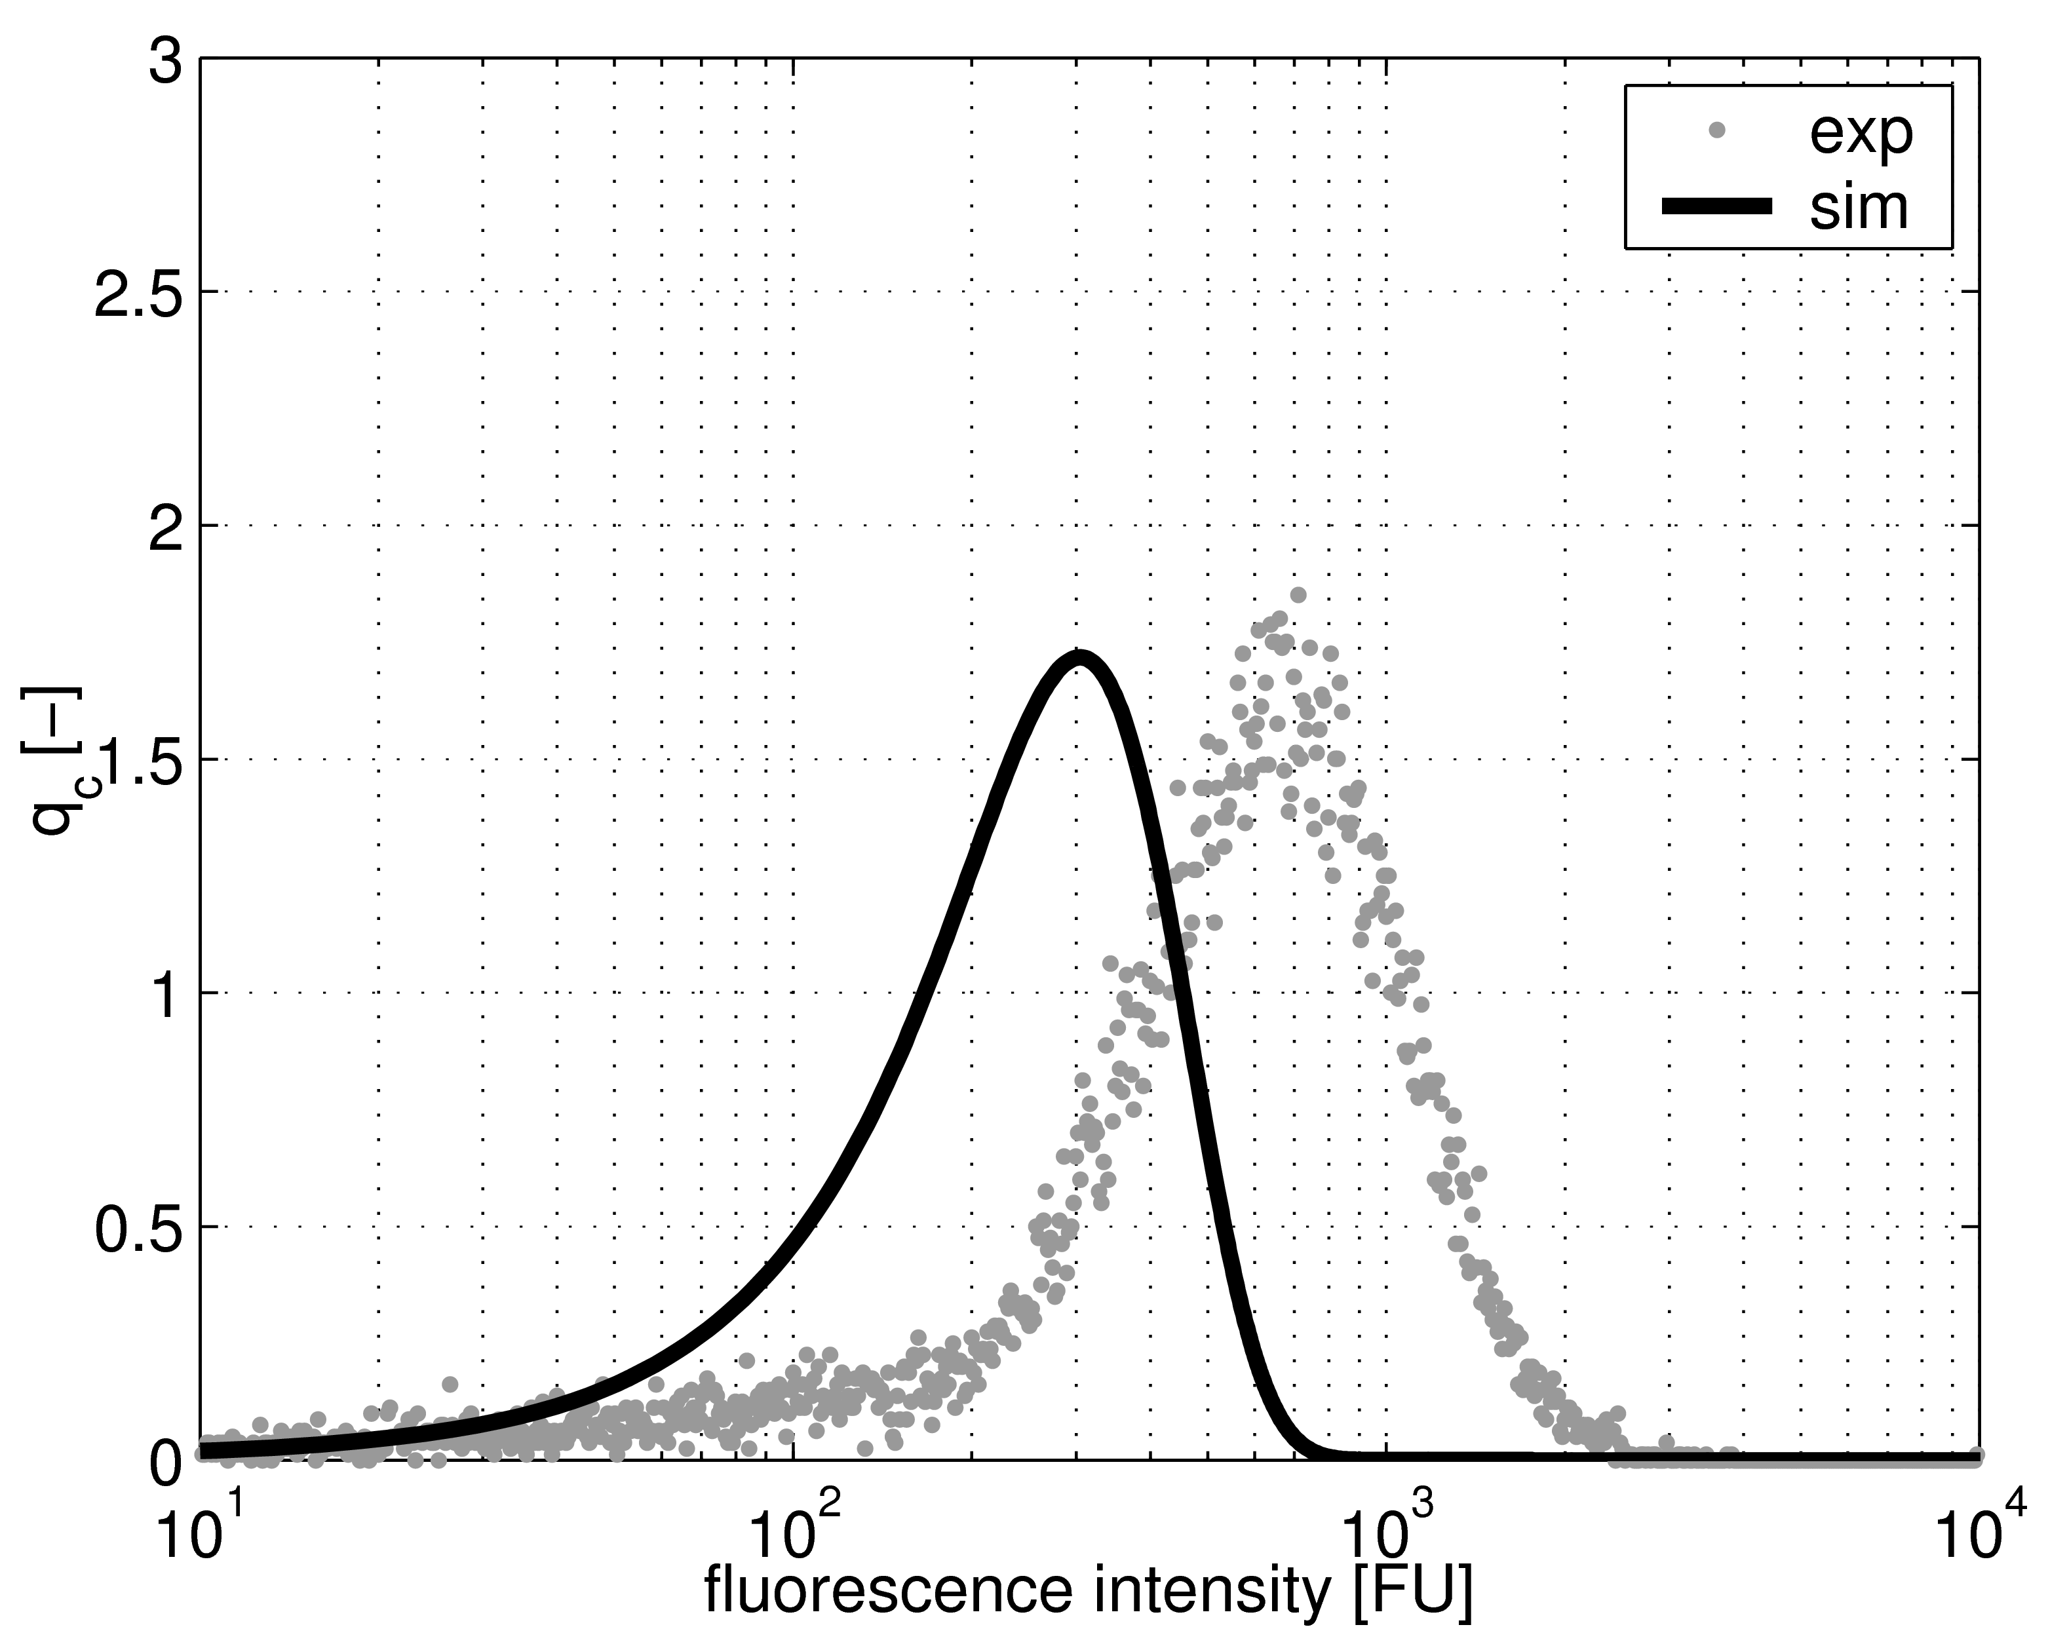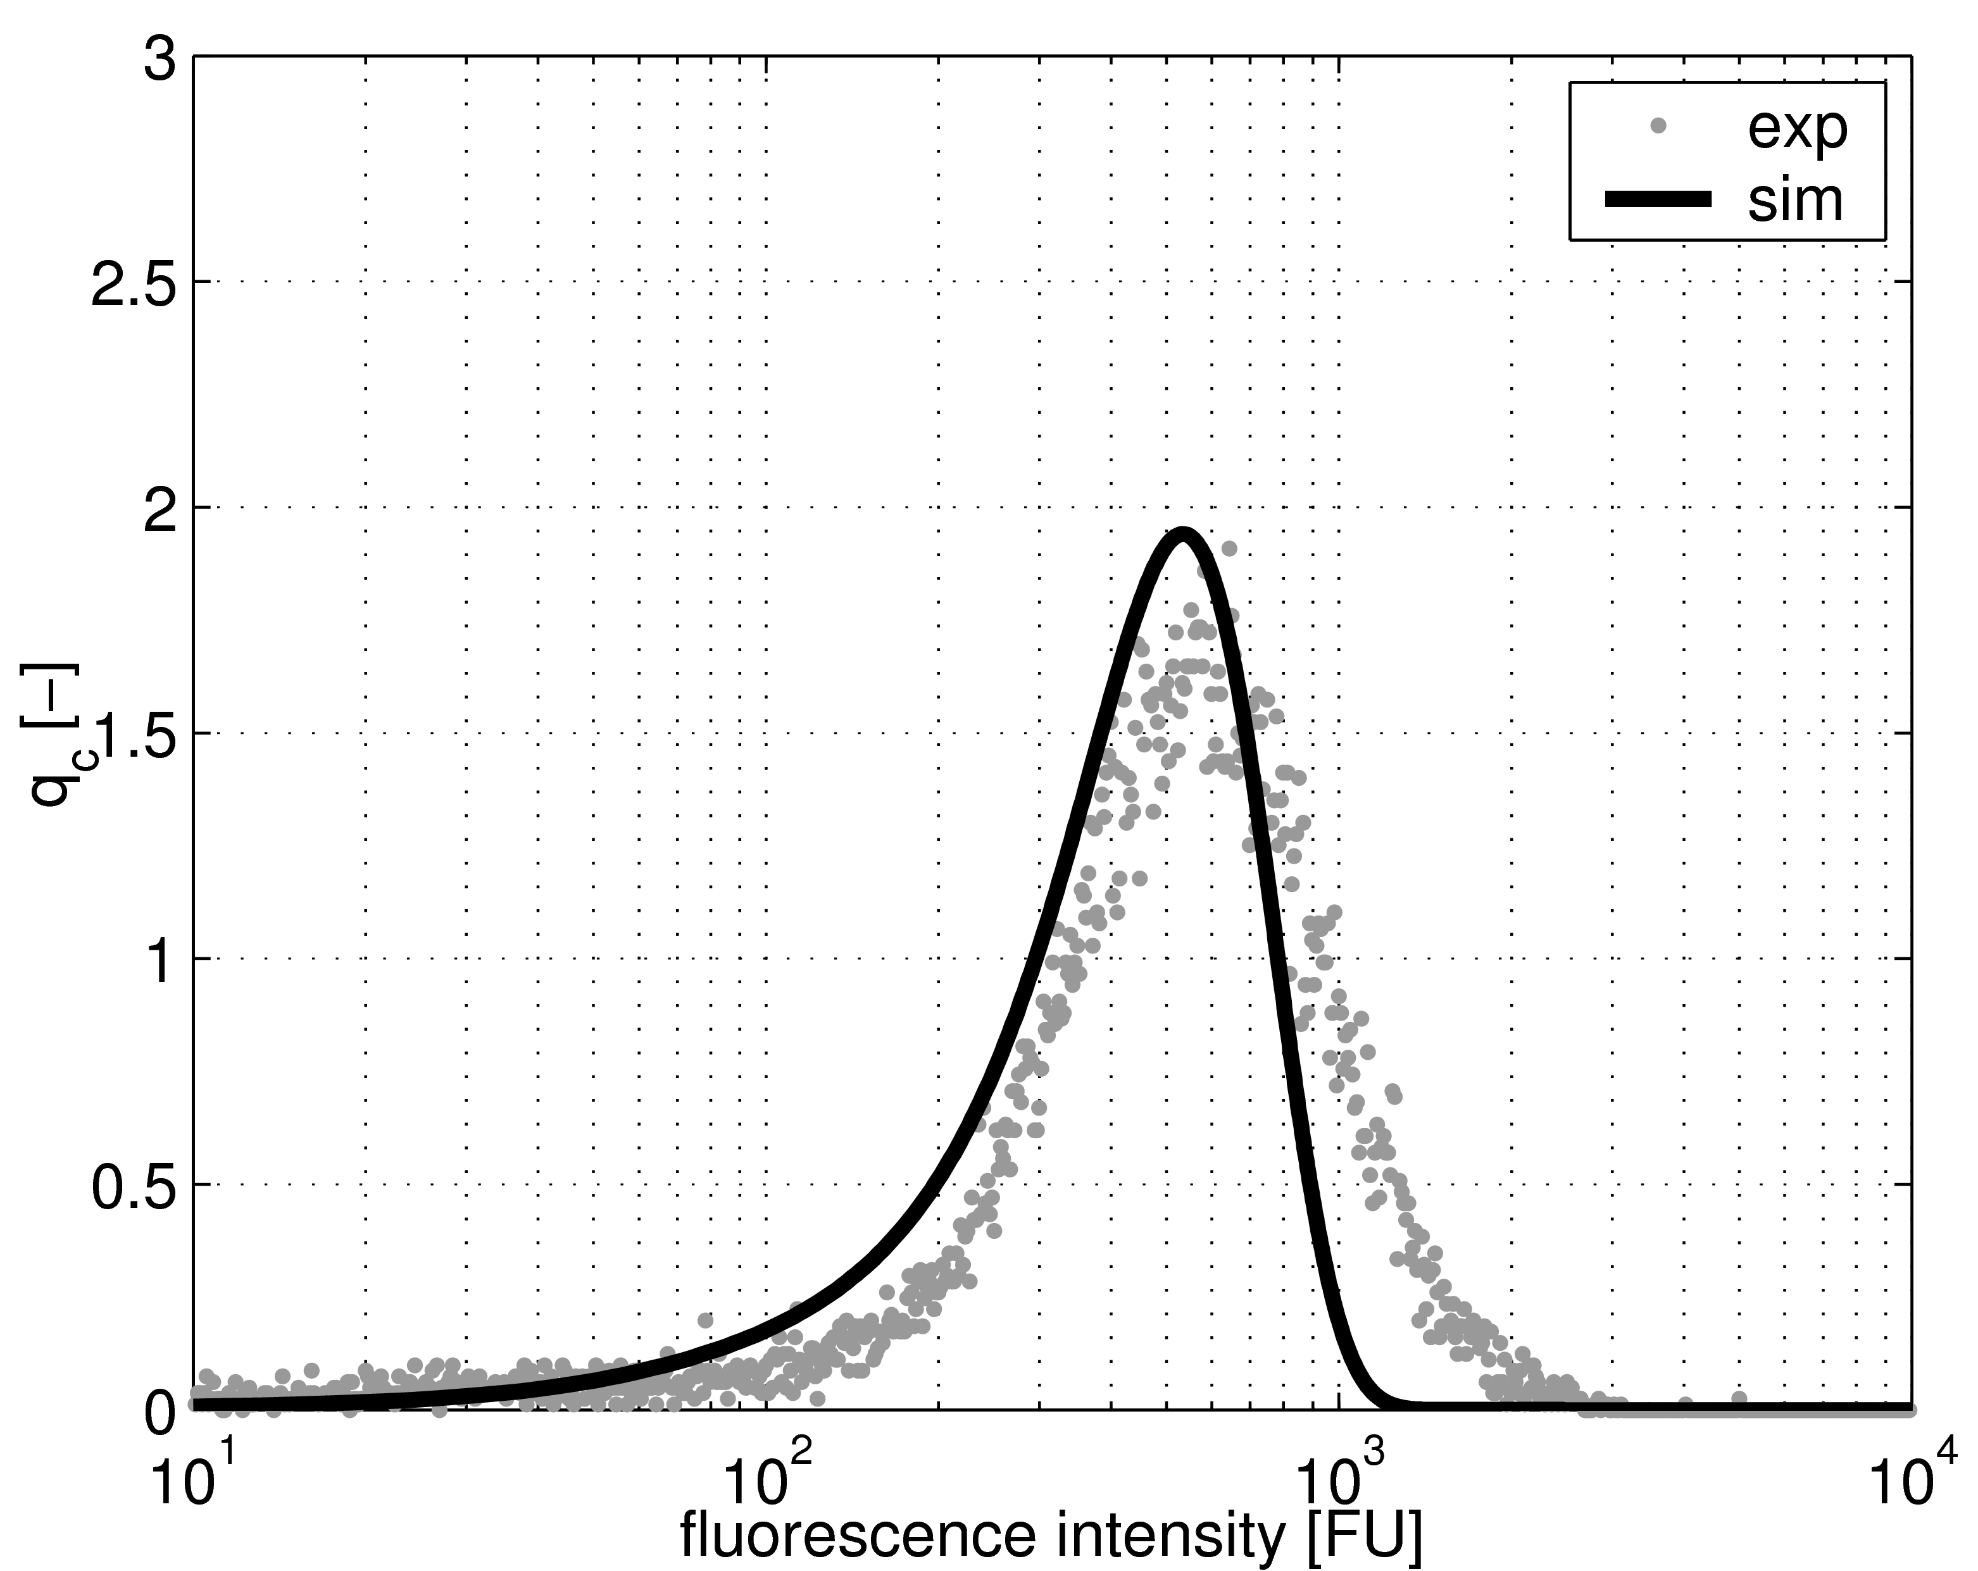
(c) t = 8 h (d) t = 12 h
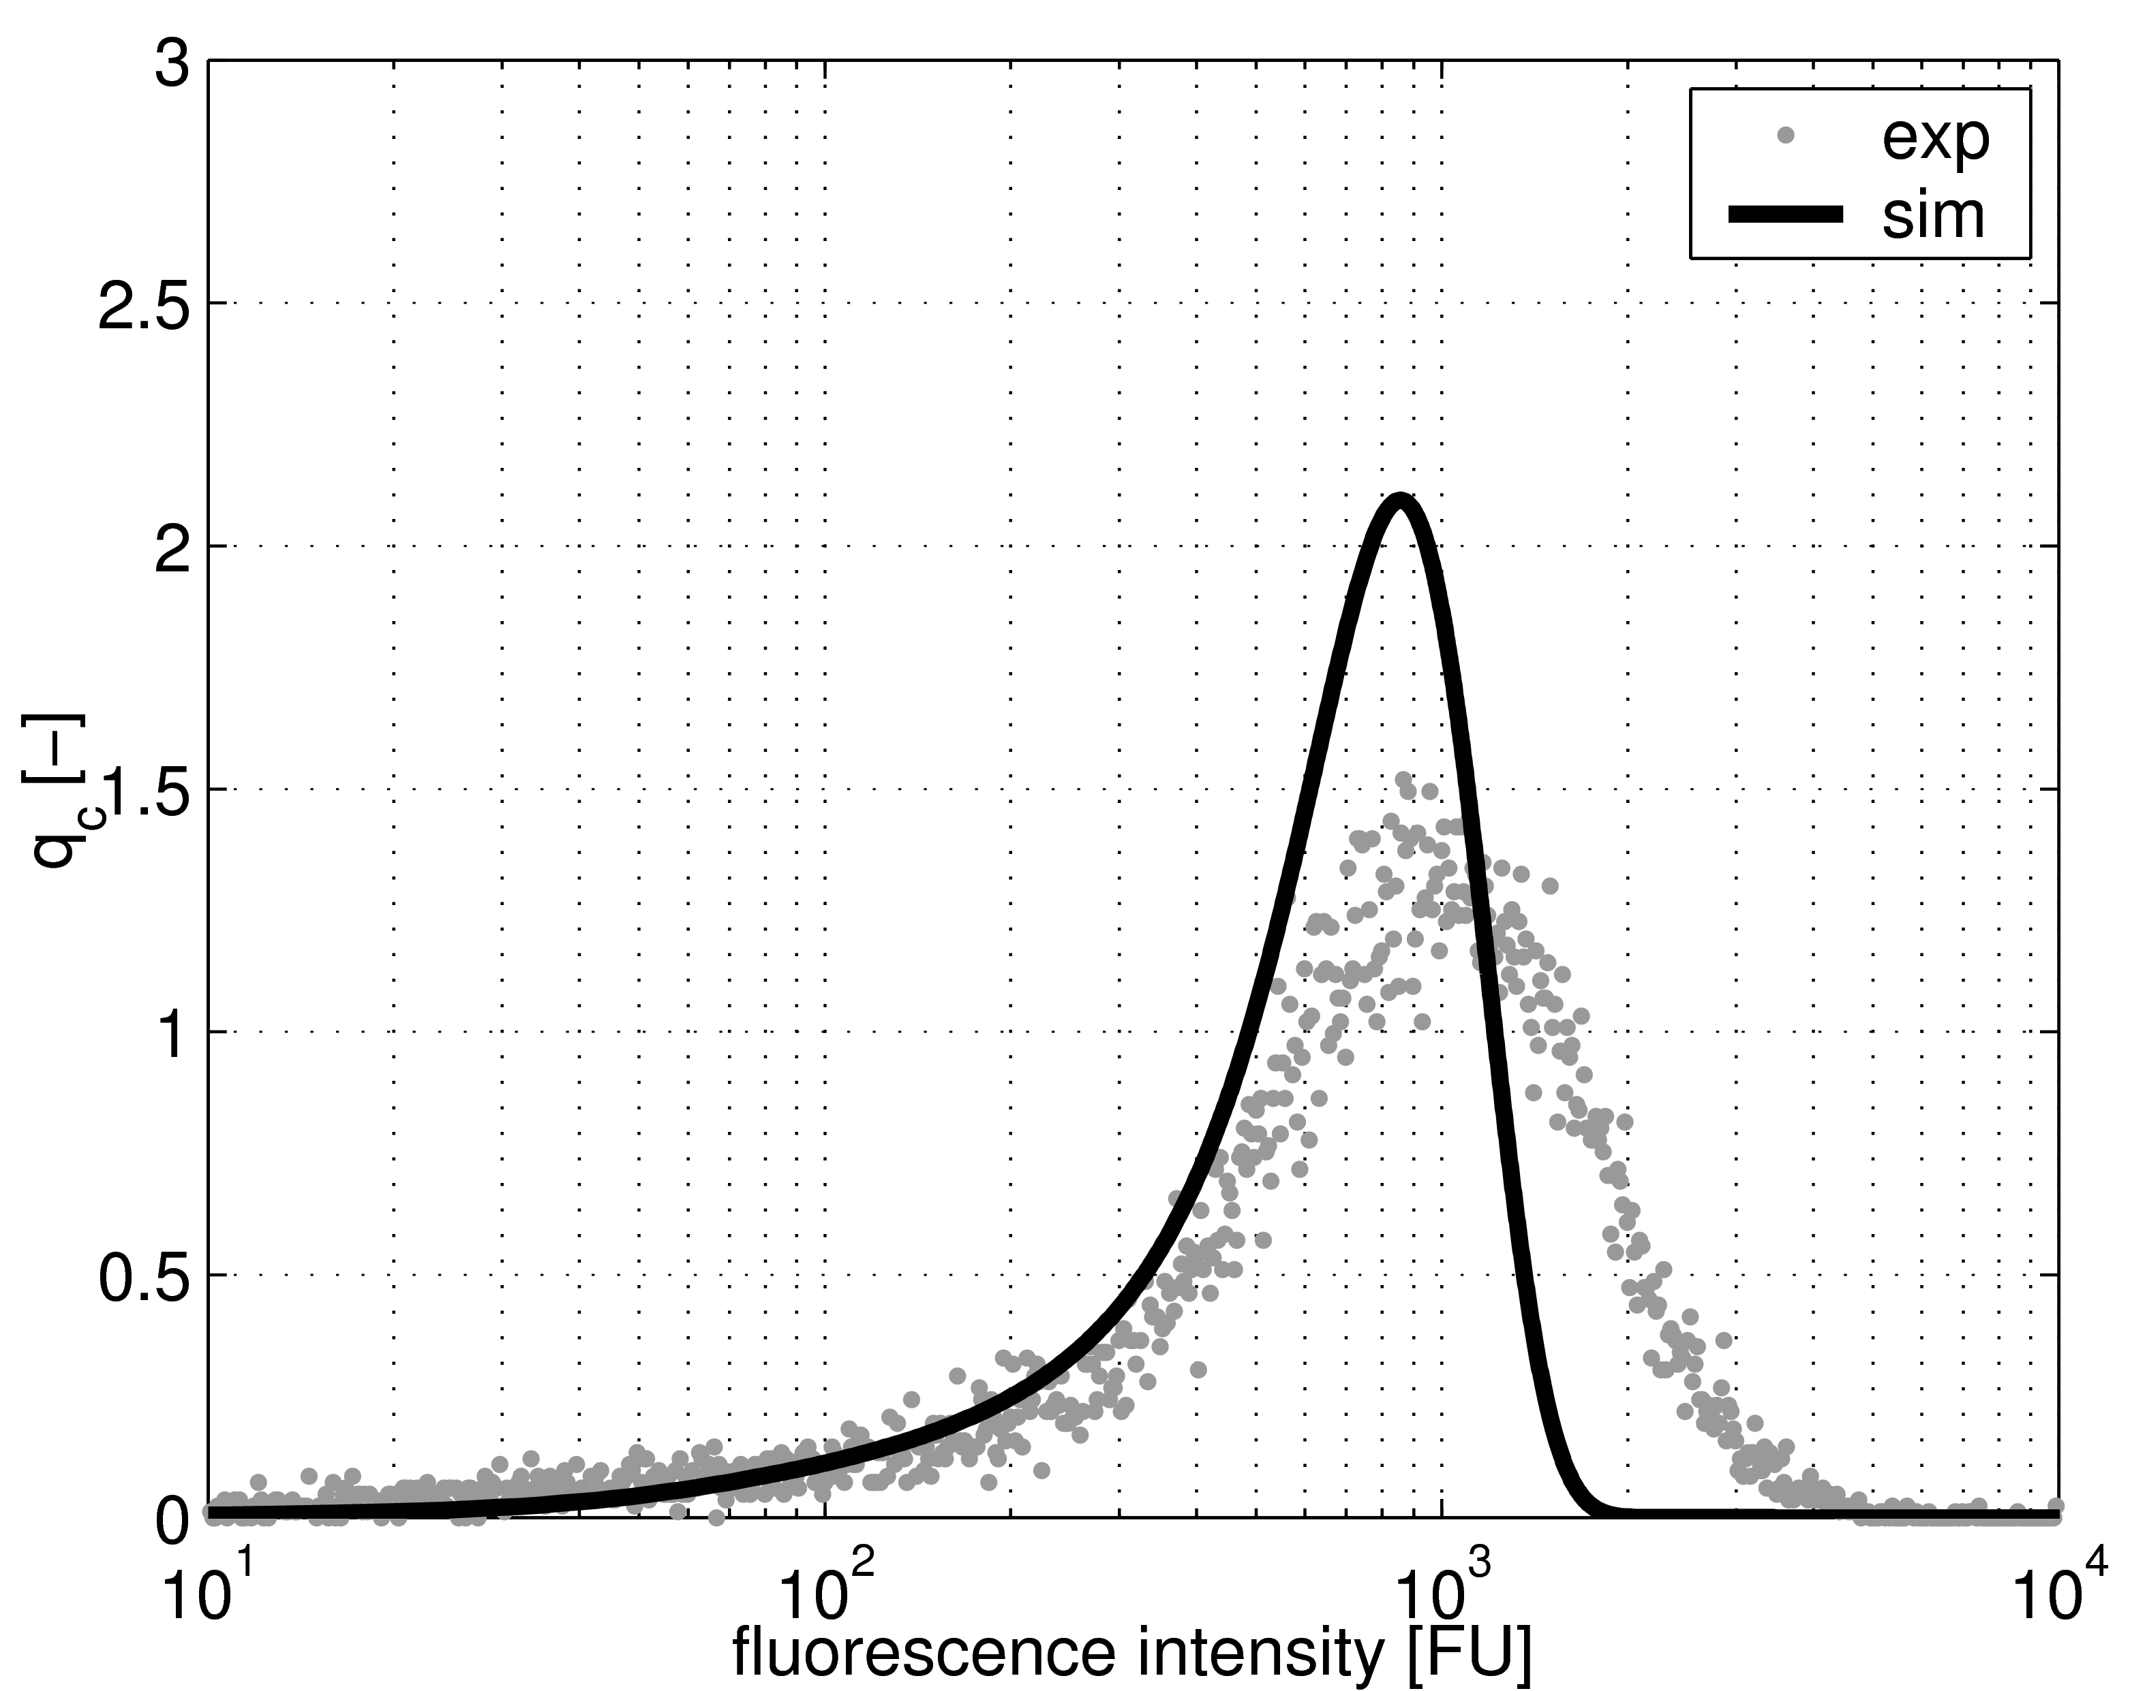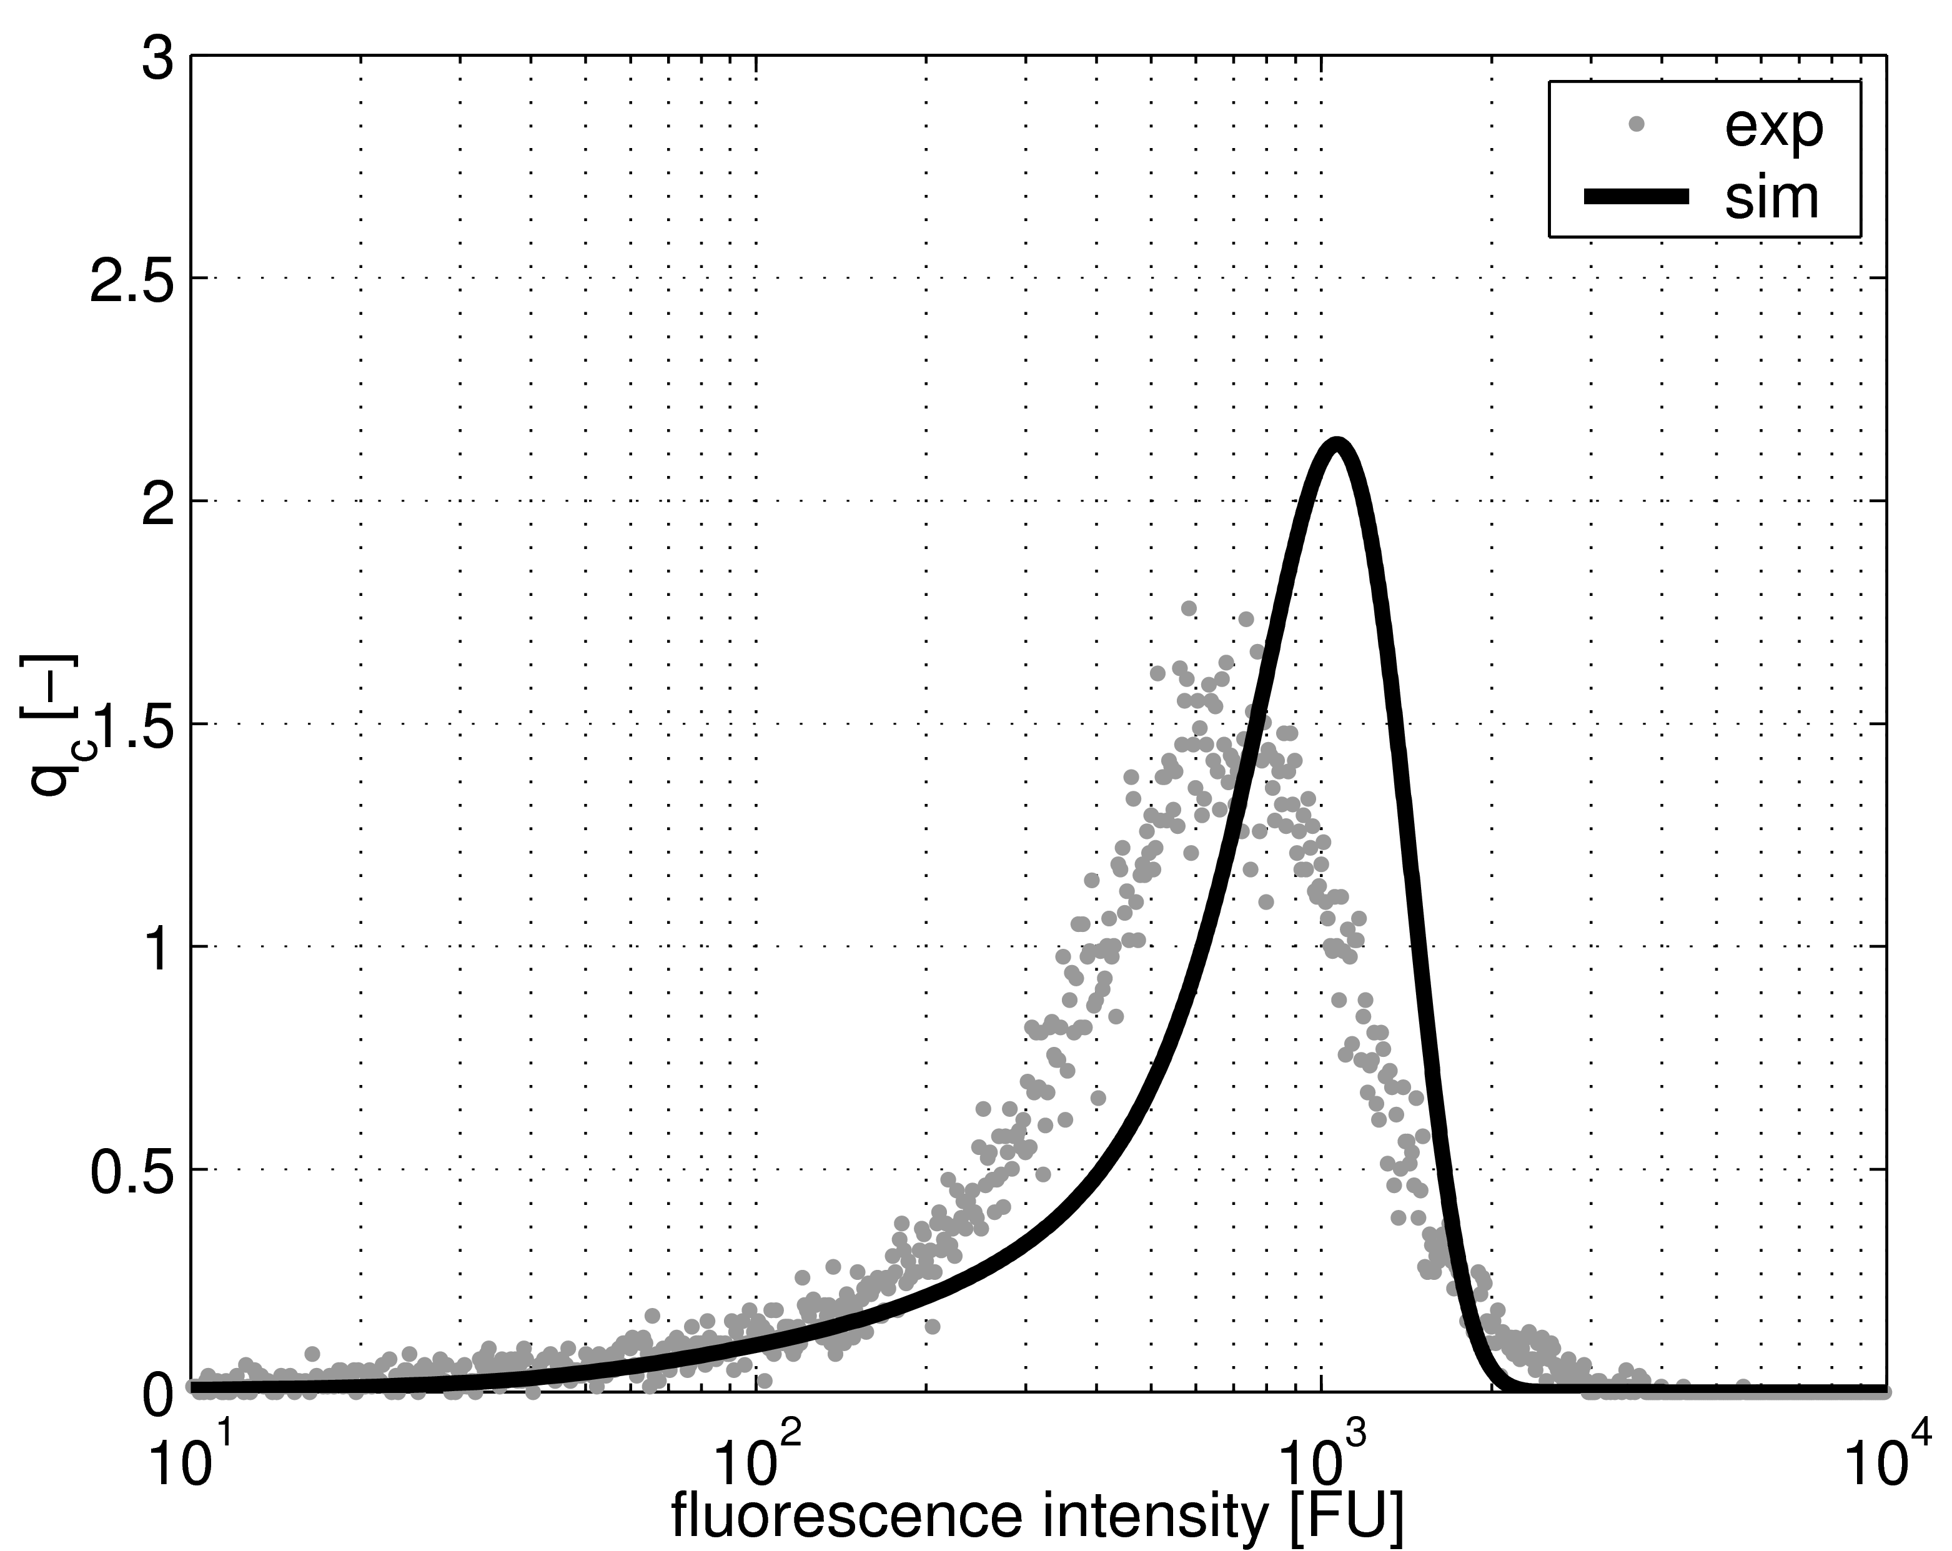
(e) t = 18 h (f) t = 22 h
Figure 2. Inner dynamics: number density function q_{c} vs. fluorescence intensity for specific time points post infection. (dots: experimental results, solid line: simulation results, MOI = 3.0, t_{shift} = 4.5 h)
    - Inner dynamics
The inner dynamics are determined by the cell distribution over the fluorescence changing with time. For comparability the cell concentrations have to be converted into number density functions, which are obtained by normalization with the overall cell concentration at the specific time point and division by the specific class width in logarithmic scale. All cells (uninfected, infected and dead) contribute to the distribution as they all show fluorescence. Figure 2 shows the comparison between simulation results and the flow cytometric data reported by Schulze-Horsel et al. [3] for MOI = 3.0. The simulation peak lags behind in the beginning and catches up for later time points, but the overall tendency of increasing mean values can be reproduced quite well. However, the present model has a drawback: for an unknown biological reason the experimental distributions fall back to smaller fluorescence intensities at later time points (data not shown). So far, this effect cannot be simulated with the presented model formulation adequately.
  - Conclusion
A new deterministic population balance model with distributed cell populations has been presented. The model is based on the unstructured approach of Möhler et al. [4]. Concerning outer dynamics the present model is equivalent to the unstructured model which proved to be sufficient to predict virus yields for different initial conditions [4]. The characteristics of the inner dynamics can be simulated except of the decrease of fluorescence intensity at later time points. The biological reasons for this effect are unclear. Presumably there are more states that have to be considered during virus replication like intercellular communication, extent of apoptosis or specific stage in cell cycle. Future computational and experimental research will aim in this directions and concentrate on structured descriptions of the virus replication in mammalian cell culture.
References
[1] J. Tree, C. Richardson, A. Fooks, J. Clegg, D. Looby, 2001. Comparison of large-scale mammalian cell culture systems with egg culture for the production of influenza virus A vaccine strains. Vaccine 19, 3444–3450.
[2] Y. Genzel, R. Olmer, B. Schäfer, U. Reichl, 2006. Wave microcarrier cultivation of MDCK cells for influenza virus production in serum containing and serum-free media. Vaccine 24 (35–36), 6074–6084.
[3] J. Schulze-Horsel, Y. Genzel, U. Reichl, 2007. Quantification of intracellular accumulation of M1 and NP of influenza A virus – monitoring of infection status of production cells during vaccine production by flow cytometry, Submitted to BioMedCentral Biotechnology.
[4] L. Möhler, D. Flockerzi, H. Sann, U. Reichl, Apr. 2005. Mathematical model of influenza A virus production in large-scale microcarrier culture. Biotechnology and Bioengineering 90 (1), 46–58.
[5] P. Licari, J. Bailey, 1992. Modeling the population dynamics of baculovirus-infected insect cells: optimizing infection strategies for enhanced recombinant protein yields. Biotechnology and Bioengineering 39 (4), 432–441.
[6] D. Knipe, P. Howley, D. Griffin, 2001. Field’s virology, 4th Edition. Lippincott Williams & Wilkins, Philadelphia.

