Cell Cycle Modelling for Off-line Dynamic Optimisation of Mammalian Cultures
Carolyn M. Lam,ª Kansuporn Sriyudthsak,ª Cleo Kontoravdi,ª Krunal Kothari,ª Hee-Ho Park,ª Efstratios N. Pistikopoulos,ª Athanasios Mantalarisª
ª Centre for Process Systems Engineering, Dept. of Chem. Eng., Imperial College London, South Kensington Campus SW7 2AZ, UK.
Abstract
Mammalian cell cultures producing high-value biopharmaceuticals are expensive and time-consuming to study due to their exclusive dependence on experimentation. A mathematical model has been developed that describes batch/fed-batch hybridoma suspension cultures under normal and chemically-arrested conditions, which is also used to optimise the fed-batch cultures. The optimised strategy was tested experimentally demonstrating that product concentration was closely predicted though the viable cell concentration was partly underestimated. Overall, the model has assisted in reducing the number of experiments required to determine optimal cell culture conditions. Further work is required to improve the model predictability.

Keywords: mammalian, hybridoma, off-line, modelling, optimisation.
  - Introduction
Biologicals, such as monoclonal antibodies (MAbs), are important drugs for the treatment of various diseases. The global market for MAbs is projected to increase to US$16.7 billion in 2008 (Reichert and Pavlou 2004). Mammalian cells are the preferred expression system in order to achieve functional products. However, large infrastructure investments, high costs of experimentation and long cultures necessitate the reduction in costs and time-to-market. Once the best cell-line and media composition have been selected, the feeding strategy for fed-batch cultures would need to be optimised to maximise the production potential of the cell culture. Continuous improvements in mammalian culture technologies are also important to maintain their competitiveness versus other alternatives such as transgenic plants and animals (Ma et al., 2003; Dyck et al., 2003).
Modelling offers advantages in providing insight into the production process and guiding experimentation, thus elimination any unnecessary experiments. Furthermore, it also enables in silico determination of best and worst case scenarios, which help focusing resources on beneficial trials. In this study, modelling of a hybridoma suspension culture based on first principles for off-line optimisation of time-varying process strategies was performed. By tracking the population in various phases of the cell cycle (G₀/G₁, S, and G₂/M), the specific productivity of each sub-population was taken into account, which reflected the culture’s intrinsic properties more accurately.
  - Materials and Methods
    - Batch and Fed-Batch Cultures
The mouse-mouse hybridoma CRL-1606 cell line producing IgG1 monoclonal antibody (MAb) against human fibronectin was obtained from ATCC. Batch cultures were inoculated at 1.5-2.0x10⁵ cell ml⁻¹ in 100ml medium containing DMEM with 25mM glucose and 4mM glutamine (GIBCO), 2.5% CBS (ATCC) and 1% Pen-Strep (GIBCO) in shake-flask incubated at 37ºC and 5% CO₂. Samples were taken every 8 h. Three out of six batch cultures were arrested with 0.5% DMSO (Wang et al., 2004) at 44 h.
A fed-batch culture was first tested in triplicates with the same initial conditions as the batch cultures and concentrated glutamine (Sigma) at 200 mM was added twice a day. Three sets of triplicate fed-batch cultures were then performed following an optimised feeding strategy with three different cell cycle-arrest times at 78 h, 96 h, and 126 h respectively. The feed contained DMEM (GIBCO) with 200mM glutamine and 500mM glucose (Sigma).
    - Cell Culture Analyses
Cell concentration and viability were measured with a Neubauer haemocytometer (Assistant, Germany) and trypan-blue (Sigma). Glucose, glutamine, lactate, and ammonium were detected using BioProfile200 (NOVA Biomedical) pre-calibrated with internal standards. Cells were fixed and stained with propidium-iodide (Sigma-Aldrich) for cell cycle analysis with flow cytometry (Beckman Coulter). The concentration of MAb was measured using an in-house sandwich ELISA assay.
  - Modelling
    - Model Structure
The model was adapted from Kontoravdi et al. (2005) for cell growth/death, nutrient uptake, and major metabolism. The model was further developed to include description of cell cycle sub-populations. The cell cycle representation was based on the yeast model of Uchiyama & Shioya (1999) and the tumour cell model of Basse et al. (2003). Eq.(1)-(4) express viable cell concentration(X_{v}[cell L⁻¹]) in terms of cells in G₀/G₁, S, and G₂/M phases. As a simplification in notation, G₀/G₁ cells will be indicated as G₁ unless otherwise stated. X_{G1}, X_{S}, X_{G2/M} [cell L⁻¹] are concentrations of viable cells in G₀/G₁, S, and G₂/M phase, respectively, whereas F_{out}[L h⁻¹] is the outlet flowrate. V[L] is the cell culture volume; b, k₁, k₂ [h⁻¹] are the transition rates of cells from G₁ to S, S to G₂, and M to G₁ respectively; and µ_{d}[h⁻¹] is the specific death rate.
$X_{v}=X_{G1}+X_{S}+X_{G2/M}$ (1)
$\frac{{\text{dX}}_{G1}}{\text{dt}}=2b⋅X_{G2/M}−k_{1}⋅X_{G1}−μ_{d}⋅X_{G1}−(\frac{F_{\text{out}}}{V})⋅X_{G1}$ (2)
$\frac{{\text{dX}}_{S}}{\text{dt}}=k_{1}⋅X_{G1}−k_{2}⋅X_{S}−μ_{d}⋅X_{S}−(\frac{F_{\text{out}}}{V})⋅X_{S}$ (3)
$\frac{{\text{dX}}_{G2/M}}{\text{dt}}=k_{2}⋅X_{S}−b⋅X_{G2/M}−μ_{d}⋅X_{G2/M}−(\frac{F_{\text{out}}}{V})⋅X_{G2/M}$ (4)
k₁, k₂, b can be rearranged and expressed in terms of the specific growth rate, µ [h⁻¹]:
$k_{1}=\frac{2−x_{G1}}{x_{G1}}⋅μ$ (5)
$k_{2}=\frac{1+x_{G2/M}}{x_{S}}⋅μ$ (6)
$b=\frac{μ}{x_{G2/M}}$ (7)
where x_{i} is fraction of cells in cell cycle phase i. x_{i} is related to the specific growth rate (Uchiyama & Shioya, 1999; Slater et al., 1977) and are expressed as follow:
$x_{G1}=1−\frac{(t_{S}+t_{G2/M})⋅μ}{\text{log}2}−θ_{S}−θ_{G2/M}$ (8)
$x_{S}=\frac{t_{S}⋅μ}{\text{log}2}+θ_{S}$ (9)
$x_{G2/M}=1−x_{G1}−x_{S}$ (10)
where θ_{i} represents the fraction of cells in cell cycle phase i when growth rate is zero, and t_{S} and t_{G2/M} [h] represent the time spent in S and G₂/M phase respectively.
Eq.(11)-(12) are the specific glucose uptake rate, Q_{glc}[mmol cell⁻¹ h⁻¹], and the specific lactate production rate, Q_{lac}[mmol cell⁻¹ h⁻¹], modified from Kontoravdi et al. (2005) based on results of the initial fed-batch culture (see Fig.2). A maintenance term for glucose uptake was removed and the glucose uptake and lactate production rates were linked to glucose concentration. In the equations below, µ[h⁻¹] is the specific growth rate, Y_{x,glc}[cell mmol⁻¹] is the cell-yield from glucose, K_{Qglc}[mM] is the half-saturation constant for glucose uptake, [GLC] is the glucose concentration [mM], Y_{max lac,glc}[mmol mmol⁻¹] is the maximum yield of lactate from glucose, K_{lac,glc}[mM] is the half-saturation constant for lactate production with respect to glucose concentration.
$Q_{\text{glc}}=\frac{μ}{Y_{x,\text{glc}}}⋅\frac{[\text{GLC}]^{2}}{K_{\text{Qglc}}^{2}+[\text{GLC}]^{2}}$ (11)
$Q_{\text{lac}}=Y_{\text{max}\text{lac},\text{glc}}⋅\frac{[\text{GLC}]}{K_{\text{lac},\text{glc}}+[\text{GLC}]}$ (12)
Eq.(13)-(14) take into account the production of MAb by each cell cycle phase, where v(%) is viability, Q_{MAb,G1} , Q_{MAb,S} , Q_{MAb,G2/M}[mg cell⁻¹ h⁻¹] are specific MAb production rates of the corresponding cell-cycle phases, [MAb] is the concentration of monoclonal-antibody [mg L⁻¹], K_{MAb}[%] is an inhibition constant for MAb production with respect to cell viability. The introduction of viability in Q_{MAb} was based on the results of Glacken et al. (1988) which demonstrated that cell culture productivity was affected by low viability; these findings were also observed in our experiments that specific productivity decreased for CRL-1606 during death phase.
$\frac{d[\text{MAb}]}{\text{dt}}=f(v)⋅(Q_{\text{MAb},G1}⋅X_{G1}+Q_{\text{MAb},S}⋅X_{S}+Q_{\text{MAb},G2/M}⋅X_{G2/M})−(\frac{F_{\text{out}}}{V})⋅[\text{MAb}]$ (13)
where $f(v)=\left\{\begin{matrix}{}^{}{}^{}0{}^{}{}^{},v≥\text{80}\text{\%} \\ \frac{1}{1+\frac{K_{\text{MAb}}}{v}}{}^{},v<\text{80}\text{\%}\end{matrix}\right.$ (14)
    - Parameter Estimation and Dynamic Optimisation
The model was implemented in gPROMS (Process Systems Enterprise Ltd.) and the parameters were estimated based on the batch and initial fed-batch data. The same set of parameters was used to generate the simulation results for the batch, fed-batch, and cell growth arrested cultures. The model consists of 13 differential equations and 32 parameters of which 7 were altered in the arrested cultures with their values programmed to switch automatically in the model when the cell cycle-arresting chemical was introduced. As a case study for product yield optimisation, the amount of feed and the cell cycle-arrest time were varied while all other cell culture conditions, e.g. feed compositions, time intervals etc., were fixed. The model-based optimisation was done using a mixed-integer dynamic optimisation algorithm (Bansal et al., 2003) with a grid of initial values for the degrees of freedom concerned. The best fed-batch strategy was selected for experimental validation with a variation in cell cycle-arrest time in two additional fed-batch cultures to test the predictability of the model.
  - Results and Discussion
    - Batch Cultures
The model was able to capture the reduction in growth rate and the corresponding increase in the G₀/G₁ phase population when cells were arrested at 44 h (Fig.1). Although the viable cell concentration of the arrested culture at late exponential phase and the final MAb concentration of the normal culture were slightly lower than predicted, it is important to note that the relative growth rates and productivity in the two cultures were in accordance with model prediction. There was a time-lag of approximately 10 h in the change in G₀/G₁ and S phase distribution at the beginning of the cell culture as compared with the model simulation. This might suggest the need of a lag term in the model in order to represent the delayed response of the cells.
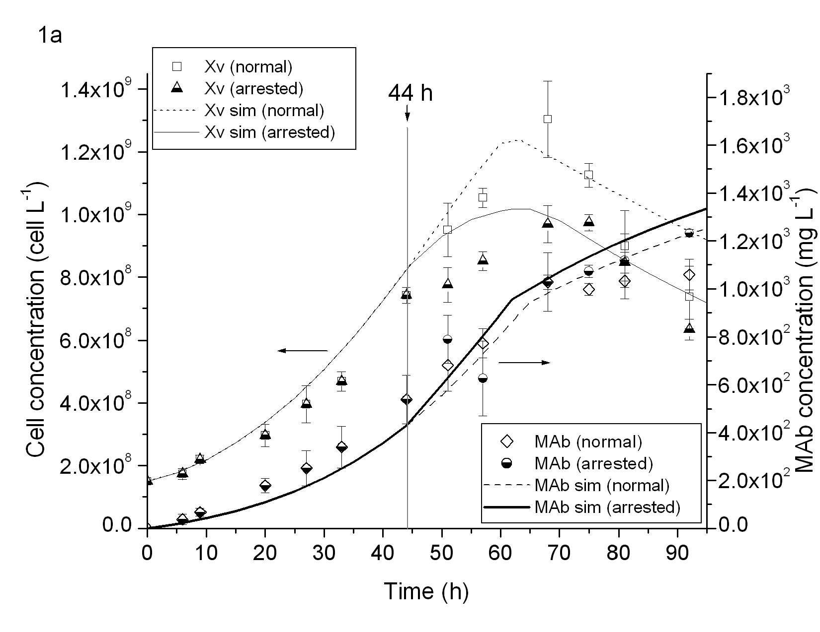
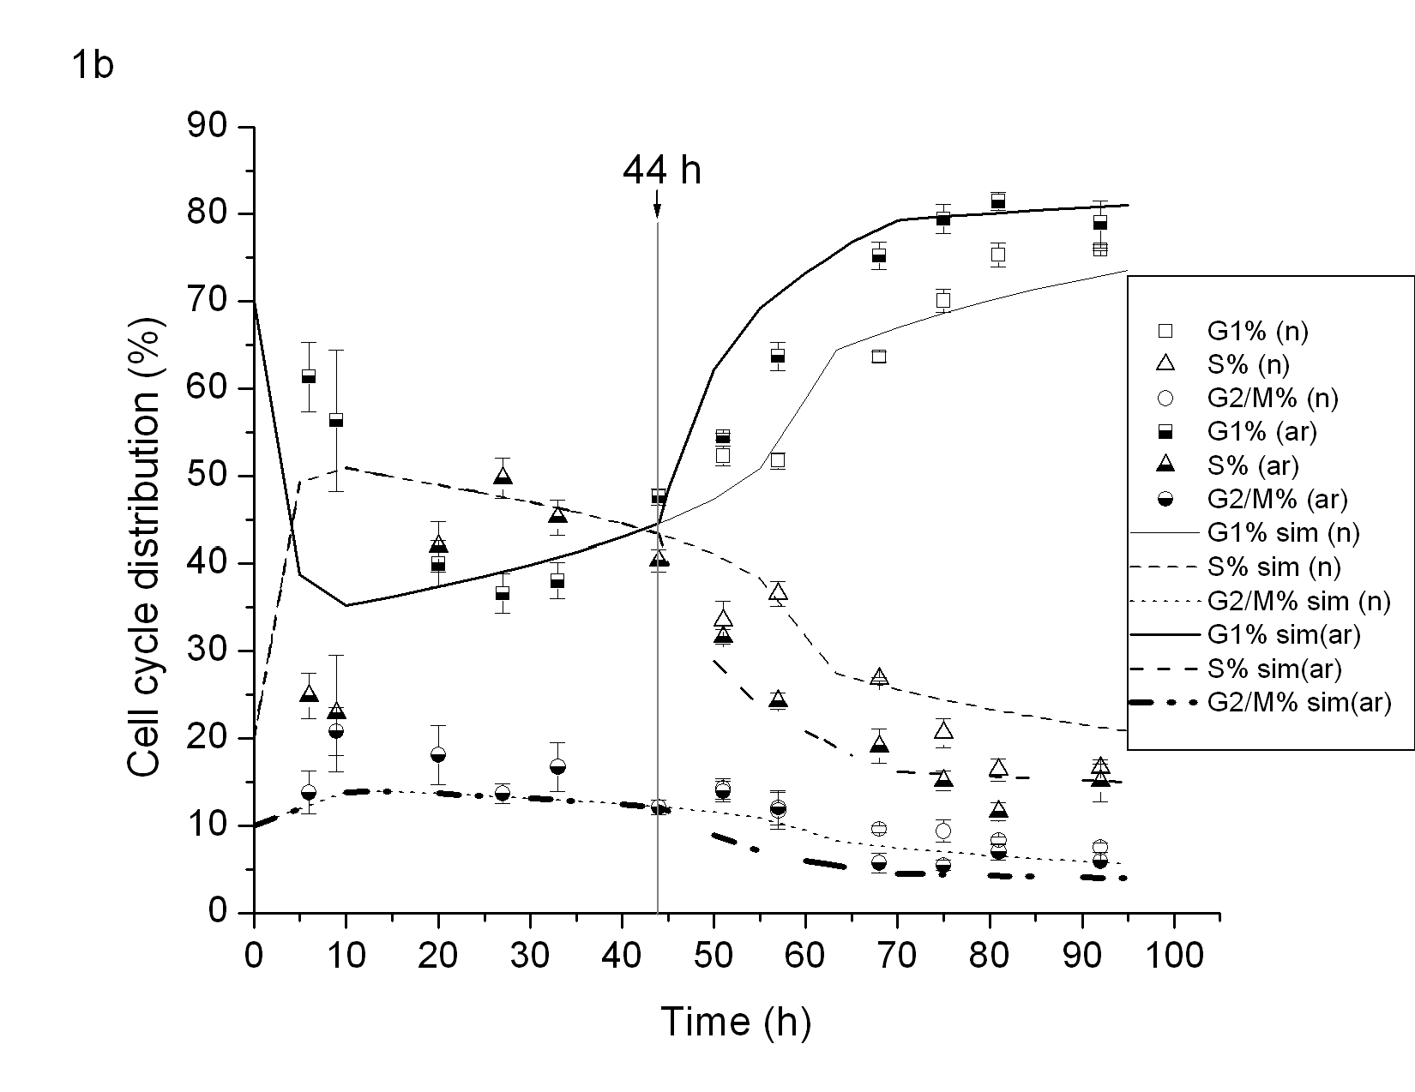
Fig.1: Batch culture data showing (a) viable cell (X_{v}) and antibody (MAb) concentration; and (b) cell cycle distribution for normal(n)/arrested(ar) cultures. Simulation results are shown by lines.
    - Fed-batch Cultures
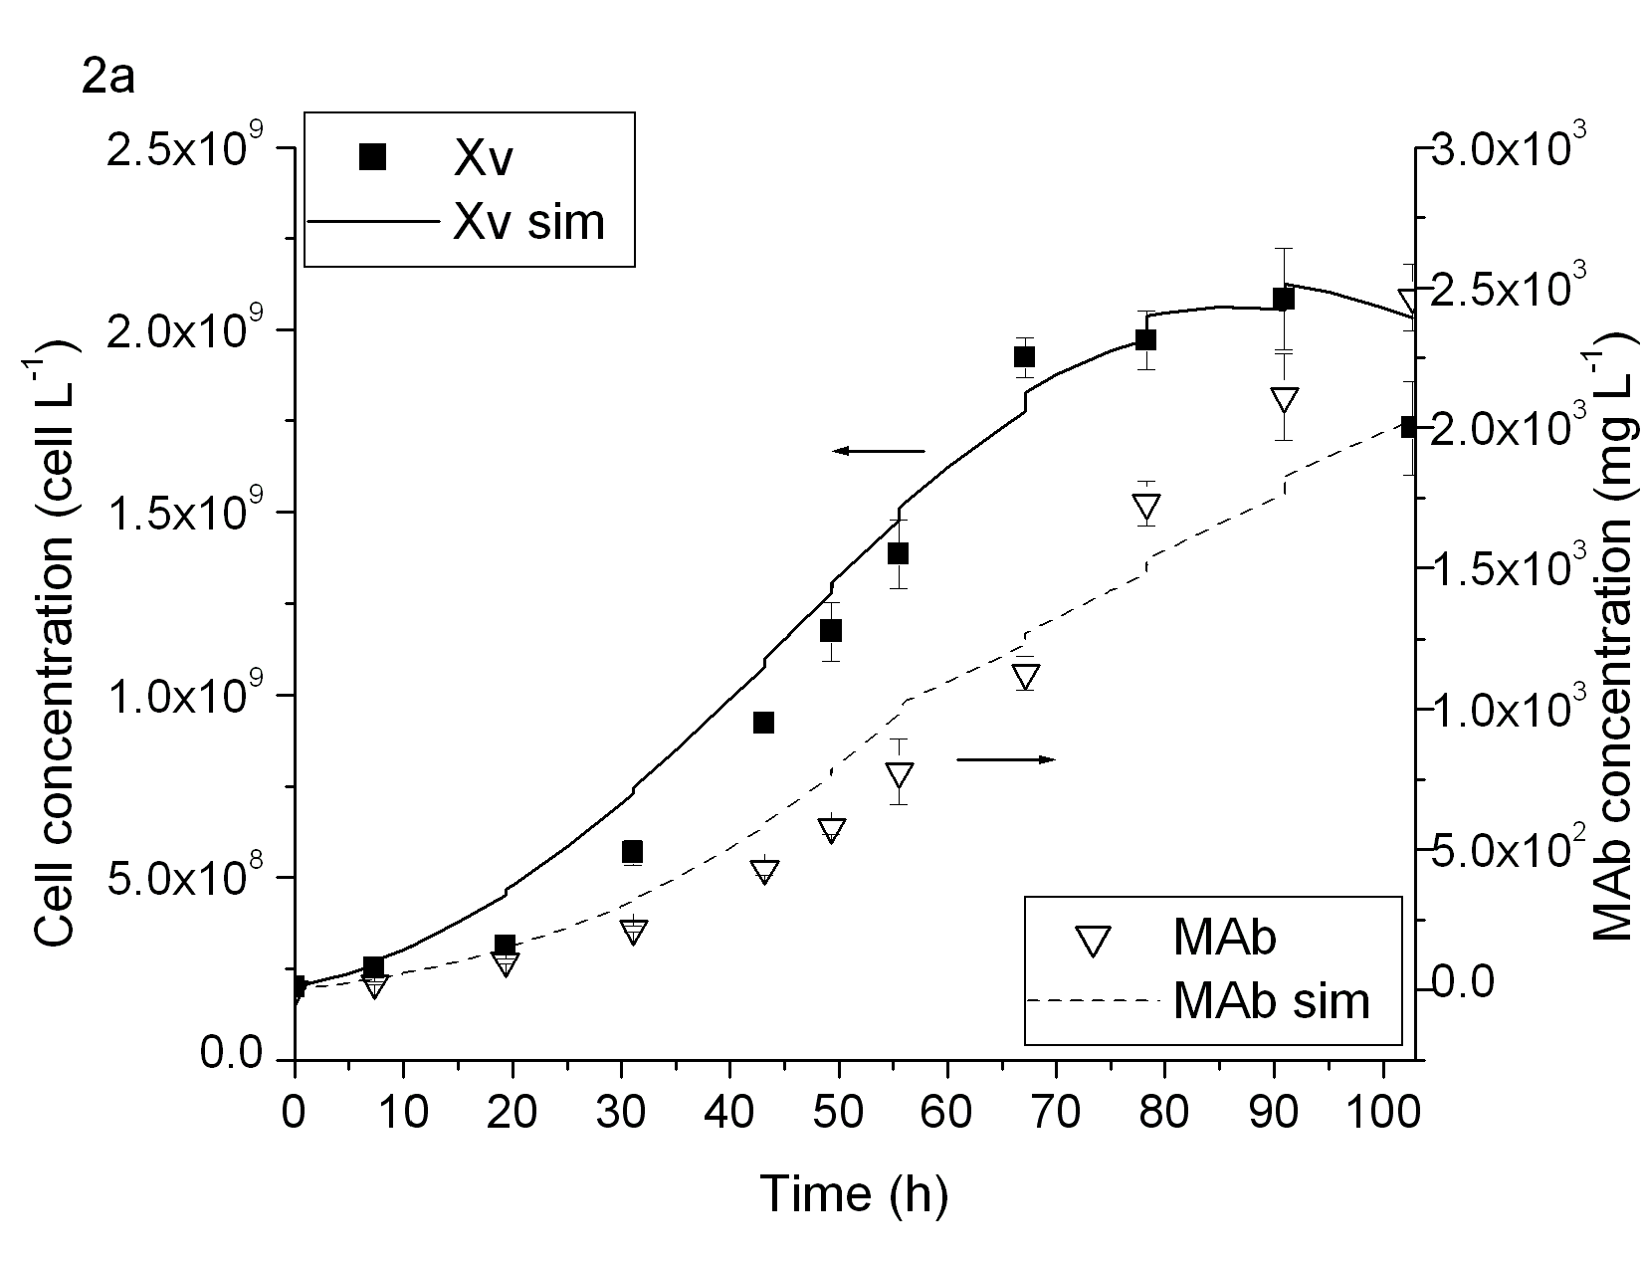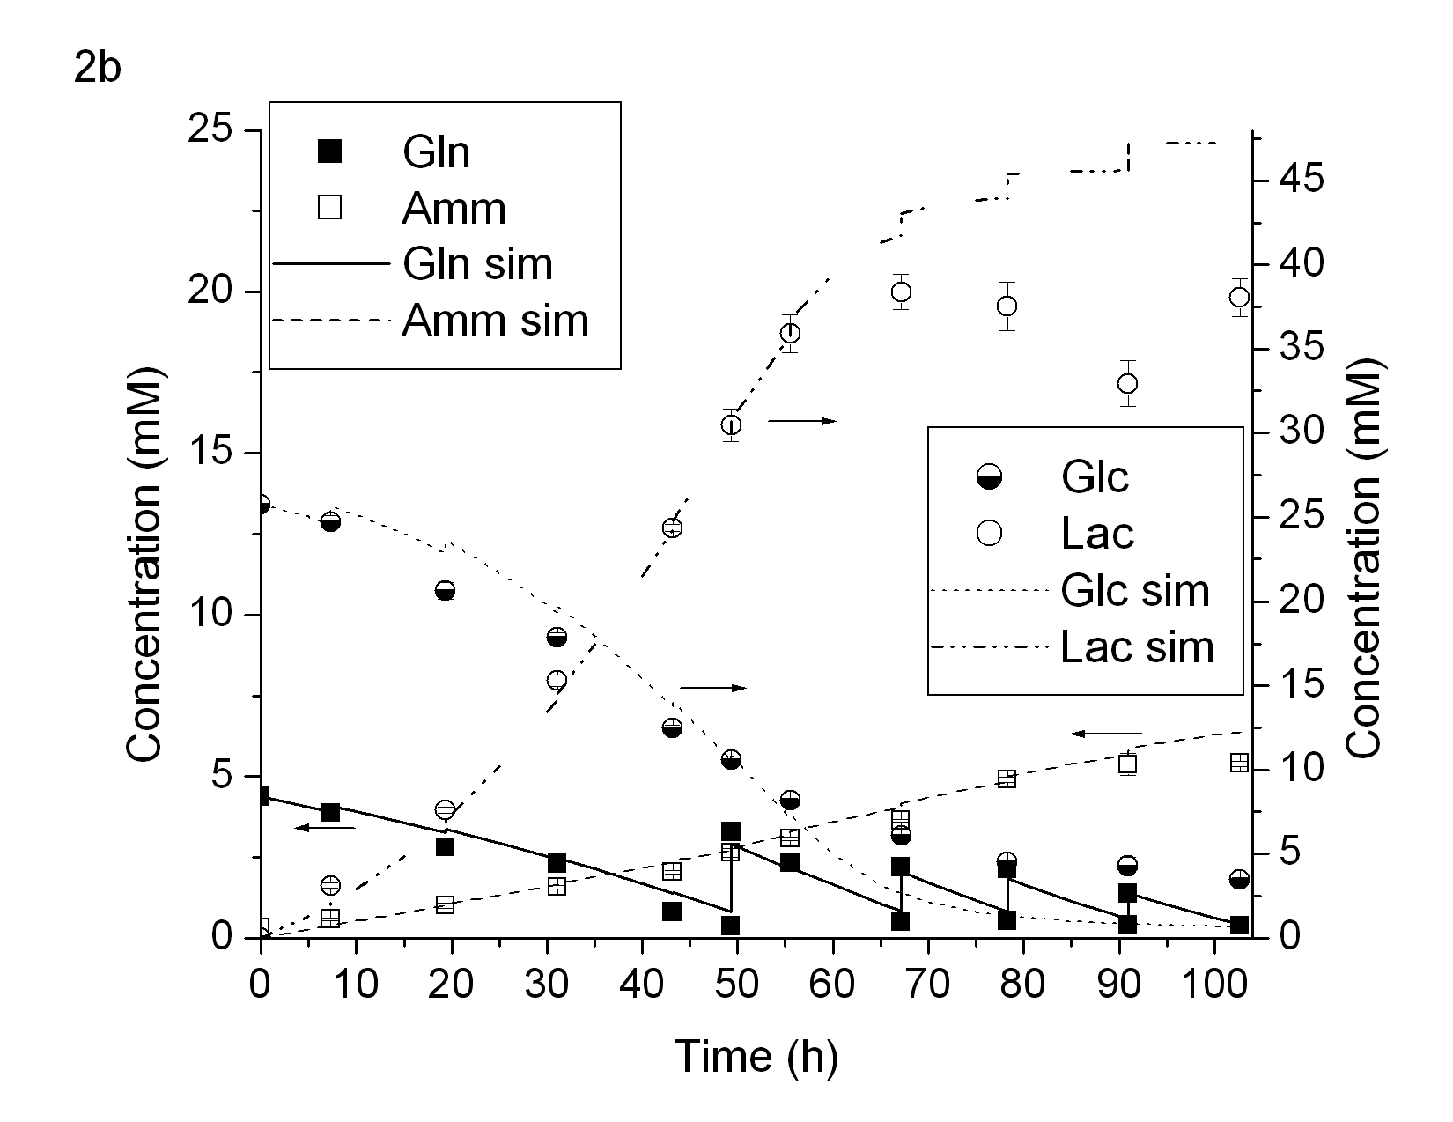
Fig.2: Initial fed-batch culture data showing (a) viable cell(X_{v}) and antibody(MAb) concentration; and (b) glutamine(Gln), ammonium(Amm), glucose(Glc), and lactate(Lac) concentration. Simulation results are shown by lines.
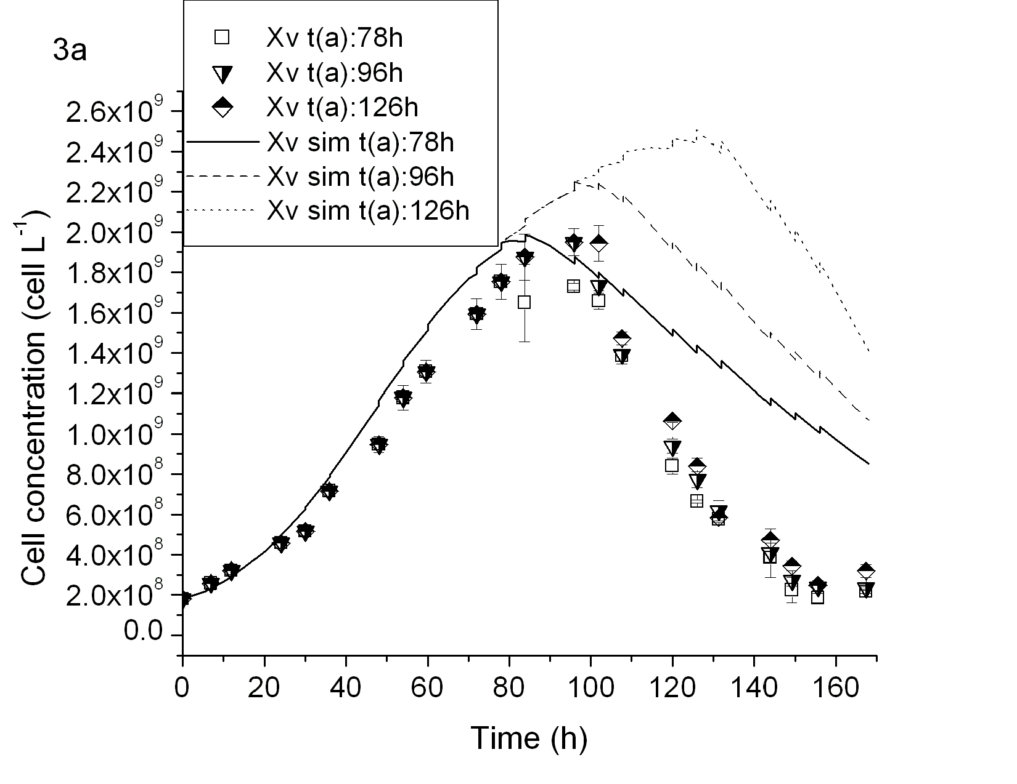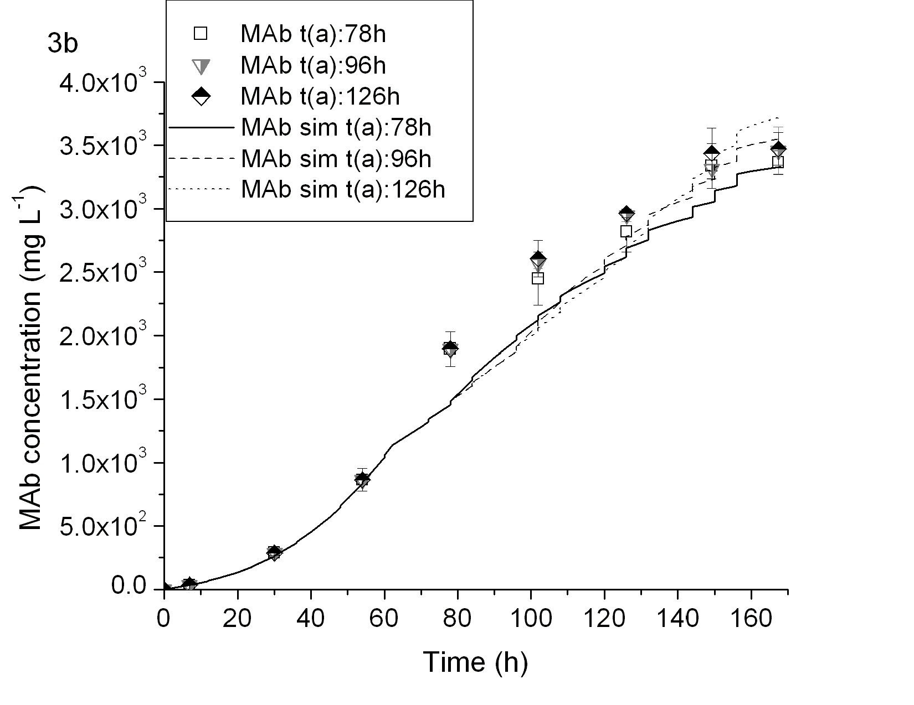
Fig.3: Optimised fed-batch data showing (a) viable cell(X_{v}) concentration; and (b) antibody (MAb) concentration for cell cycle-arrest at 126h and two other cell cycle-arrest times at 78h and 96h. Simulation results are shown by lines.
The initial fed-batch culture performed revealed a rich dynamic response of the cells when glutamine was continuously added throughout the cell culture. The simulated viable cell, MAb, glutamine, and ammonium concentrations followed the experimental trends (Fig.2). However, the cells appeared to consume less glucose and, consequently, produced less lactate after about 60 h. The model over-predicted the lactate production only near the end of the culture, suggesting that certain metabolic changes had taken place which has not been fully captured by Eq.(11)-(12).
The model-based dynamic optimisation results that were obtained from a fixed feed composition, same initial condition as the batch culture, and a feeding interval of 6-12 h, suggested an optimal cell cycle-arrest time at 126 h and supplementation with feed from 48 h onwards. The results of three different fed-batch cultures with identical supplementation strategies but various cell cycle-arrest times are shown in Fig.3. The viable cell concentration, X_{v}, was closely predicted up to about 80 h. However, after 100h, X_{v} decreased significantly in all three cultures. The predicted MAb concentration was in accordance with the experimental results with only a slight under-prediction around 80-100 h. Both model predictions and experimental results indicated a small difference in MAb yield when the cultures were arrested at different times. The optimised fed-batch experiments involved a total of 9 shake flask cultures so the deviation between the data and model predictions for X_{v} appeared to suggest a deficiency in the model. Overall, with the aid of model predictions, fewer experiments were needed in order to explore the possible limits of the cell culture production capacity. In the optimised fed-batch culture, the culture life-time was extended as indicated by the X_{v} peaking at about 100 h while the corresponding peaking time for the initial fed-batch and batch cultures were about 90 h and 65 h respectively; and the MAb yield reached ~3.5x10³ mg L⁻¹ as compared to ~2.5x10³ mg L⁻¹ in the initial fed-batch culture and ~1.3x10³ mg L⁻¹ in the batch cultures.
  - Conclusion
The model was able to predict the culture dynamics for batch, fed-batch, and cell growth arrested cultures, especially up to the exponential growth phase, after which certain variable predictions deviated from the experimental results in fed-batch cultures, e.g. the viable cell concentration in the optimised fed-batch culture tended to be overestimated, and the simulated glucose uptake rate near the end of the fed-batch cultures was higher than observed. The model closely predicted the monoclonal antibody concentration in the optimised fed-batch culture despite an underestimation of the viable cell concentration. The model developed was able to direct experimental efforts to a more focused area in this case study. The monoclonal antibody yield in the optimised fed-batch culture was ~3.5x10³ mg L⁻¹ which was about 40% higher than the initial fed-batch culture. Further improvement of the model structure may be necessary to enhance its predictive capability.
References
V. Bansal, V. Sakizlis, R. Ross, J.D. Perkins, E.N. Pistikopoulos, 2003. New algorithms for mixed-integer dynamic optimization. Computers and Chemical Engineering, 27, 647-668.
B. Basse, B.C. Baguley, E. S. Marshall, W. R. Joseph, B. van Brunt, G. Wake, D. J. N. Wall, 2003. A mathematical model for analysis of the cell cycle in cell lines derived from human tumors. Journal of Mathematical Biology, 47, 295-312.
M.K. Dyck, D. Lacroix, F. Pothier, M.-A. Sirard, 2003. Making recombinant proteins in animals - different systems, different applications. Trends in Biotechnology, 21(9), 394-399.
M.W. Glacken, E. Adema, A.J. Sinskey, 1988. Mathematical descriptions of hybridoma culture kinetics: I. Initial metabolic rates. Biotechnology and Bioengineering, 32(4), 491-506.
C. Kontoravdi, S.P. Asprey, E.N. Pistikopoulos, A. Mantalaris, 2005. Application of global sensitivity analysis to determine goals for design of experiments: An example study on antibody-producing cell cultures. Biotechnology Progress, 21, 1128-1135.
J.K.-C. Ma, P.M.W. Drake, P. Christou, 2003. The production of recombinant pharmaceutical proteins in plants. Nature Reviews Genetics, 4, 794-805.
Process Systems Enterprise Ltd. 2007. URL: www.psenterprise.com.
J.M. Reichert and A.K. Pavlou, 2004. Monoclonal antibodies market. Nature Reviews Drug Discovery, 3(5), 383-384.
M. L. Slater, S. O. Sharrow, J. J. Gart, 1977. Cell cycle of Saccharomyces cerevisiae in populations growing at different rates. Proceedings of the National Academy of Sciences of the United States of America, 74, 3850-3854.
K. Uchiyama and S. Shioya, 1999. Modeling and optimization of α-amylase production in a recombinant yeast fed-batch culture taking account of the cell cycle population distribution. Journal of Biotechnology, 71, 133-141.
X. Wang, S. He, Y. Zhang, J. Xu, Q. Feng, L. Li, L. Mi, Z. Chen, 2004. DMSO Arrested hybridoma cells for enhanced antibody production. Sheng Wu Gong Cheng Xue Bao, 20, 568-571.

