Study of a novel Heat Integrated Hybrid Pervaporation Distillation Process: Simulation and Experiments
ª M.T. Del Pozo Gómez, ª P. Ruiz Carreira, ª J.-U. Repke, ª A. Klein, ^{b} T. Brinkmann, ª G.Wozny,
ªInstitute for Process Engineering, Berlin University of Technology, Strasse des 17. Juni 135, Berlin 10623, Germany
^{b}GKSS Research Centre GmbH, Department of Process Engineering, Institute of Polymer Research, Max-Planck-Straße 1, Geesthacht D-21502, Germany
Abstract
In the present work a new developed heat integrated hybrid pervaporation distillation process is modeled and experimental studies are carried out to analyze the effect of the heat integration in the process. With the results of the experiments, the model is validated and a comparison between industrial scale non heat integrated and heat integrated processes is done. As a result, three main advantages are presented in the approach: a) reduction of the necessary external energy supply into the process, b) improvement in the pervaporation separation performance and c) reduction in the necessary membrane surface.

Keywords: heat integration, hybrid process, pervaporation, azeotropic mixtures
  - Introduction
The separation of homogeneous azeotropic mixtures has always been a highly energy consuming process in the chemical industry. Many efforts have been done in the last decade to find new and more efficient processes that improve the thermal separation techniques in practice. Between the different studied alternatives outstands the hybrid-pervaporation distillation process [F. Lipzinski, 1999]. It has been seen in previous studies [P. Kreis, 2004] that this technique can lead to a considerable reduction in the process costs by decreasing the total energy consumption. But despite of these promising results, only the application in the field of organic solvents dehydration has gained a bigger importance in the chemical industry [A. Jonquières, 2001], and the only way to increase its use is with the improvement of the pervaporation technique using a more efficient module design or a better performance membrane.
In the present paper, for the bettering of the pervaporation process, the necessary external energy supply will be reduced. The pervaporation process is a separation process, which is based on the selective transport through a dense membrane combined with a phase change of the permeating components from liquid to vapor [F. Lipnizki, 2001]. To make the change of state (liquid – vapor) possible, energy is required. That is normally reflected in a temperature drop between the inlet feed and the outlet retentate streams, what makes the use of external heat exchangers necessary after consecutive pervaporation modules. In previous studies [M. T. Del Pozo Gomez, 2007] it has been found, that the use of the saturated vapor going out at the top of the distillation column as a heating medium inside the pervaporation module (see fig.1) can lead to a lower energy consuming process avoiding the need of external heat exchangers minimizing the temperature drop along the module, and increasing the permeate flux. In the present work, the use of the heat integration in the process is studied in detail and experimentally demonstrated. For that aim, a heat exchanger has been built and integrated with a flat sheet membrane module and a model for the whole hybrid process has been built and experimentally validated. Finally, the total energy saving in an industrial scale heat integrated process is calculated.
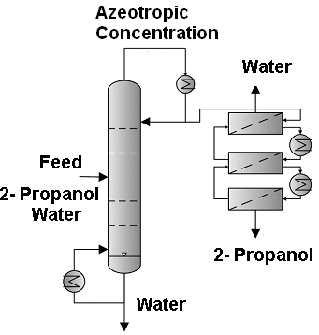 | 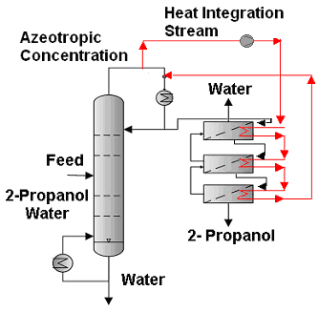
Figure 1: Hybrid pervaporation distillation process flow sheet. Left with external heat exchangers, right with heat integration.
  - Study of the heat integration concept
    - Model of the process
For the study of the process, a set of partial differential model equations for a flat sheet pervaporation membrane with an integrated heat exchanger (see fig.2) has been developed. The temperature dependence of the permeability coefficient is defined like an Arrhenius function [S. Sommer, 2003] and our new developed model of the pervaporation process is based on the model proposed by [Wijmans and Baker, 1993] (see equation 1). With this model the effect of the heat integration can be studied under different operating conditions and module geometry and material using a turbulent flow in the feed. The model has been developed in gPROMS® and coupled with the model of the distillation column described by [J.-U Repke, 2006], for the study of the whole hybrid system pervaporation distillation.
$J_{p,i}=Q_{\text{reference},i}⋅\text{exp}\left(\frac{{\text{EA}}_{i}}{R}⋅\left(\frac{1}{T_{\text{reference}}}−\frac{1}{T_{\text{feed}}}\right)\right)⋅\left(X_{i,\text{feed}}⋅γ_{i,\text{feed}}⋅p_{i,\text{feed}}^{0}−p_{i,\text{permeate}}\right)$ (1)
i Component in the mixture J_{p} Permeate flux (kg/m² hr)
Xi Mole fraction (mole/mole) $γ_{i}$ Activity coefficient
p_{i}⁰ Pressure for the pure component (bar) p_{i} Partial pressure (bar)
R Ideal gas constant (J/ mol K) T Temperature (K)
Q Permeability (kg/m² hr bar)

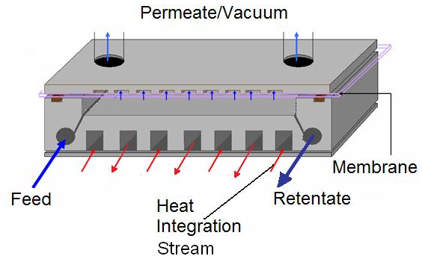 | 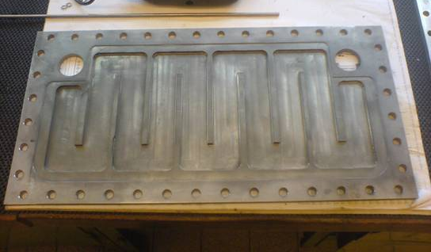
Figure 2: Flat membrane module with heat integration. Left, whole module structure, right, picture of the heat integration part.
    - Experimental work
For the model validation and the analysis of the heat integration in the hybrid pervaporation distillation process, a laboratory plant has been built at the TU -Berlin and prepared for the connection with the distillation column (see fig. 3). With this plant experiments with a flat PVA-based (Polyvinylalcohol from GKSS) hydrophilic membrane have been done. A heat exchanger has been built within the pervaporation module. The temperature in the heat exchanger has been necessary to avoid the temperature drop between feed and retentate streams in the pervaporation process. In the process a 2-Propanol/ Water mixture has been separated. The concentration of 2- Propanol in the feed is between 80 and 90 % in weight and the temperature range in the experiments was between 70 and 90°C. The feed flow is turbulent and the system fully insulated to avoid heat looses. The pressure in the permeate side has been kept at 30 mbar and the feed pressure at 1.5 bar.

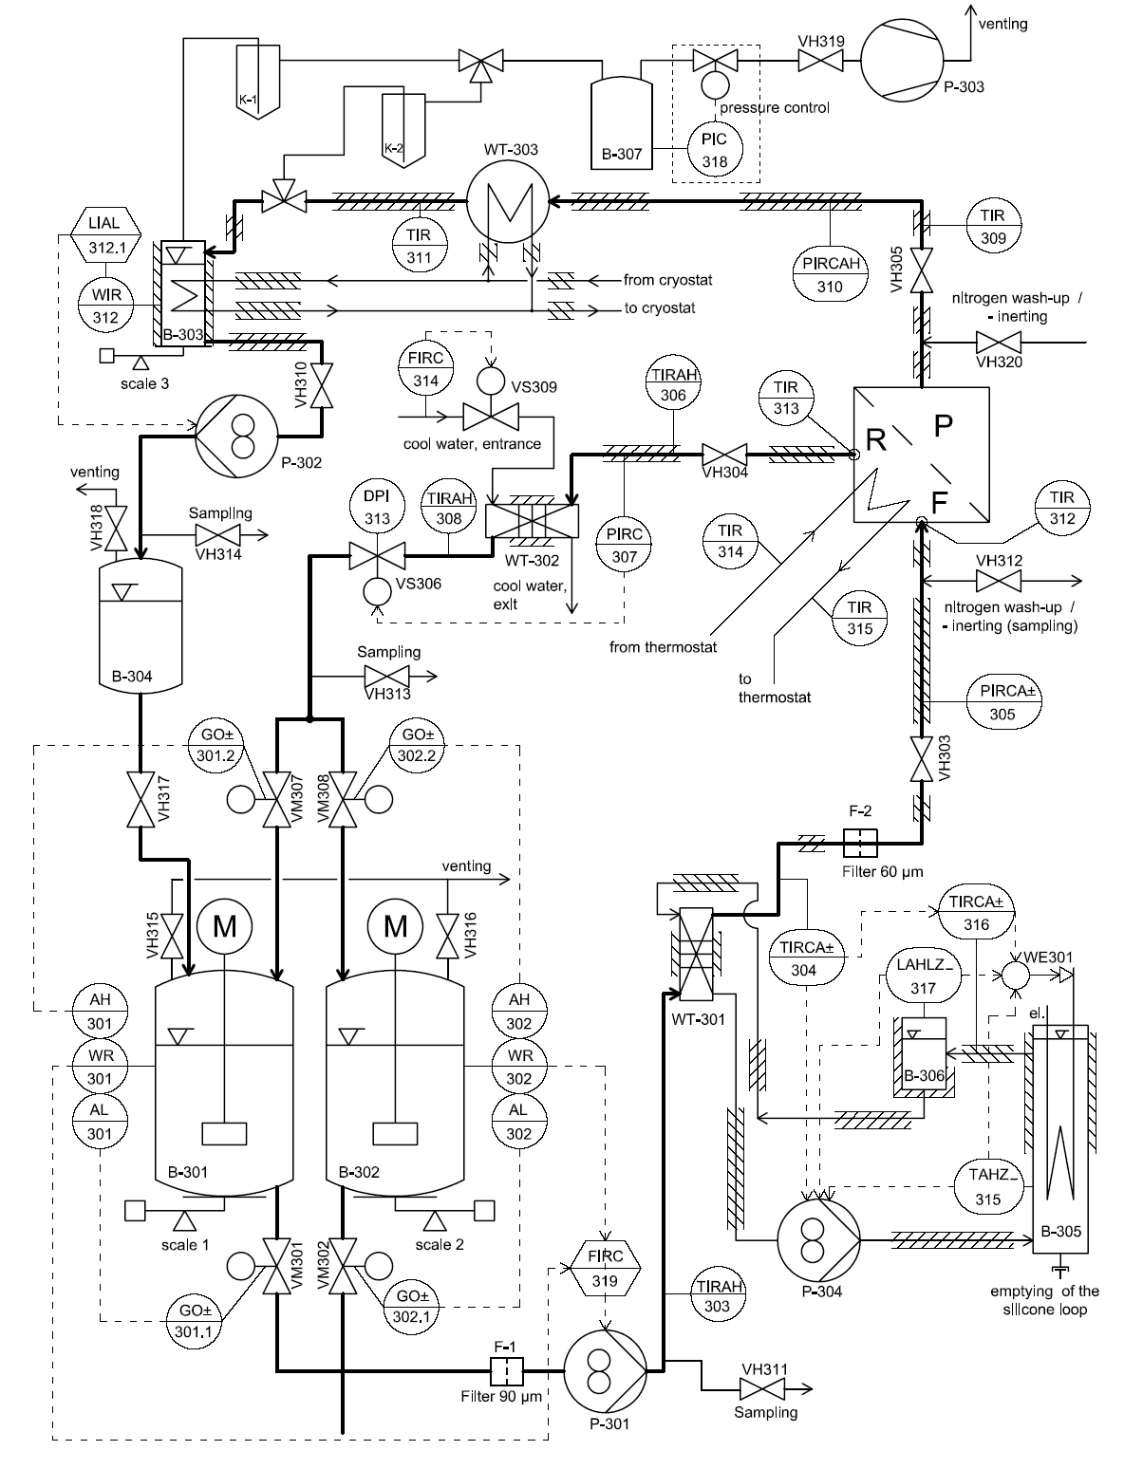
Figure 3: Pervaporation pilot plant in the TU- Berlin. Left process diagram, right pilot plant.
With help of a Freelance ABB process control system, the process was monitored and controlled and important variables of the system were recorded.
  - Results and discussion
    - Membrane characterization and validation of the model
After experimental work, the value of the activation energy (EA) and the reference permeability (Qref) for a PVA-based (from GKSS) pervaporation membrane and mixture in use have been obtained (see table1), and the model for the pervaporation process with and without heat integration has been successfully validated. The absolute error between the model and the experimental permeate fluxes is under 8% (see fig.4), and almost insignificant for the water purity in the permeate side (under 0.5%) obtaining a permeate stream with up to 99.9% in water.

Table 1. Results of the membrane characterization for a reference temperature of 70°C.
Compound | EA (J/mol) | Q_{ref} (kg/m² hr bar)
2- Propanol | -69663.2 | 6.4E-4
Water | -230.73 | 1.483

Figure 4: Model validation. Permeate flux (Jp) experimental and model results, using a flat PVA -based organic module by dehydratation of a 2- Propanol/ Water azeotropic mixture. The temperature was kept between 70 and 90°C and experiments with and without heat integration were done.
    - Influence of the heat integration in the pervaporation process
Experiments with and without heat integration have been done under the same conditions in order to study the effects of the heat integration in the process. It has been found, that by supplying the energy necessary for the pervaporation, the total permeate flux increased more than 13% (see fig.5) and, if the total energy provided by the condensation of the vapor is supplied, even a higher increase in the permeate flux can be achieved (up to 22%) getting permeate fluxes around 0.36 kg/ m² hr.

The increase in the permeate flux has an important influence into the process, making possible, either the reduction of the necessary membrane area (for a desired product purity), or the increase of the product purity (if the membrane area is kept constant). No need of external heat exchangers between two pervaporation modules is required, and all the energy supplied into the pervaporation module can be obtained from the condensation of the distillate stream [A. Klein, 2006].
Figure 5: Influence of the heat integration in the permeate flux at a feed temperature of 70°C.
Increase in the permeate flux due to the heat integration
    - Comparative study of the industrial scale process with and without heat integration
With the validated model, and on the basis of the industrial scale operation parameter presented by [S.Sommer, 2004] (see table 2), the configurations with and without heat integration have been compared for an industrial scale process. It has been found that the total energy supply in the process per kg final product can be reduced about 28% and that a higher product purity is obtained (see table 3) due to the heat integration effect. This is reflected not only in the reduction of the energy consumption, but also in a smaller necessary membrane area, if the desired purity of the product is constant.

Table 2. Operation conditions of the industrial scale simulation processes.
Pressure in the column | 1.015 bar | Feed flow rate in the column | 1875 kg/hr
Number of stages in the column | 8 | Bottom wt% Water in the column | 99.8
Feed wt% 2- Propanol in the column | 80 | Membrane Area | 125 m²
Feed wt% Water in the column | 20 | Permeate pressure | 20 mbar

Table 3. Comparison between the energy conssumption in the two processes lay -out.
 | [kW] Re-boiler | [kW] External | [kW] Condenser | [kg/hr] product | [kJ/kg product]
With heat integration | 509.87 | 46 (compressor) | 311.63 | 1490.59 (90.6% wt. 2-Propanol) | 2095.14
Without heat integration | 525 | 170 (membrane feed reheating) | 520 | 1500 (90% wt. 2-Propanol) | 2916

  - Conclusions
In the present paper, the influence of the novel heat integration concept has been successfully demonstrated and studied in detail. For that purpose, a heat exchanger has been built including a flat membrane module. A new model describing the heat integrated process has been developed in gPROMS® and experimentally validated. It has been proven that an important effect of the heat supply is the increase in the total permeate flux up to 22%. That will be directly reflected in higher product purity for a constant membrane area or in a smaller membrane surface requirement if the desired product purity is fixed, having a more profitable process. The concentration of water in the permeate side has been within the desired values (over 99.9%) and the model predictions of the separation process for the azeotropic mixture 2-Propanol/Water are adequate. The comparison of the industrial system with and without heat integration has been done. As a result, in the case with heat integration the total energy supply in the process can be reduced about 28% and the product purity can increase. In the presentation, the results of the model and experiments and the comparison of the process with and without heat integration will be shown in further detail and the advantages of the new heat integration concept will be proven.
  - Acknowledgements
The authors would like to thank EFRE (request number 10134788) for sponsoring this project, and PolyAN GmbH for the cooperation in the present research work.
References
M.T. Del Pozo Gómez, A. Klein, J.-U. Repke, G. Wozny, 2007, Study and Design of a Heat-integrated Hybrid Pervaporation-Distillation Process, ECCE-6 1357 Distillation, Absorption & Extraction.
A. Klein, J.-U. Repke, M. T. Del Pozo Gómez, G.Wozny, 2006, Hybrid -Pervaporation-Distillation processes – a novel heat-integration approach, AJChE 409 Separation Design.
J.-U. Repke, F. Forner, A Klein, 2006, Separation of Homogeneous Azeotropic Mixtures by Pressure Swing Distillation – Analysis of the Operation Performance, Chem. Eng. Techn., vol. 28, 1151-1557.
S. Sommer, T. Melin, 2004, Design and Optimization of Hybrid Separation Processes for the Dehydration of 2-Propanol and Other Organics, Ind. Eng. Chem., vol. 43, 5248-5259.
P. Kreis, 2004, Prozessanalyse hybrider Trennverfahren, Dissertation, Dortmund, Germany.
S. Sommer, 2003, Pervaporation and vapour permeation with Microporous Inorganic Membranes, PhD Thesis, RWTH Aachen, Germany.
J. Lipzinski, G. Trägardh, 2001, Modelling of Pervaporation, Models to analyze and predict the mass transfer transport in Pervaporation, Separation and Purification Methods, vol. 30(1), 49-25.
A. Jonquières, R. Clément, P. Lochon, J. Néel, M. Dresch, B. Chrétien, 2001, Industrial state-of-the-art of pervaporation and vapour permeation in the western countries, Journal of Membrane Science, vol. 206, 87 -117.
F. Lipzinski, R.W. Field and P.-K. Ten, 1999, Pervaporation-based hybrid process: a review of process design, applications and economics, Journal of Membrane Science vol. 153, 183 – 10.
J.G. Wijmans, R.W. Baker, 1993, A simple predictive treatment of the permeation process in pervaporation, Journal of Membrane Science, vol. 79, 101-113.

