Curricular and pedagogical challenges for enhanced graduate attributes in CAPE

Ian T Cameronª, Daniel R Lewin^{b}
a. School of Engineering, The University of Queensland, Brisbane, AUSTRALIA, 4072
b. PSE Research Group, Dept Chemical Engineering, Technion, Haifa 32000, ISRAEL
Extended Abstract
Computer Aided Process Engineering (CAPE) undergirds and informs a wide range of decision making in the product and process life cycle. Life cycle phases that span the planning and conceptualization of product and process, through research and development and then onto design, construction, operation and decommissioning are permeated by CAPE activities. The importance of CAPE activities and their central role in the global engineering enterprise cannot be underestimated. These activities require the use of techniques and tools for informed decision making are shown in Figure 1.

Figure 1 Some CAPE application areas across the life cycle phases
Yet, how well do we tackle the challenges of CAPE in curriculum design and deployment in higher education? What are the keys to effective development of graduate attributes and skills in the CAPE domain that can be achieved through innovative curricula and the learning environments that inform, challenge and prepare engineering graduates for work in a “model centric” world? What are the technological and informational forces that are rapidly shaping the way engineering is practised in the global context?

In this presentation, the authors seek to address some of these questions by reference to current trends in educational practice and the application of active learning principles that have been developed, deployed and assessed at institutions in Australia, Israel and elsewhere. In most cases these approaches have found extensive use over many years. It is vital that the debate is centred not just on individual, isolated courses that touch on some aspects of the CAPE issue, but that we start with holistic or systems thinking on curriculum development that provides integration and cohesion in the curriculum and leads to graduate attributes and skills necessary for the next generation of engineers.

The curriculum challenge is seen as a cohesive pathway that exercises a strong thread of CAPE activities. Pathways need to build upon basic concepts, integrate new content which illustrates the relationships amongst the principal learning components and then drives that learning with realism and relevance to maintain student engagement. The curriculum challenge has to address the major issues of:

- WHAT has the be learned: the content issue
- WHY it is to be learned: the rationale
- HOW it is to be learned: the process and methods
- WHEN it has to be learned: the pathway to be adopted

In terms of processes, there are numerous options available with the most effective focusing on active learning strategies. Figure 2 illustrates some well documented pedagogic approaches that have been adopted into curriculum delivery. They include problem and project based learning (PBL), project centred curricula (PCC) and Conceive, Design, Implement and Operate (CDIO) approaches.

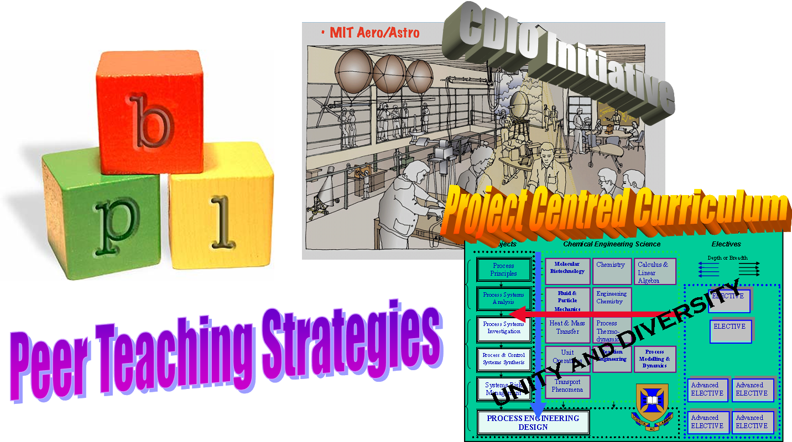
Figure 2 Active learning pedagogies in curriculum delivery

The authors will explore these key issues and illustrate holistic approaches that impact on curriculum innovation. They will draw examples from a range of applications of these important pedagogic concepts.

