Coherent Synchronized Oxidation of CH₄, C₂ H₆, C₃ H₈ by Hydrogen Peroxide

U.V.Nasirovaª, L.M.Gasanovaª, Ch.A.Mustafaevaa, I.T.Nagieva^{b}, Z.A.Mustafaevª, T.M.Nagiev^{a,b*}

ªInstitute of Chemical Problems, National Academy of Sciences of Azerbaijan, 29 H.Javid Av., 370143 Baku, Azerbaijan Republic, Tel.: (99412)492-77-87, E-mail: tnagiev@itpcht.ab.az, tnagiev@azeurotel.com
^{b}Baku State University, Azerbaijan Republic

1. Summary

The mechanism of biomimetic hydroxylation reactions of lower alkanes by hydrogen peroxide have been investigated. The catalase and hydroxylation reactions were characterized by synchronous kinetic curves.

Keywords: coherent synchronized reactions, Green Sustainable Chemistry, biomimetic catalyst.

2. Extended abstract

Creation of new catalytic systems of high selective oxidation and use of harmless oxidizers owing to which it was possible to exclude use of the technological processes, polluting an environment and breaking of existing in the nature material and power balance, actually is philosophy of new chemistry, Green Sustainable Chemistry. In the reactions of oxidation presented by us, have tried to realize the ideas of green chemistry by use of biomimetic catalysts of selective oxidation and hydrogen peroxide as soft, concerning cheap and ecologically safe oxidizer (H₂O₂ as is known, concerns to group of green oxidizers).
Biomimetic catalysts of monooxygenation, being imitating models of monooxygenase enzymes [1], have been synthesized on the basis of ironporphyrin complex derivatives, immobilized on firm carriers of the acid – base nature. These biomimics have been researched in reactions of oxidation (hydroxylation) of CH₄, C₂H₆ and С₃H₈ by hydrogen peroxide. As rather moderate temperature (180 – 240°C) occurs hydroxylation of hydrocarbons with selectivity 98-100% and high enough yields of target products.
Alongside with questions of activation and stabilization of synthesized biomimetic catalysts such as PPFe³⁺OH/AlSiMg, PPFe³⁺OH/Al₂O₃, PPFe³⁺OH/NaX, TPhPFe³⁺OH/Al₂O₃ and per-FTPhPFe³⁺OH/ Al₂O₃, mechanism of their action on course of reactions have been investigated. From these data follows: oxidation represents two coherent synchronized reactions, catalase and monooxygenase, which proceed on the following mechanism [2]:
ROH + H₂O
H₂O + O₂
RH
1
2
ImtOH
ImtOOH
H₂O
H₂O₂
H₂O₂

The most typical experimentally found kinetic patterns of CH₄ hydroxylation on PPFe³⁺OH/AlSiMg and C₃H₈ monooxygenation on per-FTPhPFe³⁺OH/Al₂O₃ are shown on curves (Fig. 1, 2).
Fig.1. Exposure time dependences of the yields of methane hydroxylation products: (1) - CH₄ conversion, (2) - yield of CH₃OH, (3) - yield of CH₂O and HCOOH, (4) – selectivity, (5) - yield of O₂ (CH₄:H₂O₂=1:1.8, 180°C, [H₂O₂] = 20wt %).

wt.%
τ, s
Fig.2. Dependences of propane hydroxylation reaction products yields on contact time:
1-O_{2,} 2-i-C₃H₇OH;
([H₂ O₂] =20 wt.%, C₃H₈ : H₂ O₂=1:2).

Mol.%
τ, s

T.M.Nagiev et.al.
As follows from the Fig.1, at short contact times (below 2.9s) the monooxygenase activity of the mimic remains low, whereas catalase activity is maximal (molecular oxygen yield exceeds 90 wt.%). Methanol yield and methane conversion increase with contact time up to τ =10s and then stabilize at a level of 49-50 wt.% with ~96% selectivity. Formaldehyde and formic acid are by-products, giving total 2.7wt.% no CO and CO₂ are detected in gaseous products.
The curve of O₂ accumulation shows that short contact times, at which the methane oxidation rate is low, are enough for complete H₂O₂ dissociation. However, as observed from shapes of O₂ and CH₃OH accumulation curves, methanol yield increases synchronously with O₂ yield decrease, and from the moment τ = 10.2s both curves stabilize. Such stabilization and synchronization of catalase and monooxygenase reactions product yields is the experimental proof of their interaction, displayed by chemical conjugation. The existence of the stabilization zone of O₂ and CH₃OH yield is associated with full H₂O₂ dissociation.
As shown in Fig.2, the curve of isopropyl alcohol accumulation versus the exposure time passes through the extrema. The process starts with a primary catalase reaction proceeding on the biomimetic, which with time induces the reaction of hydroxylation, and increases the yield of isopropyl alcohol. The curve of O₂ accumulation shows that with an increase in the exposure time a larger amount of hydrogen peroxide is consumed for the formation of isopropyl alcohol towards a maximum value (27.3 mol%, at τ =1.1s), and the yield of molecular oxygen synchronously decreases.
Coherently synchronized character of curves of catalase and monooxygenase reactions products yields depending on contact time shows, that oxidation of CH₄ and C₃H₈ proceed in a mode of a chemical interference (Fig.1, 2) [3].
The mechanism of biomimetic catalysts suggested above conforms to current views on the mechanism of the action of its biochemical analogues. This makes it possible to approach the problem of kinetically modelling substrate hydroxylation by hydrogen peroxide in term of the kinetics of enzyme catalysis. We showed above that the reaction system RH+H₂O₂+ImtOH is a two-substrate complex system in which the reaction proceeds in two stages (1) and (2). In kinetically describing the reaction, it should be borne in mind that stage (1) producing the ImtOOH intermediate is fast, and stage (2) is slow and therefore, rate-determining. This allowed us to apply the Michaelis-Menten equation in Linuver-Berk coordinates: 1/r =1/r_{max} + K_{m}/r_{max} (1/[S]), where K_{M} is the Michaelis constant; r is the substrate transformation rate; r_{max} in the maximum reaction rate and [S] is the current concentration of the substrate.
Fig.3 shows dependences of 1/r on 1/[S], which indicate a satisfactory description of plots from Fig.1 by Michaelis-Menten equation (methane). According to the date in Fig.3, Michaelis constants were determined for every temperature: K_{M}= K₂ +K₁ /K₁, where K₁ and K_{M} are rate constants of ImtOOH complex synthesis and degradation; K₂ is the rate constant of methyl alcohol synthesis.
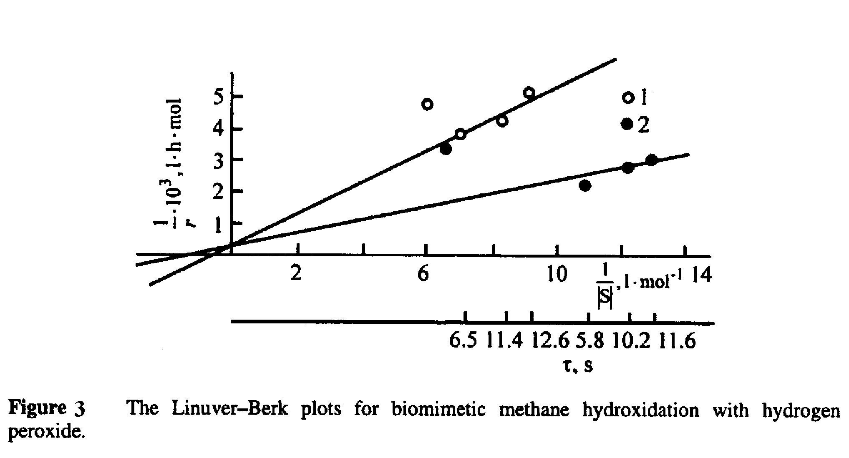
References:

1) T.M.Nagiev, L.M.Gasanova, S.Z.Zulfugarova, Ch.A.Mustafaeva, A.A.Abbasov (2003) // Chem. Eng. Comm. 190: pp.726-748.
2) T.M.Nagiev (2007) Coherent Synchronized Oxidation Reactions by Hydrogen Peroxide. Elsevier. Amsterdam. p.325.
3) A.A.Abbasov, S.Z.Zulfugarova, L.M.Gasanova, T.M.Nagiev (2003) // Jurnal Fizicheskoi Khimii. V.76, №10, pp.1758-1764.

